***Chhotu Kumar***

My project name is **Attendance Management system** using python

*******I have learnt so many things we will explain one by one.*********

To be honestly I don't about NLP,OpenCV and many more but because of AICTC internship we know so thanku so much

-------------------------------------------------------------------------------------------

1. What is the use of OpenCV.

=> OpenCV (Open Source Computer Vision Library) is a popular open-source library designed for computer vision and image processing tasks. It provides a comprehensive set of tools and functions for analyzing, manipulating, and understanding images and videos. OpenCV is widely used in areas like robotics, machine learning, real-time systems, medical imaging, augmented reality, and more.

2. What is NLP(natural language Processing).

=> NLP (Natural Language Processing) is a field of artificial intelligence that focuses on the interaction between computers and human language. Its goal is to enable computers to understand, interpret, and generate human language in a way that is both meaningful and useful.

3. what is Machine learning.

=> Machine Learning (ML) is a branch of Artificial Intelligence (AI) that focuses on enabling machines to learn from data and improve their performance over time without being explicitly programmed for specific tasks. It uses statistical techniques and algorithms to find patterns in data and make decisions or predictions.

4. what is neural Networking.

=> Neural Networks (NN) are a class of machine learning algorithms inspired by the structure and functioning of the human brain. They are designed to recognize patterns and make predictions by learning from data through interconnected nodes (called neurons), which mimic the way neurons work in the human brain.

Neural networks are a foundational concept in Deep Learning, which is a subset of machine learning that deals with large-scale models with multiple layers (known as Deep Neural Networks).

5. what are library are used in attendance management system.

=> Tinker, Tensorflow, OpenCV, numpy, and so on.

6. How can I collect data set.

=> There are lots of data set available in the internet like kaggle , and so on. You can visited them and learn so many thing. And it is also helpful for those person who want to try their model.

7. System architecture of attendance management system and how it working.

=> The Attendance Management System allows the recording of student or employee attendance and stores the data in a database for easy retrieval. It may have different access levels, including admin, teachers, and users (students or employees), with functionality to track attendance, generate reports, and send notifications.

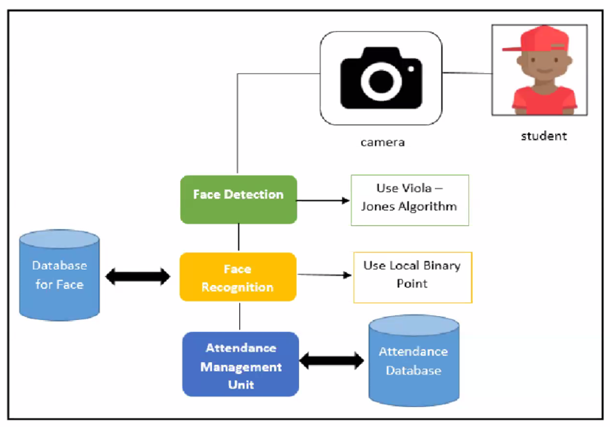

8. Which platform we should deploy project.

=> we can deploy on the cloud as well as some other platform. For deploy we use some model Tkinter, Flask and so on.

**Thanks once again Sir**