**Homework Guideline (Topic 1)**

1. 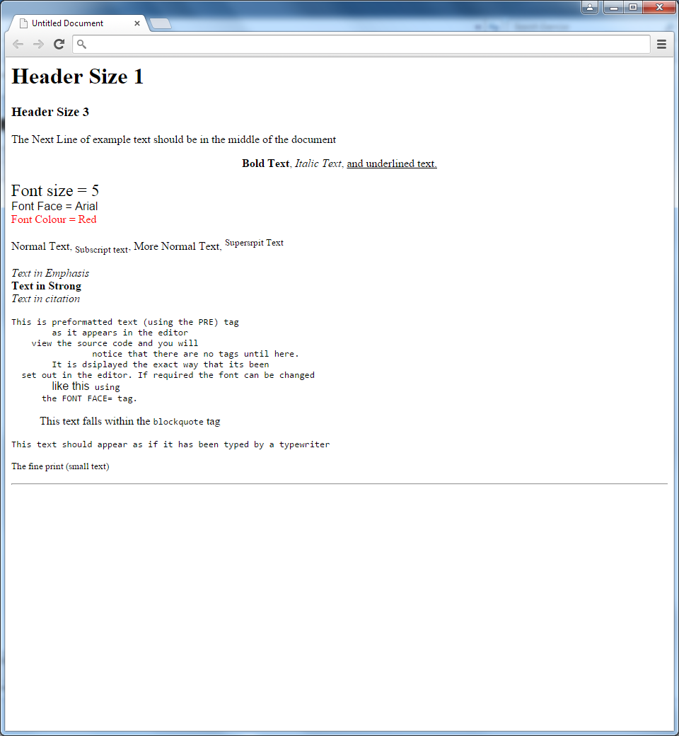**Screenshot**
2. **Objective**

* Understanding about how to use each tag.

1. **Deadline**

* Start date: 01/April/2015
* Collecting Date: 03/April/2015

1. **Instruction**

* Making an HTML file like in the picture using tags student studied

1. **Marking Criteria**

* Correctness: 80%
* Code Arrangement: 20%