**Homework Guideline (Topic 2)**

1. **Screenshot**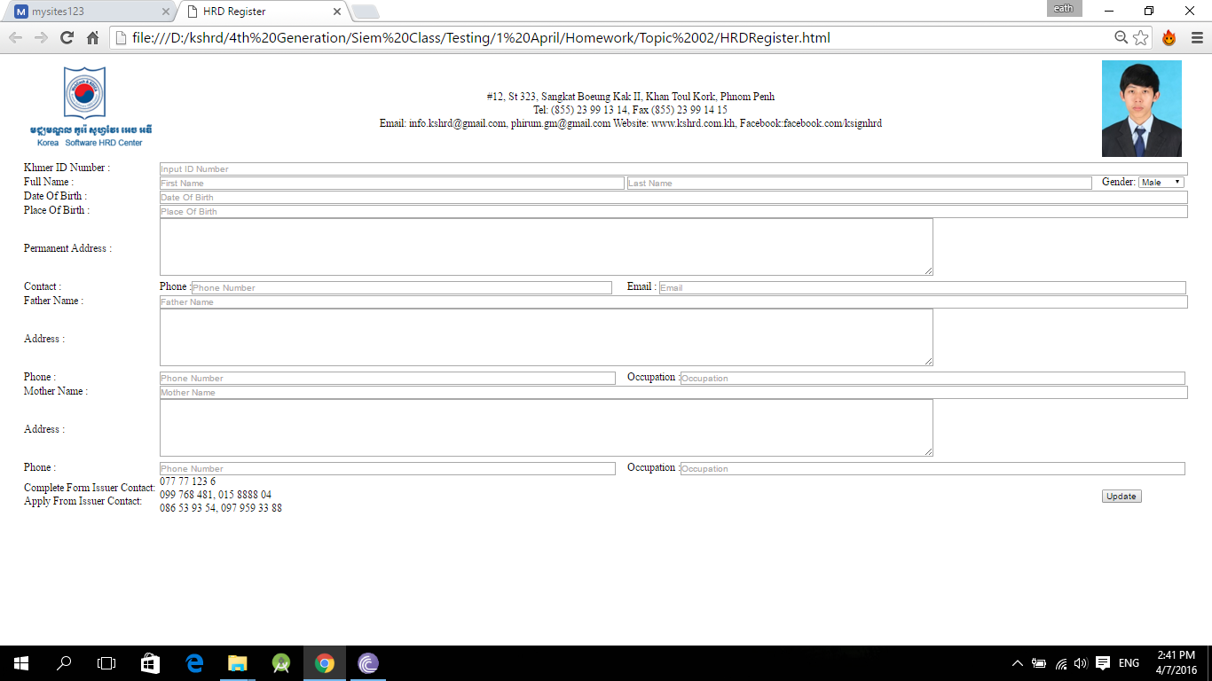
2. **Objective**

* Understanding about how to design a website layout using Table
* How to use html form (input, button, …) and its attributes

1. **Deadline**

* Start date: 07/April/2016
* Collecting Date: 08/April/2016

1. **Instruction**

* Create a form as in the image using html tags (table, img, …) without CSS.

1. **Marking Criteria**

* Correctness: 80%
* Code Arrangement: 20%