**Mini Project Guideline (1st Month)**

**Article Management Website**

1. **Objectives**

After doing the mini project, students will be able to

* Practice what they have studied in the previous month
* Enhance their skills in designing webpages
* Design Template for their final project

1. **Scope**

Students need to implement a mini-project which contains at least 5 pages. For example, students can create

* **Article Management**
* Home
* Forum
* Technology
* News
* About Us
* ……………..

1. **Instruction**

In order to do this mini project, students have to use

* Individual
* HTML
* CSS
* Bootstrap (Optional)

1. **Marking Criteria**

* Design: 50%
* Content: 25%
* Code & Code Arrangement: 25%

1. **Deadline**

* Start Date: 18/04/2016
* Submission: 28/04/2016 (Morning)
* Presentation: 28/04/2016 (Afternoon)

**Note:** For presentation, all web teachers have to participate in scoring for each class.

Example:

**Homepage**

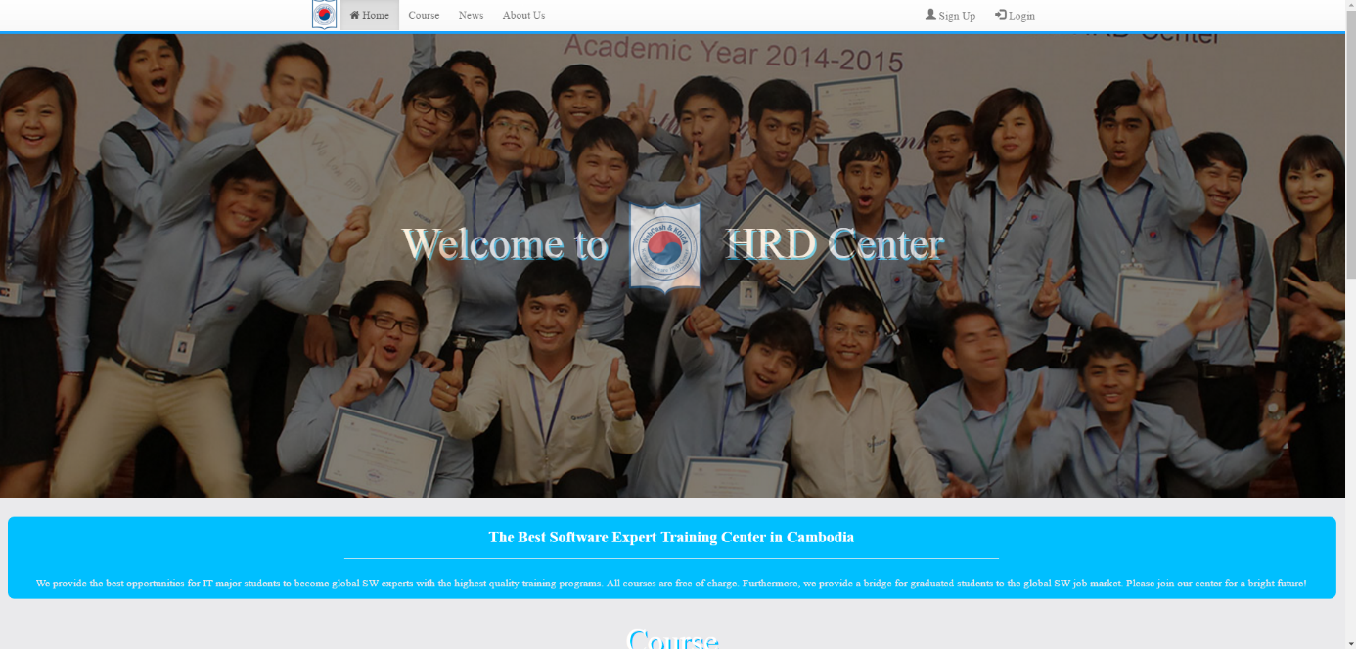



**About us**

