CHP3

USE CASE 1:

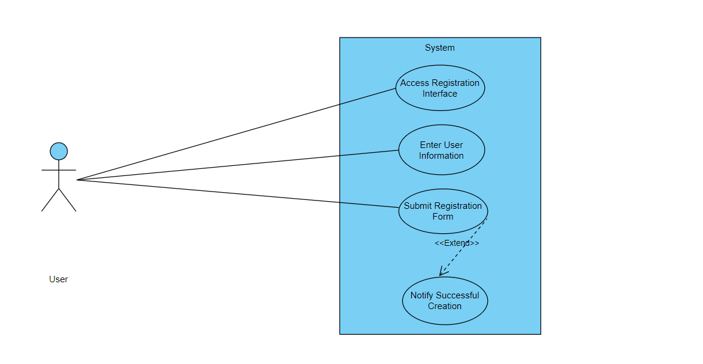

|  |  |  |
| --- | --- | --- |
| Use Case ID | UC_001 | |
| Use Case Name | Registration/Sign up | |
| Description | This use case involves the process of creating a new account within the Sign Language Transcription System, allowing users to access and utilize the system's features. | |
| Primary Actor | User | |
| Secondary Actor | None | |
| Pre-Condition | The user must have access to the system's registration interface. | |
| Post-Condition | A new user account is successfully created, and the user gains access to the system. | |
| Basic Workflow | Actor Action | System Action |
|  | * The user accesses the registration interface. * The user enters the required information, such as username, email, and password. * The user submits the registration form. * The system notifies the user of successful account creation. | * The system displays the account creation form. * The system validates the entered information. * The system processes the registration request and creates a new user account. |
| Alternate Flow | If the entered information is incomplete or fails validation:   * The system notifies the user of the validation error. * The user corrects the information and resubmits the form. * Steps 4 to 8 are repeated. | |

USE CASE 2:

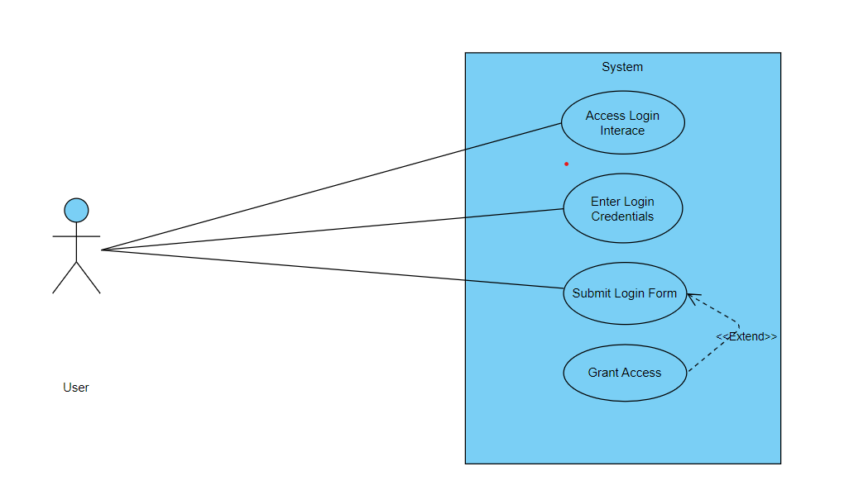

|  |  |  |
| --- | --- | --- |
| Use Case ID | UC_002 | |
| Use Case Name | Login | |
| Description | User can login to the system | |
| Primary Actor | User | |
| Secondary Actor | None | |
| Pre-Condition | The user must have access to the system's registration interface. | |
| Post-Condition | A new user account is successfully created, and the user gains access to the system. | |
| Basic Workflow | Actor Action | System Action |
|  | * The user accesses the login interface. * The user enters their username/email and password. * The user submits the login form. | * The system displays the login form. * The system validates the login credentials. * The system processes the login request and grants access to the user. |
| Alternate Flow | If the entered credentials are incorrect:   * The system notifies the user of the authentication failure. * The user retries the login with correct credentials. * Steps 4 to 6 are repeated. | |

USE CASE 3:

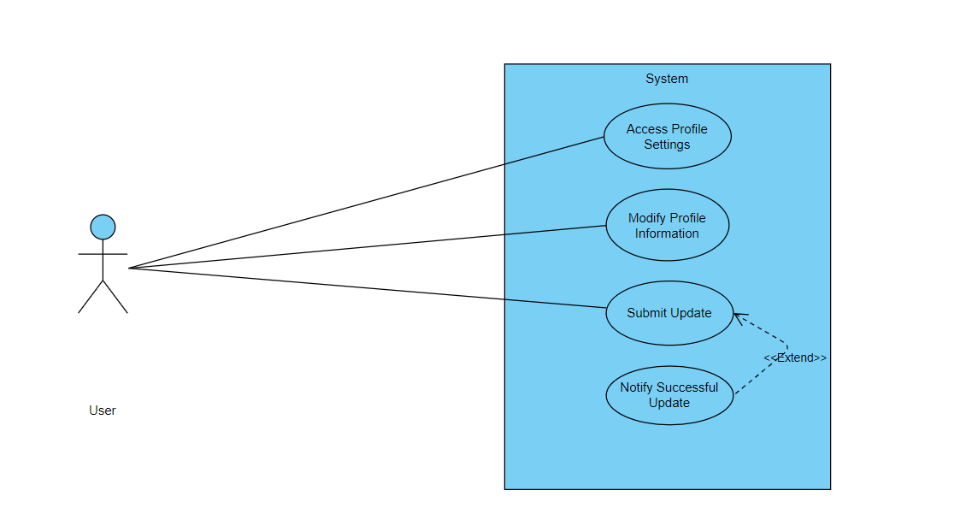

|  |  |  |
| --- | --- | --- |
| Use Case ID | UC_003 | |
| Use Case Name | Update Profile | |
| Description | This use case involves the process of updating user profile information. | |
| Primary Actor | User | |
| Secondary Actor | None | |
| Pre-Condition | The user must be logged into the system. | |
| Post-Condition | The user's profile information is successfully updated. | |
| Basic Workflow | Actor Action | System Action |
|  | * The user navigates to the profile settings. * The user modifies the desired profile details (e.g., name, email, or password). * The user submits the updated information. | * The system displays the user's current profile information. * The system validates the updated information. * The system processes the update request and reflects the changes in the user's profile. |
| Alternate Flow | If the entered information is incomplete or fails validation:   * The system notifies the user of the validation error. * The user corrects the information and resubmits the form. * Steps 4 to 6 are repeated. | |

USE CASE 4:

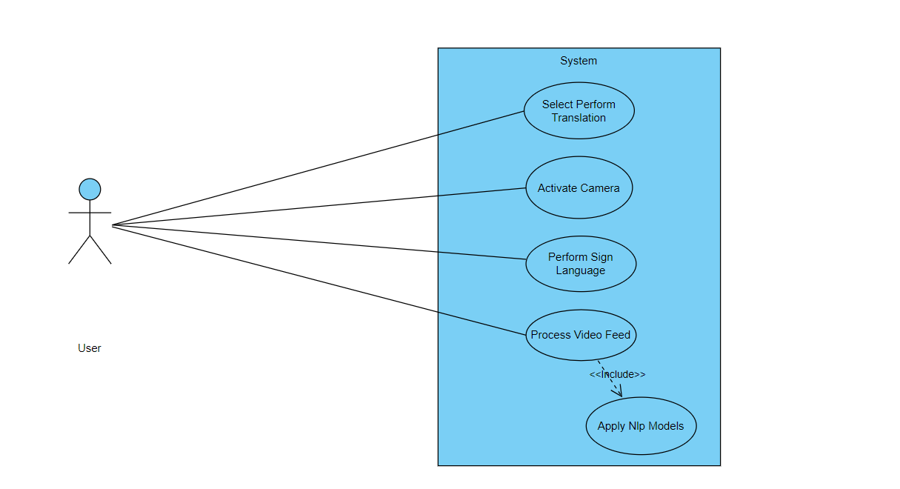

|  |  |  |
| --- | --- | --- |
| Use Case ID | UC_004 | |
| Use Case Name | Perform Sign Language Translation | |
| Description | This use case involves the system translating live Sign Language gestures into natural language in real-time. | |
| Primary Actor | User (Sign Language User) | |
| Secondary Actor | None | |
| Pre-Condition | The user must be logged into the system, and the device must have access to a camera. | |
| Post-Condition | The system successfully transcribes the Sign Language gestures into natural language. | |
| Basic Workflow | Actor Action | System Action |
|  | * The user selects the "Perform Translation" option. * The user performs Sign Language gestures in front of the camera. | * The system activates the camera for live translation. * The system processes the live video feed, extracting key features. * The system applies Natural Language Processing (NLP) models to translate gestures into text. |
| Alternate Flow | If the system encounters difficulty in recognizing gestures:   * The system may prompt the user to adjust lighting or perform clearer gestures. * Steps 3 to 5 are repeated until successful translation. | |

USE CASE 5:

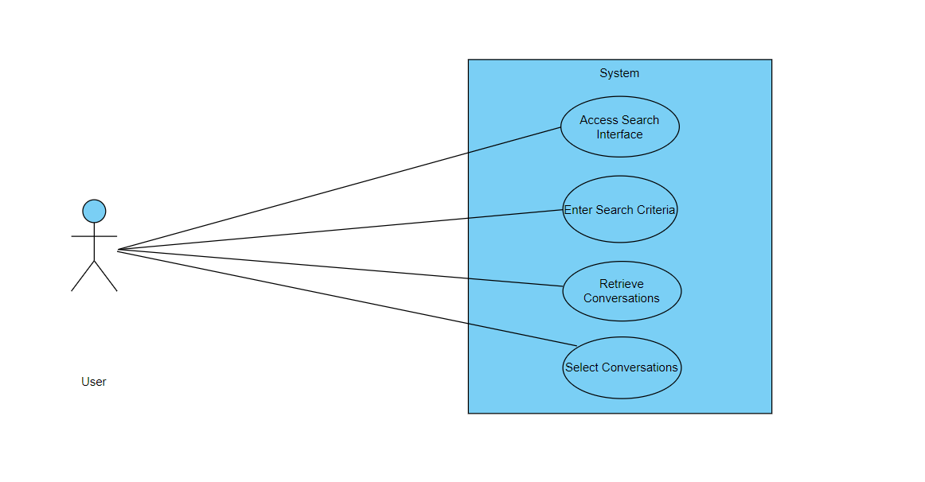

|  |  |  |
| --- | --- | --- |
| Use Case ID | UC_005 | |
| Use Case Name | Search Translated Conversations | |
| Description | This use case involves the user searching for and accessing previously translated Sign Language conversations. | |
| Primary Actor | User | |
| Secondary Actor | None | |
| Pre-Condition | The user must be logged into the system.. | |
| Post-Condition | The user successfully retrieves and views previously translated conversations. | |
| Basic Workflow | Actor Action | System Action |
|  | * The user accesses the "Search Conversations" feature. * The user enters search criteria, such as keywords, date, or participants. * The user selects a conversation from the search results. | * The system displays a search interface. * The system searches the database for relevant translated conversations. * The system presents the selected conversation in natural language text. |
| Alternate Flow | If there are no matching conversations:   * The system notifies the user of no results. * The user may refine the search criteria. * Steps 4 to 6 are repeated. | |

USE CASE 6:

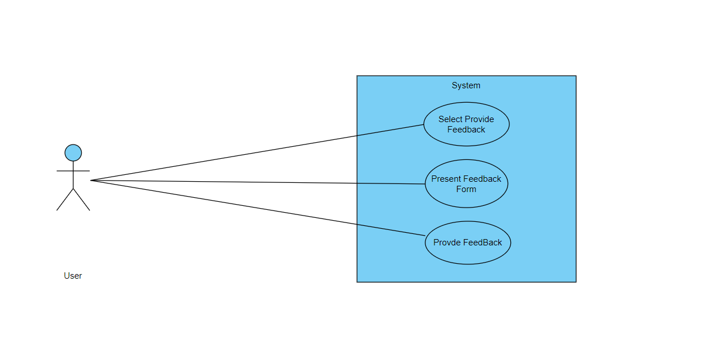

|  |  |  |
| --- | --- | --- |
| Use Case ID | UC_006 | |
| Use Case Name | Provide Feedback on Translations | |
| Description | This use case involves users providing feedback on the accuracy and quality of Sign Language translations. | |
| Primary Actor | User | |
| Secondary Actor | None | |
| Pre-Condition | The user must be logged into the system and have accessed a translated conversation. | |
| Post-Condition | User feedback is recorded and may be used for system improvement. | |
| Basic Workflow | Actor Action | System Action |
|  | * While viewing a translated conversation, the user selects the "Provide Feedback" option. * The user provides feedback on the accuracy and clarity of the translation. | * The system presents a feedback form. * The system records the user's feedback. |
| Alternate Flow | If the user chooses not to provide feedback:   * The system proceeds without collecting feedback. * The user continues with their interaction. | |

USE CASE 7:

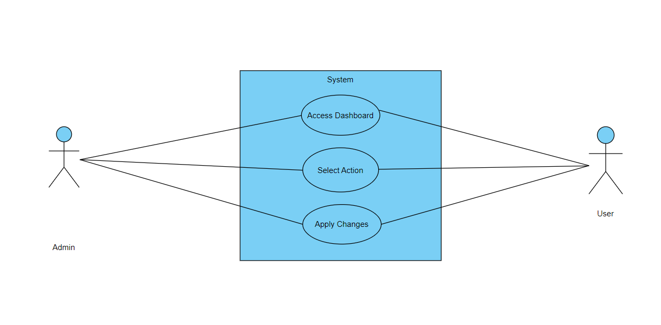

|  |  |  |
| --- | --- | --- |
| Use Case ID | UC_007 | |
| Use Case Name | System Administrator Management | |
| Description | This use case involves the actions performed by a system administrator for managing user accounts and system configurations. | |
| Primary Actor | System Administrator | |
| Secondary Actor | User | |
| Pre-Condition | The system administrator must be logged into the system.. | |
| Post-Condition | Changes to user accounts and system configurations are successfully applied. | |
| Basic Workflow | Actor Action | System Action |
|  | * The system administrator accesses the administrator dashboard. * The system administrator selects an action, such as managing user accounts or configuring system settings. | * The system displays the administrator tools and options. * The system processes the administrator's request and applies changes. |
| Alternate Flow | If an error occurs during the administrator's action:   * The system notifies the administrator of the error. * The administrator takes corrective actions. * Steps 3 to 4 are repeated. | |