**Cấu hình cho Router**

enable

configure

hostname R1

banner motd #R1 duoc cau hinh boi cuongdc#

enable secret 123

line console 0

password 123

login

exit

line vty 0 15

password 123

login

exit

exit

**Cấu hình cho SW1**

enable

configure

hostname SW1

banner motd #cau hinh boi CuongDC HE194183#

enable password 123

line console 0

password 123

login

exit

line vty 0 15

password 123

login

exit

service password-encryption

interface vlan 1

ip address 192.4.8.2 255.255.255.0

no shutdown

ip default-gateway 192.4.8.1

exit

copy running-config startup-config

**Cấu hình cho SW2**

Switch>enable

Switch#configure

Switch(config)#hostname SW2

SW2(config)#banner motd #cau hinh boi CuongDC HE194183#

SW2(config)#enable password 123

SW2(config)#line console 0

SW2(config-line)#password 123

SW2(config-line)#login

SW2(config-line)#exit

SW2(config)#line vty 0 15

SW2(config-line)#password 123

SW2(config-line)#login

SW2(config-line)#exit

SW2(config)#service password-encryption

SW2(config)#interface vlan 1

SW2(config-if)#ip address 100.1.3.2 255.255.255.0

SW2(config-if)#no shutdown

SW2(config)#ip default-gateway 100.1.3.1

SW2(config)#exit

SW2#

SW2#copy running-config startup-config

**Kiểm tra ping, telnet**

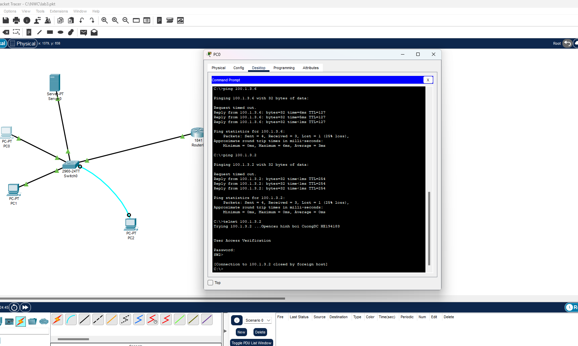

**Kiểm tra email**

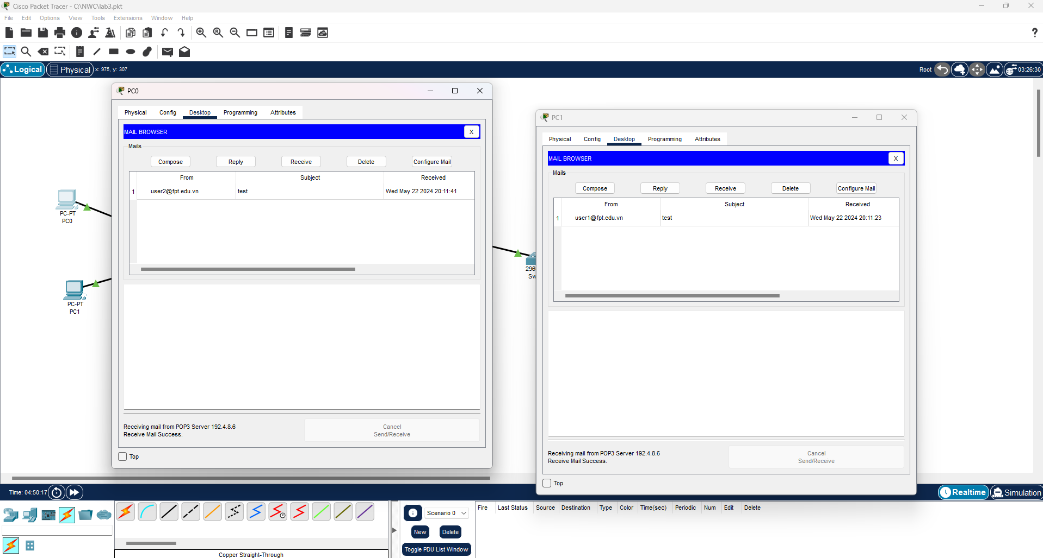

**Khai báo các dịch vụ:**

**DNS:**  
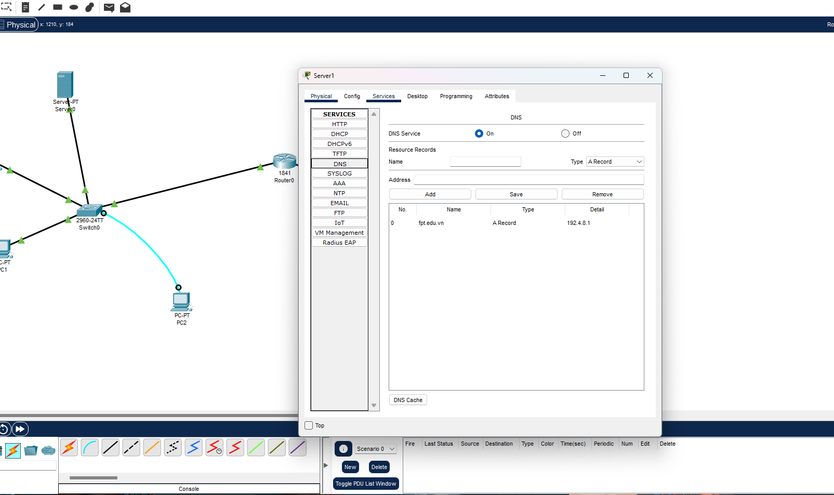

**HTTP:**

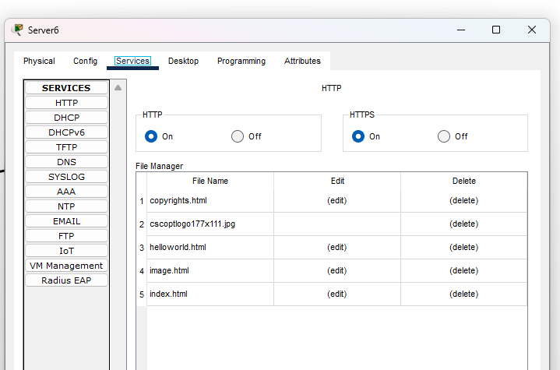

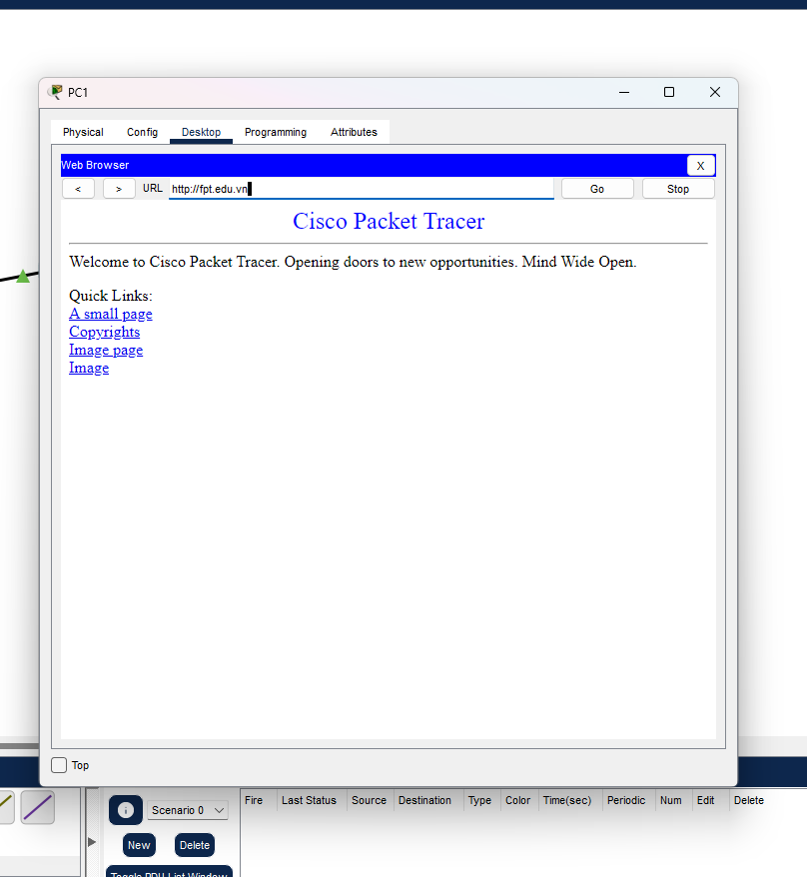

DHCP: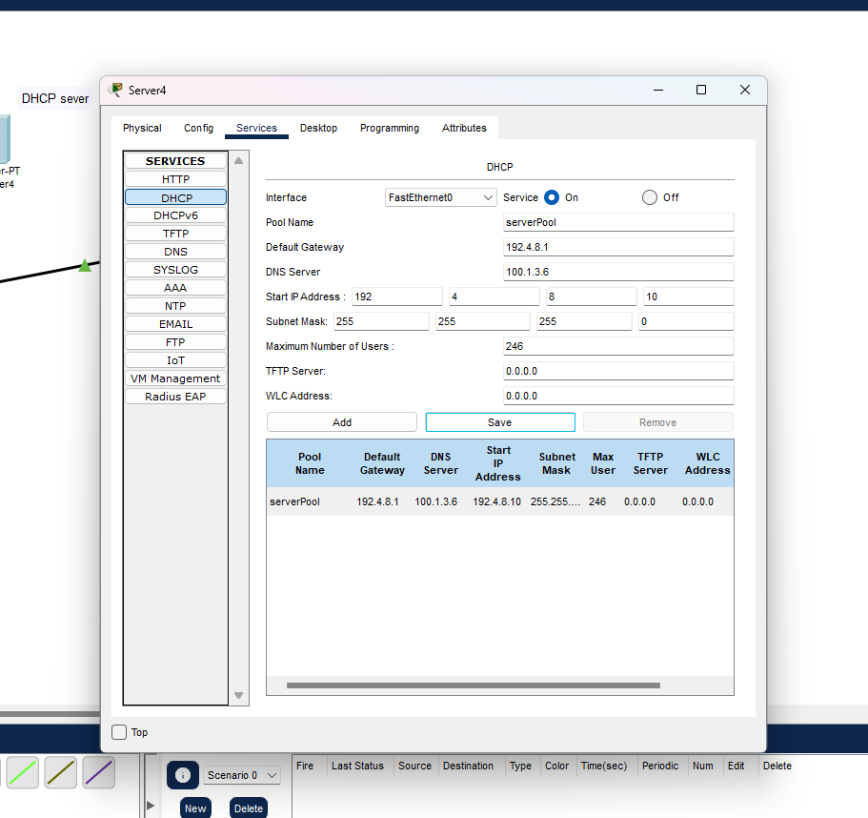

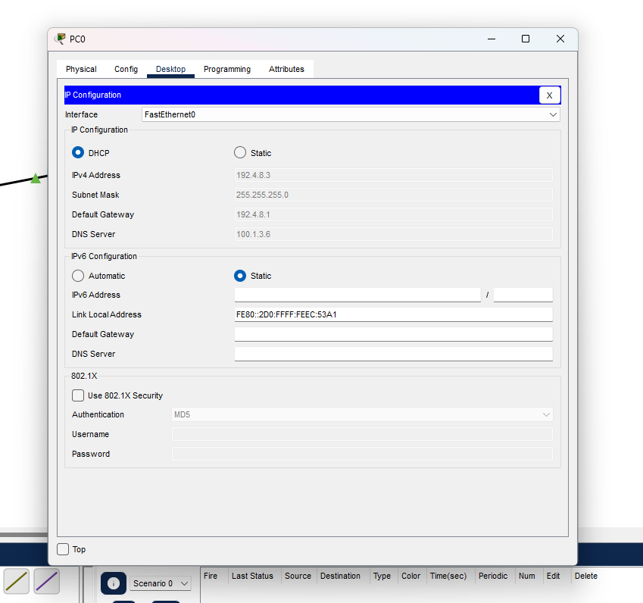

Mail:

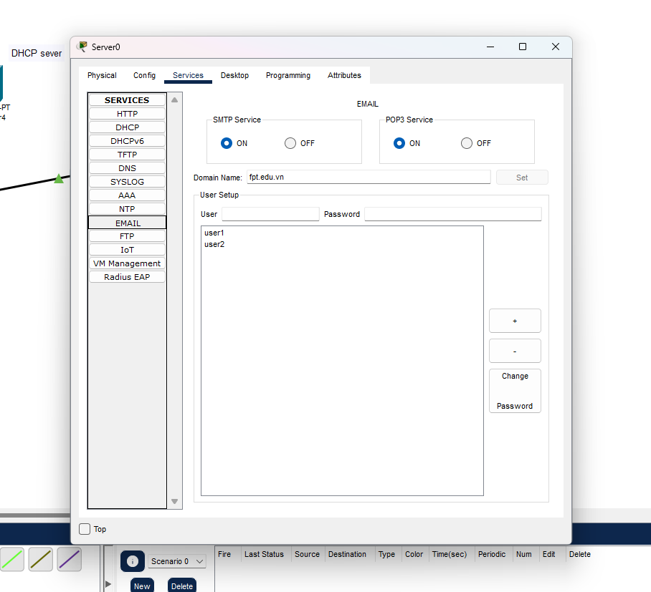

**Cài đặt TFTP:**

SW2#erase startup-config

Erasing the nvram filesystem will remove all configuration files! Continue? [confirm]

[OK]

Erase of nvram: complete

%SYS-7-NV_BLOCK_INIT: Initialized the geometry of nvram

SW2#

SW2#copy running-config tftp

Address or name of remote host []? 100.1.3.7

Destination filename [SW2-confg]? cuong

Writing running-config....!!

[OK - 1254 bytes]

1254 bytes copied in 3.009 secs (416 bytes/sec)

