

COURSE PROJECT REPORT
Subject: SWD392

– Hanoi, February 2026 –

Table of Contents
Record of Changes 3
I. Overview 4
I.1 Project Information 4
I.2 Project Team 4
II. Requirement Specification 4
II.1 Problem description 4
II.2 Major Features 4
II.3 Context Diagram 4
II.4 Nonfunction Requirements 5
II.5 Functional requirements 5
II.5.1 Actors 5
II.5.2 Use Cases 5
II.5.2 .1 Diagram(s) 5
II.5.2.2 Use case descriptions 6
II.5.3 Activity diagram 8
III. Analysis models. 9
III.1 Interaction diagrams 9
III.2 State diagram 10
IV. Design specification 11
IV.1 Integrated Communication Diagrams 11
IV.2 System High-Level Design 11
IV.3 Component and Package Diagram 11
IV.4 Class diagram 12
IV.5 Database Design 12
V. Implementation 13
V.1 Map architecture to the structure of the project 13
V.2 Map Class Diagram and Interaction Diagram to Code 13
V. Applying Alternative Architecture Patterns 13
V.1 Applying the service-oriented architecture 13
V.2 Applying Service Discovery Pattern in the service-oriented architecture 13

Record of Changes
Date | A*  M, D | In charge | Change Description
15/2/2026 | A | Khuat Quang Hung | Add project overview, project description, features, use case description, interaction diagram.
18/2/2026 | M | Khuat Quang Hung | Complete interaction diagrams including sequence diagram and communication diagram.
19/2/2026 | A | Vo Minh Tai | Complete UC-01, UC-02, and UC-03 including specifications and activity diagrams.
19/2/2026 | M | Vo Minh Tai | Revise structure and improve consistency of activity diagrams.
21/2/2026 | A | Vo Chien Thang | Design and complete State Diagram
22/2/2026 | A | Dao Chi Cuong | Design and complete System Context Diagram
22/2/2026 | A | Dao Chi Cuong | Design and complete Use Case Diagram based on identified actors and functional requirements.
23/2/2026 | A | Vo Chien Thang | Design and complete Software Context Diagram
23/2/2026 | A | Vu Hai Nam | Design and complete Entity Relationship Diagram
*A - Added M - Modified D - Deleted

I. Overview

I.1 Project Information
- Project name: Smart Monitoring Platform
- Project code: SMP
- Group name: SWD392-G4
- Software type: Software Type: Web, System,..

I.2 Project Team
Full Name | Role | Email | Mobile
Pham Duc Thang | Lecturer
Khuat Quang Hung | Leader | hungsct1702@gmail.com | 0327715098
Dao Chi Cuong | Member | cuong16032005@gmail.com | 0388235968
Vu Hai Nam | Member | vunam1315@gmail.com | 0969642110
Vo Chien Thang | Member | haivo5229@gmail.com | 0325866619
Vo Minh Tai | Member | minhtaivo22@gmail.com | 0839498777

II. Requirement Specification

II.1 Problem description
The rapid growth of IoT has created a need for monitoring systems across multiple domains such as smart homes, healthcare, industry, traffic, and agriculture. However, most existing solutions are built for a single domain, leading to duplicated development effort, high cost, and limited scalability.
The Smart Monitoring Platform (SPLA-based) provides a unified solution that supports multiple domains within one system. IoT devices or simulators send sensor data to the platform, where domain-specific logic is processed through configurable workflows. The system then stores data, generates alerts, and displays real-time information on dashboards.
By separating common core functions from variable business logic, the platform enables easy customization, reuse, and expansion for new monitoring scenarios without modifying the core system.

II.2 Major Features
FE-01: Collect real-time data from IoT devices or simulators.
FE-02: Process domain-specific logic using configurable workflows.
FE-03: Detect abnormal conditions and generate alerts.
FE-04: Send notifications via Email or Telegram.
FE-05: Display real-time data on dynamic dashboards.
FE-06: Support multiple monitoring domains within a single platform.
FE-07: Manage users, devices, and system data.

II.3 Context Diagram
System context diagram:
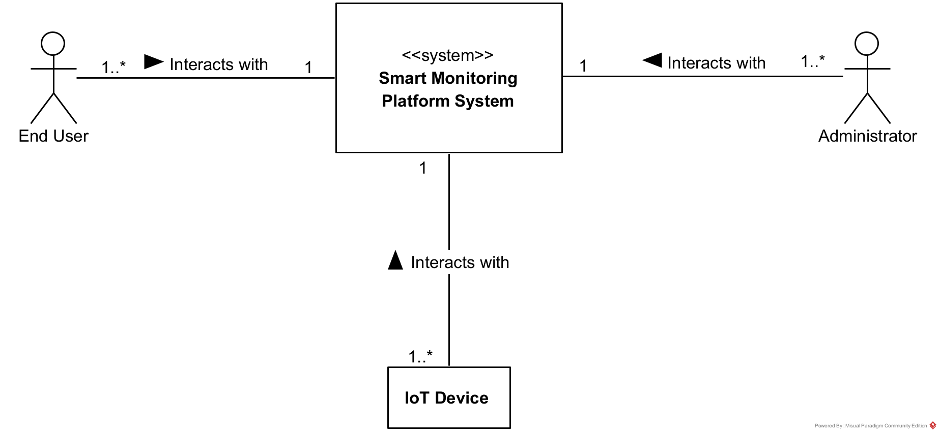
Software system context diagram: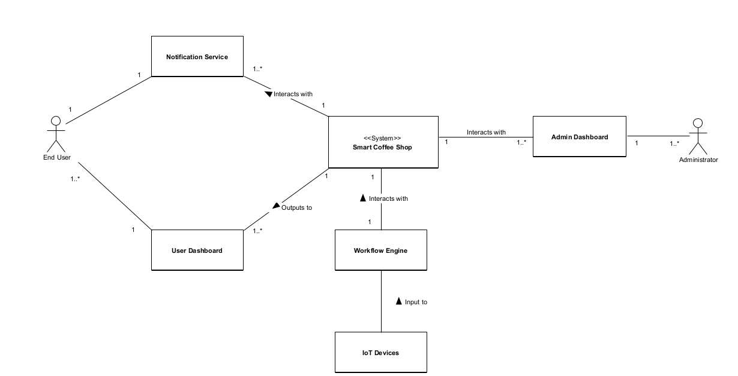

II.4 Nonfunctional requirements
# | Feature | System Function | Description
1 | Performance | Real-time Processing | The system shall process incoming sensor and update dashboards with latency less than 2 seconds.
2 | Scability | Multi-device Support | The system shall support large number of IOT devices simultaneously without performance degradation.
3 | Reliability | Fault Tolerance | The system shall continue operating even if individual components fail.
4 | Availability | Continuous Operation | The platform shall be available 24/7 with minimal downtime.
5 | Security | Authentication & Authorization | Only authorized users can access system functions and data.
6 | Data Integrity | Accurate Data Handling | The system shall ensure sensor data is stored and processed correctly without loss.
7 | Usability | User-friendly Interface | Dashboards shall be easy to use and require minimal training.
8 | Maintainability | Modular Architecture | The system shall allow easy updates and maintenance without affecting core services.
9 | Interoperability | External Integration | The system shall integrate with external services such as Email, Telegram, and AI APIs.

II.5 Functional requirements

II.5.1 Actors

# | Actor | Description
1 | Administrator | Manages system configuration, users, devices, and monitoring domains.
2 | End User | Monitors real-time data and receives alerts through dashboards.
3 | IoT Device / Simulator | Sends sensor data to the platform.
4 | Workflow Engine (n8n) | Processes business logic and applies rules to incoming data.
5 | Notification Service | Sends alerts via Email or Telegram.
6 | AI Service (Optional) | Provides advanced analysis for anomaly detection.

II.5.2 Use Cases

II.5.2 .1 Diagram(s)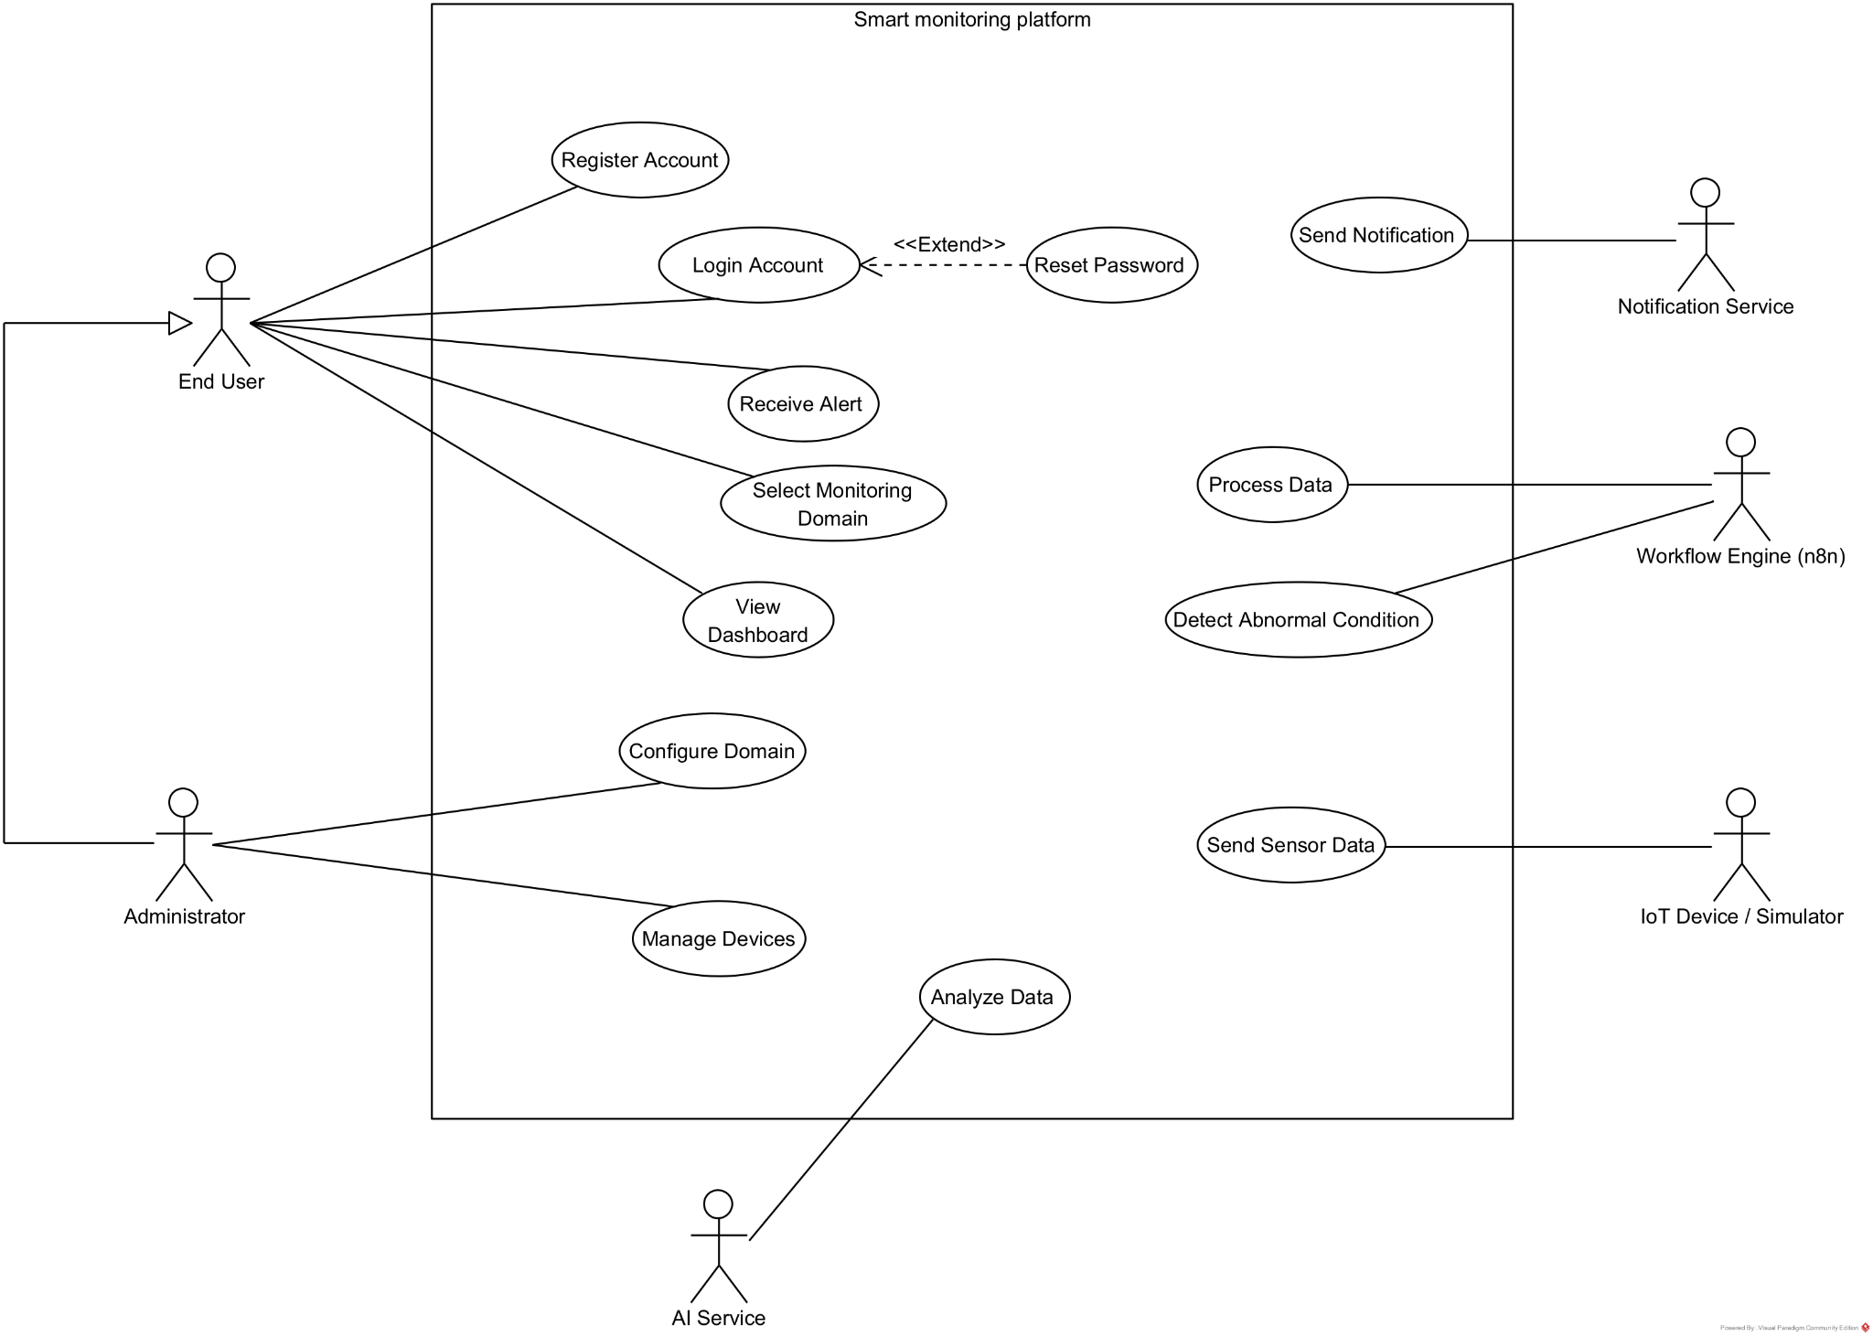

II.5.2.2 Use case descriptions
ID | Use Case | Actors | Use Case Description
01 | Register Account | End User | The user creates a new account by providing required registration information such as email and password.
02 | Login Account | End User | The user authenticates using valid credentials to access the monitoring platform.
03 | Reset Password | End User | The user requests a password reset when forgetting credentials. The system verifies identity and allows password update.
04 | View Dashboard | End User | The user views real-time sensor data, charts, and system status on the monitoring dashboard.
05 | Receive Alert | End User | The system notifies the user when abnormal conditions are detected.
06 | Manage Devices | Administrator | The administrator adds, updates, or removes IoT devices from the system.
07 | Configure Domain | Administrator | The administrator configures monitoring domains, thresholds, and rules.
08 | Send Sensor Data | IoT Device / Simulator | The device sends sensor data to the platform for processing.
09 | Process Data | Workflow Engine (n8n) | The system processes incoming data using domain-specific workflows and rules.
10 | Send Notification | Notification Service | The system sends alerts via Email or Telegram to users.
11 | Analyze Data | AI Service | The system performs advanced analysis to detect anomalies or predict issues.
12 | Switch Domain | End User | The user switches between monitoring domains, and the dashboard updates dynamically.

1. UC-01 — View Dashboard
Functional Description
UC ID and Name: | UC-01 — View Dashboard
Created By: | Group 4 | Date Created: | 2026-02-15
Primary Actor: | End User | Secondary Actors: | Core Platform, WebSocket Service
Trigger: | User opens the monitoring dashboard or selects a domain.
Description: | The user views real-time sensor data, charts, and alerts for a selected monitoring domain through the web dashboard.
Preconditions: | PRE-1: User has logged into the system.  PRE-2: At least one device is registered and sending data.  PRE-3: Network connection is available.
Postconditions: | POST-1: Dashboard displays current sensor data and system status.  POST-2: Real-time updates continue via WebSocket.
Normal Flow: | - User opens the dashboard page.  - System retrieves the selected domain configuration.  - System loads recent sensor data.  - System establishes WebSocket connection.  - Dashboard displays charts, metrics, and alerts.  - System continuously updates data in real time.
Alternative Flows: | 1.1 — Switch Domain  - User selects a different monitoring domain.  - System loads new configuration and data.  - Dashboard refreshes dynamically.
Exceptions: | 1.0.E1 — No Data Available  - If no device data exists, the system displays a “No data available” message.  1.0.E2 — Connection Failure  - If WebSocket connection fails, the system attempts reconnection and notifies the user.
Priority: | High — Must Have
Frequency of Use: | Very frequent (multiple times per day)
Business Rules: | BR-01: Only authorized users can access monitoring data.  BR-02: Data displayed must correspond to the selected domain.
Other Information: | If the network connection is lost, real-time updates stop until the connection is restored. No data is modified during this use case.
Assumptions: | - Users have basic knowledge of the dashboard interface.  - IoT devices periodically send valid data.

2. UC-02 — Manage IoT Devices

UC ID and Name: | UC-02 — Manage IoT Devices
Created By: | Group 4 | Date Created: | 2026-02-15
Primary Actor: | Administrator | Secondary Actors: | Core Platform, Database
Trigger: | Admin opens device management page.
Description: | Administrator registers, updates, or removes IoT devices from the system.
Preconditions: | PRE-1: Admin is authenticated with proper permissions.
Postconditions: | POST-1: Device list is updated in the system.  POST-2: New devices can send data.
Normal Flow: | - Admin opens device management.  - Admin enters device information.  - System validates input.  - System stores device in database.  - Updated device list is displayed.
Alternative Flows: | Admin edits device → system saves changes.
Exceptions: | 2.0.E1 — Invalid data → show error message.  2.0.E2 — Device already exists → reject registration.
Priority: | High — Must Have
Frequency of Use: | Occasional
Business Rules: | Device IDs must be unique
Other Information: | If a device is removed, it will no longer be allowed to send data to the system. Existing historical data of the device remains stored for analysis purposes. Changes to device configuration take effect immediately without requiring system restart.
Assumptions: | Admin provides correct information

3. UC-02 — UC-03 — Generate and Send Alert

UC ID and Name: | UC-03 — Generate and Send Alert
Created By: | Group 4 | Date Created: | 2026-02-15
Primary Actor: | Administrator | Secondary Actors: | Core Platform, Database
Trigger: | Incoming data exceeds defined threshold.
Description: | The system detects abnormal conditions and sends notifications to users.
Preconditions: | PRE-1: Threshold rules are configured.  PRE-2: Notification channels are available.
Postconditions: | POST-1: Alert is generated and delivered.  POST-2: Event is logged in the system.
Normal Flow: | - System receives sensor data.  - Workflow evaluates data against thresholds.  - Abnormal condition detected.  - System generates alert message.  - Notification sent via Email/Telegram.  - Alert displayed on dashboard.
Alternative Flows: | If condition is moderate → send warning instead of critical alert.
Exceptions: | 3.0.E1 — Notification failure → retry sending.  3.0.E2 — Invalid data → discard and log error.
Priority: | High — Must Have
Frequency of Use: | Frequent
Business Rules: | Alerts triggered only when thresholds exceeded
Other Information: | Alerts are logged in the system for auditing and analysis. If notification delivery fails due to external service issues, the system retries sending or stores the alert for later delivery. Critical alerts may trigger visual indicators on the dashboard even if external notifications are unavailable.
Assumptions: | External notification services are operational

Functional Description Contents
Use Case ID and Name
Give each use case a unique integer sequence number identifier. State a concise name for the use case that indicates the value the use case would provide to some user. Begin with an action verb, followed by an object.
Author and Date Created
Enter the name of the person who initially wrote this use case and the date it was written.
Primary and Secondary Actors
An actor is a person or other entity external to the software system being specified who interacts with the system and performs use cases to accomplish tasks. Different actors often correspond to different user classes, or roles, identified from the customer community that will use the product. Name the primary actor that will be initiating this use case and any other secondary actors who will participate in completing execution of the use case.
Trigger
Identify the business event, system event, or user action that initiates the use case. This trigger alerts the system that it should begin testing the preconditions for the use case so it can judge whether to proceed with execution.
Description
Provide a brief description of the reason for and outcome of this use case, or a high-level description of the sequence of actions and the outcome of executing the use case.
Preconditions
List any activities that must take place, or any conditions that must be true, before the use case can be started. The system must be able to test each precondition. Number each precondition. Example: PRE-1: User’s identity has been authenticated.
Postconditions
Describe the state of the system at the successful conclusion of the use case execution. Label each postcondition in the form POST-X, where X is a sequence number. Example: POST-1: Price of item in the database has been updated with the new value.
Normal Flow
Provide a description of the user actions and corresponding system responses that will take place during execution of the use case under normal, expected conditions. This dialog sequence will ultimately lead to accomplishing the goal stated in the use case name and description. Show a numbered list of actions performed by the actor, alternating with responses provided by the system. The normal flow is numbered “X.0”, where “X” is the Use Case ID.
Alternative Flows
Document other successful usage scenarios that can take place within this use case. State the alternative flow, and describe any differences in the sequence of steps that take place. Number each alternative flow in the form “X.Y”, where “X” is the Use Case ID and Y is a sequence number for the alternative flow. For example, “5.3” would indicate the third alternative flow for use case number 5. Indicate where each alternative flow would branch off from the normal flow, and if pertinent, where it would rejoin the normal flow.
Exceptions
Describe any anticipated error conditions that could occur during execution of the use case and how the system is to respond to those conditions. Number each alternative flow in the form “X.Y.EZ”, where “X” is the Use Case ID, Y indicates the normal (0) or alternative (>0) flow during which this exception could take place, “E” indicates an exception, and “Z” is a sequence number for the exceptions. For example “5.0.E2” would indicate the second exception for the normal flow for use case number 5. Indicate where in the normal (or an alternative) flow each exception could occur.
Priority
Indicate the relative priority of implementing the functionality required to allow this use case to be executed. Use the same priority scheme as that used for the functional requirements.
Frequency of Use
Estimate the number of times this use case will be performed per some appropriate unit of time. This gives an early indicator of throughput, concurrent usage loads, and transaction capacity.
Business Rules
List any business rules that influence this use case. Don’t include the business rule text here, just its identifier so the reader can find it in another repository when needed.
Other Information
Identify any additional requirements, such as quality attributes, for the use case that may need to be addressed during design or implementation. Also list any associated functional requirements that aren’t a direct part of the use case flows but which a developer needs to know about. Describe what should happen if the use case execution fails for some unanticipated or systemic reason (e.g., loss of network connectivity, timeout). If the use case results in a durable state change in a database or the outside world, state whether the change is rolled back, completed correctly, partially completed with a known state, or left in an undetermined state as a result of the exception.
Assumptions
List any assumptions that were made regarding this use case or how it might execute.

b. Business Rules
Provide the business rules those are applied only to the use case
ID | Business Rule | Business Rule Description
BR1 | Authorized Access | Only authenticated users can access system functions and data.
BR2 | Role-based Permissions | Administrative functions are restricted to users with administrator privileges.
BR3 | Unique Device ID | Each IoT device must have a unique identifier.
BR4 | Valid Device Information | Device registration requires complete and valid information.
BR5 | Activation Status | Only active devices are allowed to send data to the platform.
BR6 | Real-time Data Update | Dashboard data must be updated when new sensor data is received.
BR7 | Domain-based Data View | Users can view data only for the selected monitoring domain.
BR8 | Threshold-based Alert | Alerts are generated only when sensor values exceed predefined thresholds.
BR9 | Notification Channel | Alerts must be sent through configured channels (Email or Telegram).
BR10 | Alert Logging | All alerts and significant events must be recorded for auditing.
BR11 | Data Availability Handling | If no data is available, the system shall display an appropriate message.

II.5.3 Activity diagram

1. UC-01 — View Dashboard

This activity diagram describes the workflow when an End User views the real-time monitoring dashboard.

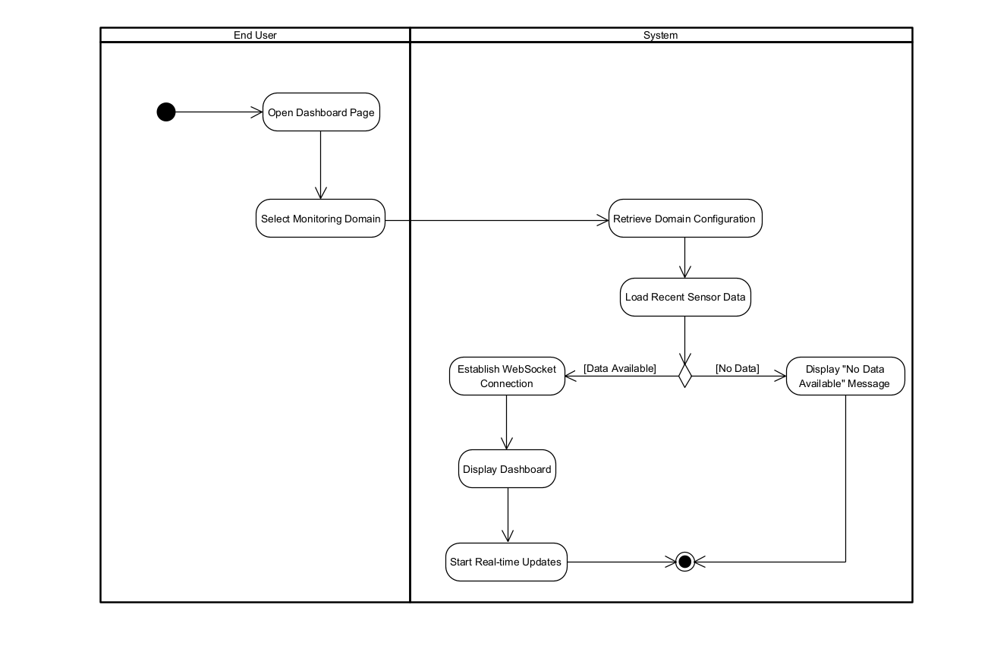
1. The End User opens the dashboard page.
2. The user selects a monitoring domain.
3. The system retrieves the corresponding domain configuration.
4. The system loads recent sensor data.
5. The system checks data availability.
6. If data exists, the system establishes a WebSocket connection.
7. The dashboard displays charts, metrics, and alerts.
8. The system continuously updates data in real time.
9. If no data is available, a notification message is displayed.

2. UC-02 — Manage IoT Devices

This activity diagram describes how the Administrator registers, updates, or removes IoT devices.

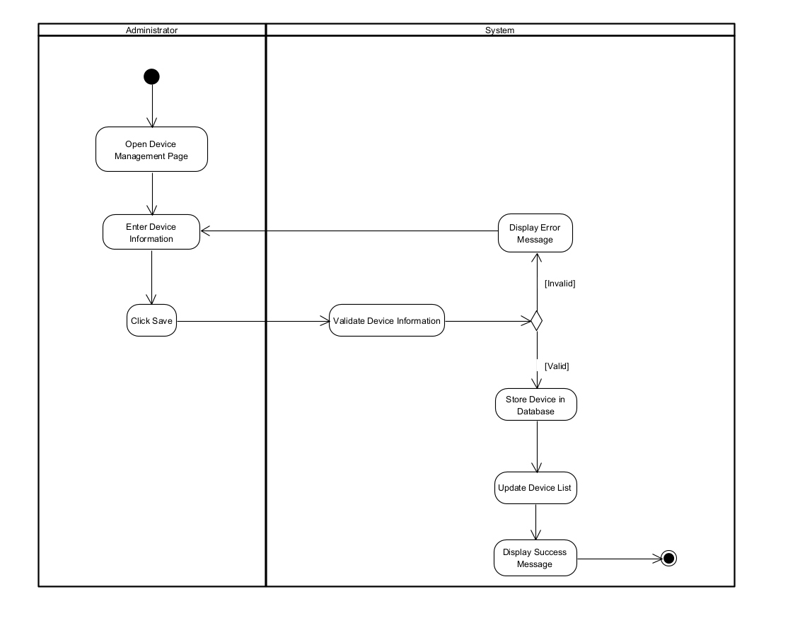
1. The Administrator opens the device management page.
2. The Administrator enters device information.
3. The Administrator clicks the Save button.
4. The system validates the input information.
5. If the information is valid, the system stores the device in the database.
6. The system updates the device list.
7. A success message is displayed.
8. If the information is invalid, an error message is displayed.
9. The administrator can re-enter the device information.

3. UC-03 — Generate and Send Alert

The system automatically generates and sends an alert when abnormal sensor data is detected.

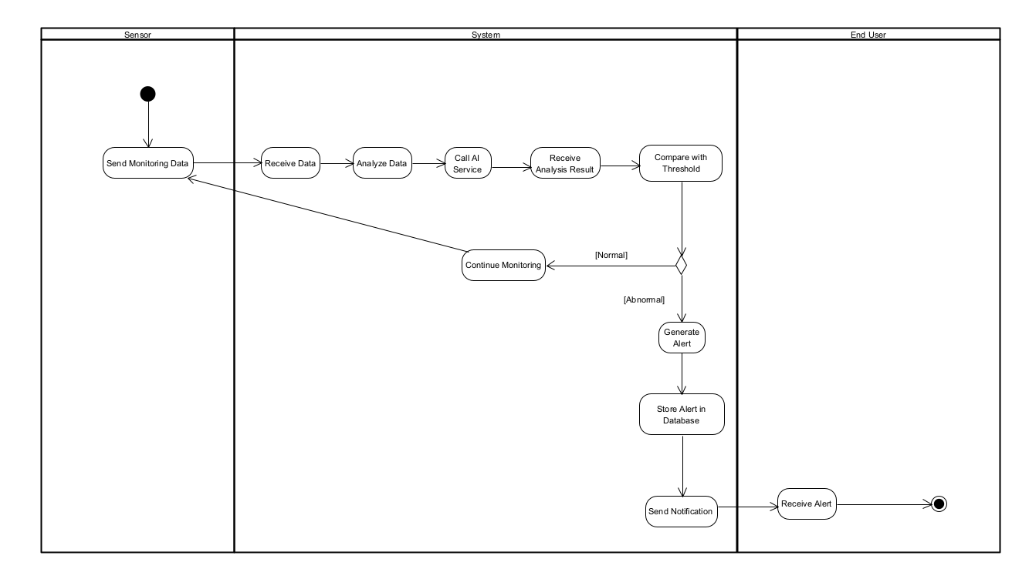
- Sensor sends monitoring data to the system
- System analyzes received data
- System compares data with threshold values
- If abnormal condition detected
- System generates alert
- System stores alert in database
- System sends notification to Administrator / End User
- System logs the alert

II.6 Entity Relationship Diagram

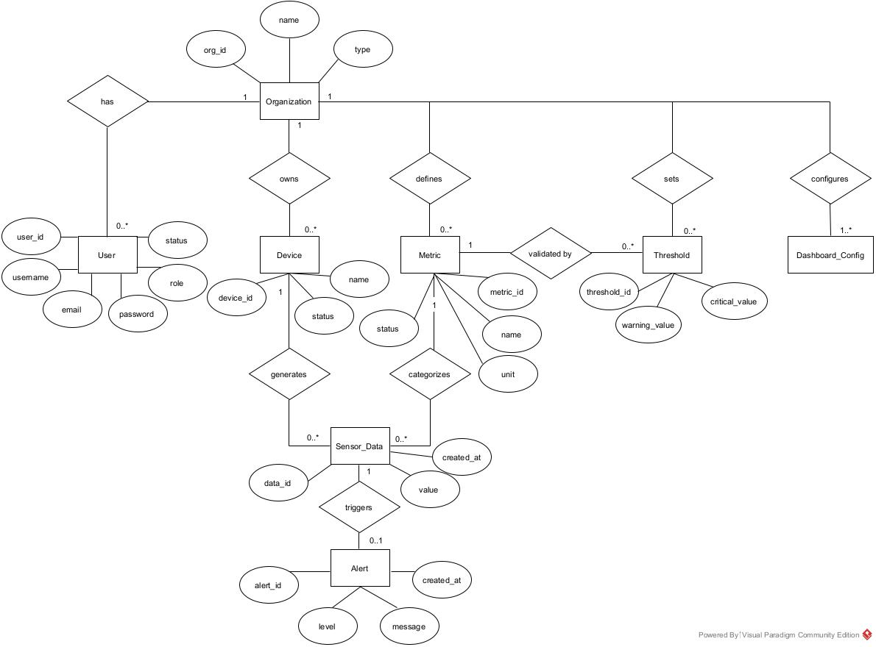

Entity Descriptions
Entity | Description
Organization | Represents a tenant such as a hospital, factory, or smart home system that uses the platform.
User | Represents system users who access the platform, including administrators and end users.
Device | Represents IoT devices or sensors registered in the system and associated with an organization.
Metric | Defines the types of data measured by devices (e.g., temperature, heart rate, humidity).
Threshold | Stores warning and critical limits for each metric specific to an organization.
SensorData | Represents real-time or historical measurements collected from devices.
Alert | Represents abnormal events generated when sensor data exceeds defined thresholds.
DashboardConfig | Defines the layout and widgets displayed on the monitoring dashboard for each organization.

III. Analysis models.

III.1 Interaction diagrams

III.1.1.Sequence Diagram

1.1.1 Sequence Diagram for View Dashboard

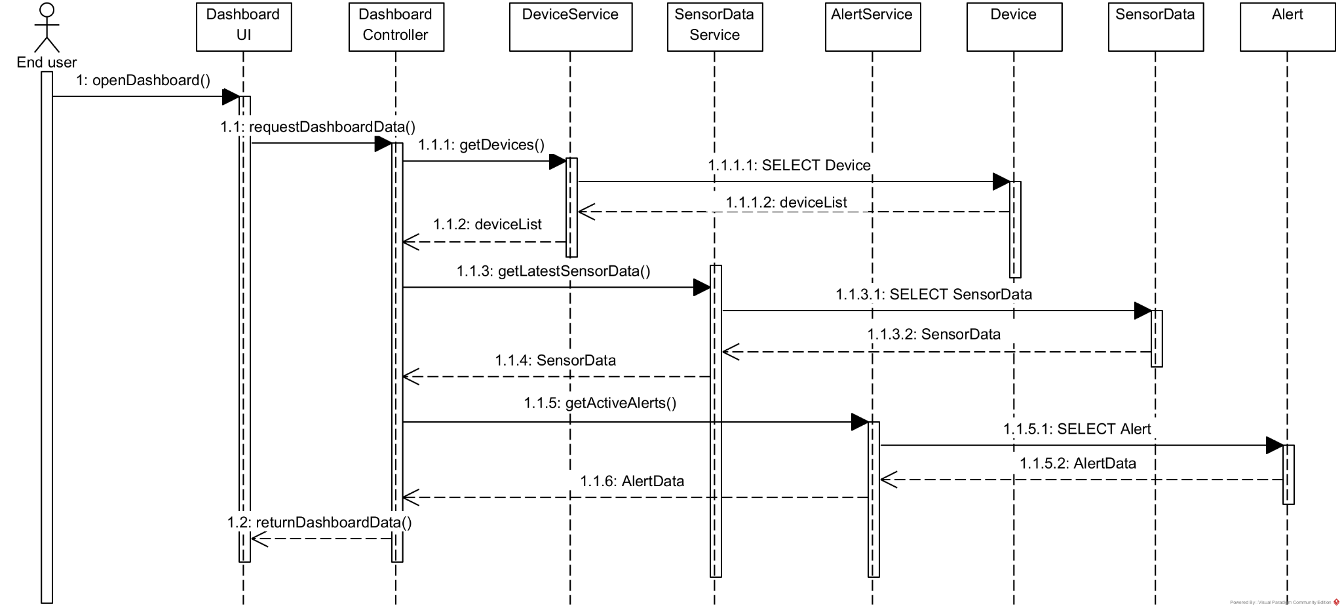

1.1.2 Sequence Diagram for Sensor Data Processing and Alert Notification
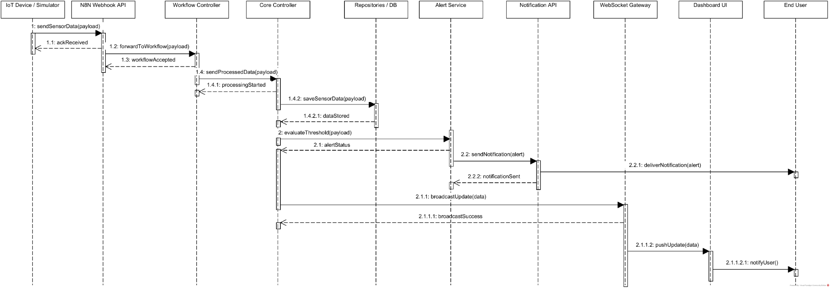

1.1.3 Sequence Diagram for device management

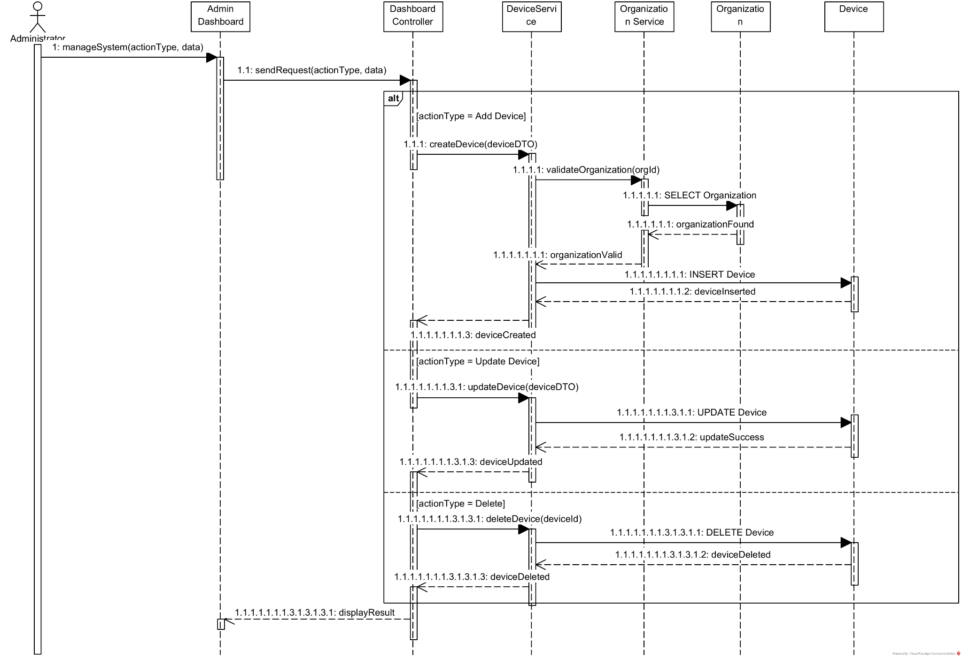
III.1.2. Communication Diagram

1.2.1 Communication Diagram for View Dashboard
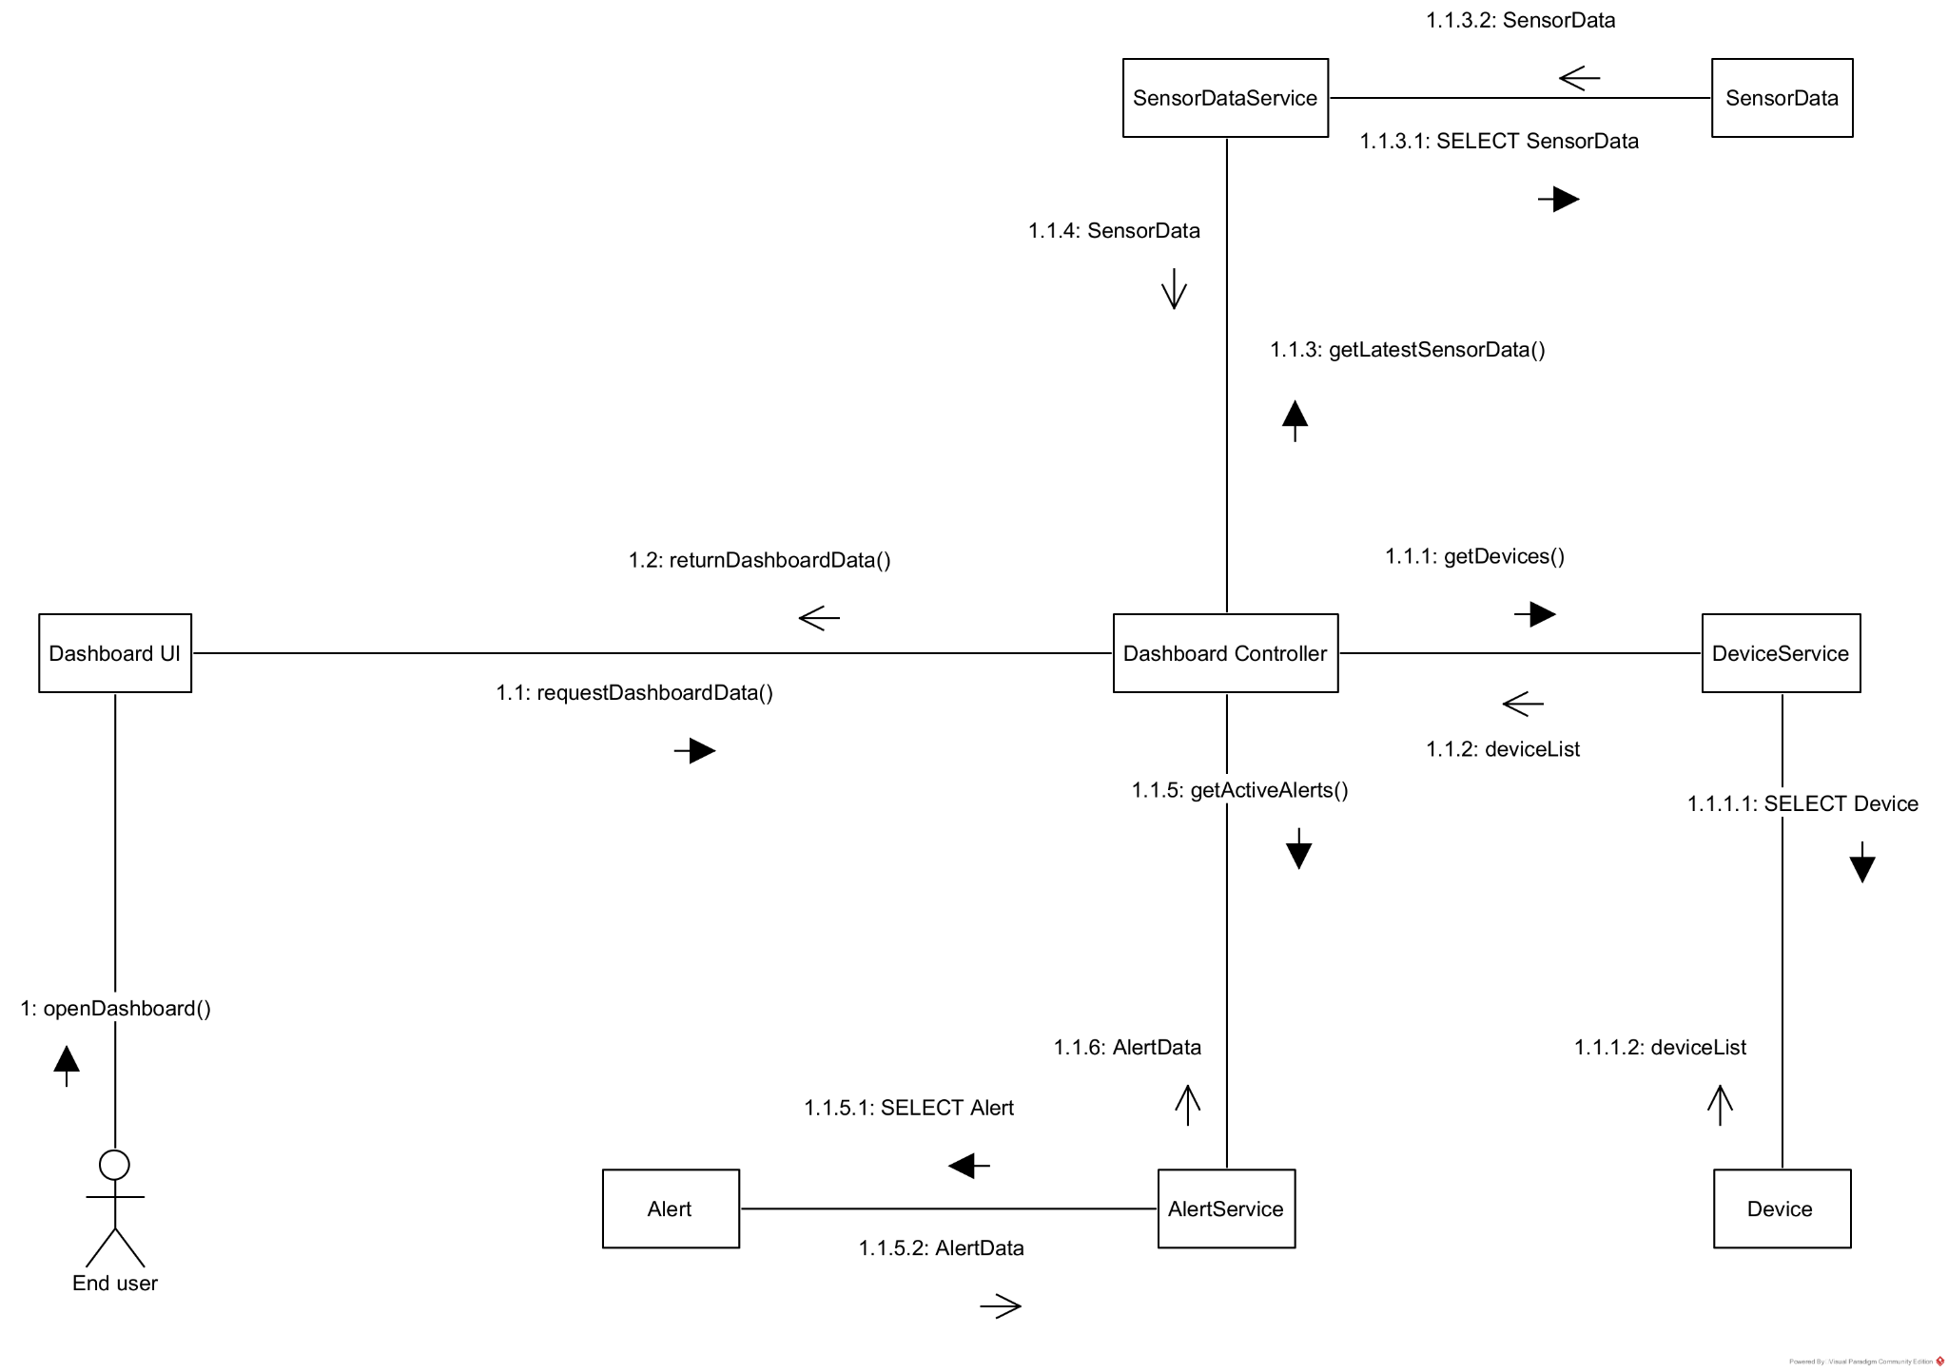
1.2.2 Communication Diagram for Sensor Data Processing and Alert Notification

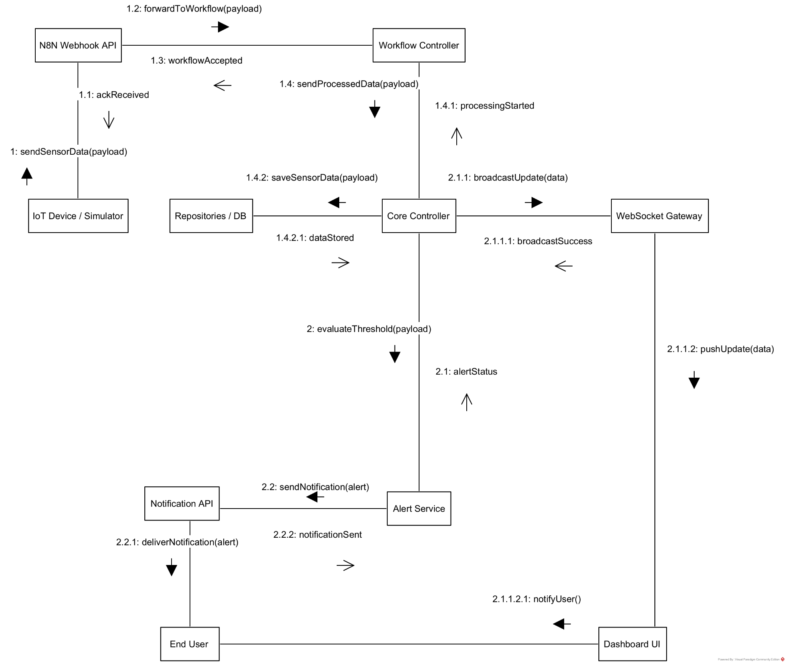

1.2.3 Communication Diagram for device management

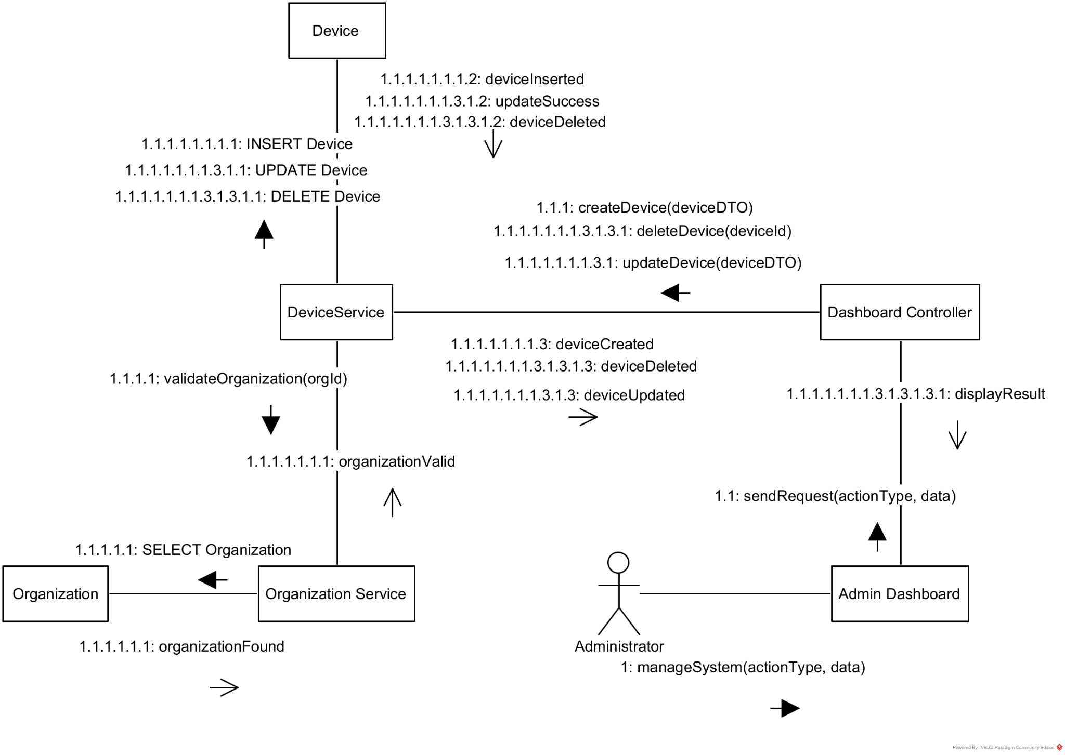

III.2 State diagram
2.1 State Diagram for View Dashboard
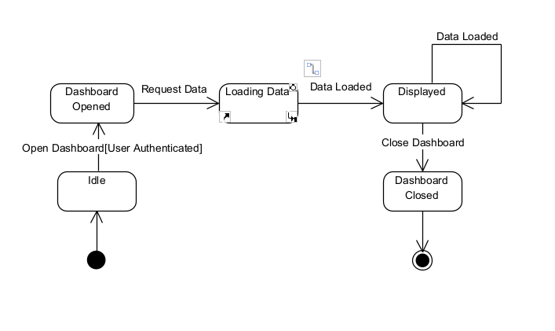
2.2 State Diagram for Sensor Data Processing and Alert Notification
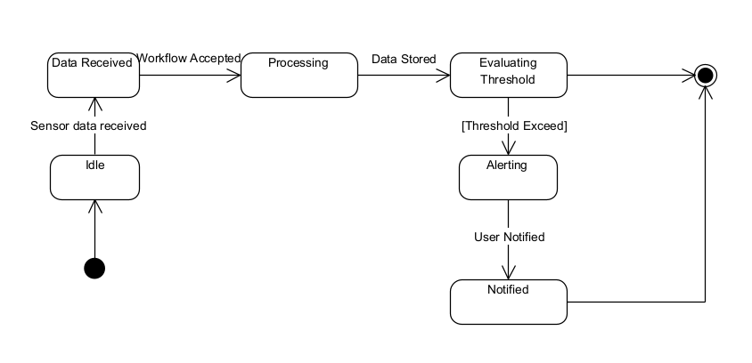
2.3 State Diagram for device management
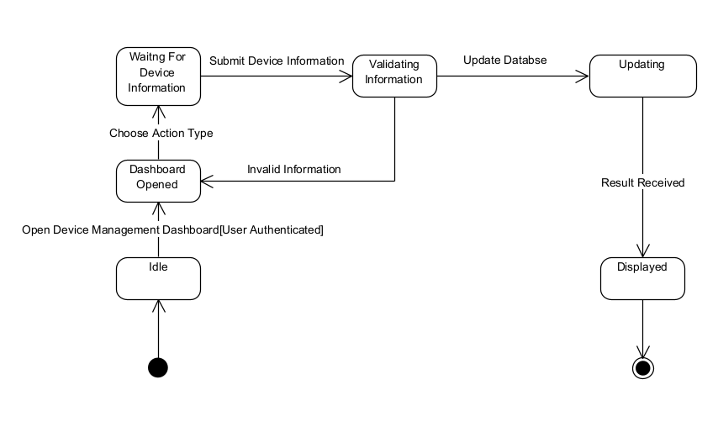

IV. Design specification

IV.1 Integrated Communication Diagrams
Sample
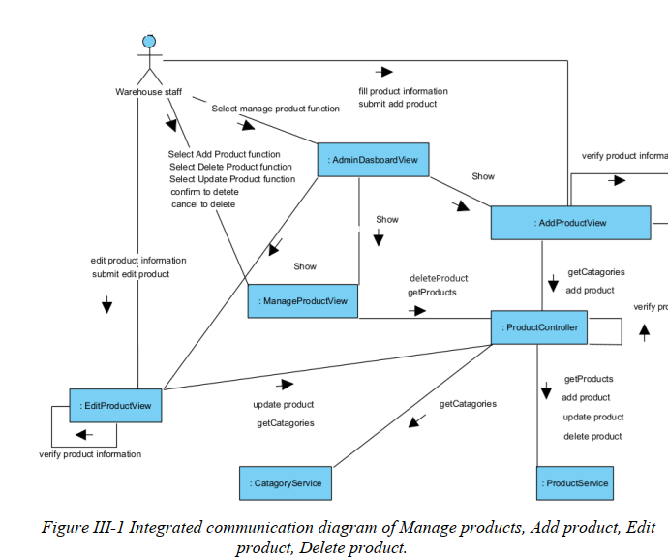

IV.2 System High-Level Design
Sample
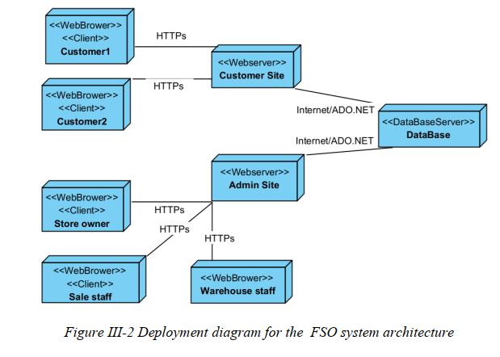

IV.3 Component and Package Diagram

IV.3.1 Component Diagram
Sample
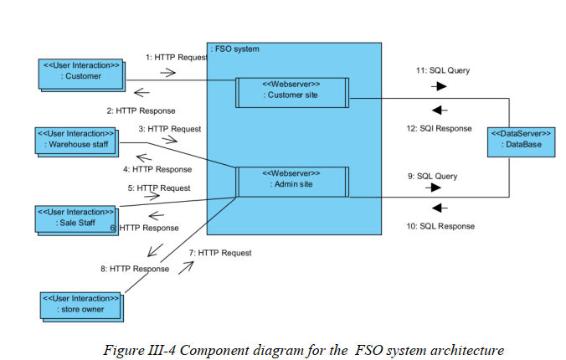

IV.3.1 . Package Diagram
[Provide the package diagram for each sub-system. The content of this section including the overall package diagram, the explanation, package and class naming conventions in each package. Please see the sample & description table format below (please note: package names don’t follow Java package naming convention yet)]
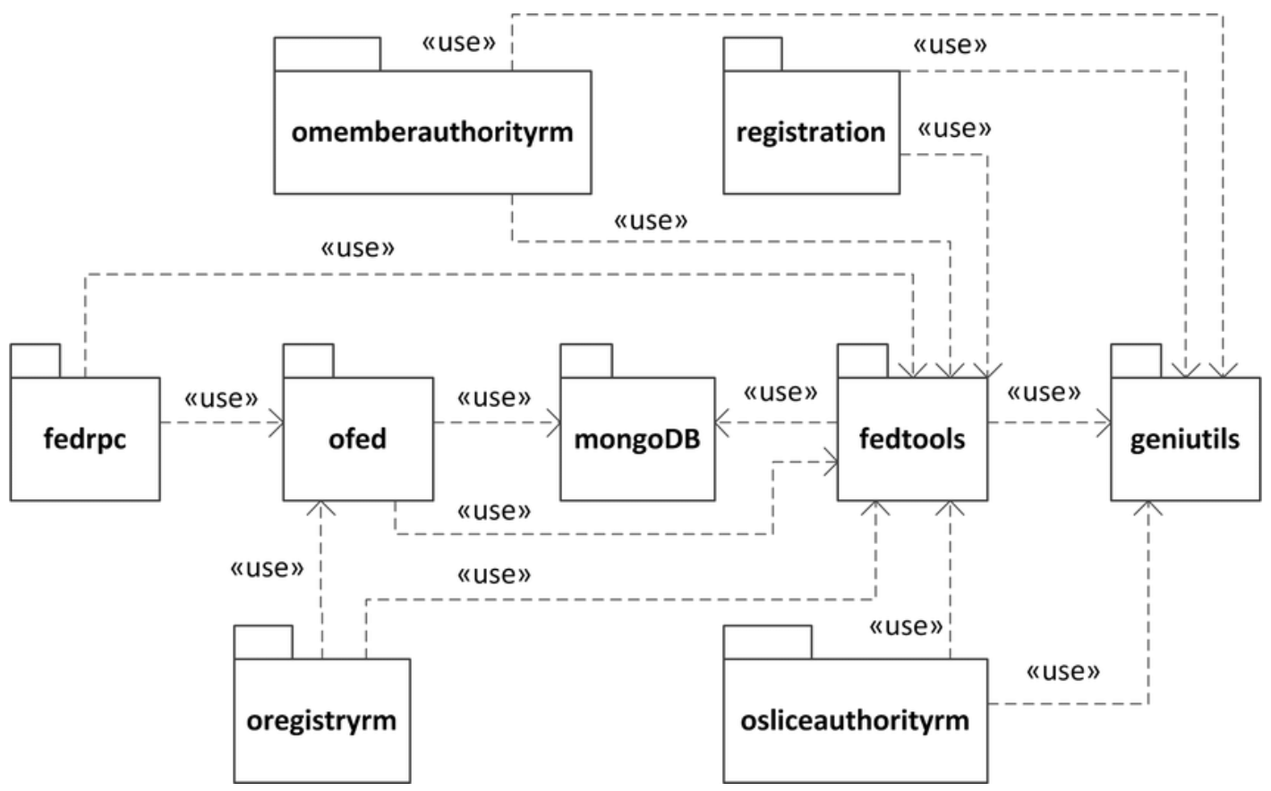
Package descriptions
No | Package | Description
01 | omemberauthorityrm | <Description of the package>
02 | registration | <Description of the package>
03 | fedrpc | <Description of the package>
04 | ofed | <Description of the package>
05 | mongoDB | <Description of the package>
06 | fedtools | <Description of the package>
07 | …

IV.4 Class diagram
[This part presents the class diagram for the relevant feature]
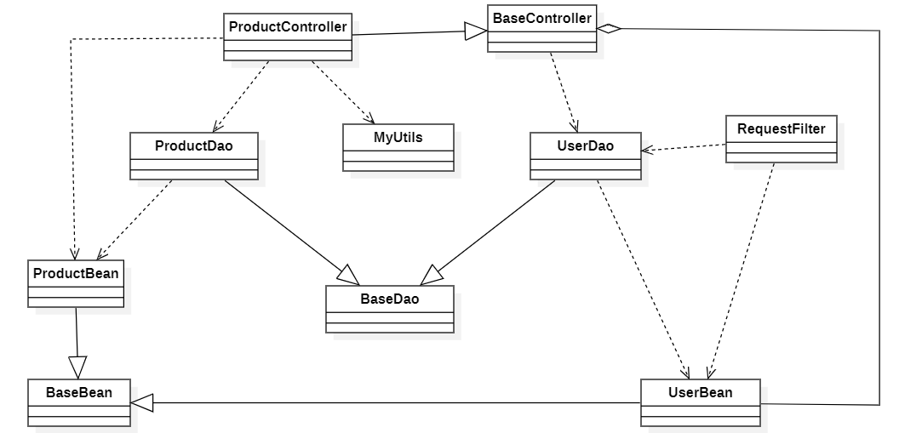

IV.5 Database Design
[Provide the tables relationship like example below – following MySQL database naming convention]

V. Implementation

V.1 Map architecture to the structure of the project
[Provide:
- Overview of the Chosen Architecture
Briefly describe the architectural style (e.g., Layered, MVC, Service-Oriented Architecture)
Explain why it was selected for this project (e.g., to meet non-functional requirements like maintainability, scalability, reusability)
- Mapping to Project Structure
Present the actual project folder/package structure
Map each layer/component in the architecture to concrete project modules]

V.2 Map Class Diagram and Interaction Diagram to Code
[Demo the implementation of several features using design patterns]

VI. Applying Alternative Architecture Patterns

VI.1 Applying the ………….. (ex: Service-Oriented Architecture (SOA)) architecture
[Redesign part of the system architecture using Service-Oriented Architecture (SOA) to improve reusability, scalability, and modularity.
Students must provide:
- Problem Identification
Briefly describe which non-functional requirement(s) are not fully supported by the current architecture (e.g., NF-05: Reusability)
- SOA-Based Solution
Reorganize system components into independent services
E.g., refactor FSOData into separate service modules
- Supporting Diagrams
Deployment Diagram
Updated Class Diagram
Component Diagram showing separate services]

VI.2 Applying Service Discovery Pattern in the service-oriented architecture
[Support dynamic service registration and discovery in SOA or microservice-based architecture for horizontal scalability and ease of expansion.
Students must provide:
- Problem & Requirement
Explain the relevant non-functional requirement (e.g., NF-06: Scalability)
Describe the need for service discovery in a growing system (e.g., multiple branches, independent modules)
- Service Discovery-Based Solution
Integrate a Service Discovery Pattern
Mention possible technologies: Consul, Eureka, Kubernetes DNS
- Supporting Diagrams
Deployment Diagram (with multiple instances and registry)
Updated Class/Component Diagram including a Discovery Service]

