|  |  |  |  |  |
| --- | --- | --- | --- | --- |
| Necsa SAFARI Logo | **Document number** |  | RR-REP-10/27 |  |
| **Revision number** |  | 0 |  |
| **Date** |  | 10 June 2010 |  |
| **Title** |  | ASSESSMENT OF THE REACTIVITY COMPUTER FOR USE WITH THE SAFARI-1 LEU CORE |  |

# authoriSation

|  |  |  |  |
| --- | --- | --- | --- |
|  | **NAME** | **SIGNED** | **DATE** |
| **Prepared** | jic Vermaak |  |  |
| **Checked** | G Ball |  |  |
| **Checked** | J Mostert |  |  |
| **Checked** | M De Kock |  |  |
| **Checked** | JF Du Bruyn |  |  |
| **Checked** | JWH Vlok |  |  |
| **Checked** | M Belal |  |  |
| **Approved** | AJ D’Arcy |  |  |

# DISTRIBUTION

|  |  |  |  |
| --- | --- | --- | --- |
|  | ***Electronic Copies:*** |  | ***Hard Copies:*** |
| 1 | JIC Vermaak | 10 | RR Records |
| 2 | G Ball | 11 |  |
| 3 | J Mostert | 12 |  |
| 4 | M De Kock | 13 |  |
| 5 | JF Du Bruyn | 14 |  |
| 6 | JWH Vlok | 15 |  |
| 7 | M Belal | 16 |  |
| 8 | AJ D’Arcy | 17 |  |
| 9 |  | 18 |  |

# Table of Contents

authoriSation 1

DISTRIBUTION 1

Table of Contents 2

LIST of figures 3

List of Tables 3

1 PURPOSE 4

2 SCOPE 4

3 References 4

4 Definitions and abbreviations 4

5 INTROduction 5

6 Point kinetics method of calculation 6

7 β-Effective and prompt neutron lifetime for safari-1 8

8 Investigation OF THE REACTIVITY COMpUTER operation 9

8.1 Derivation of the in-hour equation 9

8.2 Evaluation of the in-hour equation against current operational methods 11

8.3 The inverse Kinetic method 13

8.4 Evaluation of the inverse-kinetics method 14

8.5 Differences between an heu- and leu- safari-1 core using the inverse-kinetics method 15

8.6 Actual response of the SAFARI-1 reactivity computer 17

9 Discussion of results 18

10 Summary 18

11 Conclusion 19

12 Recommendation 19

13 appendix 20

**REVISIONS**

This document has been revised in accordance with the following schedule:

|  |  |  |  |
| --- | --- | --- | --- |
| **Rev. No.** | **Date approved** | **Nature of Revision** | **Prepared** |
| 0 | 16/07/2009 | First issue | JIC Vermaak |

# LIST of figures

Figure 7‑1 The neutron radiative-capture cross-section for U235 and U238 as well as the fission cross-section for U235 versus neutron energy. Obtained from Evaluated Nuclear Data File (ENDF/B 6.8). 8

[Figure 8‑1 A graphical determination of the roots of the In-Hour equation [ref [1]]. 10](#_Toc261003494)

[Figure 8‑2 A graphical representation of the response of a nuclear reactor to either a positive or negative step insertion of reactivity. [ref [1]] 11](#_Toc261003495)

Figure 8‑3 Correlation between the point-kinetics input data, In-hour equation and the inverse-kinetics equation. 14

Figure 8‑4 Reactivity computer values for a power signal generated by an HEU-core when the reactivity computer is programmed with HEU-core characteristics. 15

Figure 8‑5 Reactivity computer values for a power signal generated by an LEU-core when the reactivity computer is programmed with HEU-core characteristics. 15

Figure 8‑6 Power signal generated by a point kinetics code configured with LEU-core characteristics. 16

Figure 8‑7 Reactivity computer values for a computer with HEU-core characteristics and a computer with LEU-core characteristics. 16

Figure 8‑8 Reactivity values versus time displayed by the reactivity computer and recorded during an actual control-rod calibration of the SAFARI-1 reactor. Withdrawal of the control rod was stopped after 7 seconds. 17

# List of Tables

Table 6‑1 Data for the decay constant λ and delayed neutron fraction β for 6 equivalent groups of delayed neutrons. 7

Table 7‑1 Calculated values for the effective delayed neutron fraction and prompt neutron lifetime for the SAFARI-1 core for different 235U-loadings and number of plates. The data is included for both a 100% HEU core and a 100% LEU Core. 9

# PURPOSE

This assessment investigates the operation of the SAFARI-1 reactor reactivity computer and the effect the conversion from HEU-fuel to LEU-fuel has on the accuracy of the device.

# SCOPE

The information contained in the following sections explains concepts such as delayed neutron fractions, delayed neutron precursors and the neutronic behaviour for an insertion of reactivity. It also reports the results of analyses conducted on the neutronic behavior of both a 100% HEU core and a 100% LEU core as well as a comparison of the two cores. Finally an explanation on the derivation of the presented recommendation is presented.

# References

1. Duderstadt J. J., & Hamilton L. J. (1975). *Nuclear Reactor Analysis.*
2. IAEA-TECDOC-643. (1992). *Research reactor core conversion guidebook. Volume 3: Analytical verification.*
3. Matos J., E.M., P., K.E., F., & W.L., W. *Safety-related benchmark calculations for MTR-type reactors with HEU, MEU and LEU fuels.* Argonne, Illinois. Contained within IAEA-TECDOC-643.
4. Diaz A., Van der Walt R. (1965). *The start-up of the SAFARI-1 Research Reactor.* PEL 90. Atomic Energy Board. Pelindaba.
5. Ball, G. (1995). ANL/RERTR/TM-21. *Technical feasibility study of converting SAFARI-1 to LEU Fuel.*
6. Suescun Diaz D., Senra Martinez S., Carvalho da Silva F., (2007). *Formulation for the Calculation of Reactivity Without Nuclear Power History.* Journal of Nuclear Science and Technology.

# Definitions and abbreviations

**HEU:**

High Enriched Uranium. Refers to U-235 enrichment of greater or equal that 20%. In this document it refers specifically to an enrichment of 90%, as used in SAFARI-1 fuel elements at high enrichment.

**LEU:**

Low Enriched Uranium. Refers to U-235 enrichment of less than 20%. In this document it refers specifically to an enrichment of 19.75%, as used in SAFARI-1 fuel elements at low enrichment.

# INTROduction

In order to explain the function of the reactivity computer, the fundamental theoretical concepts of reactivity will be explained below.

In a nuclear reactor a very important concept relating to the change of the neutron balance is the ***multiplication factor, k***. It is defined as the ratio of neutron birth rate to the neutron rate of loss;

$$k=\frac{rate of birth}{rate of loss}$$

The rate at which neutrons are born is mainly governed by two production sources;

1. The first source is the production of neutrons directly from fission reactions whereby an amount of neutrons, $\overline{ν}$, is released on average per fission. This amount, when compensated for the parasitic absorption of the fissile isotope, is given the symbol η. These neutrons, which are released at the instance of fission, are called ***prompt neutrons****.*
2. The second source of neutrons is the neutrons emitted during the decay of radioactive isotopes (usually in the immediate decay chain of fission products) within the fuel. Due to the fact that these neutrons appear to be produced a short while after the fission reaction occurred, they are called ***delayed neutrons***. The isotopes from which these neutrons are emitted are called ***delayed neutron precursors***. The fraction of the total neutron population (within a critical reactor) arising from the delayed neutrons is called the ***delayed neutron fraction, β***.

The three factors; multiplication factor k, delayed neutron precursors and delayed neutron fraction β, plays the most fundamental role in the controllability of a nuclear reactor and are different for each reactor configuration. The multiplication factor, k, is very difficult to determine during reactor operation and therefore the concept of ***reactivity, ρ***, is used as a descriptive measure of the neutron balance inside the reactor, defined mathematically as:

$$ρ=\frac{k-1}{k}$$

It has become customary at SAFARI-1 to redefine this reactivity as a fraction of β such that it obtains the units of **dollars ($)**, where one dollar corresponds to a reactivity of β:

$$ρ'=\frac{1}{β}∙\frac{k-1}{k}$$

For purposes of explanation, it is sufficient to note that a value for *ρ’ greater than zero and smaller than one* (0<ρ’< 1) is characteristic of a controllable increase in neutron population (*i.e. delayed super-critical*); a value for *ρ’ smaller than zero* (ρ’<0) indicates a reduction in neutron population and finally a value of *ρ’ close to or greater than one* (ρ’≥1) corresponds to an uncontrollable increase in neutron population (*uncontrolled excursion or prompt-supercritical*). During normal operations a controlled insertion of less than $0.95 (95 cents) over a suitably long period is usually realized in order to keep the time rate of change of the neutron population, and therefore reactor power, in check.

The reactivity for the SAFARI-1 reactor is physically calculated using a reactivity computer which displays the reactivity of the core in cents after **presumably** accepting a ***reactor-period, T***, as input signal. It is programmed with certain core parameters which enables its function, however, the applicability of these parameters to the now fully converted LEU core needs to be established (since the computer was implemented when the reactor operated with a fully HEU core). Due to the analog electronic architecture of the reactivity computer, modification is not considered feasible, and therefore values obtained from it have to be corrected manually if possible (i.e. first record the data and then process it) and if deemed necessary.

The changes which need to be effected are determined in the subsequent sections.

# Point kinetics method of calculation

The kinetics of the reactor is a function of the reactivity inserted into the core, the fraction of delayed neutrons β, delayed neutrons precursor decay rate and delayed neutrons precursor production rate. From this relationship an equation describing the behaviour of the neutron population can be derived and is known as the ***reactor point-kinetics equation***:

|  |  |  |
| --- | --- | --- |
|  |  | (Eq. ) |

= Average thermal neutron flux [cm-2s-1];

= Average thermal neutron velocity [cm.s-1];

= time [s];

= Delayed neutron fraction;

$ρ'$ = Reactivity [$];

$l_{p}$ = Prompt neutron lifetime [s];

$λ_{i}$ = Delayed neutron precursor decay constant [s-1];

= Delayed neutron precursor concentration [cm-3];

Among these variables only the flux $ϕ$ and the concentrations of the delayed neutron precursors $C_{i}$ are functions of time. The concentrations of the delayed neutron precursors can each also be described in terms of isotope production and decay as:

|  |  |  |
| --- | --- | --- |
|  |  | (Eq. ) |

In this equation, the only new variable is the ***isotope-specific delayed neutron fraction $β_{i}$*** . It is defined as the fraction of the total neutron population that is contributed from the decay of the specific isotope i. Thus for every precursor group (there can be several groups) an individual differential equation has to be solved. This can be a very daunting task considering the numerous isotopes that decay by means of neutron emission. This difficulty can be overcome by grouping different isotopes into equivalent groups with averaged decay constants and delayed neutron fractions. Such groups are **dependent on the fuel enrichment only** and were obtained from reference 4 and shown below in .

Table ‑ Data for the decay constant λ and delayed neutron fraction β for 6 equivalent groups of delayed neutrons.

|  |  |  |  |  |
| --- | --- | --- | --- | --- |
|  | **HEU fuel**  **90% U235 enrichment** | | **LEU fuel**  **20% U235 enrichment** | |
| **Precursor group** | **Decay constant**  **λi [s-1]** | **Delayed neutron fraction βi** | **Decay constant**  **λi [s-1]** | **Delayed neutron fraction βi** |
| **1** | **0.01272** | **2.87E-04** | **0.01273** | **2.71E-04** |
| **2** | **0.03173** | **1.59E-03** | **0.03171** | **1.53E-03** |
| **3** | **0.11604** | **1.40E-03** | **0.11670** | **1.35E-03** |
| **4** | **0.31100** | **3.05E-03** | **0.31215** | **2.90E-03** |
| **5** | **1.39990** | **9.60E-04** | **1.39880** | **9.26E-04** |
| **6** | **3.86800** | **1.95E-04** | **3.85100** | **1.93E-04** |

It is important to note that although the information regarding the delayed neutron precursors is characteristic of the enrichment of the fuel only, the overall delayed neutron fraction β and prompt neutron lifetime lp is dependent on both the enrichment of the fuel and the **configuration** of the reactor (i.e. moderator to fuel ratio, moderating ratio etc.). Thus β and lp cannot be found in published literature and has to be calculated for the specific reactor being analyzed; i.e. SAFARI-1.

Once all of these variables have been obtained, the equations can be solved for the initial flux $ϕ_{0}$, reactivity inserted ρ and initial precursor concentrations $C_{i0}$. However, to avoid strenuous mathematics a **finite difference** solution method is used whereby the time variable is discretised into small elements dt, chosen to be sufficiently small as to present minimal error. This is a common method used to solve time dependant problems and is implemented in many transient physics packages such as RELAP5/SCDAP, Fluent, etc.

# β-Effective and prompt neutron lifetime for safari-1

When neutrons are released, either as prompt or delayed neutrons, they are released with a certain energy spectrum (≈0.5 to 1.5 MeV). The fission cross-section for 235U is however, quite low at this energy and therefore a neutron will first lose most of its energy through scattering collisions in the moderator (light water) before being absorbed. During these numerous scattering collisions, the energy decreases and the neutron moves through an energy spectrum (100 eV to 100 keV) where both 235U and 238U exhibits relatively large parasitic-absorption cross-sections σa as shown in **Error! Reference source not found.**. Therefore, the longer a neutron takes to reach thermal energies (≈1 eV) the higher the probability that it will be captured in a resonance absorption and is subsequently removed from the fission chain reaction. This phenomenon drives the Doppler reactivity feedback coefficient (resonances become larger with fuel temperature) but also has effects on the delayed neutron fraction β.

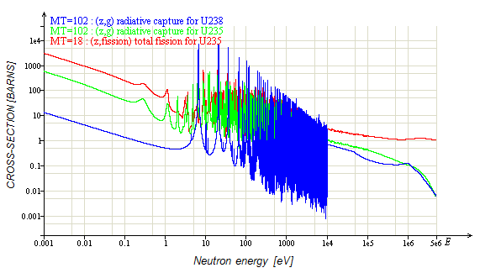

Figure ‑ The neutron radiative-capture cross-section for U235 and U238 as well as the fission cross-section for U235 versus neutron energy. Obtained from Evaluated Nuclear Data File (ENDF/B 6.8).

The delayed neutrons are largely released with much lower energy (≈0.5 MeV) than that of the prompt-neutrons (≈1.5 MeV). This means that the time it takes the delayed neutrons to thermalise is much shorter than that for the prompt neutrons and thus the delayed neutrons are much less likely to be caught in resonances. Therefore a larger percentage of the originally emitted delayed neutrons survive to reach thermal energies in comparison to the prompt neutrons and that the delayed neutron fraction β increases from the instance where the neutrons were released to the point where they can take part in the nuclear chain reaction. This increase in β is a function of how the reactor is constructed (moderator-to-fuel ratio, absorbers, etc.) and therefore the term ***effective delayed neutron fraction, βeff,*** is coined. βeff must also therefore be calculated with appropriate neutronic-codes.

Similar problems exist for the ***promp-neutron lifetime, lp,*** which is defined as the average time it takes for an emitted prompt-neutron to be absorbed in any nuclear reaction. Besides being a function of fuel enrichment, it is also a function of the reactor configuration.

These factors have been obtained from reference [5] and are given below:

Table ‑ Calculated values for the effective delayed neutron fraction and prompt neutron lifetime for the SAFARI-1 core for different 235U-loadings and number of plates. The data is included for both a 100% HEU core and a 100% LEU Core.

|  |  |  |
| --- | --- | --- |
|  | βeff | ***lp*** |
| HEU-300g 235U, 19 plates | 0.00750 | 63.7x10-6 |
| HEU-200g 235U, 19 plates | 0.00752 | 69.3x10-6 |
| LEU-340g 235U, 19 plates | 0.00717 | 53.2x10-6 |

# Investigation OF THE REACTIVITY COMpUTER operation

In order to evaluate the use of the existing reactivity computer for an LEU core, the operation of the reactivity computer needs to be investigated. Presumably, the reactivity computer implements the “in-Hour” approximation:

|  |  |  |
| --- | --- | --- |
|  |  | (Eq. ) |

Where T is the reactor period which can be derived from a reactor power signal.

It is however believed that the more likely situation is that the reactivity computer is based on the inverse-kinetics method; a more accurate yet more complex method commonly in use in reactivity computers (discussed later). The two methods are evaluated here and compared to the operation of the reactivity computer.

## Derivation of the in-hour equation

This equation has indeed been used for rod-calibrations during the initial startup of the reactor according to reference [4] (“PEL 90: The startup of the SAFARI-1 Research Reactor”) where it was referred to as the “period method”. It is however based on the direct mathematical solution of the point-kinetics equation (Eq. 1) in which only the stable period region is considered.

This equation is obtained by first taking the Laplace-transforms of (Eq. 1) and(Eq. 2) and then solving simultaneously to obtain the characteristic equation:

|  |  |  |
| --- | --- | --- |
|  |  | (Eq. ) |

= Laplace transform coefficient

$Λ$ = Prompt neutron generation time

$ρ$ = Reactivity (Δk/k)

This equation can be mathematically manipulated to incorporate 6 delayed neutron groups which in turn add other Laplace transform coefficients s1,s2...s7. The end result is a seventh-order polynomial with the roots sj as roots:

|  |  |  |
| --- | --- | --- |
|  |  | (Eq. ) |

The solution of this equation is best observed graphically in Figure 8‑1. Using these roots, the time behaviour of the flux can be expressed as:

|  |  |  |
| --- | --- | --- |
|  | $$ϕ\left(t\right)= \sum_{i=1}^{7}{ϕ_{i}.exp⁡(s_{i}t)}$$ | (Eq. 6) |

This equation can now fully characterize a step insertion of reactivity which can be graphically seen in Figure 8‑2, however, the summation of these factors presents difficulty.

Any step insertion of reactivity is first characterized by a prompt-response, which quickly dissipates due to the large negative values of s2 to s7, and then by a slow exponential response due to the positive value of s1. This is the basis on which (Eq. 3) is derived since one can neglect the s2 to s7 terms and only insert s1 into (Eq. 5).

NOTE: *The Laplace coefficients are analogous to the different sources of neutrons in a reactor; s7 being the fission source which always has the quickest response since it is directly coupled to the chain reaction, and s6 down to s1 being the delayed neutron precursors with decay constants, λ, arranged respectively large to small (half-life small to large).*

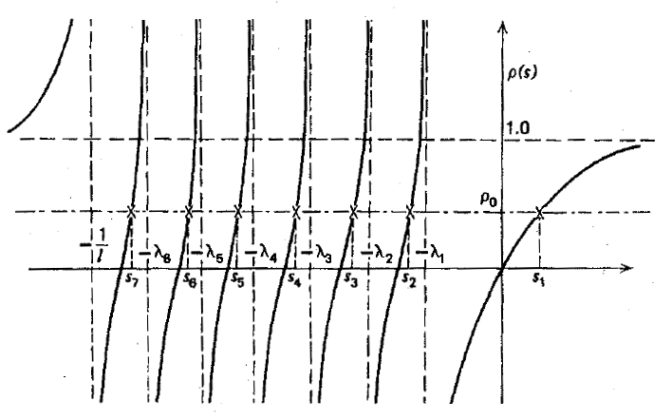

Figure ‑ A graphical determination of the roots of the In-Hour equation [ref [1]].

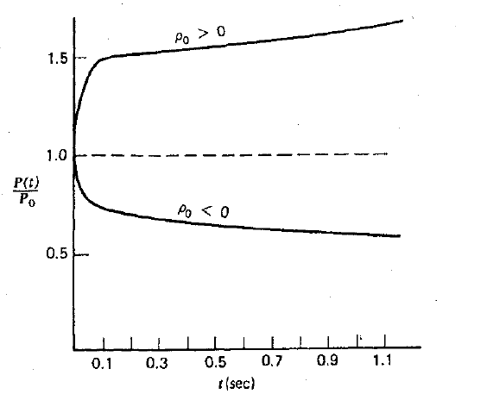

Figure ‑ A graphical representation of the response of a nuclear reactor to either a positive or negative step insertion of reactivity. [ref [1]]

## Evaluation of the in-hour equation against current operational methods

From the formulation of the In-hour approximation for reactivity one can see that only the s1 term is considered, which corresponds to the delayed neutron precursor with the smallest decay constant (largest half-life), and therefore the first few moments in time, the In-hour approximation is incapable of predicting reactivity values. This is contradictory to the method of rod-calibration for the SAFARI-1 reactor since in principle the operators do not wait for a stable period to be obtained.

Rod-calibration is conducted as follows (Rod 1 taken as example):

1. *Reactor is made critical with Rod 1 fully inserted (0.0 mm).*
2. *The power of the reactor is elevated to about 200 kW and the reactor is brought back to criticality. Typical value for the bank is about 635 mm. The reactivity computer displays very close to 0.0 cents.*
3. *The operator starts continuously withdrawing Rod 1. Typically the period will start to become less and reactor power will rise slightly.*
4. *Rod 1 is continuously withdrawn until the reactivity computer displays around 13 cents. Withdrawal is stopped, reactivity computer value is noted, Rod 1 position is noted and reactor inlet temperature is noted. (record keeping is in the form of a spreadsheet)*
5. *The bank is inserted to bring reactor power back to its original value after which the reactor is brought back to criticality. Rod 1 is brought to 50 mm.*
6. *This process is continued with Rod 1 having starting positions in 50 mm increments all the way to 700 mm.*
7. *Differential worth is calculated by:*
$$Δρ^{'}=\frac{ρ_{computer}}{Distance travelled}$$

8. *The integrated worth is then determined firstly by calculating the mid-point between the starting position of the rod before withdrawal and the position where withdrawal was halted. The incremental reactivity value is then calculated and added to the sum of all previous incremental reactivity values to obtain the integrated reactivity worth.*

$$x_{mid}=\frac{x_{initial}+x_{final}}{2}$$

$$ρ_{incr}=Δρ^{'}. x_{mid}$$

An example of such a spreadsheet is attached in the appendix.

The near continuous ramp insertion of reactivity is not within the bounds of applicability of the In-Hour approximation, since it is an approximation of the reactivity for the case where a stable period is obtained after the prompt-response of the reactor has dissipated. When a rod is moving the reactor is most definitely **within the prompt response time-zone**.

## The inverse Kinetic method

Research into the design of reactivity computers has shown that a much more accurate, yet much more complex equation, can be derived using the **inverse-kinetics** method. This method involves the solving of the reactivity from the point-kinetics equation by using the time behaviour of the flux (or power). This is the inverse of the In-hour equation which uses the time-behaviour of reactivity to derive the time-behaviour of flux. The inverse-kinetics method yields the following equation:

|  |  |  |
| --- | --- | --- |
|  |  | (Eq. ) |

= Time-behaviour of reactor power

$〈P_{0}〉$ = Steady-state power at time (0 – t)

In this equation, $〈P_{0}〉$ is included in order to prevent the time integration all the way back in time. It is assumed that the reactor has been critical, with a certain power $〈P_{0}〉$, t seconds before the instantaneous measurement.

The equation is easily employed as an analog electronic circuit and according to reference [6] is frequently used to program control rod motion.

## Evaluation of the inverse-kinetics method

By deploying a simple point-kinetics FORTRAN-90 code, a realistic power signal has been generated representative of a rod calibration exercise. This signal is then used to calculate the reactivity by using both the In-hour approximation and the inverse-kinetics method. The results are shown in Figure 8‑3.

It can be seen that the In-hour equation is not representative of the true reactivity being inserted in the prompt regions, but becomes much more accurate in the stable period region where the contributions of the faster decaying precursor groups are diminishing. The inverse-kinetics method is however much more suited and can be used with minimal error.

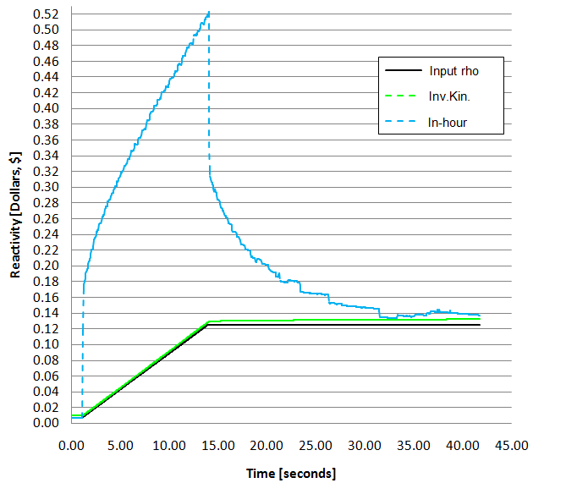

Input rho

Inv.Kin.

In-hour

Figure ‑ Correlation between the point-kinetics input data, In-hour equation and the inverse-kinetics equation for the withdrawal of a control rod.

## Differences between an heu- and leu- safari-1 core using the inverse-kinetics method

The FORTRAN-90 point-kinetics model is programmed with decay constants (λi), Beff and group Bi’s and therefore can simulate the effect the conversion to LEU fuel had on the operation of the reactivity computer. The results are shown in Figure 8‑4 and Figure 8‑5.

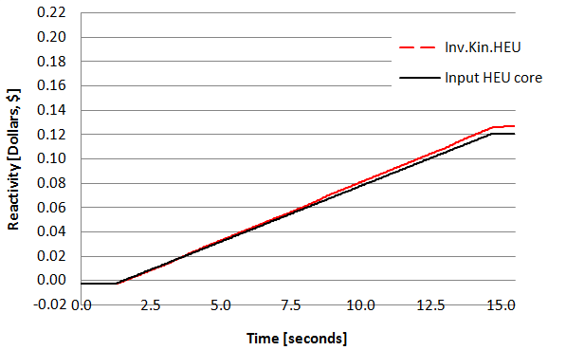

Figure ‑ Reactivity computer values for a power signal generated by an HEU-core when the reactivity computer is programmed with HEU-core characteristics. The power signal was generated while one control rod has been continuously withdrawn.

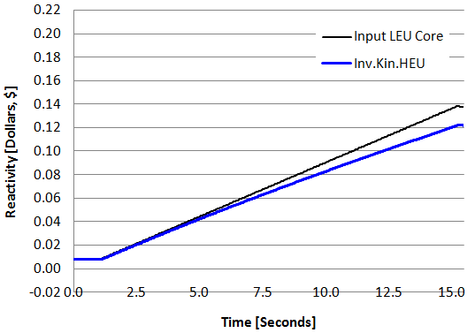

Figure ‑ Reactivity computer values for a power signal generated by an LEU-core when the reactivity computer is programmed with HEU-core characteristics. The power signal was generated while one control rod has been continuously withdrawn.

In figuresFigure 8‑6Figure 8‑7 below, a power signal was generated with LEU-core characteristics and the values of two reactivity computer configurations are shown; one configured with HEU characteristics and one with LEU characteristics.

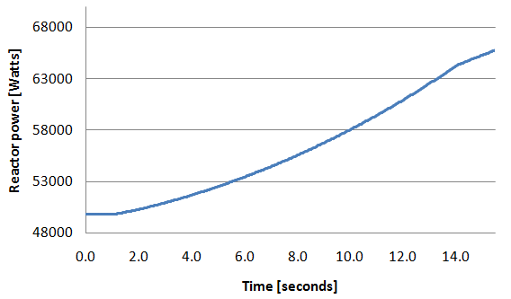

Withdrawal stopped

Withdrawal started

Figure ‑ Power signal generated by a point kinetics code configured with LEU-core characteristics during withdrawal of a single control rod.

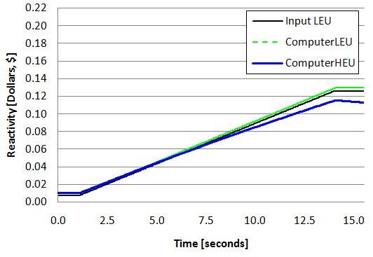

Figure ‑ Reactivity computer values for a computer with HEU-core characteristics and a computer with LEU-core characteristics during withdrawal of a single control rod.

The values calculated by the LEU-based computer reads approximately 15% higher than of the HEU-based computer at 15.5 seconds (when withdrawal is stopped). Thereafter the difference increases considerably. This is due to the larger decay constants (shorter half-lives) of the long-lived delayed neutron precursors, specifically group 1, which are used in the HEU-based computer and causes the integral over the power history to exponentially dissipate away.

## Actual response of the SAFARI-1 reactivity computer

In order to demonstrate the coherence of the mathematical model to the actual operation of the reactivity computer, values for reactivity versus time were recorded during actual control-rod calibration of the SAFARI-1 reactor and are shown in Figure 8‑8 below.

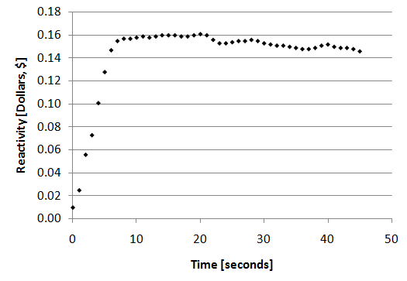

Figure ‑ Reactivity values versus time displayed by the reactivity computer and recorded during an actual control-rod calibration of the SAFARI-1 reactor. Withdrawal of the control rod was stopped after 7 seconds.

As expected the value for the reactivity, calculated by the reactivity computer, reduces with time from the moment the maximum reactivity value has been reached. This effect can clearly be observed during the later stages of the experiment (around 20 seconds onwards).

Another aspect which differs from the point-kinetics model is the spatial character of the reactor and can be observed when withdrawal is stopped at 7 seconds where the reactivity value continues to increase from 12 cents up to about 16 cents, constituting a delay in the measured power signal.

Although the point-kinetics model is not a perfect representation of the reactor’s kinetics, it can be used to judge the differences imposed by the conversion from HEU- to LEU-fuel as can be seen by the decay of the reactivity worth calculated by both the reactivity computer and the inverse-kinetic method.

# Discussion of results

According to the results in Figure 8‑4, the **inverse-kinetics** method can effectively be used to program a reactivity computer; however, the input configuration of the computer makes a sizeable difference in the calculation of reactivity since a change in the parameters βeff, βi and λi of the core in question will affect the value the computer calculates.

The computed value displayed by an HEU-based reactivity computer is lower than that of a LEU-based reactivity computer, as indicated in Figure 8‑5, for two reasons:

* Firstly, the value βeff for an HEU-core is larger than that for an LEU-core. Therefore when considering the definition of reactivity in dollars, with βeff in the denominator, the value of the reactivity for the same multiplication factor will be less for HEU than for LEU;
$$ρ'=\frac{1}{β}∙\frac{k-1}{k}$$

* Secondly, the value of the average decay constant λeff is larger for an HEU-based computer than for an LEU-based computer and therefore the integral over the history of power, exponentiates negatively much quicker for an HEU-based computer;

$$\int_{0}^{t}{e^{-λ_{i}\left(t-t^{'}\right)}.P\left(t^{'}\right).dt'}$$

This negative decay of the integral term can be observed in Figure 8‑7 at the time when withdrawal is terminated and, according to the testimonies of current reactor operators, is observed during actual rod calibrations with the current completely LEU-core.

The combined effect of these factors account for a more conservative reactivity measurement since the reactivity worth measured by an HEU-based reactivity computer will always be less than the actual reactivity worth.

# Summary

Values for relevant core parameters were extracted from reference [5] which originally accompanied the process of converting the SAFARI-1 reactor core from HEU- to LEU-fuel. Values for βeff, delayed neutron group decay constants λi, group specific delayed neutron fractions βi, prompt neutron lifetime lp and prompt-neutron generation time $Λ$ were extracted. These values were then programmed into a simple FORTRAN-90 code which simulated the SAFARI-1 reactor by means of the well known point-kinetics equation.

This point-kinetics code was then used first to investigate the possible dependence of the reactivity computer on the so called In-hour approximation and it was proven that this is not true since the approximation does not at all hold for continuous withdrawal of a control rod.

The code was then used to simulate the reactivity computer programmed with an equation derived with the inverse-kinetics method. Two configurations of this computer were simulated; one with HEU-core parameters and one with LEU-core parameters. Both these configurations were simulated as part of an HEU- and LEU-core. The analysis showed that the inverse-kinetic method provided sufficient calculation of reactivity for an HEU-core when programmed with HEU-core parameters, however, when operated on a LEU-core the computer calculated values about 15% lower than the actual reactivity worth.

When rod withdrawal is stopped, the simulation also indicated that the value displayed on the reactivity computer will slowly decay to lower values. This effect is also observed during current rod calibration processes and supports the notion that the reactivity computer operates with the inverse-kinetics equation.

# Conclusion

The reactivity computer is currently programmed with HEU-core parameters and as a result will theoretically always calculate reactivity worth to be 15% less than it actually is for an LEU core. Therefore it will calculate a more conservative value, with respect to total control-bank worth and shutdown-margin, since the core is always loaded to ensure a **minimum** control bank worth. This means that SAFARI-1 can always be assured that the total rod bank is worth approximately 15% more than is calculated by the reactivity computer. The error is therefore conservative in terms of the safety of the reactor.

By using the point-kinetics method for simulating the reactor response, the spatial character of the reactor could not be simulated and therefore the calculated response is not entirely equivalent to the true response of the reactor. This, however, does not elude the ability of the point-kinetics method to motivate the safety case since the primary concern was whether the actual reactivity computer over-estimates or under-estimates with the now fully converted LEU core. More accurate reactivity calculations can be conducted using a 3D core model in MCNP, however, such an analysis will be of a much larger scale and could take a lot of time.

# Recommendation

In order to reduce the error in using the existing reactivity computer for an LEU core, it is recommended that a correction-factor of 1.15 be applied to any future control-rod reactivity worths. Additionally, it is recommended to replace the reactivity computer with newer technology.

# appendix

SUBROUTINE PerformKinetics

USE WINTERACTER

USE PK_ENVIRONMENT

IMPLICIT NONE

INTEGER :: t

REAL :: tRho,dRho

dF = 0.0

dC1 = 0.0

dC2 = 0.0

dC3 = 0.0

dC4 = 0.0

dC5 = 0.0

dC6 = 0.0

dXe = 0.0

dIo = 0.0

dRho = (Rho - Rho_prev)/500.0

tRho = Rho_prev

Previous_flux = Flux

DO t=1,500,1

tRho = tRho + dRho

dF = dt*Beff*(tRho - 1)*Flux/(1 - tRho*Beff)/lp

dF = dF + dt*vel*lam1*C1

dF = dF + dt*vel*lam2*C2

dF = dF + dt*vel*lam3*C3

dF = dF + dt*vel*lam4*C4

dF = dF + dt*vel*lam5*C5

dF = dF + dt*vel*lam6*C6

dC1 = dt*B1*Flux/(1 - tRho*Beff)/vel/lp - dt*lam1*C1

dC2 = dt*B2*Flux/(1 - tRho*Beff)/vel/lp - dt*lam2*C2

dC3 = dt*B3*Flux/(1 - tRho*Beff)/vel/lp - dt*lam3*C3

dC4 = dt*B4*Flux/(1 - tRho*Beff)/vel/lp - dt*lam4*C4

dC5 = dt*B5*Flux/(1 - tRho*Beff)/vel/lp - dt*lam5*C5

dC6 = dt*B6*Flux/(1 - tRho*Beff)/vel/lp - dt*lam6*C6

dXe = dXe + dt*( gamX*SigF*Flux + lamI*IoC - 2.6e-18*XeC*Flux - lamX*XeC )*Xe_curve

dIo = dIo + dt*( gamI*SigF*Flux - lamI*IoC )*Xe_curve

Flux = Flux + dF

C1 = C1 + dC1

C2 = C2 + dC2

C3 = C3 + dC3

C4 = C4 + dC4

C5 = C5 + dC5

C6 = C6 + dC6

CALL UpdateDial(29.0,582.0,57.0,Period)

END DO

XeC = XeC + dXe

IoC = IoC + dIo

END SUBROUTINE

|  |  |  |  |  |  |  |  |  |  |
| --- | --- | --- | --- | --- | --- | --- | --- | --- | --- |
|  |  |  |  |  |  | |  |  |  |
| CONTROL ROD NO 1 CALIBRATION DATA | | | | | |  | CORE: | 0909-1 |  |
|  |  | | | | | | |  |  |
|  |  |  |
|  |  |  |
|  |  |  |
|  |  |  |
|  |  |  |
|  |  |  |
|  |  |  |
|  |  |  |
|  |  |  |
|  |  |  |
|  |  |  |
|  |  |  |
|  |  |  |
| BANK POS | CONTROL ROD POSITION (mm) | | | REACTIVITY WORTH (c) | | | INTEGRATED | INLET TEMP. | PERIOD |
| (mm) | CRITICAL | SUPER C. | X-AXIS | COMPUTER | DIFFIRENTIAL | | WORTH (c) | (DEG. C) | (SEC) |
| 635.0 | 0 | 157.7 | 78.9 | 13.9 | 0.9 | | 3.5 | 22.8 | 44.4 |
| 634.0 | 50 | 164.9 | 107.5 | 14.1 | 1.2 | | 7.0 | 22.6 | 39.4 |
| 634.3 | 100 | 168.6 | 134.3 | 13.4 | 2.0 | | 12.2 | 22.6 | 39.4 |
| 631.0 | 150 | 190.0 | 170.0 | 13.0 | 3.3 | | 23.8 | 22.4 | 37.3 |
| 625.0 | 200 | 227.0 | 213.5 | 13.3 | 4.9 | | 45.3 | 22.4 | 32.7 |
| 615.5 | 250 | 268.0 | 259.0 | 13.6 | 7.6 | | 79.6 | 22.3 | 29.4 |
| 602.0 | 300 | 314.5 | 307.3 | 13.6 | 9.4 | | 124.9 | 22.4 | 27.1 |
| 585.0 | 350 | 362.8 | 356.4 | 14.0 | 10.9 | | 178.7 | 22.4 | 25.2 |
| 566.5 | 400 | 413.4 | 406.7 | 15.5 | 11.6 | | 236.8 | 22.3 | 22.7 |
| 548.5 | 450 | 461.3 | 455.7 | 13.4 | 11.9 | | 294.9 | 22.3 | 27.1 |
| 533.6 | 500 | 514.4 | 507.2 | 14.1 | 9.8 | | 345.4 | 22.3 | 27.1 |
| 521.5 | 550 | 569.3 | 559.7 | 13.3 | 6.9 | | 381.5 | 22.3 | 29.4 |
| 514.0 | 600 | 624.2 | 612.1 | 13.0 | 5.4 | | 409.7 | 22.2 | 33.7 |
| 507.8 | 650 | 694.8 | 672.4 | 13.1 | 2.9 | | 427.3 | 22.2 | 44.4 |
| 504.6 | 700 | 740.9 | 720.5 | 1.2 | 0.3 | | 428.7 | 22.2 | 199 |
|  |  |  |  | **Total Integrated Worth (c)** | | | **428.7** |  |  |