Specifications & Micro-Architecture

for 16Gbps Fiber Channel FC1 layer

  - 10 September 2012
  - Revision 0.1

Revision History
Revision | Date | Description | By
0.1 | 7/15/2013 | initial draft | Leon Zhou
0.2 | 10/30/2013 | Review with tim.beyers | Leon Zhou
0.3 | 11/1/2013 | 2nd review. Removed sections on PCS encoder and decoder.  Added support for bit-wise inversion on PMA interface. | Leon Zhou

Table of Contents
1.0 Revision History 2
2.0 Table of Contents 3
3.0 List of Figures 6
4.0 List of Tables 6
5.0 Abbreviations & Definitions 8
6.0 Introduction 10
7.0 Blocks 11
7.1 fc1_kr:gen_fc1_kr[0].fc1_kr 11
7.1.1 decoder:decoder_inst 11
7.1.1.1 bit_slip:decoder_bit_slip_inst 11
7.1.1.2 block_sync:block_sync_inst 11
7.1.1.3 correction:correction_inst 11
7.1.1.3.1 corr_buff:corr_buff_inst 11
7.1.1.4 crc32_galois_d65:decoder_crc32_galois_d65_inst 11
7.1.1.5 dec_crc_comp:decoder_dec_crc_comp_inst 11
7.1.1.6 decomp:decoder_decomp_inst 11
7.1.1.6.1 reverse:dec_out_reverse_inst 12
7.1.1.7 err_detect:err_detect_inst 12
7.1.1.7.1 fec_rot_1:fr32_p64 12
7.1.1.7.2 fec_rot_21:fr_1_21 12
7.1.1.7.3 fec_rot_22:fr_1_22 12
7.1.1.7.4 fec_rot_23:fr_1_23 12
7.1.1.7.5 fec_rot_24:fr_1_24 12
7.1.1.7.6 fec_rot_25:fr_1_25 12
7.1.1.7.7 fec_rot_26:fr_1_26 12
7.1.1.7.8 fec_rot_27:fr_1_27 12
7.1.1.7.9 fec_rot_28:fr_1_28 12
7.1.1.7.10 fec_rot_29:fr_1_29 12
7.1.1.7.11 fec_rot_30:fr_1_30 12
7.1.1.7.12 fec_rot_31:fr_1_31 12
7.1.1.7.13 fec_rot_32:fr32_p0 13
7.1.1.7.14 fec_rot_32:fr32_p32 13
7.1.1.7.15 fec_rot_32:frn2112_fr32 13
7.1.1.7.16 fec_rot_32:frn2112_fr64 13
7.1.1.7.17 fec_rot_n2112:frn2112 13
7.1.1.8 gb64_65:decoder_gb64_65_inst 13
7.1.1.9 gb64_66:gb64_66_inst 13
7.1.1.10 pcs_descrambler:pcs_descrambler_inst 13
7.1.1.11 pn2112_sl:decoder_pn2112_sl_inst 13
7.1.2 encoder:encoder_inst 13
7.1.2.1 compressor:compressor_inst 13
7.1.2.2 crc32_galois_d65:encode_crc32_galois_d65_inst 13
7.1.2.3 encoder_fifo_in:encoder_fifo_in_inst 13
7.1.2.4 gb65_64:encode_gb65_64_inst 13
7.1.2.5 gb66_64:gb66_64_inst 14
7.1.2.6 pcs_out_sel:pcs_out_sel_inst 14
7.1.2.7 pcs_scrambler:pcs_scrambler_inst 14
7.1.2.8 pn2112:encode_pn2112_inst 14
7.1.3 fc1_layer_csr_dec:fc1_layer_csr_dec_inst 14
7.1.4 fc1_layer_csr_enc:fc1_layer_csr_enc_inst 14
8.0 Overview 15
8.1 Overview of Transmit (aka encoder) 15
8.2 Overview of Receive (aka decoder) 15
8.3 64B/66B Transmission Code 17
8.4 Block structure 17
8.5 FEC adaptation 18
9.0 64B/66B Transmission Code 20
9.1 64B/66B scrambling 20
9.2 Invalid Synchronization Header 21
9.3 Data Transmission Words 21
10.0 Forward Error Correction (FEC) 23
10.1 FEC Code 23
10.2 FEC Block Format 23
10.3 Composition of the FEC block 24
10.4 FEC (2112,2080) encoder 25
10.5 PN-2112 Pseudo-noise Sequence Generator 26
10.6 FEC (2112,2080) Decoding 27
10.7 FEC receive bit ordering 29
10.8 FEC block synchronization 30
10.9 State diagrams 31
11.0 64B/66B Transmission Word synchronization 33
12.0 Transmitter Training Signal Transmission Word synchronization 34
13.0 64B/66B Encoder 35
14.0 Scrambler 37
15.0 Block Synchronizer 38
16.0 Sync Header count Logic 40
17.0 Descrambler 42
18.0 64B/66B Decoder 43
19.0 Counters 44
20.0 References 45

List of Figures
Figure 1: PCS Block Diagram 18
Figure 2: 64B/66B Data Transmission Word Body 21
Figure 3: FEC Encoding Block Diagram 25
Figure 4: PN-2112 Generator 26
Figure 5: (2112, 2080) Decoding 27
Figure 6: FEC Receive Bit Ordering 29
Figure 7: FEC Lock State Diagram 31

List of Tables
Table 1: Abbreviation and Definitions 8
Table 2: FEC Block Format 23

Abbreviations & Definitions
Abbreviation & Words | Definition
8b/10b | Channel encoding that encodes 8 bits of data into a 10 bit word used in 8GFC
64/66 | Channel encoding used in 10GE & 16GFC
Channel | A term to describe the ingress data path in the FPGA.
CRC | Cyclic Redundant Check
DAL | Data Acquisition Layer – The PCB with FPGA
DDR | Double Data Rate RAM.
DPL | Data Processing Layer – Motherboard
EOF | End Of Frame. A Primitive that marks the end of a Frame.
FCS | Frame-check-sequence (CRC) for 10G Ethernet
FC-0 | The physical Fibre Channel medium.
FC-1 | FC encoding and decoding
FC-2 | FC frame and signaling
FC-3 | FC routing through fabric
FC-4 | The ULP layer
FPGA | Field programmable gate array.
Frame | A delimited group of data sent between devices in the Fibre Channel
GB/s | Giga Bytes per second
Gbps | Giga bits per second
Hard IP Block (HIP) | A specialized piece of logic, implemented in silicon, that can exist in the FPGA such as the SERDES or PCIe blocks.
Interval | The duration that counters increment before being sent to DPL
Link | A term that describes two channels whose frames arrived from the same customer link.
MAC | Media Access Controller.
MFps | Millions of Frames per Second.
Probe | The device that monitors Fibre Channels links.
RAM | Random Access Memory.
SAN | Storage Area Network.
SERDES | A serializer / deserializer that converts data from a parallel interface to a serial interface, and vice – a –versa to provide interconnect to optical SFP’s.
SOF | Start Of Frame. A Primitive that marks the beginning of a Fibre Channel Frame.
RX | A receive data path of a Link.
TX | A transmit data path of a Link.
Table 1: Abbreviation and Definitions

Introduction
This document articulates the architecture of the 16Gbps Fibre Channel FC1 layer. This machine supports both FEC-encoded data streams and non-FEC encoded data streams. It detects the data encoding automatically, and thus will recover the data stream regardless of the type of encoding used. The user can optionally lock in a type of encoding to override the automatic detection feature. This machine has 2 data interfaces. The PMD (line-side) interface is a 64-bit streaming interface. The system side interface is a streaming 64bit data interface with 2 bits of sync header. The blocks are aligned to the block boundary on this interface. There are 2 control/status register (CSR) interfaces—one for TX clock region and one for RX clock region.

The block encoding and decoding features have been folded into the FC2 layer for efficiency in implementation.

Blocks
FMAC
PMA
bit_slip
crc32_galois
dec_crc_cmp
pn2112
gb64_65
err_detect

correction

corr_buf

decomp

pcs_descrambler

gb64_66
block_sync
compressor

crc32_galois
encoder_fifo

pn2112
gb65_64
pcs_out_sel
pcs_scrambler

gb66_64
Figure 1: PCS Block Diagram

fc1_kr:gen_fc1_kr[0].fc1_kr

decoder:decoder_inst
Decoder top level.

bit_slip:decoder_bit_slip_inst
Bit slip engine. There are 2 optional designs for this module. The main design uses the Altera Native PHY’s PMA bit slip feature to slip a bit. This design is more efficient but is vendor dependent. There is an optional design (different file) that implements this feature in fabric. The fabric-based design should be used if the user is not using an Altera device. The cost of the fabric design is an additional 300 ALMs and 10% less in FMAX.

block_sync:block_sync_inst
Block synchronization engine. This block is active when the data stream is not FEC-encoded. It finds the sync headers and aligns the block.

correction:correction_inst
FEC correction. When the data stream is FEC encoded and an error is found. This module determines the correction bit sequence to be applied at the start of the error burst. The maximum supported error burst length is 11 bits.

corr_buff:corr_buff_inst
This is a store and forward data buffer used by the correction module.

crc32_galois_d65:decoder_crc32_galois_d65_inst
Calculates CRC-32 on 32 consecutive blocks. Each block has 65 bits, which is a compressed version of a 64 bit block + 2 bit sync header. The calculation is done via a 65-bit Galois field.

dec_crc_comp:decoder_dec_crc_comp_inst
CRC-32 comparison block. It compares the calculated CRC over the last 32 blocks (i.e. bits 2079:0 in a FEC block) against the transmitted CRC (i.e. bits 2111:2080 of the same FEC block).

decomp:decoder_decomp_inst
Decoder decompression block. It recovers the 2-bit sync header from the 65-bit compressed block.

reverse:dec_out_reverse_inst
Optional bit reverser on the PCS (system side) interface.

err_detect:err_detect_inst
This block determines the offset of the error burst.

fec_rot_1:fr32_p64
Rotate 32bit field by 1 from offset 64 to get rotation of 65

fec_rot_21:fr_1_21
Rotate 32bit field by 21

fec_rot_22:fr_1_22
Rotate 32bit field by 22

fec_rot_23:fr_1_23
Rotate 32bit field by 23

fec_rot_24:fr_1_24
Rotate 32bit field by 24

fec_rot_25:fr_1_25
Rotate 32bit field by 25

fec_rot_26:fr_1_26
Rotate 32bit field by 26

fec_rot_27:fr_1_27
Rotate 32bit field by 27

fec_rot_28:fr_1_28
Rotate 32bit field by 28

fec_rot_29:fr_1_29
Rotate 32bit field by 29

fec_rot_30:fr_1_30
Rotate 32bit field by 30

fec_rot_31:fr_1_31
Rotate 32bit field by 31

fec_rot_32:fr32_p0
Rotate 32bit field by 32

fec_rot_32:fr32_p32
Rotate 32bit field by 32 from offset 32 to get rotation of 64

fec_rot_32:frn2112_fr32
Rotate 32bit field by 32 from offset -2112 to get rotation of 32-2112

fec_rot_32:frn2112_fr64
Rotate 32bit field by 32 from offset 32-2112 to get rotation of 64-2001

fec_rot_n2112:frn2112
Rotate 32bit field by -2112 to find start of FEC block

gb64_65:decoder_gb64_65_inst
64 in 65 out gear box. This is used for FEC encoded data.

gb64_66:gb64_66_inst
64 in 66 out gear box. This is used for non-FEC encoded data.

pcs_descrambler:pcs_descrambler_inst
PCS descrambler. Uses X^58 + X^19 + 1 poly.

pn2112_sl:decoder_pn2112_sl_inst
Pseudo noise generator for FEC engine.

encoder:encoder_inst
Encoder top level.

compressor:compressor_inst
Compress 64 bit data + 2 bit sync header into 64 bits data + 1 bit sync header

crc32_galois_d65:encode_crc32_galois_d65_inst
Calculates CRC-32 on 32 consecutive 65-bit blocks.

encoder_fifo_in:encoder_fifo_in_inst
Elastic FIFO to absorb system side data burst.

gb65_64:encode_gb65_64_inst
65 bits in, 64 bits out gearbox.

gb66_64:gb66_64_inst
66 bits in, 64 bits out gearbox

pcs_out_sel:pcs_out_sel_inst
Select either FEC encoded or non-FEC encoded data stream

pcs_scrambler:pcs_scrambler_inst
PCS scrambler. Uses X^58 + X^19 + 1 poly.

pn2112:encode_pn2112_inst
Pseudo noise generator for FEC engine.

fc1_layer_csr_dec:fc1_layer_csr_dec_inst
Decoder side (TX clock domain) CSR block

fc1_layer_csr_enc:fc1_layer_csr_enc_inst
Encoder side (RX clock domain) CSR block

Overview

Overview of Transmit (aka encoder)
The transmit direction can operate either in FEC mode or non-FEC mode. This option is programmable via a register bit. Note that the RX data stream encoding has no effect on the TX side at all. It is up to the user to program the TX side to the correct mode. In normal operation, the TX side is disabled, as VI equipment is receive only.
Data enters the block as 64bit data blocks with 2 sync header bits. This data is buffered via an elastic FIFO to absorb data bursts. The data is then scrambled as per PCS standard. At this point, the data can take one of two directions—FEC or non-FEC.
In FEC mode, the sync header for each data block is compressed from 2 bits to 1 bit. The resulting 65 bit data blocks are grouped into groups of 32, which makes for a 2080-bit FEC block. CRC-32 is calculated over the 2080 bits and is appended to the data block. The resulting FEC block is 2112 bits. These FEC blocks are fed into a 65->64 gearbox to make a 64-bit data stream. A pseudo-random noise pattern (PN2112) is XORed to the data stream. The resulting data is presented on the PMA interface for transmission.
In non-FEC mode, the scrambled 64bit data + 2bit sync header is directly fed into a 66->64 gearbox to make a 64-bit data stream for transmission.
The encoder supports endianess swapping on both its input and output interface. It also supports bit reversing on this output (PMA) interface.

Overview of Receive (aka decoder)
The receiver supports automatic determination of encoding method of the data stream. The incoming data stream traverses both FEC and non-FEC data paths in the machine. One of the 2 data paths will achieve block-sync and the other one will not. This gives clear indication of the encoding method. Once block sync is obtained, the machine selects that data path for data output. The user can optionally override this mechanism and lock the machine into either FEC or non-FEC mode.
In FEC mode, the incoming data stream first enters the bit_slip block. When given a pulse, this block slips the data stream by 1 bit. This helps the machine to find the block boundary. It is notable that the block where the slip happens shall be discarded due to corruption. Next, the data stream is fed to a 64->65 gearbox to make a 65-bit wide data stream. The CRC-32 engine arbitrarily selects a block at initialization and assumes it as the beginning of a 2112-bit FEC block. It calculates CRC over the data field, which the data stream is buffered in a store-and-forward FIFO. Once 2112 bits are accumulated, the CRC comparator compares bits 2111:2080 of the incoming data against the calculated CRC. If there is a match, then the machine repeats the same check for the next 16 FEC blocks. If there is a mismatch, then the machine signals the bit_slip module to slip the data stream by 1 bit and repeats the process. If 16 consecutive FEC blocks show CRC match, then the link is declared in-sync and the machine exits initialization. Even after initialization, this machine continuously monitors for CRC match. If there are 4 consecutive FEC blocks with CRC mismatch, then the machine declares loss-of-sync and re-enters initialization. Once in-sync, the data stream is XORed with a PN2112, decompressed and fed to a gearbox to make 64-bit + 2 SH blocks.
In non-FEC mode, synchronization is determined by the sync header. By design, SH[1] is the inverse of SH[0]. If the sync header bits are equal, then sync header is illegal. The block sync module looks for 64 consecutive 66-bit blocks with valid sync headers. It signals the bit slip block to slip a bit, when it finds an illegal sync header. Once 64 consecutive sync headers are all valid, the machine exits initialization and declares in-sync. Once in sync the machine continuously monitors the sync header. 4 consecutive illegal sync headers will put the machine back into initialization state and declare loss-of-sync.
The recovered data blocks from the data path that has achieved synchronization are descrambled as per PCS standard and presented on the PCS interface.
The FEC machine can optionally correct an burst of 11 bits in the data stream. Once in sync, the machine calculates CRC for the FEC blocks. When there is a CRC mismatch, the machine attempts to correct the error. The difference (XOR) of the calculated CRC and the CRC carried w/ the FEC block is called the syndrome vector. Conceptually, this vector is rotated 1 bit at a time to find the equivalent syndrome vector at an earlier bit-time. The rotation is done by dividing the syndrome vector by the characteristic polynomial. Each division represents 1 rotation. The result of a rotation is another 32-bit vector representing the syndrome at that offset. When a syndrome vector, after having rotated N times, has 21 zeroes for 31:12, the syndrome vector is said to be valid. The bottom 11 bits of this valid vector are the correction bits. The number of rotations so far is the error burst offset. The data stream is corrected by XORing the 11bits of correction into the data stream starting at the error burst offset. If no syndrome vector is valid, then the error is uncorrectable.
The decoder supports endianess swapping on both its input and output interface. It also supports bit-wise inverting on its input (PMA) interface.

64B/66B Transmission Code
The PCS uses a transmission code to improve the transmission characteristics of information to be transferred across the link and to support transmission of control and data characters. The encodings defined by the transmission code ensure that sufficient transitions are present in the PHY bit stream to make clock recovery possible at the receiver. The encoding also preserves the likelihood of detecting any single or multiple bit errors that may occur during transmission and reception of information. In addition, the synchronization headers of the code enable the receiver to achieve block alignment on the incoming PHY bit stream. The 64B/66B transmission code specified for use in this standard has a high transition density and is a run-length-limited code.

The relationship of block bit positions to PMA and other PCS constructs is illustrated in following figure. This figure illustrate the processing of a block containing 8 data octets.

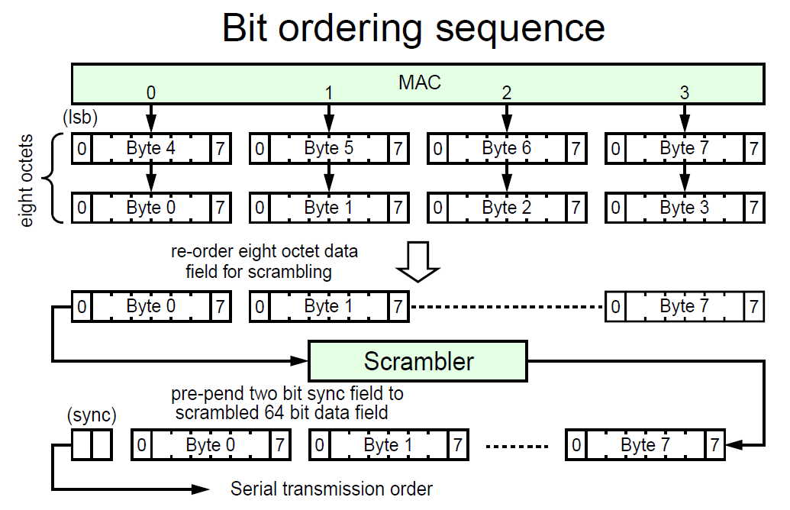
Figure 2. Transmit Bit Ordering Sequence

Block structure
Blocks consist of 66 bits. The first two bits of a block are the synchronization header (sync header). Blocks are either data blocks or control blocks. The sync header is 01 for data blocks and 10 for control blocks. Thus, there is always a transition between the first two bits of a block. The remainder of the block contains the payload. The payload is scrambled and the sync header bypasses the scrambler. Therefore, the sync header is the only position in the block that always contains a transition. This feature of the code is used to obtain block synchronization.

FEC adaptation
The FEC feature for PCS is added without bandwidth expansion. This means that the insertion of a 32-bit CRC field means some other field has to be compressed. The compression comes from the sync header. 2 bits of sync header are compressed into a single bit, thus making the compressed PCS block 65bits. This compression saves 32 bits from 32 consecutive frames. CRC-32 is appended after each block of 32x 65-bit blocks to fill that hole.
In non-FEC mode, the sync headers are used to achieve block sync. This mechanism is not available in FEC mode due to compression. In FEC mode, synchronization is achieved via CRC checks. The machine checks CRC for an arbitrary 2112-bit block. It slips the data stream by 1 bit when there is no CRC match. This process is repeated 2112 times to find the block boundary.

64B/66B Transmission Code
All 64B/66B Transmission Words consist of 66 bits. Transmission Words are either data Transmission Words or control Transmission Words. The first two bits of a Transmission Word are the synchronization header, and are set to either 01h or 10h. The remaining 64 bits of the Transmission Word are the output of a scrambler applied to the Transmission Word body. The Transmission Word body is eight bytes that represent a pair of words and/or Special Functions. See figure 10. The IEEE 802.3-2012 specification of 64B/66B references as “block payload” what this standard references as “Transmission Word body”.
Since the Transmission Word body is passed through the scrambler and the synchronization header is not passed through the scrambler, the synchronization header is the only position in the Transmission Word that always contains a transition. This feature of the code is used to obtain Transmission Word synchronization. A 64B/66B Transmission Word shall be transmitted so that each bit in the Transmission Word is transmitted before all more significant bits in the Transmission Word.
The intention is that the resulting transmitted bit sequence for Fibre Channel 64B/66B transmission coding is the same as 10GBASE-R PCS (see IEEE 802.3-2012 clause 49). IEEE 802.3-2012 uses diagramming conventions that differ from those of this standard in certain ways: Less significant bits within a byte are shown to the left of more significant bits, and bytes to be transmitted earlier are identified with less significant bits than bytes to be transmitted later. In order to provide transition from the conventions of this standard to the conventions of IEEE 802.3-2012, bit ordering designations within the 64B/66B. Transmission Word body and Transmission Word shown in this standard follow the conventions of IEEE 802.3-2012, and are different from those used by the remainder of this standard.

64B/66B scrambling
The most significant 64 bits of a 64B/66B Transmission Word is the body of the Transmission Word, which is scrambled with a self-synchronizing scrambler. For each Transmission Word body that is to be scrambled, the scrambling process shall be equivalent to this model:
- serialize the bits within the Transmission Word body so that bit 0 of the Transmission Word body is first and each remaining bit of the Transmission Word body follows all less significant bits of the Transmission Word body;
- scramble the serialized Transmission Word body as specified in IEEE 802.3-2012 subclause 49.2.6; and
- place the first bit of the scrambled output into bit 2 of the Transmission Word, and place each subsequent bit of scrambled output into a more significant bit position in the Transmission Word than any prior bit of the scrambled output.

For each Transmission Word that is to be descrambled, the descrambling process shall be equivalent to this model:
- serialize bits 2 through 65 of the Transmission Word so that bit 2 of the Transmission Word is first and each remaining bit of the Transmission Word follows all less significant bits of the Transmission Word;
- descramble the serialized Transmission Word bits as specified in IEEE 802.3-2012 subclause 49.2.10; and
- place the first bit of the descrambled output into bit 0 of the Transmission Word body, and place each subsequent bit of descrambled output into a more significant bit position in the Transmission Word body than any prior bit of the descrambled output.

The self-synchronizing scrambler/descrambler does not need to be initialized to any specific state. An implementation should not change the scrambler state or descrambler state when the port state is Active other than in accord with the specified model. If its state is modified other than in accord with the specified model, Invalid Transmission Words may be detected.

Invalid Synchronization Header
If both bits in the Synchronization Header have the same value, the Transmission Word shall cause a code violation to be reported and shall be decoded as two Idle Special Functions.

Data Transmission Words
For a Data Transmission Word, the Synchronization Header shall be set so that the least significant bit is 0 and the most significant bit is 1. A Data Transmission Word body is two successive words of FC-2M level data to transmit. Bits 0-7 of the Data Transmission Word body shall be set to the first byte to be transmitted (i.e., bits 24-31 of the first word of FC-2M level data). Subsequently higher order bytes of the Data Transmission Word body shall be set to successive bytes to be transmitted from the first word of FC-2M level data and then from the second word of FC-2M level data. See Figure 2: 64B/66B Data Transmission Word Body.

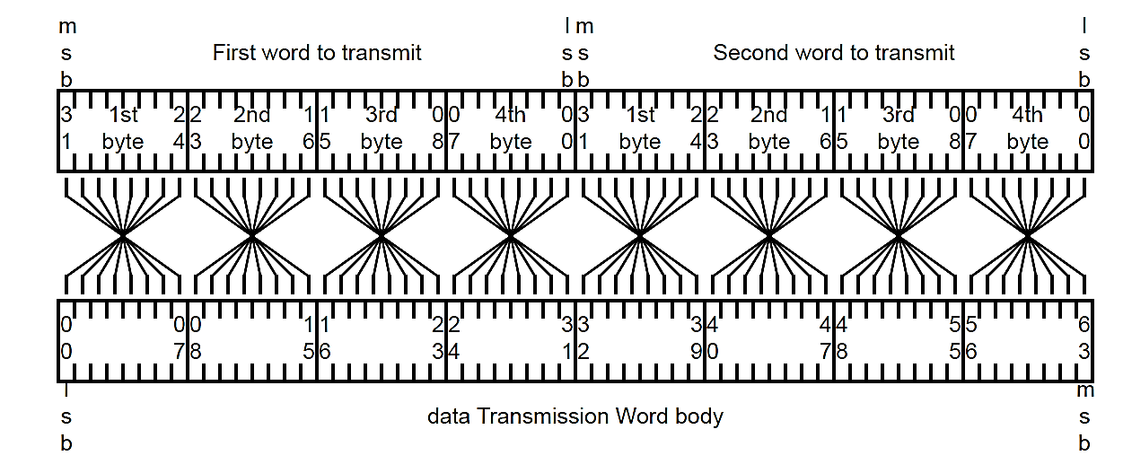
Figure 2: 64B/66B Data Transmission Word Body

Forward Error Correction (FEC)
On transmission, the FEC sublayer receives data from the PCS, transcodes 64B/66B words, performs the FEC coding/framing, scrambles and sends the data to the PMA. On reception, the FEC sublayer receives data from the PMA, performs descrambling, achieves FEC framing synchronization, decodes the FEC code, correcting data where necessary and possible, re-codes 64B/66B words, and sends the data to the PCS.

FEC Code
The FEC code used is a shortened cyclic code (2112, 2080) for error checking and forward error correction. The FEC block length is 2112 bits. The code encodes 2080 bits of payload (or information symbols) and adds 32 bits of overhead (or parity symbols). The code is systematic—meaning that the information symbols are not disturbed in anyway in the encoder and the parity symbols are added separately to the end of each block.
The (2112,2080) code is constructed by shortening the cyclic code (42987, 42955). The shortened cyclic code (2112,2080) is guaranteed to correct an error burst of up to 11 bits per block. It is a systematic code that is well suited for correction of the burst errors typical in a backplane channel (see 69.3 in 802.3-2012_section5) resulting from error propagation in the receive equalizer.

FEC Block Format
The format of the FEC block is shown in Table 2: FEC Block Format. The length of the FEC block is 2112 bits. Each FEC block contains 32 rows of 65 bits each; 64 bits of payload and 1 bit transcoding overhead (T bits). At the end of each block there is 32-bit overhead or parity check bits. Transmission is from left to right within each row and from top to bottom between rows. The payload bits carry the information symbols from the PCS layer.

T0 | 64bit Payload Word 0 | T1 | 64bit Payload Word 1 | T2 | 64bit Payload Word 2 | T3 | 64bit Payload Word 3
T4 | 64bit Payload Word 4 | T5 | 64bit Payload Word 5 | T6 | 64bit Payload Word 6 | T7 | 64bit Payload Word 7
T8 | 64bit Payload Word 8 | T9 | 64bit Payload Word 9 | T10 | 64bit Payload Word 10 | T11 | 64bit Payload Word 11
T12 | 64bit Payload Word 12 | T13 | 64bit Payload Word 13 | T14 | 64bit Payload Word 14 | T15 | 64bit Payload Word 15
T16 | 64bit Payload Word 16 | T17 | 64bit Payload Word 17 | T18 | 64bit Payload Word 18 | T19 | 64bit Payload Word 19
T20 | 64bit Payload Word 20 | T21 | 64bit Payload Word 21 | T22 | 64bit Payload Word 22 | T23 | 64bit Payload Word 23
T24 | 64bit Payload Word 24 | T25 | 64bit Payload Word 25 | T26 | 64bit Payload Word 26 | T27 | 64bit Payload Word 27
T28 | 64bit Payload Word 28 | T29 | 64bit Payload Word 29 | T30 | 64bit Payload Word 30 | T31 | 64bit Payload Word 31
32 parity bits
Table 2: FEC Block Format

Total FEC block length = (32 × 65) + 32 = 2112 bits

Composition of the FEC block
The FEC sublayer does not decrease the symbol rate of the PCS, nor does it increase the signaling rate of the PMD sublayer. Instead, the FEC sublayer compresses the sync bits from the 64B/66B encoded data provided by the PCS to accommodate the addition of 32 parity check bits for every block of 2080 bits.
The BASE-R 64B/66B PCS maps 64 bits of scrambled payload and 2 bits of unscrambled sync header into 66-bit encoded blocks. The 2-bit sync header allows establishment of 64B/66B block boundaries by the PCS sync process. The sync header is 01 for data blocks and 10 for control blocks; the sync header is the only position in the PCS block that always contain a transition and this feature of the code is used to establish 64B/66B block boundaries.
The FEC sublayer compresses the 2 bits of the sync header to 1 transcode bit. The transcode bit carries the state of BASE-R sync bits for the associated payload. This is achieved by eliminating the first bit in 64B/66B block, which is also the first sync bit, and preserving the second bit. The value of the second bit defines the value of the removed first bit uniquely, since it is always an inversion of the first bit. The transcode bits are further scrambled (as explained in Chapter 10.2) to ensure DC balance.
The 32 sequential 64B/66B blocks are transcoded in this fashion, and then 32 bits of FEC parity are computed for them. The 32 transcoded words and the 32 FEC parity bits constitute an FEC block.
The error detection property of the FEC cyclic code is used to establish block synchronization at FEC block boundaries at the receiver. If decoding passes successfully, the FEC decoder produces 32 65-bit words, the first decoded bit of each word being the transcode bit. Then the first sync bit in 64B/66B code is constructed by the inversion of the transcode bit, and the value of the second sync bit is equal to the transcode bit.

FEC (2112,2080) encoder
The block diagram of the FEC Encoder is illustrated in Figure 3: FEC Encoding Block Diagram. The 32 ⋅ 65-bit payload blocks are encoded by the (2112, 2080) code. This code is a shortened cyclic code that can be encoded by generator polynomial g(x). The FEC block is scrambled using the PN-2112 pseudo-noise sequence.
The generator polynomial g(x) for the (2112, 2080) parity-check bits is defined as given in Equation
$$g\left(x\right)= x^{32}+x^{23}+x^{11}+x^{2}+1$$
If the polynomial representation of information bits is m(x), the codeword c(x) can be calculated in systematic form as given in
$$p\left(x\right)=x^{32}*m\left(x\right) mod g(x)$$
$$c\left(x\right)=p\left(x\right)+x^{32}*m\left(x\right)$$
Figure 3: FEC Encoding Block Diagram

PN-2112 Pseudo-noise Sequence Generator
PN-2112 is a pseudo-noise sequence of length 2112 generated by the polynomial r(x), which is equal to the scrambler polynomial defined in Chapter 14.0 with initial state S57 = 1, Si–1 = Si XOR 1 or simply the binary sequence of 101010…. . Before each FEC block processing (encoding or decoding) the PN-2112 generator is initialized with this state. The PN-2112 generator shall produce the same result as the implementation shown in Figure 4: PN-2112 Generator. This implements the PN-2112 generator polynomial given in Equation
$$r\left(x\right)=1+x^{39}+x^{58}$$
Figure 4: PN-2112 Generator

Scrambling with the PN-2112 sequence at the FEC codeword boundary is necessary for establishing FEC block synchronization (to ensure that any shifted input bit sequence is not equal to another FEC codeword) and to ensure DC balance.

FEC (2112,2080) Decoding
The FEC decoding function block diagram is shown in Figure 5: (2112, 2080) Decoding. The decoder processes the 16-bit rx_data-group stream received from the PMA sublayer and descrambles the data using the PN-2112 pseudo-noise sequence.
Figure 5: (2112, 2080) Decoding

The synchronization of the 2112 bit FEC block is established using FEC decoding as described in Chapter 10.8. Each of the 32 65-bit data words is extracted from the recovered FEC block and the 2-bit sync is reconstructed for the 64B/66B codes from the transcode bit as shown in Figure 6: FEC Receive Bit Ordering. The FEC decoder provides an option to indicate decoding errors in the reconstructed sync bits. The sync bits {SH.0, SH.1} take the value as described in the following:
- If decoding is successful (by either the parity match or the FEC block is correctable) and the descrambled received transcode bit (T) is 1 then the sync bits take a value of {SH.0,SH.1} = 01 or if the descrambled received transcode bit (T) is 0 then the sync bits take a value of {SH.0,SH.1} = 10.
- If the variable FEC_Enable_Error_to_PCS is set to 1 to indicate error to PCS layer and the received FEC block has uncorrectable errors then the sync bits for the 1st, 9th, 17th, 25th, and 32nd of the 32 decoded 64B/66B blocks take a value of {SH.0,SH.1} = 11 for the 10GBASE-R PHY. The sync bits for all other 64B/66B blocks take a value as described in item a) above.
- If the variable FEC_Enable_Error_to_PCS is set to 0 and the received FEC block has uncorrectable errors then the sync bits take a value as described in item a) above. This information corresponds to one complete (2112,2080) FEC block that is equal to 32 64B/66B code blocks.
This information corresponds to one complete (2112,2080) FEC block that is equal to 32 64B/66B code blocks.
The FEC code (2112, 2080) and its performance is specified in Chapter 10.1. The FEC (2112,2080) decoder implementations shall be able to correct up to a minimum of 11-bit burst errors per FEC block.

FEC receive bit ordering
The format of the FEC block and the receive bit ordering is shown in Figure 6: FEC Receive Bit Ordering.
Figure 6: FEC Receive Bit Ordering

FEC block synchronization
The receive synchronization of FEC blocks is illustrated by FEC Lock state diagram in Figure 7: FEC Lock State Diagram.
Receive FEC block synchronization is achieved using conventional n/m serial locking techniques as described as follows:
- Test a potential candidate block start position
  - Descramble block using PN-2112 Generator per Chapter 10.5
  - Evaluate parity for the potential block
- If the parity does not match (i.e., the received parity does not match the computed parity), shift candidate start by one bit position and try again.
- Validate potential block start position has good parity for “n” consecutive blocks
  - If any of them fail shift candidate start one bit position and start again
  - If “n” consecutive blocks are received with good parity, report Block Sync
- Block Sync is established.
- If “m” consecutive blocks are received with bad parity, drop Block Sync and restart again at item a).
The procedure is repeated at most 2111 times for all bits positions in the 2112 codeword. The values for m and n are as follows: m = 8 and n = 4.

State diagrams
The FEC sublayer shall implement the FEC Lock state diagram shown in Figure 7: FEC Lock State Diagram, including compliance with the associated state variables as specified. The FEC Lock state diagram determines when the receiver has obtained FEC block lock on the received data stream.

Figure 7: FEC Lock State Diagram

64B/66B Transmission Word synchronization
64B/66B Transmission Word synchronization state shall be maintained as specified by the Lock state machine and the BER monitor state machine of the Physical Coding Sublayer (PCS) for 64B/66B, type 10GBASE-R (see subclause 49.2.13 of IEEE 802.3-2012):
If the block_lock flag of the Lock state machine is TRUE, the hi_ber flag of the BER monitor state machine is FALSE, and the receiver is not indicating Loss-of-Signal, the receiver Transmission Word synchronization state shall be Word Synchronization Acquired; and
If the block_lock flag of the Lock state machine is FALSE, the hi_ber flag of the BER monitor state machine is TRUE, or the receiver is indicating Loss-of-Signal, the receiver Transmission Word synchronization state shall be Loss of Synchronization.
If a receiver is decoding 64B/66B that has been further encoded with FEC (see 64B/66B Transmission Code), loss of FEC block synchronization (see subclause 74.10 of IEEE 802.3-2012) is indicated by the value of the fec_signal_ok variable of the FEC block synchronization state machine. A value of FALSE for the fec_signal_ok variable of the FEC block synchronization state machine shall be treated as a Loss-of-Signal indication by the receiver.
The Lock state machine relies on the property of the 64B/66B Transmission code that a bit value transition is always encoded between the two least significant bits of a Transmission Word, and because of scrambling is unlikely to occur consistently at any other 66-bit period in the encoded bit stream.
Other than loss of bit synchronization, signal conditions (e.g., code violation detection) detected between expected synchronization headers do not affect the receiver Transmission Word synchronization state during use of the 64B/66B transmission code.
If the link speed negotiation algorithm is performed using 64B/66B, then the pass sync_test count shall be 1 000.

Transmitter Training Signal Transmission Word synchronization
Transmitter Training Signal Transmission Word synchronization state shall be maintained as specified by the Frame lock state machine of the Physical Medium Dependent Sublayer and Baseband Medium, Type 10GBASE-KR (see subclause 72.6.10.4.1 of IEEE 802.3-2012), except that the condition for entry to the state machine is that the FC_Port initiates use of the Transmitter Training Signal. The training variable of the 10GBASE-KR Frame lock state machine shall be ignored:
If the frame_lock variable of the 10GBASE-KR Frame lock state machine is set to one and the receiver is not indicating Loss-of-Signal, the receiver Transmission Word synchronization state shall be Word Synchronization Acquired; and
If the frame_lock variable of the 10GBASE-KR Frame lock state machine is set to zero or the receiver is indicating Loss-of-Signal, the receiver Transmission Word synchronization state shall be Loss of Synchronization.
Transmitter Training Signal Transmission Word synchronization relies on the properties of the Transmitter Training Signal that:
- each Transmission Word begins with a 32 TUI frame marker pattern that appears nowhere else in any Transmission Word; and
- each Transmission Word ends with the physical medium being held at its zero state for two TUI. Other than an indication of Loss-of-Signal, the signal between expected frame markers shall not affect Transmitter Training Signal Transmission Word synchronization state.
- If the link speed negotiation algorithm (see 8.6) is performed using Transmitter Training Signal, then the pass sync_test count shall be 300.

Scrambler
The scrambler operates in frame synchronous mode and self-synchronous mode. Frame synchronous mode operates in Interlaken configurations. Self-synchronous mode operates as specified in IEEE 802.3-2008 clause-49.

The scrambler uses the polynomial:
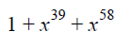
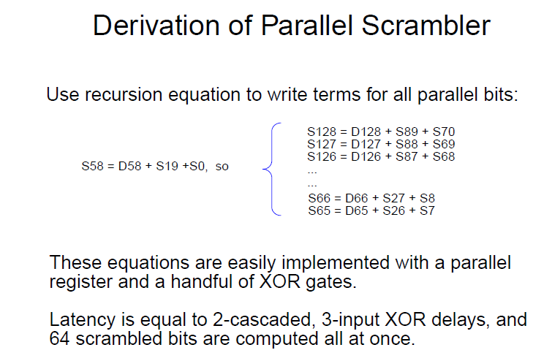

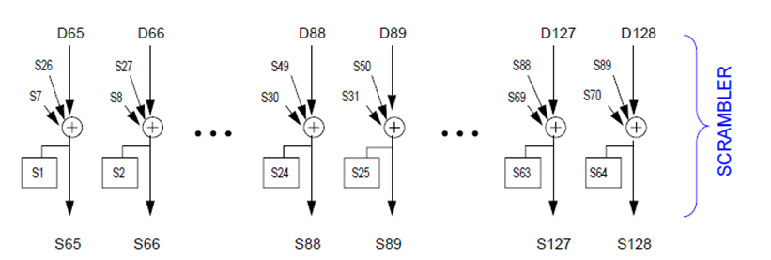

Block Synchronizer
The frame sync is acquired after 64 contiguous frames have been received with valid “01” or “10” sync headers. The block synchronizer determines the block boundary of a 66-bit word. The incoming data stream is slipped one bit at a time until a valid synchronization header (bits 65 and 66) is detected in the received data stream. After the predefined number of synchronization headers (as required by the protocol specification) is detected, the block synchronizer asserts the status signal to other receiver PCS blocks down the receiver datapath and to the FPGA fabric.
The block synchronizer is designed in accordance with IEEE 802.3-2008 clause-49.

When the receive channel is operating in normal mode, the block synchronization function receives data via 16-bit PMA_UNITDATA.request primitives. It shall form a bit stream from the primitives by concatenating requests with the bits of each primitive in order from rx_data-group[0] to rx_data-group[15] . It obtains lock to the 66-bit blocks in the bit stream using the sync headers and outputs 66-bit blocks. Lock is obtained as specified in the block lock state diagram shown in following figure.

Blocks consist of 66 bits. The first two bits of a block are the synchronization header (sync header). Blocks are either data blocks or control blocks. The sync header is 01 for data blocks and 10 for control blocks. Thus, there is always a transition between the first two bits of a block. The remainder of the block contains the payload. Therefore, the sync header is the only position in the block that always contains a transition. This feature of the code is used to obtain block synchronization.

The following Lock state diagram determines when the PCS has obtained lock to the received data stream.

Sync Header count Logic
sh_cnt is the number of sync headers within the current 64-block window sh_invalid_cnt is the number of invalid sync headers within the current 64-block window

sh_valid is set to '1' if received block rx_coded has valid sync header bits. That is, sh_valid is asserted if rx_coded[0] is not equal to rx_coded[1] and de-asserted otherwise test_sh is set when a new sync header is available for testing and false when TEST_SH state is entered. A new sync header is available for testing when the Block Sync process has accumulated enough bits from the PMA or the WIS to evaluate the header of the next block

slip_done is asserted when the SLIP requested by the Block Lock state diagram has been completed indicating that the next candidate block sync position can be tested

sh_valid: Boolean indication that is set true if received block rx_coded has valid sync header bits. That is, sh_valid is asserted if rx_coded[0] ≠ rx_coded[1] and de-asserted otherwise.

signal_ok : Boolean variable that is set based on the most recently received value of PMA_UNITDATA.indication(SIGNAL_OK). It is true if the value was OK and false if the value was FAIL.

slip_done: Boolean variable that is asserted true when the SLIP requested by the Block Lock state diagram has been completed indicating that the next candidate block sync position can be tested.

SLIP: Causes the next candidate block sync position to be tested. The precise method for determining the next candidate block sync position is not specified and is implementation dependent. However, an implementation shall ensure that all possible bit positions are evaluated.

sh_cnt: Count of the number of sync headers checked within the current 64 block window.

sh_invalid_cnt: Count of the number of invalid sync headers within the current 64 block window.

UCT (Unconditional Transition) is a special boolean variable which always has a TRUE value

Descrambler
The descrambler processes the payload to reverse the effect of the scrambler using the same polynomial.
The descrambler descrambles data per the protocol specifications supported by the 10G PCS. The descrambler operates either in frame synchronous or self-synchronous mode.

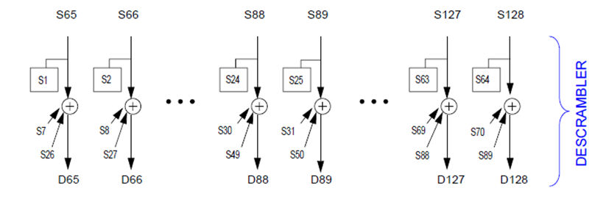

Timing diagrams
Tools used : Questa Sim (version 10.1b)
command : vsim –v <file_name>

The receive side (RX, decoder) side timing diagram is here :
Name: vsim.wlf
URL: http://vi-bugs/svn/pld/trunk/projects/bali/fc1_layer_kr/rtl/decoder/sim/vsim.wlf
Repository Root: http://vi-bugs/svn/pld

The transmit side (TX, encoder) side timing diagram is here :
Name: vsim.wlf
URL: http://vi-bugs/svn/pld/trunk/projects/bali/fc1_layer_kr/rtl/encoder/sim/vsim.wlf
Repository Root: http://vi-bugs/svn/pld

References

IEEE 802.3-2008
T11/2238-D

Review Minutes

Review 1
Reviewed version : 0.1
Reviewer : Tim Beyers
Date : 10/30/2013
Action Items :
- Modify block diagram to reflect current design
- Add per-block description
- Add functional timing diagram.
Results :
Done

Review 2
Reviewed version : 0.2
Reviewer : Chi-wei Fu, Gene Shen, Jaedon Kim, Honda Yang, Janani Nagarajan
Date : 11/1/2013
Action Items :
- Add bit inversion control on PMA interface.
- Remove sections on PCS encoder and PCS decoder, since they are not a part of the design.
Results :
Done.
Sections on PCS encoder and decoder are remove from this document.
Bit inversion support is added to RTL. The following files are changed.
Sending rtl/build/fc1_kr.qsf
Sending rtl/decoder/bit_slip/bit_slip.jv.double
Sending rtl/decoder/bit_slip/bit_slip.jv.single
Sending rtl/decoder/bit_slip/bit_slip.v
Sending rtl/decoder/decoder.v
Sending rtl/encoder/encoder.v
Sending rtl/encoder/pcs_out_sel/pcs_out_sel.v
Sending rtl/fc1_kr.v
Transmitting file data ........
Committed revision 3792.

