**FIN 557 Project Report**

**Impact of Covid on Bankruptcy**

**Group17:** Jason Chang Chien, Wei-Yu Chen, Ching-Che Chi, Pranav Ganapathy Subramanian, Gamanash Kommineni, Ana Telia, Sabelo Zwane

**Problem Statement**

1. Analyzing the financial data from WRDS during the FY 2017-2023 to assess the impact of COVID on bankruptcy
2. Analyzing z-score to evaluate its performance for predicting the bankruptcy

**Introduction**

In this analysis, we will be examining the impact of the COVID-19 pandemic on the bankruptcy of firms in the United States for the years 2017 to 2023. Specifically, we will be looking at which states have been the most affected by COVID-19 in terms of bankruptcy rates and which industries have been hit the hardest. By analyzing this data, we hope to gain a better understanding of the long-term economic effects of the pandemic and how it has affected different sectors of the economy in different regions of the country. We are also calculating a metric called Z-Score using the required variables and checking how precise the Z-Score value is indicating whether a company is safe or on-alert.

**Data sets and sources**

* **Data1 - Bankruptcy data (WRDS)**:

<https://wrds-www.wharton.upenn.edu/pages/get-data/audit-analytics/corporate-legal/bankruptcy-notification/?no_login_redirect=True>

* **Data2 - Financial Statements (WRDS):**<https://wrds-www.wharton.upenn.edu/pages/get-data/compustat-capital-iq-standard-poors/compustat/north-america-daily/fundamentals-annual/>
* **Data3 - Share Price and Shares Outstanding (WRDS):**

<https://wrds-www.wharton.upenn.edu/pages/get-data/center-research-security-prices-crsp/annual-update/stock-security-files/daily-stock-file/>

**Methodology**

We use SAS studio for our analysis, R for regression analysis and since the data was downloaded from WRDS in SAS format, no preprocessing was necessary. The data was analyzed by year, industry and state.

**Problem Statement I**

1. **Total Bankruptcy count for each year from 2017-2023:**

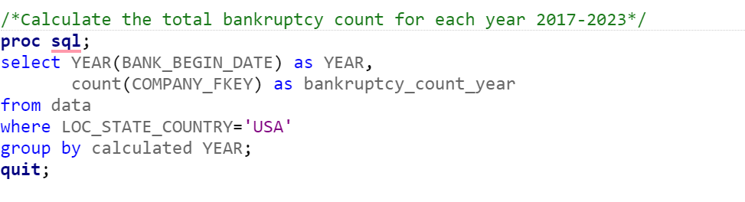

| **YEAR_bankrupted** | **bankruptcy_count_year** |
| --- | --- |
| 2017 | 52 |
| 2018 | 38 |
| 2019 | 54 |
| 2020 | 83 |
| 2021 | 19 |
| 2022 | 25 |
| 2023 | 7 |

In this code, we use the PROC SQL procedure to perform a SQL query on the data table where we have the bankruptcy data. We use the COUNT function to count the number of distinct company key values in the table that meet the condition specified in the WHERE clause: specifically, we only count firms that filed for bankruptcy in the USA. We give the resulting count an alias of bankruptcy_count_year using the AS keyword. Finally, we end the query with the QUIT statement.

From the output, it is clear that during Covid more number of firms filed for bankruptcy as we hypothesized.

1. **Calculate the bankruptcy count for each SIC each year from 2017-2023:**

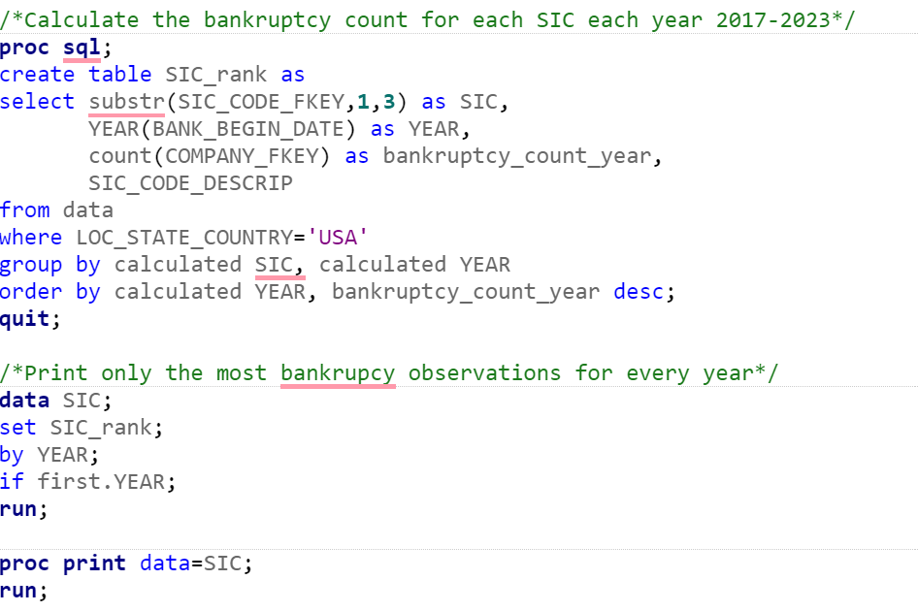

| **Obs** | **SIC** | **YEAR_bankrupted** | **bankruptcy_count_year** | **SIC_CODE_DESCRIP** |
| --- | --- | --- | --- | --- |
| **1** | 131 | 2017 | 4 | Crude Petroleum and Natural Gas |
| **2** | 131 | 2018 | 9 | Crude Petroleum and Natural Gas |
| **3** | 131 | 2019 | 11 | Crude Petroleum and Natural Gas |
| **4** | 131 | 2020 | 15 | Crude Petroleum and Natural Gas |
| **5** | 590 | 2021 | 4 | Retail-Miscellaneous Retail |
| **6** | 283 | 2022 | 6 | Pharmaceutical Preparations |
| **7** | 283 | 2023 | 2 | Biological Products, Except Diagnostic Substances |

Overall, this SAS code performs data aggregation, filtering, and sorting operations to extract meaningful insights about what kind of industries were impact during covid from the input data set.

1. **Calculate which state has highest bankruptcy percentage for each year from 2017-2023 :**

| **Obs** | **State** | **YEAR_bankrupted** | **bankruptcy_count_state** | **bankruptcy_count_year** | **bankruptcy_pct** |
| --- | --- | --- | --- | --- | --- |
| **1** | TX | 2017 | 15 | 52 | 28.85% |
| **2** | TX | 2018 | 9 | 38 | 23.68% |
| **3** | TX | 2019 | 19 | 54 | 35.19% |
| **4** | TX | 2020 | 27 | 83 | 32.53% |
| **5** | MO | 2021 | 4 | 19 | 21.05% |
| **6** | CA | 2022 | 5 | 25 | 20.00% |
| **7** | CA | 2023 | 2 | 7 | 28.57% |

**Results:**

* 2017 to 2020: Texas was the most impacted state, which accounted for about 24% to 35%
* 2021: Missouri was the most impacted state, which accounted for 21%
* 2022 to 2023: California was the most impacted state, which accounted for 29%

1. **Calculate percentage of number of firms bankrupt to total number of firm percentage for year 2020:**

| **State/Province** | **Data Year - Fiscal** | **Frequency Count** | **Ratio_firm_bankrupt_pct** |
| --- | --- | --- | --- |
| OK | 2020 | 4 | 5.6 |
| TN | 2020 | 4 | 4.4 |
| NV | 2020 | 4 | 4.4 |
| TX | 2020 | 27 | 4.1 |
| LA | 2020 | 1 | 2.3 |
| CO | 2020 | 5 | 2.3 |
| FL | 2020 | 7 | 2.1 |
| WI | 2020 | 2 | 1.9 |
| OH | 2020 | 3 | 1.5 |
| NJ | 2020 | 3 | 1.1 |
| MO | 2020 | 1 | 1.1 |
| AZ | 2020 | 1 | 0.9 |
| CT | 2020 | 1 | 0.7 |
| NC | 2020 | 1 | 0.7 |
| PA | 2020 | 2 | 0.5 |
| NY | 2020 | 7 | 0.5 |
| VA | 2020 | 1 | 0.5 |
| CA | 2020 | 7 | 0.4 |
| IL | 2020 | 2 | 0.2 |

**Results:**

* For 2020, Texas not only has the greatest percentage of corporations that filed for bankruptcy but also the ratio of companies that went bankrupt to the total number of companies is among top 5 within the country ( 4.1% of publicly traded companies with in texas)

1. **Linear regression between COVID-19 and bankruptcy by State in 2020**

In this part, we export the SAS state_bank table which we created in the previous section, then we select the number of bankruptcy which YEAR equals to 2020 and add a new variable called Covid_case which is the number of COVID-19 cases in each state in 2020 from CDC official website.

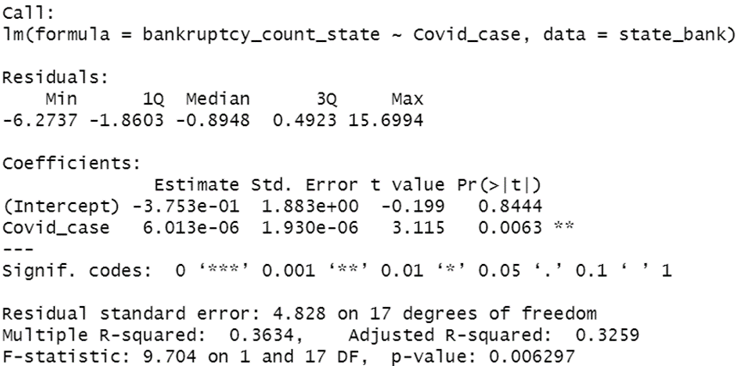

We run the linear regression to analyze the relationship between the number of COVID-19 cases in each state in 2020 and the number of bankruptcy cases in each state in 2020. The result shows that the p-value for the Covid_case variable is 0.0063, suggesting that there is a strong evidence of statistically significant relationship between COVID-19 cases and bankruptcy cases.

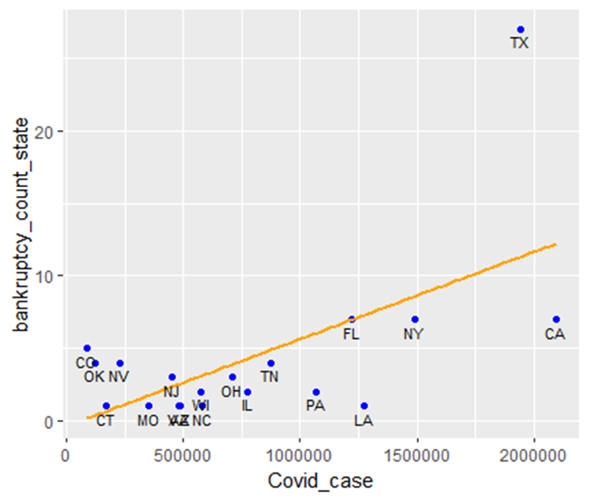

In this scatter plot, we found that there is a positive relationship between COVID-19 cases and bankruptcy number in each state. As the number of Covid cases increases in a state, the number of firms that went bankrupt also tends to increase.

**Problem Statement II**

In this part, we have to evaluate the performance of the Z-score. Z-score is a weighted average accounting ratios showed as following:

Z-Score = A x 3.3 + B x 0.99 + C x 0.6 + D x 1.2 + E x 1.4

Where,

• A=EBIT/Total Assets

• B=Net Sales /Total Assets

• C=Market Value of Equity / Total Liabilities

• D=Working Capital/Total Assets

• E=Retained Earnings /Total Assets

**Preparation for Z-score calculation**

To calculate the Z-score for each company, we need the above variables.

1. First, we have to merge the financial data with bankruptcy data. We use the bankruptcy data (data) as the left table to join the financial statement data (data2) as the right table to perform a left join, while using Ticker as the key for two tables. The merged table is named “merge”.

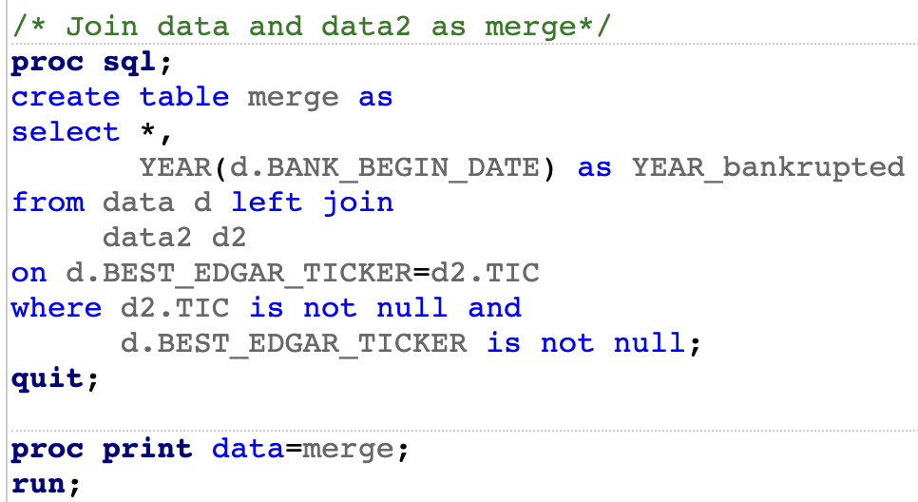

1. Second, to calculate the C in Z-score which is Market Value of Equity / Total Liabilities. We have to extract the data from data3 and calculate the market value of equity (share price * shares outstanding). We averaged the monthly share price and shares outstanding to use as the annual data. Furthermore, we perform a proc sort procedure to eliminate duplicate rows. The final table is named “market2”.
2. Based on the two tables, we then merge the “Merge” table with “Market2” table. We use “Market2” as the left table to join the “Merge” as the right table to perform a left join, while using Ticker and Year as the keys for two tables. The merged table is named “merge2”.

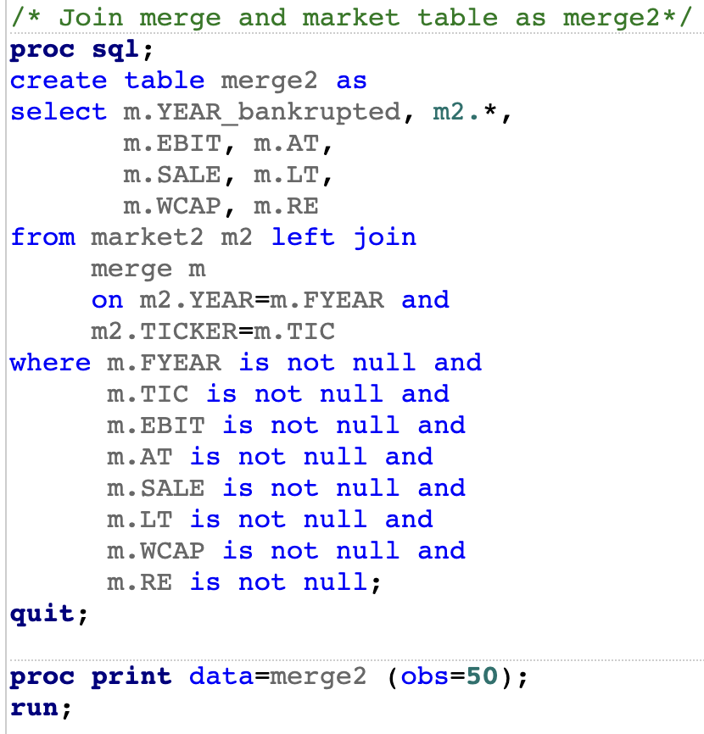

The output table merge2:

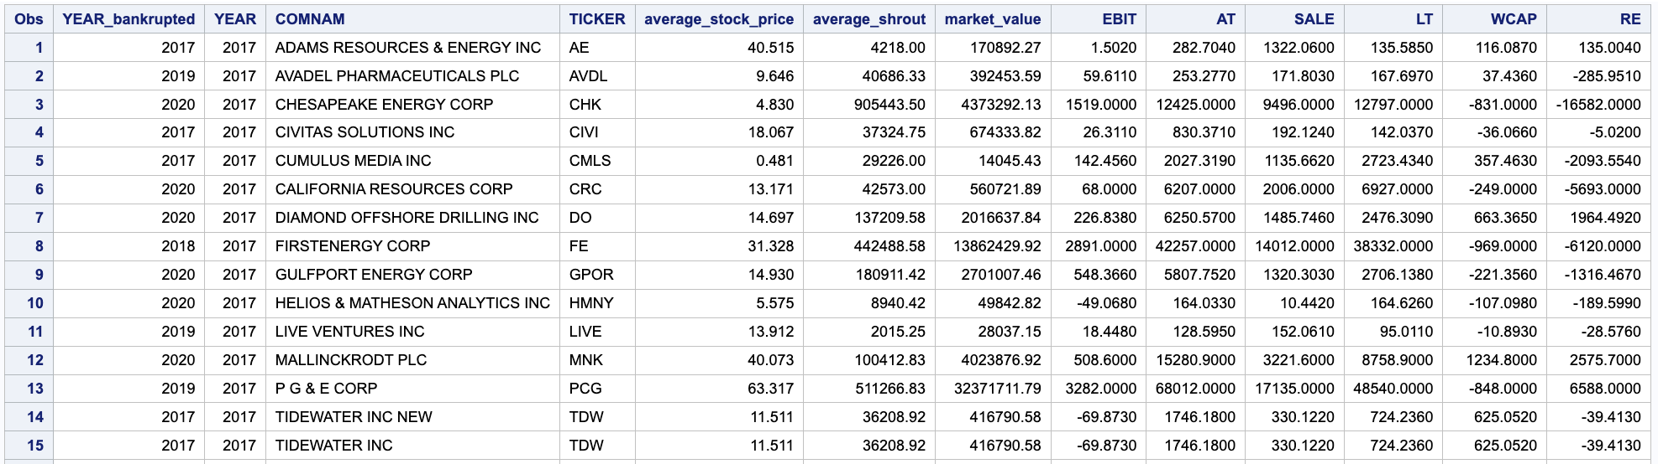

Consequently, we derive the variables that are needed when calculating the Z-score (A,B,C,D,E) from the table.

**Z-score Calculation and Evaluation**

After collecting the necessary data, we created and calculated Variables needed for the Z-score. We created a new table zscore including the following Variables: EBIT/AT, SALE/AT, market value/LT/1000, WCAP/LT and RE/AT. We calculated Z score and stored the outcome in a new table called zscore2. We ordered the result by Ticker and Year.

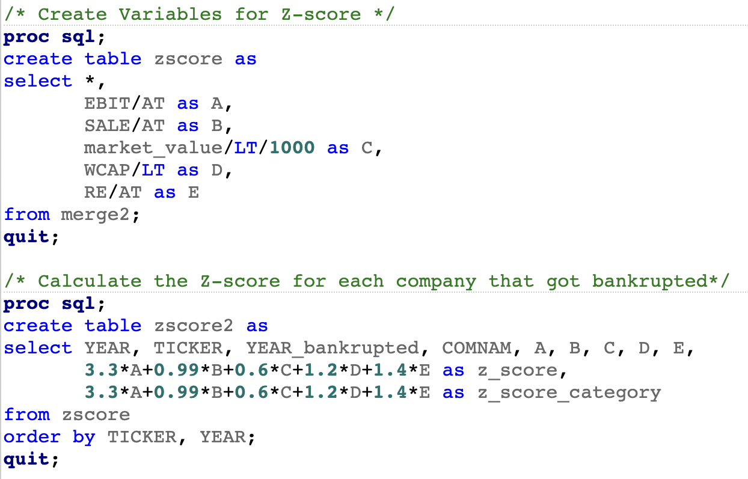

We created a format zscorefmt to assign descriptions accordingly.

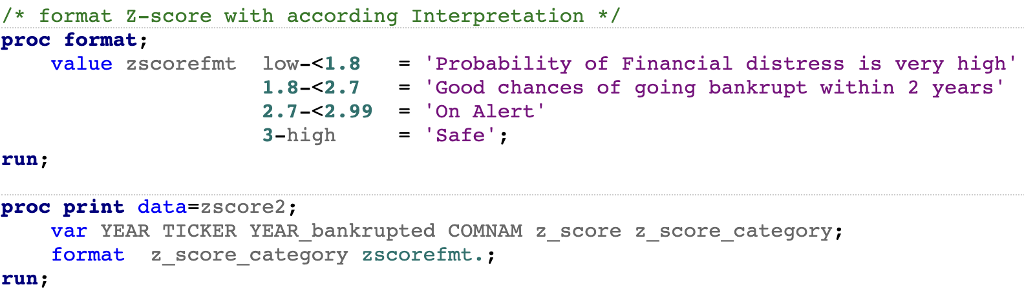

Finally, we created a table zscore3 and checked if the Z-score prediction was consistent with reality in the year the firms went bankrupt. We filtered the year of bankruptcy using having YEAR=YEAR_bankrupted option.

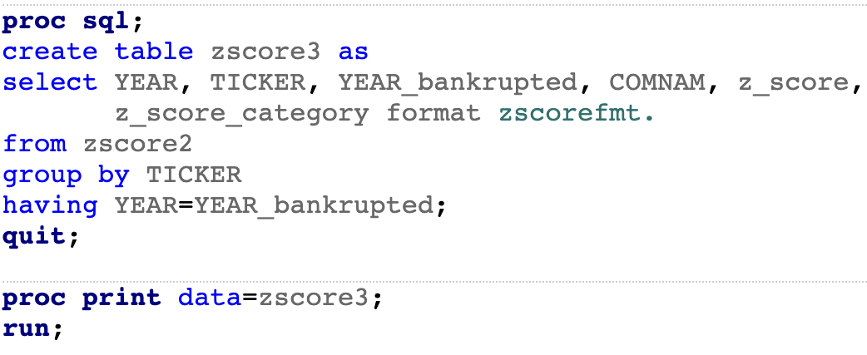

| **Obs** | **YEAR** | **TICKER** | **YEAR_bankrupted** | **COMNAM** | **z_score** | **z_score_category** |
| --- | --- | --- | --- | --- | --- | --- |
| **1** | 2017 | AE | 2017 | ADAMS RESOURCES & ENERGY INC | 7.09949 | Safe |
| **2** | 2019 | AVDL | 2019 | AVADEL PHARMACEUTICALS PLC | -3.03505 | Probability of Financial distress is very high |
| **3** | 2020 | CHK | 2020 | CHESAPEAKE ENERGY CORP | -8.45721 | Probability of Financial distress is very high |
| **4** | 2017 | CIVI | 2017 | CIVITAS SOLUTIONS INC | 2.86901 | On Alert |
| **5** | 2017 | CMLS | 2017 | CUMULUS MEDIA INC | -0.49868 | Probability of Financial distress is very high |
| **6** | 2020 | CRC | 2020 | CALIFORNIA RESOURCES CORP | -1.43959 | Probability of Financial distress is very high |
| **7** | 2020 | DEN | 2020 | DENBURY INC | -0.88550 | Probability of Financial distress is very high |
| **8** | 2020 | DO | 2020 | DIAMOND OFFSHORE DRILLING INC | 0.25051 | Probability of Financial distress is very high |
| **9** | 2018 | FE | 2018 | FIRSTENERGY CORP | 0.56245 | Probability of Financial distress is very high |
| **10** | 2020 | GPOR | 2020 | GULFPORT ENERGY CORP | -3.88882 | Probability of Financial distress is very high |
| **11** | 2020 | GTX | 2020 | GARRETT MOTION INC | 0.30203 | Probability of Financial distress is very high |
| **12** | 2019 | LIVE | 2019 | LIVE VENTURES INC | 1.71266 | Probability of Financial distress is very high |
| **13** | 2020 | MNK | 2020 | MALLINCKRODT PLC | -0.31351 | Probability of Financial distress is very high |
| **14** | 2019 | PCG | 2019 | P G & E CORP | 0.27611 | Probability of Financial distress is very high |
| **15** | 2017 | TDW | 2017 | TIDEWATER INC | 1.40447 | Probability of Financial distress is very high |
| **16** | 2017 | TDW | 2017 | TIDEWATER INC NEW | 1.40447 | Probability of Financial distress is very high |
| **17** | 2019 | TPX | 2019 | TEMPUR SEALY INTERNATIONAL INC | 3.07852 | Safe |
| **18** | 2019 | TREE | 2019 | LENDINGTREE INC | 5.33972 | Safe |
| **19** | 2020 | TT | 2020 | TRANE TECHNOLOGIES PLC | 3.22398 | Safe |
| **20** | 2020 | VAL | 2020 | VALARIS PLC | -0.41223 | Probability of Financial distress is very high |
| **21** | 2020 | WLL | 2020 | WHITING PETROLEUM CORP NEW | -6.28725 | Probability of Financial distress is very high |

**Conclusion**

After processing and analyzing the datasets, we conclude that Covid-19 had a negative impact on firm performance and pandemics have increased the number of firms, which have declared bankruptcy. This result is consistent with our expectations. We found out that the industry impacted the most was the Crude Petroleum and Natural Gas industries. Furthermore, we conclude that Texas was the state impacted the most heavily. In order to straighten our argument, that the number of bankruptcies has increased due to the pandemics, we have checked the correlation between the total number of Covid-19 cases in 2020 and the number of bankruptcies and found out that there is a significant positive relation. Moreover, Texas is a clear outlier. Furthermore, we have calculated the ratio of bankrupt firms to the total number of firms in each state, which shows that for instance in Texas 4.1% of all publicly traded companies went bankrupt in 2020.

In the second part of our analysis, we have estimated the Z-score for firms, which went bankrupt. We have concentrated on the year of bankruptcy of each firm and checked what was the status of these firms according to the Z-score in the year the firms went bankrupt. According to our analysis, Z-score is consistent with the reality in 16 out of 21. In 1 case it is close to consistency and in 4 cases the Z-score is deviating from reality. Since the sample size is small we can not estimate statistically how precise the Z-score is. However, we believe Z-score performs quite well.