Quick Intro to xlcdapp (笑裡藏道)

(Xiao Li Cang Dao App)

How to Access xlcdapp?
Currently, xlcdapp (笑裡藏道) (Xiao Li Cang Dao App) is only a prototype and it can only be accessed via the temporary website as below:
網址(暫時): https://xlcdapp.web.app

Instead of accessing the above website each time launching xlcdapp, you can save the link on your Home Screen (smartphone) or Desktop (computer). Here are the simple steps to save it:
- From the browser, access the link of xlcdapp.
- Click the button with the red circle as the screenshot below.
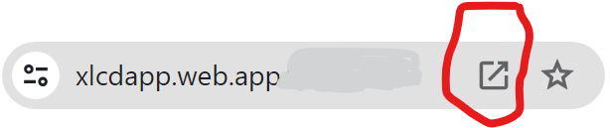
- Then follow the instructions and save it on the Home Screen (smartphone) or Desktop (computer). You’ll see an icon as below is saved. From now on, you can double-click it to launch xlcdapp.


Sign In xlcdapp (笑裡藏道)
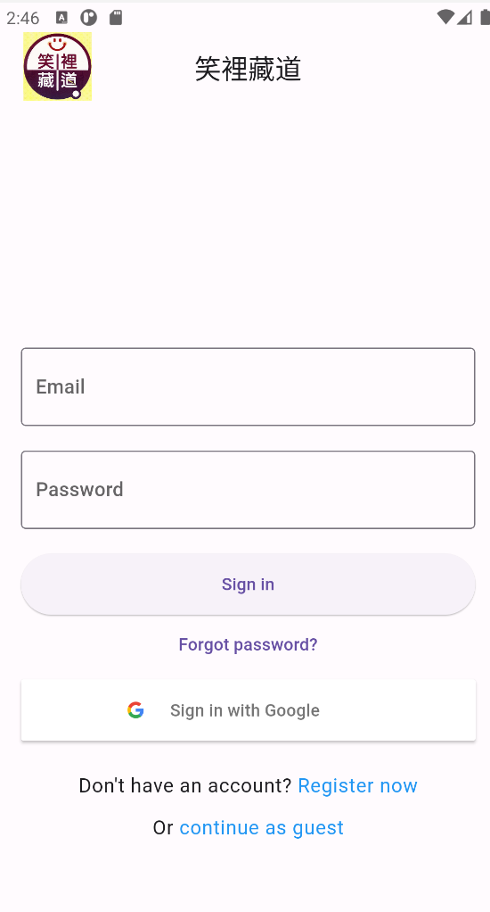
There are several ways to sign in xlcdapp (笑裡藏道):
- As a xlcdapp (笑裡藏道) guest.
  - Click “continue as guest” to sign in.
- As a registered xlcdapp (笑裡藏道) user.
  - If you are a registered user, you can use your email and password to sign in.
  - If you are not a registered user yet, you can click “Register now” and enter your email and password to register first and then come back to sign in with your user information.
- As an existing Google user.
  - If you are a Google user, you can click “Sign in with Google” to sign in.
  - If you are not a Google user yet, you can sign up as a Google user first and then come back to sign in with your Google user information.

笑裡藏道頁面
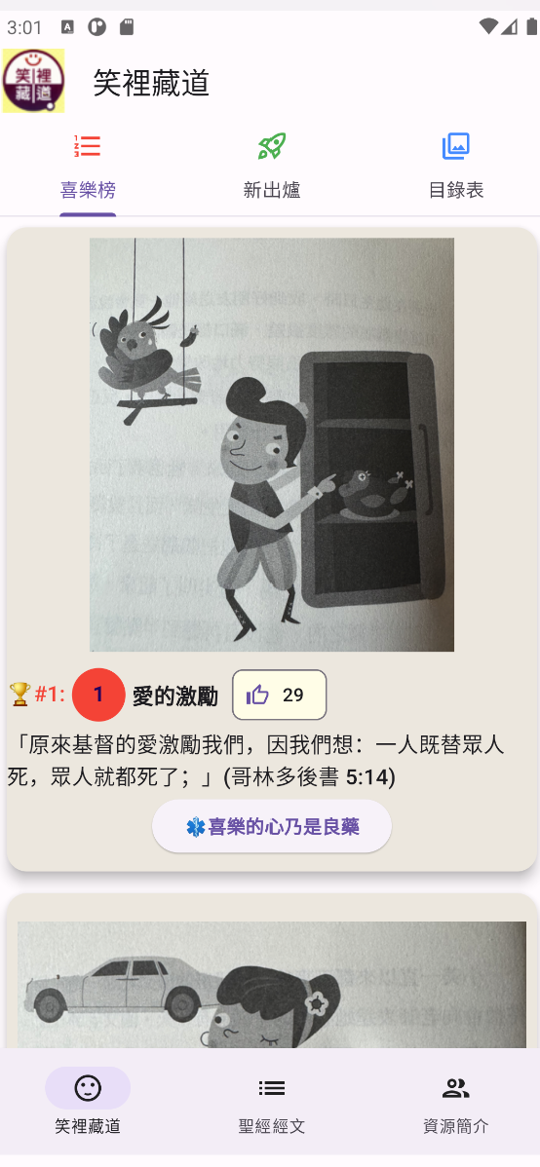

- 喜樂榜: list the top 10 articles
- 新出爐: list the newly added articles
- 珍藏品: list the entire collection of articles

聖經經文頁面
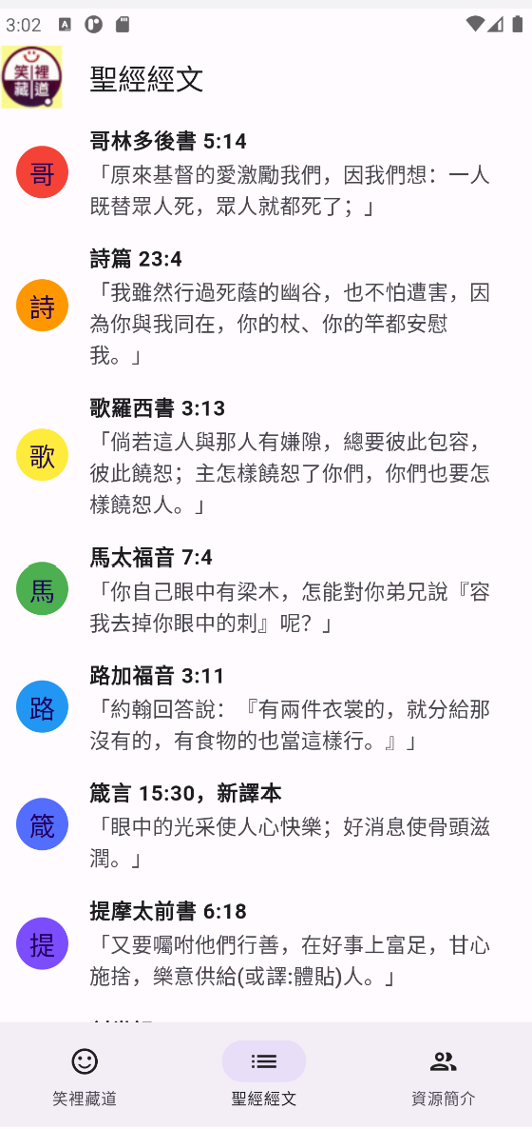

- List the entire Bible verses referenced in the articles.

資源簡介頁面

- Scan xlcdapp’s 二維碼 (QR Code) to conveniently access xlcdapp.


- Contains a list of cards to introduce the resources:
  - Introduction to the book of笑裡藏道 and a link to River Bank (靈糧書房) for making the user easier to purchase the book.
  - Introduction to the author of the book of笑裡藏道, Pastor Hing Chai Cheng (曾興才牧師), and a link to Pastor Cheng’s preaching videos on YouTube for making the user easier to watch the videos.
  - Praises of the book of笑裡藏道.
  - Introduction to the author of xlcdapp app, Chia Chang, and a link to the BibleGateway website for making the user easier to read the Bible online.

