**Computer Organization**

**0316031_0316331**

**Architecture diagram:**

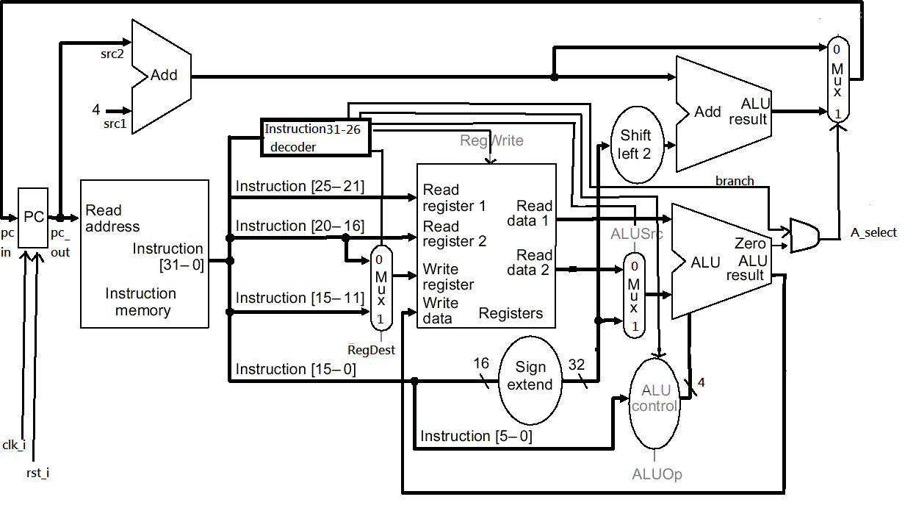

**Detailed description of the implementation:**

**A simple single CPU(A single-cycle design CPU without data memory unit).**

**To implement SRA,SRAV operation in ALU,declare two other wires with signed value to alternate unsigned value,and also an extra input shamt_for_sra.**

**Problems encountered and solutions:**

**Many bugs as usual and sometimes wrong variable name-typing does not result into error and we just need to be more careful to find out all of those problems.**

**Lesson learnt (if any):**

**Pick all the variables being used of current function to add in wave-form diagram is pretty useful for debugging.**