CSCI251 Assignment 1
UOW ID: 6097881
Full Name: Lee Chia Lin
Requirements and Execution of The Program
The requirements of the program include, reading of file that contains data such as grid-map area, city and weather information, displaying the map and summary report, and a menu option for user to enter choices.
Upon starting the program, user is prompt to enter with option 1-8.
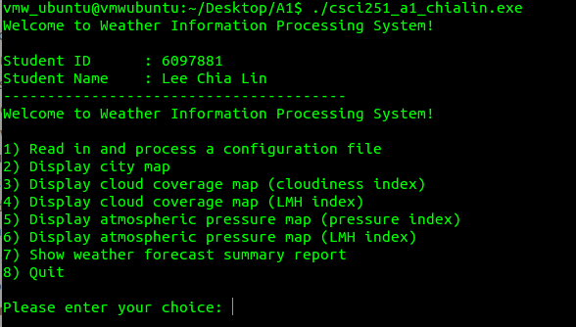
If the user tries to display map or report before the program has read in any data, the program will prompt the user to read in file.
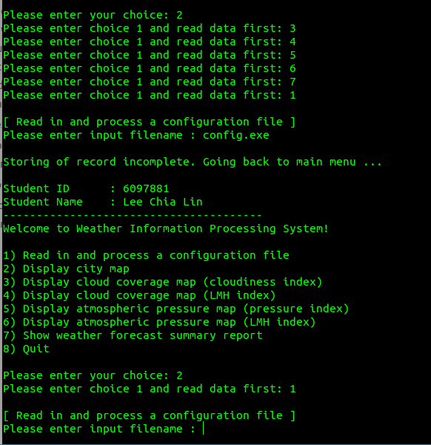
In the event that the reading of the file fails, user will have to read in a file again.
After the records of the input file was successfully read, user can start choosing option 2-7 to display map or summary report.
For option 2-7, user will be prompt to “Press <enter> to go back to main menu …” so that the user can continue when he or she is done with viewing the output.
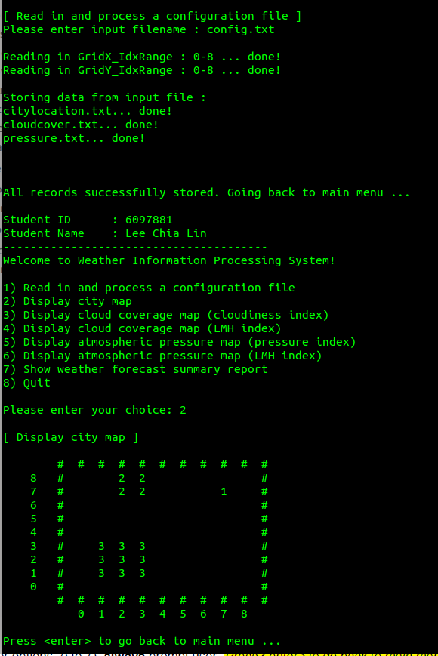
(Sample preview of choice 7)
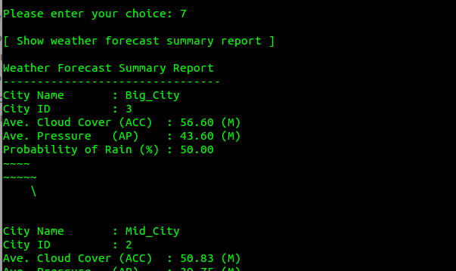
If the user tries to input another file to overwrite the existing records, the program will prompt user to quit and rerun the program, or select choice 2-7 to continue viewing information of the file that was read.
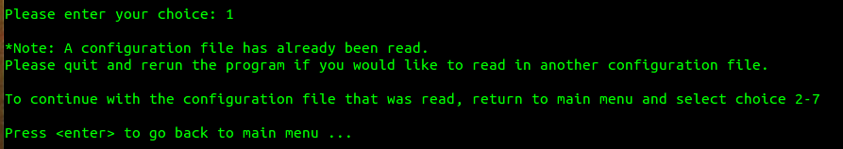

Program Design
The program design will include a total of two structs, namely GridStruct and CityStruct.
Global declaration includes two int, one int [] array, one string [] array, one 2D GridStruct array and one CityStruct array.
xSize and ySize will determine the number of rows and columns of the grid, and it will be calculated by using the values in xyRange that contains the upper and lower bound of the x and y coordinates.
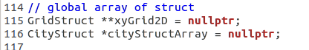
GridStruct stores the input of x and y coordinates, city id, city name, cloud cover value and pressure value. Index and LMH symbols of cloud cover and pressure will be computed and stored in the struct.
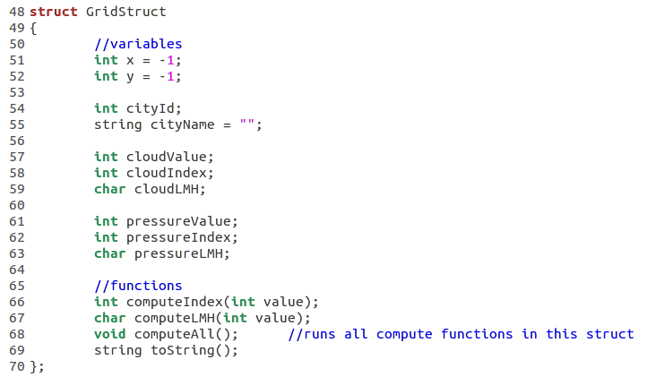
CityStruct stores the input of city name and cityGrid that contains all the grid of the city. cityGridPerimeter contains the grid surrounding the city.
Average cloud cover, pressure, index and LMH symbols of average cloud cover and average pressure, rain probability and the ASCII graphics will be computed and stored in the struct.
gridSize, cityGrid_index, cityGridPerimeter_index, cloudSum and pressureSum are values that will assist in the computation of the variables stated above.
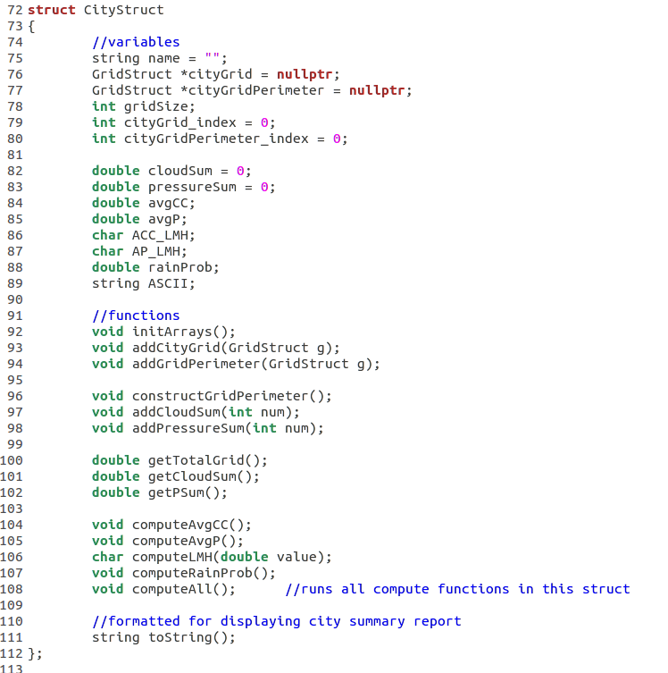

Summary of implementations
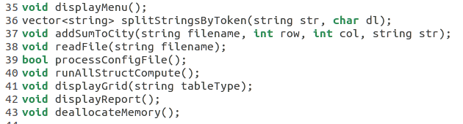
There are 9 functions in main:
- displayMenu displays the menu options 1-8
- splitStringByToken takes in a string text and a char delimiter, and split the string
- addSumToCity sums the cloud cover value and pressure value of a city
- readFile reads each of the .txt files that are in the entered input file (e.g cloudcover.txt, pressure.txt)
- processConfigFile processes the input file that includes information of the GridX_IdxRange, GridY_IdxRange and filenames.
- runAllStructCompute runs all the functions of the structs
- displayGrid takes in string tableType and displays the grid based on what tableType value was passed in
- displayReport displays the Weather Summary Report
- deallocateMemory deletes the [] and release memory
There are checks directly implemented in int main().
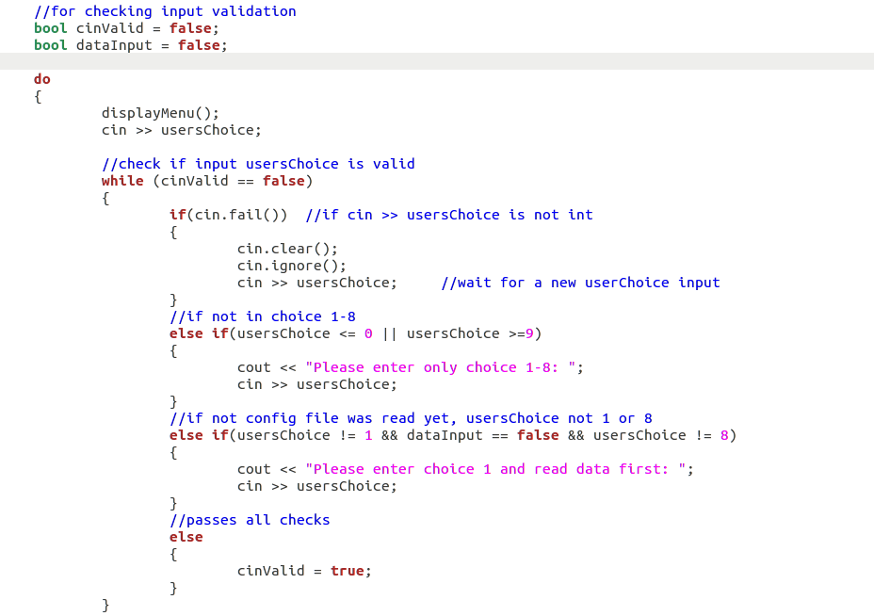
Reflection
During the development of the program, I had to explore C++ and look up information, including how to use new [] array correctly.
The compiler helps to detect the compilation errors clearly, however there are times where compilation was successful but has runtime error, such as “Segmentation fault”. Being new to C++, I had to learn what the error meant and debug accordingly.
Certain runtime errors cause the program to loop infinitely where I had applied if else to prevent it. For example, user entering “abc” for an input code “cin << int usersChoice”.
The many trials and errors allowed me to have a better understanding of C++.

