BUSINESS REQUIREMENTS DOCUMENT
Controlled procure-to-pay and supplier onboarding
Portfolio case study by Chiamaka Ikpo, based on my experience as a Procurement Officer at a commercial bank. The organisation is anonymised, the process is generalised, and approval values are illustrative. No confidential information is included.

Item | Detail
Document | Business Requirements Document (BRD)
Version | 1.0 (portfolio edition)
Author | Chiamaka Ikpo, Business Analyst
Status | Draft for stakeholder review
Related artefacts | process/as_is.bpmn, process/to_be.bpmn, backlog/user_stories.csv, docs/P2P_Requirements_Workbook.xlsx

Contents
1. Purpose and scope
2. Background and problem statement
3. Business objectives and success measures
4. Stakeholders and RACI
5. Current process (as-is)
6. Future process (to-be)
7. Requirements and business rules
8. User stories
9. Assumptions, constraints, dependencies and risks
10. Open questions
11. Sign-off

1. Purpose and scope
This document sets out the business requirements for a controlled procure-to-pay (P2P) process covering requisition, approval, supplier onboarding, purchase ordering, goods receipt and invoice matching. It is written for the business owners who must agree the requirements and for the delivery team that will build or configure the solution.

1.1 In scope
- Requisitions for goods and services raised by internal departments
- Approval routing and the approval matrix
- Supplier onboarding and due diligence (KYC) status
- Purchase order creation and issue
- Goods and service receipt
- Three-way matching of invoice, PO and receipt, and the exception queue
- Audit trail and segregation of duties
- Process performance reporting

1.2 Out of scope
- Strategic sourcing and tendering for contracts
- Contract lifecycle management
- Payment execution in the core banking system (the P2P process hands over an approved invoice)
- Choice of software vendor

2. Background and problem statement
Banks are closely regulated, so every purchase must be traceable. The current process relies on email chains, spreadsheets and manual checks. It works, but slowly, and it depends on individuals knowing what to do and who to ask.
Problem statement: Incomplete requisitions, email-based approvals, inconsistent supplier onboarding and manual invoice matching slow purchasing down, weaken the audit trail, and create a risk that the bank pays a supplier whose due diligence is incomplete.

2.1 Pain points
ID | Pain point | Impact
P-01 | Requisitions arrive incomplete, which causes back-and-forth before a PO can be raised. | Rework for procurement; slower cycle time for requesters.
P-02 | Approval routing depends on people knowing who to email. | Approvals stall or go to the wrong person; no reliable record of who approved what.
P-03 | Supplier onboarding documents are collected inconsistently. | POs can be issued to suppliers whose due diligence (KYC) is incomplete: a regulatory risk.
P-04 | Three-way match (PO, goods receipt, invoice) is checked by hand. | Payment delays, late-payment friction with suppliers, and errors that are hard to trace.

3. Business objectives and success measures
- Make the compliant path the easiest path for requesters
- Remove the possibility of issuing POs to unverified suppliers
- Give audit a complete, system-held trail for every purchase
- Pay correctly matched invoices without manual checking

KPI | Definition | Target
Requisition-to-PO cycle time | Median working days from requisition submitted to PO issued | Reduce (baseline to be measured in discovery)
First-time-complete requisitions | Requisitions approved without being returned for missing information ÷ all requisitions | ≥ 95%
Spend with unverified suppliers | PO value issued to suppliers not in Verified status | Zero
First-time match rate | Invoices matched within tolerance without manual intervention ÷ all invoices | ≥ 85%
Invoice-to-pay time | Median days from invoice receipt to payment | Within agreed supplier terms
Audit findings on P2P | Internal audit findings raised against the P2P process | Downward trend
Baselines will be measured in the first month of discovery, from a sample of recent requisitions and invoices, before targets are confirmed.

4. Stakeholders
ID | Stakeholder | Interest | Influence | Impact on them | Engagement
SH-01 | Requesting departments | Fast, simple way to buy what they need | Medium | High | Keep informed; involve in UAT
SH-02 | Procurement team | Fair sourcing, controlled spend, less rework | High | High | Manage closely; co-design
SH-03 | Finance / Accounts payable | Invoices match POs and receipts; budget control | High | High | Manage closely; own approval matrix and tolerances
SH-04 | Compliance & internal audit | Full audit trail, supplier due diligence (KYC) | High | Medium | Manage closely; sign off controls
SH-05 | Suppliers | Clear onboarding, on-time payment | Low | Medium | Keep informed

4.1 RACI
Activity | Requester | Procurement | Finance | Compliance
Raise requisition | R/A | I | I | -
Source & select supplier | C | R/A | I | C
Supplier due diligence | - | R | - | A
Approve PO | I | R | A | -
Confirm goods receipt | R/A | I | I | -
Match & pay invoice | - | C | R/A | -
R = Responsible, A = Accountable, C = Consulted, I = Informed.

5. Current process (as-is)
The current process is mapped in BPMN 2.0 (process/as_is.bpmn). Tasks shown in red are the four pain points.
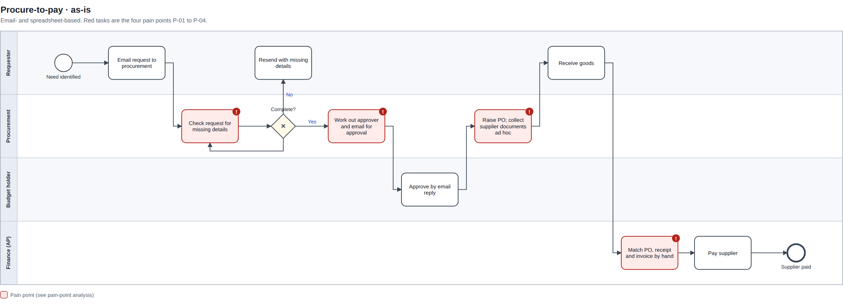

6. Future process (to-be)
The future process (process/to_be.bpmn) moves validation, routing, supplier checks and matching into the system, so people only handle decisions and exceptions.
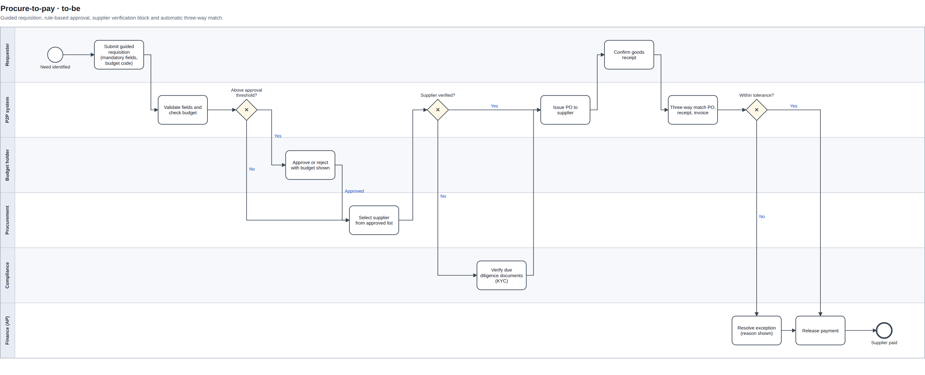

6.1 What changes
Step | As-is | To-be | Pain point addressed
Request | Free-text email | Guided form; mandatory fields; valid budget codes only | P-01
Approval | Procurement works out the approver and emails them | Rule-based routing from the approval matrix; escalation after 2 days | P-02
Supplier | Documents collected ad hoc | Standard checklist; PO blocked unless supplier is Verified | P-03
Invoice | PO, receipt and invoice compared by hand | Automatic three-way match; only exceptions reach AP | P-04

7. Requirements
Priorities use MoSCoW (Must, Should, Could, Won't this time). Each requirement traces to a pain point and to the user stories in backlog/user_stories.csv.

7.1 Business requirements
ID | Requirement | Priority | Pain point | Stories
BR-01 | Every purchase must be traceable from request to payment, including who approved it and when. | Must | P-02, P-03 | US-02, US-07
BR-02 | No purchase order may be issued to a supplier whose due diligence is not verified. | Must | P-03 | US-03, US-05
BR-03 | Invoices that match the PO and goods receipt within tolerance are paid without manual checking. | Must | P-04 | US-04

7.2 Functional requirements
ID | Requirement | Priority | Pain point | Stories
FR-01 | The requisition form enforces mandatory fields (item description, quantity, estimated value, cost centre, budget code, need-by date, spend category) and blocks submission until they are complete. | Must | P-01 | US-01
FR-02 | After a cost centre is selected, only budget codes valid for that cost centre are offered. | Must | P-01 | US-01
FR-03 | The system routes each requisition to approvers using the approval matrix (value threshold and spend category). | Must | P-02 | US-02
FR-04 | Approvers see remaining budget for the cost centre alongside the request value. | Should | P-02 | US-06
FR-05 | Approval requests not actioned within 2 working days are escalated to the approver's delegate. | Should | P-02 | US-08
FR-06 | Supplier status (Pending, Verified, Expired, Blocked) is held on the supplier record; a PO cannot be issued unless status is Verified. | Must | P-03 | US-03
FR-07 | Supplier onboarding uses a standard document checklist; compliance is notified 30 days before any document expires. | Should | P-03 | US-05
FR-08 | Requesters confirm goods or service receipt in the system against the PO. | Must | P-04 | US-09
FR-09 | The system matches invoice, PO and goods receipt on quantity and price; matches within tolerance are marked ready for payment, mismatches go to an exception queue with the reason. | Must | P-04 | US-04
FR-10 | Requesters can see the status of their requisition at each stage. | Could | P-01 | US-10
FR-11 | A monthly report shows cycle time, first-time-complete rate, match rate and spend with unverified suppliers. | Should | All | US-11

7.3 Non-functional requirements
ID | Requirement | Priority | Pain point | Stories
NFR-01 | Every create, approve, reject, change and payment action is logged with user, timestamp and before/after values; the log cannot be edited. | Must | P-02 | US-07
NFR-02 | Role-based access; segregation of duties so the same person cannot raise and approve a requisition, or create a supplier and approve a payment to it. | Must | P-02, P-03 | US-12
NFR-03 | Audit records are retained for the period required by the bank's record-retention policy. | Must | P-03 | US-07

7.4 Business rules
ID | Rule | Detail
BRL-01 | Approval matrix (illustrative values) | Up to ₦1m: line manager. ₦1m–₦10m: line manager + budget holder. Over ₦10m: + Head of Procurement and Finance Director.
BRL-02 | Category approvals | IT hardware/software also needs IT approval; legal or consultancy services also need Legal approval, at any value.
BRL-03 | Match tolerance (to be agreed with Finance) | Price: ±2% per line. Quantity: no over-receipt; under-receipt is matched to the quantity received.
BRL-04 | Supplier status | Only Verified suppliers can receive POs. Status becomes Expired automatically when a mandatory document passes its expiry date.
BRL-05 | Segregation of duties | The requester cannot approve their own requisition. Whoever creates a supplier cannot approve payments to that supplier.

8. User stories
The full backlog of 12 stories, with acceptance criteria and estimates, is in backlog/user_stories.csv (Jira import format). The four core stories are:
US-01 · Requisition
As a requester, I want a guided requisition form with mandatory fields and budget codes, so that I do not have to resubmit my request.
- Given a required field is empty, when I try to submit, then the form blocks submission and highlights the field.
- Given I have selected a cost centre, then only budget codes valid for that cost centre are shown.
US-02 · Approval
As a procurement officer, I want requisitions to route to the right approver automatically by value threshold and category, so that I no longer chase approvals by email.
- Given a requisition exceeds an approval threshold, when it is approved at one level, then it routes to the next level automatically.
- Every approval records the approver, timestamp and decision.
US-03 · Supplier onboarding
As a compliance officer, I want the system to block POs to any supplier whose due diligence documents are not verified, so that we never pay an unvetted supplier.
- Given a supplier's status is Pending, when a PO is raised for that supplier, then the system blocks it and shows which documents are missing.
US-04 · Invoice to pay
As a accounts payable officer, I want invoices matched automatically to POs and goods receipts, so that I only handle real exceptions.
- Given the invoice, PO and receipt match within tolerance, then the invoice is marked ready for payment.
- Given a mismatch, then the invoice goes to the exception queue with the reason.

9. Assumptions, constraints, dependencies and risks
Type | Item
Assumption | The bank's ERP or a P2P module can hold supplier status and enforce a PO block.
Assumption | Finance will own and maintain the approval matrix and match tolerances.
Constraint | Controls must meet the bank's regulatory and internal audit standards; no control may be weakened to save time.
Dependency | HR data for line managers and delegates must be current for routing to work.
Dependency | Cost centre and budget data must be available to the requisition form.
Risk | Requesters work around the system by raising purchases after the fact. Mitigation: retrospective POs reported monthly to the Head of Procurement.
Risk | Existing suppliers lack complete documents at go-live and are blocked. Mitigation: a document clean-up sprint before go-live, prioritised by spend.

10. Open questions
- What are the agreed approval thresholds and who approves at each level? (Values in BRL-01 are placeholders.)
- What price and quantity tolerances will Finance accept for automatic matching?
- Should low-value, low-risk purchases (for example under ₦50,000) use a simpler route or purchase cards?
- How should urgent purchases be handled when a supplier is still Pending?

11. Sign-off
Role | Name | Decision | Date
Head of Procurement
Head of Finance / AP
Head of Compliance
Business Analyst | Chiamaka Ikpo | Author

