National Taiwan University Introduction to Machine Learning and Deep Learning
Department of Civil Engineering Instructor: C.-S. CHEN
Homework 2 Report
Essay and Programming, Due 21:00, Wednesday, October 1, 2025
Student ID: B12501001
Name: 蔣尚誠

1.
(a) Using Hoeffding’s inequality, find the minimum number of flips N to ensure 95% confidence that the sample head fraction is within ±0.05 of the true mean, and enter N = 738

2. Consider a four-bit representation 1_0_ with the following ground truth. Please list all the possible target functions.
1000 | ● | ○ | ● | ● | ● | ○ | ○ | ○ | ● | ● | ● | ○ | ○ | ○ | ● | ○
1001 | ● | ● | ○ | ● | ● | ○ | ● | ● | ○ | ○ | ● | ○ | ○ | ● | ○ | ○
1100 | ● | ● | ● | ○ | ● | ● | ○ | ● | ○ | ● | ○ | ○ | ● | ○ | ○ | ○
1101 | ● | ● | ● | ● | ○ | ● | ● | ○ | ● | ○ | ○ | ● | ○ | ○ | ○ | ○

3. Report your error rate using 5 training examples and 12 training examples.

5 training examples | 12 training examples
0.12 | 0.08

Write a short essay to rationalize and comment on your findings.
5 training examples中可以train到前四元素中的三個，而12 training examples中可以train到前四元素，因此使test的error rate下降，然而因為最多也只能train到前四元素，所以當training examples再繼續增加也無法降低error rate (=0.08)。

4.
4.
(a) Calculate and report the expected out-of-sample error and its bias and variance components.

20 points
error | bias | variance
0.211 | 0.197 | 0.015
Plot
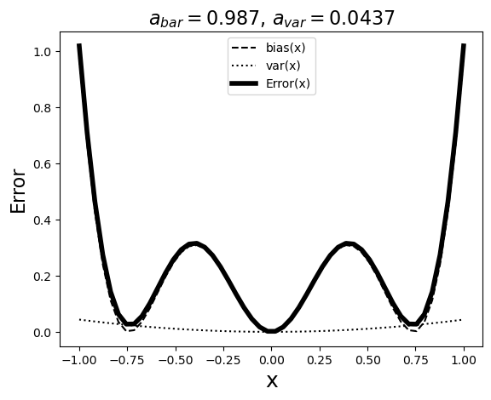

100 points
error | bias | variance
0.199 | 0.196 | 0.003
Plot
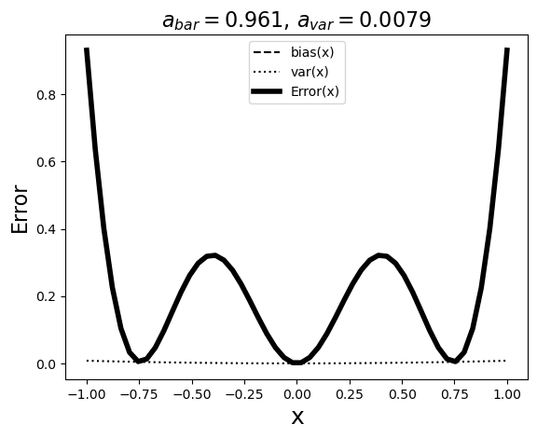
(b) Write a short essay to rationalize and comment on your findings.
$資料量從 2 → 20 → 100：variance大幅下降。bias 大多變化不大。error ≈ bias + variance，會隨資料量增加而下降。bias\left(x\right)=\left(\overline{g}\left(x\right)-f\left(x\right)\right)$可以得知，這衡量「平均模型」離真實目標 𝑓(𝑥) 的結構性差距，表示當前模型學習的限制，因此可以觀察到當訓練資料集變大時，其bias下降的幅度較小。而$var\left(x\right)=E_{D}\left[{\left(g^{\left(D\right)}\left(x\right)-\overline{g}\left(x\right)\right)}^{2}\right]$，衡量「不同訓練集」學到的模型在點 𝑥 的擺動大小，因此variance會和訓練資料集大小有關。

4.

5.
Calculate and report the expected out-of-sample error and its bias and variance components.

error | bias | variance
0.5 | 0.333 | 0.167

6. Please plot the mean score of training and validation curves using a polynomial regression model with 5-fold cross validation
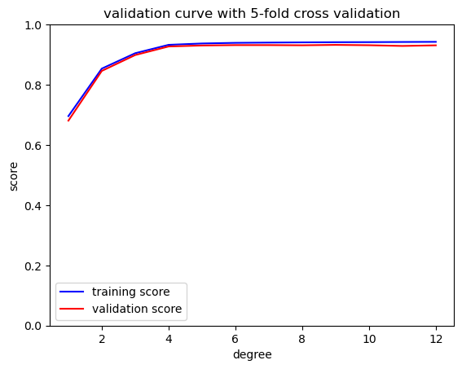

Submission Format
Please convert HW2_report_template.docx to HW2_report.pdf.

