National Taiwan University Introduction to Machine Learning and Deep Learning
Department of Civil Engineering Instructor: C.-S. CHEN
Homework 4 Report
Essay and Programming, Due 21:00, Wednesday, November 5, 2025
Student ID: B12501001
Name: 蔣尚誠

1. Print the weights for each epoch. The output format should be displayed as shown in the HW4_1.ipynb.
epoch = 1, weights = -0.00 0.40 0.40 0.40
epoch = 2, weights = -0.40 0.20 0.40 0.20
epoch = 3, weights = -0.40 0.40 0.40 0.20
epoch = 4, weights = -0.40 0.40 0.40 0.20
epoch = 5, weights = -0.40 0.40 0.40 0.20
epoch = 6, weights = -0.40 0.40 0.40 0.20
epoch = 7, weights = -0.40 0.40 0.40 0.20
epoch = 8, weights = -0.40 0.40 0.40 0.20
epoch = 9, weights = -0.40 0.40 0.40 0.20
epoch = 10, weights = -0.40 0.40 0.40 0.20
epoch = 11, weights = -0.40 0.40 0.40 0.20
epoch = 12, weights = -0.40 0.40 0.40 0.20
epoch = 13, weights = -0.40 0.40 0.40 0.20
epoch = 14, weights = -0.40 0.40 0.40 0.20
epoch = 15, weights = -0.40 0.40 0.40 0.20
epoch = 16, weights = -0.40 0.40 0.40 0.20
epoch = 17, weights = -0.40 0.40 0.40 0.20
epoch = 18, weights = -0.40 0.40 0.40 0.20
epoch = 19, weights = -0.40 0.40 0.40 0.20
epoch = 20, weights = -0.40 0.40 0.40 0.20

2. Compare the convergence behaviors (number of epochs to achieve zero error) with three cases. Discuss how learning rate and initialization influence stability and speed.
For epoch = 20, learning rate = 0.01, initial weight = 0.60, the output should be displayed as following：

epoch = 1, weights = 0.52 0.58 0.58 0.58
epoch = 2, weights = 0.44 0.56 0.56 0.56
epoch = 3, weights = 0.36 0.54 0.54 0.54
epoch = 4, weights = 0.28 0.52 0.52 0.52
epoch = 5, weights = 0.20 0.50 0.50 0.50
epoch = 6, weights = 0.12 0.48 0.48 0.48
epoch = 7, weights = 0.04 0.46 0.46 0.46
epoch = 8, weights = -0.02 0.44 0.44 0.44
epoch = 9, weights = -0.08 0.42 0.42 0.42
epoch = 10, weights = -0.14 0.40 0.40 0.40
epoch = 11, weights = -0.20 0.38 0.38 0.38
epoch = 12, weights = -0.26 0.36 0.36 0.36
epoch = 13, weights = -0.32 0.34 0.34 0.34
epoch = 14, weights = -0.34 0.32 0.34 0.34
epoch = 15, weights = -0.34 0.32 0.34 0.34
epoch = 16, weights = -0.34 0.32 0.34 0.34
epoch = 17, weights = -0.34 0.32 0.34 0.34
epoch = 18, weights = -0.34 0.32 0.34 0.34
epoch = 19, weights = -0.34 0.32 0.34 0.34
epoch = 20, weights = -0.34 0.32 0.34 0.34

===== epoch = 14時收斂

For epoch = 20, learning rate = 0.10, initial weight = 0.25, the output should be displayed as following

epoch = 1, weights = -0.15 0.05 0.25 0.25
epoch = 2, weights = -0.15 0.05 0.45 0.25
epoch = 3, weights = -0.35 0.05 0.45 0.25
epoch = 4, weights = -0.35 0.25 0.45 0.45
epoch = 5, weights = -0.55 0.25 0.45 0.25
epoch = 6, weights = -0.55 0.45 0.45 0.25
epoch = 7, weights = -0.55 0.45 0.45 0.25
epoch = 8, weights = -0.55 0.45 0.45 0.25
epoch = 9, weights = -0.55 0.45 0.45 0.25
epoch = 10, weights = -0.55 0.45 0.45 0.25
epoch = 11, weights = -0.55 0.45 0.45 0.25
epoch = 12, weights = -0.55 0.45 0.45 0.25
epoch = 13, weights = -0.55 0.45 0.45 0.25
epoch = 14, weights = -0.55 0.45 0.45 0.25
epoch = 15, weights = -0.55 0.45 0.45 0.25
epoch = 16, weights = -0.55 0.45 0.45 0.25
epoch = 17, weights = -0.55 0.45 0.45 0.25
epoch = 18, weights = -0.55 0.45 0.45 0.25
epoch = 19, weights = -0.55 0.45 0.45 0.25
epoch = 20, weights = -0.55 0.45 0.45 0.25

===== epoch = 6時收斂

第一題為epoch = 3時收斂 (learning rate = 0.10, initial weight = 0.60)，可得知當learning rate (影響收斂速度) 越大，代表每次改變權重的幅度越多，越快到達權重的收斂位置；當Initial weights (影響早期錯誤數) 越接近最後的收斂位置時，所需的修正就較少，越快到達權重的收斂位置。

即使資料是可以被正確分類的，只要一開始設定的learning rate或initial weight不一樣，神經網路在訓練時走的路徑就會不同。當模型第一次成功把資料全部分對時，它就會停下來，不再繼續往更好的解微調，因此每次訓練最後收斂的位置都可能不一樣。

3.
(a) Using the square root error as our error function, derive and compute $δ^{(3)}$, $δ^{(2)}$, $δ^{(1)}$.
$$δ^{(3)}$$ | $$δ^{(2)}$$ | $$δ^{(1)}$$
[[-0.56]] | [[-0.21]] | [[-0.13]  [0.26]]

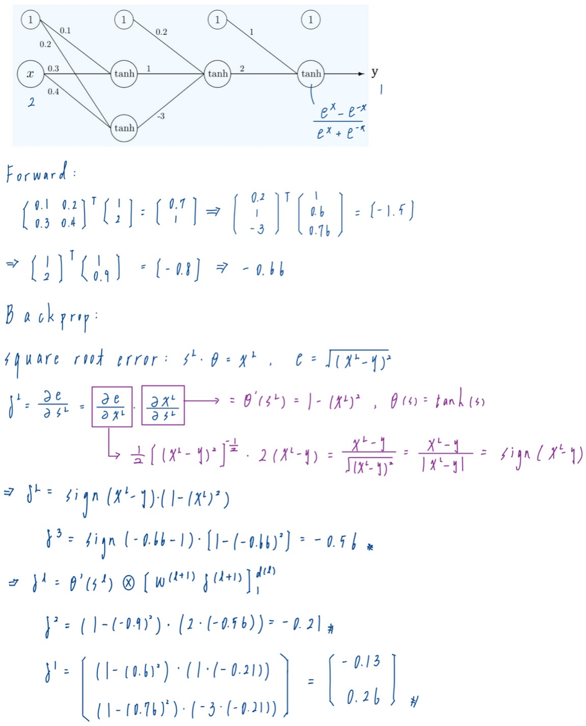
(b) Compute $\frac{∂e}{∂W^{(1)}}$, $\frac{∂e}{∂W^{(2)}}$, $\frac{∂e}{∂W^{(3)}}$.
$$\frac{∂e}{∂W^{(1)}}$$ | $$\frac{∂e}{∂W^{(2)}}$$ | $$\frac{∂e}{∂W^{(3)}}$$
[[-0.13 0.26]  [-0.26 0.52]] | [[-0.21]  [-0.13]  [-0.16]] | [[-0.56]  [0.50]]

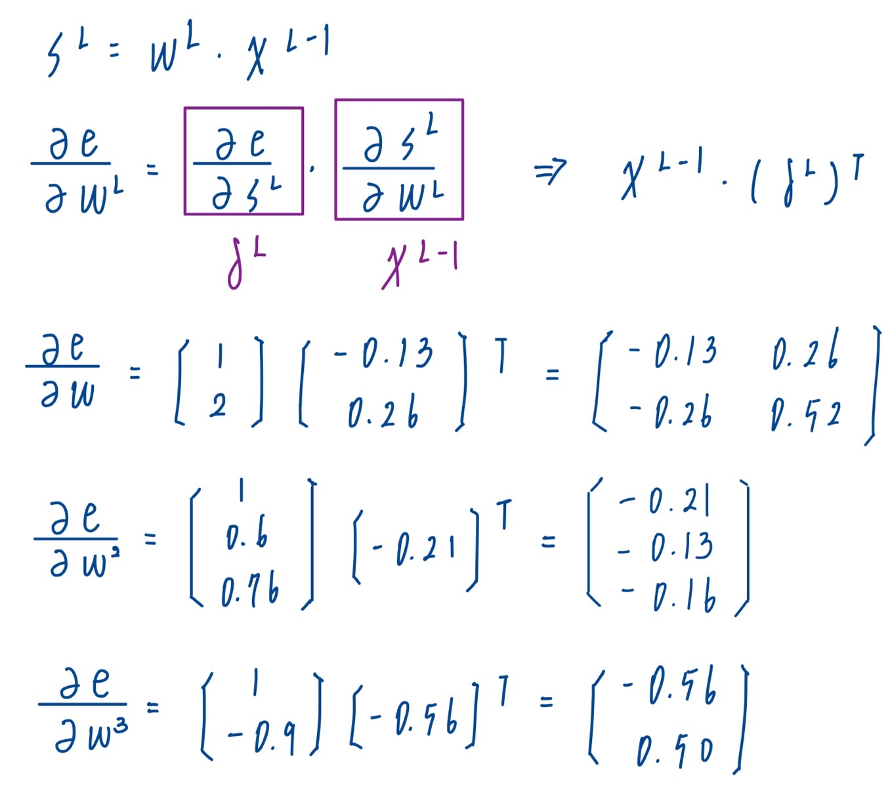

(c) Update the weight matrices using this single datapoint with a learning rate $η=0.5$, repeat the forward propagation.
$$W^{\left(3\right)}(t)$$ | $$W^{\left(2\right)}(t)$$ | $$W^{\left(1\right)}(t)$$
[[1.28]  [1.75]] | [[0.305]  [1.065]  [-2.92]] | [[0.165 0.07]  [0.43 0.14]]

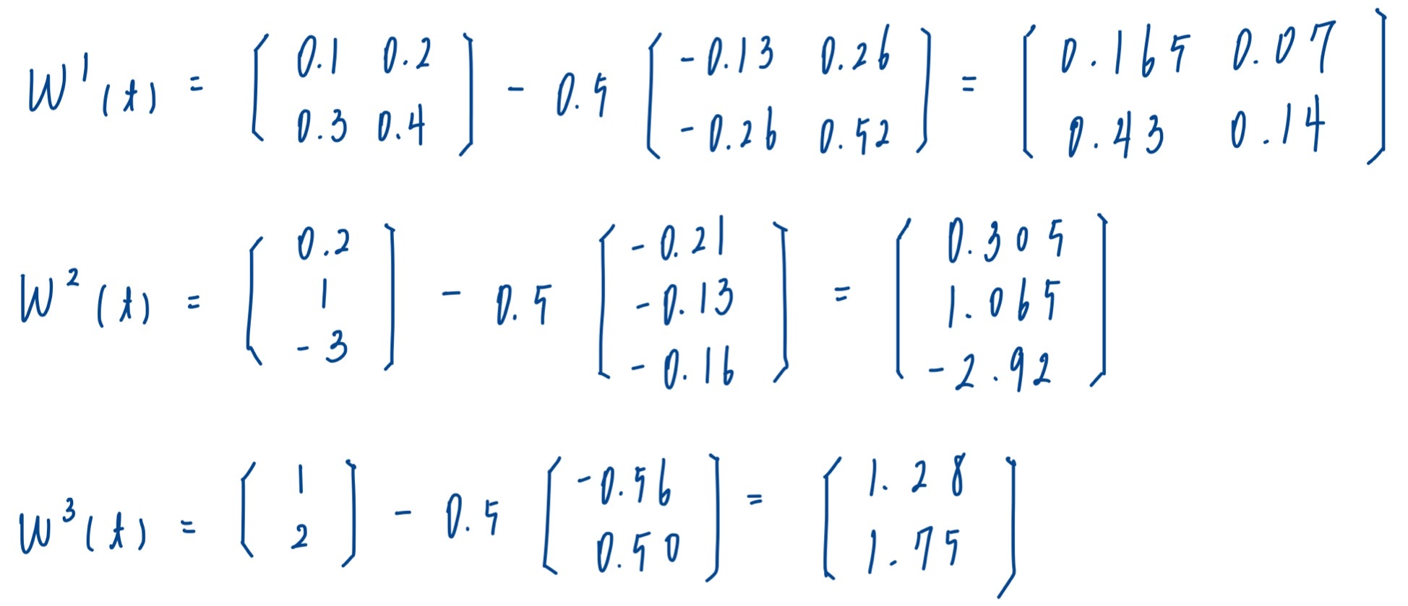

Compute $s^{(1)}$, $x^{(1)}$,$s^{(2)}$, $x^{(2)}$, and $x^{(3)}$.
$$s^{(1)}$$ | $$x^{(1)}$$ | $$s^{(2)}$$ | $$x^{(2)}$$ | $$x^{(3)}$$
[[1.025]  [0.35]] | [[1.00]  [0.77]  [0.32]] | [[0.19]] | [[1.00]  [0.18]] | [[0.92]]

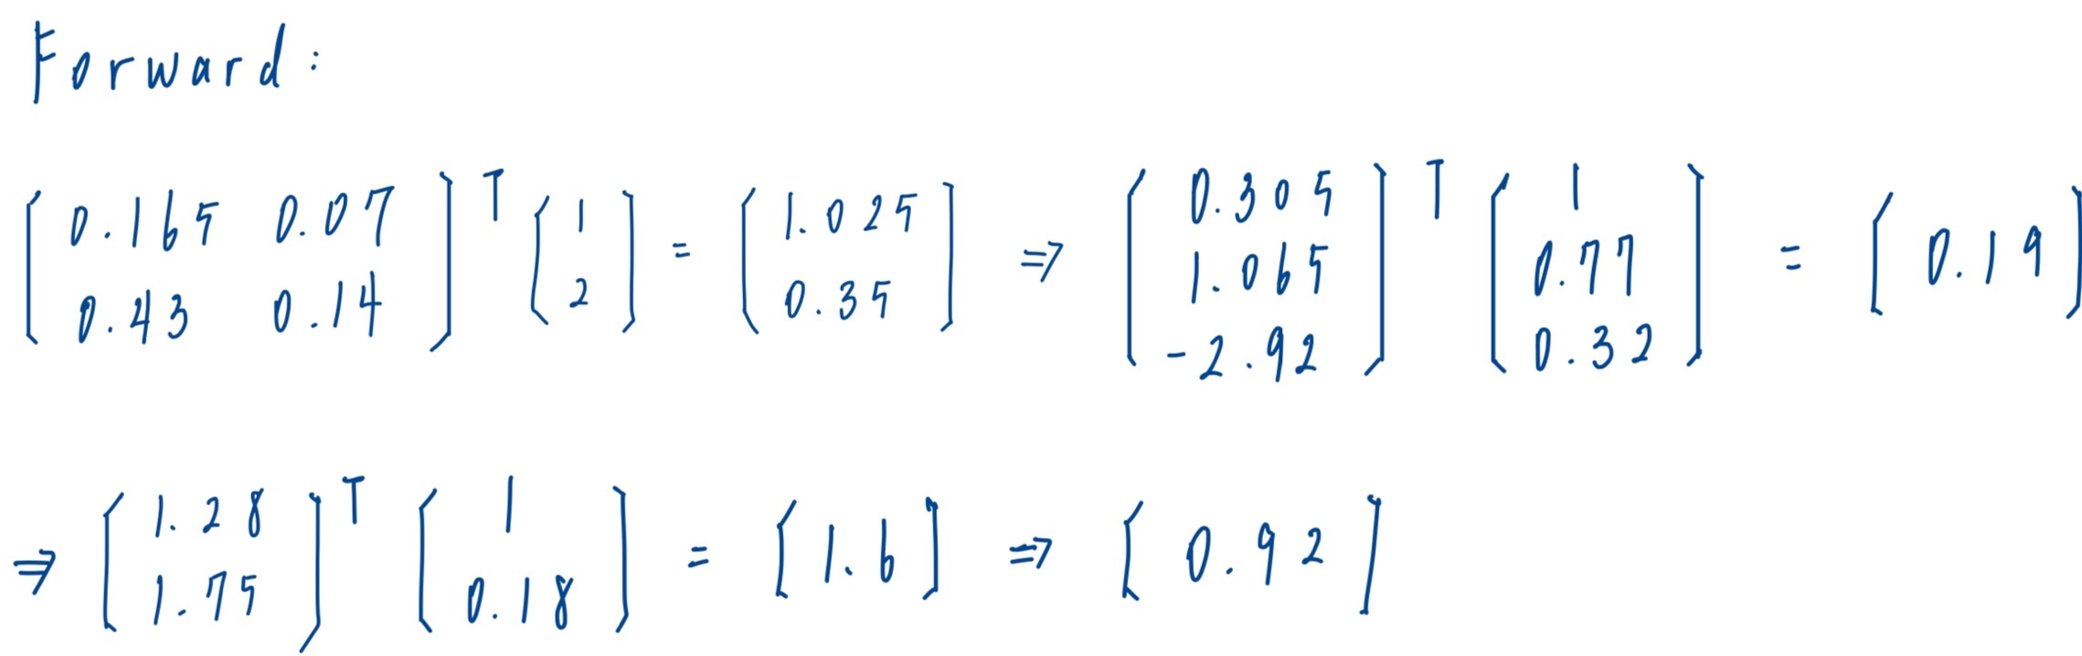

4.
(a) Derive and compute $s^{(1)}$, $x^{(1)}$,$s^{(2)}$, $x^{(2)}$, and $x^{(3)}$.
$$s^{(1)}$$ | $$x^{(1)}$$ | $$s^{(2)}$$ | $$x^{(2)}$$ | $$x^{(3)}$$
[[0.700000] [1.000000]] | [[1.000000]  [0.604368] [0.761594]] | [[-1.480415] [2.367119]] | [[1.000000]  [-0.901546] [0.914285]] | [[1.379970]]

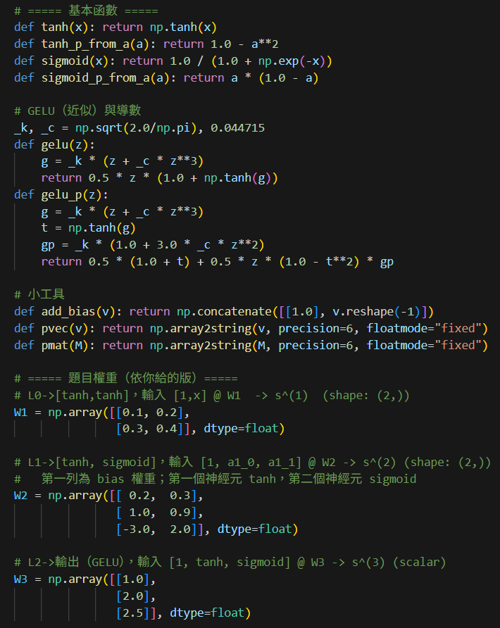

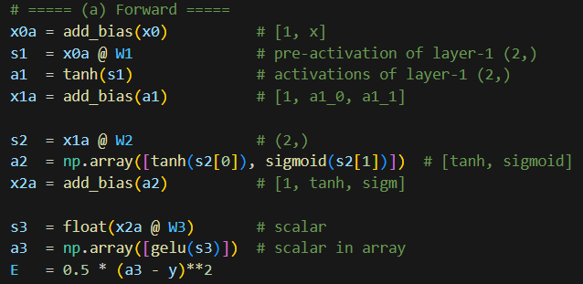

(b) Using the sum square as our error function, derive and compute $δ^{(3)}$, $δ^{(2)}$, $δ^{(1)}$.
$$δ^{(3)}$$ | $$δ^{(2)}$$ | $$δ^{(1)}$$
[[0.857356]] | [[0.321021]  [0.167972]] | [[ 0.299721]  [-0.263373]]

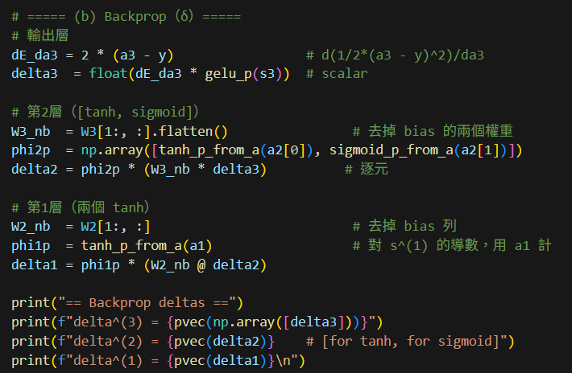

(c) Compute $\frac{∂e}{∂W^{(1)}}$, $\frac{∂e}{∂W^{(2)}}$, $\frac{∂e}{∂W^{(3)}}$.
$$\frac{∂e}{∂W^{(1)}}$$ | $$\frac{∂e}{∂W^{(2)}}$$ | $$\frac{∂e}{∂W^{(3)}}$$
[[ 0.299721 -0.263373]  [ 0.599443 -0.526746]] | [[0.321021 0.167972]  [0.194015 0.101517]  [0.244487 0.127927]] | [[ 0.857356]  [-0.772946]  [ 0.783868]]

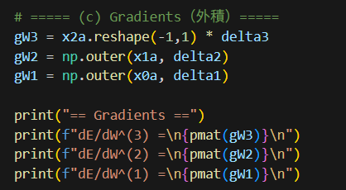

Submission Format
Convert HW4_report_template.docx to HW4_report.pdf, then place HW4_report.pdf and HW4_1.ipynb into a folder named {yourStudentID}_HW4 and compress it into a ZIP file for upload to NTU COOL. Below are the file formats for upload.
