r/Hostile Architecture:
Sentiment and Community Analysis

SCENARIO
Have you ever noticed metal spikes in front of shop windows or curved benches with lots of armrests and limited seating?
These elements are examples of a controversial design trend called “Hostile Architecture”, which is a form of urban design that aims to regulate public behaviour, often by excluding marginalised groups such as the homeless.
This crucial issue shapes our surroundings nowadays, however it has often gone unnoticed since it does not affect everyone equally. For instance, I don’t mind leaning awkwardly against the new metal bar-rests for just ten minutes at the bus stop; still, such designs are being spread all around the world to discourage certain behaviors, often at the expense of inclusivity and dignity.
Recently, public awareness of the problem has increased and, along with that, several online debates have risen.
Among the most used social networks, Reddit stands out for its open and unfiltered discussions, allowing users to express their perspectives freely on a wide variety of topics.
Users of the platform continuously give birth to different topic-specific discussion communities, such as: HostileArchitecture, urbandesign, friendlyarchitecture and many more.
Among these, r/HostileArchitecture stands out as a particularly engaged and emotionally charged community. It serves not only as a forum for sharing images of hostile design, but also as a space for activism, public awareness, and critique, making it an ideal case study for understanding how online communities engage with urban design controversies.
This study does not aim to represent global public opinion on hostile architecture; rather, it seeks to understand interaction dynamics and emotional tone emerging within this specific online community.
Specifically, this project provides an insightful study of the subreddit r/HostileArchitecture, focusing on comments, posts and users.
More specifically, the objective was to investigate how people engage with the topic: who drives the conversation, how information flows between users, and what the sentimental/emotional tone of their contributions reveals. Ultimately, the combination of network and sentiment analysis, allows for the detection of both structural dynamics and the shared sentiment across communities.

IDEA
Unlike political and sports-related subreddits, where there are clear and distinct observable sentimental communities, r/HostileArchitecture was initially expected to have only a negative tone, whereas its counterpart r/friendlyarchitecture was expected to only have positive sentiment.
Another hypothesis concerned the evolution of user engagement, which was believed to increase over time, first given the suggestion of the subreddit by the platform, second considering that the world is becoming more and more digitally connected.
Finally, it was worth verifying whether top users (influencers) matched and reinforced the average sentiment of the community or whether they moved upstream.
To investigate these assumptions in depth, a hybrid approach was adopted. The idea was to carry out a study which meaningfully combined at the same time sentiment and network/community analysis.
This is the underlying structure of the project:
- Posts, comments and users collection
- Comments preprocessing
- Named Entity Recognition and frequency analysis
- Sentiment analysis on posts, comments and Emotional analysis on users, comments and posts
- Network analysis of comments replies leveraging centrality measures (degree centrality and betweenness centrality)
- Temporal analysis on post growth and post sentiment; insight on user’s activity levels and sentiments
- Community detection based on interaction in comments, identification of hubs and strongly connected components and sentiment comparison (hubs/scc vs community sentiment)

MODELS FOR TOPOLOGY AND CONTENT ANALYSIS
The following is a list of all the models and techniques that were employed in the analysis:

DATA GATHERING
Data Gathering was carried out thanks to PRAW (Python Reddit API Wrapper), which was preferred over direct use of Reddit API for its reliability and user-friendly design. PRAW does automatically manage API pagination and rate limits, which, on the other hand, have to be manually engineered when using the API; moreover, the data retrieved are returned as Python objects, making it easier to extract related information (e.g. body, author, created_utc, parent_id…).
This was particularly valuable for the project, where it was crucial to extract a large amount of posts and full comment threads without handling low-level API complexities.
The collected data were: posts, comments and users. The newest thousand posts were retrieved, along with the relative comments, of which up to 10 branches were stored, as well as their authors. Three separate data frames were built, including some additional columns for preliminary data inspection.
- posts_df: id, title, author, score, comments, num_comments, created_utc, url, selftext, upvote_ratio
- comments_df: post_id, comment_id, author, body, created_utc, parent_id, score
- authors_df: author, commnet_count, avg_score, influence_score

COMMENTS PREPROCESSING
Using the NLTK library, which is a Natural Language Processing tool for analysing and working with human language (stopwords, WordNetLemmatizer, TweetTokenizer), the body of the comments was preprocessed as follows and stored in a new column (processed_body) in the comments_df:
- clean_text: removal of URLs, HTMLs, backslashes, numbers, extra white spaces
- remove_punctuation
- tokenize
- remove_stopwords
- lemmatize

Then, the frequency (Frequdist by NLTK) of the words in the processed body was displayed in a WordCloud, after the removal of words that were irrelevant to the study (words that are obviously frequent, like “homeless” or “architecture”).
NAMED ENTITY RECOGNITION
NER was performed on the body of the comments to identify hotspots and most mentioned entities: geographical-political entities (GPE), organizations (ORG), facilities (FAC).
The entities were extracted using en_core_web_sm, which is a small-sized English model trained on written web text and provided by spaCy.
Moreover, a new list containing design words that were expected to be highly relevant, was defined (urban_keywords). The scope was to determine their frequency across the comments and their co-occurrence with top 5 GPE entities.

SENTIMENT ANALYSIS
Sentiment Analysis was performed using VADER (Valence Aware Dictionary and sEntiment Reasoner), which is a rule-based model optimized for social media text.
Specifically, it was applied on the raw body of comments, as it outputs a compound score for each, taking into account punctuation, capitalization, degree modifiers and emoticons.
The comments were classified into one of three different classes on the basis of the compound:
- positive: if score > 0.05
- negative: if score < - 0.05
- neutral: otherwise
The resulting sentiment label was stored in a new column (comments_df[‘sentiment’]) for further comparisons.

EMOTIONS DETECTION
The study of emotions relied on NRCLex, which is a lexicon that maps words to 8 basic emotion categories: anger, fear, anticipation, trust, surprise, sadness, joy, disgust, positive and negative sentiments.
It was performed on all comments to assign each to their detected predominant emotion and, more in depth, on the top 10 users (classified by engagement) to see how much of each emotion they expressed across all their comments.

SENTIMENT AND EMOTIONAL ANALYSIS ON POSTS
The title and the body of posts was combined and stored in a new column (posts_df[‘fulltext’]); then the posts were also assigned a compound and sentiment category (still using analyzer by VADER). Those with a neutral compound were entirely discarded, while the others were ordered: 10 posts with the most positive and 10 posts with the most negative sentiments (in terms of compound) were taken as samples for the whole category (positive - negative) to show the amount of the 8 emotions in each for comparison.

NETWORK ANALYSIS
Network Analysis was carried out using NetworkX, which is a library used to represent and work with complex networks.
For each comment, the parent comments were identified and a graph was defined: users represented the nodes, while the action of replying determined a directed edge.
For visualisation purposes, smaller subgraphs were displayed: the users were sorted, once by degree centrality (number of edges connected to node) and once by betweenness centrality (number of shortest paths passing through the node), the first 50 nodes with the highest scores were identified and used to plot two distinct subgraphs.

TEMPORAL ANALYSIS
For Temporal Analysis, the values in posts_df['created_utc'] column, that were initially stored in the UNIX format (number of seconds since January 1st, 1970 (UTC)) were transformed into readable datetime format.
After this transformation, the posting trend was plotted (starting from when posts were collected, about September 2021) by month and by year.
Furthermore, a third plot displayed the flow of each sentiment with time across posts.

From another perspective, an analogous analysis was carried out on the sentiment expressed by user per activity level. The amount of comments per user was counted and each user was classified into one of three activity groups:
- total comments < 2 → inactive
- total comments < 6 → semi-active
- total comments > 6 → active
These thresholds were tailored to the user activity given the relatively small size of the subreddit, and the fact that it hasn’t gone viral recently.
Finally, each user was paired with their most common sentiment across their comments and they were clustered by intensity of activity, coloured by sentiment.

COMMUNITY DETECTION
Community Detection was performed using a Greedy Modularity Algorithm, which analysed users' interactions in the comments and returned an undirected graph, having the users as nodes and their interactions as edges.
For simplicity, only the communities with more than a hundred members were considered, as they are the most meaningful. For each community, the average sentiment across its members was computed and stored in filtered_stats_df.
Three graphs of the selected top communities were then displayed:
- Sample of the total number of the participants, divided by five (for visualisation purposes)
- Full representation of all the members in each community (for transparency, but extremely messy)
- Simplified visualisation of the communities, highlighting influencers (hubs). The influencers were identified by computing a personalised function, which leveraged degree, betweenness and closeness centrality (influence_score =(0.5 * degree_centrality.get(node, 0) + 0.3 * betweenness_centrality.get(node, 0) + 0.2 * closeness_centrality.get(node, 0)))
To deepen the understanding of sentiment distribution within the detected communities, two further analyses were conducted and the results were shown in a pie chart:
- The average sentiment for each influencer in all communities
- The average sentiment per member of the Strongly Connected Component in biggest community

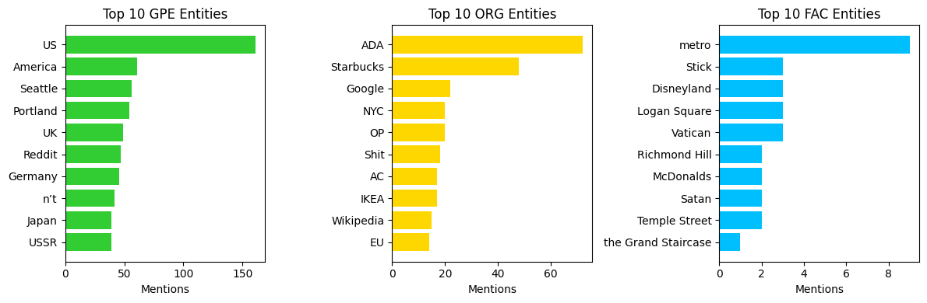
RESULTS

Considering that the amount of comments being analysed was about a thousand, the frequency of the entities is not as meaningful as expected. As a consequence, the only solid finding is that the USA is the most affected country.
The FAC entity was actually expected to yield more significant results; however, the detected entities were rarely discussed, and mainly concerned commercial companies, which are not really the target of the study. Therefore, a list of urban keywords was manually defined to better address elements of urban design. This proved to be much more effective, in fact it was further studied in intersection with GPE, confirming the results previously drawn.
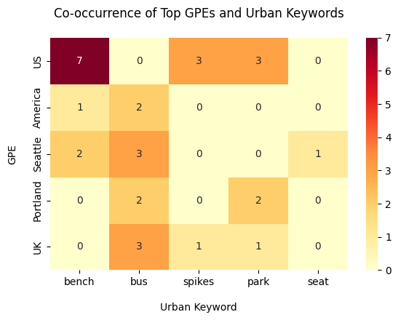
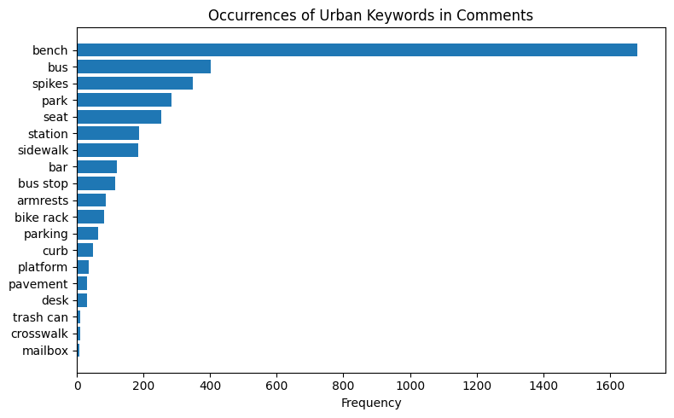
Noticeably, the entities retrieved contain some odds one out. The reason why is that small models like en_core_web_sm, have limited discrimination accuracy compared to larger models.
Additionally, capitalisation and typographic errors can significantly affect the task of entity recognition and cause ambiguities, which are hardly solved by small models.

Sentiment and Emotion analysis can be jointly evaluated: it was shown that there is an almost equal distribution among positive, negative, neutral sentiments. This division is mirrored also quite accurately by the emotional classification of the comments.
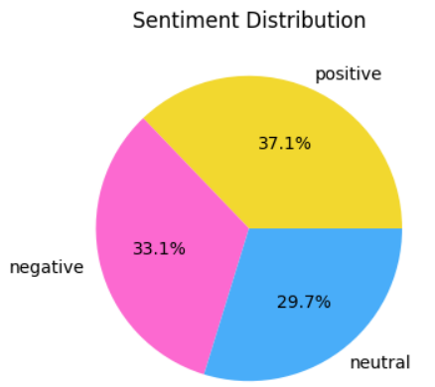
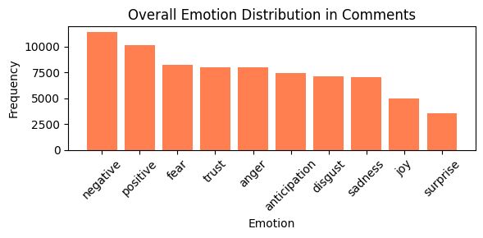

At user level, considering the ten most active ones, it emerges that they all expressed both positive and negative emotions, surprisingly also following a pattern that is clearly noticeable in the graph below.
Joshua Pearce, the most active user among all (also a moderator of the subreddit), is well above the others, but still seems to follow the noticed pattern.
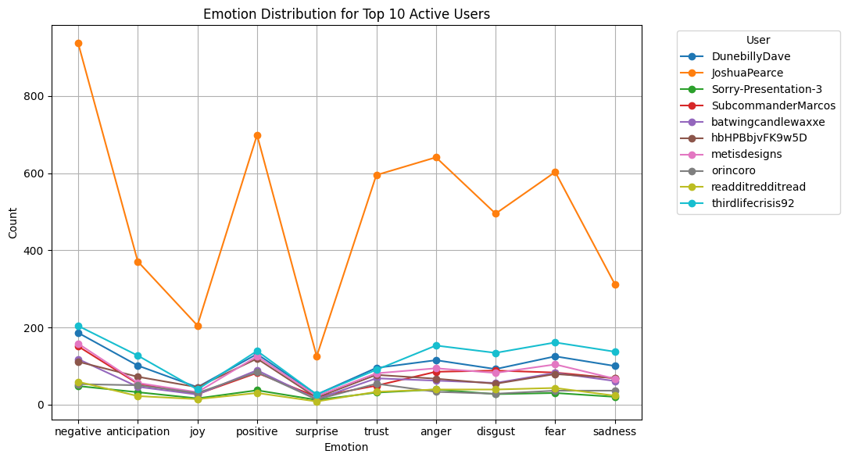

At the level of posts, it is proved that positive posts generally convey more positive emotions (anticipation, joy, surprise), while negative posts convey more negative emotions (anger, disgust, fear, sadness).
Curiously, there is a non-zero influence of the emotions expressed by the opposite sentiment in each category (positive vs negative posts).
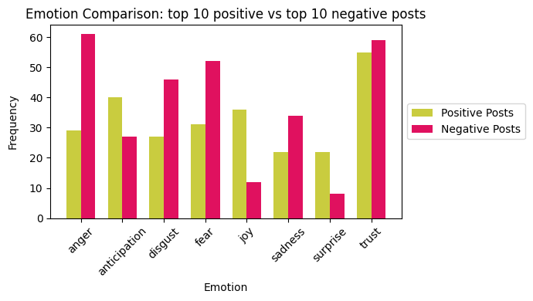

Moving on to Network Analysis, the networks of comments replies by the first fifty users were plotted first by degree centrality and then by betweenness centrality.
The two different measures were chosen to have two different perspectives: degree centrality weights the popularity of a node, while betweenness centrality weights the structural importance.
In fact:
- Degree centrality: shows the most active or most replied-to users
- Betweenness centrality: shows the users who act as bridges between communities
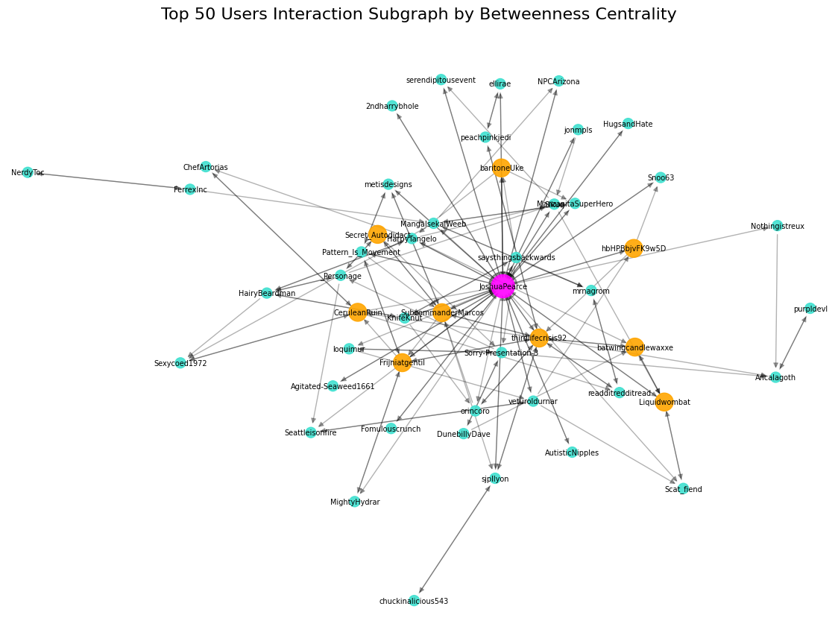
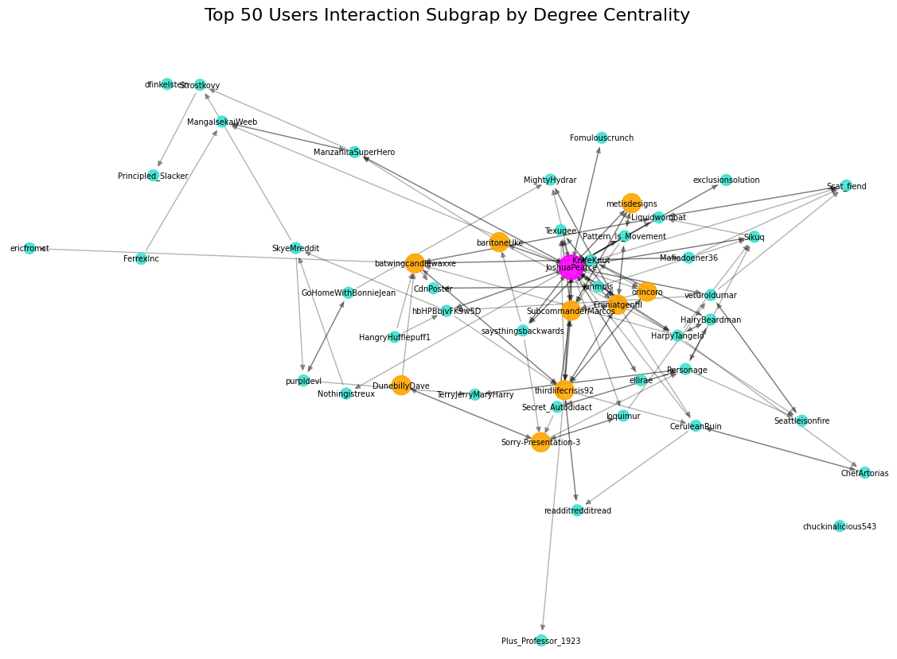

The node with the highest degree was highlighted in pink (exactly the top_user), while the other users in the top_user_set were coloured in orange, and the rest of the nodes are light blue.
The comparison between the two, shows that the central node (Joshua Pearce) stays the same, suggesting that the user is both very popular and also structurally crucial. Among the orange nodes, the majority is kept the same in both representations, while some users are orange in one and light blue in the other.

For what concerns temporal analysis, a very rough plot of submission postings overtime showed a steep growth from 2021 to 2022, with 350 posts publication per year, followed by a rapid decline from 2022 to 2023, reaching 200 posts per year, which remained constant till 2024, where the submissions have become rarer and rarer, fewer than 100 per year.
Refining the plot by months (September 2021 - today), in order to have a more accurate plot, showed that there is a clear descending trend. However, the line exhibits high variability, often fluctuating by 20 posts per month once every two/three months.
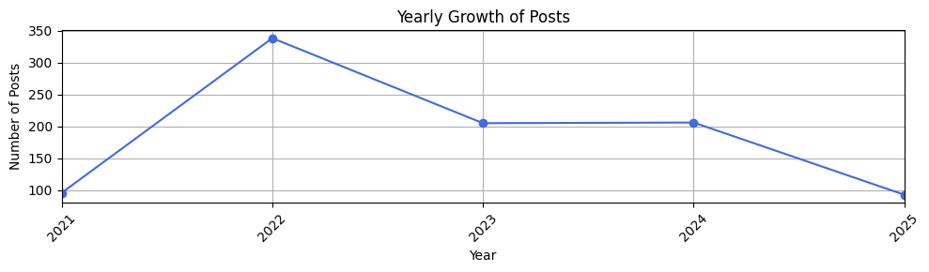

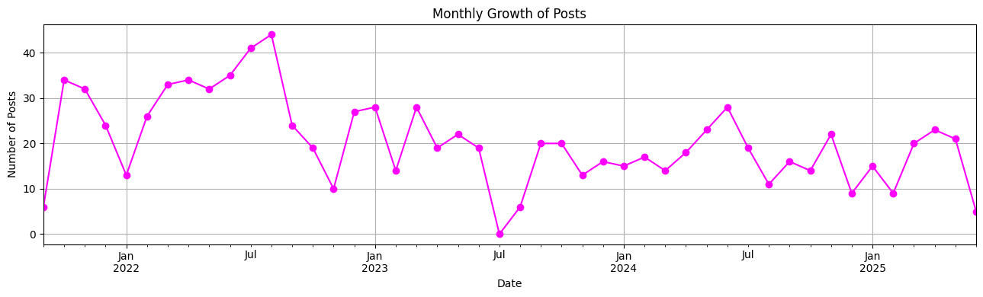

A further analysis concerned sentiments flow overtime. To wrap everything up coherently with the objective of the study, the sentiment taken into consideration was the one expressed in submissions.
Although all three sentiments have always been present, there is a significant prevalence of the neutral and negative sentiments over the positive one. Specifically, the two prevailing sentiments have been coinciding in quantity from 2023 till today; it is however remarkable that in 2022, there has been quite a noticeable gap between the two: 160 posts were neutral and 100 were negative.
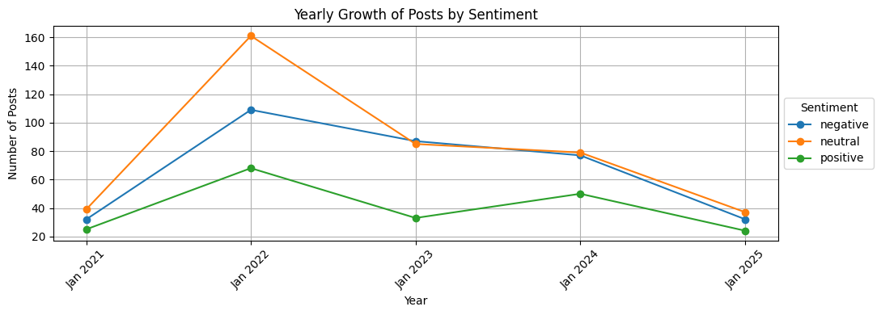

Lastly, to investigate the duality of neutral and negative against positive sentiments from another perspective, users of the retrieved comments were divided into three categories, namely: active, inactive and semi-active. The idea was to check whether that pattern was reflected also in the comments and, possibly, if the lack of positive comments was general or whether it depended on the intensity of activity of the users.
The clusters, and especially the bar chart plotted below, helped to draw some conclusions:
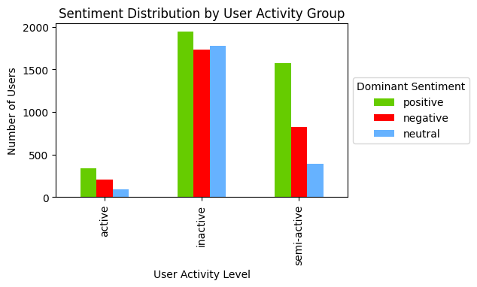
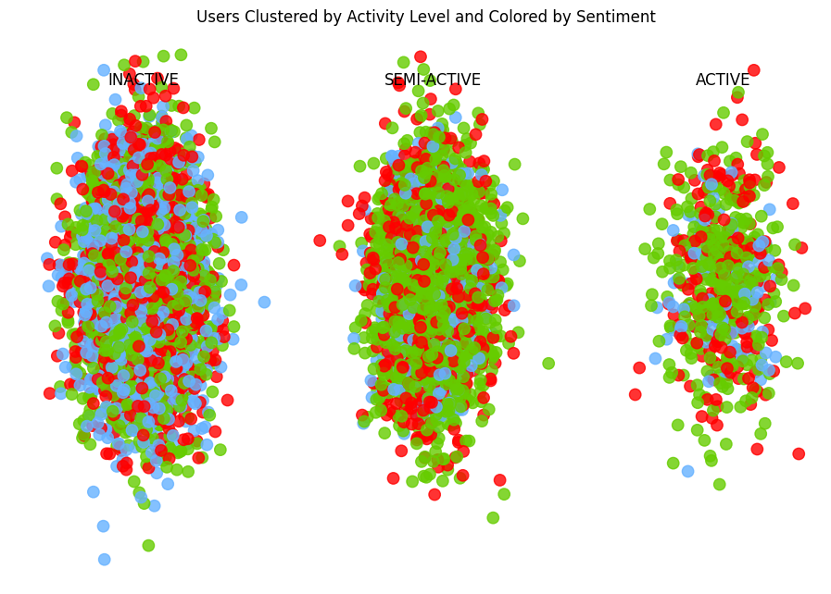

First of all, it is impossible to ignore the imbalance of the number of users belonging to the three clusters (the activity groups). However this is very much expected, and will be delved into later.
Although the amount of users generally writing positive, negative and neutral comments actively or inactively is more or less the same within their cluster of belonging, it is striking that, among semi-active users, the prevalent sentiment is the positive one (prevalent by more than five hundred members over the negative sentiment, and by almost a thousand members over the neutral sentiment).
Therefore, it can be inferred that the sentimental pattern identified among submissions, was wrongly suspected to be also found among comments.

Lastly, it was worth investigating communities, at different levels, and relating the findings to the sentiments, once again.
The first step was to identify the communities through a Greedy Modularity Algorithm, which returned a graph displaying the interactions among the users in the comments. Several communities were identified but, for ease of operations and to reduce time complexity, only the communities having more than a hundred members were further evaluated. In particular, a large number of communities had from two to twenty members, and they were considered statistically irrelevant; in fact, the biggest community found had almost 800 members.
The plotted network was self-explanatory, clearly displaying the communities in distinct colours, each arranged in its own cluster positioned along a circular layout.

The second step consisted in locating the top 20 influencers, with the aim of analysing their role as hubs in driving interactions and influencing sentiment across the network.
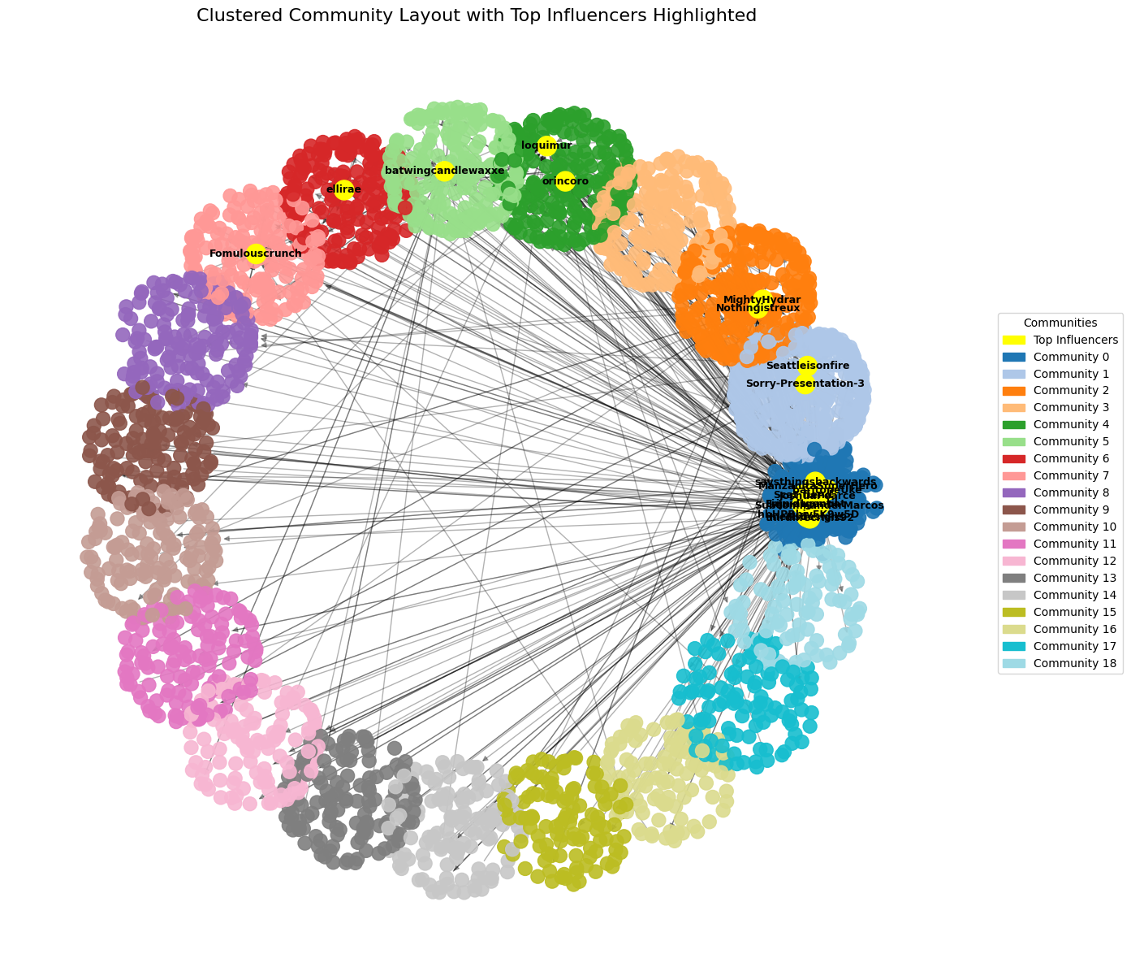

Considering that communities are ordered by size (belonging users), influencers are more densely located within the top seven communities, particularly concentrating in the first three. In fact, more than half of the hubs are found in Community 0, which is the biggest (about eight hundred members); Community 1, 2, 4 host two influencers each, while Community 5, 6, 7 have 1 influencer each.

With the purpose of linking the previous analysis to sentiment, a very insightful comparison was conducted to verify the attitude of the influencers with regard to their community; these were the possible cases:
- Match: when the sentiment of the influencers matched that of the community, regardless of whether it was positive, negative or neutral
- More Positive: when the sentiment of the influencers was positive, and that of the community was neutral or negative
- More Negative: when the sentiment of the influencers was negative, and that of the community was positive or neutral
- Other: when the influencer was neutral and the community was either positive or negative
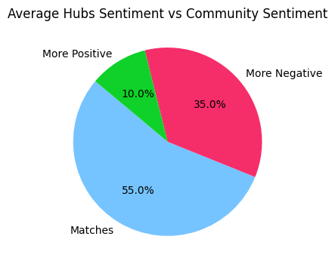

The results showed that more than half of the influencers match the sentiment of their community, while the other half leans towards being more negative. In general, hubs could either reinforce the sentiment expressed in their communities or they could be in contrast with it, being against the mainstream attitude. In this specific subreddit, we find a mixture of both; a deeper analysis on the evaluation and comparison of scores for the sentiments, could help draw more robust conclusions about the degree of “aversion” of More Positive and More Negative influencers.

The very last step consisted in identifying a strongly connected component (SCC), and carrying out a similar sentiment analysis as above. The biggest SCC was located in Community 0, and this allowed for a fairer comparison between the two.
Actually, 464 SCC were found in the biggest community, however most of them had fewer than 20 members, and they were believed to be statistically irrelevant. In the end, only the biggest SCC was taken as a sample: it grouped 293 users out of 800 members in the community.
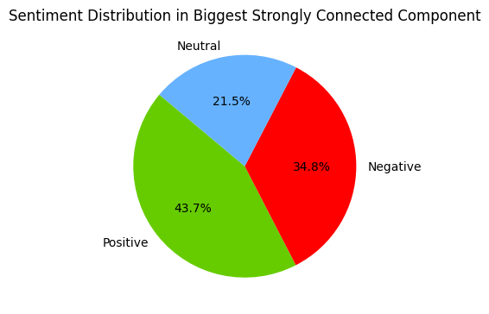

The sentiment in Community 0 was previously computed as being positive and the analysis of sentiment among the 293 members of the SCC shows a similar pattern to that identified before: almost half of them matched the sentiment in their community, while the other half tends to be more negative. In this case, there is also a visible section of neutral users (20%), which was not retrieved in the influencers’ sentiment analysis (it would correspond to the Other category).

DISCUSSION AND CONCLUSION
Conversations on social networks are often driven by young users, who foster informal discussions, filled with slang, sarcasm, emojis, and sometimes even multiple languages. On one hand, these features enrich the debates, on the other, they may generate confusion and overly challenge the models which have to discriminate the real meaning behind the irony. For instance, sarcastic positivity or ironic negativity may result in sentiment misclassification, which should be taken into account when interpreting the results.

Given that this complexity does also characterise Reddit, a hybrid approach was adopted, combining both network-based and content-based analysis. Also, the study was carried both at a user-centric and at a socio-centric level, allowing the investigation of user-based sentiment and behavior, and of community structure and group dynamics. This duality was essential to embrace not just engagements in the discussion, but also how the discussion flows through structural connections and emotional tones.

An initial hypothesis, stated that the subreddit would have a predominant negative sentiment given the presence of the r/friendlyarchitecture which was believed to represent its counterpart.
However, the results of the analysis have proved that there is a more (but not perfectly) balanced sentiment distribution from both the network and the community point of view.
This conclusion suggests that the subreddit also serves as a space for debates, where different contrasting opinions are spoken out, rather than a space for critiques and complaints. A further assumption is that, it is possible that people sometimes shared posts and comments which would be more suitable for the r/friendlyarchitecture rather than the hostile one.

A significant part of the study concerned network and community analysis, with the aim of investigating the structure of interactions and sentiment patterns.
The application of Greedy Modularity allowed the identification of distinct communities which, interestingly, were not polarised, unlike in other subreddits, where there are clear sentiment boundaries. In the case of this subreddit, each community contained mixed sentiments.
To deepen the structural analysis, the central users were studied. They are the so called “influencers” (hubs), and their presence is crucial in a social network: they are distinguished by ordinary users because they have many more connections (in-going and out-going edges in a directed graph); these several relationships allow them to be quicker in sharing information and fuelling conversations.
Particularly, looking at the amount of arrows that cross the space and point at other communities, it can be unequivocally inferred that the top twenty influencers also play the special role of bridges. A bridge is someone who has multiple links to communities around them, thus having the power of faster trends spreading, information diffusion and acting as role models.
Finally, to complement the influencer-based analysis, the study explored strongly connected components, which are a further step in evaluating the community. The difference is that only nodes which have bidirectional arrows, thus more solid interactions, are present in SCCs; communities, instead, group users regardless of the direction of their connections. Members of an SCC on a social media platform can be regarded as “core conversational users”.
This last investigation confirmed the findings so far: even among users that are more closely related to each other there are subgroups of sentiments, with a slight prevalence for the positive one.

