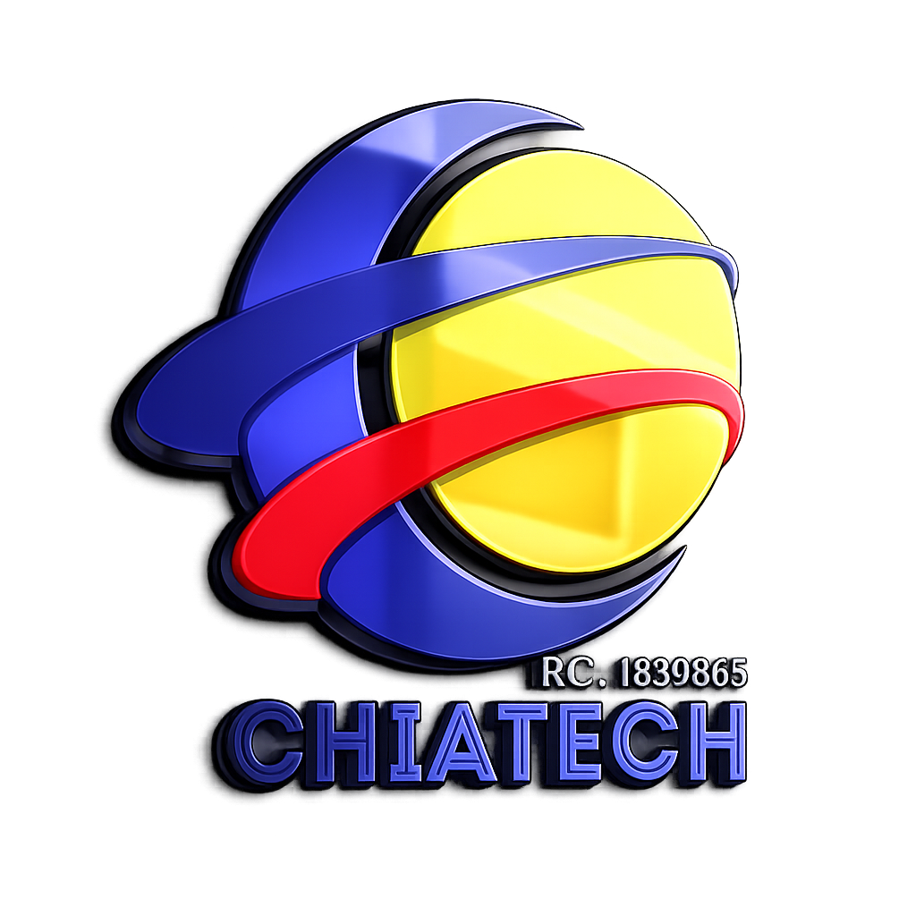
ACCEPTED ARTICLE AGREEMENT

Copyright, Licensing, Authorship & Publication Agreement
Author-retained copyright · CC BY 4.0 default open-access licence
SCIENCE · TECHNOLOGY · ENGINEERING · MATHEMATICS · EDUCATION · HUMANITIES & SOCIAL SCIENCES · ENTREPRENEURSHIP & MANAGEMENT
COMPLETE AFTER ACCEPTANCE · BEFORE VERSION-OF-RECORD RELEASE
Published by CHIA TECH SOLUTIONS AND RESOURCES LIMITED · RC 1839865 · Nigeria
ISSN: Pending assignment · DOI prefix: Pending registration

A · Article record
Field | Final / accepted record
Manuscript ID / eLocator
Full article title
Article type
Primary SETEHEM domain
Secondary domain, if any
Corresponding author
Acceptance date
Planned publication date
ISSN | Pending / journal controlled
DOI | Pending / journal controlled
STANDARD AUTHOR LIMIT
This agreement captures up to 12 individually named authors. More than 12 qualifying authors require prior editor approval and the Large-Collaboration Authorship Continuation Sheet or an approved group-authorship record. Every qualifying author must be represented in the final publication record.

B · Author register (maximum 12 standard byline authors)
# | Full legal name | Publication name | ORCID iD | Affil. no.
1
2
3
4
5
6
7
8
9
10
11
12

C · Author contact and signature register
Legal Name | Email | Telephone / country | Signature & date
1
2
3
4
5
6
7
8
9
10
11
12

D · Affiliation key
No. | Department · Institution · City · State/Region · Country
1
2
3
4
5
6
7
8

E · Authorship and contributor declarations
By signing this agreement, each author confirms all of the following:
- ☐ I made a genuine scholarly contribution that satisfies the journal’s authorship criteria; I reviewed the final manuscript and approve publication.
- ☐ I accept accountability for my contribution and will cooperate with questions about accuracy or integrity.
- ☐ The author order has been agreed by the author group; no qualifying author has been omitted and no honorary, gift or guest author has been added.
- ☐ Contributors who do not qualify for authorship are appropriately acknowledged with their permission where required.
- ☐ Any authorship change after submission will be requested transparently and supported by written agreement from all affected authors.

F · CRediT contributor roles
Enter author initials against each applicable role. More than one author may share a role. Roles describe contribution and do not by themselves determine authorship.
CRediT role | Author initials / names
Conceptualization
Data curation
Formal analysis
Funding acquisition
Investigation
Methodology
Project administration
Resources
Software
Supervision
Validation
Visualization
Writing – original draft
Writing – review & editing

G · Copyright ownership and licence to publish
1. Copyright ownership. Copyright remains with the author(s), or with an employer/other rights holder where applicable law or contract places ownership there. This agreement does not require transfer of copyright to CHIA TECH SOLUTIONS AND RESOURCES LIMITED.
2. First-publication and publishing rights. The rights holder grants CHIA TECH SOLUTIONS AND RESOURCES LIMITED, as publisher of CHIATECH JOURNAL, the right of first publication and a non-exclusive, worldwide, royalty-free licence to edit for style and production, reproduce, publish, distribute, communicate, preserve, archive, index, register metadata, deposit with scholarly services, and maintain the article and its versions of record in print, digital and machine-readable formats.
3. Open-access licence. Unless the accepted article records another approved licence, the final scholarly article will be made available under Creative Commons Attribution 4.0 International (CC BY 4.0). The public may share and adapt the licensed material for any purpose, including commercially, provided appropriate attribution is given, a licence link is supplied, and changes are indicated. The publisher will not add restrictions that contradict the CC BY 4.0 terms.
4. Third-party material. Material not owned by the author(s) and not covered by the article licence must be clearly identified in the article with the applicable credit, licence, permission or lawful-use basis. Authors remain responsible for obtaining necessary permissions.
CC BY 4.0: Creative Commons Attribution 4.0 International

H · Originality, rights and publication warranties
- ☐ The manuscript is original except where sources and prior versions are transparently cited; it is not under conflicting exclusive publication commitment elsewhere.
- ☐ All quotations, figures, tables, instruments, datasets and other third-party materials are used lawfully and accurately attributed.
- ☐ No confidential, defamatory, unlawfully discriminatory or privacy-infringing material is knowingly included.
- ☐ All research ethics, consent, safety, data-protection and institutional requirements applicable to the work were followed and are accurately disclosed.
- ☐ Funding, competing interests and relevant relationships are fully disclosed.
- ☐ AI-assisted tools, if substantively used, are disclosed; AI is not listed as an author and was not used to fabricate evidence, citations or authorship.

I · Data, corrections and publication integrity
Authors authorise the journal to correct, update, retract or issue expressions of concern in accordance with its published policies when the scholarly record requires it. Authors agree to preserve underlying records for the period required by their discipline/institution and to cooperate with legitimate integrity inquiries.

J · Metadata, DOI, indexing and archiving
Authors authorise publication and dissemination of bibliographic metadata including names, affiliations, ORCID iDs, abstract, keywords, funding and licence information. The publisher may register a DOI, deposit metadata with Crossref or other scholarly services, and preserve the article through appropriate repositories/archives. Pending identifiers must not be replaced until formal registration is confirmed.

K · Author image, voice and explanatory media
The article may be accompanied by a complimentary explanatory video or other accessibility media. Author voice, image or likeness is used only with explicit permission. Accuracy of any explanatory media must be checked against the final scholarly article.
Permission option | Select
I permit use of my recorded voice for article-related explanatory media. | ☐ Yes ☐ No
I permit use of my image/likeness for article-related explanatory media. | ☐ Yes ☐ No
I prefer journal-created narration/visuals without my voice or likeness. | ☐ Yes ☐ No

L · Final corresponding-author certification
The corresponding author certifies that all listed authors have received this agreement, the identity/signature records are authentic, all authors approved the accepted version and publication terms, and the final author order is correct.
Corresponding author | Signature | Date
LEGAL / POLICY NOTE
This journal form records the publisher’s publication policy and author permissions; it is not individualized legal advice. Where an employer, funder or law controls copyright ownership, the corresponding author must disclose that status before publication.

