CHIATECH JOURNAL
  - SETEHEM · VOLUME 1 · ISSUE 2 · AUGUST 2026 · e026
  - PIONEER PUBLICATION · ACCEPTED ARTICLE · CRITICAL REVIEW AND FRAMEWORK ARTICLE · ARTIFICIAL INTELLIGENCE · COMPUTING · EDUCATION TECHNOLOGY

Prompt Engineering for Reliable Large-Language-Model Interaction: From Instruction Design and Grounding to Evaluation and Prompt-Injection Resilience
CHIA Shiaondo Kenneth
CHIATECH Solutions and Resources Ltd, Abuja, Nigeria
ORCID: 0009-0009-6434-4586 · Correspondence: chiakenneth01@gmail.com
Article | Volume/Issue | Publication | ISSN | DOI
e026 | 1(1) | Pioneer Issue · August 2026 | Pending assignment | Pending registration

Abstract
Background: Prompt engineering has evolved from ad hoc wording tricks into a broader discipline for specifying tasks, supplying evidence, orchestrating tools and evaluating model behavior. Objective: This article critically synthesizes prompt-engineering research and proposes a reliability-oriented architecture for human–LLM interaction that integrates instruction design, grounding, tool governance, security and verification. Methods: A critical narrative review integrated foundational prompting studies, recent prompting taxonomies, retrieval-augmented generation, tool-using agents and generative-AI risk guidance. Results: Effective prompting is best understood as a five-layer system: task specification, contextual grounding, reasoning scaffolds, tool/action orchestration and output verification. Techniques such as few-shot prompting, decomposition, self-consistency, retrieval and ReAct can improve performance, but effects depend on model, task and evaluation conditions. Reliability deteriorates when prompts substitute for missing evidence, when tool permissions are excessive, or when untrusted retrieved content can alter instructions. Prompt injection therefore changes prompt engineering from a productivity concern into a security and governance concern. Conclusion: Reliable AI interaction requires prompt design to be coupled with source control, structured outputs, least-privilege tools, repeatable tests and human review proportional to risk. The proposed architecture shifts attention from 'clever prompts' to verifiable workflows.
Keywords: prompt engineering; large language models; retrieval-augmented generation; prompt injection; AI reliability; LLM evaluation; agentic AI

1. Introduction
Prompt engineering began largely as the deliberate formulation of instructions, context, examples, roles, constraints, chaining and decomposition. Those techniques remain useful, but the field has matured beyond a list of wording tricks. Contemporary LLM systems retrieve documents, call tools, write code, interact with software and sometimes act autonomously across multiple steps. A prompt can therefore influence not only text generation but also data access and downstream actions.
Large surveys now document dozens of prompting techniques and inconsistent terminology across the literature. Schulhoff et al. (2024) organized 58 LLM prompting techniques, while Sahoo et al. (2024) reviewed techniques and applications across task domains. This variety creates a practical problem: users can optimize phrasing while neglecting the larger sources of error—weak task definitions, missing evidence, inappropriate tools, untrusted context and absent verification.
The purpose of this article is to synthesize prompt engineering as a reliability discipline. It proposes a five-layer architecture that treats prompts as one component of a governed human–AI workflow and identifies evaluation criteria for education, research, software development and organizational use.

2. Review Approach
This article uses a critical narrative synthesis of foundational and contemporary literature on prompting, retrieval, tool use, evaluation and LLM security. It distinguishes experimentally supported techniques from context-dependent practice recommendations and treats prompt design as one layer of a wider reliability system. The synthesis emphasizes techniques with broad relevance to instruction following, reasoning, retrieval and tool use, with special attention to security because prompt injection can cause LLM-integrated applications to privilege malicious or irrelevant instructions embedded in untrusted context.
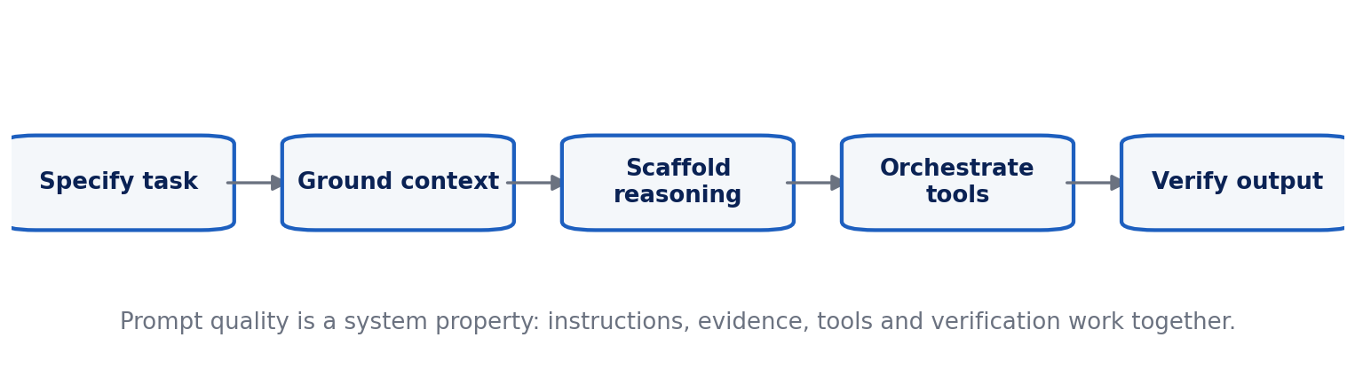
Figure 1. Five-layer architecture for reliable prompt-driven LLM workflows.

3. From Prompt Wording to Workflow Architecture
Task specification is the first layer. A reliable prompt states the goal, audience, inputs, constraints, acceptable uncertainty and expected output form. Role labels can help establish perspective or domain conventions, but role prompting cannot confer expertise that the model does not possess. Explicit success criteria are more auditable than vague instructions such as 'make this better.'
Contextual grounding is the second layer. Model behavior improves when relevant facts, definitions, source excerpts or retrieved documents are supplied in a form that clearly separates evidence from instructions. Retrieval-augmented generation (RAG) is especially useful when answers depend on changing, proprietary or domain-specific information, but retrieval adds its own failure modes: missing documents, poor chunking, stale sources and hostile content.
Reasoning scaffolds form the third layer. Few-shot examples can demonstrate task structure; decomposition can break complex problems into manageable subtasks; chain-of-thought research showed that intermediate reasoning exemplars can improve performance on some reasoning tasks (Wei et al., 2022). In operational systems, however, reliability should be judged from verifiable outputs rather than assumed from verbose reasoning text. Self-consistency and independent solution checks are useful when multiple plausible reasoning paths exist.
Tool and action orchestration is the fourth layer. ReAct-style systems interleave reasoning with actions such as retrieval or external tool use. This is powerful because the model can obtain information or execute operations that are unavailable from its static parameters. It is also risky: a prompt error can become an action error. Tool schemas, permission boundaries, transaction limits and human approval gates therefore become part of prompt engineering.
Output verification is the fifth layer. Structured schemas, citation requirements, deterministic checks, unit tests, reference calculations, source validation and human review make outputs testable. A prompt that says 'be accurate' is not a control; a workflow that checks every cited claim against retrieved evidence is.

4. Technique Selection by Problem Type
Table 1. Prompt Engineering for Reliable Large-Language-Model Interaction: analytical matrix.
Technique | Best suited to | Principal caution
Clear instruction + constraints | Routine generation, transformation, classification | Over-constraint can omit needed nuance; vague success criteria remain hard to evaluate.
Few-shot examples | Format learning, style, classification, structured tasks | Examples can bias outputs and may not cover edge cases.
Decomposition / prompt chaining | Multi-step research, planning, analysis | Errors can propagate; each stage needs validation.
Reasoning scaffolds / self-consistency | Mathematical and logical tasks with checkable answers | Verbose rationale is not proof of correctness; compare final outputs against evidence/tests.
RAG / source grounding | Current, proprietary or document-based knowledge | Retrieval can be incomplete, stale or contaminated by prompt injection.
ReAct / tool use | Search, computation, code, workflow automation | Tool calls create real-world risk; apply least privilege and approval gates.

5. Prompt Injection, Data Boundaries and Least Privilege
Prompt injection occurs when untrusted input attempts to redirect the model away from the system’s intended task. The attack surface grows when applications ingest web pages, emails, documents or tool outputs. A retrieved passage can contain text that looks like an instruction, and an agent may treat it as higher priority than the user expects. Defenses therefore need architectural separation: untrusted content should be marked as data; system rules should not be placed inside user-editable context; sensitive tools should be unavailable unless required; and consequential actions should require explicit authorization.
No single prompt can guarantee security. NIST's Generative AI Profile treats information-security and confabulation risks as lifecycle concerns, which implies logging, monitoring, red teaming, incident response and change management. Prompt templates should be versioned like software, with test suites that include malformed inputs, adversarial instructions, missing context and ambiguous requirements.

6. Evaluation: What Counts as a Better Prompt?
Prompt quality is task-dependent and should be evaluated using more than stylistic preference. Recommended measures include task accuracy or rubric attainment, factual consistency with approved sources, calibration of uncertainty, robustness to paraphrase, completeness, format compliance, latency, token cost and human utility. For coding, executable tests are stronger than prose judgments; for research summarization, citation support and coverage matter; for education, pedagogical correctness and appropriateness for the learner matter.
A/B testing should hold the model version, temperature, tool access, retrieved evidence and evaluation set constant. Repeated trials are important where sampling variance is material. This discipline prevents users from attributing improvements to prompt wording when they actually result from a different model or changed retrieval context.

7. Applications and Professional Practice
Content generation benefits from explicit audience, genre, evidence and revision criteria. Code generation benefits from interface specifications, tests, dependency constraints and secure coding requirements. Data analysis benefits from schema definitions, unit conventions and reproducible calculations. Dialogue systems need conversation-state rules and escalation policies. Translation needs terminology glossaries and validation by domain speakers when stakes are high. Across these applications, a prompt is best treated as an executable specification that remains subject to verification.

8. Research, Governance and Prompt-Operations Implications
Organizations that rely on prompting at scale should establish prompt operations analogous to lightweight software configuration management. Production prompts, system instructions, retrieval templates and tool schemas should have owners, version identifiers and change histories. A change that appears stylistic can alter model behavior, token use or tool selection, so important workflows should be regression-tested before updated prompts are released.
Prompt libraries also need scope boundaries. A template that performs well for one model version or one subject domain may fail after migration because instruction hierarchy, context handling and tool behavior differ. Documentation should therefore record the intended model family, required context, prohibited data, evaluation set and known failure cases. Reuse is valuable only when the assumptions travel with the prompt.
Human factors deserve equal attention. Novice users often infer competence from fluent prose and may accept citations, calculations or interpretations without checking them. Training should teach users to identify which claims require external verification and when the model should be asked to expose sources, calculations or structured intermediate artifacts. The goal is calibrated reliance: users should neither trust all outputs nor reject AI assistance categorically.
Research on prompt engineering should move toward standardized reporting. Studies ought to identify the exact model and date, inference settings, complete prompt template, number of trials, evaluation items, tool access and scoring procedure. Without these details, prompt findings are difficult to reproduce and may be obsolete by the time they are applied. Cross-model studies should distinguish techniques that generalize from those that exploit idiosyncratic behavior of one model generation.
For agentic systems, prompt evaluation must extend beyond text quality to action quality. Researchers and practitioners should record attempted actions, permission denials, unsafe or unnecessary tool calls, recovery from tool failures and the effect of malicious content encountered during retrieval. This turns prompt engineering into an empirically testable layer of AI systems engineering rather than a collection of anecdotal recipes.

8.1 PromptOps: Versioning, Test Suites and Operational Governance
Prompt engineering becomes reproducible when prompts, tool schemas, retrieval settings and evaluators are treated as versioned operational artifacts. A production prompt should have an identifier, purpose, model compatibility record, expected inputs, output schema, regression tests and documented failure cases. Changes to model version, temperature, retrieval corpus or tool permissions should trigger re-evaluation because apparent prompt improvements may actually reflect changes elsewhere in the system.
Security testing must be part of that lifecycle. Real-world prompt-injection evaluations published in 2026 show that application-level settings can be more vulnerable than simplified research benchmarks and that both prompt-level and model-level defenses have important limitations (Cui et al., 2026). The practical implication is architectural: untrusted text should be treated as data rather than authority, sensitive actions should be isolated behind explicit permissions, and consequential outputs should pass deterministic or human approval checks.
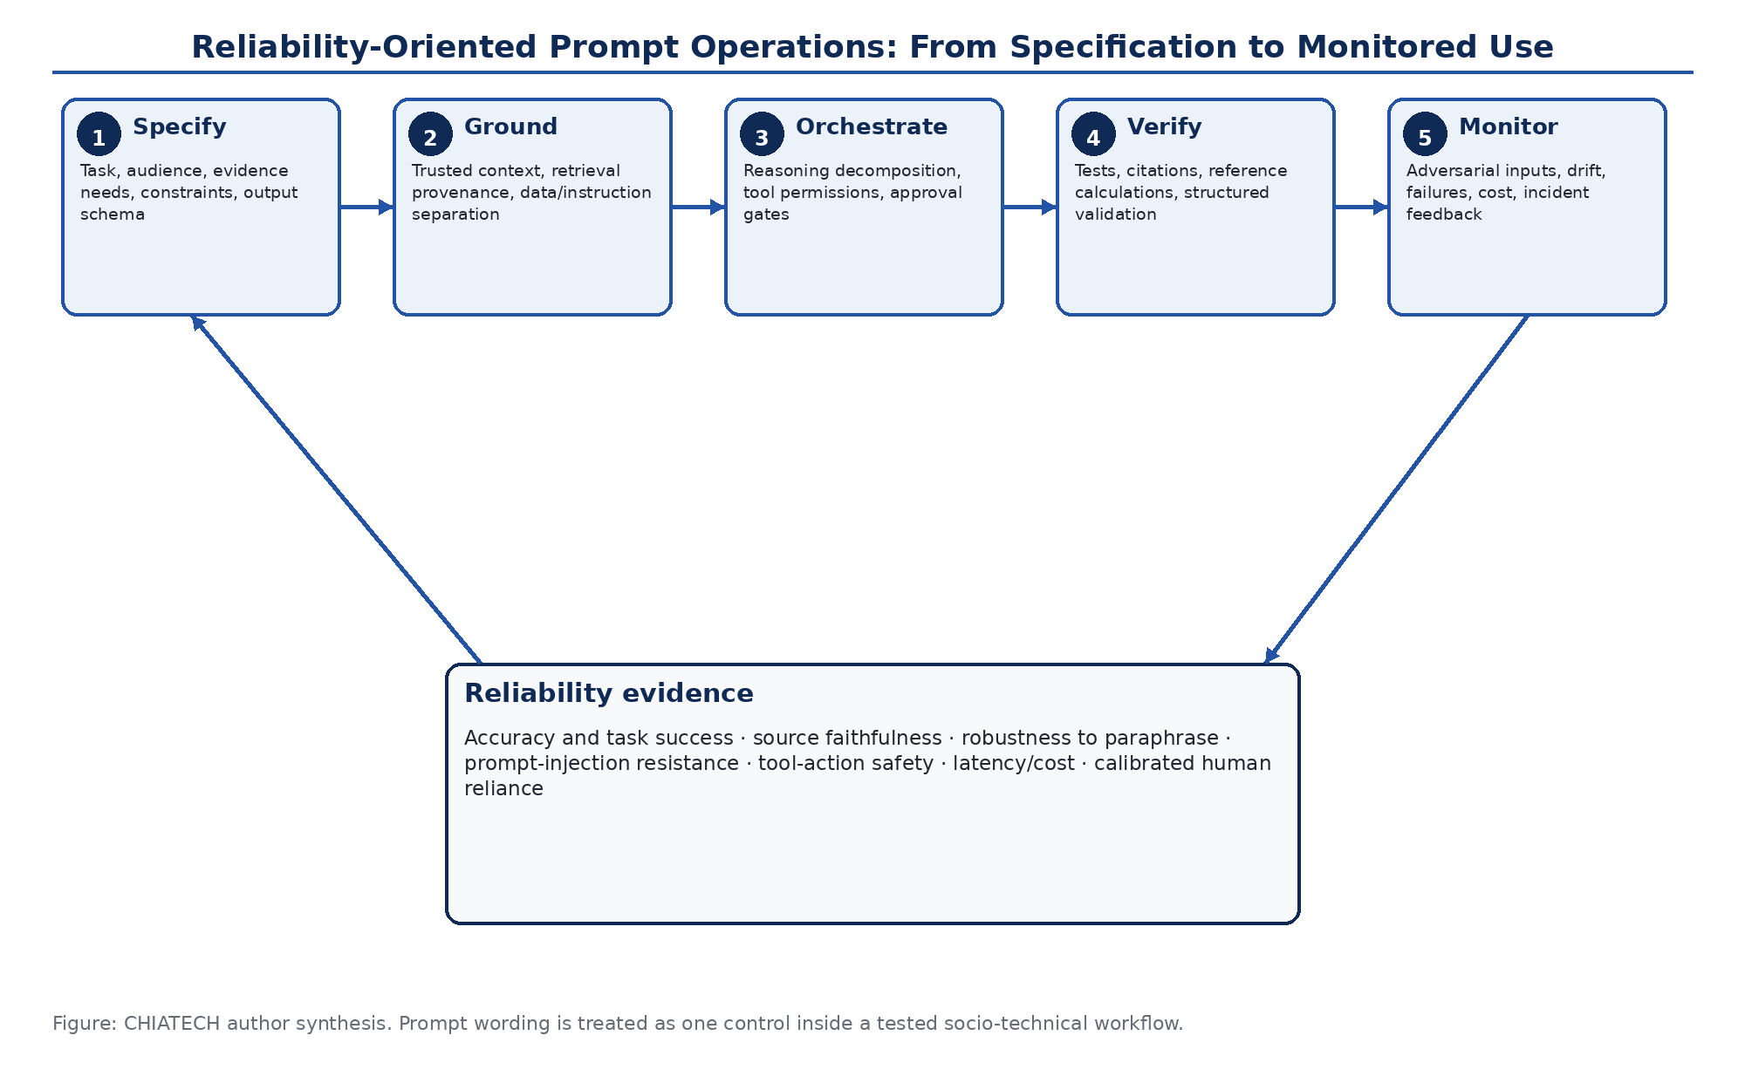
Figure 2. Reliability-oriented PromptOps lifecycle. Prompt quality is operationalized as a tested workflow linking task specification, grounding, tool governance, verification and post-deployment monitoring. Original author synthesis.
Table 2. Common LLM workflow failure modes and publication-grade controls
Failure mode | Why prompt wording alone is insufficient | Primary control
Unsupported factual generation | Fluent text can conceal absent or stale evidence. | Ground against approved sources; require claim-level citation or deterministic verification.
Prompt injection | Untrusted content can contain competing instructions. | Separate data from instructions; apply least-privilege tools, action allowlists and approval gates.
Tool misuse | A plausible language error can become a consequential external action. | Typed schemas, sandboxing, transaction limits, pre-execution validation and human confirmation.
Output drift after model update | The same prompt can behave differently across model versions. | Version prompts and models; maintain regression sets and acceptance thresholds.
Reasoning inconsistency | A convincing rationale may not correspond to the correct answer. | Evaluate final outputs with reference calculations, executable tests or independent checks.
Over-trust by users | Fluency can inflate confidence beyond actual model competence. | Uncertainty cues, provenance, review protocols and training for calibrated reliance.

9. Conclusion
Prompt engineering is no longer adequately described as the art of asking an AI better questions. It is a systems discipline that connects human intent to model behavior through task specification, grounding, scaffolding, tool control and verification. The most important advance is conceptual: prompt quality should be measured by reliable task completion under realistic failure conditions, not by eloquence of the prompt or fluency of the response.

Declarations

Ethics: Not applicable; this article reports no new human- or animal-participant research.
Funding: The author declares that no external funding was received specifically for this article.
Competing interests: The author declares no competing interests.
Data availability: No new primary dataset was generated. The analysis is based on the peer-reviewed and authoritative sources cited in the article.
Author contributions: CHIA Shiaondo Kenneth: conceptualization, critical literature synthesis, framework development, interpretation, visualization and manuscript authorship.
AI-assisted editorial support: AI-assisted tools were used for language refinement, formatting and consistency checking. They were not used as authors or as substitutes for scholarly judgement; responsibility for source verification, interpretation and final approval remains with the author and journal editor.

References
Autio, C., Schwartz, R., Dunietz, J., Jain, S., Stanley, M., Tabassi, E., Hall, P., & Roberts, K. (2024). Artificial Intelligence Risk Management Framework: Generative Artificial Intelligence Profile (NIST AI 600-1). NIST. https://doi.org/10.6028/NIST.AI.600-1
Lewis, P., Perez, E., Piktus, A., Petroni, F., Karpukhin, V., Goyal, N., Küttler, H., Lewis, M., Yih, W.-t., Rocktäschel, T., Riedel, S., & Kiela, D. (2020). Retrieval-augmented generation for knowledge-intensive NLP tasks. Advances in Neural Information Processing Systems, 33, 9459–9474.
Sahoo, P., Singh, A. K., Saha, S., Jain, V., Mondal, S., & Chadha, A. (2024). A systematic survey of prompt engineering in large language models: Techniques and applications. arXiv:2402.07927.
Schulhoff, S., Ilie, M., Balepur, N., Kahadze, K., Liu, A., Si, C., Li, Y., Gupta, A., Han, H., Schulhoff, S., et al. (2024). The Prompt Report: A systematic survey of prompting techniques. arXiv:2406.06608.
Wang, X., Wei, J., Schuurmans, D., Le, Q. V., Chi, E. H., Narang, S., Chowdhery, A., & Zhou, D. (2023). Self-consistency improves chain of thought reasoning in language models. International Conference on Learning Representations.
Wei, J., Wang, X., Schuurmans, D., Bosma, M., Ichter, B., Xia, F., Chi, E., Le, Q. V., & Zhou, D. (2022). Chain-of-thought prompting elicits reasoning in large language models. Advances in Neural Information Processing Systems, 35, 24824–24837.
White, J., Fu, Q., Hays, S., Sandborn, M., Olea, C., Gilbert, H., Elnashar, A., Spencer-Smith, J., & Schmidt, D. C. (2023). A prompt pattern catalog to enhance prompt engineering with ChatGPT. Proceedings of the 30th Conference on Pattern Languages of Programs. https://doi.org/10.64346/PLoP2023p05
Yao, S., Zhao, J., Yu, D., Du, N., Shafran, I., Narasimhan, K., & Cao, Y. (2023). ReAct: Synergizing reasoning and acting in language models. International Conference on Learning Representations.
Zhou, Y., Muresanu, A. I., Han, Z., Paster, K., Pitis, S., Chan, H., & Ba, J. (2023). Large language models are human-level prompt engineers. International Conference on Learning Representations.
Cui, C., Wu, Y., Backes, M., & Zhang, Y. (2026). Rethinking assessments of prompt injection attacks. Findings of the Association for Computational Linguistics: ACL 2026, 23773–23799. https://doi.org/10.18653/v1/2026.findings-acl.1191
Suggested citation: Chia, S. K. (2026). Prompt Engineering for Reliable Large-Language-Model Interaction: From Instruction Design and Grounding to Evaluation and Prompt-Injection Resilience. CHIATECH JOURNAL · SETEHEM, 1(1), e026.
© 2026 CHIA Shiaondo Kenneth. Published by CHIATECH JOURNAL · SETEHEM under the Creative Commons Attribution 4.0 International (CC BY 4.0) licence.

