CHIATECH JOURNAL
  - SETEHEM · VOLUME 1 · ISSUE 2 · AUGUST 2026 · e027
  - PIONEER PUBLICATION · ACCEPTED ARTICLE · CRITICAL REVIEW AND CONCEPTUAL FRAMEWORK ARTICLE · ARTIFICIAL INTELLIGENCE · ROBOTICS · ENGINEERING · SAFETY

Explainable Deep Reinforcement Learning in Robotics: A Taxonomy of Explanations, Evaluation Criteria and Safety-Critical Deployment
CHIA Shiaondo Kenneth
CHIATECH Solutions and Resources Ltd, Abuja, Nigeria
ORCID: 0009-0009-6434-4586 · Correspondence: chiakenneth01@gmail.com
Article | Volume/Issue | Publication | ISSN | DOI
e027 | 1(1) | Pioneer Issue · August 2026 | Pending assignment | Pending registration

Abstract
Background: Deep reinforcement learning (DRL) can support robotic control, navigation and manipulation, but opaque policies create obstacles for debugging, operator trust and safety assurance. Objective: This article is a critical review and deployment framework for explainable reinforcement learning (XRL) in robotics. Methods: The analysis synthesizes XRL taxonomies, explainable-AI concepts and safe-learning literature, organizing methods by stakeholder question, temporal scope and explanation mechanism. Results: Explanations can target state features, action choice, reward structure, trajectories, counterfactual alternatives or policy summaries. Post-hoc attribution, surrogate models, trajectory examples and natural-language summaries can make behavior more inspectable, but explanation quality is multidimensional. Fidelity, stability, completeness, comprehensibility and actionability must be evaluated separately. In robotics, explanation does not constitute a safety certificate: a plausible explanation may still describe an unsafe policy. The proposed assurance stack therefore couples XRL with constrained action spaces, runtime monitors, fallback controllers, logging and human escalation. Conclusion: XRL is most valuable when linked to a concrete stakeholder decision—debugging, supervision, incident investigation or acceptance testing—and evaluated for both faithfulness to the policy and usefulness to the human operator. Safe robotic deployment requires explainability and control assurance to be designed together.
Keywords: explainable AI; reinforcement learning; robotics; deep reinforcement learning; safe learning; human–robot interaction; AI assurance

1. Introduction
DRL policies can achieve sophisticated behavior while remaining difficult for operators to interpret. In a robot, that opacity is not merely a usability issue: decisions unfold over time, actions alter the physical environment, sensors are imperfect and safety constraints may be violated before a human can intervene. Explainability is therefore an assurance problem as well as a usability problem, requiring methods that reveal policy behavior without confusing interpretability with proof of safety.
Explainable reinforcement learning has grown into a distinct research area. Bekkemoen (2024) reviewed 189 XRL studies and emphasized that explanation method should be selected according to the stakeholder question. Milani et al. (2024) similarly note that RL creates unique explainability challenges because the agent’s objective, state transitions and temporal consequences matter in addition to an individual prediction. Robotics adds physical safety, distribution shift and human–robot coordination to that challenge.

2. Why DRL Explanations Are Different
In supervised learning, an explanation may ask why one input produced one classification. In RL, the relevant question is often sequential: why did the agent select this action now, how did earlier states influence the decision, what future outcome was it optimizing, and what alternative action would have changed the trajectory? Reward design further complicates interpretation because a policy can exploit unintended aspects of the reward function while appearing successful on a narrow metric.
Four stakeholder questions organize this review: What did the agent attend to? Why did it choose this action? What alternative actions or trajectories were available? What constraint or safety mechanism prevented unacceptable behavior? These questions correspond to different explanation types and should not be collapsed into one generic 'interpretability score.'
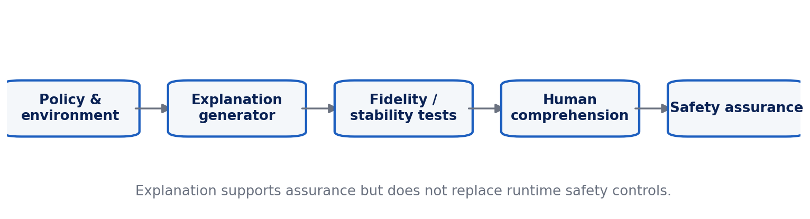
Figure 1. Explainability-to-assurance stack for DRL-based robotic systems.

3. Taxonomy of XRL Methods for Robotics
Feature- and saliency-based methods attribute a decision to elements of the observation, such as image regions, lidar features or state variables. They can be useful for sensor debugging but may be unstable and can be difficult to interpret when temporal history matters. Reward decomposition explains the contribution of reward components and can reveal undesirable optimization incentives. Policy summarization and surrogate models approximate complex policies with simpler rules or decision structures, trading fidelity for comprehensibility.
Trajectory-based explanations use representative episodes, critical states or contrastive examples to show how behavior unfolds. Counterfactual explanations ask what would have changed the action or outcome, which aligns well with operator questions such as 'Would the robot still turn left if the pedestrian were two metres farther away?' Natural-language explanations can improve accessibility but introduce a separate generation problem: the verbal explanation must be checked against the actual policy rather than evaluated only for plausibility.

4. Evaluation: Fidelity Is Necessary but Not Sufficient
Table 1. Explainable Deep Reinforcement Learning in Robotics: analytical matrix.
Evaluation dimension | Question | Example evidence
Fidelity | Does the explanation reflect the actual policy? | Perturbation tests, surrogate agreement, causal interventions.
Stability | Do similar states receive compatible explanations? | Sensitivity under small observation changes.
Completeness | Does it cover relevant temporal/reward factors? | Trajectory and reward-component coverage.
Comprehensibility | Can intended users correctly interpret it? | Human prediction/quiz accuracy, time to understand.
Actionability | Does it help diagnosis or intervention? | Fault localization, faster recovery, better override decisions.
Safety utility | Does it improve detection of unsafe behavior? | Constraint-violation identification and calibrated intervention.
Operational cost | Can explanation be produced in time? | Latency, compute and memory overhead.

5. From Explainability to Safety Assurance
Safe-learning research emphasizes constrained and certifiable behavior rather than explanation alone. Brunke et al. (2022) review approaches including robust control, model-predictive methods, safety filters and safe RL. These mechanisms address whether an action is permitted or whether a system can remain inside an acceptable operating envelope. XRL addresses a different question: whether humans can understand, diagnose or supervise the learned behavior.
The proposed assurance stack places the learned policy and environment at the bottom, followed by an explanation generator, quantitative explanation tests, human-comprehension testing and independent safety controls. Runtime monitors should detect violations or novel states; a safety shield or fallback controller should constrain action where feasible; event logs should preserve states, actions, explanations and interventions for post-incident analysis. For high-risk deployments, human override and explicit operational boundaries remain necessary even when explanations are strong.

6. Reproducible Evaluation Protocol for Explainable Robotic Policies
A reproducible XRL robotics study should specify one robotic task and policy, preregister stakeholder questions, select at least two complementary explanation methods, and evaluate both task performance and explanation properties. The test set should include normal operation, distribution shifts and controlled failure cases. Human studies should separate perceived trust from calibrated understanding; an explanation that increases confidence without increasing the ability to predict or diagnose robot behavior is potentially harmful.
Metrics should include task reward/success, constraint violations, explanation fidelity, stability under small perturbations, latency, human prediction accuracy, diagnostic accuracy and time-to-intervention. Reproducibility requires software versions, seeds, environment settings, policy checkpoints and explanation parameters.

7. Limitations and Research Priorities
Current XRL methods are often evaluated on simulated tasks, small user studies or method-specific metrics, which makes cross-study comparison difficult. Natural-language explanations raise additional concerns about hallucinated rationales. Future work should develop benchmark suites where safety-critical events, operator questions and explanation-quality measures are standardized across robotic domains. There is also a need to study explanation under real-time constraints, multi-agent settings and long-horizon autonomy.

8. Human Factors, Incident Analysis and Assurance in Practice
A useful explanation should improve a human decision, not merely produce a visually attractive heat map. In supervisory robotics, operators may need to predict the agent's next action, judge whether a state is unfamiliar, decide when to take control or diagnose why a task failed. Human-subject evaluation should therefore use task-based measures—prediction accuracy, diagnostic accuracy, intervention quality and response time—rather than satisfaction or perceived trust alone.
Trust should be calibrated to system competence. Explanations can create an illusion of understanding when they are plausible but unfaithful. One practical test is forward prediction: after seeing the explanation, can an operator better anticipate what the policy will do in a new but related state? Another is fault localization: when a failure is introduced through a sensor, reward term or environmental change, does the explanation help the user identify the source? These measures connect interpretability to operational value.
Incident analysis creates a second use case. A robotic event log should preserve policy version, observations, selected actions, safety-filter interventions, relevant rewards and explanation outputs with synchronized timestamps. Post-incident review can then distinguish policy error, perception error, environmental novelty, unsafe reward incentives and human-supervision failures. Explanation methods that cannot be reproduced from recorded states have limited forensic value.
Assurance also requires organizational controls. Model updates and retraining should trigger regression tests on safety-critical scenarios and explanation behavior. Operators need clearly defined override authority, while engineers need escalation criteria for unexplained or unstable actions. Explanations should never be used to rationalize behavior after the fact when the underlying policy evidence does not support the narrative.
The strongest research direction is therefore integrated assurance: evaluate task success, constraints, explanation fidelity and human performance in the same experimental protocol. Such designs can reveal trade-offs—for example, whether a more comprehensible surrogate loses too much fidelity, or whether a high-fidelity explanation is too slow for real-time supervision. These trade-offs are central to deploying XRL outside simulation.

8.1 Stakeholder-Centred Explanation Selection
Explanation method should be chosen from the decision that a stakeholder must make. Engineers need causal or diagnostic evidence about sensors, reward terms and policy components; operators need concise trajectory or counterfactual information that supports intervention; safety teams need auditable evidence that constraints and fallback controls function independently of the explanation channel. This stakeholder distinction prevents a common category error in XRL research: treating a visually compelling attribution map as equally useful for debugging, real-time supervision and safety certification.
Recent work on integrated safety and explainability reinforces this separation. AEGIS-RL combines abstract explainable graphs with falsification-oriented safety analysis, illustrating a broader movement toward systems in which explanations help locate and understand unsafe behavior while independent methods search for counterexamples and enforce constraints (Le et al., 2026). For robotics, the resulting assurance case should join policy performance, explanation fidelity, human-task performance and safety-control effectiveness in a single test protocol.
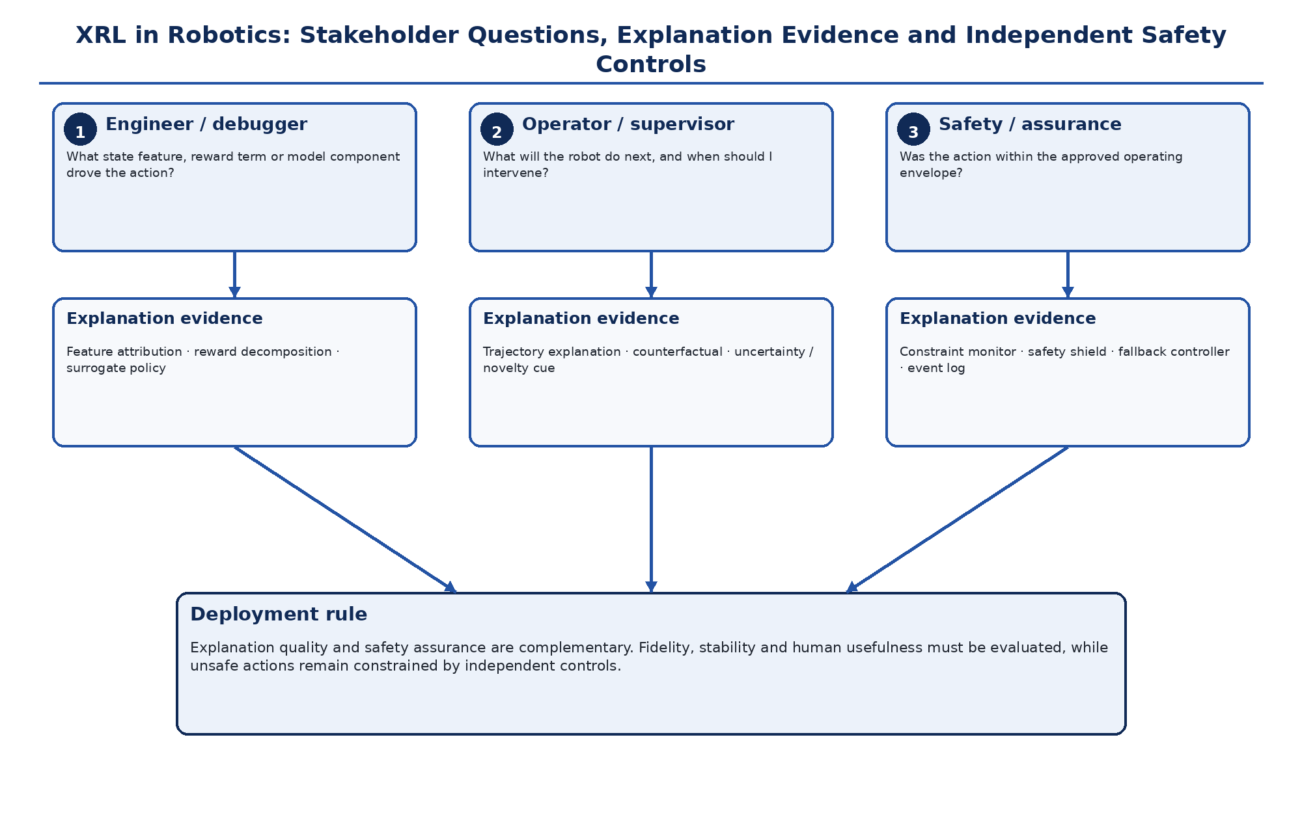
Figure 2. Stakeholder-centred XRL assurance map. Engineering diagnosis, operator supervision and safety assurance require different explanation evidence and independent controls. Original author synthesis.
Table 2. Explanation methods, useful questions and characteristic failure modes
Method family | Best question | Characteristic failure mode | Recommended validation
Feature/saliency attribution | Which observation features influenced the action? | Instability under small input changes; temporal context omitted. | Perturbation tests, repeatability and temporal sensitivity checks.
Reward decomposition | Which objective component shaped the action? | Reward terms may not explain representation or perception errors. | Counterfactual reward interventions and ablation.
Surrogate policy/rules | Can the policy be summarized compactly? | Comprehensibility may come at the cost of low fidelity. | Agreement on held-out trajectories and fidelity/error bounds.
Trajectory/example explanation | How did behavior unfold over time? | Cherry-picked episodes can hide rare unsafe behavior. | Coverage of normal, shifted and failure scenarios.
Counterfactual explanation | What minimal change would alter action or outcome? | Counterfactual may be infeasible or outside the robot dynamics. | Feasibility constraints and simulator/physical validation.
Natural-language rationale | Can a human rapidly understand the decision? | Plausible but unfaithful explanations may create over-trust. | Trace rationale to policy evidence; test forward prediction and fault localization.

9. Conclusion
Explainability can make DRL-based robotic systems more inspectable, debuggable and governable, but it is not a substitute for safe control. The strongest design principle is to connect every explanation to a stakeholder decision and every safety claim to an independent control or test. Robotics requires both: explanations that faithfully expose why the policy behaves as it does, and assurance mechanisms that limit what the policy is allowed to do.

Declarations

Ethics: Not applicable; this article reports no new human- or animal-participant research.
Funding: The author declares that no external funding was received specifically for this article.
Competing interests: The author declares no competing interests.
Data availability: No new primary dataset was generated. The analysis is based on the peer-reviewed and authoritative sources cited in the article.
Author contributions: CHIA Shiaondo Kenneth: conceptualization, critical literature synthesis, framework development, interpretation, visualization and manuscript authorship.
AI-assisted editorial support: AI-assisted tools were used for language refinement, formatting and consistency checking. They were not used as authors or as substitutes for scholarly judgement; responsibility for source verification, interpretation and final approval remains with the author and journal editor.

References
Arrieta, A. B., Díaz-Rodríguez, N., Del Ser, J., Bennetot, A., Tabik, S., Barbado, A., García, S., Gil-López, S., Molina, D., Benjamins, R., Chatila, R., & Herrera, F. (2020). Explainable artificial intelligence (XAI): Concepts, taxonomies, opportunities and challenges toward responsible AI. Information Fusion, 58, 82–115. https://doi.org/10.1016/j.inffus.2019.12.012
Bekkemoen, Y. (2024). Explainable reinforcement learning (XRL): A systematic literature review and taxonomy. Machine Learning, 113, 355–441. https://doi.org/10.1007/s10994-023-06479-7
Brunke, L., Greeff, M., Hall, A. W., Yuan, Z., Zhou, S., Panerati, J., & Schoellig, A. P. (2022). Safe learning in robotics: From learning-based control to safe reinforcement learning. Annual Review of Control, Robotics, and Autonomous Systems, 5, 411–444. https://doi.org/10.1146/annurev-control-042920-020211
Dazeley, R., Vamplew, P., & Cruz, F. (2023). Explainable reinforcement learning for broad-XAI: A conceptual framework and survey. Neural Computing and Applications, 35, 16893–16916.
Gu, S., Yang, L., Du, Y., Chen, G., Walter, F., Wang, J., & Knoll, A. (2024). A review of safe reinforcement learning: Methods, theories and applications. IEEE Transactions on Pattern Analysis and Machine Intelligence, 46(12), 11216–11235. https://doi.org/10.1109/TPAMI.2024.3457538
Milani, S., Topin, N., Veloso, M., & Fang, F. (2024). Explainable reinforcement learning: A survey and comparative review. ACM Computing Surveys, 56(7), Article 168. https://doi.org/10.1145/3616864
Sutton, R. S., & Barto, A. G. (2018). Reinforcement learning: An introduction (2nd ed.). MIT Press.
Doshi-Velez, F., & Kim, B. (2017). Towards a rigorous science of interpretable machine learning. arXiv:1702.08608.
Le, T., Shefin, R., Gupta, D., Le, T., & Alqahtani, S. (2026). AEGIS-RL: Abstract, explainable graphs for integrated safety in RL. Autonomous Agents and Multi-Agent Systems, 40, 33. https://doi.org/10.1007/s10458-026-09749-5
Suggested citation: Chia, S. K. (2026). Explainable Deep Reinforcement Learning in Robotics. CHIATECH JOURNAL · SETEHEM, 1(1), e027.
© 2026 CHIA Shiaondo Kenneth. Published by CHIATECH JOURNAL · SETEHEM under the Creative Commons Attribution 4.0 International (CC BY 4.0) licence.

