CHIATECH JOURNAL
  - SETEHEM · VOLUME 1 · ISSUE 2 · AUGUST 2026 · e028
  - PIONEER PUBLICATION · ACCEPTED ARTICLE · EVIDENCE-INFORMED DESIGN FRAMEWORK ARTICLE · EDUCATION · HIGHER EDUCATION · EDUCATIONAL TECHNOLOGY · FACULTY DEVELOPMENT

Microlearning for Faculty TPACK Development in Higher Education: An Evidence-Informed Design and Evaluation Framework
CHIA Shiaondo Kenneth
CHIATECH Solutions and Resources Ltd, Abuja, Nigeria
ORCID: 0009-0009-6434-4586 · Correspondence: chiakenneth01@gmail.com
Article | Volume/Issue | Publication | ISSN | DOI
e028 | 1(1) | Pioneer Issue · August 2026 | Pending assignment | Pending registration

Abstract
Background: Faculty are expected to integrate rapidly changing digital and AI tools into teaching, yet professional development is often detached from disciplinary content, constrained by time and evaluated mainly through self-report. Objective: This article develops an evidence-informed microlearning architecture for strengthening faculty TPACK through authentic, discipline-linked practice and multi-source evaluation. Methods: A critical design synthesis connected the Technological Pedagogical Content Knowledge (TPACK) framework with recent systematic reviews of micro-courses, teacher digital competence and AI-focused professional development. Results: Microlearning is most defensible when short modules are embedded in an iterative cycle of diagnosis, focused instruction, authentic teaching practice, feedback, reflection and evidence of transfer. Five-to-ten-minute units can lower participation barriers, but duration alone does not create learning; modules must be sequenced around real pedagogical problems and supported by practice. The proposed 12-week model progresses from baseline diagnosis and core integration decisions to discipline-specific design, assessment/AI use and classroom transfer. Evaluation should combine TPACK measures with artifact rubrics, technology-use logs, observations, student feedback and interviews. Conclusion: Microlearning can be a practical delivery architecture for faculty TPACK development, but its effectiveness depends on coherence, authentic application, institutional support and multi-source evaluation rather than on the brevity of content.
Keywords: TPACK; microlearning; faculty development; higher education; teacher digital competence; professional development; AI in education

1. Introduction
Faculty development is most credible when programme design and evaluation are specified together. A 12-week mobile microlearning architecture with five-to-ten-minute units can be evaluated through pre/post TPACK measures, technology-use logs, student feedback, interviews, observations, reflective journals and scored teaching artifacts. This combination makes it possible to distinguish perceived confidence from demonstrated instructional transfer.
TPACK remains a useful framework for this design because it rejects the idea that technology knowledge can be developed independently of pedagogy and content. Mishra and Koehler (2006) conceptualized technology integration as a situated interaction among technological, pedagogical and content knowledge. In practice, a faculty member does not need generic competence with every tool; the more consequential question is whether the selected technology improves the teaching of specific disciplinary ideas for specific learners.
Microlearning offers a potential response to the time constraints of academic work. Recent systematic evidence on higher-education micro-courses suggests that short, flexible and contextualized formats can support teacher digital competence, while recent reviews of AI professional development emphasize the importance of TPACK alignment, authentic practice and sustained support (Dogan et al., 2025; Trujillo-Juárez et al., 2025).

2. Design Principles
The first principle is diagnosis before delivery. Faculty differ widely in digital confidence, teaching context, disciplinary practices and access to institutional systems. A common course sequence can therefore waste time on familiar tools while overlooking weak areas such as digital assessment, accessibility, data ethics or AI-supported feedback. Baseline diagnosis should combine self-report with at least one authentic design or performance task.
The second principle is pedagogical anchoring. Every technology module should start with a teaching problem—such as making an abstract process visible, eliciting student reasoning, providing feedback at scale or supporting collaboration—rather than with a tool feature list. This preserves the PCK core of TPACK and reduces the risk of technology adoption for its own sake.
The third principle is micro-practice. A five-minute explanation should be followed by a small act of teaching design: revise one slide sequence, build one formative check, create one accessible resource, analyze one AI-generated response or redesign one assessment prompt. The fourth principle is feedback and reflection, and the fifth is transfer: evidence should show whether faculty use the new integration strategy in a real course and whether that use is pedagogically coherent.
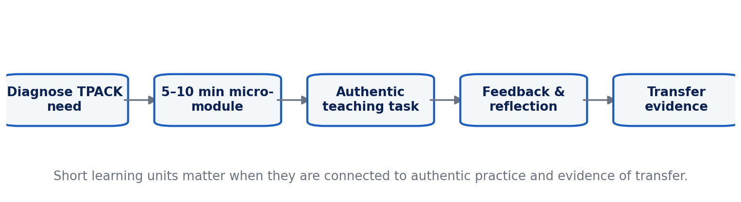
Figure 1. Practice-linked microlearning cycle for faculty TPACK development.

3. Content Design for the AI Era
Current faculty development must extend beyond conventional learning-management systems and presentation software. AI introduces new TPACK questions: when does a generative model support disciplinary thinking, when does it bypass desirable struggle, how should outputs be verified, and how should assessment be redesigned when students have ubiquitous access to generation tools? AI professional development should therefore include prompt/evidence design, output verification, academic integrity, privacy, accessibility and discipline-specific use cases rather than generic demonstrations.
Microlearning is well suited to this rapidly changing environment because small units can be revised more easily than monolithic courses. However, constant tool updates can fragment the curriculum. A stable conceptual spine—learning objectives, evidence, feedback, cognitive load, accessibility, assessment validity and responsible data use—allows specific technologies to change without making the professional-development programme obsolete.

4. Proposed 12-Week Microlearning Architecture
Table 1. Microlearning for Faculty TPACK Development in Higher Education: analytical matrix.
Phase | Weeks | Microlearning focus | Authentic evidence
Diagnose & orient | 1–2 | Baseline TPACK, digital ethics, learning goals, accessibility. | Baseline task, personal integration goal, course-context map.
Integrate & design | 3–5 | Representation, interaction, formative assessment, collaboration. | Redesigned lesson segment and peer feedback.
Deepen by discipline | 6–8 | Discipline-specific simulations, data tools, media, coding or specialist platforms. | Disciplinary learning artifact with rationale.
AI & assessment | 9–10 | Generative AI, verification, feedback, assessment redesign, academic integrity. | AI-use protocol and revised assessment.
Transfer & evaluate | 11–12 | Classroom implementation, reflection, evidence collection, next-step planning. | Observed/implemented activity, student evidence, reflective portfolio.

5. Evaluation Framework
Statistical procedures should follow the study design rather than be selected by convention. For a single cohort, pre/post comparisons can estimate change; for multiple disciplinary or intervention groups, mixed or multilevel models may better reflect nested data. Effect sizes and confidence intervals should accompany significance tests. Reliability testing is necessary but does not establish construct validity by itself.
Self-reported TPACK should not be the sole outcome. Recent validity work warns that perceptions of technology knowledge may diverge from demonstrated performance. A stronger evaluation triangulates six forms of evidence: validated TPACK/digital-competence measures, lesson or assessment artifacts scored with a rubric, platform or technology-use logs, structured teaching observations, student feedback and qualitative accounts of transfer barriers. The critical outcome is not whether faculty enjoyed the micro-course, but whether they made better technology-pedagogy-content decisions in authentic teaching.

6. Institutional Conditions for Success
Individual development is constrained by infrastructure, workload, policy and local support. Departments should provide protected time, exemplars from the same discipline, accessible technology, technical support and communities of practice. Recognition systems should value evidence of teaching improvement rather than tool adoption counts. Where AI or analytics are involved, institutional guidance on privacy, intellectual property, accessibility and human oversight should accompany training.

7. Research Agenda and Limitations
The 12-week architecture is an evidence-informed design proposition rather than a claim that one fixed dosage will produce identical effects across institutions. Comparative studies should examine alternative module doses, spacing schedules and support models, retention beyond the immediate post-test, and transfer across disciplines. Cost and participation equity also matter: flexible digital delivery may broaden access, but faculty with weak connectivity, limited devices or heavy teaching loads can still be excluded.

8. Implementation Roadmap for Higher-Education Institutions
A university can implement the framework without launching a large centralized programme at once. The first stage is an institutional needs audit that combines faculty self-assessment, samples of teaching artifacts and strategic priorities such as online learning, assessment redesign, accessibility or responsible AI. Results should be analyzed by discipline and role because the relevant technological-pedagogical-content intersections differ between laboratory science, quantitative courses, humanities seminars and professional programmes.
The second stage is to build a small core catalogue of reusable micro-modules linked to authentic outputs. Each module should state a teaching problem, demonstrate one integration strategy, provide an example from a discipline, require a micro-practice task and end with a verification or reflection prompt. Modules should be accessible on mobile devices, downloadable where connectivity is uneven and designed so that screen-reader and captioning requirements are met.
The third stage is supported transfer. Departments can run short design clinics where faculty bring a real lesson or assessment and adapt it with a colleague or learning designer. Peer examples are valuable because they show what TPACK looks like inside a disciplinary culture. Communities of practice can also surface local constraints that a generic course misses, including class size, laboratory availability, accreditation rules and assessment expectations.
The fourth stage is evidence-based recognition. Completion badges alone reward participation, not teaching improvement. A stronger model recognizes portfolios containing a redesigned artifact, implementation evidence, student response and reflection on what changed. Such evidence can support teaching awards, probation or promotion dossiers where institutional policy allows, increasing the likelihood that faculty development is treated as professional work rather than optional remediation.
Finally, the programme itself should be reviewed each semester. Modules with low transfer, high dropout or persistent misconceptions should be redesigned. Emerging tools can be added without abandoning the stable TPACK logic. This continuous-improvement approach is particularly important for generative AI, where product capabilities change rapidly but pedagogical questions about evidence, feedback, learning goals and assessment validity remain comparatively stable.

8.1 Construct Validity and Evidence Triangulation
TPACK evaluation is vulnerable to construct inflation when self-reported confidence is treated as equivalent to demonstrated capability. A faculty member may report confidence with a learning-management system yet still choose technology that weakens disciplinary representation, assessment validity or accessibility. Recent review evidence on TPACK instruments likewise emphasizes the importance of instrument purpose and validity when technology selection is the target construct (Gonscherowski & Rott, 2026).
A stronger evaluation strategy triangulates three levels of evidence. The first is knowledge and judgment, captured by TPACK or digital-competence measures and scenario-based decisions. The second is artifact quality, captured through rubrics applied to lesson plans, assessments, media or AI-use protocols. The third is enacted transfer, captured through observation, platform traces, student work and reflective interviews. Convergence across these levels provides a more defensible account of professional learning than satisfaction or self-report alone.
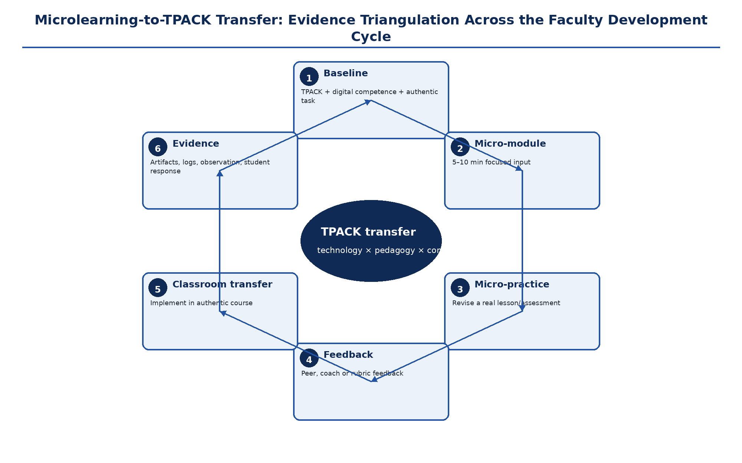
Figure 2. Microlearning-to-TPACK transfer and evidence-triangulation cycle. Short inputs are linked to authentic faculty practice, feedback, classroom transfer and multiple forms of evidence. Original author synthesis.
Table 2. Multi-source evaluation framework for faculty TPACK development
Evidence source | What it measures | Strength | Interpretive caution
Validated TPACK/digital-competence scale | Perceived or scenario-based knowledge integration | Efficient baseline/post-program comparison | Self-report can overestimate enacted competence.
Teaching/assessment artifact rubric | Quality of technology–pedagogy–content design decisions | Direct evidence of design competence | Rubric quality and inter-rater reliability are essential.
Teaching observation | Enacted classroom integration | Captures implementation and adaptation | Observer presence and limited sampling can affect inference.
Technology-use logs | Frequency and patterns of platform/tool use | Behavioral trace independent of recall | Use does not automatically imply pedagogical quality.
Student evidence | Learning products, feedback, engagement or performance | Connects faculty practice to learner experience | Outcomes are influenced by many factors beyond faculty development.
Reflective interview/journal | Mechanisms, barriers and professional reasoning | Explains why transfer succeeds or fails | Requires systematic coding and attention to social desirability.

9. Conclusion
Microlearning can make faculty development more feasible, but brevity is only a delivery characteristic. TPACK development requires coherent learning goals, authentic teaching problems, guided practice, feedback and evidence of classroom transfer. The proposed 12-week architecture converts short modules into a cumulative professional-learning pathway and provides a testable foundation for future empirical evaluation.

Declarations

Ethics: Not applicable; this article reports no new human- or animal-participant research.
Funding: The author declares that no external funding was received specifically for this article.
Competing interests: The author declares no competing interests.
Data availability: No new primary dataset was generated. The analysis is based on the peer-reviewed and authoritative sources cited in the article.
Author contributions: CHIA Shiaondo Kenneth: conceptualization, critical literature synthesis, framework development, interpretation, visualization and manuscript authorship.
AI-assisted editorial support: AI-assisted tools were used for language refinement, formatting and consistency checking. They were not used as authors or as substitutes for scholarly judgement; responsibility for source verification, interpretation and final approval remains with the author and journal editor.

References
Backfisch, I., Scherer, R., Schneider, J., & Lachner, A. (2025). Validity of self-report measures of teachers’ technological pedagogical content knowledge: A meta-analytic perspective. Educational Research Review, 49, 100718.
Dogan, S., Nalbantoglu, U. Y., Celik, I., & Agacli Dogan, N. (2025). Artificial intelligence professional development: A systematic review of TPACK, designs, and effects for teacher learning. Professional Development in Education, 51(3), 519–546. https://doi.org/10.1080/19415257.2025.2454457
Mishra, P., & Koehler, M. J. (2006). Technological pedagogical content knowledge: A framework for teacher knowledge. Teachers College Record, 108(6), 1017–1054. https://doi.org/10.1111/j.1467-9620.2006.00684.x
Trujillo-Juárez, S.-I., Chaparro-Sánchez, R., Morita-Alexander, A., Escudero-Nahón, A., & Delgado-González, A. (2025). Strengthening teacher digital competence in higher education through micro-courses: A systematic literature review. Discover Education, 4, 247. https://doi.org/10.1007/s44217-025-00687-0
UNESCO. (2023). Guidance for generative AI in education and research. UNESCO. https://doi.org/10.54675/EWZM9535
Voogt, J., Fisser, P., Pareja Roblin, N., Tondeur, J., & van Braak, J. (2013). Technological pedagogical content knowledge—A review of the literature. Journal of Computer Assisted Learning, 29(2), 109–121. https://doi.org/10.1111/j.1365-2729.2012.00487.x
Gonscherowski, P., & Rott, B. (2026). A systematic review of the literature on TPACK instruments used with pre-service teachers from 2017 to 2023 focused on selecting digital resources. Journal of Computers in Education, 13, 945–982. https://doi.org/10.1007/s40692-025-00379-6
Suggested citation: Chia, S. K. (2026). Microlearning for Faculty TPACK Development in Higher Education. CHIATECH JOURNAL · SETEHEM, 1(1), e028.
© 2026 CHIA Shiaondo Kenneth. Published by CHIATECH JOURNAL · SETEHEM under the Creative Commons Attribution 4.0 International (CC BY 4.0) licence.

