CHIATECH JOURNAL
  - SETEHEM · Volume 1, Issue 1 · Pioneer July/August 2026 · Part 2 · e029
  - PIONEER PUBLICATION · ACCEPTED ARTICLE · CRITICAL REVIEW AND PEDAGOGICAL FRAMEWORK ARTICLE · STEM EDUCATION · AUGMENTED REALITY · PROBLEM-BASED LEARNING

Augmented-Reality-Enhanced Problem-Based Learning in STEM Education: Mechanisms, Evidence and an Implementation Framework for Engagement and Critical Thinking
CHIA Shiaondo Kenneth
CHIATECH Solutions and Resources Ltd, Abuja, Nigeria
ORCID: 0009-0009-6434-4586 · Correspondence: chiakenneth01@gmail.com
Article | Volume/Issue | Publication | ISSN | DOI
e029 | 1(1) | Pioneer July/August · Part 2 | Pending assignment | Pending registration

Abstract
Background: Augmented reality (AR) can overlay manipulable digital information on physical environments, while problem-based learning (PBL) organizes learning around authentic problems. Their combination is promising for STEM education but can also amplify cognitive load, novelty effects and access inequalities if technology is not pedagogically integrated. Objective: This article critically synthesizes evidence on augmented-reality-enhanced problem-based learning (AR-PBL) and develops an implementation and evaluation framework for engagement, critical thinking, conceptual learning and transfer. Methods: The framework draws on systematic reviews and meta-analytic evidence on AR/immersive STEM learning and PBL, while preserving The article’s emphasis on engagement, critical thinking and content learning. Results: Existing evidence supports positive average effects of AR on STEM achievement, but effect size varies by subject, learner level, design and implementation. AR contributes most when it makes invisible or spatial phenomena inspectable, supports manipulation and provides timely feedback inside a meaningful problem-solving cycle. The proposed five-stage model links authentic problems, AR visualization, inquiry/manipulation, collaborative solution building and reflection/transfer. Evaluation should separate behavioral, cognitive and emotional engagement from critical-thinking and content outcomes and should monitor cognitive load, accessibility and retention. Conclusion: AR is not a pedagogy and PBL is not improved merely by adding immersive media. Productive integration requires representational purpose, learner agency, structured collaboration, reflection and equitable access.
Keywords: augmented reality; problem-based learning; STEM education; critical thinking; student engagement; immersive learning; constructivism

1. Introduction
A rigorous evaluation of AR-enhanced PBL should compare it with an equally active non-AR PBL condition rather than with lecture alone, so that the incremental value of the technology can be separated from the effect of problem-based pedagogy. A 16-week design with approximately 200 undergraduate STEM learners can support this comparison when baseline equivalence, implementation fidelity, critical-thinking measures, content outcomes, delayed retention and process data are specified prospectively.
Systematic reviews provide a strong basis for this reframing. Ibáñez and Delgado-Kloos (2018) found that AR in STEM commonly supported information access and exploration but argued for stronger attention to science skills and metacognitive support. More recent evidence is larger: Wang et al. (2024) synthesized 33 studies and reported a moderate overall effect on STEM achievement (effect size 0.586), while Tene et al. (2024) found that immersive technologies generally supported engagement and performance but emphasized the need for adaptable, inclusive design. These findings justify investigation, not automatic adoption.

2. Theoretical Logic of AR-Enhanced PBL
PBL is grounded in active knowledge construction: learners confront a problem, identify what they need to know, investigate, propose solutions and reflect. AR can add representational affordances within that cycle by placing digital models, annotations or data in relation to physical objects and spaces. This is especially useful when STEM phenomena are invisible, too small, too large, dynamic, hazardous or spatially difficult to represent on a flat page.
The central design principle is representational necessity. If a conventional diagram communicates a concept adequately, AR may add unnecessary interaction cost. If understanding depends on spatial relation, embodied manipulation or real-time overlay, AR can reduce representational distance. The learning benefit is therefore mediated by task design, not by the technology label itself.
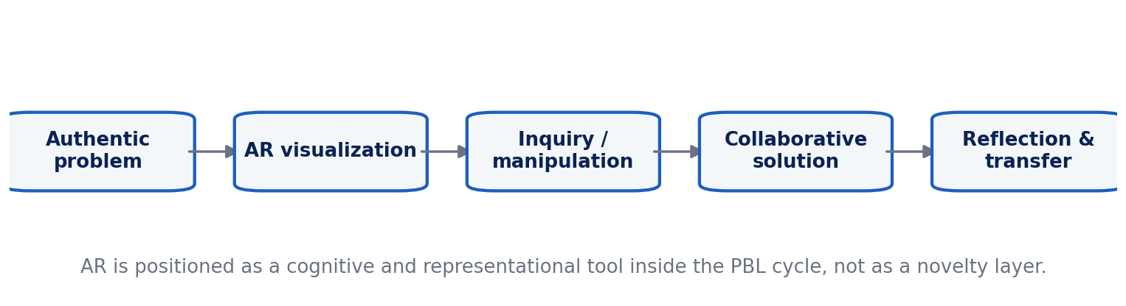
Figure 1. AR-enhanced PBL cycle for STEM learning.

3. Five-Stage Implementation Framework
Stage 1 establishes an authentic problem with a clear disciplinary outcome. Stage 2 introduces AR only where visualization or contextual overlay addresses a representational barrier. Stage 3 requires learners to manipulate variables, gather evidence or test interpretations rather than passively viewing a model. Stage 4 shifts from individual exploration to collaborative solution construction, with roles and evidence requirements that prevent superficial division of labour. Stage 5 makes reflection explicit: learners explain what changed in their model, which evidence supported the solution and how the solution transfers beyond the AR environment.

4. Evidence and Outcome Interpretation
Achievement effects reported in meta-analysis should be interpreted as an average across heterogeneous interventions, not a guaranteed gain for every AR lesson. Moderator analyses in Wang et al. (2024) indicate that effects vary across STEM domains and educational levels. The design of comparison groups is particularly important: AR versus lecture can confound technology with active pedagogy, while AR-enhanced PBL versus well-designed non-AR PBL provides a stronger test of the additional representational value of AR.
Engagement also requires conceptual precision. Time-on-task or excitement may reflect novelty rather than durable cognitive engagement. Evaluation should distinguish behavioral participation, emotional interest and cognitive investment. Critical thinking measures should assess analysis, evidence evaluation, inference and justification rather than only satisfaction with the technology.

5. Design Risks and Mitigations
Table 1. Augmented-Reality-Enhanced Problem-Based Learning in STEM Education: analytical matrix.
Design risk | Why it matters | Mitigation
Novelty effect | Initial excitement can be mistaken for sustained learning. | Use delayed measures and compare against equally active non-AR PBL.
Cognitive overload | Interface actions may compete with conceptual reasoning. | Minimize controls, sequence information, provide orientation and cues.
Representation mismatch | Visually impressive models may emphasize irrelevant features. | Map every AR element to a learning objective and evidence task.
Access inequality | Device quality, vision/mobility needs or connectivity can exclude learners. | Provide accessible alternatives, shared roles and offline-capable materials.
Collaboration without reasoning | Group work can become task division rather than joint sense-making. | Assign evidence roles, require shared justification and reflection.
Privacy / analytics | AR platforms may collect camera, location or interaction data. | Minimize data, document consent and follow institutional privacy rules.

6. Evaluation Blueprint for Future Empirical Testing
A robust empirical validation should use transparent pre/post and delayed-transfer logic. Groups should receive matched learning objectives, teacher time and problem difficulty. Baseline equivalence should be reported, and where random assignment is impossible, analysis should adjust for pre-test differences. Outcomes should include content knowledge, a validated critical-thinking measure, engagement subscales, delayed retention and task-specific transfer. Process data can capture AR interactions, collaboration and help-seeking.
Qualitative observations and interviews are valuable for identifying mechanisms: whether the overlay helped learners notice relevant features, whether collaboration became more evidence-based, and where interface demands distracted from reasoning. Effect sizes and confidence intervals should accompany significance tests, and adverse outcomes such as discomfort, exclusion or technical failure should be reported rather than omitted.

7. Implications for Resource-Constrained STEM Contexts
AR does not require a fully immersive headset. Smartphone or tablet-based overlays can reduce cost, but device ownership, camera quality, battery life, data connectivity and maintenance still shape access. Offline assets, shared-device roles and non-AR equivalent materials should be designed from the beginning. Teachers also require time to test markers, 3D models, instructions and fallback activities before class. In resource-constrained settings, pedagogical robustness matters more than technical spectacle.

8. Teacher Design Checklist and Research Priorities
Before selecting an AR platform, the teacher should be able to state the representational problem the technology solves. Useful questions include: What cannot students readily see or manipulate in the conventional lesson? Which features of the overlay must they attend to? What action will they perform with the representation, and what evidence will show that they understood the underlying STEM idea rather than simply navigated the interface? If these questions have weak answers, AR is probably not necessary.
The learning sequence should also control information density. Labels, animations, 3D objects and real-world camera views can compete for attention. Multimedia-learning principles suggest signaling important features, segmenting complex processes and removing decorative content that does not support the learning goal. Orientation time should be kept separate from conceptual assessment so that students are not penalized for unfamiliar interface mechanics.
Collaboration requires explicit design. Shared AR does not automatically produce shared reasoning. Teachers can assign roles such as evidence collector, model manipulator, skeptic and reporter, then rotate them across tasks. Group products should include a claim, supporting observations and a justification. Individual exit tasks are still useful for determining whether each learner can transfer the group’s reasoning independently.
Research should investigate durability as well as immediate performance. Delayed post-tests can distinguish learning from short-lived novelty; transfer tasks can determine whether students use the concept outside the AR context. Studies should report hardware, software version, tracking method, teacher preparation time, technical failures and accessibility accommodations because these implementation variables affect both effectiveness and scalability.
A final priority is comparative value. The right question is not whether AR can produce positive outcomes, but whether it produces enough additional learning, engagement or access to justify its cost relative to high-quality diagrams, physical models, simulations or non-AR PBL. Cost-effectiveness, teacher workload and equitable participation should become normal outcomes in AR-STEM research.

8.1 Learner Characteristics, Accessibility and Treatment Heterogeneity
Average effects can conceal substantial variation across learners. A 2025 systematic review of learner characteristics in AR-supported STEM found that only a small subset of studies explicitly tested interactions between learner characteristics and AR versus non-AR conditions, with spatial ability the most frequently examined factor and mixed evidence regarding its moderating role (2025 review in Learning and Individual Differences). This gap matters because AR can simultaneously reduce representational difficulty for some learners and increase navigation or cognitive-load demands for others.
Accessibility should therefore be treated as a design variable rather than a post-hoc accommodation. Equivalent non-AR representations, captioned and text-described content, device-sharing protocols, low-bandwidth/offline options and interaction alternatives for learners with visual or motor constraints should be planned before implementation. Equity analysis should report participation and outcome patterns by relevant access variables without assuming that device availability alone guarantees comparable learning opportunity.

8.2 Mechanism-Based Evaluation
The strongest AR-PBL studies test not only whether achievement changed but how the intervention produced that change. Process measures can capture whether learners inspected relevant spatial features, manipulated variables, revised hypotheses, used evidence in group discussion and transferred the resulting model to a non-AR problem. This mechanism-based approach helps distinguish learning from novelty and supports cost-effectiveness decisions: AR is justified when its representational affordance produces learning value that cannot be achieved as efficiently with diagrams, physical models or conventional simulations.
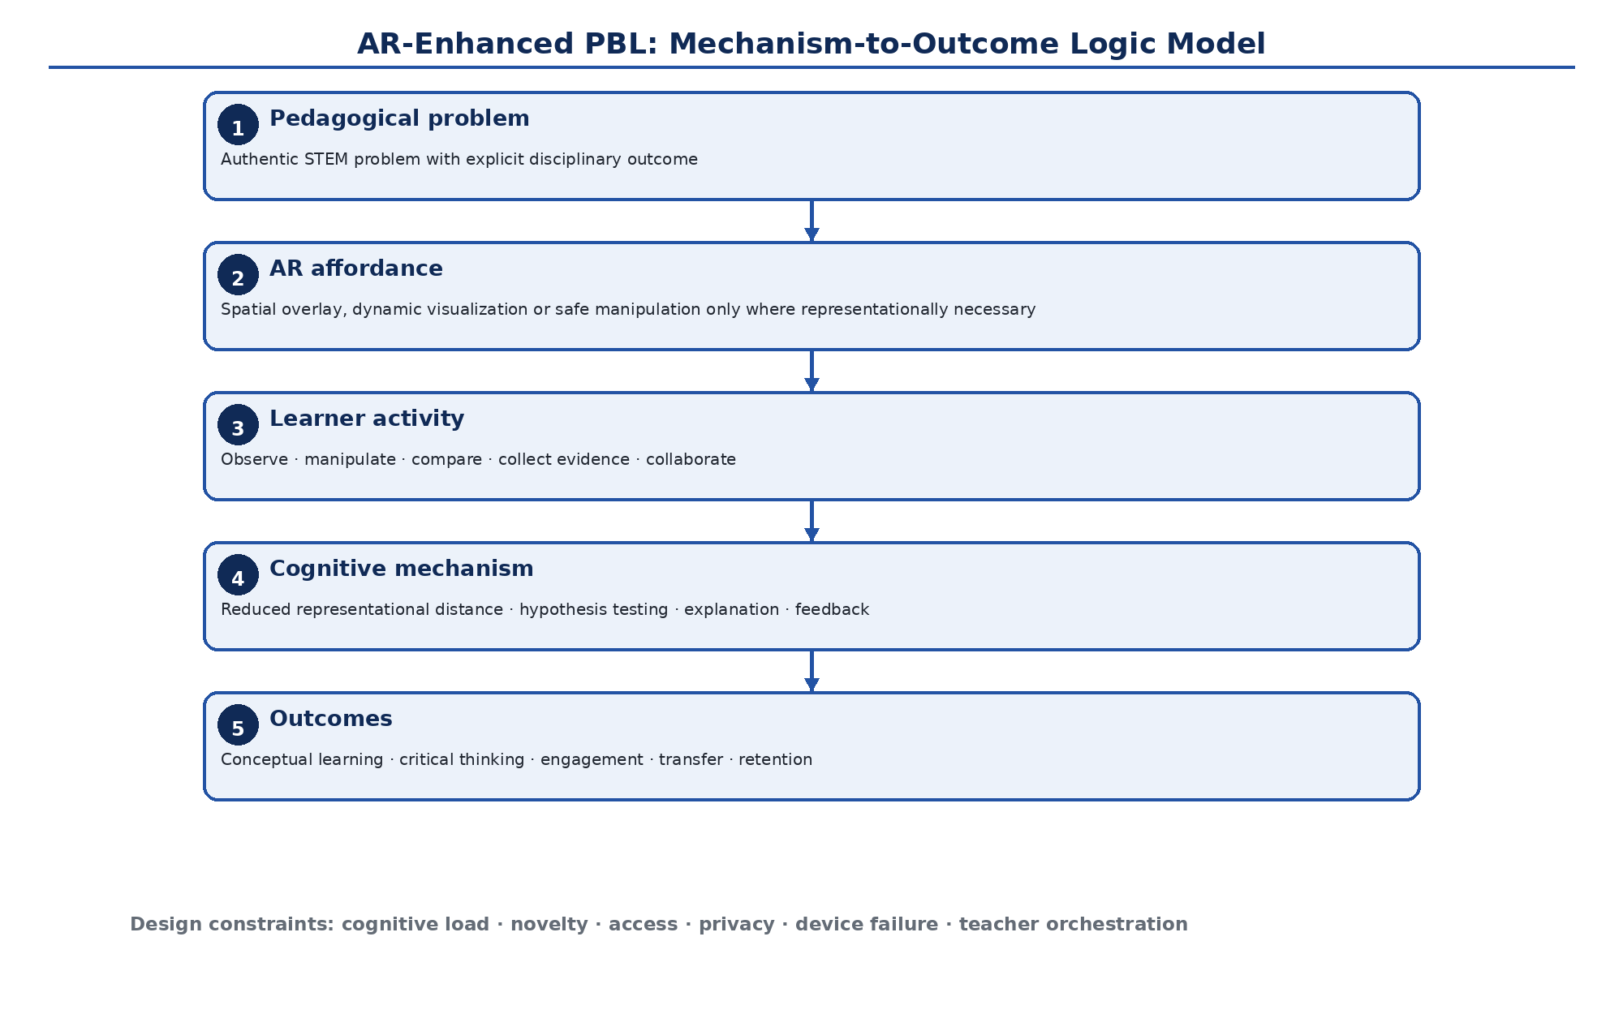
Figure 2. Mechanism-to-outcome logic model for AR-enhanced problem-based STEM learning. AR is positioned as a representational affordance inside a problem-solving cycle rather than as a pedagogy in itself. Original author synthesis.
Table 2. Strong design choices for testing the incremental value of AR in PBL
Design element | Preferred practice | Reason
Comparator | AR-enhanced PBL vs matched non-AR PBL | Separates AR's representational contribution from the effect of active problem-based pedagogy.
Baseline | Prior knowledge, relevant spatial skill and access variables | Supports adjustment and interpretation of treatment heterogeneity.
Outcomes | Content learning, critical thinking, engagement dimensions, delayed retention and transfer | Avoids equating enjoyment or time-on-task with learning.
Process evidence | Interaction logs, observations, group discourse and help-seeking | Tests the mechanisms through which AR affects reasoning.
Implementation fidelity | Teacher time, problem difficulty, AR exposure and technical failures documented | Reduces confounding from unequal delivery.
Equity and adverse events | Access barriers, discomfort, exclusion and device failure reported | Makes benefits and costs visible rather than selectively reporting positive outcomes.

9. Conclusion
The strongest case for AR-enhanced PBL is not that immersive technology automatically raises engagement, but that appropriately designed overlays can make difficult STEM representations manipulable within authentic problem solving. The proposed framework positions AR as one tool inside a constructivist learning cycle and provides explicit criteria for evaluating whether the added technology improves reasoning, learning and transfer enough to justify its cost and complexity.

Declarations

Ethics: Not applicable; this article reports no new human- or animal-participant research.
Funding: The author declares that no external funding was received specifically for this article.
Competing interests: The author declares no competing interests.
Data availability: No new primary dataset was generated. The analysis is based on the peer-reviewed and authoritative sources cited in the article.
Author contributions: CHIA Shiaondo Kenneth: conceptualization, critical literature synthesis, framework development, interpretation, visualization and manuscript authorship.
AI-assisted editorial support: AI-assisted tools were used for language refinement, formatting and consistency checking. They were not used as authors or as substitutes for scholarly judgement; responsibility for source verification, interpretation and final approval remains with the author and journal editor.

References
Ibáñez, M.-B., & Delgado-Kloos, C. (2018). Augmented reality for STEM learning: A systematic review. Computers & Education, 123, 109–123. https://doi.org/10.1016/j.compedu.2018.05.002
Koçoğlu, A., & Kanadlı, S. (2025). The effect of problem-based learning on learning outcomes: A second-order meta-analysis. Educational Research Review, 48, 100690.
Tene, T., Marcatoma Tixi, J. A., Palacios Robalino, M. de L., Mendoza Salazar, M. J., Vacacela Gomez, C., & Bellucci, S. (2024). Integrating immersive technologies with STEM education: A systematic review. Frontiers in Education, 9, 1410163. https://doi.org/10.3389/feduc.2024.1410163
Wang, X.-M., Yu, D.-D., Yu, X.-H., Hwang, G.-J., & Li, F. (2024). Impacts of augmented reality-supported STEM education on students’ achievement: A meta-analysis of selected SSCI publications from 2010 to 2023. Education and Information Technologies, 29(15), 20547–20585.
Hmelo-Silver, C. E. (2004). Problem-based learning: What and how do students learn? Educational Psychology Review, 16, 235–266. https://doi.org/10.1023/B:EDPR.0000034022.16470.f3
Mayer, R. E. (2009). Multimedia learning (2nd ed.). Cambridge University Press.
Koç, A., & Kanadlı, S. (2025). Effect of interactive learning environments on learning outcomes in science education: A network meta-analysis. Journal of Science Education and Technology, 34, 681–703. https://doi.org/10.1007/s10956-025-10202-7
Kozlova, Z., Bach, K. M., Edelsbrunner, P. A., & Hofer, S. I. (2025). Bringing learners into focus: A systematic review of learner characteristics in AR-supported STEM education. Learning and Individual Differences, 122, 102727. https://doi.org/10.1016/j.lindif.2025.102727
Suggested citation: Chia, S. K. (2026). Augmented-Reality-Enhanced Problem-Based Learning in STEM Education. CHIATECH JOURNAL · SETEHEM, 1(1), e029.
© 2026 CHIA Shiaondo Kenneth. Published by CHIATECH JOURNAL · SETEHEM under the Creative Commons Attribution 4.0 International (CC BY 4.0) licence.

