CHIATECH JOURNAL
  - SETEHEM · VOLUME 1 · ISSUE 2 · AUGUST 2026 · e030
  - PIONEER PUBLICATION · ACCEPTED ARTICLE · CRITICAL REVIEW AND PRACTICE FRAMEWORK ARTICLE · MATHEMATICS EDUCATION · STEM EDUCATION · NIGERIA

Teaching Further Mathematics in Nigerian Secondary Schools: An Evidence-Informed Multi-Pedagogy Framework for Problem Solving, Inquiry, Technology and Collaboration
CHIA Shiaondo Kenneth
CHIATECH Solutions and Resources Ltd, Abuja, Nigeria
ORCID: 0009-0009-6434-4586 · Correspondence: chiakenneth01@gmail.com
Article | Volume/Issue | Publication | ISSN | DOI
e030 | 1(1) | Pioneer Issue · August 2026 | Pending assignment | Pending registration

Abstract
Background: Further Mathematics is important for students progressing into mathematics-intensive STEM fields, yet examination evidence repeatedly identifies weaknesses in interpretation, matrices, vectors, calculus, units, diagram use and the communication of mathematical working. Objective: This article critically synthesizes mathematics-education evidence and Nigerian curriculum/examination priorities into a multi-pedagogy framework for teaching Further Mathematics in secondary schools. Methods: A critical review integrated The article’s focus on teacher-centred instruction, problem-solving, inquiry, technology-integrated instruction and collaborative learning with WAEC Chief Examiner evidence and recent mathematics-education research. Results: No single pedagogy is sufficient for the range of conceptual, procedural and representational demands in Further Mathematics. Explicit instruction is valuable for modelling unfamiliar procedures; structured problem solving develops representation and transfer; inquiry supports conjecture and conceptual reasoning; digital tools support visualization and rapid experimentation; and collaboration can expose reasoning when tasks require explanation rather than answer sharing. The proposed framework sequences these approaches around concept formation, guided modelling, problem representation, investigation, deliberate practice and reflective feedback. Conclusion: Improvement requires orchestration rather than replacement of teaching methods. Examination preparation should preserve complete reasoning, units and diagrams while classroom learning should progressively move students from teacher modelling to independent and collaborative problem solving.
Keywords: Further Mathematics; mathematics pedagogy; problem solving; inquiry-based learning; technology integration; collaborative learning; Nigeria

1. Introduction
Further Mathematics teaching can be understood as an orchestration problem rather than a contest between traditional and innovative methods. Teacher modelling, structured problem solving, inquiry, technology-supported visualization, collaborative mathematical argument and deliberate practice each serve different cognitive functions and should be sequenced according to topic demands and learner expertise.
The need is visible in examination evidence. WAEC's 2023 Further Mathematics Paper 2 report identified premature approximation, omission of units, poor interpretation of questions, weak understanding of vectors, matrices/determinants and trapezium-rule integration, and overdependence on calculators with essential working omitted. The recommended remedies emphasized careful reading, diagrams, principles, syllabus coverage and sustained problem practice. These weaknesses span conceptual knowledge, representation, procedure and mathematical communication, which makes a one-method solution unlikely.

2. Why a Multi-Pedagogy Framework Is Needed
Further Mathematics contains topics that demand different forms of learning. A new symbolic procedure may require concise expert modelling; a modelling problem requires interpretation and assumptions; a geometry or vector task may benefit from visualization; an optimization or numerical method task may benefit from digital experimentation; and proof or reasoning benefits from explanation and critique. Pedagogy should therefore be selected according to the cognitive work required by the topic and the learner’s stage of expertise.
Recent secondary-mathematics evidence supports active approaches but also identifies implementation conditions. Ssali et al. (2025), reviewing 56 studies of PBL in secondary mathematics, found that self-regulation, school climate, social influences and teacher feedback shape effective implementation. A 2026 Nigerian quasi-experiment in Minna with 152 SSII students also reported stronger mathematics achievement under inquiry-based and ICT-driven pedagogy than under conventional lecture teaching (Bashir & Usman, 2026). Such findings support diversification of instruction while cautioning against treating any method as context-free.
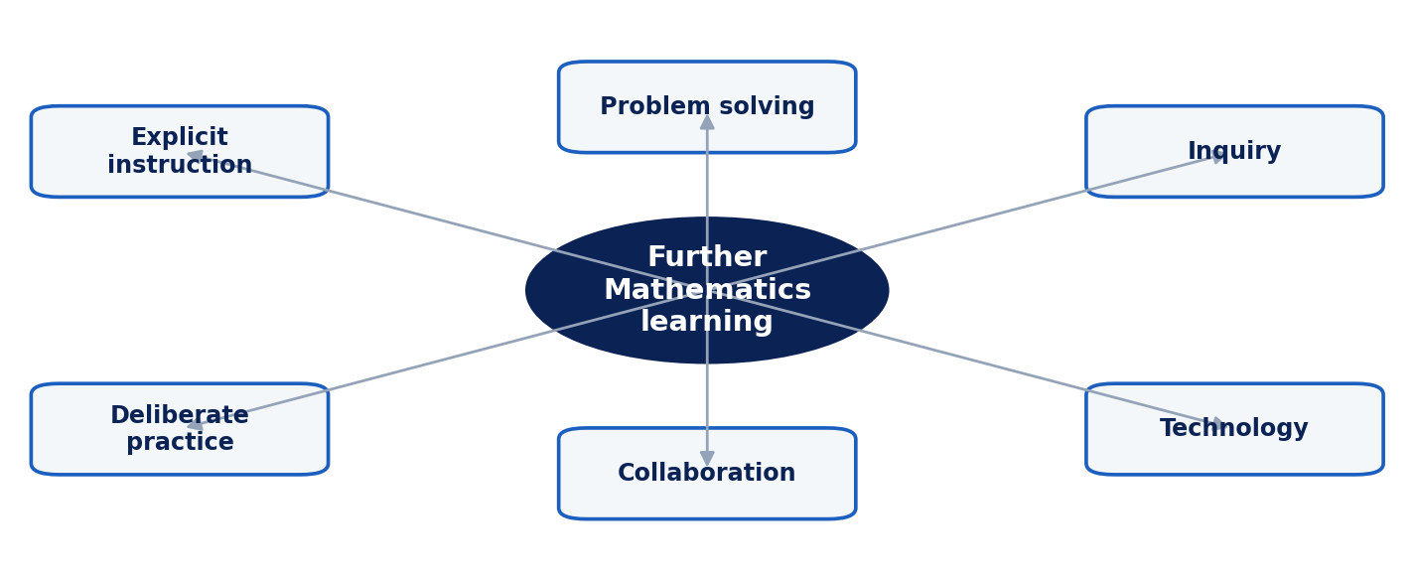
Figure 1. Multi-pedagogy architecture for Further Mathematics learning.

3. The Six Instructional Functions
Explicit instruction should be used strategically to establish notation, prerequisite knowledge, worked examples and efficient procedures. It becomes problematic when it occupies the entire learning cycle and students never make decisions. Worked examples should therefore fade: the teacher first models complete reasoning, then prompts missing steps, and finally asks students to construct and justify solutions independently.
Problem-solving instruction should make representation visible. Before selecting equations, students identify givens, unknowns, relationships, units, diagrams and relevant principles. A structured routine that moves from givens and unknowns to equation selection, substitution and solution is consistent with Pólya’s broader heuristic tradition and supports explicit monitoring of mathematical decisions. Inquiry then extends beyond solving a known type: students vary parameters, form conjectures, test cases and explain why a relationship holds.
Technology should support mathematical insight rather than hide reasoning. Graphing software, spreadsheets, computer algebra and dynamic geometry can accelerate exploration and visualization, but examination readiness still requires students to communicate essential working without delegating decisions to a tool. Collaboration is similarly conditional: group tasks should require comparison of methods, error diagnosis and argumentation, not merely division of exercises. Deliberate practice consolidates all of these modes through spaced, mixed and progressively challenging problems with feedback.

4. Topic-to-Pedagogy Alignment
Table 1. Teaching Further Mathematics in Nigerian Secondary Schools: analytical matrix.
Learning demand | Primary pedagogy | Example of appropriate use
New notation/procedure | Explicit modelling + worked examples | Introducing matrix operations, differentiation rules or mechanics notation.
Problem representation | Structured problem solving | Translate words/diagrams into knowns, unknowns, equations, units and assumptions.
Conceptual relationships | Inquiry | Vary parameters, test conjectures and explain patterns.
Visualization / computation | Technology-integrated learning | Explore functions, transformations, vectors, statistics or numerical methods.
Reasoning and communication | Collaborative critique | Compare solution paths, diagnose errors, defend assumptions.
Fluency and transfer | Deliberate mixed practice | Spaced examination-style problems with feedback and complete workings.

5. Assessment and Feedback
Assessment should diagnose error types rather than only total marks. A student who chooses the wrong equation needs different feedback from one who makes an arithmetic slip or omits units. Useful categories include interpretation/representation, concept selection, algebraic manipulation, calculation, diagram/graph, units/notation and conclusion. Item-level error profiles can guide reteaching and reduce the tendency to respond to every low score with more undifferentiated practice.
Technology can support low-stakes retrieval practice, immediate feedback and item analytics, but automated marking should not reward final answers while ignoring method where method is part of the construct. For high-stakes Further Mathematics, students should routinely produce complete solutions and annotate graphs, diagrams and reasoning.

6. A Classroom Sequence for Gwagwalada and Similar Contexts
A practical 80–100 minute double period can begin with a short retrieval/prerequisite check, followed by explicit modelling of one key idea. Students then complete one partially scaffolded problem using a structured representation routine. A small inquiry or technology task follows, allowing variables or representations to be changed. Pairs or groups compare methods and explain an error case. The lesson ends with an individual examination-style problem and a short reflection on the decision points in the solution.
This sequence is adaptable to low-resource settings. Where one projector or teacher laptop is available, technology can be demonstrated collectively and followed by paper-based reasoning. Where no digital tool is available, pre-generated graphs or tables can still support inquiry. The framework therefore treats technology as an affordance, not a prerequisite for active mathematics learning.

7. Limitations and Research Agenda
Empirical testing in Gwagwalada and comparable Nigerian contexts should define comparable instructional units, use validated achievement measures, document teacher fidelity and control for pre-test differences. Clustered classes should be analyzed with methods that recognize class-level dependence. Qualitative observation could clarify which pedagogical processes—representation, discussion, feedback or tool use—actually explain achievement differences.

8. Implementation Roadmap and Teacher Development
Moving to multi-pedagogy instruction requires planning at department level rather than asking individual teachers to improvise. A useful starting point is a topic audit: teachers identify where students most often fail to interpret problems, choose principles, visualize relationships or communicate complete solutions. WAEC diagnostic comments, school assessment data and marked scripts can be combined to create an error map for each term.
Schemes of work can then specify not only content coverage but the dominant form of reasoning students should practise. For example, a matrices unit may combine explicit modelling of operations, technology-supported exploration of transformations, and collaborative error analysis. A mechanics unit may emphasize diagrams, units, model assumptions and structured problem representation before extensive calculation. This makes pedagogical variety purposeful rather than fashionable.
Teacher development should use lesson study or collaborative planning around actual Further Mathematics tasks. Teachers can compare two ways of presenting the same concept, anticipate student misconceptions and agree on what counts as complete working. Where digital tools are available, professional learning should focus on how to use them to reveal structure and test conjectures, including when to turn the tool off so that students can demonstrate independent reasoning.
Assessment calendars should include cumulative mixed practice rather than isolating each topic until examination revision. Interleaving functions, calculus, vectors, statistics and mechanics helps students decide which principle applies, a skill that blocked practice does not require. Feedback should identify the decision that failed and provide a next task that specifically targets that weakness.
School leaders can support implementation by protecting collaborative planning time, ensuring syllabus coverage is realistic, improving access to current texts and basic digital resources, and reviewing results by misconception rather than only pass rate. This creates a practical route from method comparison to a sustainable instructional improvement programme.

8.1 Curriculum and Assessment Context in Nigeria
Nigeria's revised senior-secondary curriculum retains Further Mathematics within the Science field while Digital Technologies is included among core and compulsory senior-secondary subjects (NERDC, 2025). This policy context strengthens the case for integrating mathematical reasoning with appropriate digital tools, but it does not reduce the need for symbolic fluency, complete written working and interpretation. The curriculum environment therefore supports a dual aim: conceptual and computational sophistication during learning, and disciplined mathematical communication during assessment.
WAEC Chief Examiner evidence remains a useful diagnostic source because it identifies recurring performance errors rather than only pass rates. In the 2023 Further Mathematics Paper 2 report, weaknesses included premature approximation, omission of units, poor interpretation, weak vectors and matrices/determinants, difficulty with trapezium-rule integration and excessive calculator dependence with essential working omitted. These errors map directly to the proposed framework: representation before calculation, explicit units, diagram use, concept selection, gradual release of worked examples and sustained mixed problem practice.
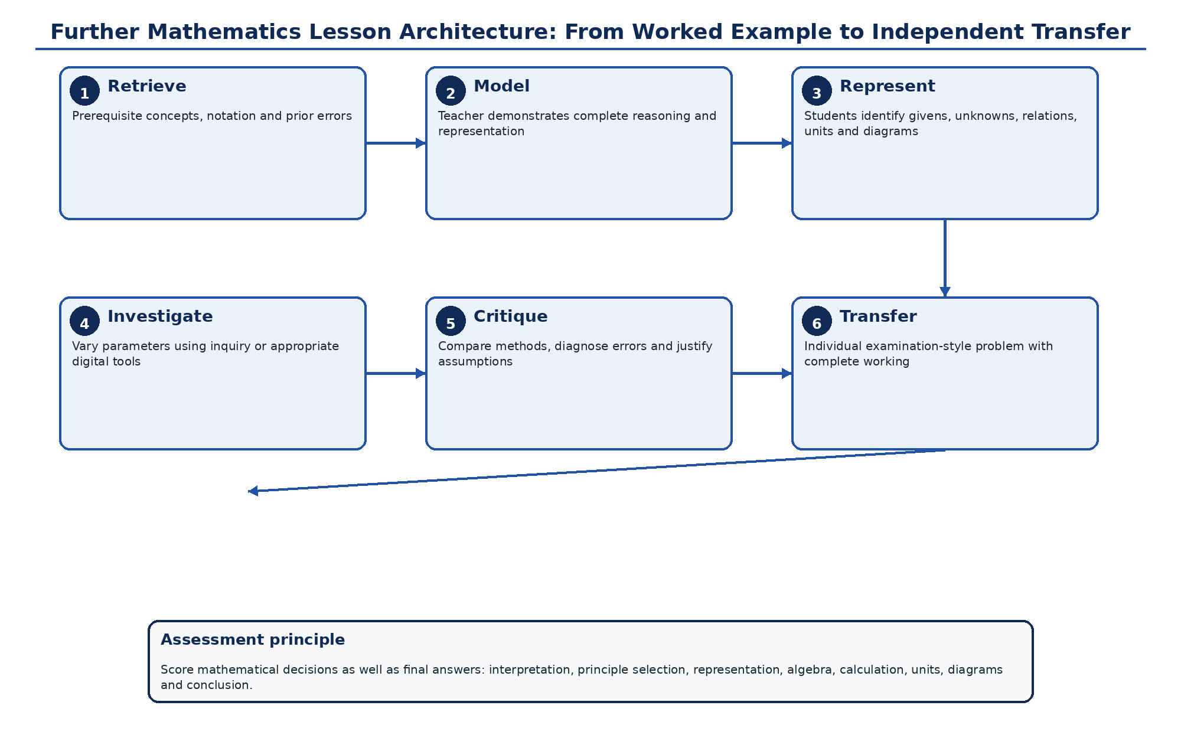
Figure 2. Further Mathematics lesson architecture from retrieval and expert modelling to representation, inquiry, critique and independent transfer. Original author synthesis.
Table 2. Error-diagnostic feedback framework for Further Mathematics
Error category | Observable evidence | Instructional response
Interpretation / representation | Misreads conditions; omits a diagram; identifies wrong knowns/unknowns. | Require a representation stage before equations; annotate givens, unknowns, units and constraints.
Principle selection | Chooses an inapplicable theorem, formula or method. | Use contrasting worked examples and ask students to justify why a principle applies.
Algebraic manipulation | Correct model but invalid transformations or sign errors. | Short targeted fluency practice with error analysis rather than repeating the whole topic.
Calculation / approximation | Arithmetic, calculator entry or premature rounding errors. | Estimate first; retain sufficient precision; check reasonableness and unit scale.
Graph / vector / matrix representation | Incorrect axes, vector direction, matrix setup or determinant structure. | Use visual models, dynamic tools where available and paper-based reconstruction.
Units / notation | Correct number but incomplete unit, symbol or vector notation. | Make notation and dimensional checks explicit scoring criteria.
Communication / conclusion | Method incomplete or answer not interpreted in context. | Require final statement linking result to the question and showing essential working.

9. Conclusion
Further Mathematics teaching should not be framed as a choice between traditional and innovative methods. Students need expert modelling, structured problem solving, inquiry, visualization, mathematical dialogue and deliberate practice at different moments. A multi-pedagogy design responds directly to the varied weaknesses identified by examination evidence and creates a progression from supported procedures to independent mathematical reasoning.

Declarations

Ethics: Not applicable; this article reports no new human- or animal-participant research.
Funding: The author declares that no external funding was received specifically for this article.
Competing interests: The author declares no competing interests.
Data availability: No new primary dataset was generated. The analysis is based on the peer-reviewed and authoritative sources cited in the article.
Author contributions: CHIA Shiaondo Kenneth: conceptualization, critical literature synthesis, framework development, interpretation, visualization and manuscript authorship.
AI-assisted editorial support: AI-assisted tools were used for language refinement, formatting and consistency checking. They were not used as authors or as substitutes for scholarly judgement; responsibility for source verification, interpretation and final approval remains with the author and journal editor.

References
Bashir, A. U., & Usman, H. (2026). Effects of inquiry-based learning and ICT-driven pedagogy on achievement in mathematics concepts among secondary school students in Minna Metropolis, Niger State, Nigeria. Zamfara International Journal of Education, 6(3), 335–341. https://doi.org/10.64348/zije.2026414
Pólya, G. (1945). How to solve it. Princeton University Press.
Ssali, C., Batiibwe, M. S. K., Dahl, B., Kaliisa, H., Mango, J. M., & Mayende, G. (2025). Problem-based learning in secondary school mathematics: A review. Educational Research, 67(2), 212–230. https://doi.org/10.1080/00131881.2025.2493255
West African Examinations Council. (2023). Further Mathematics Paper 2, WASSCE (PC), 2023: Candidates’ weaknesses and suggested remedies. WAEC e-Learning Portal.
Schoenfeld, A. H. (1985). Mathematical problem solving. Academic Press.
Hiebert, J., & Grouws, D. A. (2007). The effects of classroom mathematics teaching on students’ learning. In F. K. Lester Jr. (Ed.), Second handbook of research on mathematics teaching and learning (pp. 371–404). Information Age Publishing.
Nigerian Educational Research and Development Council. (2025). NERDC-approved subjects for the revised senior secondary curriculum. NERDC, Abuja, Nigeria.
Suggested citation: Chia, S. K. (2026). Teaching Further Mathematics in Nigerian Secondary Schools. CHIATECH JOURNAL · SETEHEM, 1(1), e030.
© 2026 CHIA Shiaondo Kenneth. Published by CHIATECH JOURNAL · SETEHEM under the Creative Commons Attribution 4.0 International (CC BY 4.0) licence.

