  - PIONEER PUBLICATION · ACCEPTED ARTICLE · ORIGINAL RESEARCH ARTICLE · SETEHEM: TECHNOLOGY & EDUCATION × HUMANITIES

Establishment of a Mean Body-Measurement Chart for School Uniforms and Accessories of Primary-School Children Aged 6–12 Years in Jos, Plateau State, Nigeria: An Anthropometric and Prototype-Development Study
Lydia Kachollom AKILA¹* and D. A. AGBO²
¹Department of Home and Rural Economics, Plateau State College of Agriculture, Garkawa, Plateau State, Nigeria
²Department of Home Science and Management, Joseph Sarwuan Tarka University, Makurdi, Benue State, Nigeria
Corresponding author: lydiaakila1@gmail.com
Article | Volume/Issue | Published | ISSN | DOI
e032 | 1(1) | July 2026 | Pending assignment | Pending registration
Revised and expanded from the open Zenodo v1 record (10 November 2024; DOI 10.5281/zenodo.17928414; CC BY 4.0).

Abstract
Background: Age labels alone rarely capture the body-size variation needed for well-fitting school uniforms. Locally measured anthropometric data are therefore important for garment sizing, comfort and production planning. Purpose: This study established an age-banded mean body-measurement chart for primary-school children aged 6–12 years in Jos, Plateau State, and translated the chart into school-uniform and accessory prototypes. Methods: The archived study used an applied mixed-methods design. Its substantiated quantitative core comprised measurements from 367 children grouped as 6–7, 8–9 and 10–12 years. Stature, chest, waist and hip measurements were summarized with means and standard deviations in SPSS. This revised article recomputed coefficients of variation from the published summaries and examined six prototype plates and two wearer-trial plates supplied with the research record. Results: Mean stature progressed from 115 to 130 and 145 cm across the three age bands; corresponding chest means were 60, 70 and 80 cm, waist means were 55, 65 and 75 cm, and hip means were 65, 75 and 85 cm. Reported standard deviations ranged from 1.174 to 5.992 cm. Relative dispersion was greatest for waist circumference in every band (10.9%, 6.3% and 5.1%, respectively). The measurements were translated into three graded base sizes and applied to boys’ and girls’ uniform families, headwear, neckwear and school bags. Photographs document construction and wearer application, but no numerical fit scores accompanied the archive. Conclusion: The study provides a useful local base chart and demonstrates its manufacturability. It should be treated as a provisional production reference—not a population sizing standard—until raw-data percentiles, sex-specific distributions, coverage rates, measurement error and structured wearer-fit outcomes are established.
Keywords: anthropometry; school uniform; clothing sizing system; primary-school children; garment prototype; apparel fit; Jos; Plateau State; Nigeria

1. Introduction
School uniforms are high-frequency garments: children wear them for long hours, move in them and replace them repeatedly as they grow. Fit therefore has practical consequences for comfort, mobility, appearance, durability and household expenditure. Yet commercial uniforms are often purchased through age labels that assume children of the same age share comparable proportions. Clothing-sizing research shows that this assumption is weak because stature and girth dimensions vary within age groups and across populations (Widyanti et al., 2017; Destaw et al., 2025). A locally measured chart can reduce guesswork by linking size designation to dimensions that pattern makers and manufacturers can reproduce.
International standards provide a disciplined vocabulary for this work. ISO 8559-1:2017 defines anthropometric measurements used to create size-and-shape profiles; ISO 8559-2:2025 specifies primary and secondary dimension indicators; ISO 8559-3:2018 addresses the construction of body-measurement tables and intervals; and ISO 8559-4:2023 introduces coverage-ratio determination. These standards also clarify a critical distinction: body measurements describe the wearer, whereas finished-garment measurements include design ease, movement allowance, fabric behaviour, seam construction and style. A mean body chart cannot simply be copied as a cutting chart.
The need for population-specific evidence is particularly important in Nigeria. Anthropometric studies among Nigerian schoolchildren demonstrate growth variation associated with age, sex, nutritional status and socioeconomic context (Goon et al., 2011; Mbagwu et al., 2025). The WHO growth reference likewise shows that school-age growth is continuous rather than uniform across broad age bands (de Onis et al., 2007). Recent Nigerian uniform research in Rivers State and neighbouring West African sizing work further support the use of measured stature and girths, not age alone, when defining children’s clothing sizes (Azunwena & Ikechi, 2024; Biney-Aidoo et al., 2025).

1.1 Problem statement and study contribution
Before this study, the source project identified no documented Jos-specific chart linking the principal dimensions required for primary-school uniform production to locally observed children aged 6–12 years. Uniform makers therefore risked relying on imported charts, informal age labels or one-off measurements that are difficult to standardize across production runs. The study contributes three linked outputs: a measured age-banded body profile, a provisional three-size production reference, and physical prototype evidence spanning girls’ and boys’ uniforms and coordinated accessories. The present e032 version strengthens the original 2024 Zenodo paper by preserving its numerical results, integrating the prototype archive, updating the standards and literature, and stating the evidentiary limits of the chart explicitly.

1.2 Aim and objectives
The study aimed to establish and apply a mean body-measurement chart for school uniforms and accessories of primary-school children aged 6–12 years in Jos, Plateau State. Specifically, it sought to:
1. determine mean stature, chest, waist and hip measurements for children aged 6–7, 8–9 and 10–12 years;
2. examine the absolute and relative dispersion of the reported measurements across age bands;
3. translate the reported means into a transparent, provisional three-size reference for uniform production; and
4. document the construction and wearer application of graded school-uniform and accessory prototypes.

2. Literature Review and Analytical Framework

2.1 Children’s growth and regional anthropometry
Children aged 6–12 years experience substantial changes in stature, girth and body proportion. Growth is not a fixed annual increment, and the timing and magnitude of change differ among children. The WHO 5–19-year reference uses month-specific distributions rather than broad age averages for this reason (de Onis et al., 2007; World Health Organization, 2007). Nigerian evidence also warns against assuming a single national profile. Goon et al. (2011) documented anthropometric and nutritional variation among urban primary-school children in Makurdi, while Mbagwu et al. (2025) found significant socioeconomic and sex-related differences in dimensions among schoolchildren in Lagos. Such findings do not invalidate a Jos chart; they define it as a local reference whose generalizability must be tested.

2.2 From measurements to a clothing-sizing system
A clothing-sizing system classifies a target population into a manageable number of size groups using primary control dimensions and secondary dimensions that improve fit. In a detailed study of 654 Indonesian children aged 6–10 years, Widyanti et al. (2017) measured 49 dimensions and used principal component analysis to propose a standard system. More recent work with Ghanaian boys aged 7–12 years combined height, age and key girths and created multiple size variations within age categories (Biney-Aidoo et al., 2025). These studies illustrate the difference between reporting group means and validating a sizing system: a robust system normally requires raw distributions, dimension correlations, clustering or interval rules, and coverage evaluation. The ISO 8559 series formalizes these steps.
For school uniforms, size designation should be legible to both manufacturers and families. Stature is useful as a primary indicator because it relates to garment lengths, while chest, waist and hip dimensions control width and shaping. Surjit (2021) similarly emphasizes girth and length measures in girls’ school-uniform sizing. However, the selected dimensions must be converted into finished-garment specifications through ease allowances appropriate to the garment type, fabric and required movement. Research on ill-fitting school footwear offers an analogous warning: dimensions that omit functional allowance can produce a nominally correct size that is uncomfortable in use (Breet & Venter, 2022).

2.3 Prototyping and fit verification
Prototype construction is the bridge between an anthropometric chart and an operational sizing system. A pattern drafted from a base measurement set must be checked for balance, ease, sitting and walking comfort, arm movement, closure stress and visual grade consistency. Digital scanning can improve measurement repeatability, but posture control and repeat scanning remain important (Parker et al., 2021). Digital body-measurement technologies and 3D simulation can also support made-to-measure and on-demand production (Casciani & Bertolini, 2025), while recent fit research confirms the value of movement-based evaluation and systematic pattern correction (Yang & Baytar, 2024; Choi & Choi, 2025). For workshops without scanners, the same logic can be implemented through calibrated manual measurement, a toile or trial garment, and a structured fit checklist.

2.4 Analytical framework
The paper interprets the study as a measurement-to-product chain: sampled body dimensions generate summary statistics; selected control dimensions define provisional base sizes; pattern development adds garment-specific ease; prototype construction tests manufacturability; and wearer trials test whether the resulting garment performs under posture and movement. Evidence at one stage cannot substitute for the next. In particular, means and standard deviations can support base-size design, but population coverage requires raw percentiles or another explicit coverage analysis, and photographs can document prototype existence but cannot replace scored fit outcomes.

3. Materials and Methods

3.1 Design, setting and evidentiary boundary
The original project was described as a sequential explanatory mixed-methods study conducted in Jos, Plateau State, Nigeria. It combined an anthropometric field survey, questionnaires and interviews, and a prototype-development component. The source tables identify the measurement data as Field Survey 2023. For this e032 article, the quantitative measurement summaries and supplied prototype photographs constitute the substantiated analytical record. The qualitative materials were not preserved as coded themes, counts or quotations in the archived manuscript; consequently, they inform contextual interpretation but are not presented as independent empirical findings.

3.2 Participants and measurement variables
The measurement component involved 367 primary-school children aged 6–12 years in Jos. The source grouped participants into 6–7, 8–9 and 10–12 years and reported that the children represented diverse cultural and ethnic backgrounds. Four clothing-relevant dimensions were retained: stature, chest circumference, waist circumference and hip circumference. Measurements were recorded in centimetres using the study’s standardized measuring tools. The archive did not retain age-band sample sizes, sex distribution, sampling-frame details, instrument models, calibration logs or technical-error-of-measurement values; these items could not be reconstructed and were not invented in the revision.

3.3 Measurement interpretation
The present terminology follows ISO 8559-1:2017: stature is treated as a vertical body dimension and chest, waist and hip as girth dimensions. This alignment standardizes interpretation but does not retrospectively assert that every procedural requirement of ISO 8559-1 was followed in the 2023 fieldwork. All values are body measurements rather than finished-garment dimensions. Pattern developers must add garment- and fabric-specific ease before cutting.
Table 1. Study components and the evidence used in the e032 analysis.
Component | Record available | Analytical use | Boundary
Anthropometric survey | n = 367; three age bands; four means and four SDs per band | Primary quantitative evidence | No raw rows, subgroup n or percentiles
Questionnaire/interviews | Mentioned in source methods | Context only | No coded results or quotations retained
Prototype development | Six prototype photographs | Document garment and accessory translation | No pattern blocks, ease schedule or construction log
Wearer application | Two photographic plates | Document prototype wear/fitting stage | No fit scale, assessor agreement or movement scores

3.4 Statistical analysis
The original study analysed the anthropometric data in SPSS and reported arithmetic means and standard deviations. The present revision retained those values exactly and calculated the coefficient of variation (CV = SD/mean × 100) to compare relative dispersion across measurements expressed in the same unit. One-standard-deviation planning envelopes were calculated only as descriptive design diagnostics. Because age-band sample sizes and raw observations were unavailable, standard errors, confidence intervals, sex comparisons, hypothesis tests, correlations, percentile tables, cluster solutions and coverage rates were not computed.

3.5 Provisional size construction and prototype review
Each age-band mean profile was treated as a provisional base body size: JOS-115, JOS-130 and JOS-145, named for mean stature. Chest, waist and hip means were retained as secondary indicators. These labels were chosen for transparency and do not constitute an ISO certification. Prototype photographs were reviewed by garment family, apparent grade sequence and coordination of uniform and accessory components. Wearer photographs were interpreted descriptively; no unrecorded fit result was inferred from appearance alone.

4. Results

4.1 Reported body-measurement profile
All four reported mean dimensions increased across the three age bands (Table 2). Mean stature rose by 15 cm from one band to the next, while chest, waist and hip each rose by 10 cm. The oldest category covered three chronological years (10–12) whereas the younger categories covered two; the apparent regularity of the mean progression should therefore be read as a property of the reported summaries, not as proof of a fixed annual growth increment.

Table 2. Reported mean body measurements and standard deviations (cm). Source: Field Survey 2023, preserved from Zenodo v1.
Measurement | 6–7 years | 8–9 years | 10–12 years
Stature | 115 ± 5.732 | 130 ± 3.017 | 145 ± 1.592
Chest | 60 ± 4.772 | 70 ± 2.823 | 80 ± 2.055
Waist | 55 ± 5.992 | 65 ± 4.110 | 75 ± 3.847
Hip | 65 ± 4.000 | 75 ± 3.271 | 85 ± 1.174

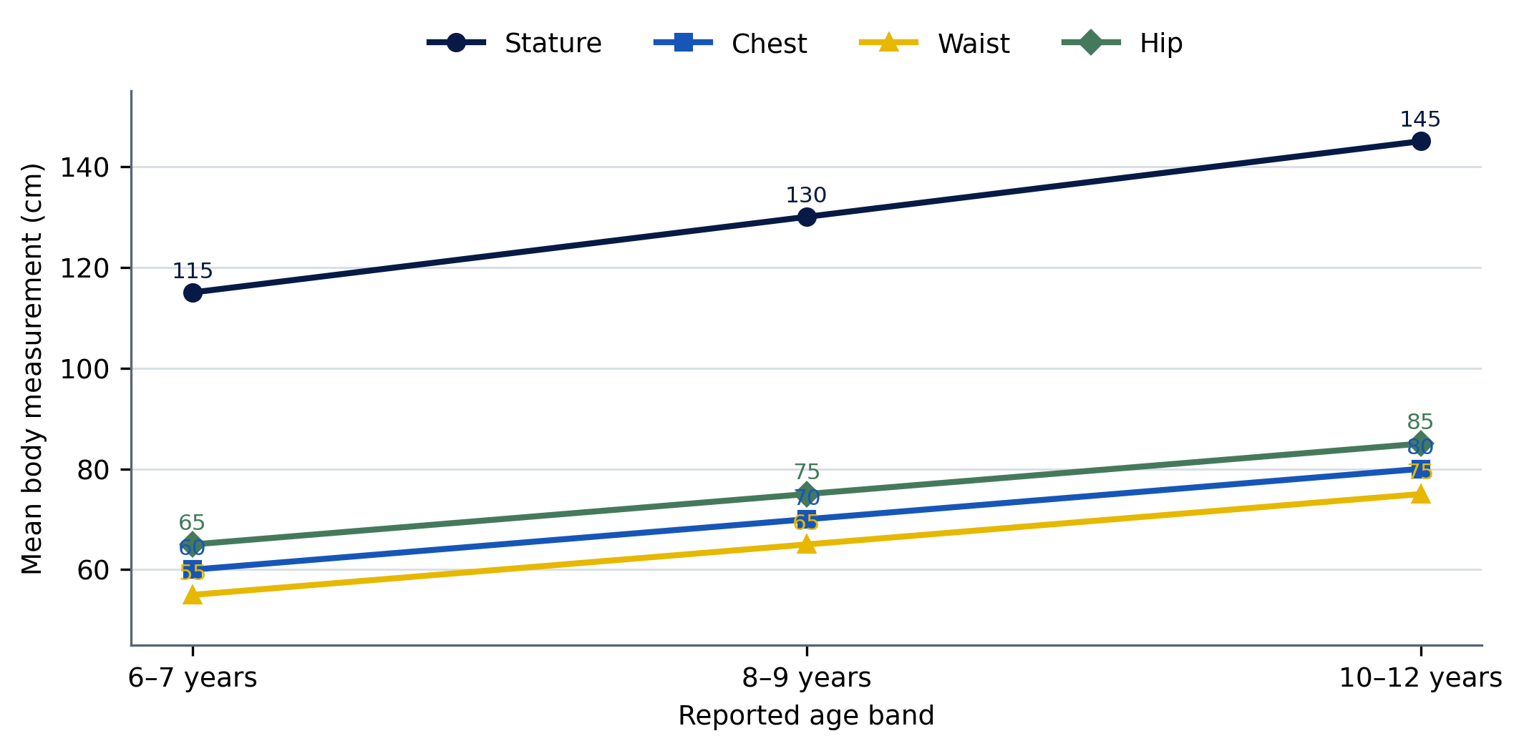
Figure 1. Progression of the four reported mean measurements across age bands. Values are body measurements in centimetres; the lines connect categorical age-band summaries and do not represent individual longitudinal growth.

4.2 Relative dispersion
The CV analysis identifies waist circumference as the most variable dimension relative to its mean in every age band (Table 3). The 6–7-year group showed the greatest relative variability overall, with a waist CV of 10.9% and chest CV of 8.0%. A single base size is therefore least likely to accommodate the youngest band without additional fit options or alteration allowance. The very low CVs reported for stature and hip in the 10–12-year band should be validated against raw data because the band spans three years and its subgroup size is unknown.
Table 3. Coefficients of variation derived from the published mean and SD values.
Measurement | 6–7 years | 8–9 years | 10–12 years
Stature | 5.0% | 2.3% | 1.1%
Chest | 8.0% | 4.0% | 2.6%
Waist | 10.9% | 6.3% | 5.1%
Hip | 6.2% | 4.4% | 1.4%

4.3 Provisional three-size body chart
Table 4 converts the reported age-band profiles into transparent size codes based on stature. The chart is a base-body reference for pattern development, stock planning and measurement communication. It is not a finished-garment specification. Garment ease should be set separately for shirts, trousers, skirts, pinafores, jackets and accessories, and schools should provide a fit-exchange or alteration route for pupils outside the base profile.
Table 4. Provisional Jos body-size chart for school-uniform development (cm).
Size code | Age reference | Stature | Chest | Waist | Hip | Use
JOS-115 | 6–7 | 115 | 60 | 55 | 65 | Youngest base block; prioritize width options
JOS-130 | 8–9 | 130 | 70 | 65 | 75 | Intermediate base block
JOS-145 | 10–12 | 145 | 80 | 75 | 85 | Oldest base block; verify within-band growth

Note. Dimensions are reported body means. Do not cut garments to these girths; add design and movement ease. Age is a reference only, not the sole size selector.

4.4 Prototype development evidence
The prototype archive shows that the measurement concept was translated beyond a numerical table. Four graded uniform families were constructed in three visible sizes, followed by coordinated headwear, neckwear and school bags. The families combine plain and checked fabrics and include boys’ and girls’ silhouettes. This breadth demonstrates product application across multiple school-uniform components, although the archive does not supply the pattern dimensions, ease values, fabric test results or unit construction sequence required for replication.
Table 5. Prototype evidence and its defensible interpretation.
Plate | Product family | Visible grading/application | Evidence supported
P1 | Yellow/green checked girls’ ensemble | Three sizes | Graded uniform construction
P2 | Red checked shirt/blue trouser boys’ ensemble | Three sizes | Graded uniform construction
P3 | White shirt/blue checked trouser boys’ ensemble | Three sizes | Graded uniform construction
P4 | Red checked shirt/blue pinafore girls’ ensemble | Three sizes | Graded uniform construction
P5 | Caps, ties and neckwear | Coordinated variants | Accessory extension of uniform families
P6 | School bags | Four bag forms | Accessory/product diversification
T1–T2 | Wearer application | Boys’ and girls’ ensembles | Photographic fitting stage; no scored outcome

Prototype Uniform Families
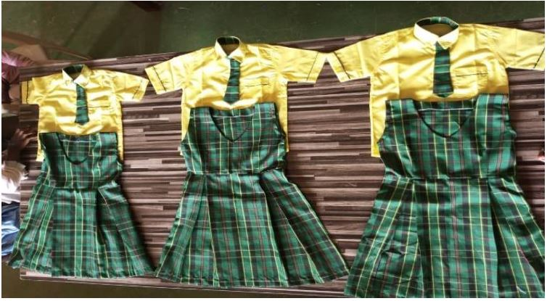  (A) Yellow/green checked girls’ family | 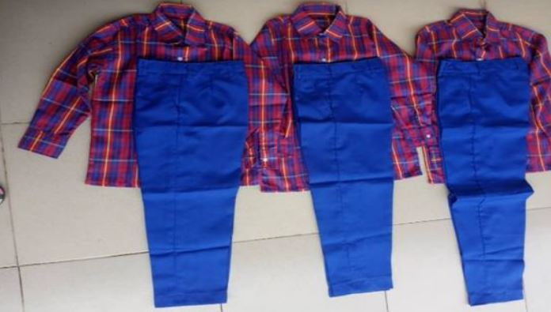  (B) Red checked shirt/blue trouser boys’ family
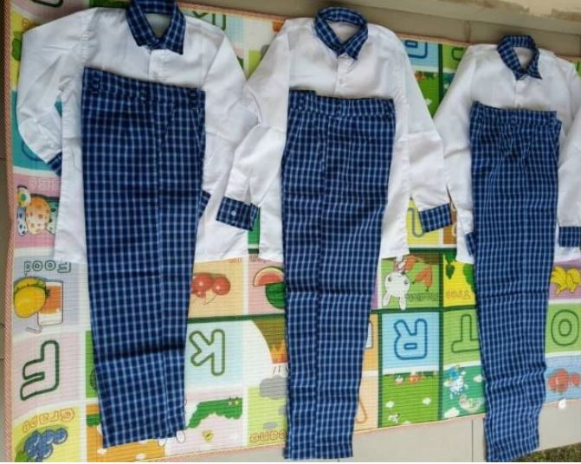  (C) White shirt/blue checked trouser boys’ family | 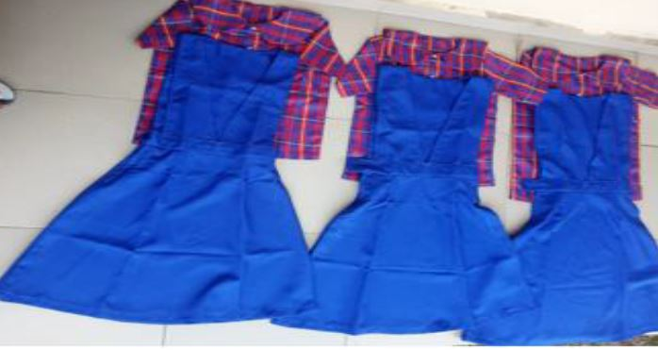  (D) Red checked shirt/blue pinafore girls’ family
Figure 2. Four school-uniform prototype families translated into three visible size grades. Photographs supplied with the author’s prototype archive; panels A–D correspond to PROTOTYPE1–PROTOTYPE4.
Across the four families, the design logic is consistent: a shared colour/fabric identity is maintained while garment dimensions are visibly graded. This is important for uniform production because grading should preserve proportion, placement of contrast fabric, pocket position, collar scale and overall silhouette rather than enlarge every component mechanically. The photographs confirm construction output, but a technical production pack would still need nested patterns, seam allowances, tolerance limits and graded placement specifications.

4.5 Accessory prototypes and wearer application
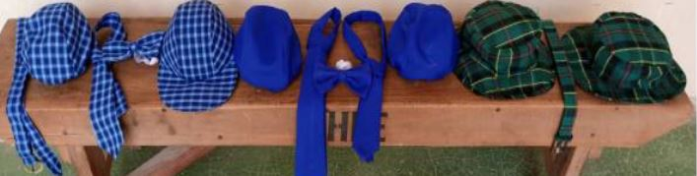  (A) Coordinated caps, ties and neckwear | 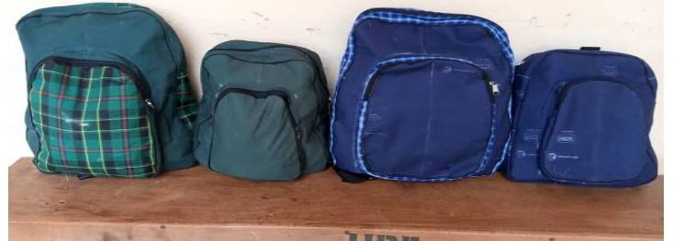  (B) School-bag prototypes
Figure 3. Coordinated accessory prototypes extending the uniform system beyond garments. Panels correspond to PROTOTYPE5 and PROTOTYPE6.
The accessory plates demonstrate design-system coherence: checked uniform fabrics reappear in caps, ties and bag panels, while solid blue components create visual continuity across garment families. Accessory sizing, however, requires additional control dimensions—particularly head circumference for caps and functional capacity/strap dimensions for bags—which were outside the four-measure body chart. The prototypes therefore demonstrate aesthetic and product coordination rather than a fully validated accessory-sizing system.

4.6 Wearer-Application Evidence
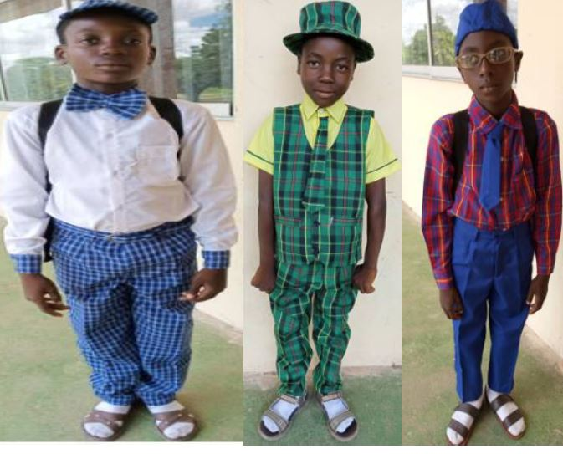  (A) Boys’ wearer application | 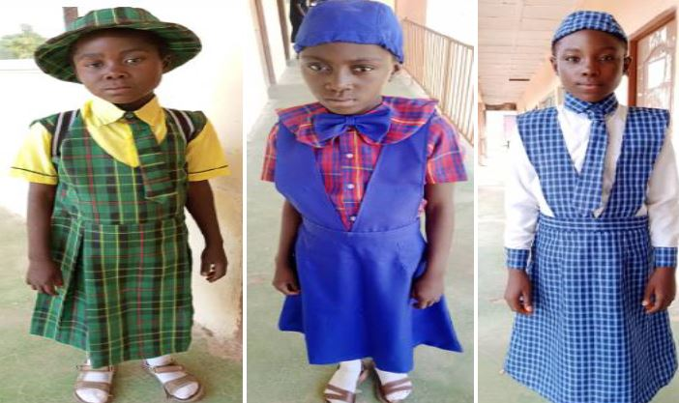  (B) Girls’ wearer application
Figure 4. Photographic wearer application of boys’ and girls’ prototype ensembles. Images document the fitting stage; the archive contains no numerical comfort, mobility or assessor-fit scores, so no performance effect is inferred.
The wearer plates establish that the prototypes progressed to physical application on children and were not merely flat-lay design samples. Visual evidence shows complete ensembles and differentiated sizes, but static photographs cannot establish sitting comfort, arm reach, thermal comfort, seam pressure, closure strain or repeated-wash performance. Those outcomes require a structured protocol and should be the next validation stage.

5. Discussion

5.1 What the measurement progression establishes
The study establishes a coherent local progression in the four retained control dimensions. The results are useful because they convert an informal age label into explicit centimetre values that can be checked at the point of measurement, pattern drafting and procurement. The 15-cm stature interval also creates memorable base-size codes. This approach aligns with the general principle in ISO 8559-2:2025 that garment size designation should communicate relevant body dimensions rather than rely on ambiguous nominal labels.
The results do not show that all children in an age band will fit one garment. Waist circumference had the highest relative dispersion and would drive many fit failures in close-fitting skirts, trousers and pinafores. The youngest group was also the most heterogeneous in relative terms. A practical range should therefore combine a stature-based base code with width options or an alteration feature, such as adjustable waist elastic, adequate seam allowance or multiple girth variants. Biney-Aidoo et al. (2025) reached a comparable conclusion by combining height with key dimensions and multiple size variations for Ghanaian boys.

5.2 Why the chart is provisional rather than a population standard
A statistically validated sizing system requires more information than the archive retains. Age-band sample counts are needed to compute standard errors; raw observations are needed to estimate percentiles and dimension correlations; sex-specific analyses are needed because growth patterns can diverge; and coverage ratios are needed to determine how many children each proposed size actually accommodates. ISO 8559-3:2018 and ISO 8559-4:2023 make these steps explicit. The present chart is therefore a defensible production starting point and a pilot standardization instrument, but describing it as a complete Jos or Plateau State standard would exceed the evidence.
This qualification strengthens rather than diminishes the contribution. Widyanti et al. (2017) measured 49 dimensions and used multivariate analysis; Mbagwu et al. (2025) demonstrated the importance of sex and socioeconomic context in Nigerian growth; and Destaw et al. (2025) identify population coverage and outdated datasets as recurrent sizing-system challenges. Against that benchmark, the present four-measure chart is intentionally simple and workshop-ready, while its limitations define a clear replication agenda.

5.3 Prototype evidence and experimental maturity
The construction of multiple prototype families is the study’s principal applied strength. It demonstrates that the chart was used to organize real garment production across three grades and across girls’ and boys’ silhouettes. The inclusion of accessories also shows design thinking at ensemble level. Nevertheless, manufacturability is not the same as fit validation. A mature experiment would record the body size assigned to each wearer, the garment’s finished measurements and ease, assessors’ fit ratings, wearer comfort and movement ratings, alteration requirements, and post-laundering dimensional change.
Future validation can remain practical. Tailors can use a one-page fit sheet that scores neckline, shoulder, chest, waist, hip, rise, sleeve, hem, sitting, walking and arm elevation. Two assessors can independently rate each garment, and disagreements can be reconciled. Where resources permit, repeated manual measurements or 3D scanning can quantify reliability and posture effects (Parker et al., 2021; Casciani & Bertolini, 2025). Pattern corrections should be returned to the base block, as recommended by fit-adjustment research (Yang & Baytar, 2024; Choi & Choi, 2025), so that improvement benefits the next production run rather than only the individual garment.

5.4 Educational, production and policy implications
For clothing and home-economics education, the study provides a compact demonstration of the full product-development sequence: field measurement, descriptive analysis, chart construction, pattern translation, prototype manufacture and wearer application. Students can reproduce the workflow while improving its statistical and experimental controls. For uniform producers, the chart offers explicit base dimensions, reduces dependence on informal age labels and encourages a reusable measurement record. For schools and education authorities, local sizing trials can reduce avoidable exchanges and give families clearer information at purchase.
Policy adoption should proceed as a pilot rather than a mandate. A school or producer can test JOS-115, JOS-130 and JOS-145 against a fresh sample, record alterations and returns, and add width variants only where the data justify them. A broader Plateau State study should stratify by sex, single year of age, school type and locality, and should include multiple seasons if uniform layers differ. This would convert the present chart from a local mean reference into a coverage-tested regional system.

6. Recommended Quality-Control and Validation Protocol
Table 6. Minimum protocol for adopting and validating the provisional Jos chart.
Stage | Required action | Evidence to retain | Decision gate
1. Measurement | Use defined landmarks; repeat critical girths; record measurer | Individual sheet, instrument ID, repeat values | Technical error within preset tolerance
2. Size assignment | Select by stature plus chest/waist/hip, not age alone | Assigned size and out-of-range flags | No forced assignment when girths conflict
3. Pattern/ease | Document finished garment measures and ease by style | Base block, grade rule, ease schedule | Movement allowance technically justified
4. Prototype | Construct trial sample in intended or equivalent fabric | Construction sheet and defect log | Balance and assembly acceptable
5. Wearer fit | Score static and movement fit with child/guardian feedback | Fit form, assessor ratings, alteration record | Minimum fit threshold achieved
6. Coverage | Analyse fit success, exchanges and alterations by subgroup | Coverage table and return reasons | Size retained, split or revised
7. Review | Repeat survey periodically as growth/population patterns change | Versioned chart and revision history | New version approved before production

This protocol keeps the system usable in small tailoring workshops while creating the evidence required for larger-scale procurement. It also separates errors caused by measurement, size assignment, pattern/ease and sewing—an essential distinction when revising a chart.

7. Limitations
The study is limited by the level of detail preserved in the archived record. The age-band sample sizes, sex distribution, participating schools, sampling fractions, instrument specifications, calibration records and technical measurement error were not available. The raw dataset was unavailable, preventing percentile, correlation, clustering, sex-specific and coverage analyses. The three age bands are unequal in width, and the 10–12 category combines three years of growth. Questionnaire and interview results were not retained as a traceable qualitative dataset. Prototype documentation did not include patterns, ease allowances, fabric specifications, test methods, scored fit outcomes or laundering results. Identifiable wearer photographs require the journal’s documented parent/guardian consent controls. These constraints mean that the proposed chart should not be generalized beyond the study context or treated as a regulatory standard without further validation.

8. Conclusion and Recommendations
The research produced a clear local anthropometric profile for 367 primary-school children aged 6–12 years in Jos and translated that profile into graded school-uniform and accessory prototypes. Mean stature was 115, 130 and 145 cm across the three age bands, with matching chest/waist/hip profiles of 60/55/65, 70/65/75 and 80/75/85 cm. Waist circumference showed the greatest relative variability, underscoring the need for width options or adjustable construction. The physical prototypes demonstrate that the chart is actionable, but the evidence does not yet establish population coverage or quantified fit performance.
The JOS-115, JOS-130 and JOS-145 profiles should therefore be adopted as pilot base sizes. Producers should label sizes with stature and girths, document garment ease, retain alteration capacity and collect return/fit data. Future research should preserve row-level measurements; report age and sex distributions; calculate percentiles, correlations and coverage; quantify technical measurement error; and test prototypes under static, movement and laundering conditions. A larger stratified survey across Plateau State can then determine whether the pilot chart should be expanded, split by body type or revised into a formally validated regional sizing system.

Declarations
Table 7. Publication declarations and provenance.
Declaration | Statement
Ethics and consent | The study involved children. No names are reported. The author supplied identifiable prototype-fitting photographs for this revision; the CHIATECH JOURNAL editorial file must retain documented parent/guardian consent and applicable child assent before public release.
Funding | No external funding was reported in the source research record.
Competing interests | No competing interest was reported in the source research record.
Data availability | The open Zenodo v1 article is available at https://doi.org/10.5281/zenodo.17928414. Its published summary statistics and the author-supplied prototype image set support this revision. Row-level participant data were not included in the archive.
Author contributions | L. K. Akila: conceptualization, investigation, measurement study, prototype development, data curation and original manuscript. D. A. Agbo: supervision, methodological guidance and critical review. Role attribution follows the researcher/supervisor metadata in the Zenodo record.
Version provenance | This e032 article is a substantively revised and expanded journal version of Zenodo v1, published 10 November 2024 (DOI 10.5281/zenodo.17928414) under CC BY 4.0. Reported field values were retained; derived CVs and the prototype analysis are identified explicitly.
Peer-review model | CHIATECH JOURNAL applies double-blind peer review to original research articles in the Pioneer Publication series.
Copyright and licence | © 2026 The authors. Published open access under the Creative Commons Attribution 4.0 International (CC BY 4.0) licence.

References
Akila, L. K., & Agbo, D. A. (2024). Establishment of mean body measurement chart for school uniforms and accessories of primary school children ages 6 to 12 years in Jos, Plateau State, Nigeria [Version 1]. Zenodo. https://doi.org/10.5281/zenodo.17928414
Azunwena, R. N., & Ikechi, O. J. (2024). Development of clothes sizing system for designing school uniform for pre-school children using anthropometric data in Rivers State, Nigeria. American Journal of Economics and Business Management, 7(7), 58–70. https://doi.org/10.31150/ajebm.v7i7.2839
Biney-Aidoo, V., Senayah, W. K., Osei, A., & Antiaye, E. (2025). A standard sizing system for clothes based on anthropometric statistics of Ghanaian boys aged seven to twelve years. Journal of Home Economics Research, 32(2), 7–18.
Breet, M. C., & Venter, R. (2022). Are habitually barefoot children compelled to wear ill-fitting school shoes? A cross-sectional study. BMC Pediatrics, 22, Article 187. https://doi.org/10.1186/s12887-022-03263-9
Casciani, D., & Bertolini, M. (2025). Towards a sustainable on-demand fashion industry: The impact of digital body measurement technologies. Discover Sustainability, 6, Article 478. https://doi.org/10.1007/s43621-025-01269-8
Choi, J., & Choi, H. E. (2025). Development of a body type optimized pattern library based on fit adjustment frameworks. Fashion and Textiles, 12, Article 30. https://doi.org/10.1186/s40691-025-00437-8
de Onis, M., Onyango, A. W., Borghi, E., Siyam, A., Nishida, C., & Siekmann, J. (2007). Development of a WHO growth reference for school-aged children and adolescents. Bulletin of the World Health Organization, 85(9), 660–667. https://doi.org/10.2471/BLT.07.043497
Destaw, A., Bizuneh, B., Hailu, F., Tsegaye, S., & Mamo, B. (2025). Advancements and challenges in clothing sizing systems: A systematic literature review (2000–2022). Research Journal of Textile and Apparel, advance online publication, 1–18. https://doi.org/10.1108/RJTA-05-2025-0115
Goon, D. T., Toriola, A. L., Shaw, B. S., Amusa, L. O., Monyeki, M. A., Akinyemi, O., & Alabi, O. A. (2011). Anthropometrically determined nutritional status of urban primary schoolchildren in Makurdi, Nigeria. BMC Public Health, 11, Article 769. https://doi.org/10.1186/1471-2458-11-769
International Organization for Standardization. (2017). ISO 8559-1:2017, Size designation of clothes—Part 1: Anthropometric definitions for body measurement. https://www.iso.org/standard/61686.html
International Organization for Standardization. (2018). ISO 8559-3:2018, Size designation of clothes—Part 3: Methodology for the creation of body measurement tables and intervals. https://www.iso.org/standard/67334.html
International Organization for Standardization. (2023). ISO 8559-4:2023, Size designation of clothes—Part 4: Determination of the coverage ratios of body measurement tables. https://www.iso.org/standard/80356.html
International Organization for Standardization. (2025). ISO 8559-2:2025, Size designation of clothes—Part 2: Primary and secondary dimension indicators. https://www.iso.org/standard/85590.html
Mbagwu, S. I., Obi, N. P., Okubike, E. A., Ezeuko, V. C., Anokwulu, I. O., & Onyemunosa-Ibeabuchi, M. N. (2025). Socioeconomic disparities in adolescent growth: An anthropometric study of Nigerian school children in Lagos. BMC Public Health, 25, Article 763. https://doi.org/10.1186/s12889-025-22001-1
Parker, C. J., Gill, S., Harwood, A., Hayes, S. G., & Ahmed, M. (2021). A method for increasing 3D body scanning’s precision: Gryphon and consecutive scanning. Ergonomics, 65(1), 39–59. https://doi.org/10.1080/00140139.2021.1931473
Surjit, R. (2021). An overview of sizing system for girls’ school uniform. In Proceedings of the First International Conference on Combinatorial and Optimization (ICCAP 2021). https://doi.org/10.4108/eai.7-12-2021.2314525
Widyanti, A., Mahachandra, M., Soetisna, H. R., & Sutalaksana, I. Z. (2017). Anthropometry of Indonesian Sundanese children and the development of clothing size system for Indonesian Sundanese children aged 6–10 year. International Journal of Industrial Ergonomics, 61, 37–46. https://doi.org/10.1016/j.ergon.2017.05.008
World Health Organization. (2007). Growth reference data for 5–19 years. https://www.who.int/tools/growth-reference-data-for-5to19-years
Yang, Y., & Baytar, F. (2024). Fit models’ roles in identifying fit issues in the apparel technical design process and implications for improving 3D virtual fitting. Fashion and Textiles, 11, Article 32. https://doi.org/10.1186/s40691-024-00398-4

Publication Record
How to cite: Akila, L. K., & Agbo, D. A. (2026). Establishment of a mean body-measurement chart for school uniforms and accessories of primary-school children aged 6–12 years in Jos, Plateau State, Nigeria: An anthropometric and prototype-development study. CHIATECH JOURNAL, 1(1), e032. DOI pending.
Article: e032 · Pioneer Publication · Volume 1, Issue 1 · July 2026
ISSN: Pending assignment · CHIATECH JOURNAL DOI: Pending registration · Prior Zenodo DOI: 10.5281/zenodo.17928414
Publisher: CHIA TECH SOLUTIONS AND RESOURCES LIMITED · RC 1839865 · Nigeria
Journal contact: chiatechlibrary@gmail.com

