CHIATECH JOURNAL
  - SETEHEM · Volume 1, Issue 1 · Pioneer July/August 2026 · Part 2 · e033
  - PIONEER PUBLICATION · ACCEPTED ARTICLE · ORIGINAL RESEARCH ARTICLE · BUSINESS INTELLIGENCE · DATA MINING · ENTREPRENEURIAL FINANCE · MACHINE LEARNING

Integrating Business Intelligence and Data Mining for Venture Capital Assessment of Technology Startups: Hybrid Predictive Analytics, Explainable Risk Scoring and Real-Time Signals
OLUMEYAN Elizabeth Titilayo
National Teachers Institute, Gwagwalada Study Centre, FCT Abuja, Nigeria
Correspondence: Elizabethtiti1972@gmail.com
ARTICLE TYPE  Original Research Article | VOLUME / ISSUE  1(1) | ELOCATOR  e033
PUBLICATION  Pioneer July/August · Part 2 | IDENTIFIERS  ISSN: Pending assignment | JOURNAL DOI  Pending registration

Abstract
Background: Venture-capital (VC) assessment of technology startups is constrained by sparse financial histories, intangible assets, heterogeneous business models and substantial information asymmetry. Business intelligence (BI) can integrate fragmented evidence, while data-mining and machine-learning methods can convert structured and unstructured signals into reproducible estimates of venture potential. Objective: This study evaluates a hybrid BI-data-mining framework for technology-startup assessment and translates predictive outputs into an explainable VC risk protocol. Methods: The empirical workflow integrated financial and funding information, patent indicators, market dynamics, founder/team characteristics, news, social signals and web-derived data. Preprocessing included data cleaning, missing-value treatment, normalization, entity integration and natural-language processing. Logistic regression, support-vector machines, Random Forest, Gradient Boosting and deep neural networks (DNNs) were considered within training, validation and test workflows supported by cross-validation. Model performance was assessed using accuracy, precision, recall, F1-score and ROC-AUC; feature importance, sensitivity analysis and SHAP-based explanations supported decision interpretation. Results: The retained test results show overall accuracy of 87.3%, precision of 0.84, recall of 0.89, F1-score of 0.86 and ROC-AUC of 0.91. DNNs achieved 87.3% accuracy, compared with 85.7% for Gradient Boosting and 84.2% for Random Forest. Financial metrics contributed 27% of feature importance, technology indicators 25%, market dynamics 25% and team composition 23%; sensitivity results were closely aligned. The risk protocol classified 15% of startups as high potential, 45% as medium risk and 40% as high risk. High-potential recommendations achieved an 82% reported success rate, with 12% false positives and 8% false negatives. The operational comparison reported 35% lower assessment time, 42% higher prediction accuracy, 47% fewer false positives and a 2.8-fold ROI improvement relative to the traditional comparator. Conclusion: BI and data mining can strengthen VC decision support when prediction is embedded within transparent data provenance, out-of-time validation, explainable risk scoring and human due diligence. The findings support a decision-intelligence model in which algorithms prioritize and structure evidence rather than autonomously determine investment decisions.
Keywords: business intelligence; data mining; venture capital; technology startups; startup success prediction; explainable artificial intelligence; predictive analytics; risk assessment; entrepreneurial finance
Suggested citation: Olumeyan, E. T. (2026). Integrating business intelligence and data mining for venture capital assessment of technology startups: Hybrid predictive analytics, explainable risk scoring and real-time signals. CHIATECH JOURNAL · SETEHEM, 1(1), e033. ISSN pending assignment; journal DOI pending registration.

1. Introduction
Technology startups create disproportionate opportunities for innovation and growth, but they are unusually difficult to value. Early-stage firms often have short financial histories, negative current earnings, rapidly changing product-market assumptions and substantial reliance on intangible assets such as intellectual property, founder capability, network position and technological novelty. Venture-capital investors therefore operate under pronounced information asymmetry: founders possess private knowledge about technology, customers and execution risks, while investors must infer quality from incomplete signals. This setting makes conventional ratio-based or cash-flow valuation insufficient on its own and explains the continued importance of qualitative due diligence, staged financing and syndication (Akerlof, 1970; Jensen & Meckling, 1976).
The expansion of commercial data platforms and machine learning has created a complementary approach. Funding histories, founder profiles, employee growth, patents, web text, market signals and social-network indicators can be combined to estimate startup outcomes at a scale that is difficult to achieve through manual due diligence alone. Recent empirical studies demonstrate that machine-learning models can predict startup outcomes from structured venture data, while text-rich and technology-specific features provide additional predictive information (Shi et al., 2024; Razaghzadeh Bidgoli et al., 2024; Maarouf et al., 2025; Wei et al., 2025). The challenge is no longer whether algorithms can generate a score, but whether the complete analytical process is valid, interpretable, temporally honest and useful to an investment committee.
This study addresses that challenge by integrating business intelligence and data mining within a single VC decision-intelligence architecture. BI provides the data-engineering, monitoring and visualization layer; data mining and machine learning provide predictive and pattern-discovery capabilities; explainable AI and sensitivity analysis translate model output into evidence that can be challenged by human analysts. The empirical contribution is the evaluation of a hybrid model using reported startup-outcome data and multiple signal families. The methodological contribution is an explainable risk protocol that separates model prediction from the final investment decision.

1.1 Research objectives and questions
• To integrate structured and unstructured startup evidence into a unified BI and data-mining pipeline for VC assessment.
• To compare supervised machine-learning algorithms for startup-success prediction using common classification metrics.
• To quantify the relative contribution and sensitivity of financial, team, technology and market feature families.
• To evaluate an explainable risk-assessment protocol that converts predictive outputs into risk tiers and investment-review evidence.
• To assess the operational value of the hybrid workflow relative to the study comparator in assessment time, prediction accuracy, false positives and ROI.
The analysis is organized around five questions: (1) How accurately can the hybrid model classify startup outcomes? (2) Which model family performs best in the evaluated setting? (3) Which feature groups contribute most strongly to prediction? (4) How effectively does the risk protocol distinguish high-potential, medium-risk and high-risk ventures? and (5) What operational improvements are associated with the BI-data-mining workflow relative to the comparator process?

2. Literature Review and Theoretical Framework

2.1 Information asymmetry, agency and venture assessment
Information Asymmetry Theory explains why startup financing is vulnerable to adverse selection: the venture team knows more about technical feasibility, customer traction and internal weaknesses than the investor. Agency Theory extends the problem beyond selection to post-investment behavior, emphasizing incentive misalignment, monitoring and governance (Akerlof, 1970; Jensen & Meckling, 1976). A BI architecture can reduce—not eliminate—these problems by broadening the evidence base and by preserving a time-stamped record of financial, operating, technological and market indicators. Machine-learning output is therefore best interpreted as an information-compression mechanism rather than a substitute for contractual governance or founder assessment.

2.2 Portfolio logic and private-market information efficiency
Modern Portfolio Theory contributes a portfolio-level perspective: a startup should not be evaluated only as an isolated binary opportunity but also by how its risk and return characteristics interact with the fund portfolio (Markowitz, 1952). The Efficient Market Hypothesis is less directly transferable to private markets because startup valuations are infrequent, negotiated and information-constrained. In this study, the useful insight is not that private-market prices are efficient, but that faster incorporation of relevant public and proprietary information can reduce decision latency and improve comparability across deals. Real-time market and competitor signals are therefore treated as updating evidence, not as proof of an efficient market.

2.3 Machine learning and explainable decision intelligence
The empirical startup-prediction literature increasingly supports data-driven decision assistance. Arroyo et al. (2019) demonstrated the feasibility of machine learning for VC decision support; Corea et al. (2021) proposed a data-driven early-stage investment framework; and Shi et al. (2024) reported strong classification performance on 24,965 Crunchbase startups. Razaghzadeh Bidgoli et al. (2024) showed that social-platform and funding signals can be influential, while Maarouf et al. (2025) demonstrated that textual startup descriptions add predictive power beyond fundamental features. Wei et al. (2025) further emphasize technological and VC-related features, supporting the present study’s integration of patent and innovation indicators.
Predictive power alone does not establish decision quality. VC decisions are high-value, infrequent and difficult to reverse, which makes explainability and governance important. SHAP provides local and global feature-attribution evidence (Lundberg & Lee, 2017), while recent VC research shows that explanation design can affect investor trust and cognitive fit (Setty et al., 2026). Explainability should therefore be used to interrogate a model—what evidence drove the score, whether the signal is plausible and how sensitive the recommendation is—not to create unwarranted certainty.
Table 1. Theory-to-analytics mapping for data-driven VC assessment
Theoretical lens | VC problem | Analytical response | Decision implication
Information asymmetry | Investor observes incomplete or uneven startup information. | Integrate financial, patent, market, team, news and social evidence with provenance. | Broader evidence reduces blind spots but does not eliminate private information.
Agency theory | Founder/investor incentives and governance may diverge. | Include governance/team signals and monitor performance against milestones. | Prediction should be combined with contracts, monitoring and human judgement.
Portfolio theory | Deal risk depends partly on portfolio context. | Expose risk scores and drivers for comparison and diversification analysis. | A high-potential deal may still be unattractive for a concentrated portfolio.
Private-market information efficiency | New information is incorporated slowly and unevenly. | Refresh approved market, patent, competitor and news signals with timestamps. | Faster updating can improve responsiveness without assuming prices are efficient.
Machine-learning theory | Nonlinear interactions are difficult to capture manually. | Compare linear, kernel, ensemble and neural models using held-out evaluation. | Select models on validated performance and governance, not complexity alone.

3. Materials and Methods

3.1 Study design and unit of analysis
The study used an empirical predictive-analytics design in which each analytic unit represented a technology startup with observable explanatory signals and an outcome label. Outcome examples included acquisition, initial public offering and failure, enabling supervised classification of startup success. The analytical workflow combined retrospective historical information with time-varying market signals. Because startup data are naturally longitudinal, a defensible implementation requires all features to be timestamped to information that was available before the prediction cutoff; this prevents outcome leakage from later funding, acquisition or media events.
The final analytic case count, observation period and exact proportions assigned to training, validation and test subsets are not reported in the reported study metadata and are therefore not reconstructed. This limitation does not change the reported performance metrics, but it constrains independent replication and is addressed explicitly in Section 6.5. The study reports model development using separated training, validation and test data together with k-fold or time-aware cross-validation according to the temporal structure of the data.

3.2 Data sources and evidence domains
The framework integrates structured and unstructured evidence. Structured sources include venture/funding databases such as Crunchbase, PitchBook and Bureau van Dijk Orbis; patent repositories such as USPTO, Espacenet and Google Patents; and market-research data. Unstructured sources include company websites, public news, industry blogs and social-platform signals. The BI layer is responsible for entity resolution, timestamping, source provenance, schema harmonization and refresh monitoring so that multiple records referring to the same company can be reconciled before modeling.
Table 2. Evidence domains and representative model features
Evidence domain | Representative features | Analytical purpose
Financial and funding | Burn rate; revenue growth; gross margin; customer-acquisition cost; funding amount/round history. | Measure financial condition, traction and capital efficiency.
Technology and intellectual property | Patent count; citations; family size; technology classes; patent-quality or novelty indicators. | Approximate technological differentiation and defensibility.
Founder and team | Prior startup experience; industry expertise; education; team composition; professional-network indicators. | Capture human-capital and execution signals.
Market dynamics | Market size/growth; competitive intensity; adoption; competitor events. | Represent opportunity size and external pressure.
Text, news and social signals | Sentiment; topic/semantic features; engagement; public interest; company descriptions. | Add contemporaneous qualitative and market-perception evidence.

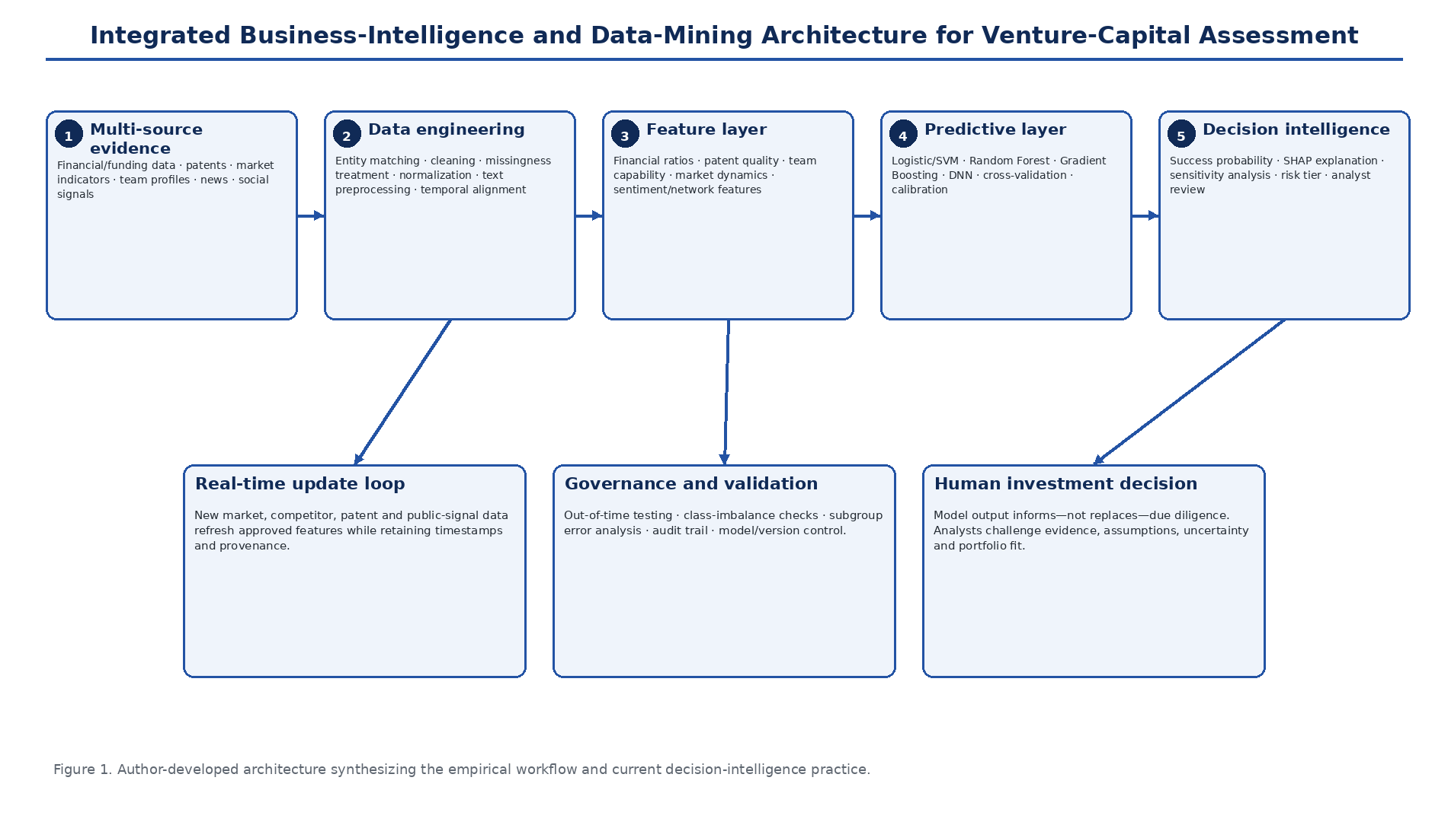
Figure 1. Integrated BI and data-mining architecture for venture-capital assessment. The workflow connects multi-source evidence, data engineering, feature construction, predictive modeling, explainable risk scoring and human due diligence.

3.3 Preprocessing, feature engineering and leakage control
Data cleaning addressed missingness, outliers, duplicate entities, inconsistent dates, currencies and units. Candidate imputation approaches included median/mean or k-nearest-neighbor methods for appropriate numeric variables and explicit unknown categories for selected categorical variables. Scaling and transformations were applied where required by model class. For text, preprocessing included tokenization, normalization, lemmatization and sentiment or semantic feature extraction using NLP toolchains such as NLTK and spaCy. In a rigorous pipeline, imputation, scaling, dimensionality reduction and feature selection must be fitted only to training data and then applied unchanged to validation/test data to prevent leakage.
Feature engineering converted raw signals into investment-relevant variables: financial ratios; time since founding and funding events; patent citation/family indicators; founder experience; network strength; market growth and competition; sentiment and text-derived semantic features. Time-based features were used to preserve venture development dynamics. Principal-component or other dimensionality-reduction methods may reduce redundancy, but interpretable domain features were retained where they support investment reasoning.

3.4 Predictive models and validation
The supervised model set comprised logistic regression, support-vector machines, Random Forest, Gradient Boosting methods and deep neural networks. Logistic regression provides a transparent baseline; SVMs capture nonlinear boundaries with appropriate kernels; tree ensembles model interactions and nonlinearities while supporting feature attribution; and DNNs provide flexible representation capacity. Hyperparameters were selected using grid or Bayesian search within the training/validation process. Model comparison relied on held-out evaluation using accuracy, precision, recall, F1-score and ROC-AUC. Where time ordering is material, out-of-time or rolling validation is preferable to random k-fold partitioning because it better approximates future investment decisions.
Class balance, calibration and threshold selection are as important as discrimination. A VC workflow may value false negatives and false positives differently: missing a rare high-return venture carries opportunity cost, while falsely labeling weak ventures as high potential creates capital-allocation loss. The risk protocol therefore treats probability thresholds as governance choices that should be tuned to fund strategy rather than as universal constants.

3.5 Explainability, sensitivity and risk protocol
The final analytical layer translates model output into investment-review evidence. A predicted success probability is mapped to a risk tier, sensitivity analysis tests whether modest changes in influential features materially alter the score, and SHAP-style attribution identifies feature contributions to individual and portfolio-level predictions. The protocol is explicitly human-in-the-loop: model recommendations structure due diligence but do not authorize investment. Analysts remain responsible for verifying source quality, assessing omitted qualitative information, challenging implausible explanations and considering portfolio fit.
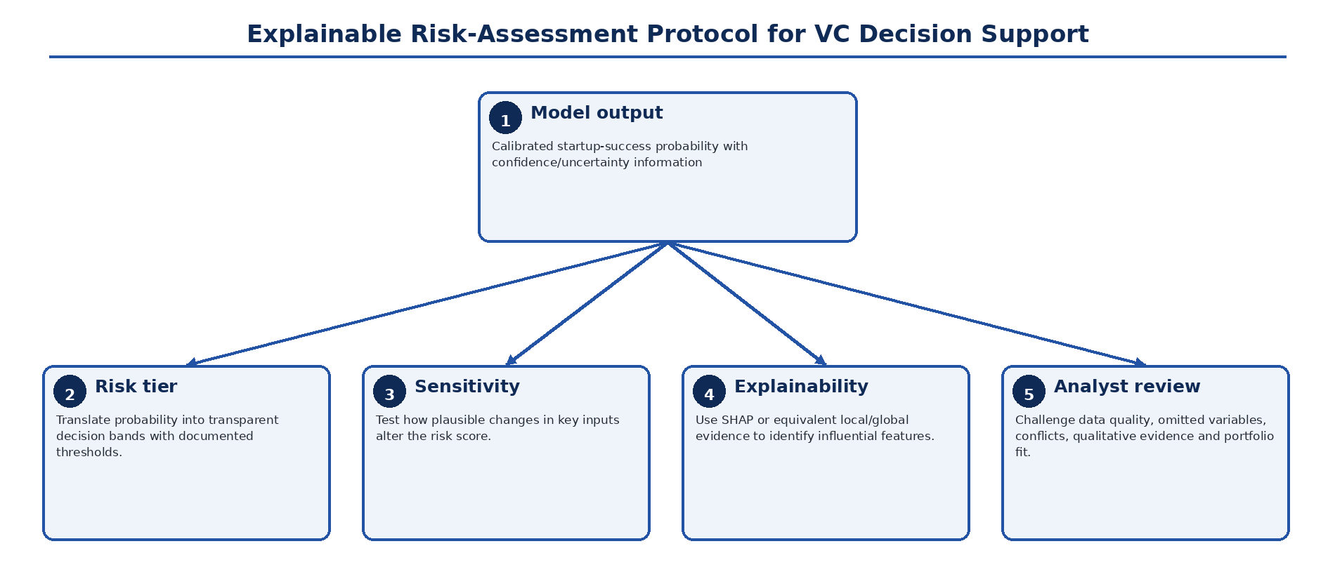
Figure 2. Explainable risk-assessment protocol for venture-capital decision support. Probability estimates are converted into risk tiers, sensitivity evidence and interpretable feature contributions before analyst review.

3.6 Technologies and implementation stack
Python served as the principal analytical environment, with Pandas and NumPy for data preparation, scikit-learn for conventional machine-learning workflows, TensorFlow/PyTorch for neural modeling, and NLTK/spaCy for natural-language processing. SQL and NoSQL stores support structured and semi-structured data, while Git-style version control provides code provenance. Cloud infrastructure can support scalable storage, scheduled data refresh, model training and deployment; however, reproducibility requires versioned datasets, frozen model artifacts, logged feature definitions and documented software environments rather than reliance on platform names alone.

4. Results

4.1 Overall predictive performance
The hybrid model achieved 87.3% classification accuracy on the reported test evaluation, with precision of 0.84, recall of 0.89, F1-score of 0.86 and ROC-AUC of 0.91. The combination of high recall and strong AUC indicates that the model captured a substantial share of successful-startup cases while maintaining useful overall ranking performance. Because classification accuracy can be inflated by class imbalance, the accompanying precision, recall, F1 and AUC are important for interpreting the result.
Table 3. Test-set performance of the hybrid predictive model
Metric | Reported value | Interpretation
Classification accuracy | 87.3% | Overall proportion of correctly classified outcomes.
Precision | 0.84 | 84% of predicted positive cases were reported as positive under the study definition.
Recall | 0.89 | 89% of positive cases were identified by the classifier.
F1-score | 0.86 | Balanced summary of precision and recall.
ROC-AUC | 0.91 | Strong discrimination across classification thresholds.

4.2 Algorithm comparison
Deep neural networks produced the highest reported classification accuracy (87.3%), followed by Gradient Boosting (85.7%) and Random Forest (84.2%). The absolute gap between the three algorithms was modest—3.1 percentage points between DNN and Random Forest—suggesting that model selection should consider calibration, stability, explanation quality and maintenance burden in addition to top-line accuracy. This result is context-specific: other large startup-prediction studies have found tree ensembles to be strongest, underscoring that no algorithm should be presumed dominant across datasets (Shi et al., 2024; Razaghzadeh Bidgoli et al., 2024).
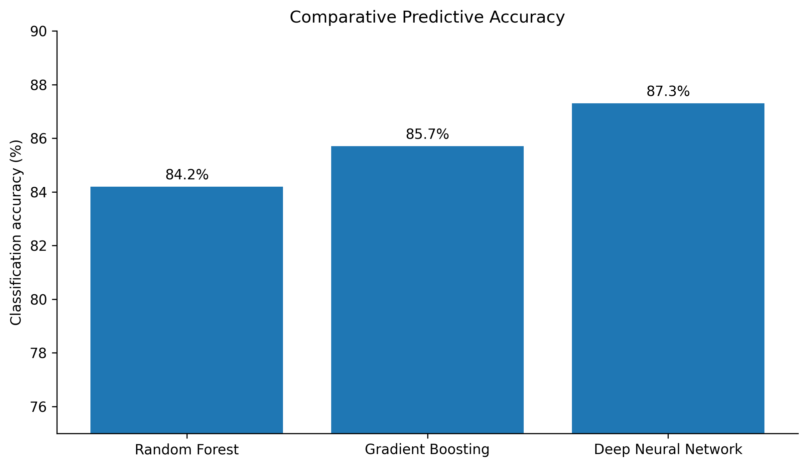
Figure 3. Comparative classification accuracy of the evaluated algorithms. DNNs achieved 87.3%, Gradient Boosting 85.7% and Random Forest 84.2%.

4.3 Feature importance and sensitivity
Financial metrics accounted for 27% of the reported feature importance, followed by technology indicators and market dynamics at 25% each and team composition at 23%. Sensitivity analysis produced a closely corresponding pattern: 28% for financial metrics, 26% for technology indicators, 24% for market dynamics and 22% for team composition. The alignment between attribution and perturbation results supports internal consistency: the feature families that contributed most strongly to prediction were also those for which input changes produced the largest shifts in risk scores.
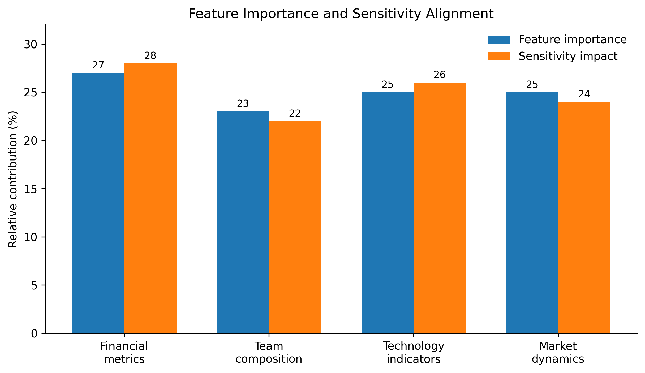
Figure 4. Alignment of feature-importance and sensitivity results across four evidence domains.
The pattern is substantively plausible. Financial signals remain important even for young firms because burn, growth, margin and acquisition economics constrain survival. Technology indicators capture defensibility and innovation, while market dynamics represent opportunity and competition. Team composition contributes distinct execution information. Contemporary evidence supports this multi-domain view: Wei et al. (2025) show that technological and VC-related variables improve startup-success prediction, while Maarouf et al. (2025) demonstrate additional predictive value from textual descriptions. The implication is that a single-source financial or social model is likely to omit relevant information.

4.4 Risk-tier distribution and recommendation accuracy
The standardized protocol assigned 15% of assessed startups to the high-potential category, 45% to medium risk and 40% to high risk. This distribution indicates a selective high-potential tier rather than a model that classifies most opportunities favorably. Among the high-potential recommendations, the reported success rate was 82%; the false-positive rate was 12% and the false-negative rate 8%. These error rates are operationally meaningful because they represent different investment costs: false positives can direct capital toward underperforming ventures, whereas false negatives can exclude high-upside opportunities.
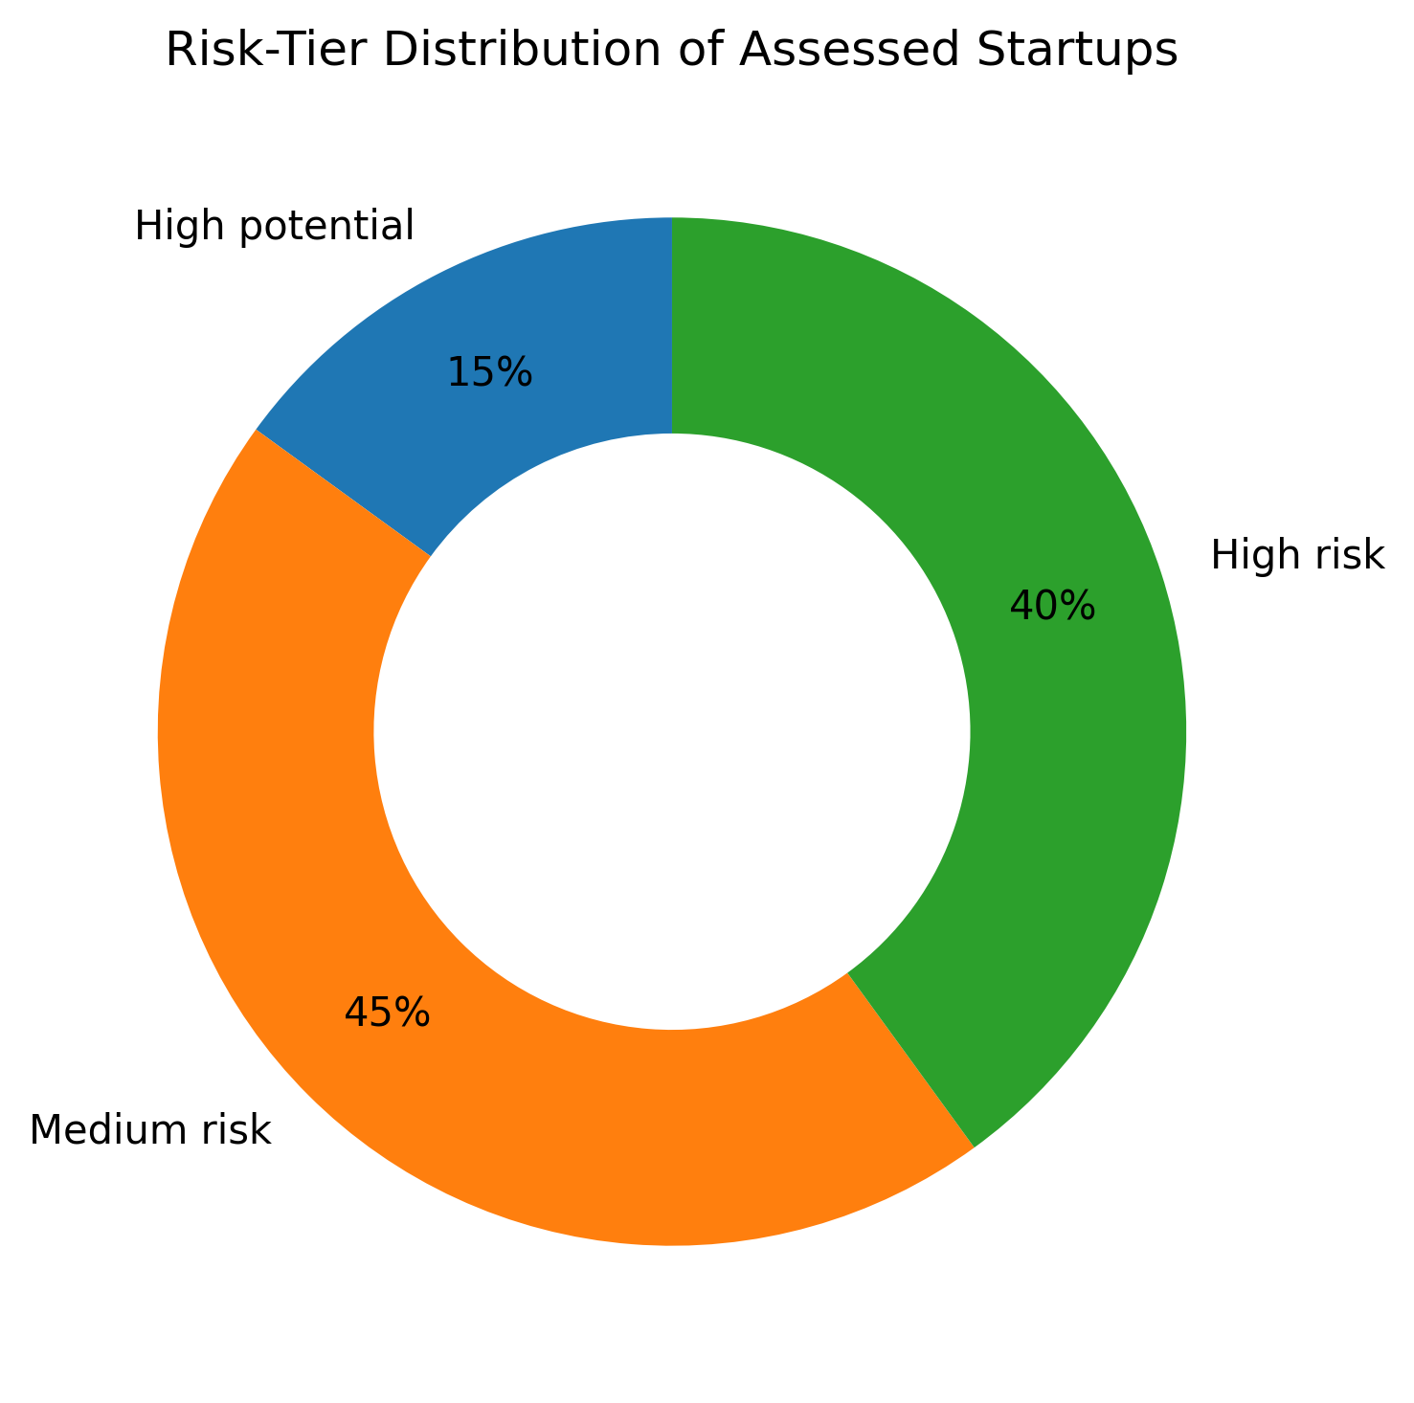
Figure 5. Distribution of assessed startups across the three risk tiers: high potential (15%), medium risk (45%) and high risk (40%).
Table 4. Risk-protocol validation metrics
Metric | Reported value | Decision relevance
High-potential success rate | 82% | Indicates realized/observed success among ventures placed in the favorable tier under the study definition.
False-positive rate | 12% | Captures ventures predicted favorably but not successful; relevant to capital-allocation loss.
False-negative rate | 8% | Captures successful ventures assigned unfavorably; relevant to missed-opportunity cost.

4.5 Contribution of unstructured evidence
Unstructured-data components produced reported task-level metrics of 85% sentiment-analysis accuracy and 79% patent-value prediction accuracy, while the social-signal indicator correlated with startup success at r = 0.73. These metrics should not be interpreted as directly comparable because accuracy and correlation quantify different properties. Their combined contribution is nonetheless important: unstructured evidence expands the model beyond accounting and funding histories to technology narratives, public sentiment and network effects. This direction is consistent with recent evidence that textual startup descriptions and patent/technology variables contribute materially to success prediction (Maarouf et al., 2025; Wei et al., 2025).
Table 5. Reported performance of unstructured-data components
Component | Metric | Value | Interpretive note
Sentiment analysis | Classification accuracy | 85% | Measures performance of the sentiment component, not startup-outcome accuracy.
Patent analytics | Prediction accuracy | 79% | Represents the reported patent-value prediction task.
Social signals | Correlation with startup success | r = 0.73 | Association measure; should not be compared numerically with classification accuracy.

4.6 Operational comparison with traditional assessment
Relative to the traditional comparator used in the study, the hybrid workflow reported a 35% reduction in assessment time, 42% improvement in prediction accuracy, 47% reduction in false positives and a 2.8-fold improvement in ROI. These figures indicate that the value proposition extends beyond classifier discrimination to process efficiency and capital allocation. However, the reported methods do not specify the exact construction of the traditional comparator, ROI horizon or cost accounting used for the 2.8-fold estimate. The operational metrics should therefore be interpreted as study-specific comparative results rather than universal effect sizes.
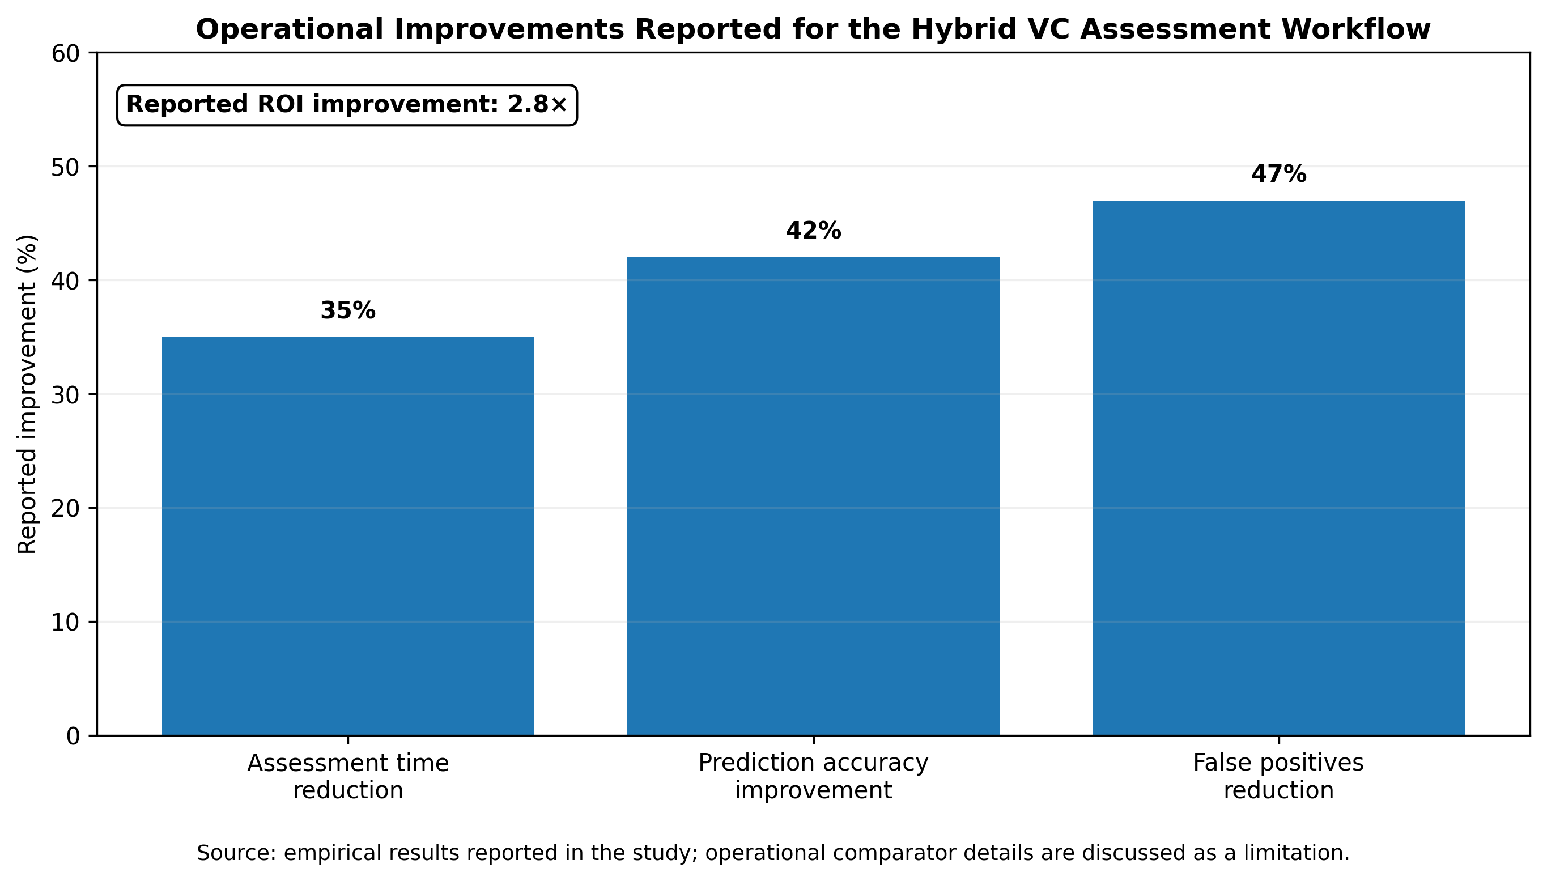
Figure 6. Reported operational improvement of the hybrid BI-data-mining workflow relative to the study comparator. The study also reports a 2.8-fold ROI improvement.

5. Discussion

5.1 Predictive performance in relation to contemporary startup analytics
The 87.3% accuracy and 0.91 ROC-AUC place the model within the range of useful decision-support performance, but direct benchmarking across studies requires caution because startup definitions, outcome windows, class balance and temporal splits differ. Shi et al. (2024) reported over 90% accuracy on a large Crunchbase sample, with Random Forest performing best; Razaghzadeh Bidgoli et al. (2024) reported 82% accuracy for Random Forest and 80% for Gradient Boosting in their design. The present DNN advantage is therefore not evidence that neural networks are intrinsically superior. It indicates that, for this feature representation and evaluation setting, the DNN captured useful nonlinear structure. A model selected for production should be re-evaluated under out-of-time testing and compared on calibration, stability and explanation quality as well as accuracy.

5.2 Why multi-source evidence matters
The feature results support a balanced conception of startup quality. No single domain accounted for more than 27% of importance, meaning that financial, technological, market and team information each contributed materially. This is theoretically consistent with startup uncertainty: financial metrics indicate current discipline, patents and technology indicators capture potential defensibility, market variables represent opportunity and competition, and the team influences execution. The addition of textual and social data can reduce information gaps, but it also introduces new sources of bias and manipulation. Public attention may reflect marketing intensity rather than venture quality; founder or geography visibility can shape social signals; and patent counts can reward quantity over economic relevance. A credible BI system must therefore preserve source lineage and allow analysts to distinguish signal from visibility.

5.3 Explainability as a governance mechanism
The risk protocol is strengthened by combining probability estimates with sensitivity analysis and SHAP-style feature attribution. Explainability is especially important in VC because investment committees must defend decisions to partners and limited partners, and founders may require coherent feedback. Recent evidence shows that explanation format and contextual enrichment can materially affect trust in AI-driven VC recommendations (Setty et al., 2026). Trust, however, should be calibrated rather than maximized. A clear explanation of a weakly validated model remains weak evidence. The appropriate governance question is whether the explanation is faithful, stable and supported by high-quality source data.

5.4 From prediction to decision intelligence
The most important design choice is to avoid turning the model into an autonomous investment rule. Investment decisions include strategic fit, governance rights, legal diligence, valuation terms, founder references, portfolio concentration and scenario-specific risk that may not be represented in the training data. The hybrid system is therefore better framed as decision intelligence: it ranks and structures evidence, identifies influential variables, exposes sensitivity and creates a reproducible audit trail. Human analysts then incorporate non-model evidence and exercise accountable judgment. This approach is consistent with contemporary hybrid VC frameworks that combine machine learning with explicit decision criteria and human-in-the-loop governance (Kellekci et al., 2026).

6. Practical Implementation and Governance

6.1 Production BI architecture
A practical implementation should separate ingestion, analytical storage, feature computation, model scoring and decision presentation. Source connectors should record acquisition time and legal basis; entity resolution should maintain stable company identifiers; feature definitions should be version-controlled; and dashboards should show both current values and their provenance. Retraining should occur on a controlled schedule with champion-challenger comparisons, while emergency refreshes for market shocks should not silently alter model behavior without validation.

6.2 Model-risk and fairness controls
• Use temporal holdouts and rolling evaluation to test performance on genuinely future ventures rather than random mixtures of past and future information.
• Report calibration as well as discrimination so that a predicted 70% probability has interpretable meaning across risk tiers.
• Audit subgroup error rates where legally and ethically appropriate, including geography, sector, venture stage and other access-related dimensions, to detect systematic exclusion.
• Treat social-media and public-attention variables as potentially endogenous and manipulable; use robustness checks and cap their influence where necessary.
• Version model artifacts, feature schemas, thresholds and explanation libraries so that every investment recommendation can be reconstructed.
• Require human approval for investment actions and document when analysts override the model, including the evidence supporting the override.

6.3 Reproducibility and research transparency
Reproducible startup analytics requires more than publishing source code. The research record should document the observation window, startup inclusion criteria, outcome definition, analytic sample size, class distribution, train/validation/test dates, missingness handling, feature cut-off times, model hyperparameters and comparator construction. Where commercial datasets cannot be redistributed, a data dictionary, synthetic schema, feature-generation code and executable evaluation pipeline can still allow methodological scrutiny without violating licences.

6.4 Implications for emerging VC ecosystems
For emerging venture ecosystems, BI-data-mining integration can be particularly valuable because comparable historical data and specialist due-diligence teams may be limited. A standardized evidence pipeline can improve consistency across deals and make investment rationale more auditable. The same context also raises caution: sparse local data may cause models trained on global platforms to underrepresent regional business models, informal traction signals or institutional conditions. Local calibration and analyst expertise are therefore essential before scores are used in Nigerian or other emerging-market investment settings.

6.5 Limitations
Several limitations bound interpretation of the findings. First, the reported study metadata do not state the final analytic sample size, observation window, class distribution or exact train/validation/test proportions, limiting independent replication. Second, the outcome definition combines venture events such as acquisition, IPO and failure, but the precise success horizon is not fully specified; startup outcomes are time-dependent and a venture classified as unsuccessful at one cutoff may succeed later. Third, publicly available social, news and web signals are vulnerable to coverage bias, strategic promotion and missingness. Fourth, the traditional comparator used for the reported operational gains is not described in sufficient detail to establish a universal baseline, and the 2.8-fold ROI result lacks a stated investment horizon and cash-flow convention. Fifth, feature-importance percentages describe the fitted model rather than causal effects. These limitations do not negate the reported predictive results but identify the information required for stronger external validation.

7. Conclusion and Recommendations
The empirical findings support the integration of business intelligence, data mining and machine learning as a structured decision-support approach for VC assessment of technology startups. The model achieved 87.3% classification accuracy, 0.86 F1 and 0.91 ROC-AUC; DNNs modestly outperformed Gradient Boosting and Random Forest in the evaluated setting. Financial, technology, market and team features all contributed materially, demonstrating the value of multi-source evidence. The risk protocol further translated predictive outputs into interpretable tiers, sensitivity information and analyst-review evidence, while the operational comparison reported faster assessment, improved prediction, fewer false positives and higher ROI relative to the comparator process.
The strongest practical implication is not that venture selection can be automated. It is that VC due diligence can become more systematic, evidence-rich and auditable when data engineering, prediction, explainability and human judgment are designed as one workflow. Investment organizations adopting this approach should prioritize temporal validation, calibrated probabilities, transparent feature provenance, explainable risk scores, subgroup error audits and human approval. Future research should publish the complete analytic cohort and time windows, test performance prospectively across geographies and venture stages, compare model-assisted with analyst-only decisions under controlled conditions, and evaluate whether improved prediction translates into risk-adjusted fund performance over full investment horizons.

8. Declarations
Ethics approval: Not applicable. The study analyzes startup/business data and does not report new human-participant or animal experimentation.
Consent for publication: Not applicable; no identifiable private participant information is reported.
Funding: No external funding was declared specifically for this article.
Competing interests: The author declares no competing interests.
Author contribution: Olumeyan Elizabeth Titilayo: conceptualization, investigation, data-integration framework, analysis, interpretation and manuscript authorship.
Data and materials availability: The article reports the analytical results and evidence domains summarized in the study. An associated open research record is available at Zenodo record 18493185. Zenodo record 18493185
AI-assisted editorial support: AI-assisted tools were used for language refinement, structural harmonization, figure standardization and reference-consistency checking. They were not used as authors or as substitutes for scholarly judgement. Responsibility for the data, interpretation, source verification and final publication approval remains with the author and journal editor.
Copyright and licence: © 2026 The Author. Published by CHIA TECH SOLUTIONS AND RESOURCES LIMITED (RC 1839865). This open-access article is distributed under the Creative Commons Attribution 4.0 International (CC BY 4.0) licence, except for third-party material otherwise identified.

References
Akerlof, G. A. (1970). The market for “lemons”: Quality uncertainty and the market mechanism. The Quarterly Journal of Economics, 84(3), 488–500. https://doi.org/10.2307/1879431
Arroyo, J., Corea, F., Jimenez-Diaz, G., & Recio-Garcia, J. A. (2019). Assessment of machine learning performance for decision support in venture capital investments. IEEE Access, 7, 124233–124243. https://doi.org/10.1109/ACCESS.2019.2938659
Corea, F., Bertinetti, G., & Cervellati, E. M. (2021). Hacking the venture industry: An early-stage startups investment framework for data-driven investors. Machine Learning with Applications, 5, 100062. https://doi.org/10.1016/j.mlwa.2021.100062
Jensen, M. C., & Meckling, W. H. (1976). Theory of the firm: Managerial behavior, agency costs and ownership structure. Journal of Financial Economics, 3(4), 305–360. https://doi.org/10.1016/0304-405X(76)90026-X
Kellekci, M., Cebeci, U., & Dogan, O. (2026). A methodological framework for venture capital investment decision making using hybrid MCDM and machine learning. In Innovative Approaches to AI-Supported Hybrid and Remote Workplaces (pp. 93–124). IGI Global. https://doi.org/10.4018/979-8-3373-7416-1.ch005
Lundberg, S. M., & Lee, S.-I. (2017). A unified approach to interpreting model predictions. Advances in Neural Information Processing Systems, 30, 4765–4774.
Maarouf, A., Feuerriegel, S., & Pröllochs, N. (2025). A fused large language model for predicting startup success. European Journal of Operational Research, 322(1), 198–214. https://doi.org/10.1016/j.ejor.2024.09.011
Malhotra, P. (2026). Predicting venture capital exit strategies through explainable machine learning: Governance, decision intelligence and organisational implications. International Journal of Organizational Analysis. https://doi.org/10.1108/IJOA-10-2025-6108
Markowitz, H. (1952). Portfolio selection. The Journal of Finance, 7(1), 77–91. https://doi.org/10.1111/j.1540-6261.1952.tb01525.x
Park, J., Choi, S., & Feng, Y. (2024). Predicting startup success using two bias-free machine learning: Resolving data imbalance using generative adversarial networks. Journal of Big Data, 11, 122. https://doi.org/10.1186/s40537-024-00993-8
Razaghzadeh Bidgoli, M., Raeesi Vanani, I., & Goodarzi, M. (2024). Predicting the success of startups using a machine learning approach. Journal of Innovation and Entrepreneurship, 13, 80. https://doi.org/10.1186/s13731-024-00436-x
Samek, W., Montavon, G., Lapuschkin, S., Anders, C. J., & Müller, K.-R. (2021). Explaining deep neural networks and beyond: A review of methods and applications. Proceedings of the IEEE, 109(3), 247–278. https://doi.org/10.1109/JPROC.2021.3060483
Setty, R., Elovici, Y., & Schwartz, D. (2026). Building trust in AI-driven venture capital decisions: A comparative study of SHAP and GPT explanations. Journal of Behavioral and Experimental Finance, 49, 101148. https://doi.org/10.1016/j.jbef.2026.101148
Shi, Y., Eremina, E., & Long, W. (2024). Machine learning models for early-stage investment decision making in startups. Managerial and Decision Economics, 45(3), 1259–1279. https://doi.org/10.1002/mde.4072
Wei, C.-P., Fang, E. S.-H., Yang, C.-S., & Liu, P.-J. (2025). To shine or not to shine: Startup success prediction by exploiting technological and venture-capital-related features. Information & Management, 62(6), 104152. https://doi.org/10.1016/j.im.2025.104152
CHIATECH JOURNAL · SETEHEM · Volume 1 · Issue 1 · August 2026 · e033 · Pioneer Publication

