CHIATECH JOURNAL
  - SETEHEM · Volume 1, Issue 1 · Pioneer July/August 2026 · Part 2 · e034
  - PIONEER PUBLICATION · ACCEPTED ARTICLE · ORIGINAL RESEARCH ARTICLE · ACCOUNTING · DATA SCIENCE · INFORMAL ENTERPRISE · FINANCIAL ANALYTICS

Accounting Practices, Digitalisation and Financial-Risk Analytics among Informal Small Businesses in Gwagwalada, Abuja: An Empirical Accounting Data-Science Study
Olumeyan Elizabeth Titilayo
National Teachers Institute, Gwagwalada Study Centre, FCT Abuja, Nigeria
Correspondence: Elizabethtiti1972@gmail.com
ARTICLE TYPE  Original Research Article | VOLUME / ISSUE  1(1) | ELOCATOR  e034
PUBLICATION  Pioneer July/August · Part 2 | IDENTIFIERS  ISSN: Pending assignment | JOURNAL DOI  Pending registration

Abstract
Background: Informal and microbusinesses depend on timely financial information, yet many operate with incomplete records, weak separation of business and personal funds, and irregular reconciliation. Digitalisation creates new opportunities for affordable record keeping and data-driven risk monitoring, but evidence from local informal-business settings remains limited. Objective: This study examined accounting practices, financial patterns and study-defined financial-risk classification among informal small businesses in Gwagwalada, Abuja, and evaluated whether basic accounting-practice variables provide useful internal risk discrimination. Methods: A cross-sectional empirical dataset comprising 150 businesses from seven commercial clusters and eight business categories was analysed. Variables covered daily revenue, expense, profit and gross margin; primary record-keeping method; business banking; separation of personal and business funds; reconciliation frequency; financial challenges; a study-derived digital-accounting score; accounting-maturity class; and a binary financial-risk label. Descriptive statistics, chi-square tests, Cramér’s V, Mann–Whitney testing, odds ratios and repeated stratified five-fold cross-validation were used. Results: Notebook/ledger recording was most common (61.3%), 24.0% relied on mental/no records and only 10.0% primarily used a mobile/digital method. Although 75.3% used a business bank account, only 29.3% separated personal and business funds. Forty-four percent were classified as high risk. Financial-risk classification differed significantly by record-keeping method (χ²(3)=18.99, p<.001, V=.356), fund separation (χ²(1)=6.14, p=.013, V=.202) and reconciliation frequency (χ²(4)=23.62, p<.001, V=.397), but not by business-bank-account use (p=.219). Mental/no-record businesses had 6.20 times the odds of high-risk classification compared with notebook/ledger users, while never reconciling carried 5.63 times the odds relative to daily reconciliation. An accounting-practice random forest achieved mean repeated-cross-validation ROC-AUC=.737±.099, indicating moderate internal discrimination rather than deployment-ready credit prediction. Conclusion: The strongest risk signals in this local sample were not mere access to banking or high turnover, but the discipline of recording, separating funds and reconciling accounts. Practical digital bookkeeping should therefore be implemented as an accounting-control intervention, supported by training and simple analytics, rather than as technology adoption alone.
Keywords: accounting data science; record keeping; digital accounting; informal enterprises; financial risk; internal control; small business; Gwagwalada; Nigeria; machine learning
Suggested citation: Olumeyan, E. T. (2026). Accounting practices, digitalisation and financial-risk analytics among informal small businesses in Gwagwalada, Abuja: An empirical accounting data-science study. CHIATECH JOURNAL · SETEHEM, 1(1), e034.

1. Introduction
Small informal and microbusinesses are information-intensive enterprises even when they operate with minimal formal accounting infrastructure. Daily decisions about stock replenishment, customer credit, pricing, cash withdrawal, supplier payment and business survival depend on knowing what has been sold, what has been spent, what is owed and how much cash truly belongs to the business. When these facts remain in memory or are mixed with household finance, owners may operate without a reliable view of profit, liquidity or risk. Accounting record keeping is therefore not only a compliance activity; it is a basic information system for managerial control.
Recent Nigerian evidence continues to show a persistent gap between access to financial services and the disciplined use of business records. Studies across Kano, Rivers, Plateau and national SME samples have linked record keeping and digital accounting with stronger information use, operational efficiency and financial performance (Hamid et al., 2023; Mohammed et al., 2024; Aderinto, 2025; Garba & Mohammed, 2026). Importantly, the International Growth Centre’s Nigerian e-bookkeeping work suggests that digital tools are more likely to be adopted when accompanied by personalised support, and that digital records can improve the precision with which small firms recall profits (Oyebanjo, 2024, 2025). These findings shift the policy question from whether digital accounting is useful to how it can be embedded in the routines of informal firms.
Data science adds a second layer to this problem. Once business transactions and accounting practices are captured consistently, descriptive dashboards can show margin structure and cash patterns, while statistical and machine-learning methods can identify combinations of practices associated with elevated risk. However, predictive analytics must be interpreted carefully. Small-business risk labels may be study-derived rather than lender-validated default outcomes, local samples may be heterogeneous, and opaque models can overfit weak signals. Recent financial-risk research therefore emphasizes trustworthy information, careful validation and explainability when machine learning is used with small firms (Bitetto et al., 2024; Gu et al., 2024).
Gwagwalada is a useful setting for examining this intersection because its roadside and informal commercial clusters include highly heterogeneous activities: provisions and grocery trading, POS services, food vending, tailoring, phone accessories, salons, fruit and vegetable trading, and vehicle-related services. Their turnover structures differ substantially, yet all require decisions about records, reconciliation, banking and household-business boundaries. This study therefore links accounting practice to empirical data science while keeping the interpretation grounded in observable local business routines.

1.1 Research objectives, questions and hypotheses
• To describe the record-keeping, business-banking, fund-separation and reconciliation practices of sampled informal businesses in Gwagwalada.
• To compare revenue, profit and gross-margin patterns across major business categories.
• To test whether record-keeping method, fund separation and reconciliation frequency are associated with study-defined financial-risk classification.
• To examine whether the digital-accounting score differs between high-risk and normal-risk businesses.
• To evaluate the internal discriminative performance of accounting-practice variables using transparent repeated cross-validation.
The study addressed five corresponding questions: What accounting practices dominate the sample? How do financial profiles differ by business category? Which accounting-control practices are statistically associated with risk classification? Does digital-accounting maturity differ by risk status? And how much internal classification information is carried by accounting-practice variables compared with selected financial-profile variables?
The inferential tests evaluated the null hypotheses that (H01) primary record-keeping method is independent of financial-risk classification, (H02) separation of personal and business funds is independent of risk classification, and (H03) reconciliation frequency is independent of risk classification. A fourth analytical expectation was that an exploratory practice-based classifier should demonstrate discrimination above chance if these routines contain meaningful risk information.

2. Literature Review and Analytical Framework

2.1 Record keeping as an information-processing capability
A small business can be viewed as a recurring information-processing system: transactions create data; records preserve those data; reconciliation compares records with cash or bank evidence; and accounting summaries convert the records into information for decisions. Weak record keeping increases uncertainty because the owner must rely on recall, intuition and incomplete transaction evidence. Nigerian research consistently reports that more systematic records are associated with better use of accounting information and enterprise sustainability (Onwuchekwa & Ukpong, 2023; Hamid et al., 2023; Aderinto, 2025). The causal direction may vary, but the managerial logic is clear: decisions improve when information is timely, retrievable and internally consistent.

2.2 Internal control in microbusiness form
Formal internal-control systems are often discussed in the context of larger organizations, yet three basic controls have direct equivalents in microbusinesses. First, separation of personal and business funds creates an accounting boundary around the enterprise. Second, a dedicated business account improves traceability, although account ownership alone does not guarantee disciplined bookkeeping. Third, reconciliation detects inconsistencies between recorded transactions and the cash, receipts or bank evidence that should support them. These routines reduce the risk that owner withdrawals, missed debts, unrecorded purchases or cash leakages are mistaken for business performance.

2.3 Digital accounting and the adoption gap
Digital accounting can lower the cost of transaction capture, automate summaries and preserve records more reliably than memory. Yet adoption depends on perceived usefulness, digital skills, cost, trust and support. Nigerian studies report positive associations between digital accounting and SME performance, while recent experimental and implementation work stresses that information about benefits is often insufficient without hands-on assistance (Mohammed et al., 2024; Ajape et al., 2024; Oyebanjo, 2024; Garba & Mohammed, 2026). The implication is that digitalisation should be judged by whether it changes accounting behaviour—not simply by whether a bank account, smartphone or app is present.

2.4 Accounting data science and responsible risk analytics
The data-science perspective treats accounting-practice data as structured features that can be summarized, tested and used in exploratory prediction. Machine learning can capture nonlinear interactions, but small-business applications require conservative validation. Bitetto et al. (2024) found that machine learning can outperform traditional approaches when small-firm information is limited, while Gu et al. (2024) emphasize the centrality of trustworthy financial information and balanced model evaluation. For local informal-enterprise studies, the appropriate objective is therefore risk screening and hypothesis generation rather than automated lending decisions.
Figure 1. Empirical accounting-data-science workflow used in the study.
1  Field evidence  150 businesses  7 clusters  8 categories | 2  Accounting metrics  Revenue  Expense  Profit  Margin | 3  Practice controls  Records  Banking  Fund separation  Reconciliation | 4  Statistical analysis  Descriptives  χ² / V  Mann–Whitney  Odds ratios | 5  Data-science layer  Repeated CV  Logistic model  Random forest  AUC / F1
The framework separates descriptive accounting evidence from inferential association and exploratory classification. This prevents a predictive model from substituting for the underlying accounting interpretation.

3. Materials and Methods

3.1 Study design, setting and sample
The study adopted a cross-sectional empirical design using business-level data collected in Gwagwalada, Federal Capital Territory, Abuja, over the period 1 January to 30 June 2026. The final analytic dataset contained 150 informal and roadside businesses distributed across seven commercial/location clusters: Dagiri, SDP Junction, Secretariat Road, Kutunku, UniAbuja Main Gate, Phase 3 and Phase 1. Representation covered eight activity groups: provisions/grocery, POS operations, food vending, phone accessories, tailoring/fashion, barber/salon, fruit/vegetable selling, and vulcanizer/mechanic services. A stratified representation strategy was used to ensure that both location and business category were represented in the analytic sample.

3.2 Variables and accounting measures
The structured business schedule captured location, business category, educational level, years in business, estimated daily revenue, estimated daily expense, primary record-keeping method, business-bank-account use, separation of personal and business funds, reconciliation frequency, the most important financial challenge, accounting maturity, financial-risk class and a digital-accounting score. Daily profit was calculated as revenue minus expense; gross margin was profit divided by revenue × 100; and expense ratio was expense divided by revenue × 100.
Primary record keeping was classified as notebook/ledger, mental/none, mobile app/digital or receipts only. Reconciliation was classified as daily, weekly, monthly, rarely or never. The Digital_Accounting_Score ranged from 0 to 6 and summarized the intensity of accounting/digital practice. Accounting_Maturity and Financial_Risk_Label are study-derived classification variables used for internal analysis; they should not be interpreted as audited accounting opinions, external credit ratings or observed loan-default outcomes.

3.3 Data quality and analytical strategy
Data were screened for completeness, arithmetic consistency and implausible ratios. Revenue, expense and profit relationships were cross-checked, and gross-margin plus expense-ratio percentages were expected to sum approximately to 100% subject to rounding. Because most instrument items are factual or categorical practice indicators rather than reflective psychometric items, Cronbach’s alpha was not treated as an appropriate primary quality criterion. Analysis focused instead on coding consistency, derived-variable arithmetic and transparent operational definitions.
Descriptive analysis used counts, percentages, means, medians and standard deviations. Because revenue was strongly right-skewed by high-turnover POS activity, both mean and median were reported. Associations between categorical accounting practices and financial-risk class were evaluated using Pearson chi-square tests with Cramér’s V as an effect-size measure. The Digital_Accounting_Score was compared between risk groups with the Mann–Whitney U test, and selected 2×2 contrasts were summarized as unadjusted odds ratios with 95% confidence intervals.
Exploratory classification used repeated stratified five-fold cross-validation with three repeats. Logistic regression and random forest models were evaluated on held-out folds. Categorical variables were one-hot encoded within each training fold; numerical variables were standardized for logistic regression. Class balancing was applied in the classifiers. The practice model used primary record-keeping method, business-bank-account use, separation of funds and reconciliation frequency. A financial-profile model used revenue, profit, gross margin, business tenure and business category; a combined model joined both feature sets. Performance was summarized by ROC-AUC, balanced accuracy, F1 and ordinary accuracy. These models are internal analytical tests, not externally validated credit-scoring tools.
Table 1. Sample profile (n=150)
Dimension | Category | n | %
Location | Dagiri | 26 | 17.3%
Location | SDP Junction | 23 | 15.3%
Location | Secretariat Road | 22 | 14.7%
Location | Kutunku | 21 | 14.0%
Location | UniAbuja Main Gate | 20 | 13.3%
Location | Phase 3 | 19 | 12.7%
Location | Phase 1 | 19 | 12.7%
Education | Secondary | 57 | 38.0%
Education | OND/NCE | 42 | 28.0%
Education | HND/BSc | 39 | 26.0%
Education | Primary | 10 | 6.7%
Education | Postgraduate | 2 | 1.3%
Business tenure | 7–10 years | 49 | 32.7%
Business tenure | 4–6 years | 38 | 25.3%
Business tenure | 1–3 years | 36 | 24.0%
Business tenure | >10 years | 18 | 12.0%
Business tenure | <1 year | 9 | 6.0%

4. Results

4.1 Accounting and financial-practice profile
The sample displayed a clear predominance of manual record keeping. Notebook/ledger recording accounted for 92 businesses (61.3%), followed by mental/no records in 36 (24.0%), mobile app/digital recording in 15 (10.0%) and receipts only in 7 (4.7%). Business banking was considerably more common than digital accounting: 113 businesses (75.3%) used a business bank account, but only 44 (29.3%) reported separating personal and business funds. Reconciliation occurred daily in 46 businesses (30.7%) and weekly in 43 (28.7%), while 36 (24.0%) never reconciled and 20 (13.3%) did so rarely. The accounting-maturity classification was low for 122 businesses (81.3%), moderate for 14 (9.3%) and high for 14 (9.3%).
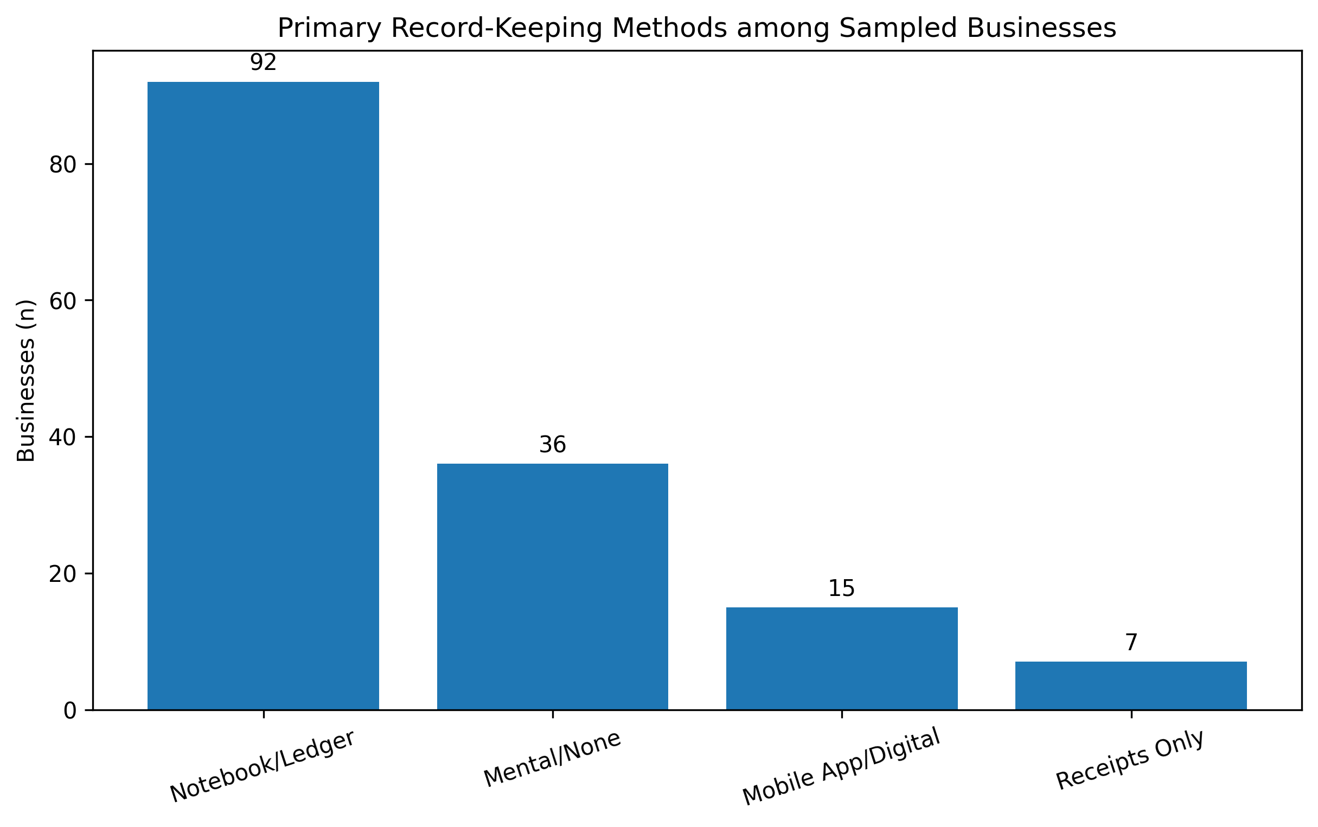
Figure 2. Distribution of primary record-keeping methods. Manual notebook/ledger use dominated the sample, while digital-first record keeping remained uncommon.
Estimated daily revenue averaged ₦89,713, but the median was only ₦40,850, confirming strong right skew. Mean daily profit was ₦13,317 (median ₦11,800), and mean gross margin was 28.0%. These statistics show why turnover alone is an incomplete indicator of small-business financial health.
Table 2. Financial and digital profile by business category
Business category | n | Median revenue | Median profit | Mean margin | Digital score | High-risk %
Barber/Salon | 15 | ₦21,800 | ₦9,100 | 39.9% | 1.73 | 33.3%
Food Vendor (Buka) | 20 | ₦60,300 | ₦17,700 | 32.4% | 1.75 | 55.0%
Fruit/Veg Seller | 12 | ₦24,200 | ₦9,650 | 38.7% | 0.75 | 58.3%
POS Operator | 25 | ₦320,400 | ₦10,500 | 3.7% | 3.40 | 40.0%
Phone Accessories | 16 | ₦24,400 | ₦10,100 | 40.1% | 2.12 | 43.8%
Provisions/Grocery | 39 | ₦85,200 | ₦19,100 | 22.6% | 1.79 | 38.5%
Tailoring/Fashion | 15 | ₦26,800 | ₦11,100 | 38.6% | 1.67 | 46.7%
Vulcanizer/Mechanic | 8 | ₦21,800 | ₦7,950 | 37.7% | 0.88 | 50.0%
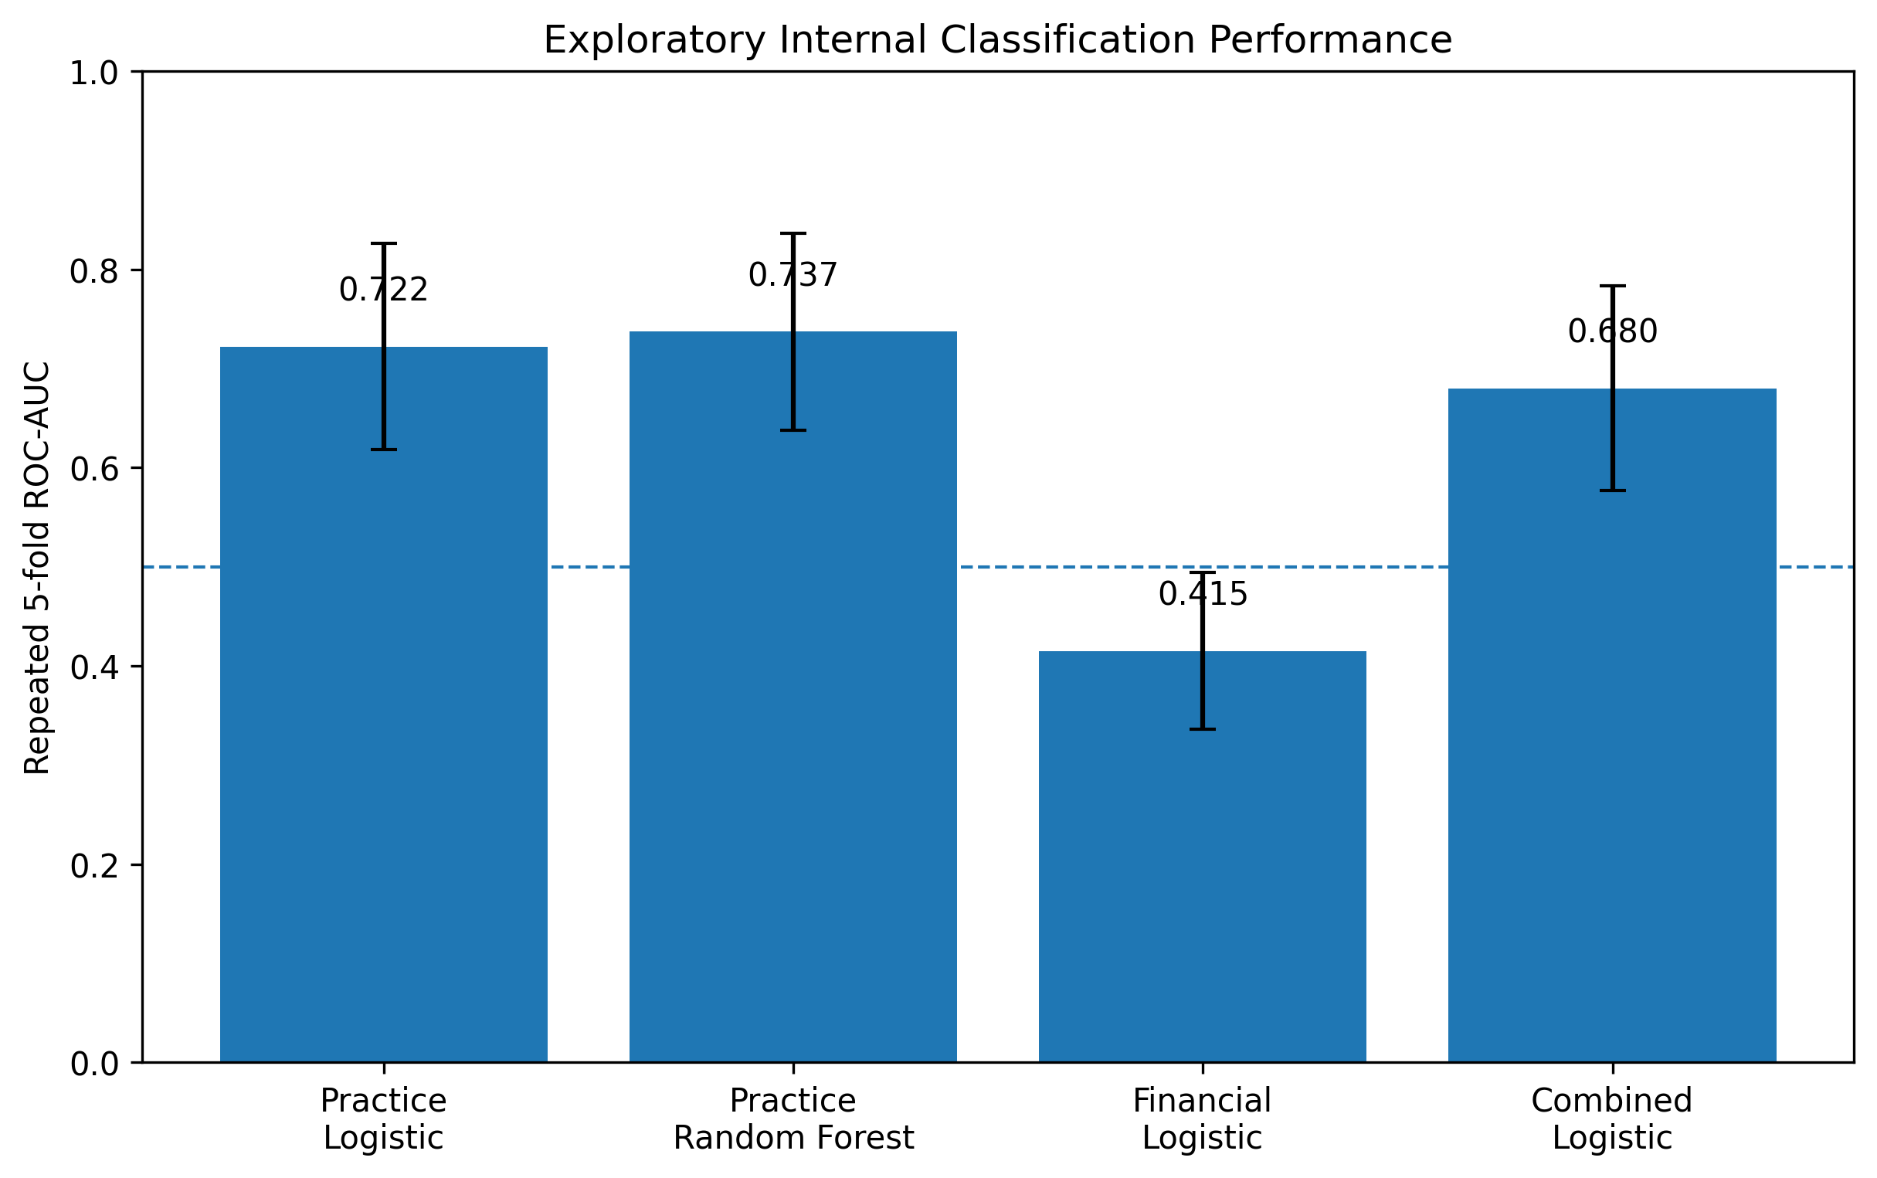
Figure 3. Business-category financial profile. POS operators recorded exceptionally high turnover but very low gross margins, demonstrating the distinction between transaction volume and profitability.
POS operators had the highest median daily revenue (₦320,400) but an average gross margin of only 3.65%, reflecting the pass-through nature of cash-in/cash-out transaction flows. By contrast, phone-accessory, barber/salon, fruit/vegetable and tailoring businesses had much lower turnover but mean gross margins near 38–40%. The figure therefore reinforces the accounting need to monitor margin and expense structure rather than sales turnover in isolation.

4.2 Financial challenges
Customer debt was the most frequently reported financial challenge (39 businesses; 26.0%), followed by inflation/high cost of goods (35; 23.3%), multiple taxation (31; 20.7%), power-supply costs (24; 16.0%) and lack of capital (21; 14.0%). These challenges were widely distributed across risk classes; the overall challenge-by-risk association was not statistically significant (χ²(4)=3.09, p=.542). The result suggests that common environmental pressures are pervasive across the informal-business population rather than unique to one risk class.
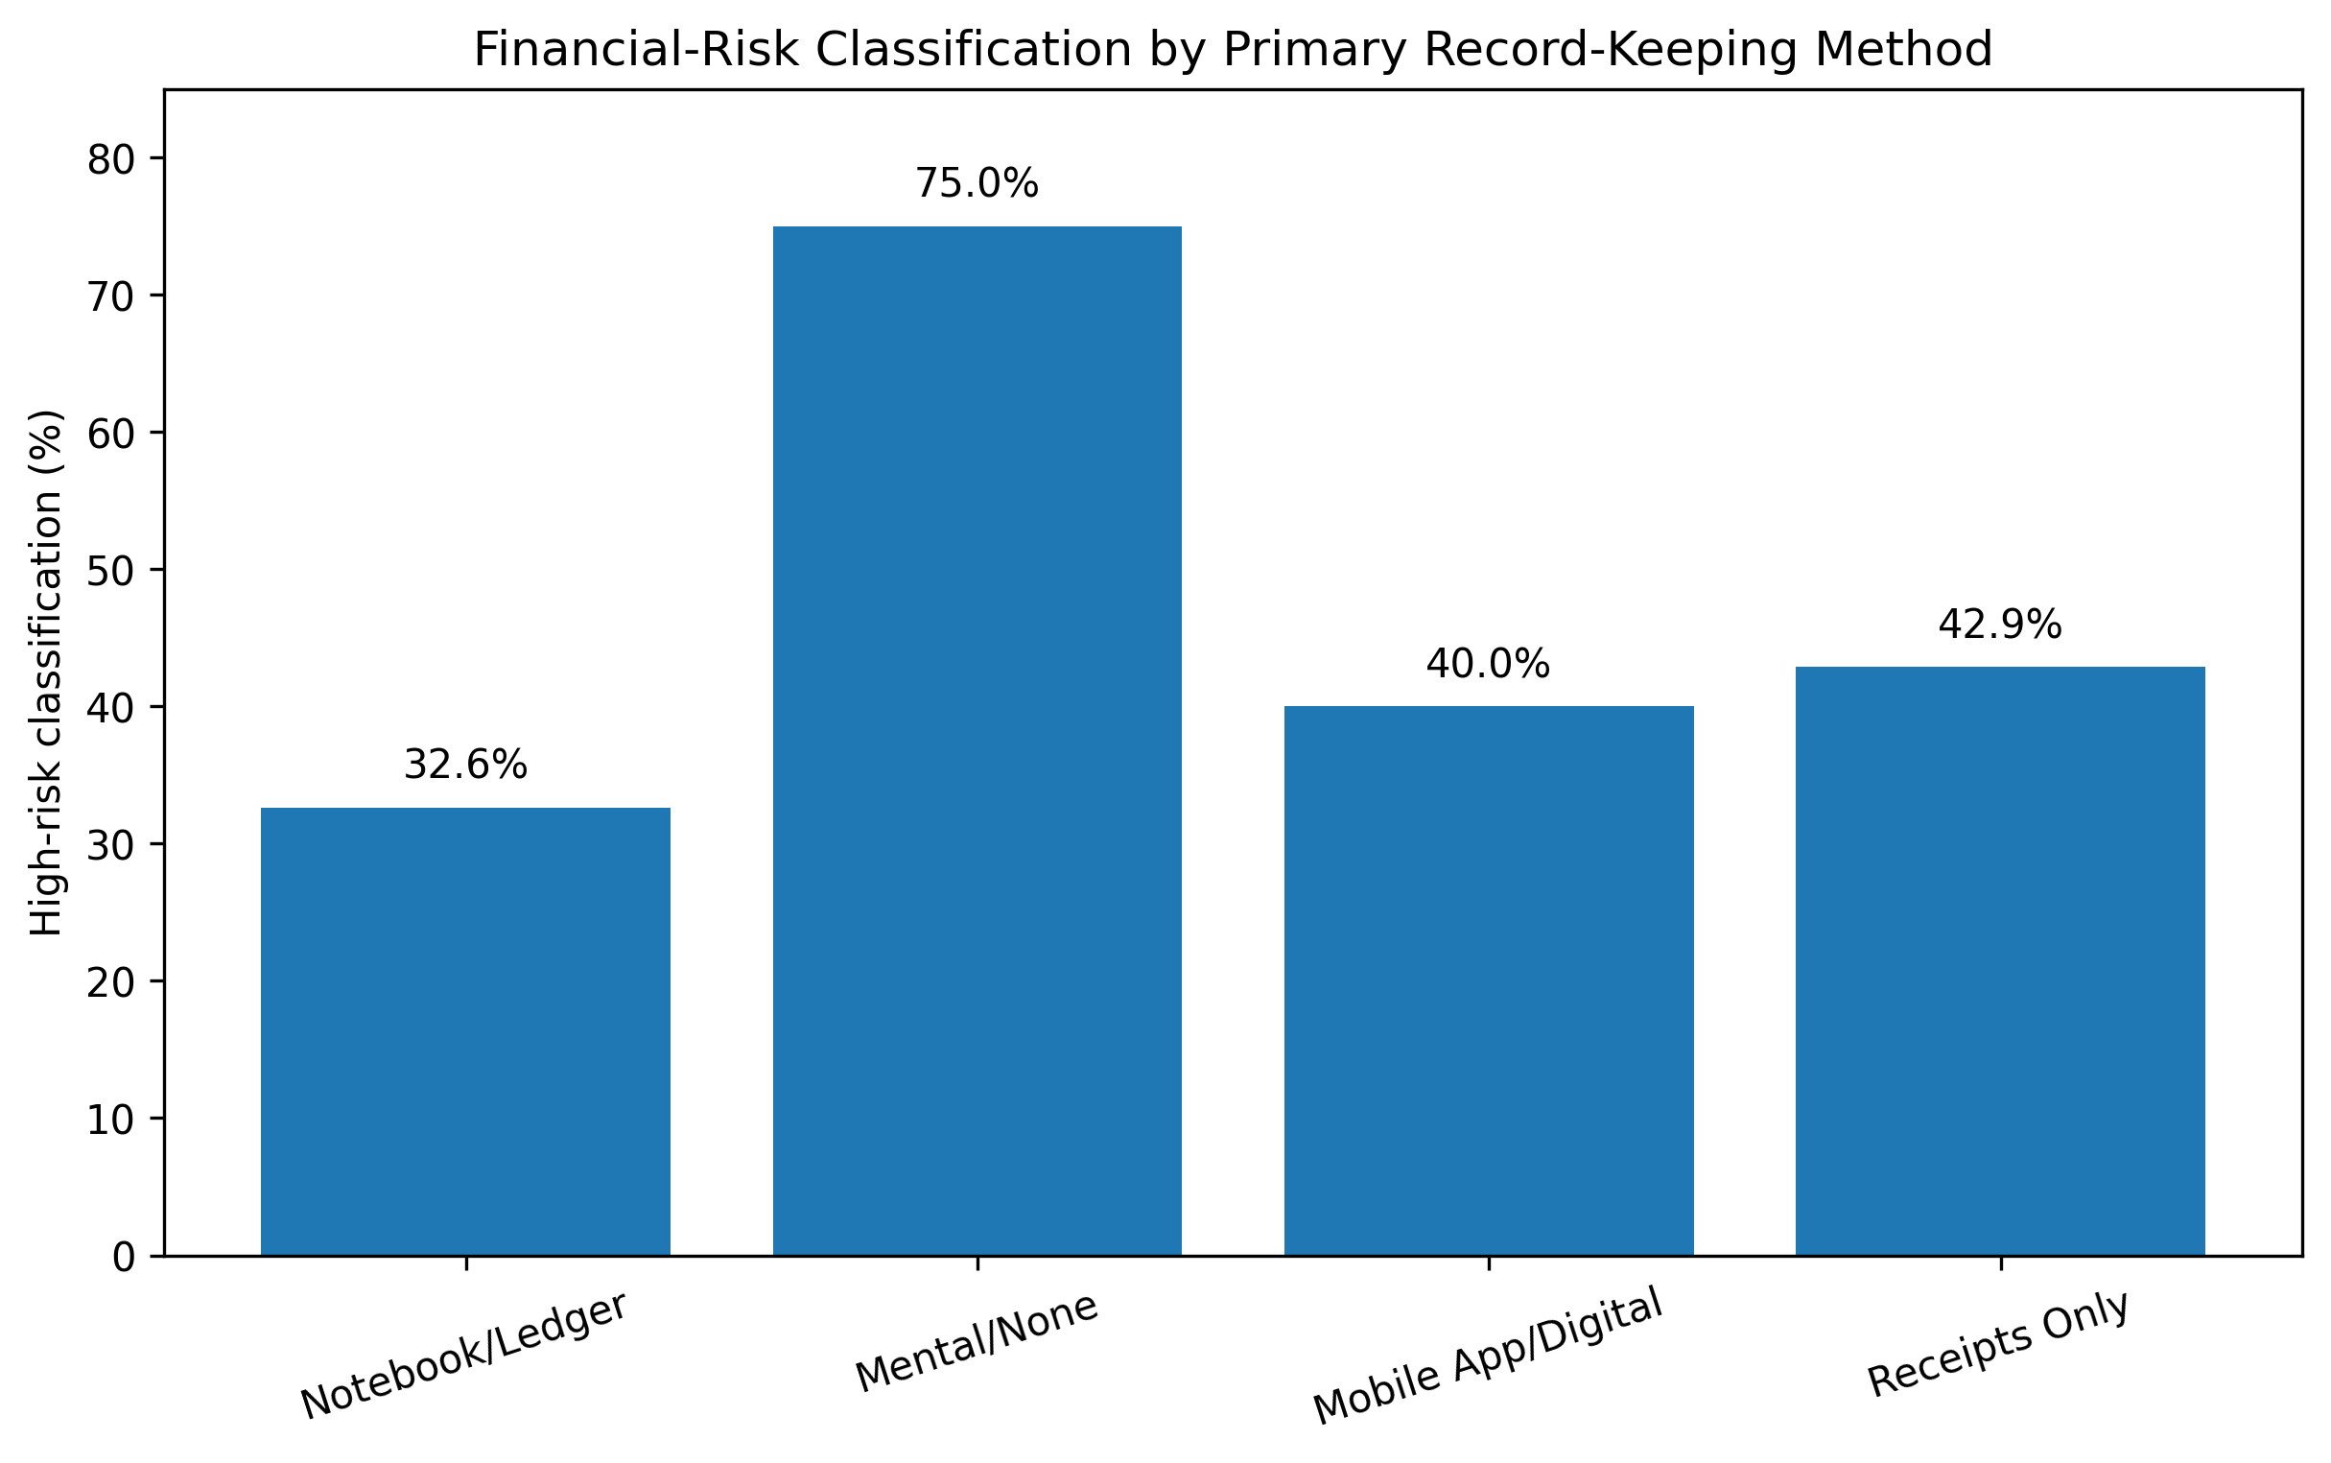
Figure 4. Most frequently reported financial challenges among sampled businesses.

4.3 Accounting practices and financial-risk classification
Sixty-six businesses (44.0%; 95% Wilson CI 36.3–52.0%) were classified as high risk and 84 (56.0%) as normal risk. The strongest categorical association was reconciliation frequency (χ²(4)=23.62, p<.001, Cramér’s V=.397). High-risk classification affected 75.0% of businesses that never reconciled, compared with 34.8% of daily reconcilers. The unadjusted odds of high-risk classification were 5.63 times higher for businesses that never reconciled than for daily reconcilers (95% CI 2.14–14.81).
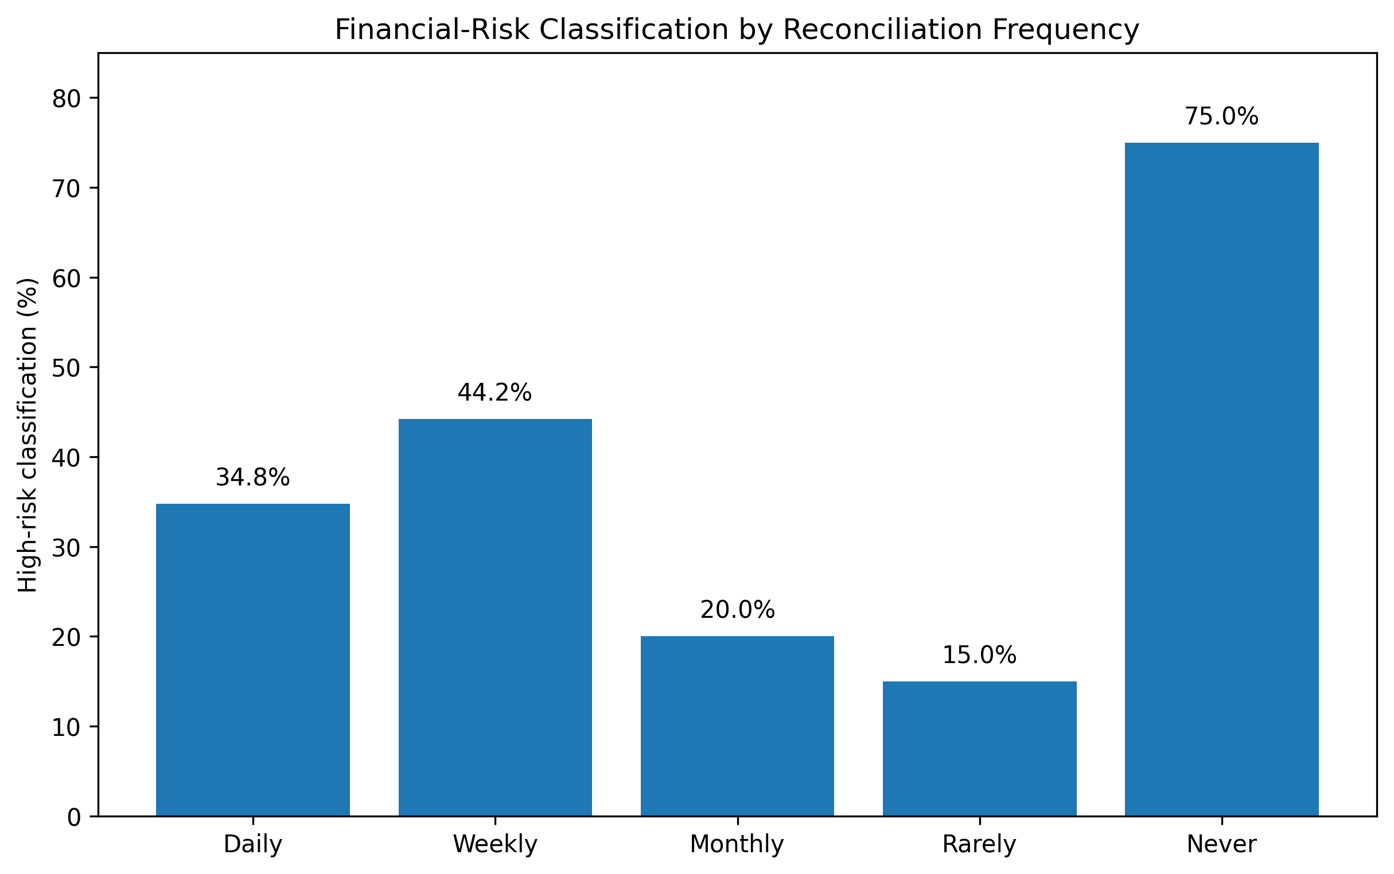
Figure 5. High-risk classification by reconciliation frequency. The highest risk rate occurred among businesses that never reconciled their records.
Primary record-keeping method was also strongly associated with risk (χ²(3)=18.99, p<.001, V=.356). High-risk classification occurred in 75.0% of mental/no-record businesses, 40.0% of mobile/digital users, 32.6% of notebook/ledger users and 42.9% of receipts-only businesses. Relative to notebook/ledger use, mental/no-record businesses had an odds ratio of 6.20 for high-risk classification (95% CI 2.59–14.82). In a direct contrast, mobile/digital users had lower odds than mental/no-record businesses (OR=.22, 95% CI .06–.80).
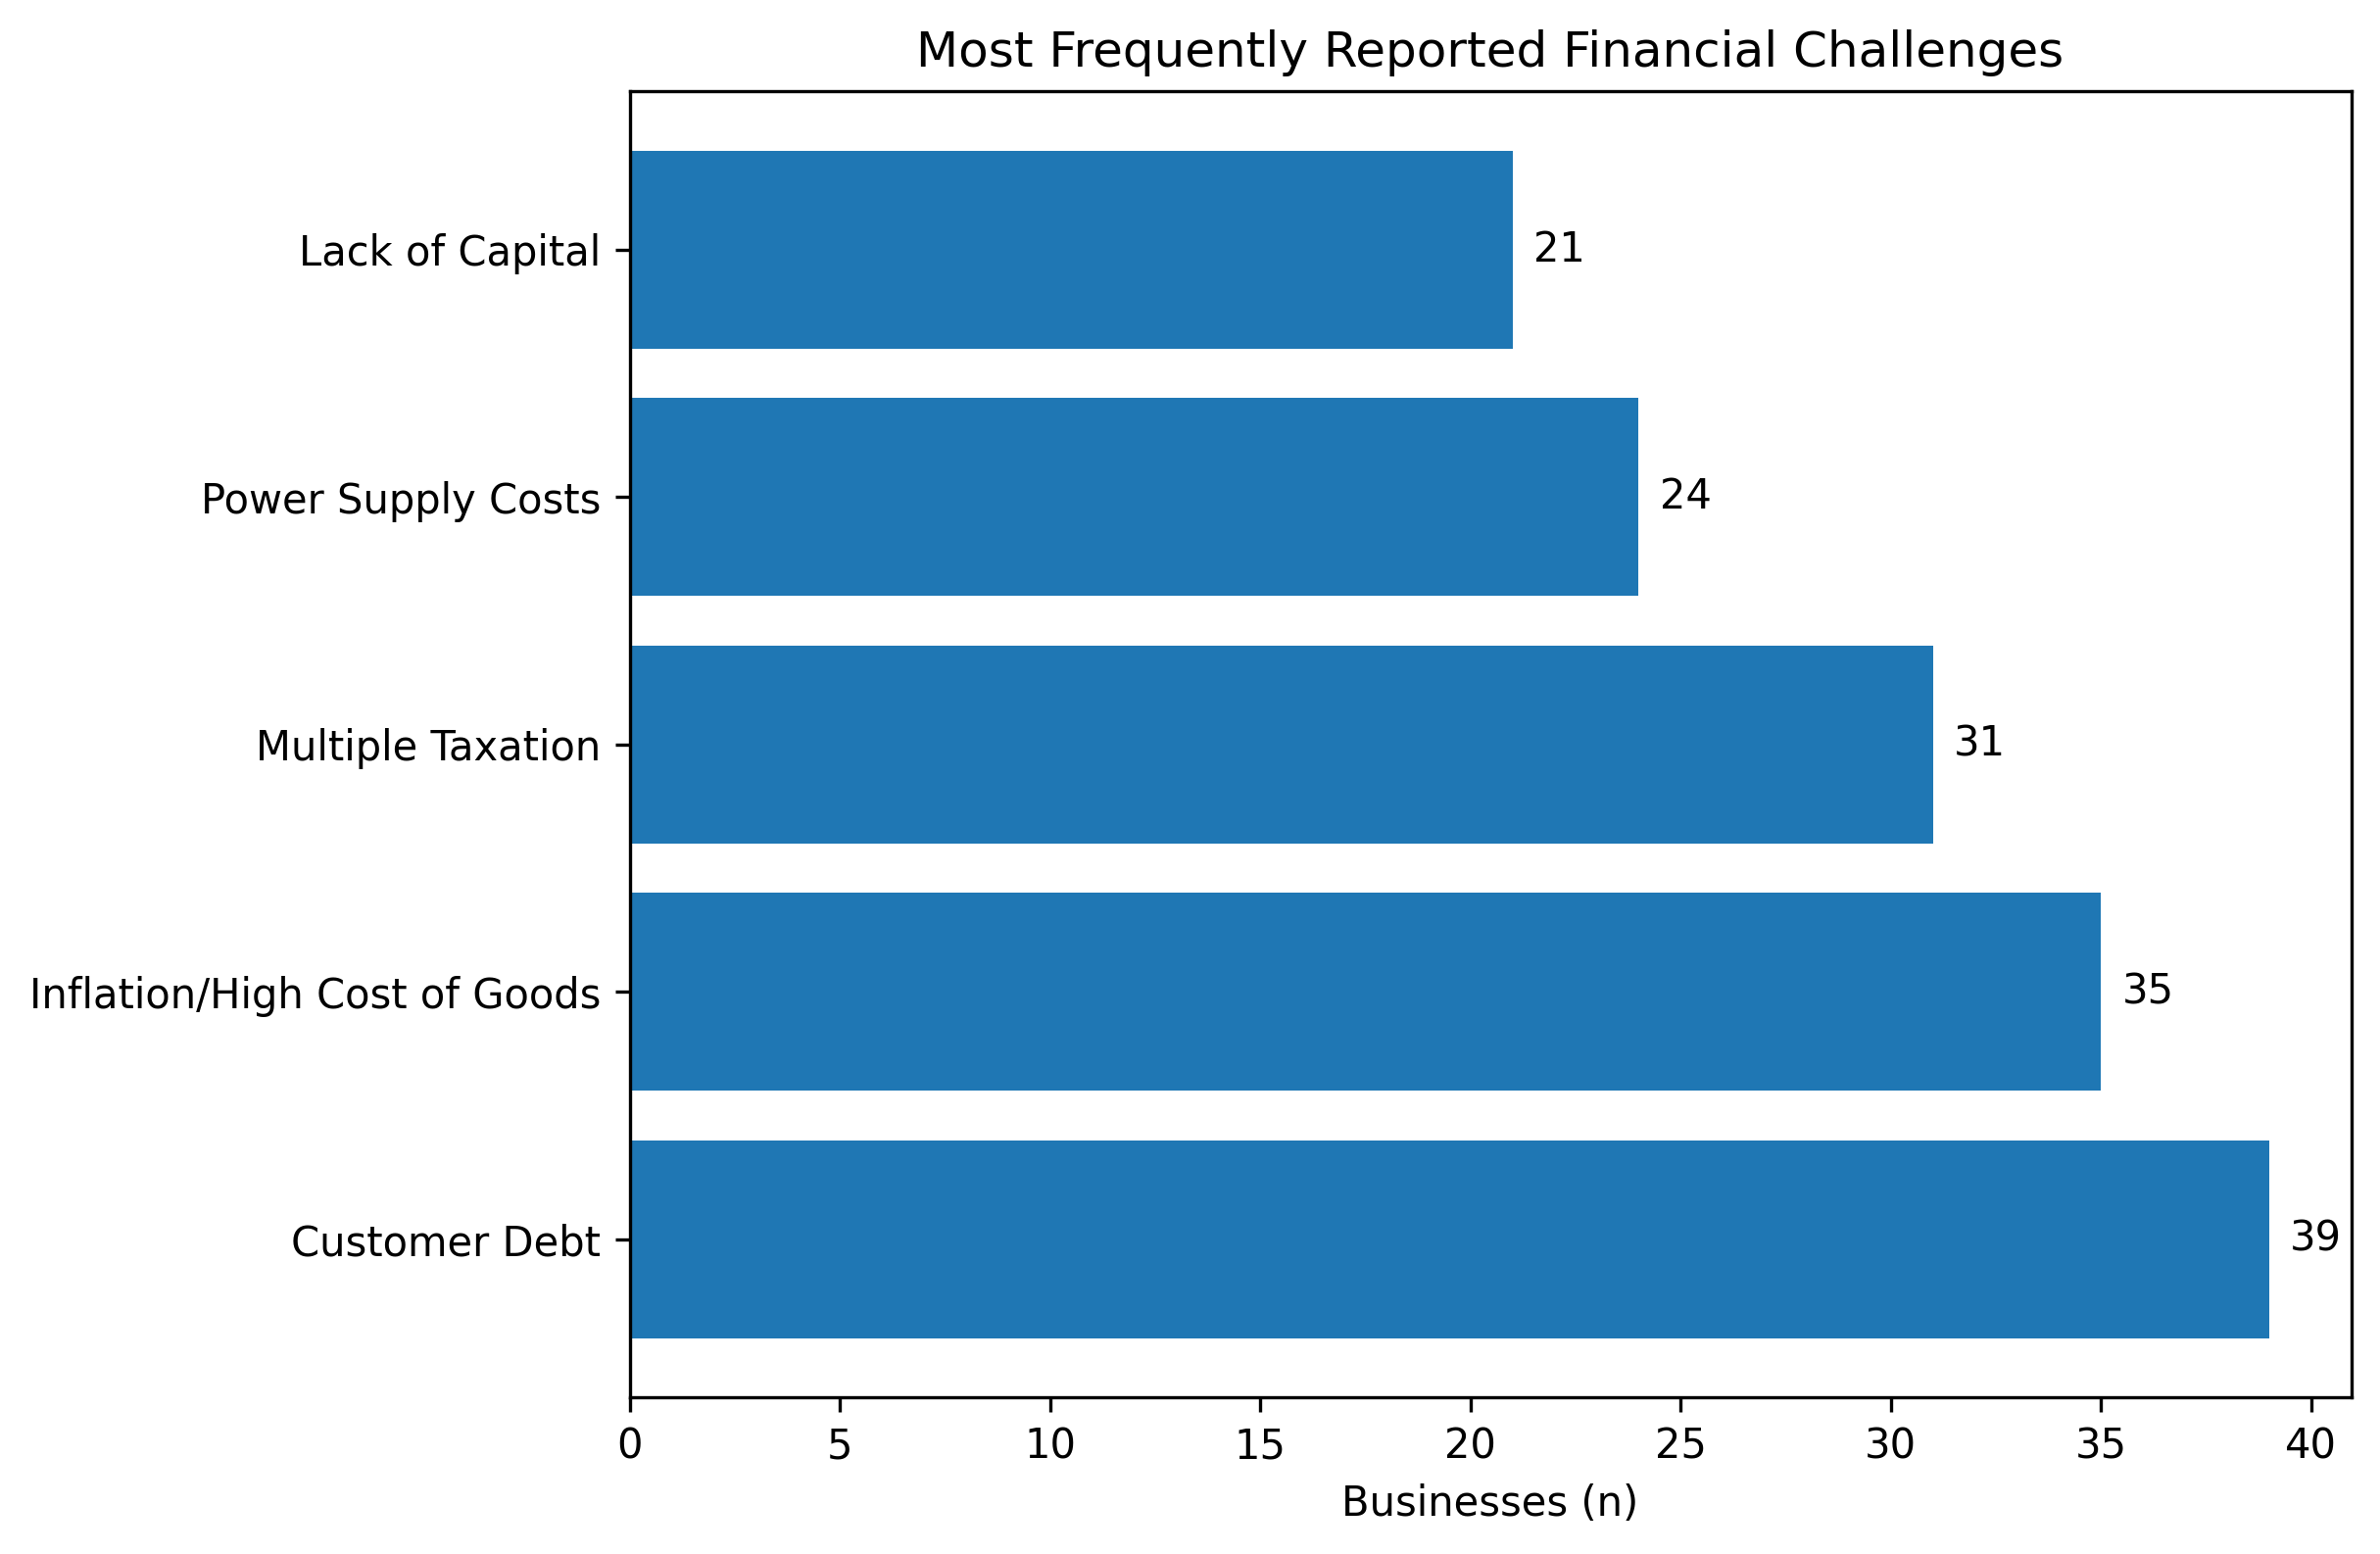
Figure 6. High-risk classification by record-keeping method. Mental/no-record businesses showed the highest risk concentration.
Separation of personal and business funds was independently informative at the bivariate level (χ²(1)=6.14, p=.013, V=.202). High-risk classification occurred in 50.9% of businesses that did not separate funds compared with 27.3% of those that did. The odds ratio for businesses that separated funds was .36 (95% CI .17–.78), indicating materially lower odds of high-risk classification in this sample. In contrast, merely having a business bank account was not significantly associated with risk (χ²(1)=1.51, p=.219, V=.100).
The study-derived Digital_Accounting_Score was also lower among high-risk businesses (mean 1.68; median 1) than among normal-risk businesses (mean 2.14; median 2). The Mann–Whitney comparison was significant (U=1,940.5, p<.001; rank-biserial effect≈.300). The practical interpretation is not that digitisation mechanically creates profitability, but that stronger accounting/digital routines are more common among businesses outside the high-risk classification.
Table 3. Associations between accounting practices and study-defined financial-risk classification
Variable | Test | p | Cramér V | Interpretation
Primary record keeping | χ²(3)=18.99 | <.001 | .356 | Strongest contrast: mental/no records vs notebook, OR=6.20 (2.59–14.82)
Separate personal/business funds | χ²(1)=6.14 | .013 | .202 | Separation associated with lower odds, OR=.36 (.17–.78)
Reconciliation frequency | χ²(4)=23.62 | <.001 | .397 | Never vs daily reconciliation, OR=5.63 (2.14–14.81)
Business bank account | χ²(1)=1.51 | .219 | .100 | Access alone was not significantly associated with risk
Accounting maturity | χ²(2)=5.64 | .059 | .194 | Borderline evidence; moderate-maturity group had lowest observed risk

4.4 Exploratory data-science classification
Repeated stratified cross-validation showed that accounting-practice variables contained moderate internal discriminatory information. The practice-based random forest achieved the strongest average ROC-AUC (.737±.099), balanced accuracy (.686) and F1 (.644). The practice logistic model produced similar but slightly lower discrimination (ROC-AUC=.722±.104). Adding selected financial-profile variables did not improve the logistic model (ROC-AUC=.680±.103), while the financial-profile-only model was unstable and uninformative (ROC-AUC=.415±.079).
Table 4. Repeated stratified five-fold cross-validation performance
Model | Feature set | ROC-AUC | Balanced acc. | F1 | Accuracy
Practice logistic regression | record keeping + banking + fund separation + reconciliation | 0.722 ± 0.104 | 0.656 | 0.608 | 0.662
Practice random forest | record keeping + banking + fund separation + reconciliation | 0.737 ± 0.099 | 0.686 | 0.644 | 0.691
Financial-profile logistic regression | revenue + profit + gross margin + business tenure + category | 0.415 ± 0.079 | 0.431 | 0.398 | 0.429
Combined logistic regression | practice + selected financial profile | 0.680 ± 0.103 | 0.623 | 0.588 | 0.622
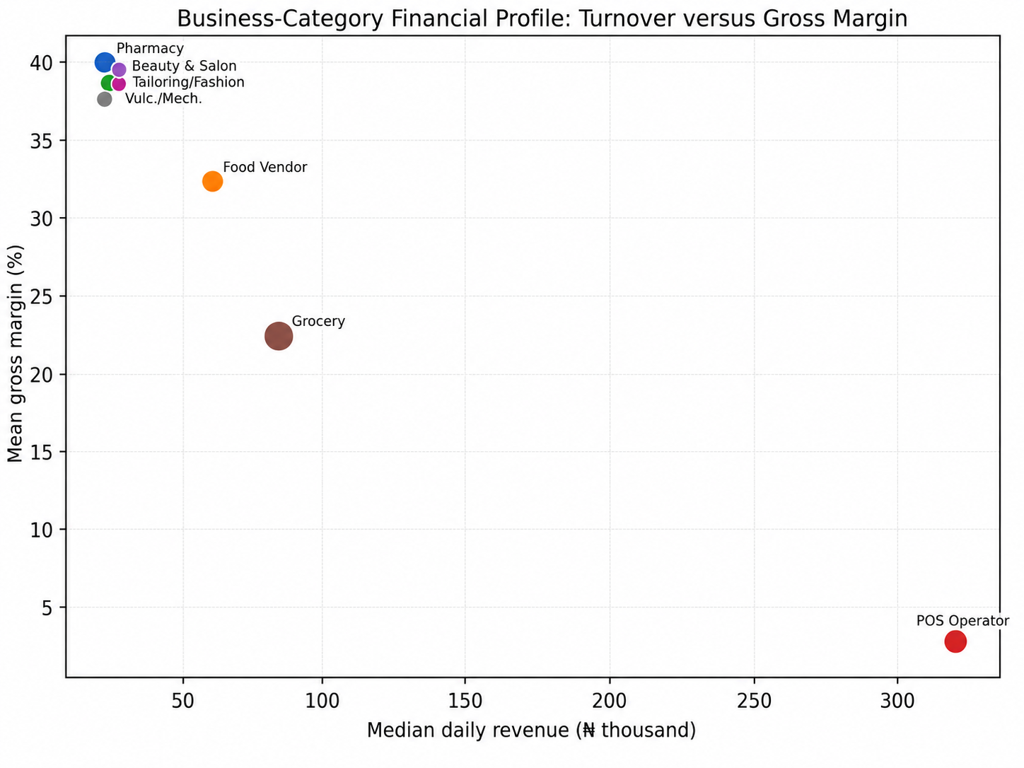
Figure 7. Exploratory internal classification performance. Error bars show the standard deviation of ROC-AUC across repeated validation folds; the dashed line marks chance-level discrimination (0.50).
The model comparison is substantively important. It indicates that simple accounting-control behaviours carried more stable internal classification information than raw financial profile alone. However, the result should not be converted into an automated credit or insolvency score. The outcome label is a study-defined risk class rather than observed default, the sample is local and relatively small, and there is no external validation cohort. The proper use of the model is therefore analytical screening: identifying which practices deserve closer managerial or research attention.

5. Discussion

5.1 The central gap is accounting discipline, not banking access
One of the clearest findings is the gap between financial-service access and accounting control. Three-quarters of businesses used a business bank account, yet fewer than one-third separated personal and business funds and only one in ten primarily used a digital accounting method. Bank-account ownership alone was not significantly related to the study risk label. This distinction matters for financial-inclusion policy: an account can facilitate payments without producing a usable business ledger, a reconciled cash position or a defensible profit estimate. Digital finance becomes managerial infrastructure only when transactions are captured, classified and reviewed.
This finding is consistent with the broader Nigerian digital-record literature. Oyebanjo (2024, 2025) reports that digital record adoption improves when technology is combined with personalised support, while Garba and Mohammed (2026) and Mohammed et al. (2024) link digital-accounting use with SME performance outcomes. The Gwagwalada evidence extends that discussion by showing that fund separation and reconciliation—not simply technology possession—are closely associated with lower internal risk classification.

5.2 Mental accounting is a material vulnerability
The 24% of businesses relying primarily on memory or no records were not merely less formal; they were concentrated in the high-risk class. The six-fold odds ratio relative to notebook/ledger users is large enough to be managerially meaningful even in a modest sample. A paper notebook is therefore not obsolete in this context. For a resource-constrained enterprise, a complete and consistently used ledger may be a stronger control than a digital application that is installed but not integrated into daily routines. Digitisation should build on disciplined recording rather than substitute for it.

5.3 Reconciliation is a practical early-warning routine
The strongest association in the study involved reconciliation. Never-reconciling businesses had a 75% high-risk rate and more than five times the odds of high-risk classification compared with daily reconcilers. Reconciliation forces the owner to confront discrepancies between remembered sales, recorded transactions, cash, inventory movement and bank evidence. It can expose customer-credit leakage, omitted expenses, cash withdrawals and transaction errors before they accumulate. For training interventions, this suggests that reconciliation may be a higher-value behavioural target than generic financial-literacy instruction.

5.4 High turnover can conceal thin economic margins
The category analysis demonstrates why accounting ratios are essential. POS operators generated by far the highest turnover but only a 3.65% mean gross margin, whereas several lower-turnover businesses operated near 40% margins. A proprietor who equates transaction volume with profit can therefore misread business performance. The distinction is especially relevant in cash-intensive informal settings, where large flows can coexist with narrow retained value. Training and digital dashboards should separate turnover, expenses, gross margin and cash available to the owner.

5.5 Data science should augment, not replace, accounting judgement
The exploratory classifiers achieved moderate rather than exceptional discrimination, and the practice-based models outperformed the financial-only model. This supports a restrained view of accounting data science: useful risk signals can emerge from routine behaviour, but local labels and small samples are not sufficient for autonomous decision systems. Bitetto et al. (2024) and Gu et al. (2024) similarly emphasize that small-firm risk prediction depends heavily on information quality and validation. In this setting, the highest-value analytical products are likely to be interpretable dashboards, exception flags, reconciliation alerts and periodic risk reviews that remain under human judgement.

6. Practical Accounting Data-Science Framework for Informal Businesses
The empirical findings support a staged framework that can be implemented without enterprise-grade accounting infrastructure. The objective is to create a minimum viable accounting information system that improves records first and adds analytics second.
Table 5. Six-stage accounting data-science framework for informal small businesses
Stage | Accounting action | Data-science / control output
1. Capture | Record daily sales, purchases, customer debt, owner withdrawals and major operating costs. | Complete transaction log; missing-record rate.
2. Separate | Use a dedicated business cash/bank boundary and code owner withdrawals distinctly. | Proportion of transactions attributable to business; unexplained withdrawals.
3. Reconcile | Compare ledger totals with cash, bank/POS evidence and key supplier/customer balances. | Reconciliation variance; unresolved items; reconciliation frequency.
4. Summarize | Calculate revenue, expense, profit, gross margin, expense ratio and debt exposure. | Weekly/monthly dashboard and category benchmarks.
5. Flag | Use simple rules or validated models to identify deteriorating patterns. | Margin decline, rising expense ratio, repeated reconciliation gaps, customer-debt concentration.
6. Act and learn | Document the management action and review the next period. | Corrective action, outcome, residual risk and updated business rule.
The framework deliberately places machine learning at the end rather than the beginning. A model cannot compensate for transactions that were never recorded or a business boundary that does not exist. The first analytical investment should therefore be in data-generating routines: transaction capture, fund separation and reconciliation. Once these routines become stable, simple automated checks can be introduced, followed by predictive modelling where a validated outcome and sufficient historical data exist.

7. Implications for Policy, Training and Practice
• Design digital-bookkeeping interventions around real accounting routines. Training should require owners to enter actual daily sales, expenses, debts and withdrawals and then reconcile them, rather than merely demonstrate app features.
• Treat separation of personal and business funds as a core financial-health intervention. Business accounts should be paired with guidance on owner drawings, household transfers and transaction classification.
• Use reconciliation frequency as a practical monitoring indicator for microfinance, cooperative and business-development programmes. A business that never reconciles may require support before more complex analytics are introduced.
• Build sector-sensitive dashboards. POS businesses require turnover and commission/margin views that differ from grocery, food, fashion or repair businesses.
• Use data-science models as decision support. Model outputs should be interpretable, periodically revalidated and combined with owner context rather than used as automatic eligibility rules.
• Prioritize low-cost and offline-capable tools for informal-business environments, with local coaching and data-protection guidance.

8. Limitations and Future Research
The study is cross-sectional and therefore identifies association rather than causation. Financial values are business-reported daily estimates rather than audited statements, and the sample is limited to 150 businesses in one FCT locality. Category sizes are unequal, and the unusually high turnover/low-margin structure of POS operators affects aggregate revenue statistics. The Digital_Accounting_Score, Accounting_Maturity and Financial_Risk_Label are study-derived analytical variables; the risk label is not an observed loan-default outcome or an external credit rating. Accordingly, the classification models should be interpreted only as internal exploratory analytics.
Future research should follow businesses longitudinally, collect transaction-level or periodic ledger evidence, document the exact construction and validation of composite accounting/risk scores, and test whether interventions that improve record keeping, fund separation and reconciliation subsequently improve cash-flow stability, financing access or survival. Larger multi-location samples would permit hierarchical modelling and stronger sector-specific comparisons. A prospective model should use outcomes such as arrears, business discontinuation, verified cash-flow stress or financing performance and should be externally validated before operational deployment.

9. Conclusion
The empirical evidence from 150 informal businesses in Gwagwalada shows that accounting quality is a behavioural infrastructure. The most consequential differences were not between firms with and without a bank account, nor between high- and low-turnover businesses. They were differences in how consistently the business recorded transactions, separated household and enterprise funds, and reconciled its accounts. Mental/no-record businesses and never-reconciling businesses had substantially higher study-defined financial-risk classification, while fund separation was associated with lower risk. Digital-accounting intensity was also lower among high-risk businesses.
The data-science analysis adds a useful but deliberately bounded finding: simple practice variables provided moderate internal discrimination of risk class, whereas selected financial-profile variables alone did not generalize well. This reinforces a practical sequence for informal-enterprise digitalisation—first generate trustworthy accounting data, then summarize and reconcile it, and only then apply predictive analytics. For small-business policy and training in Nigeria, the priority should therefore be not technology for its own sake, but disciplined, low-cost accounting routines that produce reliable data for both owners and future digital financial services.

10. Declarations
Ethics and confidentiality: The analysis uses de-identified business records and reports only aggregate findings; no personal names, business names or direct personal identifiers are included in the publication.
Funding: No specific external funding is declared for this study.
Competing interests: The author declares no competing interests.
Data availability: The de-identified analytic dataset and codebook are held by the author and may be made available for scholarly verification subject to appropriate data-sharing and confidentiality conditions.
Author contributions: Olumeyan Elizabeth Titilayo: conceptualization, field study, data curation, accounting analysis, interpretation and manuscript authorship.
AI-assisted editorial support: AI-assisted tools were used for statistical cross-checking, language refinement, visual preparation and formatting. They were not used as authors or as substitutes for scholarly judgement. The author and journal editor retain responsibility for data provenance, interpretation, source verification and final approval.
Copyright and licence: © 2026 The Author. Published by CHIA TECH SOLUTIONS AND RESOURCES LIMITED (RC 1839865). This open-access article is distributed under the Creative Commons Attribution 4.0 International (CC BY 4.0) licence, except for third-party material otherwise identified.

References
Aderinto, A. A. (2025). Accounting record-keeping in small and medium enterprises in Nigeria: A source of enhanced business performance. Asian Journal of Advanced Research and Reports, 19(4), 366–380. https://doi.org/10.9734/ajarr/2025/v19i4989
Ajape, M. K., Okpala, O. P., & Salawu, M. W. (2024). SMEs’ commitment to sustainability practices in Nigeria: Examining the role of technology-based accounting systems. Lagos Journal of Banking, Finance and Economic Issues, 5(1).
Bitetto, A., Cerchiello, P., Filomeni, S., Tanda, A., & Tarantino, B. (2024). Can we trust machine learning to predict the credit risk of small businesses? Review of Quantitative Finance and Accounting, 63, 925–954. https://doi.org/10.1007/s11156-024-01278-0
Garba, A., & Mohammed, I. A. (2026). Digital accounting systems adoption and barriers: Impacts on SME performance and sustainability in Nigeria. Archives of Current Research International, 26(1), 224–234. https://doi.org/10.9734/acri/2026/v26i11717
Gu, Z., Lv, J., Wu, B., Hu, Z., & Yu, X. (2024). Credit risk assessment of small and micro enterprise based on machine learning. Heliyon, 10(5), e27096. https://doi.org/10.1016/j.heliyon.2024.e27096
Hamid, K. T., Maigoshi, Z. S., & Abdullahi, Z. (2023). Impact of accounting record-keeping on the sustainability of small-scale enterprises in Kano Metropolis. FUDMA Journal of Accounting and Finance Research, 1(2), 71–87. https://doi.org/10.33003/fujafr-2023.v1i2.35.71-87
Mohammed, K. A., Inuwa, U., & Enemali, V. A. (2024). Influence of digital accounting system on small and medium scale enterprise performance in Plateau State, Nigeria. International Journal of Intellectual Discourse, 7(1), 181–189.
Olajide, M., & Obialo, F.-K. (2020). Effects of record keeping on the growth of small scale enterprises in Abeokuta South Local Government Area, Ogun State, Nigeria. Journal of Economics, Management and Trade, 26(5), 34–43. https://doi.org/10.9734/jemt/2020/v26i530254
Onwuchekwa, C. A., & Ukpong, O. U. (2023). Accounting records-keeping and utilization by small scale business operators in Rivers State, Nigeria. International Journal of Business and Management Review, 11(6), 1–12. https://doi.org/10.37745/ijbmr.2013/vol11n6112
Oyebanjo, A. (2024). Beyond beneficial information: The impact of additional consulting on digital record adoption and profit measurement. International Growth Centre Working Paper.
Oyebanjo, A. (2025). Enhancing initial adoption of digital records and best practices among small firms: Evidence from Nigeria. International Growth Centre Policy Brief.
World Bank. (2025). The Global Findex Database 2025: Connectivity and financial inclusion in the digital economy. World Bank.
World Bank. (2026). Why digital payments still stop at the small shop—and how to fix it. World Bank Development Blog, March 17, 2026.
CHIATECH JOURNAL · SETEHEM · Volume 1, Issue 1 · Pioneer July/August 2026 · Part 2 · e034 · Pioneer Publication

