  - PIONEER PUBLICATION · ACCEPTED ARTICLE · ORIGINAL RESEARCH ARTICLE · SETEHEM: TECHNOLOGY & EDUCATION × HUMANITIES

Optimizing Primary-School Uniform Mass Production Through Computer-Aided Basic-Block Development: A Reproducible Parametric Grading and Marker-Planning Experiment
Lydia Kachollom AKILA¹*, Godiya Chindang MWANLE¹ and Mariya Mohammed USMAN²
¹Department of Home and Rural Economics, Plateau State College of Agriculture, Garkawa, Plateau State, Nigeria
²Home Economics Department, Federal College of Education (Technical), Gombe, Gombe State, Nigeria
*Corresponding author: lydiaakila1@gmail.com · Co-authors: godiyakady@gmail.com; mariyamusman1977@gmail.com
Article | Volume/Issue | Published | ISSN | DOI
e035 | 1(1) | July 2026 | Pending assignment | Pending registration

Abstract
Background: Primary-school uniform production depends on repeatable sizing, accurate blocks and economical markers. Yet many small and medium clothing operations still redraft patterns by size and plan cutting layouts sequentially. Purpose: This study developed and evaluated a software-neutral, computer-aided workflow for translating a local three-size body chart into parametric school-shirt and trouser cutting envelopes and mixed-size marker plans. Methods: The design experiment used published aggregate measurements for 367 children aged 6-12 years in Jos, Nigeria. Three base profiles - JOS-115, JOS-130 and JOS-145 - supplied stature, chest, waist and hip inputs. Transparent drafting rules produced 15 cutting envelopes per uniform set. A deterministic best-fit-decreasing shelf algorithm was compared with a size-batched next-fit-row baseline under four production mixes and usable fabric widths of 140, 147 and 150 cm, yielding 12 scenarios. Primary outcomes were marker length and percentage reduction; modelled planar occupancy and fabric area were secondary diagnostics. Results: Across the nine 30-set production scenarios, optimized marker length was 7.51-12.32% lower than the baseline (mean 9.59%). Mean modelled planar occupancy increased from 63.57% to 70.31%, a gain of 6.74 percentage points. At 147 cm width, marker-length reductions were 8.61%, 9.31% and 10.21% for balanced, younger-heavy and older-heavy size mixes, respectively. These corresponded to projected savings of 107.4-140.3 linear metres of 147 cm fabric per 1,000 uniform sets under the model assumptions. Conclusion: Parametric grading and mixed-size marker planning can convert a local body chart into a consistent, auditable pre-production system and materially reduce modelled fabric demand. The cutting envelopes are proof-of-concept geometry, not production patterns; physical toile fitting, fabric-specific constraints, shrinkage and factory validation remain mandatory before adoption.
Keywords: computer-aided design; school uniform; basic block; parametric grading; marker planning; fabric utilization; mass production; Jos; Nigeria

1. Introduction
School uniforms are high-volume, repeat-purchase garments. A producer may cut the same style across several child sizes for many schools, terms or procurement cycles. In this setting, apparently small inconsistencies in a basic block, grade rule or cutting marker propagate into repeated alteration, recutting and material loss. The production problem is therefore not only how to draw a shirt or trouser pattern, but how to convert reliable body measurements into a controlled digital system that can be reused, audited and revised.
Computer-aided design (CAD) supports pattern drafting, editing, grading, storage and marker planning. Compared with repeated manual construction, digital files can preserve geometry and communicate changes across design and cutting functions. Kılıç (2019) found shorter process times for CAD than manual preparation across basic-pattern, modelling, grading and marker operations, while Chaudhary et al. (2020) linked CAD adoption with design accuracy, shorter product-development lead time and more consistent production. The benefits are not automatic, however: software cost, operator competence, fit validation and the quality of the measurement system determine whether digitization improves the product or merely reproduces a weak pattern faster.
For children's uniforms, sizing quality is central. ISO 8559 distinguishes body dimensions from garment dimensions and requires size designation to communicate relevant body measures rather than obscure nominal labels. Nigerian and regional evidence also cautions against treating age alone as an adequate size selector because children's dimensions vary within age groups (Widyanti et al., 2017; Azunwena & Ikechi, 2024; Akila & Agbo, 2024). CAD should therefore begin with explicit anthropometric inputs and retain a traceable path from body chart to block, grade and marker.

1.1 Problem statement and contribution
The supplied working manuscript identified CAD as a route to precision and mass-production efficiency but did not contain a completed method, analytical dataset or results for Sections III-VIII. A publication-quality contribution requires a testable design object and quantified comparison. This e035 study supplies that missing empirical core through a deterministic computational experiment. It does not claim factory time observations or wearer-fit outcomes. Instead, it asks a narrower and reproducible question: when the same parametric cutting envelopes and grain direction are held constant, how much marker length can be reduced by mixed-size computerized placement relative to a transparent size-batched baseline?

1.2 Aim, objectives and research questions
The study aimed to develop and evaluate a reproducible computer-aided workflow for basic-block grading and marker planning for primary-school uniform mass production. It specifically sought to:
- translate three locally derived body-size profiles into explicit parametric cutting-envelope rules for a school shirt and straight trouser;
- generate repeatable multi-size batches and marker layouts under different fabric widths and size assortments;
- compare size-batched and mixed-size placement strategies using marker length and modelled planar occupancy; and
- define the production controls and physical validation required before the proof-of-concept can become a factory pattern library.
Two questions guided the experiment: (RQ1) How does mixed-size best-fit shelf placement change marker length and modelled occupancy relative to a size-batched next-fit layout? (RQ2) How stable is the improvement across 140, 147 and 150 cm usable fabric widths and balanced or age-skewed production mixes?

2. Literature Review and Analytical Framework

2.1 From anthropometry to size designation
A body-measurement table is an input to garment engineering, not a cutting specification. ISO 8559-1:2017 standardizes anthropometric definitions, ISO 8559-2:2025 specifies primary and secondary dimension indicators, ISO 8559-3:2018 addresses body-measurement tables and intervals, and ISO 8559-4:2023 introduces coverage-ratio evaluation. Together, these standards establish that size labels should be grounded in body dimensions and that the adequacy of a size system must eventually be tested against population coverage.
The Jos record used in this study reported mean stature, chest, waist and hip measurements for 367 children grouped into 6-7, 8-9 and 10-12 years (Akila & Agbo, 2024). It offers a compact local starting point, but the absence of participant-level percentiles and sex-specific distributions means that its three profiles are provisional base sizes rather than a complete population sizing standard. This distinction is retained in the present CAD experiment.

2.2 Digital pattern development and grading
Digital pattern development formalizes the relationship between measurements and geometry. A parameter change can update related lines, points and grade increments without redrawing every size independently. Papachristou et al. (2019) demonstrated that both licensed and open-source CAD environments can support garment-development learning, while Mupfumbati et al. (2021) showed that accessible vector tools can be used to teach computerized basic-block construction. These findings matter for Nigerian small-scale producers and training institutions because a useful workflow should not depend exclusively on expensive proprietary systems.
Recent pattern-library research extends the logic from simple size grading to body-type correction. Choi and Choi (2025) embedded structured fit-adjustment rules in a digitized pattern matrix, but their work also shows why automation requires body-shape evidence and fit validation. The present experiment deliberately remains at base-size and marker-planning level; it does not infer posture or body-shape corrections from four mean dimensions.

2.3 Marker planning, width and size assortment
Marker planning arranges the complete set of pattern pieces within a fixed usable fabric width while respecting grain, nap, print direction, matching and cutting constraints. Marker length directly affects fabric consumption. Mixed-size markers can use otherwise stranded spaces more effectively than single-size or sequential arrangements, but the result depends on piece geometry, width and assortment. Pamuk and Yildiz (2016) found that width and placement strategy affected marker efficiency, and Haque (2016) showed that marker type changes fabric utilization. More recent work on children's clothing likewise reports that size and width choices influence nesting efficiency (Badawy & Hussien, 2025).

2.4 Digital fit does not replace wearer validation
A precise marker can reproduce an ill-fitting garment efficiently. Pattern accuracy must therefore be separated from fit adequacy. Yang and Baytar (2024) show that technical fit assessment involves balance, ease, garment landmarks, tactile response and movement; virtual tools do not fully reproduce human soft-tissue behaviour or subjective comfort. Casciani and Bertolini (2025) similarly position digital measurement and on-demand production as promising but implementation-dependent. For primary-school uniforms, physical toiles, child/guardian feedback and movement checks remain essential safeguards.

2.5 Analytical framework
The study treats mass-production preparation as a five-stage evidence chain: anthropometric input, parametric rule definition, grade generation, marker optimization and fabric-use diagnostics. Each stage has a distinct failure mode. Weak measurements create weak sizes; unstable formulas create inconsistent blocks; unverified grade rules distort proportions; poor nesting wastes fabric; and unvalidated fit can harm comfort even when every digital coordinate is reproduced correctly.
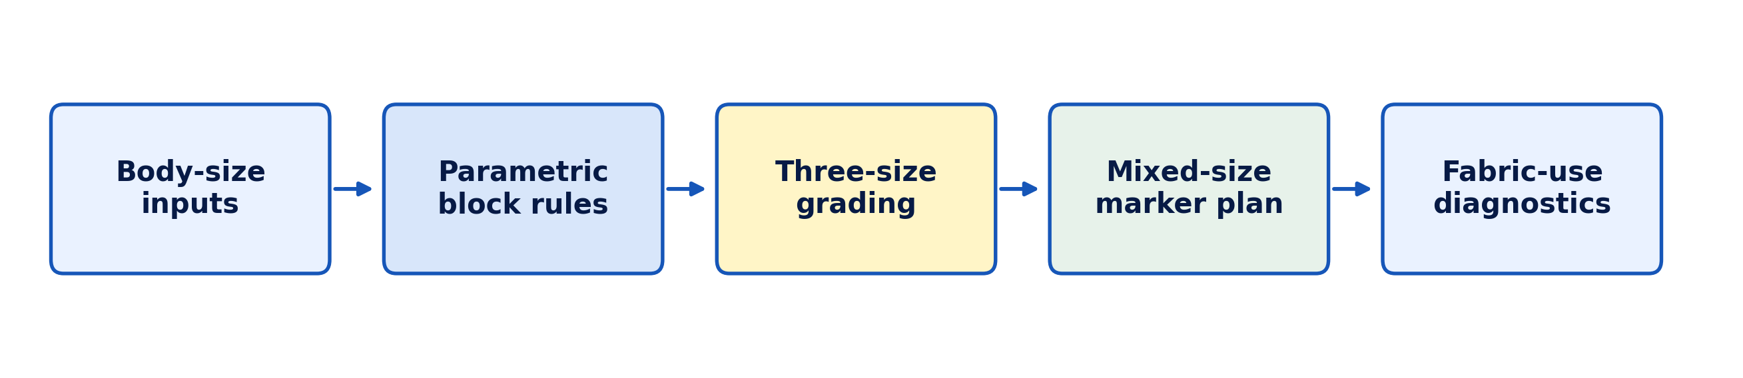
Figure 1. Analytical workflow used to convert body-size inputs into graded cutting envelopes and marker diagnostics.

3. Materials and Methods

3.1 Design and evidentiary boundary
This was a technical-design study with a controlled deterministic computational experiment. It used no new human participants, interviews, factory time observations or commercial CAD files. The experiment was implemented in Python 3.12.13 with Matplotlib 3.10.8 for visualization. All calculations were deterministic; no random seed or stochastic search was used. The experimental unit was one complete marker generated for a specified size mix and usable fabric width.

3.2 Anthropometric inputs and provisional size codes
Table 1 reproduces the four published mean dimensions used as design controls. The labels JOS-115, JOS-130 and JOS-145 identify the mean stature of each profile. Age remains a reference, not the sole size selector. Values are body dimensions in centimetres and exclude garment ease, seam allowance, shrinkage and style allowance.
Table 1. Provisional body-size inputs used in the e035 CAD experiment (cm). Source: Akila and Agbo (2024).
Size code | Age reference | Stature | Chest | Waist | Hip
JOS-115 | 6-7 | 115 | 60 | 55 | 65
JOS-130 | 8-9 | 130 | 70 | 65 | 75
JOS-145 | 10-12 | 145 | 80 | 75 | 85

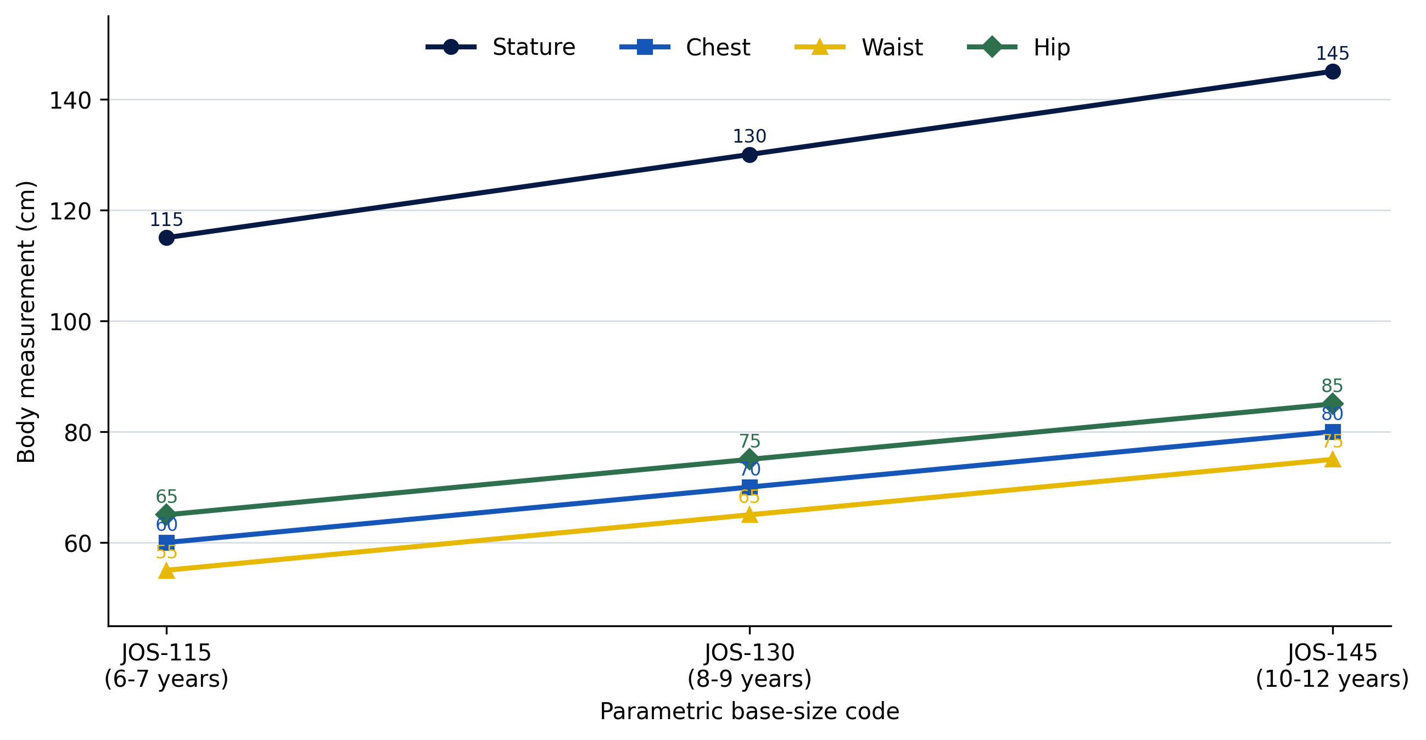
Figure 2. Anthropometric control dimensions for the three parametric base-size profiles.

3.3 Parametric cutting-envelope specification
A simplified unisex short-sleeve school shirt and straight trouser were represented by 15 cutting envelopes per set. Each envelope was a grain-constrained width-by-length rectangle containing a tapered proof-of-concept pattern shape. The formulas in Table 2 were applied independently to each size profile. Total shirt chest ease was 12 cm before division; additional constants supplied drafting clearance and the envelope-level one-centimetre seam boundary. Piece-specific occupancy coefficients approximated the area of the simplified non-rectangular shape within its rectangle. They were declared before analysis and used only for the modelled planar-occupancy diagnostic.
Table 2. Parametric rules for one proof-of-concept uniform set.
Piece | Qty | Width rule (cm) | Length rule (cm) | Occupancy
Shirt front | 2 | (Chest + 12)/4 + 2 | 0.40 × stature | 0.80
Shirt back | 1 | (Chest + 12)/2 + 2 | 0.40 × stature | 0.82
Short sleeve | 2 | Chest/4 + 6 | 0.22 × stature | 0.72
Collar | 2 | (0.43 × chest + 8)/2 | 9 | 0.76
Trouser front | 2 | Hip/4 + 5 | 0.57 × stature | 0.79
Trouser back | 2 | Hip/4 + 7 | 0.57 × stature | 0.81
Waistband | 2 | Waist/2 + 6 | 7 | 0.92
Pocket | 2 | 14 + 0.02 × hip | 16 + 0.02 × stature | 0.80

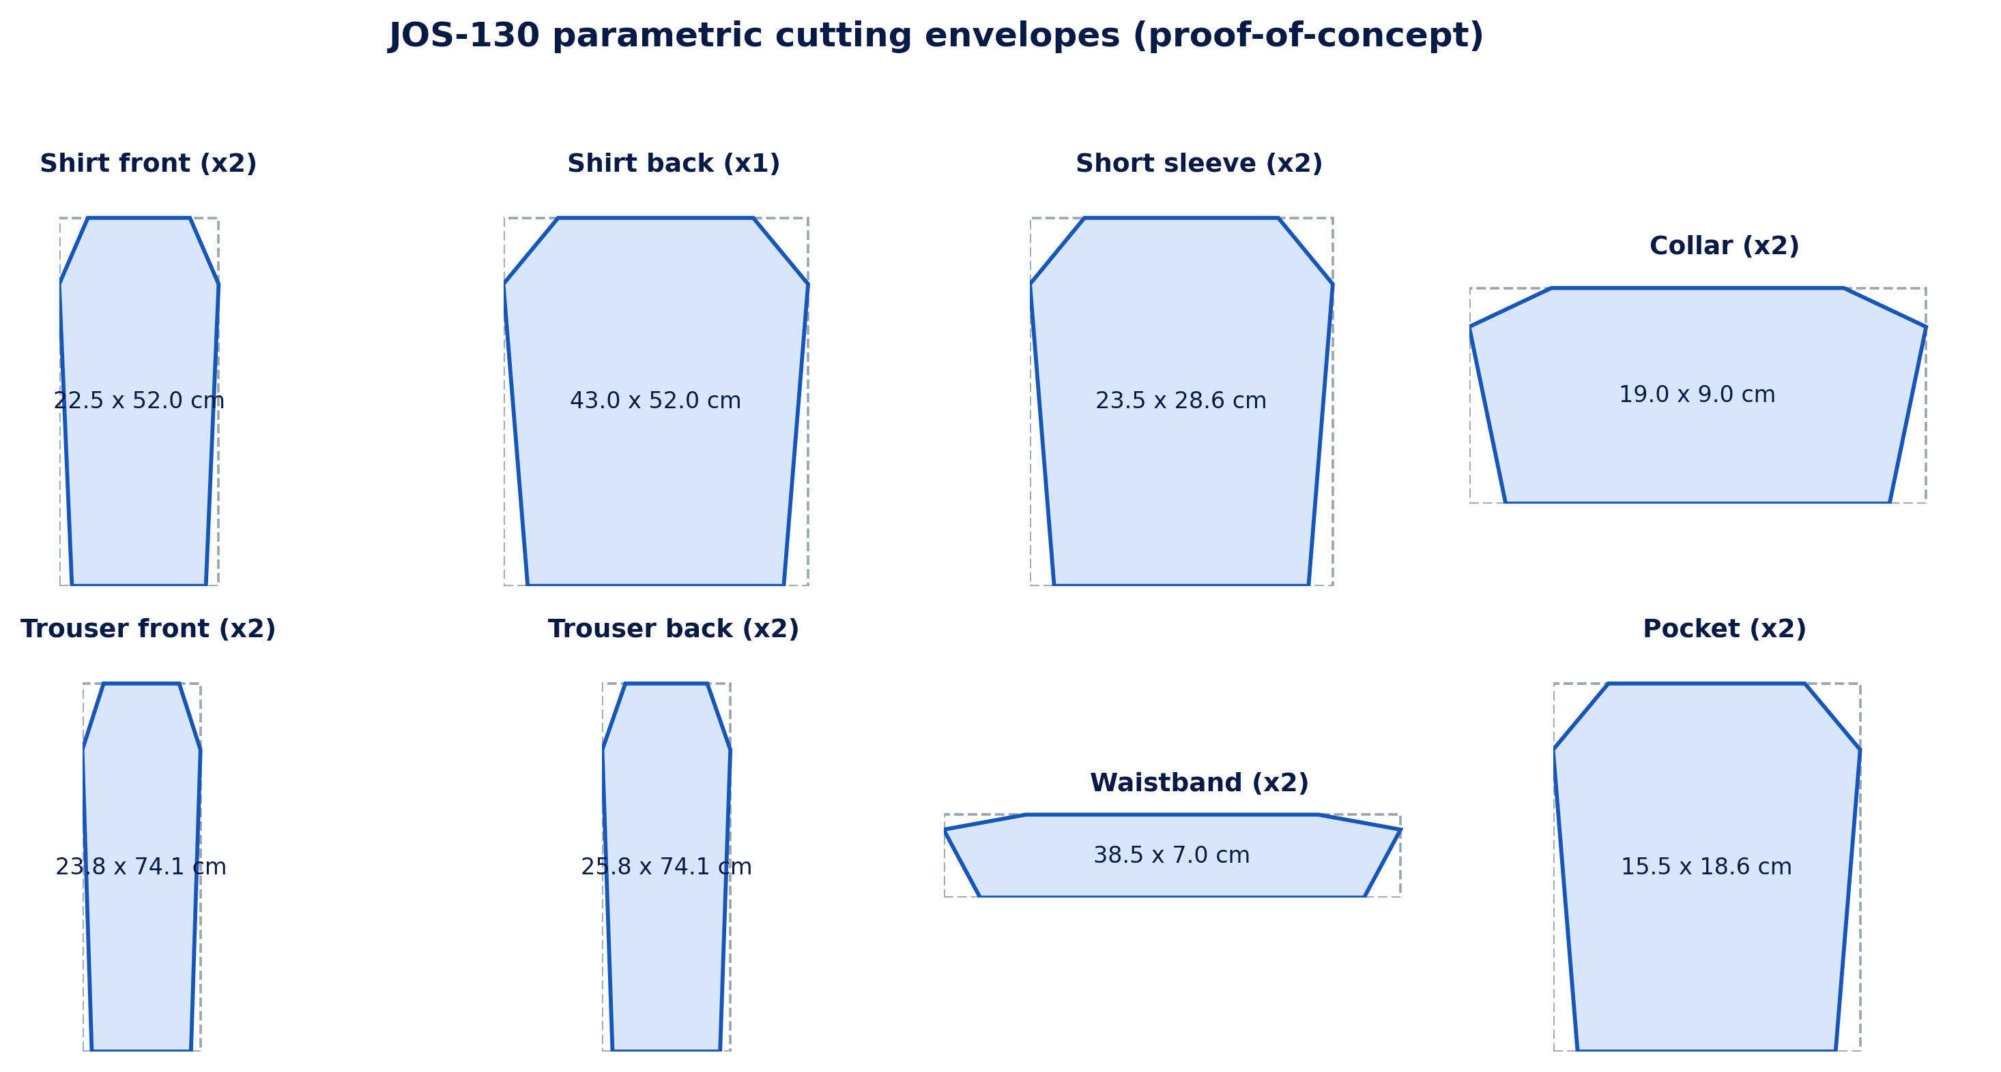
Figure 3. JOS-130 cutting-envelope geometry used in the reproducible simulation. Dashed rectangles are the nesting boundaries; shapes are not sew-ready production patterns.

3.4 Experimental factors and comparator algorithms
Four size mixes were crossed with three usable widths, producing 12 marker scenarios (Table 3). The pilot marker contained one set of each size and served as a visual trace. The three production markers each contained 30 uniform sets and 450 pattern pieces. A constant 1 cm horizontal and vertical gap separated envelopes.
Table 3. Factorial marker scenarios and their analytical purpose.
Size mix | JOS-115 | JOS-130 | JOS-145 | Purpose
Pilot 1:1:1 | 1 | 1 | 1 | Visual algorithm trace
Balanced 10:10:10 | 10 | 10 | 10 | Equal production mix
Young-heavy 16:10:4 | 16 | 10 | 4 | Lower-size demand
Old-heavy 4:10:16 | 4 | 10 | 16 | Upper-size demand

Baseline algorithm. The size-batched next-fit-row layout ordered pieces by size and construction sequence. Each piece was placed in the current row if it fit; otherwise a new row began. This is a transparent comparator, not a measured manual-marker performance claim.
Optimized algorithm. The mixed-size best-fit-decreasing shelf layout sorted all pieces by descending length and width. Each piece was assigned to the existing compatible shelf leaving the least residual width; a new shelf was opened when none fitted. Grain direction was fixed, so 90-degree rotation was prohibited. Sizes could share shelves.

3.5 Outcomes and analytical procedure
Marker length (L) was the primary outcome. Percentage reduction was calculated as (Lbaseline - Loptimized)/Lbaseline × 100. Modelled planar occupancy was ΣAi/(W × L) × 100, where Ai was the envelope area multiplied by its declared piece-shape occupancy coefficient and W was usable width. Fabric area saved was W × (Lbaseline - Loptimized), converted to square metres. Results were reported descriptively because each layout was deterministic rather than a random sample.
Interpretation boundary: The experiment isolates layout logic. It does not model plaid matching, directional nap, defects, shrinkage, splicing, end allowance, fabric relaxation, cutting-table limits or production tolerance. The reported occupancy is a simulation diagnostic, not a commercial CAD-marker certificate.

4. Results

4.1 Parametric grading output
The three body profiles generated a coherent progression of shirt and trouser cutting envelopes. For example, the shirt-front envelope increased from 20.0 × 46.0 cm in JOS-115 to 25.0 × 58.0 cm in JOS-145, while the trouser-front envelope progressed from 21.25 × 65.55 cm to 26.25 × 82.65 cm. Because every dimension was derived from a named control, the grade was reproducible and internally consistent. The result demonstrates geometric repeatability, not fit validity.

4.2 Marker performance at 147 cm usable width
Table 4. Production-marker comparison at 147 cm usable width.
Production mix | Sets | Baseline L (m) | Optimized L (m) | Reduction | Optimized occupancy
Balanced 10:10:10 | 30 | 37.40 | 34.17 | 8.61% | 70.76%
Young-heavy 16:10:4 | 30 | 34.99 | 31.73 | 9.31% | 69.93%
Old-heavy 4:10:16 | 30 | 41.24 | 37.03 | 10.21% | 70.69%

At 147 cm width, mixed-size placement shortened every production marker. The balanced marker fell from 37.40 to 34.17 m, the younger-heavy marker from 34.99 to 31.73 m, and the older-heavy marker from 41.24 to 37.03 m. The corresponding reductions were 8.61%, 9.31% and 10.21%. Modelled occupancy converged near 70% despite the different size mixes.
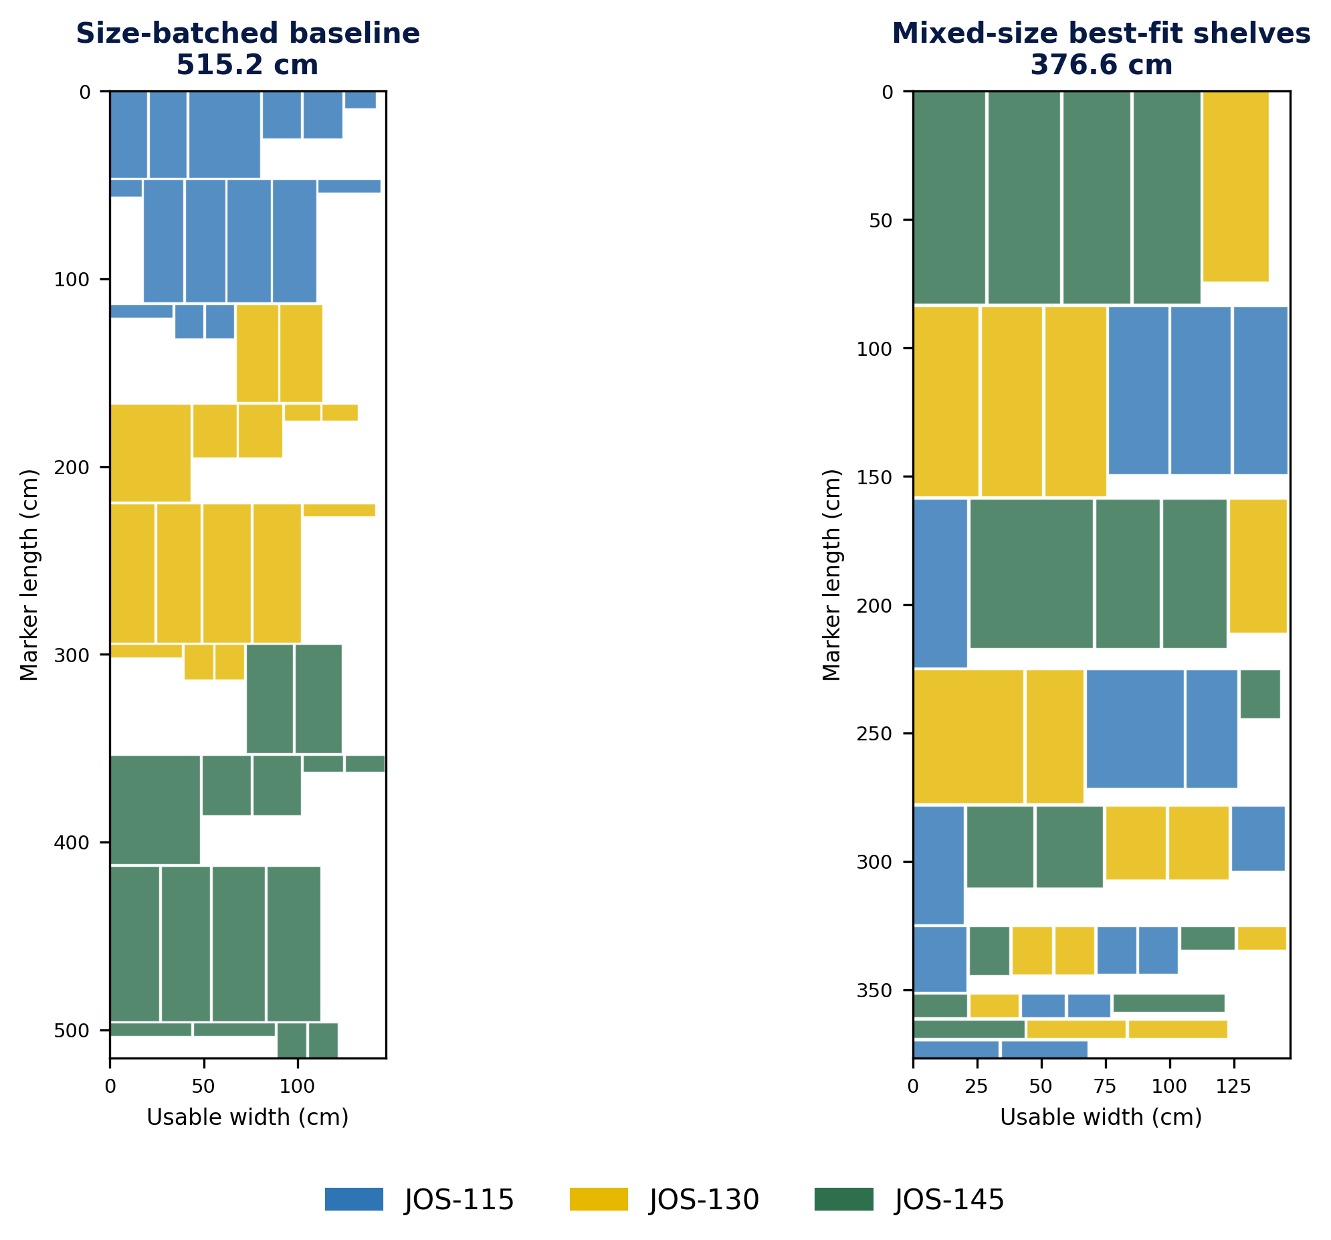
Figure 4. Pilot 1:1:1 marker trace. Mixed-size placement reduced modelled marker length from 515.2 to 376.6 cm (26.9%). The small pilot exaggerates fragmentation and is not the production effect estimate.

4.3 Fabric-width and assortment sensitivity
Table 5. Optimized marker length per set and reduction across production scenarios.
Production mix | Width (cm) | Optimized m/set | Length reduction | Occupancy
Balanced 10:10:10 | 140 | 1.204 | 12.32% | 70.30%
Balanced 10:10:10 | 147 | 1.139 | 8.61% | 70.76%
Balanced 10:10:10 | 150 | 1.127 | 10.11% | 70.10%
Young-heavy 16:10:4 | 140 | 1.112 | 9.54% | 69.82%
Young-heavy 16:10:4 | 147 | 1.058 | 9.31% | 69.93%
Young-heavy 16:10:4 | 150 | 1.034 | 9.39% | 70.09%
Old-heavy 4:10:16 | 140 | 1.296 | 9.26% | 70.69%
Old-heavy 4:10:16 | 147 | 1.234 | 10.21% | 70.69%
Old-heavy 4:10:16 | 150 | 1.214 | 7.51% | 70.42%

Across the nine production scenarios, marker-length reduction ranged from 7.51% to 12.32% and averaged 9.59%. Mean modelled occupancy rose from 63.57% under size-batched placement to 70.31% after mixed-size optimization, a gain of 6.74 percentage points. The lowest optimized length per set occurred for the younger-heavy mix at 150 cm width (1.034 m/set); the highest occurred for the older-heavy mix at 140 cm (1.296 m/set). This confirms that both size assortment and usable width affect consumption.
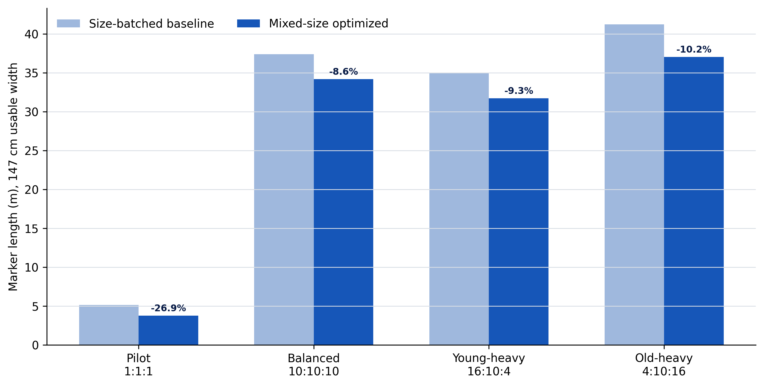
Figure 5. Marker-length comparison at 147 cm usable width. Percentage labels show the reduction produced by mixed-size best-fit placement.

4.4 Production-scale material implication
Scaling the 147 cm results arithmetically to 1,000 sets, the balanced mix would use 107.4 fewer linear metres of fabric under the optimized layout, the younger-heavy mix 108.6 fewer metres, and the older-heavy mix 140.3 fewer metres. These equal modelled area savings of approximately 157.8, 159.7 and 206.3 m², respectively. They are planning estimates, not purchase quantities: a factory must add allowances for shrinkage, defects, end loss, shade lots, lay length and cutting-room practice.

5. Discussion

5.1 What the experiment establishes
The results support a limited but important conclusion: with the same set of grain-constrained envelopes, mixing sizes and allocating each piece to the best compatible shelf reduces stranded width and marker length. The improvement persisted across all production mixes and widths. This agrees with established marker research showing that width, size combination and placement strategy influence fabric utilization (Pamuk & Yildiz, 2016; Haque, 2016; Badawy & Hussien, 2025).
The mean 9.59% reduction should not be interpreted as a universal CAD saving. It is the effect of one transparent heuristic relative to one transparent baseline within the declared geometry. Commercial auto-nesting may perform better because it can interlock true polygons, use more sophisticated searches and apply fabric rules. Conversely, real plaid, nap and defect constraints may reduce the feasible gain. The value of the experiment lies in reproducibility and decision structure rather than a guaranteed factory percentage.

5.2 Implications for primary-school uniform mass production
A digital base-block library creates a single controlled source for repeated uniform orders. When chest, waist, hip or stature changes, the affected formula can be traced and the full size range regenerated. This reduces undocumented redrawing and supports consistent notches, seam references and grade increments. CAD adoption research likewise emphasizes repeatability, file storage and faster revision as production benefits (Kılıç, 2019; Chaudhary et al., 2020).
For schools or producers, the practical planning unit should be a size assortment, not an isolated nominal size. Enrolment records, recent measurements and previous exchange data can estimate the expected ratio of JOS-115, JOS-130 and JOS-145 orders. The marker should then be optimized for that ratio and the actual usable width of the selected fabric. The present results show that a younger-heavy order needs less length per set than an older-heavy order; procurement that ignores the mix will misstate demand even if total enrolment is correct.

5.3 Fit, ease and quality-control requirements
The experiment's geometric precision must not be confused with wearer comfort. The JOS profiles contain only four mean dimensions, and the broad 10-12-year group may contain substantial within-band variation. A production pattern requires neckline, shoulder, armscye, sleeve, rise, inseam, crotch depth and other measures, as well as body-shape and posture adjustments. Choi and Choi (2025) demonstrate the complexity of systematic fit correction, while Yang and Baytar (2024) show why movement and tactile feedback remain central to fit evaluation.
Accordingly, ease should be stored as a garment-and-fabric-specific schedule, not buried in a size label. A woven shirt, stretch trouser and pinafore require different movement and design allowances. Each size should be toile-tested on more than one child representing the intended measurement range, with documented guardian consent and child assent where identifiable fitting data or images are retained.

5.4 Accessible CAD adoption and skills development
Small workshops may adopt the workflow incrementally. Open-source or general vector tools can support coordinate-based drafting and training when commercial apparel systems are unaffordable (Papachristou et al., 2019; Mupfumbati et al., 2021). The minimum digital discipline is more important than a particular brand: named measurements, formula-controlled points, versioned blocks, locked grade rules, piece metadata, grainlines and an auditable marker report.
Training should connect digital commands to pattern-making reasoning. Operators must understand why a point moves, which body dimension controls it, how seam lengths are reconciled and when software output should be rejected. A poorly trained operator can generate a visually tidy but technically invalid file at high speed. The production system should therefore retain human approval gates at block validation, graded nest review, toile fitting and final marker release.

6. Recommended Production and Validation Protocol
Table 6. Minimum controls for converting the proof-of-concept into a production CAD library.
Stage | Required action | Evidence to retain | Release gate
1. Measurement | Collect defined dimensions by trained measurers; repeat critical girths | Individual sheet, instrument ID, repeat values | Technical error within tolerance
2. Base block | Draft full shirt and trouser blocks with explicit ease and seam rules | Formula sheet, point coordinates, seam reconciliation | Pattern technologist approval
3. Grading | Apply controlled increments; inspect nested outlines and notches | Versioned grade-rule table and overlay | No distorted curves or unmatched seams
4. Toile | Construct each size in production-equivalent fabric | Construction record, defect and alteration log | Static balance acceptable
5. Wearer fit | Assess dressing, sitting, walking, squatting and arm elevation | Child/guardian feedback and two-assessor fit sheet | Minimum fit threshold achieved
6. Marker | Optimize actual polygons for fabric width, grain, nap and matching | CAD marker report, piece count, length and efficiency | Every piece present and technically valid
7. Pilot cut | Run a controlled lay; record shrinkage, defects, recuts and sewing issues | Lay ticket, bundle audit and consumption variance | Variance within production tolerance
8. Review | Analyse alterations, exchanges and returns by size and school | Coverage dashboard and version history | Retain, split or revise size

The protocol separates measurement error, pattern error, fit error and marker inefficiency. This matters because a shorter marker is desirable only when it contains the correct pieces and the garments produced from them pass dimensional and wearer-fit checks.

7. Limitations
The study used aggregate means from three broad age bands and did not process raw anthropometric records, percentiles, sex distributions, correlations or coverage ratios. The parametric envelopes were simplified geometric proxies rather than digitized production patterns. Piece-shape occupancy coefficients were assumptions declared for the simulation, not areas measured from physical patterns. The shelf algorithm did not interlock polygons or model 90-degree rotations because grain direction was fixed. Plaid and stripe matching, one-way nap, defects, shrinkage, splicing, end allowance, cutting-table length, fabric relaxation and sewing tolerances were excluded. No operator time, software cost, factory throughput, physical fabric consumption, finished-garment dimensions or child fit outcomes were measured. Therefore, the findings establish comparative computational performance within the model, not commercial cost savings or validated garment fit.

8. Conclusion and Recommendations
This study completed the original CAD-uniform concept as a reproducible technical-design experiment. Three locally derived body profiles were transformed into 15 parametric shirt-and-trouser cutting envelopes per set and evaluated across 12 marker scenarios. Mixed-size best-fit placement reduced marker length in every scenario. Across production-sized tests the mean reduction was 9.59%, while the modelled occupancy diagnostic increased by 6.74 percentage points.
The evidence supports adoption of parametric grading and mixed-size marker planning as a pilot pre-production method. It does not justify immediate factory cutting from the illustrated envelopes. The next stage should construct complete sew-ready blocks, expand the measurement set, validate ease and grade rules through physical toiles, and run controlled factory comparisons using actual pattern polygons, real fabrics, recorded operator time and measured consumption. Producers should archive each approved block, grade, marker and fit decision as a versioned digital production record. With those controls, CAD can help school-uniform manufacturers improve consistency, responsiveness and material stewardship without sacrificing fit or child comfort.

Declarations
Table 7. Publication declarations and evidentiary provenance.
Declaration | Statement
Ethics | The e035 computational phase involved no new human participants and used only published aggregate body measurements. Any future child fitting study requires documented parent/guardian consent, applicable child assent and institutional ethical review where required.
Funding | No external funding was reported in the supplied manuscript.
Competing interests | No competing interest was reported in the supplied manuscript.
Data availability | All anthropometric inputs, formulas, scenario definitions and the complete 12-scenario result matrix are reported in this article. No participant-level data were processed.
Author contributions | The supplied manuscript established the three-author order but did not include a CRediT statement. Contribution roles should be confirmed by all authors in the final editorial proof; no unverified roles are assigned here.
Version provenance | Article e035 substantially completes and updates the authors' supplied working manuscript by adding the reproducible method, computational experiment, results, critical discussion and current literature. No prior DOI is claimed for the supplied manuscript.
Peer-review model | CHIATECH JOURNAL applies double-blind peer review to original research articles in the Pioneer Publication series.
Copyright and licence | © 2026 The authors. Published open access under the Creative Commons Attribution 4.0 International (CC BY 4.0) licence.

References
Akila, L. K., & Agbo, D. A. (2024). Establishment of mean body measurement chart for school uniforms and accessories of primary school children ages 6 to 12 years in Jos, Plateau State, Nigeria [Version 1]. Zenodo. https://doi.org/10.5281/zenodo.17928414
Azunwena, R. N., & Ikechi, O. J. (2024). Development of clothes sizing system for designing school uniform for pre-school children using anthropometric data in Rivers State, Nigeria. American Journal of Economics and Business Management, 7(7), 58-70. https://doi.org/10.31150/ajebm.v7i7.2839
Badawy, M. A. H., & Hussien, M. (2025). The effect of different sizes and widths of markers on the nesting efficiency when using some software: Case study of a model of children's clothing. International Design Journal, 15(6), 281-298. https://doi.org/10.21608/idj.2025.369643.1296
Casciani, D., & Bertolini, M. (2025). Towards a sustainable on-demand fashion industry: The impact of digital body measurement technologies. Discover Sustainability, 6, Article 478. https://doi.org/10.1007/s43621-025-01269-8
Chaudhary, S., Kumar, P., & Johri, P. (2020). Maximizing performance of apparel manufacturing industry through CAD adoption. International Journal of Engineering Business Management, 12, 1-12. https://doi.org/10.1177/1847979020975528
Choi, J., & Choi, H. E. (2025). Development of a body type optimized pattern library based on fit adjustment frameworks. Fashion and Textiles, 12, Article 30. https://doi.org/10.1186/s40691-025-00437-8
Destaw, A., Bizuneh, B., Hailu, F., Tsegaye, S., & Mamo, B. (2025). Advancements and challenges in clothing sizing systems: A systematic literature review (2000-2022). Research Journal of Textile and Apparel, advance online publication, 1-18. https://doi.org/10.1108/RJTA-05-2025-0115
Haque, M. N. (2016). Impact of different sorts of marker efficiency in fabric consumption. International Journal of Textile Science, 5(5), 96-109. https://doi.org/10.5923/j.textile.20160505.02
International Organization for Standardization. (2017). ISO 8559-1:2017, Size designation of clothes-Part 1: Anthropometric definitions for body measurement. https://www.iso.org/standard/61686.html
International Organization for Standardization. (2018). ISO 8559-3:2018, Size designation of clothes-Part 3: Methodology for the creation of body measurement tables and intervals. https://www.iso.org/standard/67334.html
International Organization for Standardization. (2023). ISO 8559-4:2023, Size designation of clothes-Part 4: Determination of the coverage ratios of body measurement tables. https://www.iso.org/standard/80356.html
International Organization for Standardization. (2025). ISO 8559-2:2025, Size designation of clothes-Part 2: Primary and secondary dimension indicators. https://www.iso.org/standard/85590.html
Kılıç, A. Ş. (2019). Comparison of CAD and manual system efficiency in pre-production preparation process. Textile and Apparel, 29(1), 73-84. https://doi.org/10.32710/tekstilvekonfeksiyon.437799
Mupfumbati, L., Chuma, C., & Chimbindi, F. (2021). Online instructional material for computer aided garment pattern making training in colleges: A case study of Zimbabwe. International Journal of Costume and Fashion, 21(1), 54-66. https://doi.org/10.7233/ijcf.2021.21.1.054
Pamuk, O., & Yildiz, E. Z. (2016). A study about parameters affecting the marker plan efficiency. Textile and Apparel, 26(4), 430-435.
Papachristou, E., Kyratsis, P., & Bilalis, N. (2019). A comparative study of open-source and licensed CAD software to support garment development learning. Machines, 7(2), Article 30. https://doi.org/10.3390/machines7020030
Widyanti, A., Mahachandra, M., Soetisna, H. R., & Sutalaksana, I. Z. (2017). Anthropometry of Indonesian Sundanese children and the development of clothing size system for Indonesian Sundanese children aged 6-10 year. International Journal of Industrial Ergonomics, 61, 37-46. https://doi.org/10.1016/j.ergon.2017.05.008
Yang, Y., & Baytar, F. (2024). Fit models' roles in identifying fit issues in the apparel technical design process and implications for improving 3D virtual fitting. Fashion and Textiles, 11, Article 32. https://doi.org/10.1186/s40691-024-00398-4

Publication Record
How to cite: Akila, L. K., Mwanle, G. C., & Usman, M. M. (2026). Optimizing primary-school uniform mass production through computer-aided basic-block development: A reproducible parametric grading and marker-planning experiment. CHIATECH JOURNAL, 1(1), e035. DOI pending.
Article: e035 · Pioneer Publication · Volume 1, Issue 1 · July 2026
ISSN: Pending assignment · CHIATECH JOURNAL DOI: Pending registration
Publisher: CHIA TECH SOLUTIONS AND RESOURCES LIMITED · RC 1839865 · Nigeria
Journal contact: chiatechlibrary@gmail.com

