CHIATECH JOURNAL
  - SETEHEM · VOLUME 1 · ISSUE 2 · AUGUST 2026 · e036
  - PIONEER PUBLICATION · ACCEPTED ARTICLE · CRITICAL REVIEW ARTICLE · ACCOUNTING · DATA SCIENCE · MSMEs · DIGITAL FINANCE · NIGERIA

Accounting Data Science, Digital Record-Keeping and Financial-Risk Management among MSMEs in Nigeria: A Critical Review of Evidence, Infrastructure and Policy
Olumeyan Elizabeth Titilayo
National Teachers Institute, Gwagwalada Study Centre, FCT Abuja, Nigeria
Correspondence: Elizabethtiti1972@gmail.com
ARTICLE TYPE  Critical Review Article | VOLUME / ISSUE  1(1) | ELOCATOR  e036
PUBLICATION  Pioneer Issue · August 2026 | IDENTIFIERS  ISSN: Pending assignment | JOURNAL DOI  Pending registration

Abstract
Background: Nigeria’s micro, small and medium enterprise (MSME) economy is large, highly informal and increasingly digital. Yet digital payments do not automatically produce reliable accounts, and access to a bank or fintech channel does not guarantee disciplined record keeping, fund separation, reconciliation or usable financial statements. Objective: This review synthesizes Nigerian evidence on accounting practices, digital record-keeping, accounting information systems, financial inclusion and emerging data-analytics approaches, and develops a practical accounting-data-science framework for MSME financial management and risk assessment. Review approach: A structured critical review prioritized Nigeria-specific peer-reviewed studies and authoritative institutional evidence published mainly from 2020 to August 2026, supplemented by foundational guidance on alternative data and small-business reporting. Evidence was organized around record quality, internal control, digital adoption, analytics, credit access, taxation and data governance. Synthesis: The 2021 SMEDAN/NBS survey reported about 39.65 million MSMEs; PwC’s synthesis of that survey attributes 46.32% of GDP, 96.9% of businesses and 87.9% of employment to the sector. NBS reported that 93.0% of employment was informal in Q2 2024. Nigerian studies consistently link record keeping and accounting-information use with stronger business control and financial performance, while digital-accounting studies identify perceived usefulness, technological literacy, cost, complexity and support as important adoption conditions. A Nigerian e-bookkeeping pilot found that personalized micro-consulting alongside digital tools increased first-adoption steps by 95% compared with information alone and improved precision in profit recall. Meanwhile, CBN payment statistics show transaction volumes large enough to generate substantial digital business footprints, and recent World Bank/IFC evidence identifies alternative transaction data as a potential bridge to MSME credit where conventional financial statements are weak. Conclusion: The central policy and practice challenge is no longer simply whether Nigerian MSMEs have access to digital finance; it is whether transaction trails are converted into reliable accounting information, internal control, explainable analytics and decision-ready evidence. The review proposes a six-level Nigerian MSME accounting-data-science maturity model and recommends record-first digitalization, reconciliation-centered training, interoperable bookkeeping/payment tools, privacy-preserving analytics, accountant-supported adoption and externally validated credit-risk models.
Keywords: accounting data science; MSMEs; digital record-keeping; accounting information systems; financial inclusion; financial risk analytics; alternative data; Nigeria; informal economy
Suggested citation: Olumeyan, E. T. (2026). Accounting data science, digital record-keeping and financial-risk management among MSMEs in Nigeria: A critical review of evidence, infrastructure and policy. CHIATECH JOURNAL · SETEHEM, 1(1), e036.

1. Introduction
Nigeria’s MSME economy is simultaneously economically central, institutionally fragmented and data-rich in ways that are not yet fully captured by conventional accounting systems. The joint SMEDAN/NBS MSME survey is widely reported as identifying approximately 39.65 million MSMEs. PwC Nigeria (2024), drawing on the 2021 survey, reports that MSMEs contributed 46.32% of national GDP, represented 96.9% of businesses and accounted for 87.9% of employment. At the same time, the National Bureau of Statistics (NBS, 2024) estimated informal employment at 93.0% of total employment in Q2 2024. These figures explain why small-business accounting is not a narrow bookkeeping issue: the reliability of records held by micro and small firms affects productivity measurement, tax compliance, credit allocation, business continuity and the quality of national economic information.
The accounting problem has changed with digitalisation. Many small firms now receive or make payments through banks, point-of-sale (POS) terminals, mobile applications, web transfers and mobile-money channels. Central Bank of Nigeria (CBN, 2024) statistics for January-June 2024 record billions of transactions across internet, POS, mobile-app and mobile-money channels. These payment trails can reduce the invisibility of cash-only businesses, but a payment history is not the same as an accounting system. Unless transactions are classified, matched to supporting documents, reconciled, separated from household flows and summarized into decision-relevant measures, digitalisation can produce more data without producing better control.
This distinction is particularly important for informal firms because financial and business boundaries are often porous. Owners may use one account for family and business needs, rely on memory for customer debt, price without cost attribution, confuse high turnover with high profitability, or postpone reconciliation until liquidity problems become visible. In such settings, basic accounting discipline—recording, classification, separation of funds, reconciliation and periodic review—creates the foundation on which digital accounting and data analytics can add value. The companion Gwagwalada empirical study in this Pioneer issue reached a similar conclusion: local risk signals were associated more strongly with record-keeping and reconciliation practices than with bank-account access alone (Olumeyan, 2026).

1.1 Review questions and contribution
The review addresses four questions: (1) What does current Nigerian evidence show about record keeping, accounting-information use and MSME performance? (2) How are digital payments, digital accounting systems and financial inclusion changing the information environment of small firms? (3) Where can accounting data science and alternative data improve financial-risk assessment without overstating predictive capability? and (4) What policy, professional and governance conditions are required for responsible scale-up? The paper contributes a record-to-decision architecture and a maturity model designed for Nigerian MSMEs, linking accounting fundamentals to increasingly sophisticated digital and analytical capabilities.
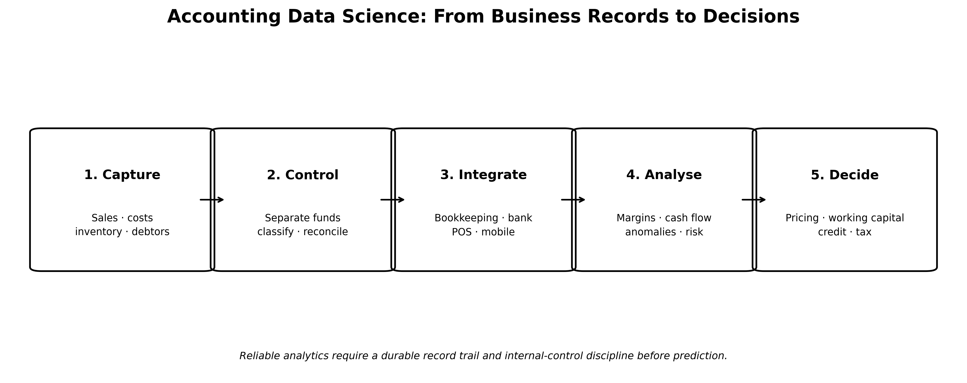
Figure 1. Record-to-decision architecture for accounting data science in Nigerian MSMEs. Original author synthesis based on Nigerian accounting, digital-finance and alternative-data evidence reviewed in this article.

2. Review Approach and Evidence Base
This article is a structured critical narrative review rather than a systematic review or meta-analysis. Searches conducted for the publication update combined terms such as “Nigeria SMEs record keeping”, “digital accounting Nigeria SMEs”, “accounting information system SMEs Lagos”, “e-bookkeeping Nigeria small firms”, “financial inclusion Nigeria MSMEs”, “digital payments Nigeria”, “alternative data MSME credit Nigeria”, “SME governance accounting Nigeria” and “Nigeria data protection automated decision making”. Priority was given to Nigeria-specific peer-reviewed research, official Nigerian statistics and regulation, and high-authority development-finance evidence. The principal evidence window was 2020-August 2026, while earlier authoritative guidance was retained when it directly informed alternative-data credit reporting or accounting-system design.
Evidence was interpreted according to source function. National statistics and regulatory documents were used to establish scale, informality, payment infrastructure, governance and legal context. Peer-reviewed regional studies were used to identify recurring relationships between accounting practices, digital adoption and business outcomes. Development-agency research was used where it offered stronger experimental or market-level evidence on digital record adoption and MSME finance. Because samples, definitions and outcome measures differ substantially, findings were not pooled into a single effect size. Cross-sectional associations are therefore described as associations, not as causal effects, unless the source design supports stronger inference.

3. Nigeria’s MSME and Informal-Economy Context
The scale of the Nigerian MSME sector makes the quality of business information a macroeconomic issue. PwC Nigeria (2024) reports, based on the SMEDAN/NBS 2021 survey, that MSMEs account for almost all businesses and a very large share of employment, while contributing close to half of GDP. NBS labour statistics show that the wider employment structure remains overwhelmingly informal. For accounting policy, this means that requirements designed around fully formalized companies cannot simply be transplanted to nano and micro firms. A practical system must create reliable information at low cost and must accommodate owner-managed, cash-intensive and mixed-digital businesses.
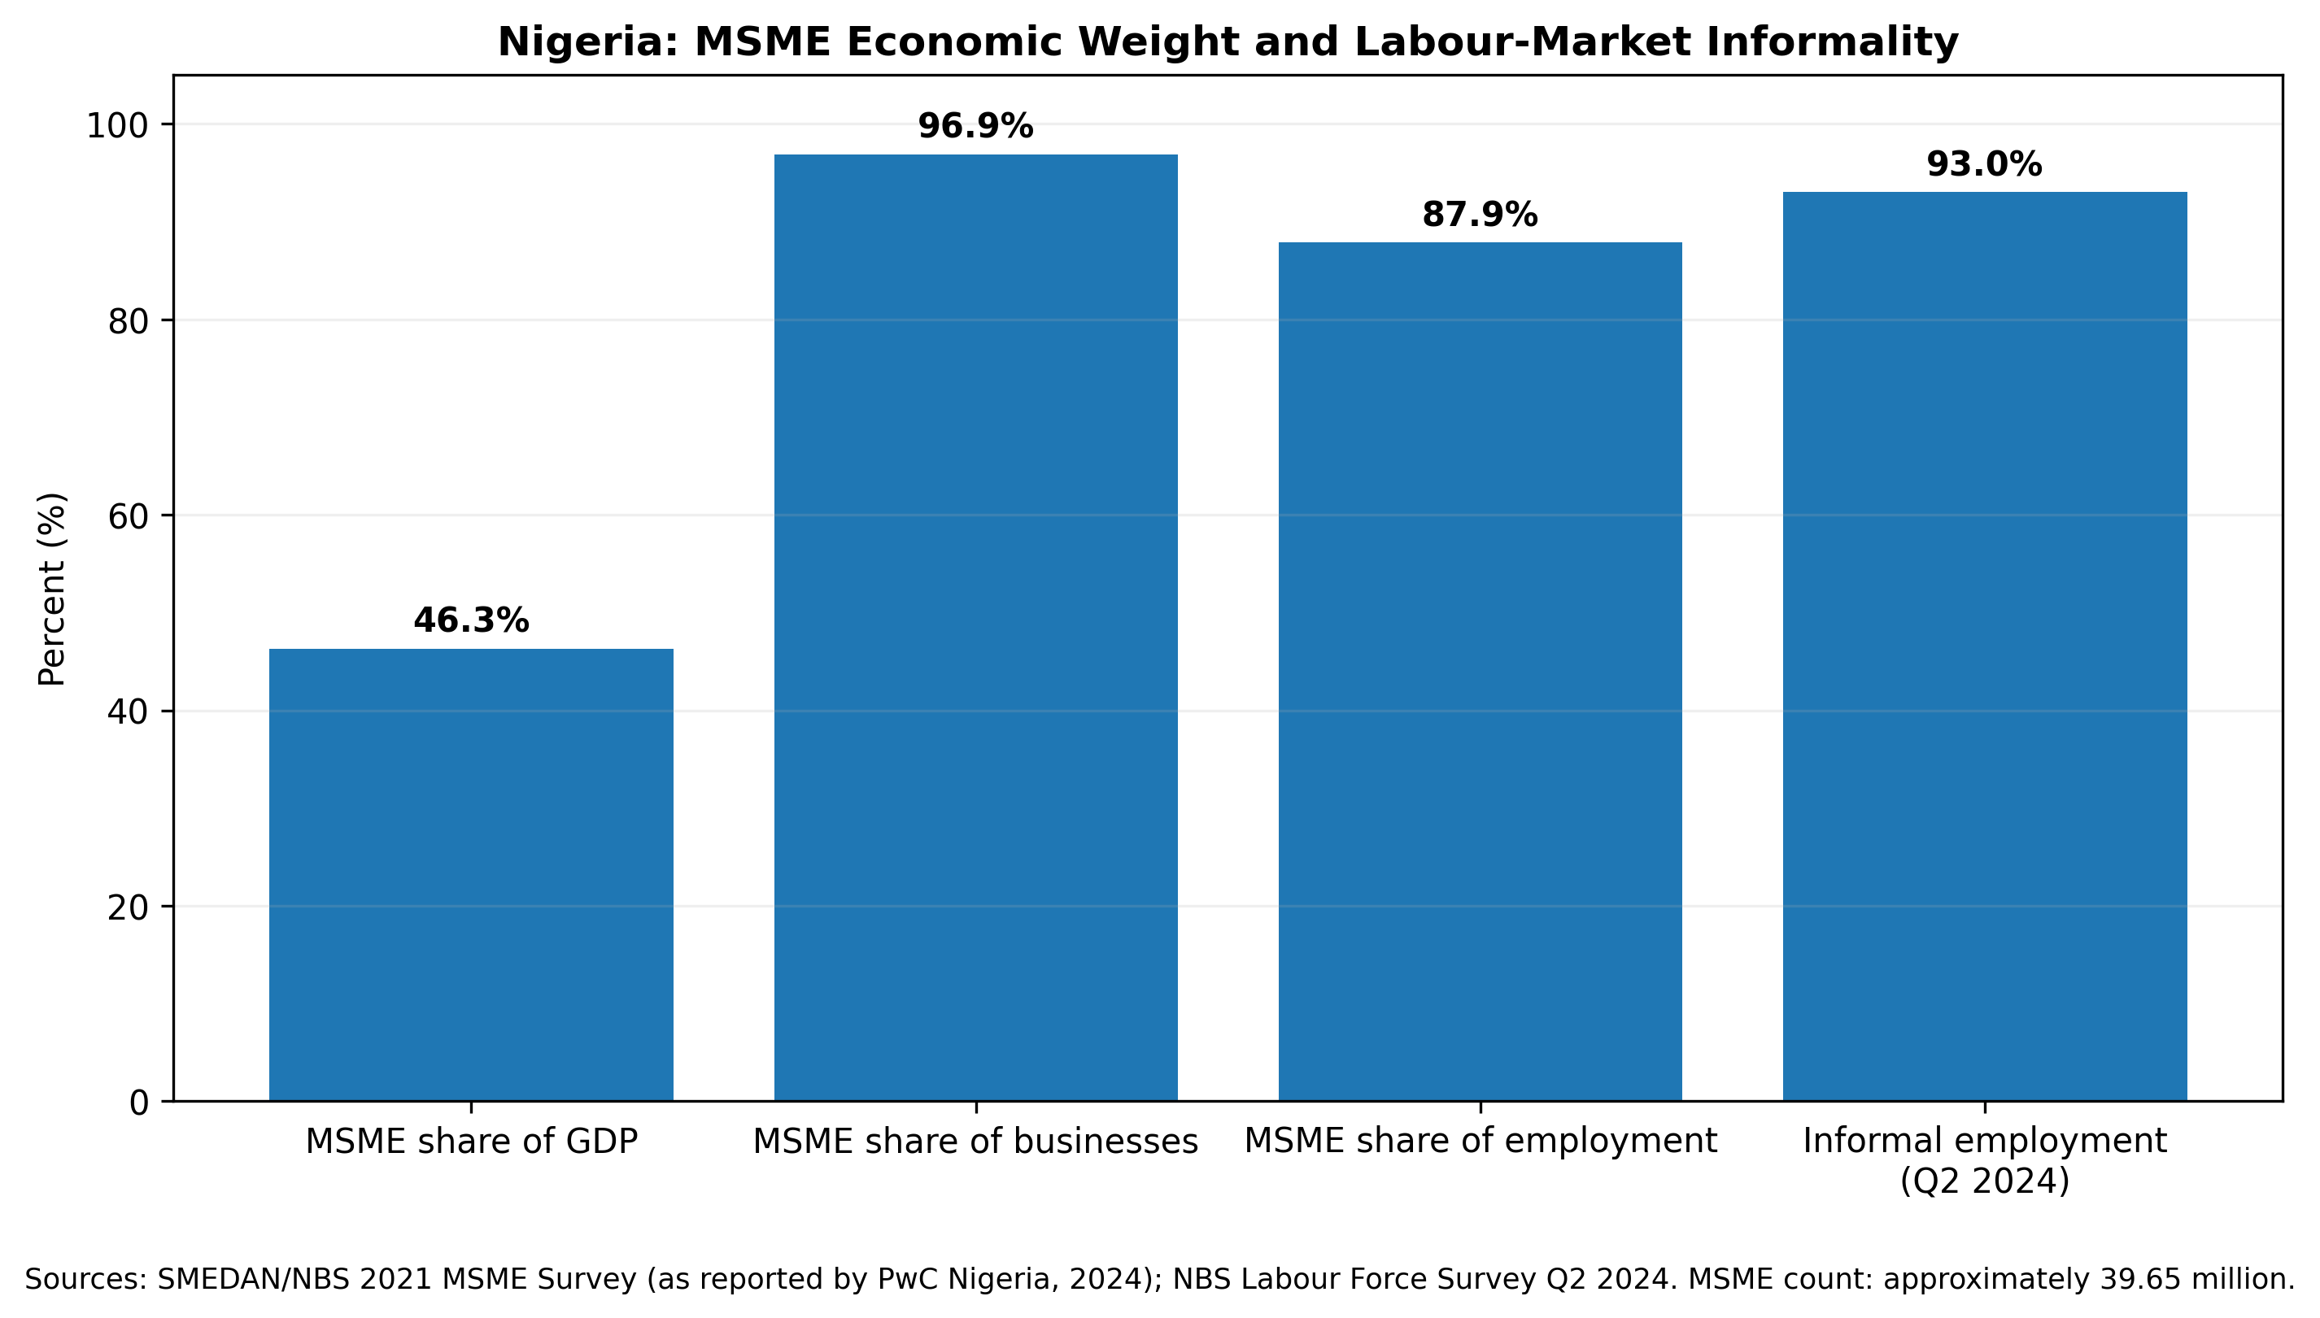
Figure 2. Nigeria’s MSME economic weight and labour-market informality. Sources: SMEDAN/NBS 2021 MSME Survey as summarized by PwC Nigeria (2024); NBS Labour Force Survey Q2 2024.
Table 1. Selected national indicators relevant to MSME accounting and financial analytics in Nigeria
Indicator | Latest evidence used | Accounting/analytics implication
MSME population | ≈39.65 million MSMEs (SMEDAN/NBS 2021 survey) | Any scalable accounting intervention must work for high-volume, heterogeneous and largely owner-managed enterprises.
Economic contribution | 46.32% of GDP; 96.9% of businesses; 87.9% of employment (PwC Nigeria, 2024, reporting SMEDAN/NBS) | Weak business records can affect credit allocation, productivity measurement and enterprise resilience at national scale.
Informal employment | 93.0% of total employment in Q2 2024 (NBS, 2024) | Formal financial statements are absent for much economic activity; simplified but reliable records are therefore strategically important.
Formal financial inclusion | 64% of adults in 2023; 26% financially excluded (EFInA, 2023) | Access has expanded, but access alone should not be treated as evidence of financial control or business resilience.
MSME credit gap | ≈₦13 trillion unmet demand estimated by IFC (2022) | Transaction and accounting data may reduce information asymmetry but cannot substitute for sound underwriting governance.
Bank-credit access | World Bank reported in 2025 that fewer than 1 in 20 Nigerian MSMEs had access to bank credit | Improved financial records and alternative-data infrastructure remain directly relevant to credit visibility.

4. Accounting Records as a Management and Control Infrastructure
The Nigerian literature is remarkably consistent on one point: records have value when they are used, not merely when they exist. Olajide and Obialo (2020), studying 120 small enterprises in Abeokuta South, found that 59.2% kept records manually by themselves and linked stock, income/expenditure, debtor and creditor records with sales growth, profitability and operational efficiency. Onwuchekwa and Ukpong (2023), using 450 small-business operators in Rivers State, reported strong positive relationships between record keeping and utilization of subsidiary books and ledger accounts. In Abuja Metropolis, Okoh et al. (2023) similarly concluded that accounting records supported monitoring, financial-statement preparation, expense tracking, property tracking and tax-return preparation.
These findings should be understood through an internal-control lens. Even very small businesses need mechanisms that establish what happened, who owes what, how much cash belongs to the business and whether recorded balances agree with external evidence. In microbusiness form, the most consequential controls are often simple: separation of business and personal funds; daily or weekly transaction capture; debtor and creditor tracking; inventory movement records; bank/POS/mobile reconciliation; and owner review of gross margin, cash position and obligations. The Financial Reporting Council of Nigeria’s SME Business Governance Guidelines (FRC, 2024) explicitly emphasize credible accounting practices from the start of operations and reliable financial statements appropriate to enterprise size.
The practical implication is that digitalisation should not begin with software selection. It should begin with a minimum accounting dataset. For a typical Nigerian trader, food vendor, service provider or POS operator, that dataset includes date, transaction type, amount, payment channel, customer/supplier reference, expense category, inventory implication, debtor/creditor status and evidence link. Once those fields are recorded consistently, manual and digital systems become comparable at the information level, and migration to an app or accounting information system becomes easier.

5. Digital Record-Keeping, Accounting Information Systems and Adoption Conditions
Digital accounting can reduce the cost of record capture, automate summaries, preserve transaction history and connect accounting information with payments. Yet adoption is neither automatic nor uniform. In South-West Nigeria, Ebhota, Hongxing, and Sampene (2024) analysed 825 SMEs and reported significant relationships among digital transformation, big-data analytics, customer experience, budgetary control and financial performance. Ajape, Okpala, and Salawu (2024), studying 387 SME owners and managers in Lagos, identified perceived usefulness and technological literacy as important adoption factors, while initial cost and complexity were barriers. More recent Nigerian studies likewise report positive relationships between digital accounting-system use, information quality and SME performance, while emphasizing cost, reliability and user capability (Garba & Mohammed, 2026; Sanni & Akinrinola, 2026).
The strongest causal-adjacent evidence in this area comes from Nigeria’s e-bookkeeping research programme. Oyebanjo (2024, 2025) reports that combining digital record-keeping technology with personalized micro-consulting substantially improved initial adoption behaviour; the 2025 policy brief reports a 95% increase in the probability of taking first-use steps relative to basic information alone. Digital records also improved the precision with which firms recalled profits. The result is important because it shifts the policy question from “Should firms be given an app?” to “What support enables owners to interpret and use the records produced by the app?”
Table 2. Selected Nigeria-specific evidence on accounting records and digital accounting
Study / setting | Design / sample | Principal evidence | Review interpretation
Olajide & Obialo (2020), Abeokuta South | Survey; n=120 small enterprises | 59.2% self-kept manual records; stock, income/expense and debtor/creditor records linked with business outcomes. | Manual recording remains common; accounting usefulness depends on complete record categories.
Onwuchekwa & Ukpong (2023), Rivers State | Survey; n=450 | Significant positive relationships between record keeping and utilization of subsidiary books/ledgers. | Keeping and using records are distinct capabilities and should be trained together.
Okoh et al. (2023), Abuja Metropolis | Survey of SMEs | Record keeping and financial literacy associated with monitoring, statements, expense tracking and tax preparation. | Financial literacy complements bookkeeping; information must be interpreted, not merely stored.
Ebhota et al. (2024), South-West Nigeria | PLS-SEM; n=825 SMEs | Digital transformation related to big-data analytics, budgetary control and financial performance. | Digital capability can strengthen management control when analytics are integrated with budgeting.
Ajape et al. (2024), Lagos State | Questionnaire; n=387 SME owners/managers | Usefulness and technological literacy supported technology-based accounting adoption; cost and complexity constrained it. | Adoption policy must address capability and total cost, not awareness alone.
Oyebanjo (2024, 2025), Nigeria | E-bookkeeping pilot / policy evaluation | Personalized micro-consulting plus digital tools increased first-adoption steps by 95% vs information alone; digital records improved profit-recall precision. | Human support is a major complement to technology, especially for first-time adopters.
Olumeyan (2026), Gwagwalada | Cross-sectional field study; n=150 | Manual ledgers dominated; mental/no records and never-reconciling businesses showed higher study-defined risk; practice-only RF ROC-AUC ≈.737. | Local evidence supports record-first risk analytics but not deployment of unvalidated credit scoring.
Garba & Mohammed (2026), Nigeria | Survey; 106 usable responses | Digital accounting awareness/use and perceived benefits positively associated with SME performance/sustainability. | Benefits are plausible but cross-sectional self-report limits causal interpretation.
Sanni & Akinrinola (2026), Lagos State | Survey; 255 usable responses | AIS cost/maintenance, data accuracy, system integrity and reporting timeliness significantly related to financial performance. | Information quality and system reliability are core accounting outcomes, not secondary IT issues.

6. Digital Payments as an Accounting Data Source
Nigeria’s payment infrastructure has created a much larger pool of machine-readable transaction evidence than was available to earlier generations of small firms. CBN (2024) reports that, in the first half of 2024, web/internet transfers accounted for 11.638 billion transactions, mobile-money operators 7.181 billion, POS 6.396 billion and mobile apps 3.493 billion, alongside ATM, USSD and other channels. These figures are system-wide rather than MSME-specific, but they demonstrate the scale of digital traces now embedded in commerce.
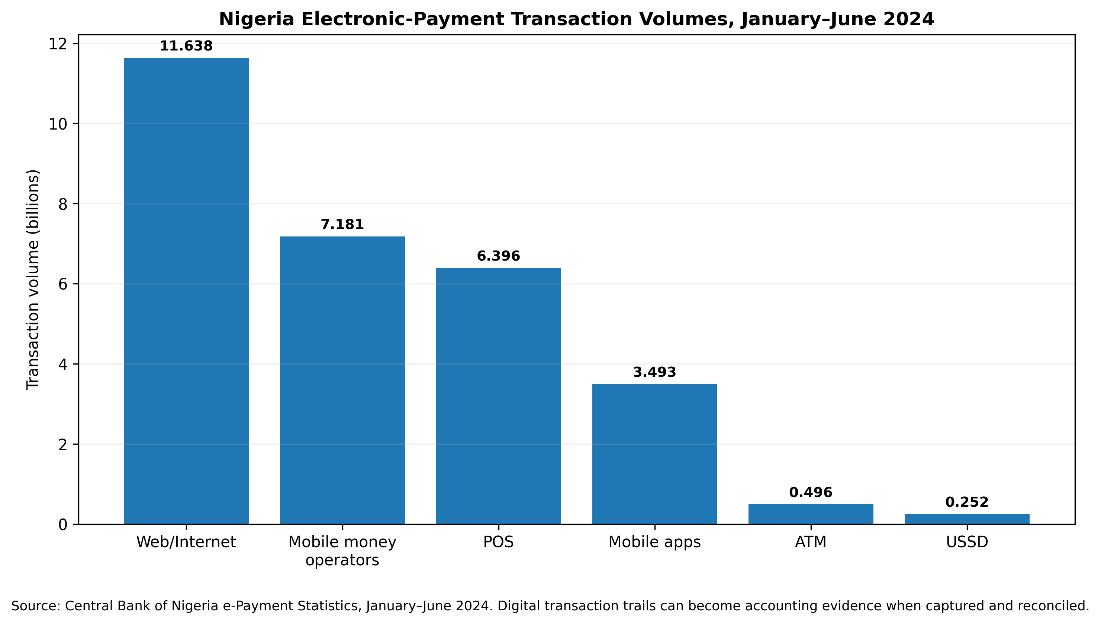
Figure 3. Selected Nigerian e-payment transaction volumes, January-June 2024. Source: Central Bank of Nigeria (2024). Volumes are national payment-system totals and are not MSME-only measures.
For accounting, the key opportunity is automated matching. A digital payment should ideally flow into a bookkeeping system with date, amount, payer/payee, channel, reference and business category, after which the owner confirms the economic meaning of the transaction. This reduces duplicate entry and creates a stronger audit trail. The risk is that raw bank or POS statements can still misclassify transfers, owner withdrawals, pass-through cash, refunds or customer deposits. Reconciliation therefore remains indispensable even in highly digital firms.

7. Financial Inclusion, Credit Visibility and Alternative Data
Financial inclusion has improved, but the Nigerian evidence distinguishes access from resilience. EFInA’s 2023 Access to Financial Services survey reports that formal financial inclusion rose to 64% from 56% in 2020 and that financial exclusion fell to 26%. The implied remainder is access through informal channels only. For small businesses, broader access is valuable because it can generate identifiable transaction histories, yet those histories need accounting context before they can support credit appraisal.
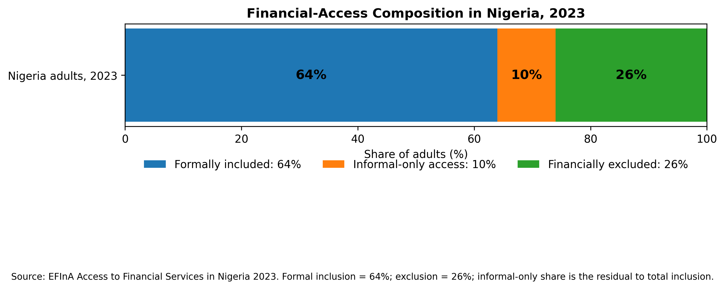
Figure 4. Financial-access composition among Nigerian adults in 2023. Source: EFInA (2023). Informal-only access is derived as the residual between total inclusion and the reported formal-inclusion/exclusion shares.
The finance gap remains large. IFC (2022) estimated unmet Nigerian MSME credit demand at about ₦13 trillion. In December 2025, the World Bank reported that fewer than one in twenty Nigerian MSMEs had access to bank credit and approved the FINCLUDE programme, which includes an AI-enabled digital platform intended to modernize loan appraisal and use better data. These developments make accounting data quality strategically important: lending algorithms can only be as reliable as the transaction identities, business boundaries, labels and outcomes used to train and validate them.
International credit-reporting guidance supports the use of alternative data—digital payments, utility records, online bookkeeping, trade transactions and other digital footprints—to improve visibility for firms with thin credit files (World Bank/ICCR, 2018). But alternative data should complement, not bypass, accounting discipline. A payment stream can indicate cash flow, while reconciled accounting records explain margin, seasonality, inventory needs, owner withdrawals, customer concentration and obligations. The combination is more informative than either source alone.

8. From Accounting Data to Financial-Risk Analytics
Accounting data science can be defined as the disciplined use of accounting records, digital transaction trails, statistical methods and machine-learning tools to improve measurement, explanation and financial decisions. For MSMEs, the most valuable applications are often simpler than enterprise-scale artificial intelligence. Descriptive dashboards can identify margin compression, cash shortfalls and rising customer debt. Diagnostic analysis can isolate whether weak cash flow is driven by expenses, inventory, receivables or owner withdrawals. Forecasting can estimate working-capital needs. Anomaly detection can flag unusual transactions or reconciliation breaks. Classification models can support risk screening, provided they are validated and do not replace accountable credit judgment.
The companion Gwagwalada study illustrates both the promise and the boundary of this approach. Accounting-practice variables produced moderate internal discrimination of a study-defined financial-risk label, while more complex feature sets were less stable (Olumeyan, 2026). That pattern supports parsimonious modeling: when sample size is limited, transparent variables such as reconciliation frequency, record-keeping mode and fund separation may be more defensible than high-dimensional black-box models. A model with a modest but stable ROC-AUC can be useful for research and targeting training; it is not automatically suitable for lending, pricing or automated exclusion.
Table 3. Accounting-data-science use cases for Nigerian MSMEs and minimum controls
Use case | Accounting inputs | Potential benefit | Minimum control
Cash-flow monitoring | Daily sales, expenses, transfers, owner drawings | Early detection of liquidity stress | Daily/weekly reconciliation and separation of household transactions.
Margin analysis | Revenue, cost of goods/services, transaction fees | Distinguishes high turnover from true profitability | Consistent expense classification and sector-appropriate cost allocation.
Receivables risk | Customer balances, due dates, payment history | Prioritizes collection and reduces hidden working-capital lock-up | Customer identifiers and ageing rules; avoid punitive automation without review.
Inventory analytics | Purchases, sales, stock counts, shrinkage | Reduces stock-outs, overstock and leakage | Periodic physical counts and exception review.
Credit-risk support | Reconciled statements + payment histories + business characteristics | Improves visibility where audited statements are unavailable | Out-of-time validation, calibration, explainability, bias testing and human underwriting.
Tax/compliance support | Classified transactions, invoices, asset/expense records | More reliable returns and audit trail | Document retention, applicable accounting rules and reconciliation to filed figures.
Fraud/anomaly detection | Transaction sequences, reversals, unusual amounts or counterparties | Flags events for review | Alerts must trigger investigation, not automatic accusation.

9. A Nigerian MSME Accounting Data-Science Maturity Model
The evidence suggests that digital transformation should be staged. Firms that cannot reconstruct basic sales and expenses should not begin with predictive analytics. The proposed maturity model therefore moves from durable record creation to internal control, digital accounting, descriptive analytics and finally governed predictive use. Progression is capability-based rather than software-based: a business may own sophisticated payment tools and still remain at a low accounting maturity level if transactions are not classified or reconciled.
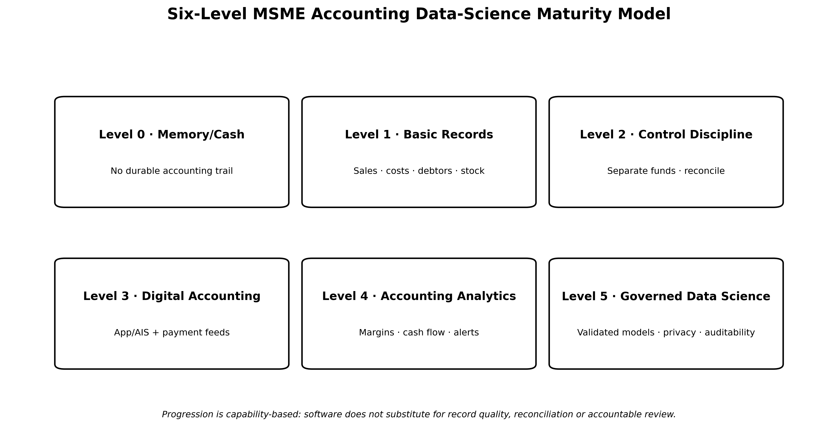
Figure 5. Proposed six-level Nigerian MSME accounting-data-science maturity model. Original author synthesis. Each level depends on the data-quality and control capability established beneath it.
This staged view also clarifies professional roles. At Levels 0-2, the most valuable intervention may be a simplified chart of accounts, cash/bank reconciliation and coaching. At Level 3, integration between payment channels and low-cost bookkeeping becomes valuable. At Level 4, the emphasis shifts to ratios, cash-flow trends and dashboards. Level 5 requires a much higher standard: model versioning, documented outcomes, privacy controls, explainability, bias testing, external validation and clear human authority over consequential decisions.

10. Tax Digitalisation, Reporting Governance and Data Protection
Digital accounting is increasingly connected with public compliance infrastructure. Nigeria’s Federal Inland Revenue Service operates TaxPro MAX and the Automated Tax Remittance System/e-invoicing infrastructure, which make registration, validation and digital tax interactions more data-dependent. For MSMEs, stronger records can reduce the cost of tax preparation and provide an evidential link between business activity and reported figures. However, digital tax systems also increase the consequences of misclassification, incomplete records and mixing household with business transactions.
The Financial Reporting Council’s SME governance guidance provides an important proportionality principle. Medium-sized entities should prepare a complete set of financial statements, while micro and small entities can prepare reliable statements appropriate to their operations and need not be forced into reporting complexity that exceeds their scale (FRC, 2024). The review therefore supports “minimum sufficient accounting”: simplified records should still be complete enough to establish cash, revenue, costs, debtors, creditors, inventory and owner equity/withdrawals.
Data governance becomes more important as small-business records move into cloud systems and are reused for scoring. The Nigeria Data Protection Act 2023 requires fair, lawful, transparent and secure personal-data processing and establishes rights including access, rectification, objection and protection in relation to automated decision making. Small-business analytics may contain customer, employee, supplier and owner data; fintechs, accountants and lenders therefore need purpose limitation, data minimization, secure access, retention controls and transparent explanations when analytics influence consequential decisions (NDPC, 2023).

11. Evidence Gaps and Methodological Priorities
The Nigerian literature is useful but still methodologically uneven. Much of the evidence is cross-sectional, self-reported and geographically concentrated in Lagos, Abuja, Ogun, Rivers and selected South-West settings. SME definitions vary, samples may exclude unregistered or survivalist firms, and financial performance is often measured by perceptions rather than verified accounts. Digital-accounting studies also face common-method bias when the same respondent reports adoption, usefulness and performance. These limitations do not invalidate the findings, but they reduce the strength of causal claims.
Future studies should prioritize longitudinal designs that follow firms before and after record-keeping interventions; transaction-linked outcomes rather than perception alone; preregistered definitions of profit, cash flow and financial distress; sector-stratified samples; and external validation of predictive models across states and time periods. For digital credit, studies should report calibration, false-positive/false-negative costs, fairness across gender and geography, and how human underwriters use model outputs. For bookkeeping interventions, adoption should be measured from actual app or record use rather than stated intention. The Nigerian research agenda should move from “Does technology help?” to “Which accounting capability, for which type of firm, under what support model, at what cost, and with what measurable decision benefit?”

12. Policy and Practice Recommendations
The evidence supports a coordinated implementation strategy rather than isolated technology procurement.
• SME owners should establish a minimum accounting routine before adopting advanced analytics: daily transaction capture, separate business funds, debtor/creditor tracking, periodic inventory review and bank/POS/mobile reconciliation.
• SMEDAN, enterprise-development programmes and financial institutions should pair digital bookkeeping tools with short, personalized coaching, reflecting Nigerian evidence that support materially improves initial adoption.
• Accountants and accounting educators should design simplified sector templates for traders, POS operators, food vendors, artisans, pharmacies, salons and service businesses rather than offering one generic ledger structure.
• Banks and fintechs should use payment and bookkeeping data as complementary evidence in credit assessment, with transparent feature definitions, consent, calibration, bias testing and human review.
• CBN/payment providers should promote interoperable exports or APIs that allow MSMEs to transfer transaction histories into bookkeeping applications without repeated manual entry.
• FRC and professional bodies should continue proportional reporting guidance for micro and small entities, emphasizing reliable operational statements and audit trails over unnecessary complexity.
• FIRS digital-tax initiatives should be accompanied by practical accounting education so that digital filing does not become detached from reliable underlying books and supporting documents.
• Researchers should publish data dictionaries, codebooks, model specifications and out-of-time validation results when using MSME accounting data for prediction, while protecting confidential business and personal information.
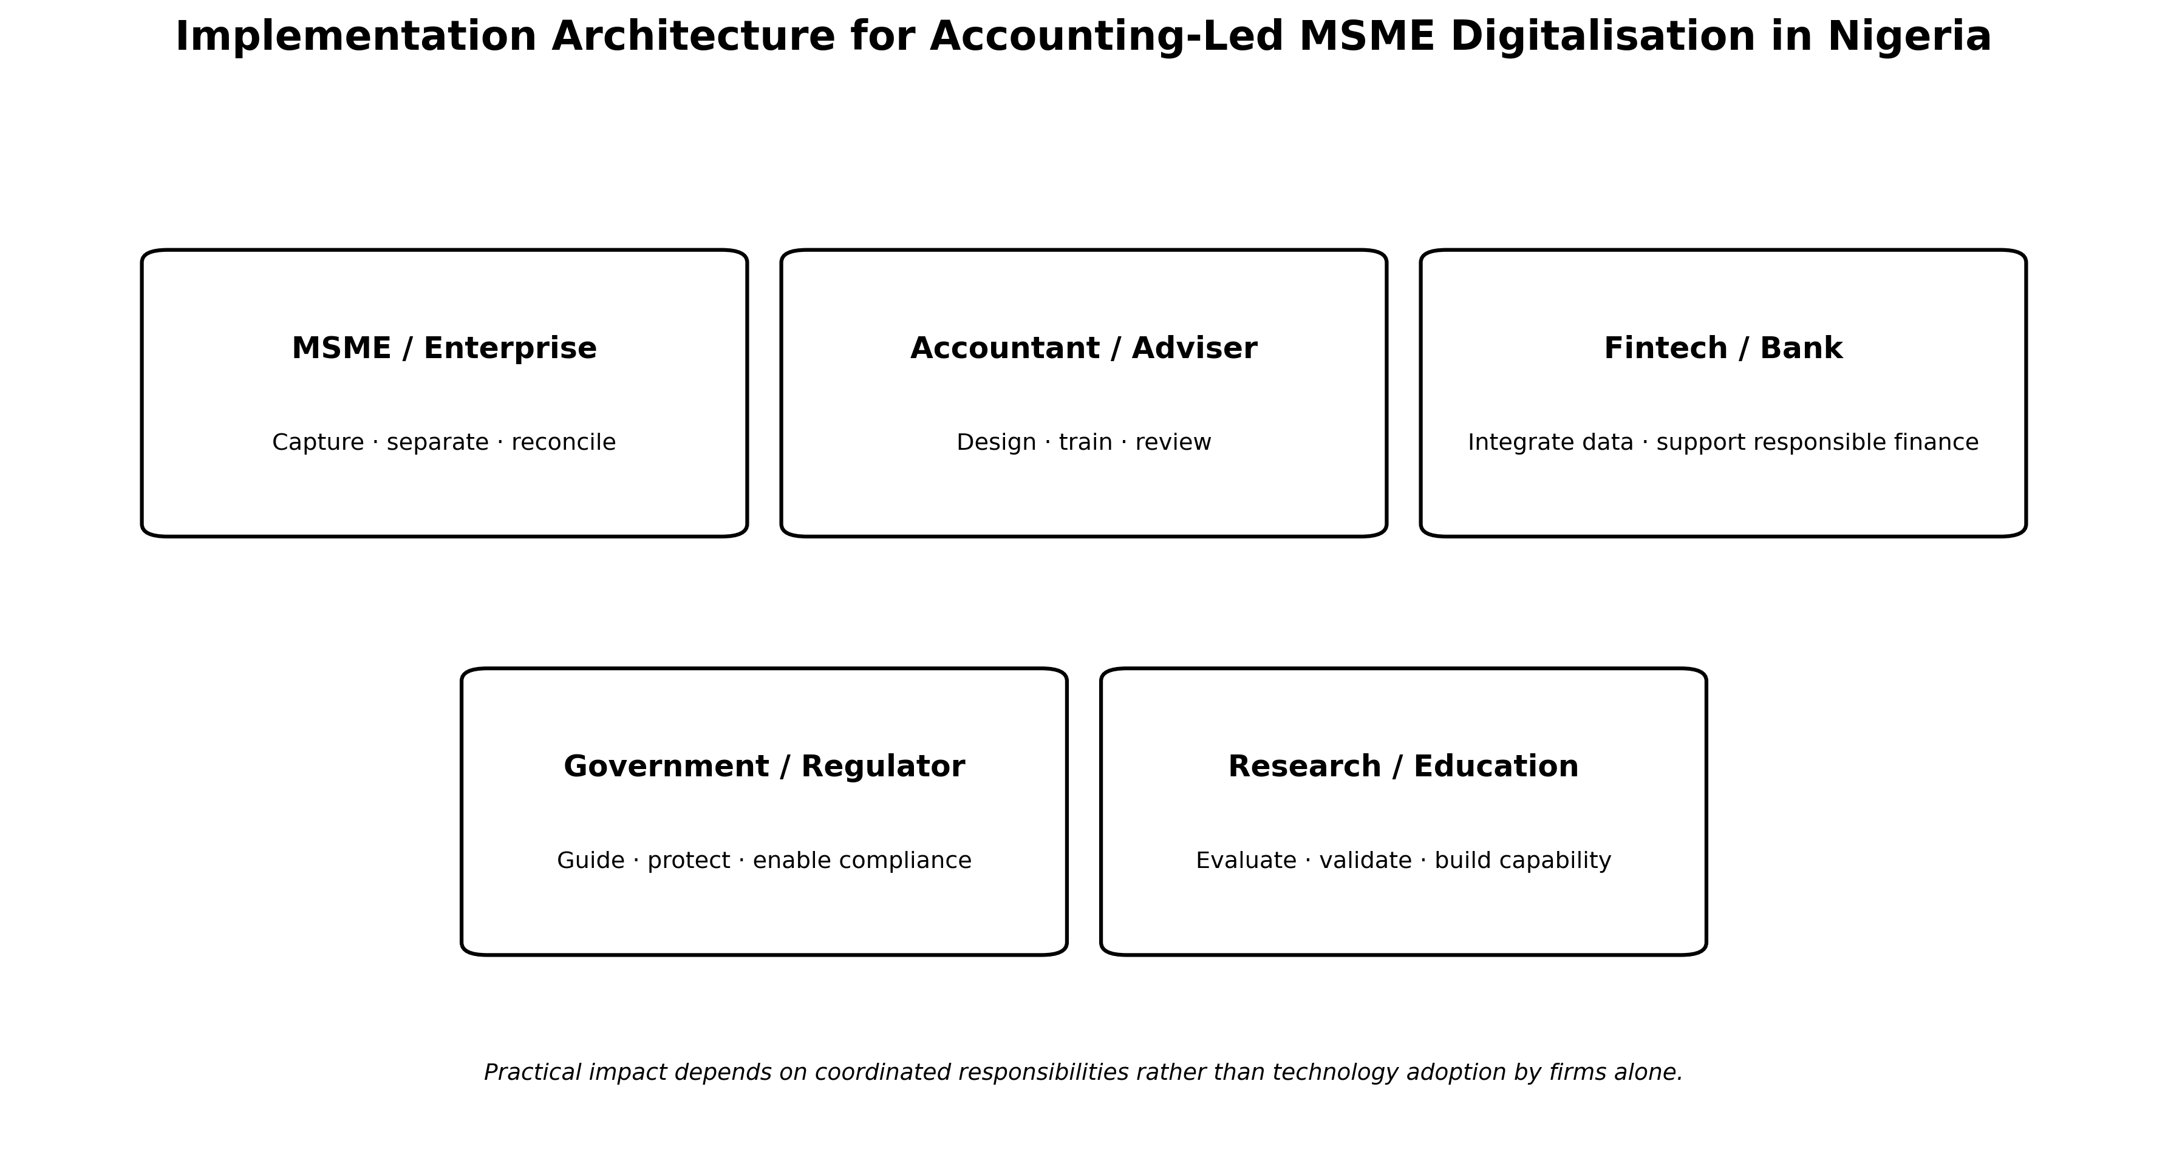
Figure 6. National implementation architecture for accounting-led MSME digitalisation in Nigeria. Original author synthesis integrating enterprise practice, professional support, fintech/banking infrastructure, regulation and research.

13. Conclusion
Nigeria’s MSME digital transition is creating an unprecedented volume of financial data, but the value of that data depends on accounting discipline. The review shows that record keeping, use of accounting information, digital-accounting capability and financial literacy are repeatedly associated with better control and performance across Nigerian studies. Experimental and policy evidence further suggests that small firms adopt digital records more successfully when technology is accompanied by personalized support. At the financial-system level, payment digitisation and alternative data can improve visibility for firms that lack audited statements, an increasingly important capability in a market where formal MSME credit remains scarce.
The practical sequence is therefore record first, reconcile second, digitise third and analyse fourth. Predictive models should come last, after transaction identities, business boundaries and accounting categories are sufficiently reliable. This sequence prevents “data science” from becoming a substitute for accounting and instead makes it an extension of accounting information quality. For Nigeria, the greatest opportunity lies in connecting simple, trusted bookkeeping with payment infrastructure, proportionate reporting, privacy-preserving analytics and professional support so that millions of small firms can convert everyday transaction activity into stronger decisions, more credible financial histories and improved access to responsible finance.

Declarations
Ethics: Not applicable. This article is a critical review and reports no new human-participant or animal research.
Funding: The author declares that no external funding was received specifically for this review article.
Competing interests: The author declares no competing interests.
Data availability: No new primary dataset was generated for this review. National statistics and research evidence are available from the cited sources. The companion empirical article e034 uses a separate field dataset.
Author contribution: Olumeyan Elizabeth Titilayo: conceptualization, literature synthesis, framework development, interpretation, visualization and manuscript authorship.
AI-assisted editorial support: AI-assisted tools were used for literature discovery support, language refinement, document formatting, visualization and consistency checking. They were not used as an author or as a substitute for scholarly judgment. The author and journal editor retain responsibility for source verification, interpretation and final approval.
Copyright and licence: © 2026 Olumeyan Elizabeth Titilayo. Published by CHIATECH JOURNAL · SETEHEM under the Creative Commons Attribution 4.0 International (CC BY 4.0) licence, except for third-party material identified otherwise.

References
Ajape, M. K., Okpala, O. P., & Salawu, M. W. (2024). SMEs’ commitment to sustainability practices in Nigeria: Examining the role of technology-based accounting systems. Lagos Journal of Banking, Finance and Economic Issues, 5(1), 37–47.
Central Bank of Nigeria. (2024). E-payment statistics: Industry data by e-payment channels and others for January to June 2024. Central Bank of Nigeria. https://www.cbn.gov.ng/PaymentsSystem/ePaymentStatistics.html
Ebhota, O. S., Hongxing, Y., & Sampene, A. K. (2024). Investigating the influence of digital transformation, budgeting and budgetary control on the financial performance of SMEs. Scientific African, 26, e02429. https://doi.org/10.1016/j.sciaf.2024.e02429
Enhancing Financial Innovation & Access. (2023). Access to Financial Services in Nigeria 2023 survey. EFInA. https://efina.org.ng/research/
Federal Inland Revenue Service. (n.d.-a). TaxPro MAX. https://taxpromax.firs.gov.ng/
Federal Inland Revenue Service. (n.d.-b). Automated Tax Remittance System (ATRS) / e-Invoice portal. https://atrs.firs.gov.ng/
Financial Reporting Council of Nigeria. (2024). SME business governance guidelines 2024. https://frcnigeria.gov.ng/wp-content/uploads/2025/04/SME-Corporate-Governance-Guidelines-2024.pdf
Garba, A., & Mohammed, I. A. (2026). Digital accounting systems adoption and barriers: Impacts on SME performance and sustainability in Nigeria. Archives of Current Research International, 26(1), 224–234. https://doi.org/10.9734/acri/2026/v26i11717
International Finance Corporation. (2022). Market Bite Nigeria: Innovation offers key to the broader MSME finance market. World Bank Group. https://www.ifc.org/en/insights-reports/2022/market-bite-nigeria-innovation-offers-key-to-the-broader-msme-finance-market
National Bureau of Statistics. (2024). Nigeria Labour Force Survey Q2 2024. NBS. https://www.nigerianstat.gov.ng/elibrary/read/1241594
Nigeria Data Protection Commission. (2023). Nigeria Data Protection Act 2023. https://ndpc.gov.ng/wp-content/uploads/2024/03/Nigeria_Data_Protection_Act_2023.pdf
Okoh, J. I., Amahi, F. U., Agbadua, O. B., Atokpe, M. M., & Nwajei, I. M. (2023). Influence of accounting record keeping and financial literacy on financial performance of SMEs in Abuja Metropolis. African Banking and Finance Review Journal, 3(3), 126–141.
Olajide, M., & Obialo, F.-K. (2020). Effects of record keeping on the growth of small scale enterprises in Abeokuta South Local Government Area, Ogun State, Nigeria. Journal of Economics, Management and Trade, 26(5), 34–43. https://doi.org/10.9734/jemt/2020/v26i530254
Olumeyan, E. T. (2026). Accounting practices, digitalisation and financial-risk analytics among informal small businesses in Gwagwalada, Abuja: An empirical accounting data-science study. CHIATECH JOURNAL · SETEHEM, 1(1), e034. DOI pending registration.
Onwuchekwa, C. A., & Ukpong, O. U. (2023). Accounting records-keeping and utilization by small scale business operators in Rivers State, Nigeria. International Journal of Business and Management Review, 11(6), 1–12. https://doi.org/10.37745/ijbmr.2013/vol11n6112
Oyebanjo, A. (2024). Beyond beneficial information: The impact of additional consulting on digital record adoption and profit measurement. International Growth Centre Working Paper. https://www.theigc.org/publications/beyond-beneficial-information-impact-additional-consulting-digital-record-adoption-and
Oyebanjo, A. (2025). Enhancing initial adoption of digital records and best practices among small firms: Evidence from Nigeria. International Growth Centre Policy Brief. https://www.theigc.org/publications/enhancing-initial-adoption-digital-records-and-best-practices-among-small-firms
PwC Nigeria. (2024). Building resilience: Strategies for MSME success in a changing landscape—PwC MSME Survey 2024. https://www.pwc.com/ng/en/publications/strategies-for-msme-success.html
Sanni, L. A., & Akinrinola, O. O. (2026). Accounting information system and financial performance of SMEs in Lagos State Nigeria. Nigerian Journal of Banking and Financial Issues, 11(2).
Small and Medium Enterprises Development Agency of Nigeria & National Bureau of Statistics. (2021). 2021 MSME survey report. SMEDAN/NBS. https://smedan.gov.ng/wp-content/uploads/2022/03/2021-MSME-Survey-Report_1.pdf
World Bank. (2018). Use of alternative data to enhance credit reporting to enable access to digital financial services by individuals and SMEs operating in the informal economy: Guidance note. World Bank Group. https://documents.worldbank.org/en/publication/documents-reports/documentdetail/099456306092223565
World Bank. (2025). World Bank approves $500 million to expand finance for small businesses in Nigeria. https://www.worldbank.org/en/news/press-release/2025/12/22/world-bank-approves-500-million-to-expand-finance-for-small-businesses-in-nigeria
CHIATECH JOURNAL · SETEHEM · Volume 1, Issue 1 · August 2026 · e036 · Pioneer Publication

