CHIATECH JOURNAL
  - SETEHEM · Volume 1, Issue 1 · Pioneer July/August 2026 · Part 2 · e037
  - PIONEER PUBLICATION · ACCEPTED ARTICLE · EMPIRICAL RESEARCH ARTICLE · EDUCATIONAL MANAGEMENT · SCHOOL SAFETY · CHILD AGENCY · NIGERIA

The Educational Trinity: Home, Child, and School Environment for Secure Learning in Nigeria
Wilfred Ogbu
Department of Educational Management, Faculty of Education, University of Abuja, Abuja, Nigeria
Correspondence: ogbuwilfred212@gmail.com
ARTICLE TYPE  Empirical Research Article | VOLUME / ISSUE  1(1) | ELOCATOR  e037
PUBLICATION  Pioneer July/August · Part 2 | IDENTIFIERS  ISSN: Pending assignment | JOURNAL DOI  Pending registration

Abstract
Background: Safe learning in Nigeria depends on more than school infrastructure; it also depends on the alignment of family safeguarding routines, the school safety climate and the child’s capacity to regulate behaviour, seek help and act safely. Objective: This study examined the educational trinity of home security practices (HSPS), school safety climate (SSCS) and child agency/self-regulation (CASS) in relation to a composite Child Future Readiness Index (CFRI). Methods: The archived study used an explanatory cross-sectional design and multistage sampling of 1,242 Junior Secondary Two students, 1,038 matched parents/guardians and 216 teachers from 54 public schools in Lagos, Kaduna and Anambra States (18 schools per state). Validated scales and school-record indicators were analysed with two-level models and structural equation modelling at α = .05. This journal version reproduces the deposited estimates; no row-level dataset or analysis scripts were available for independent reanalysis. Results: HSPS significantly predicted SSCS (β = .31, SE = .04, 95% CI [.23, .39], p < .001), and SSCS significantly predicted CFRI (β = .27, SE = .05, 95% CI [.17, .37], p < .001). Child agency strengthened both the HSPS→SSCS pathway (interaction β = .08, p = .006) and the SSCS→CFRI pathway (interaction β = .10, p = .004). The reported indirect HSPS→SSCS→CFRI path was β = .08 (95% CI [.05, .12], p < .001), with a direct HSPS→CFRI path of β = .06 (p = .041). Conclusion: The reported evidence supports an integrated educational-management strategy in which home-school safety alignment and child agency are treated as complementary components of secure learning. Because the design is cross-sectional, the indirect path should be interpreted as statistical mediation rather than proof of temporal causation.
Keywords: school safety; home-school partnership; child agency; school climate; future readiness; educational management; Nigeria
Suggested citation: Ogbu, W. (2026). The educational trinity: Home, child, and school environment for secure learning in Nigeria. CHIATECH JOURNAL · SETEHEM, 1(1), e037.

1. Introduction
Nigeria’s school-safety challenge is simultaneously physical, social, administrative and developmental. The Federal Ministry of Education’s National Policy on Safety, Security and Violence-Free Schools places safe and secure learning at the centre of educational provision and adopts a holistic view that includes violence prevention, emergency preparedness, learner protection and coordinated response (Federal Ministry of Education, 2021). Yet policy adoption does not guarantee school-level implementation. UNICEF’s 2024 monitoring of the Minimum Standards for Safe Schools reported an average implementation level of about 42% across the assessed states at the end of 2023 and found that only 37% of schools had early-warning systems for threats. These implementation gaps are consequential because insecurity, weak infrastructure, bullying, psychosocial stress and disrupted attendance can jointly erode learning and well-being (UNICEF, 2024).
National financing and coordination mechanisms have expanded in response. The National Plan on Financing Safe Schools (2023–2026) provides a multiyear architecture for protecting at-risk schools and strengthening prevention and response, while Nigeria’s implementation of the Safe Schools Declaration has increasingly emphasized interagency coordination, school-level protocols and community engagement (Federal Ministry of Finance, Budget and National Planning, 2022; Global Coalition to Protect Education from Attack [GCPEA], 2025). These initiatives are strongest when they connect what happens around the school with what happens inside households and with the child’s own capacity to recognize risk, seek help, self-regulate and participate constructively in school life.
Contemporary research also supports treating school climate as an educational outcome environment rather than a peripheral welfare issue. A meta-analysis of K–12 studies found a positive association between school/classroom climate and academic achievement (Erdem & Kaya, 2024), while recent systematic reviews link supportive school climate with better emotional health, engagement and academic outcomes and call for developmentally responsive school environments, particularly during early adolescence (Podiya et al., 2025; Renick et al., 2025). The World Bank’s RIGHT+ framework similarly frames physical learning environments as resilient, inclusive, green, healthy and teaching-and-learning-conducive systems that require effective implementation, not infrastructure spending alone (World Bank, 2025).
The empirical problem is therefore relational: a child moves daily between home, school and community systems, but research and administration often measure those domains separately. This study addresses that fragmentation by modelling home security practices, school safety climate and child agency together, with child future readiness represented by a composite of engagement, attendance, core-subject proficiency and psychosocial well-being. The contribution is not a claim that a cross-sectional model proves causation; rather, it is an integrated test of whether the deposited data show coherent multilevel associations and indirect statistical pathways consistent with an educational-trinity perspective.

1.1 Purpose, objectives, research questions and hypotheses
The purpose was to determine how home security practices, school safety climate and child agency jointly relate to a secure learning ecology and to child future readiness. The study pursued three objectives: (1) determine the influence of home security practices on school safety climate; (2) examine the relationship between school safety climate and CFRI; and (3) assess whether child agency moderates the home-to-school and school-to-readiness pathways.
RQ1 asked how home security practices relate to the quality of the secure and conducive school learning environment. RQ2 asked how school safety climate relates to CFRI. RQ3 asked how child agency shapes the combined influence of home and school factors on CFRI. The null hypotheses were H01: home security practices do not significantly predict the secure and conducive school learning environment; and H02: school safety climate does not significantly predict CFRI.

2. Conceptual and Evidence Framework
The educational-trinity model integrates three complementary traditions. Bronfenbrenner’s ecological systems theory locates the child within nested and interacting microsystems, with the home-school relationship forming a mesosystem in which consistency, communication and reciprocal expectations can influence development (Bronfenbrenner, 1979). Bandura’s social cognitive theory adds reciprocal determinism among personal, behavioural and environmental factors and provides a rationale for treating self-regulation and safety self-efficacy as active moderators, not merely as outcomes of environmental conditions (Bandura, 1986). Epstein’s school-family-community partnership model provides an administrative bridge by emphasizing structured communication, learning support and shared responsibility across home and school (Epstein, 1995).
Within this model, HSPS represents parental monitoring, digital-safety routines, safe-commute arrangements, supportive socio-emotional conditions and home-study routines. SSCS represents the perceived and operational quality of physical safety, policy enforcement, adult responsiveness, anti-bullying practice and psychosocial support. CASS represents the child’s self-regulation, help-seeking, safety self-efficacy and prosocial peer behaviour. CFRI combines academic engagement, attendance, core-subject proficiency and psychosocial well-being. The model therefore expects home practices to support a safer school experience, the school climate to relate positively to readiness, and child agency to strengthen the translation of environmental support into outcomes.
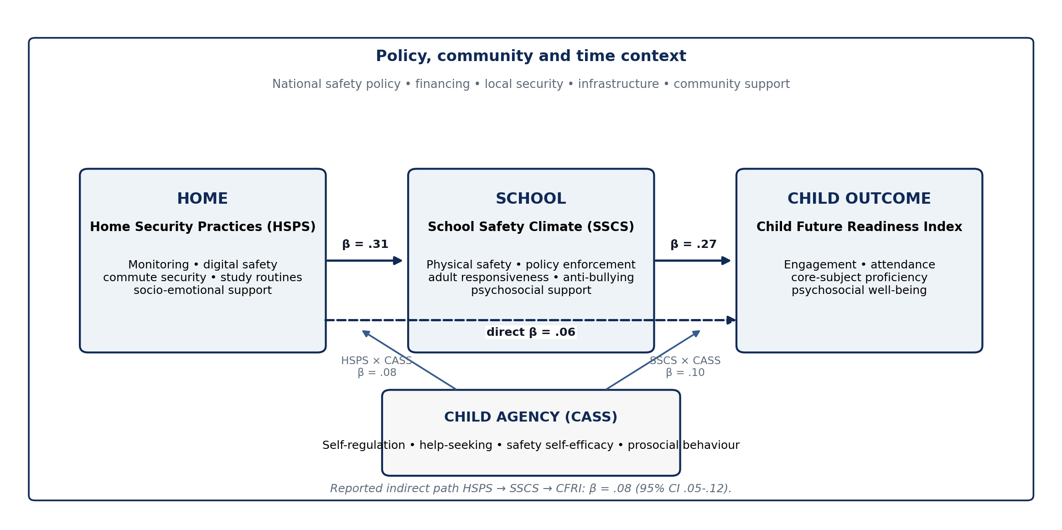
Figure 1. Educational-trinity analytical model with the reported standardized pathways. The broader context reflects ecological, policy and community influences; coefficients are those reported in the archived study.

2.1 Current evidence and the Nigerian policy context
The updated evidence base strengthens, but does not replace, the study’s empirical results. Nigeria’s 2021 national policy requires a comprehensive safety approach, while the 2024 MSSS monitoring report demonstrates a persistent implementation gap between formal commitments and conditions experienced by schools. The 2025 GCPEA case study further documents Nigeria’s efforts to operationalize the Safe Schools Declaration through national coordination, financing and security-sector engagement. Together, these sources support the administrative premise that safety depends on systems that connect school leadership, government, families, security actors and learners rather than on isolated protective measures.
International school-climate evidence is consistent with this logic. Erdem and Kaya’s (2024) meta-analysis found that climate and achievement are meaningfully related, and Podiya et al. (2025) showed that supportive relationships, connectedness and belonging are associated with improved emotional and academic outcomes among adolescents. Renick et al. (2025) emphasize developmental fit: early adolescents benefit when school environments recognize growing needs for autonomy, identity development and emotionally supportive relationships. This is directly relevant to JS2 learners, for whom safety routines are most likely to be effective when they are paired with age-appropriate agency and help-seeking skills.

3. Method

3.1 Research design and setting
The archived study adopted an explanatory cross-sectional design with multilevel and structural-equation components. The analytic population comprised JS2 students, their parents/guardians and teachers in public junior secondary schools in Lagos State (South West), Kaduna State (North West) and Anambra State (South East). The three-state design was intended to reflect contrasting regional, urban/peri-urban and security contexts while retaining a common public-school level and grade.

3.2 Source-record reconciliation and editorial provenance
The archived abstract contains an internal jurisdictional inconsistency: it lists Abuja, Lagos, Kaduna, Adamawa, Katsina and Anambra, whereas the population and sampling sections specify Lagos, Kaduna and Anambra; the sampling total is explicitly 54 schools at 18 schools per state; and the robustness section tests state heterogeneity only across Lagos, Kaduna and Anambra. e037 therefore uses the internally coherent three-state design. No reported sample size, coefficient, confidence interval, p value or reliability estimate has been changed. This correction is editorial reconciliation of the study description, not a new statistical analysis.

3.3 Sampling and participants
Multistage sampling proceeded from purposively selected states to randomly selected local education districts and schools, followed by cluster sampling of intact JS2 classes. The reported final sample comprised 54 public schools (18 per state), 1,242 students, 1,038 parents/guardians matched to participating students and 216 teachers. The archived report states that an a-priori multilevel power analysis assuming a small-to-medium effect (f² = .05), α = .05 and power = .90 indicated a minimum of approximately 1,000 student observations across 50 clusters. The underlying power-analysis software and specification file were not deposited, so this statement is reported as source information rather than independently verified.

3.4 Measures
Table 1. Sample structure and operational measures
Construct / source | Operationalisation | Scale / reported role
Home Security Practices Scale (HSPS) | 12 items covering supervision routines, digital safety, commute security and home study conditions. | 4-point Likert; predictor
School Safety Climate Scale (SSCS) | 16 items covering physical security, policy enforcement, adult support, anti-bullying practice and psychosocial services. | 5-point Likert; mediator/outcome
Child Agency and Self-Regulation Scale (CASS) | 10 items assessing self-regulation, help-seeking, peer prosocial behaviour and safety self-efficacy. | 4-point Likert; moderator
Child Future Readiness Index (CFRI) | Standardised composite of attendance, core-subject average, a 4-item engagement subscale and a 6-item well-being subscale. | z-standardised composite; outcome
Participants | 1,242 students; 1,038 matched parents/guardians; 216 teachers in 54 schools. | Students nested within schools

3.5 Validity and reliability
Content validity was reported as established by five experts in educational administration and guidance/counselling. A pilot involving 180 respondents from two schools per state informed item refinement. Confirmatory factor analysis (CFA) produced fit statistics within conventional acceptable ranges, and internal consistency estimates were above .80 for all reported scales/subscales.
Table 2. Reported measurement-model fit and internal consistency
Measure | CFI | TLI | RMSEA | Cronbach’s α
HSPS | .96 | .95 | .048 | .84
SSCS | .95 | .94 | .051 | .89
CASS | .97 | .96 | .042 | .86
Engagement subscale | — | — | — | .82
Well-being subscale | — | — | — | .81

3.6 Analysis
Descriptive statistics summarized scale distributions. The CFRI intraclass correlation coefficient (ICC) was used to assess school-level clustering. Two-level linear models estimated the HSPS→SSCS and SSCS→CFRI relationships with state fixed effects, robust standard errors and controls for student gender, age, household-assets socioeconomic proxy and school size. Moderation by CASS was tested through interaction terms. A structural equation model estimated the indirect HSPS→SSCS→CFRI path and the remaining direct HSPS→CFRI path. Statistical significance was set at p < .05.

3.7 Reproducibility boundary
The journal version is evidence-preserving rather than re-analytical. The PDF supplied for editorial reconstruction contains the tables and narrative estimates but not the row-level dataset, codebook, missing-data log, model syntax, covariance matrix, CFA/SEM output, cluster identifiers or analysis scripts. Accordingly, coefficients and confidence intervals below are reproduced from the archived source, while the literature and policy interpretation have been updated to August 2026. No new coefficients are generated or presented as independent verification.

4. Results

4.1 Descriptive statistics and clustering
Table 3. Descriptive statistics and school-level clustering
Measure | Mean | SD | Interpretive note
HSPS | 3.11 | 0.52 | 4-point scale
SSCS | 3.74 | 0.49 | 5-point scale
CASS | 3.05 | 0.48 | 4-point scale
CFRI | 0.00 | 1.00 | Standardised composite
CFRI ICC | 0.12 | — | 12% of variance reported at school level

The mean HSPS score was 3.11 (SD = .52), the mean SSCS score was 3.74 (SD = .49), and the mean CASS score was 3.05 (SD = .48). CFRI was standardized to a mean of 0 and SD of 1. The reported ICC of .12 indicates non-trivial clustering of future-readiness outcomes within schools and supports the use of a multilevel framework rather than a single-level analysis that assumes independent student observations.

4.2 RQ1/H01: Home security practices and school safety climate
Home security practices significantly predicted school safety climate after the reported covariate and state adjustments (standardised β = .31, SE = .04, 95% CI [.23, .39], p < .001). H01 was therefore rejected in the archived analysis. Interpreted as an association, a one-standard-deviation increase in HSPS corresponded with an estimated .31-standard-deviation increase in SSCS, holding the specified controls constant.

4.3 RQ2/H02: School safety climate and child future readiness
School safety climate significantly predicted CFRI (standardised β = .27, SE = .05, 95% CI [.17, .37], p < .001), leading to rejection of H02. The effect is compatible with the study’s proposition that students who experience safer, more responsive and more supportive school environments also show stronger combined engagement, attendance, proficiency and psychosocial-readiness indicators.

4.4 RQ3: Child agency, moderation and the indirect pathway
Table 4. Reported hypothesis, moderation and indirect-path estimates
Model path / effect | β | SE | 95% CI | p | Interpretation
HSPS → SSCS | .31 | .04 | [.23, .39] | < .001 | H01 rejected
SSCS → CFRI | .27 | .05 | [.17, .37] | < .001 | H02 rejected
HSPS × CASS → SSCS | .08 | .03 | [.02, .14] | .006 | Agency strengthened home→school association
SSCS × CASS → CFRI | .10 | .04 | [.02, .18] | .004 | Agency strengthened school→readiness association
Indirect HSPS → SSCS → CFRI | .08 | — | [.05, .12] | < .001 | Significant statistical indirect path
Direct HSPS → CFRI | .06 | — | — | .041 | Residual direct association
Total HSPS → CFRI | .14 | — | — | < .001 | Reported total association

Both interaction terms were positive and statistically significant. Higher CASS scores strengthened the reported association between HSPS and SSCS (β = .08, SE = .03, p = .006) and the association between SSCS and CFRI (β = .10, SE = .04, p = .004). In practical terms, the environmental supports represented by home and school factors were more strongly associated with outcomes at higher levels of student self-regulation, help-seeking and safety self-efficacy.
The SEM reported an indirect HSPS→SSCS→CFRI effect of β = .08 (95% CI [.05, .12], p < .001), a direct HSPS→CFRI effect of β = .06 (p = .041) and a total HSPS→CFRI effect of β = .14 (p < .001). The source described this pattern as partial mediation. Because exposure, mediator and outcome were measured within a cross-sectional design, e037 uses the more cautious term significant statistical indirect pathway; temporal mediation would require longitudinal or experimental evidence.
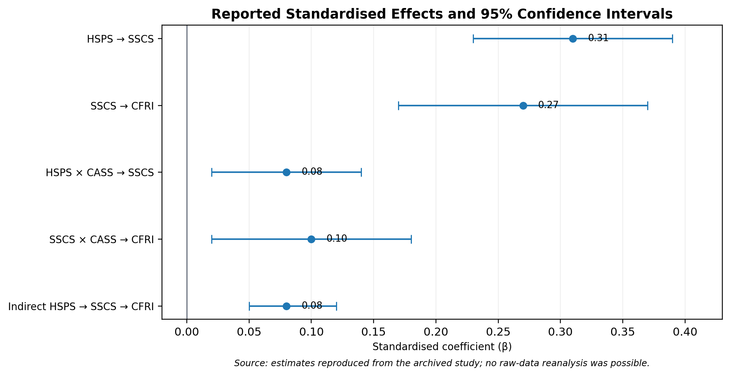
Figure 2. Reported standardized coefficients and 95% confidence intervals for effects for which the archived paper provided intervals. Error bars reproduce the deposited estimates; they are not independently re-estimated.

4.5 Robustness and state-sensitivity checks
Table 5. Reported robustness and sensitivity checks
Check | Archived result | Interpretation
State heterogeneity | Three-way interactions with state were not significant. | No evidence in the reported model that the focal effects differed across Lagos, Kaduna and Anambra.
Alternative CFRI weighting | Substantively similar coefficients and significance. | Main conclusions were reported as insensitive to reasonable alternative weighting.
Cluster-robust vs model-based SEs | Inferences unchanged. | Reported statistical conclusions did not depend on the standard-error option.

These checks strengthen internal consistency of the reported pattern but should not be read as external replication. The absence of significant state interactions may reflect genuine stability, limited power for higher-order interaction tests, or both. Similarly, alternative CFRI weightings address one specification choice but do not substitute for validation of the index in additional cohorts.

5. Discussion

5.1 Home security practices as a mesosystem resource
The strongest single reported coefficient in the focal model was the HSPS→SSCS association (β = .31). The finding is theoretically coherent with ecological systems theory because the child’s school experience is partly conditioned by routines and expectations carried across the home-school boundary. Monitoring, safe travel planning, digital-safety rules and socio-emotional support may increase the consistency of safety expectations, improve communication around incidents and make children more willing to report risks. In administrative terms, home security practices are not a substitute for school responsibility; they are a mesosystem resource that can reinforce or weaken the school’s own safety structures.
This interpretation fits Nigeria’s policy architecture. The national policy and Safe Schools implementation mechanisms emphasize coordinated action among schools, families, communities and public agencies (Federal Ministry of Education, 2021; GCPEA, 2025). It also explains why isolated parent-awareness campaigns are unlikely to be enough. The relevant unit is a routine: what parents monitor, how commute risks are handled, which channels are used to report concerns, how schools respond, and whether the child sees the same expectations across settings.

5.2 School safety climate and future readiness
The SSCS→CFRI coefficient (β = .27) is consistent with the wider school-climate literature. School climate is not only the absence of attack; it includes belonging, adult responsiveness, fair and predictable rules, peer relations, psychosocial support and a physical environment that permits learning. Erdem and Kaya (2024) synthesize evidence linking school/classroom climate with achievement, while Podiya et al. (2025) identify supportive relationships, connectedness and belonging as correlates of emotional health and academic performance. The RIGHT+ framework adds an infrastructure perspective by emphasizing resilient, inclusive, healthy and learning-conducive facilities (World Bank, 2025).
The CFRI construction is therefore conceptually defensible as a broad readiness outcome because school safety can plausibly touch attendance, engagement, proficiency and well-being simultaneously. However, the composite also hides heterogeneity: a child may attend regularly while experiencing poor well-being, or may perform well academically despite weak belonging. Future work should report both the composite and its component outcomes so that administrators can see which dimension of readiness changes most strongly.

5.3 Child agency as a protective amplifier
The moderation results are important because they position children as active participants in safety rather than passive recipients of adult protection. Agency in this study includes self-regulation, help-seeking, safety self-efficacy and prosocial behaviour. The positive interactions indicate that favourable home and school conditions were more strongly associated with safety/readiness when agency was higher. This is compatible with social cognitive theory and with recent developmentally informed school-climate research emphasizing autonomy, supportive relationships and age-appropriate participation (Bandura, 1986; Renick et al., 2025).
The policy implication is not to shift responsibility for safety onto children. Rather, agency-building should give learners usable skills within accountable adult systems: recognizing unsafe situations, knowing whom to contact, reporting without fear of retaliation, regulating behaviour under stress, supporting peers appropriately and understanding digital and physical safety rules. Agency becomes protective when adults are responsive; help-seeking in an unresponsive system can otherwise expose the child to frustration or additional risk.

5.4 From statistical indirect path to administrative coordination
The significant HSPS→SSCS→CFRI indirect path gives the educational-trinity model its clearest integrative signal. The finding is compatible with a sequence in which stronger home practices support a stronger school-safety experience, which in turn relates to readiness. Yet cross-sectional mediation cannot establish that this sequence unfolded over time. A defensible administrative reading is therefore: the three domains are statistically connected in a pattern consistent with coordinated influence, and this pattern merits longitudinal testing and programmatic implementation rather than causal certainty.

6. Implementation Framework and Recommendations
Implementation should convert the statistical model into routines that can be audited at home, school and system levels. The recommendations below retain the source paper’s practical emphasis while aligning it with the 2021 national policy, 2024 MSSS monitoring evidence and subsequent Safe Schools implementation guidance.
• Parents and guardians should receive structured safety-literacy support covering commute planning, digital safety, emergency contacts, socio-emotional support and home-study routines, with simple multilingual checklists rather than one-off sensitization events.
• Schools should institutionalize whole-school safety systems: visible safeguarding focal persons, incident-reporting procedures, early-warning mechanisms, regular drills, anti-bullying protocols, psychosocial referral pathways and routine review by the School-Based Management Committee.
• Child-agency instruction should be embedded in age-appropriate curricular and co-curricular activities, including self-regulation, help-seeking, peer support, digital citizenship, safe disclosure and practical scenario exercises.
• Home-school communication should use low-friction channels suited to local conditions—SMS/USSD, phone trees, parent meetings and written safety notices—with explicit escalation routes for urgent incidents.
• School Improvement Plans should include measurable safety and belonging indicators, not only infrastructure inputs. Examples include early-warning coverage, response time, learner knowledge of reporting channels, drill completion, bullying reports resolved and access to psychosocial support.
• State and federal implementation of the National Plan on Financing Safe Schools should connect expenditure tracking to school-level MSSS indicators so that financing can be linked to observable preparedness, infrastructure and response capacity.
• Researchers and education authorities should prioritize longitudinal school panels and implementation trials that measure home practices, school climate, agency and separate CFRI components at multiple time points.
Table 6. Educational-trinity implementation matrix
Level | Minimum action set | Suggested monitoring evidence
Home | Monitoring routine; safe commute plan; digital-use rules; emotional check-in; school contact protocol. | Parent checklist completion; contact accuracy; reported use of routines.
Child | Help-seeking map; self-regulation practice; peer-support norms; digital/physical safety scenarios. | Student knowledge checks; help-seeking confidence; participation records.
School | MSSS-based risk audit; focal person; incident reporting; drills; anti-bullying and psychosocial referral. | Early-warning coverage; drill logs; incident response time; referral completion; climate survey.
System / community | Safe-school financing; interagency coordination; high-risk corridor support; public accountability. | Budget releases; MSSS implementation score; response-centre records; school-level expenditure trace.

7. Limitations, Integrity Notes and Research Priorities
First, the cross-sectional design limits causal and temporal inference. The direct, moderation and indirect-path estimates should be interpreted as adjusted associations within the reported model. Second, several constructs rely on self-report and may share method variance, although CFRI also includes school-record indicators. Third, the study covers three states and public JS2 schools; generalization to the North East, North Central, private schools, primary schools or senior secondary schools requires additional evidence. Fourth, the archived source does not provide item-level missingness, non-response analysis, measurement invariance by state or gender, or detailed SEM diagnostics beyond the reported CFA fit statistics and focal paths.
Fifth, replication materials were not included in the supplied archive. Independent verification would require the de-identified data, codebook, scoring rules, matching logic for parent/student records, model syntax, software/version information and a reproducible analysis script. Sixth, the source does not report an institutional ethics committee, approval identifier, consent/assent procedures or safeguarding protocol, despite involving minors and linked parent/teacher data. e037 does not invent those details. Any final archival record should preserve the author’s ethics documentation in accordance with journal policy and applicable institutional requirements.
The next research step is a longitudinal design in which HSPS, SSCS and CASS are measured at baseline, CFRI components are followed over time, and intervention schools receive a clearly specified home-school-child safety package. Such a design could test whether changes in home routines precede changes in school climate and whether gains in agency modify the trajectory of attendance, engagement, attainment and well-being.

8. Conclusion
The Educational Trinity reframes secure learning as coordinated educational management rather than a single-site security problem. In the reported three-state sample, stronger home security practices were associated with stronger school safety climate; stronger school safety climate was associated with higher child future readiness; and child agency strengthened both pathways. The significant indirect path further supports an integrated home-school-child model, although the cross-sectional design does not establish causal mediation.
For practice, the message is specific: improve the school environment, strengthen the routines that connect home and school, and teach children how to use protective systems safely and confidently. Nigeria already has a policy, financing and minimum-standards architecture for safe schools; the central implementation task is to make those systems visible and functional at school and household level. For research, the priority is equally clear: preserve the reported empirical pattern, publish the data and code needed for independent replication, and test the trinity longitudinally.

Declarations
Ethics and consent: The archived source reports human-participant data from minors, parents/guardians and teachers but does not state an ethics committee, approval number, assent/consent procedure or safeguarding protocol. This journal version makes no unsupported claim of ethics approval. The author remains responsible for supplying the journal with the relevant documentation where required.
Funding: No specific external funding is reported in the archived source for this study.
Competing interests: The author declares no competing interests.
Data availability: The row-level dataset, codebook and analysis scripts were not included with the supplied Zenodo/PDF source used for this editorial reconstruction. e037 therefore reproduces the deposited statistical estimates and does not claim independent reanalysis. Replication materials may be requested from the author.
Author contribution: Wilfred Ogbu: conceptualization, study design, investigation, interpretation and original manuscript authorship, as represented in the archived source. The journal revision reorganizes and updates presentation without altering reported coefficients.
Prior version and provenance: A prior version is archived as Ogbu (2025), Zenodo record 17845930, DOI 10.5281/zenodo.17845930. e037 corrects the source’s abstract-level jurisdiction list to the three-state design consistently described by the methods, sampling allocation and state-sensitivity analysis: Lagos, Kaduna and Anambra. No numerical result was altered.
AI-assisted editorial support: AI-assisted tools were used for literature discovery support, language refinement, document formatting, visualization and consistency checking. They were not used as an author or as a substitute for scholarly judgment. The author and journal editor retain responsibility for source verification, interpretation and final approval.
Copyright and licence: © 2026 Wilfred Ogbu. Published by CHIATECH JOURNAL · SETEHEM under the Creative Commons Attribution 4.0 International (CC BY 4.0) licence, except for third-party material identified otherwise.

References
Bandura, A. (1986). Social foundations of thought and action: A social cognitive theory. Prentice-Hall.
Bronfenbrenner, U. (1979). The ecology of human development: Experiments by nature and design. Harvard University Press.
Cohen, J., McCabe, L., Michelli, N. M., & Pickeral, T. (2009). School climate: Research, policy, practice, and teacher education. Teachers College Record, 111(1), 180–213.
Epstein, J. L. (1995). School/family/community partnerships: Caring for the children we share. Phi Delta Kappan, 76(9), 701–712.
Erdem, C., & Kaya, M. (2024). The relationship between school and classroom climate, and academic achievement: A meta-analysis. School Psychology International, 45(4), 380–408. https://doi.org/10.1177/01430343231202923
Federal Ministry of Education. (2021). National policy on safety, security and violence-free schools in Nigeria with implementing guidelines. https://education.gov.ng/wp-content/uploads/2021/09/National-Policy-on-SSVFSN.pdf
Federal Ministry of Finance, Budget and National Planning. (2022). National plan on financing safe schools (2023–2026). https://protectingeducation.org/wp-content/uploads/Nigieria_National-Plan-on-Financing-Safe-Schools_SPREAD.pdf
Global Coalition to Protect Education from Attack. (2025). Nigeria: A case study on implementing the Safe Schools Declaration. https://protectingeducation.org/publication/nigeria-a-case-study-on-implementing-the-safe-schools-declaration/
Ogbu, W. (2025). The educational trinity: Home, child, and school environment for secure learning in Nigeria. Zenodo. https://doi.org/10.5281/zenodo.17845930
Podiya, J. K., Navaneetham, J., & Bhola, P. (2025). Influences of school climate on emotional health and academic achievement of school-going adolescents in India: A systematic review. BMC Public Health, 25, 54. https://doi.org/10.1186/s12889-024-21268-0
Renick, J., Reich, S. M., & Phan, H. K. (2025). Towards developmentally informed school climate research. Contemporary School Psychology, 29, 695–714. https://doi.org/10.1007/s40688-025-00565-4
UNICEF. (2024). Minimum Standards for Safe Schools in Nigeria: Monitoring report, July–December 2023. UNICEF Nigeria. https://www.unicef.org/nigeria/reports/minimum-standards-safe-schools-nigeria
World Bank. (2025). RIGHT+ framework for physical learning environments: Maximizing investment impact in education spaces and facilities. World Bank. https://www.worldbank.org/en/topic/education/publication/right-framework-physical-learning-environments
CHIATECH JOURNAL · SETEHEM · Volume 1, Issue 1 · Pioneer July/August 2026 · Part 2 · e037 · Pioneer Publication

