CHIATECH JOURNAL
  - SETEHEM · VOLUME 1 · ISSUE 2 · AUGUST 2026 · e039
  - PIONEER PUBLICATION · ACCEPTED ARTICLE · ORIGINAL RESEARCH ARTICLE · TEXTILES · CIRCULAR ECONOMY · FAMILY ECONOMICS · SUSTAINABLE LIVELIHOODS · NIGERIA

Textile Upcycling, Family Empowerment and Circular Livelihoods in Jos North, Nigeria: Empirical Evidence from 100 Upcycling Households
Akila, L. K.¹* · Agbo, D. A.²
¹ Department of Home and Rural Economics, Plateau State College of Agriculture, Garkawa, Plateau State, Nigeria.
² Department of Home Science and Management, Joseph Sarwuan Tarka University, Makurdi, Benue State, Nigeria.
*Corresponding author: lydiaakila1@gmail.com · Co-author: drdianadagbo@gmail.com
ARTICLE TYPE  Original Research Article | VOLUME / ISSUE  1(1) | ELOCATOR  e039
PUBLICATION  Pioneer Issue · August 2026 | ISSN  Pending assignment | DOI  Pending registration

Abstract
Background: Textile upcycling converts discarded or surplus fabrics into products of renewed or higher use value and can link household livelihood strategies with circular-economy objectives. Objective: This study examined upcycling participation, family empowerment, income effects, environmental benefits and practical constraints among families engaged in textile upcycling in Jos North, Plateau State, Nigeria. Methods: A cross-sectional survey was conducted among 100 families purposefully selected from a field-identified population of 312 families involved in upcycling activities around Katako, Terminus and adjoining Jos North communities. Data were collected in person with the Upcycling and Family Empowerment Questionnaire and analysed with percentages, descriptive comparison, Pearson correlation and an independent-samples t-test. Results: Participation increased from low (20%) to medium (50%) and high (80%) levels alongside progressively more complex activities, from scrap use and stuffing to garment transformation, household products and recovery of buttons, zippers and trims. Reported family-income increases were +10%, +25% and +50% across the low, medium and high participation levels, respectively. The principal barriers were lack of tools/equipment (30%), insufficient training/skills (20%) and limited market access (15%). Upcycling participation was strongly associated with family empowerment (r=.75, p<.01; derived 95% CI .65-.82). The environmental hypothesis was also supported (t=2.56, p<.05), indicating greater waste reduction/resource recovery among more active upcycling families. Conclusion: In Jos North, textile upcycling operates simultaneously as a material-circulation practice and a household livelihood strategy. Its expansion, however, depends on skills, equipment, product-quality development, market access and supportive circular-economy institutions. The evidence supports integrating household upcycling into vocational training, microenterprise support and locally grounded textile-waste strategies while avoiding causal claims that exceed the cross-sectional design.
Keywords: textile upcycling; circular economy; family empowerment; household livelihoods; textile waste; sustainable fashion; resource recovery; Jos North; Plateau State; Nigeria
Suggested citation: Akila, L. K., & Agbo, D. A. (2026). Textile upcycling, family empowerment and circular livelihoods in Jos North, Nigeria: Empirical evidence from 100 upcycling households. CHIATECH JOURNAL · SETEHEM, 1(1), e038. ISSN pending assignment; DOI pending registration.

1. Introduction
Textile waste sits at the intersection of environmental pressure, consumption patterns, livelihood insecurity and design opportunity. The United Nations Environment Programme reports that the textile sector produces about 2-8% of global greenhouse-gas emissions, consumes approximately 215 trillion litres of water annually and contributes materially to microplastic pollution (UNEP, 2025). At the same time, the dominant take-make-discard model continues to lose material value through short product lifetimes and poorly developed recovery systems. Circular-economy approaches respond by keeping products and materials in use at their highest practical value through reuse, repair, redesign, remanufacture and recycling (Ellen MacArthur Foundation, 2024; De Felice et al., 2025).
Upcycling occupies a distinctive position within this hierarchy. Unlike downcycling, which may reduce material quality, upcycling deliberately transforms discarded textiles into products with renewed functional, aesthetic or economic value. It can involve repair, redesign, patchwork, garment transformation, accessories, household textiles and the recovery of usable components. These practices can reduce demand for virgin materials and avoided production can generate environmental benefit, although the magnitude of that benefit depends on what new production is actually displaced (Sandin & Peters, 2018). Upcycling is therefore both a materials strategy and a form of skilled making.
The livelihood dimension is especially important in Nigeria. Household enterprises, tailors, artisans and informal microbusinesses operate close to local material flows and can convert fabric scraps and post-consumer garments into saleable goods. Recent Nigerian evidence shows that the potential is substantial but underused. Bashorun et al. (2025), studying 225 registered fashion designers in Lagos and Oyo States, reported 37,899.16 kg of fabric scraps generated annually and identified significant untapped value-creation potential. Okeke (2025) likewise argues that reuse, repair, recycling and upcycling can reduce textile waste while generating income and employment. These findings make household-level evidence from Jos important because circularity depends not only on industrial infrastructure but also on the capabilities, incentives and constraints of families and microenterprises.

1.1 Research problem and contribution
Much sustainable-fashion research emphasizes environmental impacts, consumer attitudes or industrial recycling. Less attention is given to the household as a site where waste recovery, skill acquisition, family cooperation and income generation occur together. In Jos North, second-hand markets, tailoring activities and informal workshops create conditions in which discarded garments and scraps can circulate into new uses. Yet the extent to which participation is associated with family empowerment, income and perceived resource recovery—and the barriers that prevent households from scaling the practice—requires empirical documentation.
This study contributes place-specific evidence from 100 upcycling families. It examines the activity ladder from basic scrap use to garment and household-product transformation, quantifies the reported income progression, identifies operational constraints and tests the association between upcycling participation and family empowerment. The paper further situates the field findings within updated Nigerian and international circular-textile scholarship through August 2026.

2. Conceptual and Empirical Background

2.1 Circular economy, material value and textile waste
Circular-economy theory seeks to narrow, slow and close material loops. For textiles, this means preventing unnecessary waste, extending garment life, preserving fibre and component value and designing business systems that reward reuse and repair. Recent systematic reviews show that circular practices can reduce environmental burdens and support innovation, but implementation remains constrained by collection systems, consumer demand, technology, infrastructure and policy (Saha et al., 2024; De Felice et al., 2025). The Ellen MacArthur Foundation (2024) identifies Extended Producer Responsibility as an important policy mechanism for financing collection and sorting, while its 2026 business statement emphasizes the need for policies that allow resale and repair business models to scale.
For African economies, circular fashion has an additional development dimension. Local designers, tailors and entrepreneurs already possess repair, alteration and creative-remanufacturing skills that can support job creation and material circulation (Ellen MacArthur Foundation, 2021). Nigeria-specific scholarship increasingly frames upcycling and waste-to-value enterprise as a route to resource efficiency, entrepreneurship and environmental improvement (Okeke, 2025; Bashorun et al., 2025; Solaja et al., 2025).

2.2 Family empowerment and sustainable livelihoods
Family empowerment is treated in this study as increased capacity to act, earn, create, cooperate and make livelihood decisions. Upcycling can contribute through at least four mechanisms: acquisition of practical production skills; reduction of household expenditure by extending material life; creation of saleable products and microenterprise income; and strengthened social participation through shared family or community activity. Upcycling research also shows that the practice can produce forms of agency and valuation that are not reducible to profit alone: makers develop identity, material knowledge and ethical attachment through the act of transforming discarded materials (Painter et al., 2025).
The economic opportunity is nevertheless conditional. Households need tools, product-design and finishing skills, access to suitable waste streams, customer acceptance, working capital and routes to market. Evidence from Nigerian SMEs more broadly shows that lack of finance, technical skills, awareness, infrastructure and policy support constrains circular-economy adoption (Adesua-Lincoln, 2025). Thus, empowerment outcomes should be understood as emerging from the interaction between household capability and the local enabling environment.
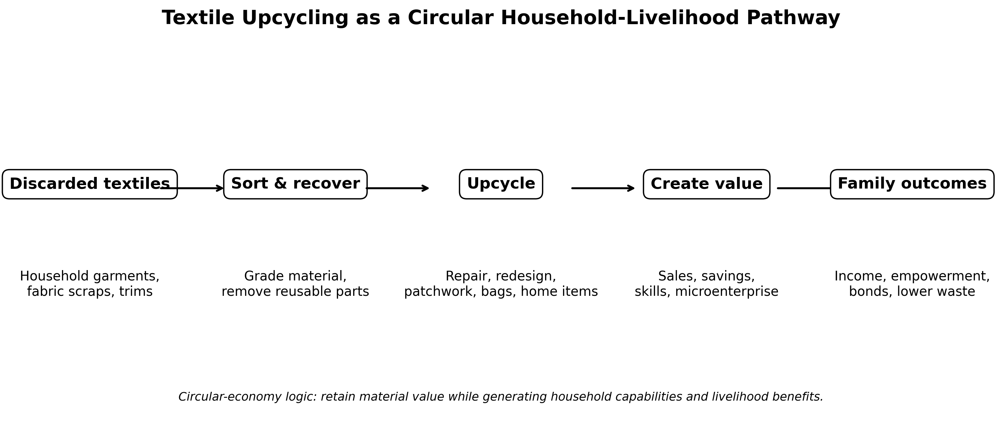
Figure 1. Textile upcycling as a circular household-livelihood pathway. Author synthesis informed by circular-economy and upcycling literature (Sandin & Peters, 2018; Ellen MacArthur Foundation, 2024; Painter et al., 2025).

2.3 Study objectives, questions and hypotheses
The study pursued three objectives: (1) to assess fabric-waste upcycling activities associated with sustainable development and family empowerment in Jos North; (2) to examine the social, economic and environmental effects of upcycling on participating families; and (3) to determine the obstacles confronting family-based textile upcycling.
Correspondingly, the research questions asked what upcycling activities families undertake, what social/economic/environmental effects are reported, and what barriers constrain household participation. Two null hypotheses were tested: H01—upcycling participation is not significantly associated with family empowerment; H02—upcycling participation does not have a significant positive environmental effect through textile-waste reduction and resource recovery.

3. Methodology

3.1 Design and study area
A cross-sectional survey design was used. The study was conducted in Jos North, Plateau State, Nigeria, with field attention to Katako and Terminus markets and adjoining settlements including Tudun Wada and Kabong. These locations support second-hand trade, tailoring and small-scale upcycling activities and therefore provide an appropriate setting for examining household conversion of discarded textiles into useful products.

3.2 Population, sample and sampling
The field population comprised 312 families identified as having participated in upcycling activities or programmes in Jos North. A sample of 100 willing families was selected using a purposive non-probability approach centred on active upcycling locations. The design intentionally prioritised households with relevant experience; consequently, the results describe participating families and should not be generalized statistically to all households in Jos North.

3.3 Instrument and variables
Data were collected in person using the Upcycling and Family Empowerment Questionnaire. The instrument covered level of participation, examples of textile-waste conversion, perceived family empowerment, income effects, social outcomes, environmental/resource-recovery effects and operational constraints. Upcycling participation was represented at low (20%), medium (50%) and high (80%) levels in the field instrument. The study did not estimate item-level reliability coefficients; interpretation therefore focuses on the reported construct associations, descriptive response patterns and the inferential tests specified for the study.

3.4 Statistical analysis and ethical safeguards
Percentages and descriptive comparisons were used for participation, income, social/environmental outcomes and barriers. Pearson correlation tested the relationship between upcycling participation and family empowerment. The reported environmental hypothesis was evaluated with an independent-samples t-test. For the correlation, a 95% confidence interval was additionally derived using Fisher's z transformation. Statistical significance was interpreted at conventional thresholds of p<.05 and p<.01. Participants were informed about the purpose of the study, participation was voluntary, withdrawal was permitted and survey information was treated confidentially.

4. Results

4.1 Upcycling participation and activity profile
Participation displayed a clear activity progression. At the low level (20%), households engaged mainly in basic scrap utilization such as quilting, patchwork and stuffing. Medium participation (50%) involved more deliberate product transformation, including conversion of shirts to skirts and production of tote bags from scraps. High participation (80%) extended to household textiles such as pillowcases and table runners and to systematic disassembly of garments for reusable buttons, zippers and trims. The pattern suggests that deeper participation is associated with increasing technical complexity and more complete recovery of material value.
Table 1. Upcycling activity profile by participation level
Participation level | Representative activities | Circular-value interpretation
Low (20%) | Cutting scraps for quilting/patchwork; stuffing | Basic diversion of small textile remnants from disposal
Medium (50%) | Garment transformation (e.g., shirts to skirts); tote bags from scraps | Functional redesign and creation of saleable/useful products
High (80%) | Pillowcases, table runners; disassembly for buttons, zippers and trims | Broader product portfolio and systematic component recovery

4.2 Economic, social and environmental effects
Reported income benefits increased with participation intensity. Low-participation families reported a 10% rise in family income, medium-participation families 25%, and high-participation families 50%. Social effects also deepened: medium participation was associated with achievement and skill development, while high participation was linked with stronger family bonds and potential community entrepreneurship. Environmental effects progressed from moderate to significant and then substantial waste reduction/resource conservation.
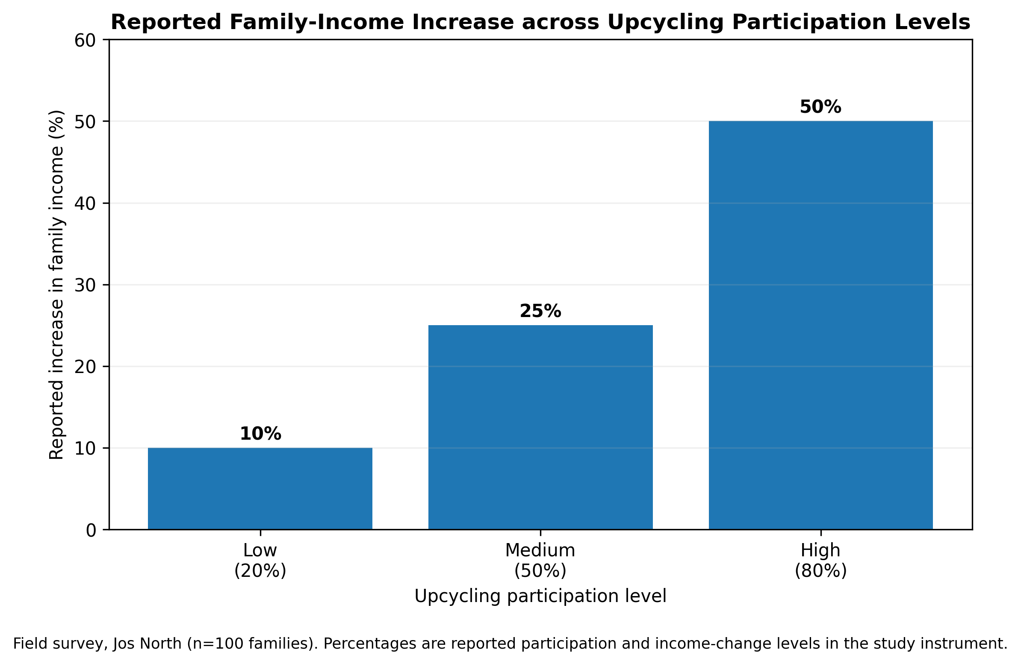
Figure 2. Reported increase in family income across upcycling participation levels. Field survey, Jos North (n=100 families).
Table 2. Reported family effects across participation levels
Participation | Income change | Social effect | Environmental/resource effect
Low (20%) | +10% | Limited/early-stage social effect | Moderate reduction in waste
Medium (50%) | +25% | Achievement and skill development | Significant reduction in waste
High (80%) | +50% | Stronger family bonds; potential community entrepreneurship | Substantial waste reduction and resource conservation

4.3 Constraints to upcycling
The most frequently reported constraint was lack of access to tools and equipment (30%). Insufficient training and skills affected 20% of families, while 15% identified limited market access for upcycled products. These constraints are complementary rather than independent: limited tools restrict product quality and scale; skills gaps limit design innovation and finishing; and weak market channels reduce the return to household effort.
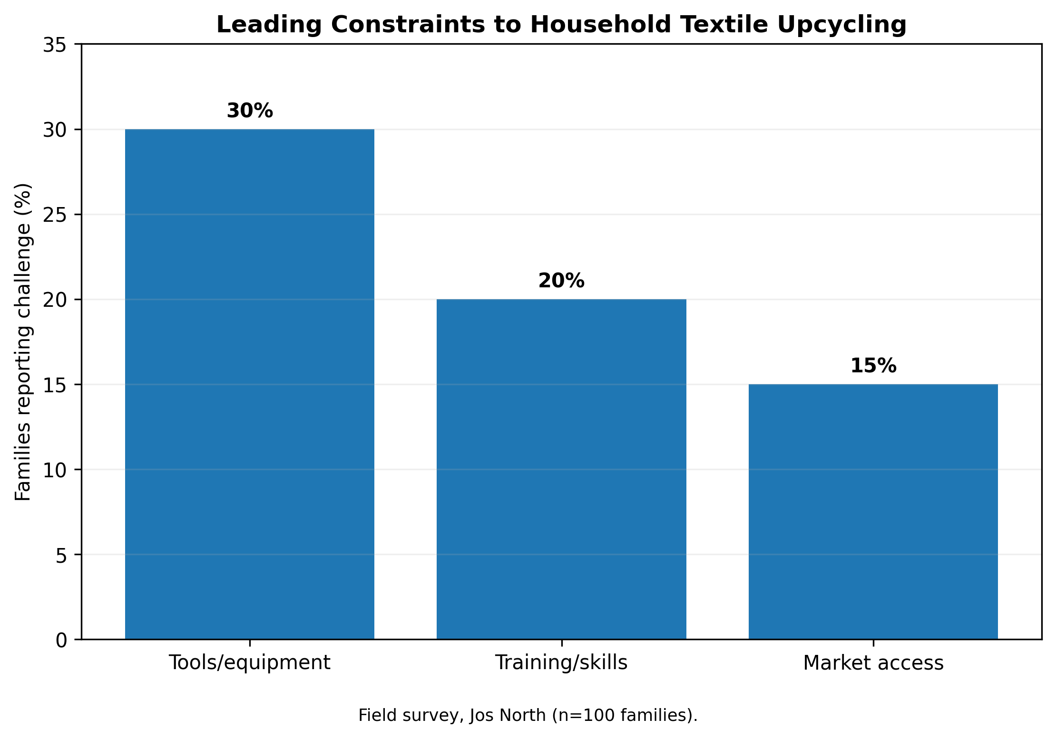
Figure 3. Leading constraints reported by families engaged in textile upcycling in Jos North. Field survey (n=100).

4.4 Hypothesis tests
Upcycling participation was strongly and positively related to family empowerment (r=.75, p<.01). With n=100, the Fisher-z-derived 95% confidence interval is approximately .65-.82. The coefficient corresponds to about 56.3% shared variance (r²=.5625), indicating a substantial association while not establishing causation. H01 was therefore rejected.
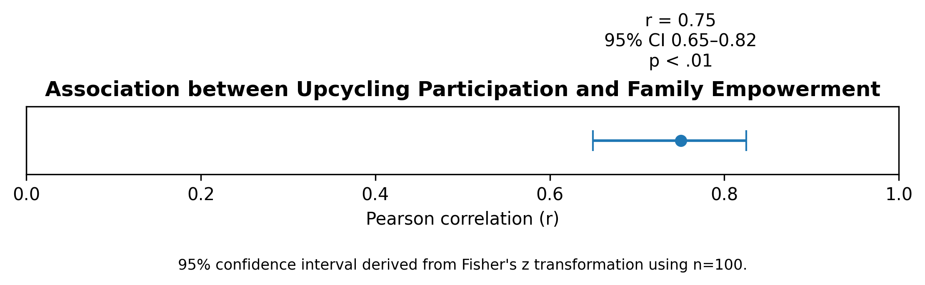
Figure 4. Relationship between upcycling participation and family empowerment. The confidence interval was derived from the reported r=.75 using n=100.
The environmental hypothesis was also rejected: the reported independent-samples t-test was t=2.56, p<.05, supporting a statistically significant difference in environmental/resource-recovery outcomes associated with higher participation. Degrees of freedom and group-specific means/standard deviations were not estimated in the study output, so a standardized mean-difference effect size is not reported.
Table 3. Summary of inferential findings
Hypothesis | Statistic | Decision | Interpretation
H01: no association between participation and family empowerment | r=.75, p<.01; 95% CI .65-.82 | Reject H01 | Strong positive association; cross-sectional and non-causal
H02: no positive environmental effect of upcycling participation | t=2.56, p<.05 | Reject H02 | Higher participation is associated with stronger waste-reduction/resource-recovery outcomes

5. Discussion

5.1 Upcycling as household capability and circular practice
The strong relationship between participation and empowerment supports the interpretation of upcycling as more than waste management. Families acquire practical competencies, create usable products, recover components and potentially convert skills into enterprise. This is consistent with Coppola et al. (2021), who conceptualize consumer upcycling as a form of self-production, and with Painter et al. (2025), who show that upcycling can create relational and material forms of sustainable agency. In Jos North, the transition from stuffing and patchwork to garment redesign, household textiles and component recovery represents a practical capability ladder.
The results also align with broader Nigerian evidence. Bashorun et al. (2025) documented significant scrap generation among fashion designers in South-West Nigeria, alongside considerable unexploited value-creation potential. Okeke (2025) similarly identifies repair, reuse, recycling and upcycling as feasible strategies for retaining textile value and creating livelihoods. The Jos evidence adds a household/family dimension to this literature by showing how participation is associated with empowerment and reported income change.

5.2 Income effects and the need for enterprise-quality evidence
The reported progression from +10% to +50% family income suggests economic relevance, but it should be read as descriptive field evidence rather than a causal return estimate. Upcycling income depends on material access, product quality, time, pricing, customer demand and whether production displaces other household work. Future studies should therefore record baseline income, upcycling-specific sales, material and labour costs, gross margin and hours worked. Such accounting would distinguish revenue growth from real livelihood gain and allow comparison across product types.
The market-access constraint reported by 15% of households is particularly important because the circular value of a product is not realized merely by producing it. Product finishing, consistency, design, storytelling, pricing, packaging, digital marketing and customer trust shape whether upcycled goods achieve repeat sales. Current global policy discussions similarly emphasize that circular business models such as repair and resale need supportive market rules and infrastructure to scale (Ellen MacArthur Foundation, 2026).

5.3 Environmental interpretation
The environmental result is consistent with the physical logic of upcycling: each textile or component kept in use is diverted from immediate disposal and may reduce demand for new material. However, environmental benefit should not be assumed to equal the mass of textile diverted. Life-cycle evidence shows that reuse and recycling benefits depend strongly on the amount of virgin production displaced and on transport, energy and processing requirements (Sandin & Peters, 2018). This suggests a practical research agenda for Jos: measure kilograms of textile recovered, product lifetime extension, avoided purchases, energy inputs and residual waste rather than relying only on perceived waste reduction.
The relevance of this agenda is reinforced by current international evidence. UNEP (2025) reports that textiles remain a major contributor to greenhouse-gas emissions, water use and microplastic pollution, while only a small share of fibre comes from textile-to-textile recycling. For Nigeria, where collection and sorting systems remain fragmented, household and microenterprise upcycling can contribute to circularity even before advanced fibre recycling infrastructure becomes widespread.

5.4 Barriers and enabling conditions
The barrier profile points directly to intervention design. Tools/equipment (30%) is the largest immediate constraint, indicating that sewing machines, cutting tools, irons, finishing equipment and safe workspaces may limit production capacity. The 20% skills deficit suggests demand for training in material sorting, pattern adaptation, design, joining methods, quality finishing, costing and basic entrepreneurship. The 15% market constraint requires product-development and demand-side support, not only production training.
These findings are consistent with the wider Nigerian circular-economy literature. Adesua-Lincoln (2025) identifies finance, technical knowledge, infrastructure, policy and market conditions as persistent SME adoption barriers. Bashorun et al. (2025) recommend awareness, incentives and innovative fabric-scrap management training, while recent Nigerian work on circular textiles emphasizes the need for locally appropriate repair, reuse and upcycling systems (Okeke, 2025; Solaja et al., 2025). The policy implication is that upcycling programmes should be designed as small-enterprise ecosystems rather than one-off craft workshops.

6. Practical and Policy Implications
For Plateau State and local governments, textile upcycling can be integrated into waste-reduction, youth/women livelihood and microenterprise programmes. The most useful interventions are those that connect material supply, training, equipment, quality assurance and markets. For tertiary and vocational institutions, upcycling can be embedded in clothing, home economics, entrepreneurship and sustainability curricula through project-based production linked to costing and market testing. For cooperatives and NGOs, shared equipment hubs can lower household capital barriers and support batch production, finishing and packaging.
At national level, the evidence supports a shift from treating textile waste only as a sanitation problem to treating it as a recoverable economic resource. A textile-circularity agenda should include sorting and collection, incentives for reuse/repair, entrepreneurship support, market standards for upcycled goods, public procurement pilots, digital-market access and eventual producer-responsibility mechanisms. Such an agenda would align with broader circular-economy trends in Africa and with emerging international policy on textile EPR and circular business models (Ellen MacArthur Foundation, 2024, 2026).
Table 4. Action framework for scaling household textile upcycling
Stakeholder | Priority action | Expected practical effect
Households/upcyclers | Record materials, time, costs and sales; improve finishing and product consistency | Better pricing, quality control and evidence of profitability
Training institutions | Teach sorting, redesign, pattern adaptation, finishing, costing and digital marketing | Higher technical competence and product diversity
Government/NGOs | Shared equipment hubs, small grants/credit, waste-collection partnerships | Lower entry barriers and more reliable material access
Markets/businesses | Retail partnerships, fairs, online channels and procurement pilots | Expanded demand and customer trust
Researchers | Longitudinal income tracking, LCA, product durability and market studies | Stronger causal and environmental evidence
Policy/regulators | Develop textile-circularity guidance and EPR-ready collection/sorting systems | Institutional support for scale and traceability

7. Limitations and Research Agenda
The study has four principal limitations. First, purposive non-probability sampling restricts population generalization. Second, the cross-sectional design establishes association rather than temporal or causal effects. Third, income and environmental outcomes were reported as survey measures rather than independently audited financial records or life-cycle inventories. Fourth, the instrument did not generate item-level reliability coefficients, and the environmental t-test was reported without degrees of freedom or group-specific descriptive statistics, limiting reconstruction of standardized effect size. These constraints do not nullify the observed patterns, but they define the appropriate level of inference.
Future studies should use longitudinal panels of upcycling households; record kilograms and types of textile recovered; collect sales, cost and labour-time data; assess product durability and displacement of new purchases; and test market demand experimentally. Comparative studies across Plateau State, Lagos, Kano, Aba and other textile/fashion clusters could identify which enabling conditions are context specific and which can inform national circular-textile policy.

8. Conclusion and Recommendations
Textile upcycling in Jos North is associated with a meaningful household-development pattern: deeper participation corresponds with more complex material-recovery activities, higher reported income gains, stronger social benefits and greater perceived waste reduction. The association between participation and family empowerment is strong (r=.75), and the environmental hypothesis is statistically supported (t=2.56, p<.05). The practical barriers—tools/equipment, skills and market access—show that the next step is not simply to encourage families to upcycle more, but to build the capability and market infrastructure that makes upcycling economically durable and environmentally credible.
The study therefore recommends coordinated provision of shared tools and equipment; competency-based upcycling and entrepreneurship training; market-development support including digital channels and retailer partnerships; integration of textile upcycling into home economics, clothing and vocational curricula; locally organized textile collection and sorting; and stronger longitudinal research linking household income records with material-flow and environmental indicators. With these supports, discarded textiles can become both a circular resource and a platform for family livelihood resilience in Jos and comparable Nigerian communities.

Declarations
Table 5. Publication declarations
Declaration | Statement
Ethics and consent | Participation was voluntary; respondents were informed of the purpose of the study and their right to withdraw, and survey information was treated confidentially.
Funding | The authors declare that no external funding was received specifically for this article.
Competing interests | The authors declare no competing interests.
Data availability | The findings are based on the field survey of 100 upcycling families described in the methodology. De-identified underlying data may be shared by the corresponding author subject to consent, privacy and institutional requirements.
Author contributions | Akila, L. K.: conceptualization, field investigation, data interpretation and manuscript preparation. Agbo, D. A.: supervision, methodology review, interpretation and critical revision. Both authors approved the final publication version.
AI-assisted editorial support | AI-assisted tools were used for language refinement, formatting, visual preparation and reference-consistency checking. They were not used as authors or as substitutes for scholarly judgement; the authors and journal editor retain responsibility for source verification, interpretation and final approval.
Copyright and licence | © 2026 The Authors. Published by CHIA TECH SOLUTIONS AND RESOURCES LIMITED (RC 1839865). Open access under CC BY 4.0, except for third-party material otherwise identified.

References
Adesua-Lincoln, A. (2025). Challenges to environmental sustainability and circular economy practices of Nigerian small and medium enterprises. Journal of Sustainable Business, 10, Article 6. https://doi.org/10.1186/s40991-025-00110-9
Bashorun, O. E., Badiru, I. O., Oyewole, M. F., Adebisi, T. T., Braide, O. O., & Lawal, A. O. (2025). Potentials of fabric scraps management for value creation among fashion designers in South West Nigeria. African Journal of Science, Technology, Innovation and Development, 17(6), 823-833. https://doi.org/10.1080/20421338.2025.2540241
Coppola, C., Vollero, A., & Siano, A. (2021). Consumer upcycling as emancipated self-production: Understanding motivations and identifying upcycler types. Journal of Cleaner Production, 285, 124812. https://doi.org/10.1016/j.jclepro.2020.124812
De Felice, F., Fareed, A. G., Zahid, A., Nenni, M. E., & Petrillo, A. (2025). Circular economy practices in the textile industry for sustainable future: A systematic literature review. Journal of Cleaner Production, 486, 144547. https://doi.org/10.1016/j.jclepro.2024.144547
Ellen MacArthur Foundation. (2021). Circular economy in Africa: Fashion and textiles. Ellen MacArthur Foundation.
Ellen MacArthur Foundation. (2024). Pushing the boundaries of extended producer responsibility policy for textiles. Ellen MacArthur Foundation.
Ellen MacArthur Foundation. (2026). Circular business models are ready to scale: Targeted policy action can make it happen. Ellen MacArthur Foundation.
Kamble, Z., & Behera, B. K. (2021). Upcycling textile wastes: Challenges and innovations. Textile Progress, 53(2), 65-122. https://doi.org/10.1080/00405167.2021.1986965
Khumalo, M., Patnaik, S., & Chisin, A. (2025). Empowering township elderly women: Upcycling post-consumer waste clothes into sustainable livelihoods. Proceedings of the 6th Product Lifetimes and the Environment Conference (PLATE2025), 6. https://doi.org/10.54337/plate2025-10399
Niinimäki, K., Peters, G., Dahlbo, H., Perry, P., Rissanen, T., & Gwilt, A. (2020). The environmental price of fast fashion. Nature Reviews Earth & Environment, 1, 189-200. https://doi.org/10.1038/s43017-020-0039-9
Okeke, N. K. (2025). An investigation of how the circular economy's upcycling, repair, reuse and recycling strategies might increase resource efficiency and reduce fabric waste generation in Nigeria. Journal of Design Studio, 7(1), 107-124. https://doi.org/10.46474/jds.1596272
Painter, M., Hiller, A., & Oehlmann, J. (2025). Upcycling agency: Material and human transformation for sustainability in fashion. Journal of Business Ethics, 196, 827-843. https://doi.org/10.1007/s10551-024-05878-7
Saha, K., Dey, P. K., & Kumar, V. (2024). A comprehensive review of circular economy research in the textile and clothing industry. Journal of Cleaner Production, 444, 141252. https://doi.org/10.1016/j.jclepro.2024.141252
Sandin, G., & Peters, G. M. (2018). Environmental impact of textile reuse and recycling - A review. Journal of Cleaner Production, 184, 353-365. https://doi.org/10.1016/j.jclepro.2018.02.266
Solaja, O. M., Osifo, O. K., & Adegoke, D. (2025). Integrating recycled PET plastics into Nigeria's textile industry: Environmental, ethical, and circular economy perspectives. Circular Economy and Sustainability, 5(6), 5369-5397. https://doi.org/10.1007/s43615-025-00625-0
United Nations Environment Programme. (2025). International Day of Zero Waste 2025: Key messages - fashion and textiles. UNEP.
United Nations Environment Programme. (2025). Minimizing fashion's environmental footprint. UNEP Annual Report 2025.
CHIATECH JOURNAL · SETEHEM · Volume 1, Issue 1 · August 2026 · e038 · Pioneer Publication

