PIONEER PUBLICATION · PEER-REVIEWED ORIGINAL RESEARCH ARTICLE · CLOTHING TECHNOLOGY · DIGITAL FASHION · CAD · TVET · INFORMAL ENTERPRISE · NIGERIA
CHIATECH JOURNAL
  - SETEHEM · VOLUME 1 · ISSUE 2 · AUGUST 2026 · e040

Digital Transformation in Clothing Technology: Awareness, Practical Adoption and Barriers to Computer-Aided Design among Tailors in Jos Metropolis, Nigeria
Akila, L. K.¹* · Anisah, Jacks Zongoro²
¹ Department of Home and Rural Economics, Plateau State College of Agriculture, Garkawa, Plateau State, Nigeria.
² Federal College of Education (Technical), Gombe, Gombe State, Nigeria.
*Corresponding author: lydiaakila1@gmail.com · Co-author: ajzongoro@gmail.com
ARTICLE  Original Research Article | TYPE  Empirical / Descriptive Survey | VOLUME / ISSUE  1(1) | ELOCATOR  e040
PUBLICATION  Pioneer Issue · August 2026 | ISSN  Pending assignment | DOI  Pending registration | ACCESS  Open Access · Double-Blind Peer Reviewed

Abstract
Background: Computer-aided design (CAD) has become integral to contemporary apparel design, pattern engineering, grading, specification development and digitally mediated production, yet adoption within informal tailoring enterprises can lag behind awareness. Objective: This study assessed awareness, practical use and barriers to CAD adoption among tailors in Jos Metropolis, Plateau State, Nigeria, and interpreted the findings within current clothing-technology and vocational-skills evidence. Methods: A descriptive survey design was used. A structured questionnaire was administered to a purposive sample of 150 tailors in Jos Metropolis. The analysis used descriptive percentages; two additional descriptive indicators—the awareness–use gap and use-to-awareness ratio—were calculated directly from the reported percentages. Results: CAD awareness was 68.4%, whereas only 18.2% of respondents reported practical use of CAD for pattern drafting and clothing-design work. The resulting awareness–use gap was 50.2 percentage points, and practical use represented approximately 26.6% of the reported awareness level. The leading barriers were the high cost of computer hardware/software (82.5%), epileptic power supply (76.0%) and lack of technical training (64.3%). These results indicate that knowledge of CAD is substantially more widespread than the capability to integrate it into routine tailoring practice. Conclusion: Digital transformation in the Jos tailoring sector is constrained by a combined affordability–infrastructure–skills problem rather than by awareness alone. Practical adoption requires shared or subsidised digital-fashion infrastructure, reliable power, modular hands-on CAD training and integration of digital pattern-making into informal apprenticeship and vocational education. The study provides locally grounded evidence for a staged transition from CAD awareness to routine, productivity-oriented digital clothing practice.
Keywords: computer-aided design; clothing technology; digital fashion; fashion entrepreneurship; pattern drafting; technology adoption; informal apprenticeship; vocational education; Jos Metropolis; Nigeria
Suggested citation: Akila, L. K., & Anisah, J. Z. (2026). Digital transformation in clothing technology: Awareness, practical adoption and barriers to computer-aided design among tailors in Jos Metropolis, Nigeria. CHIATECH JOURNAL · SETEHEM, 1(1), e040. ISSN pending assignment; DOI pending registration.

1. Introduction
Clothing technology is being reshaped by digital design, computer-aided pattern engineering, virtual prototyping, automated grading, technical specification systems and digitally connected production. A recent systematic review of 386 publications describes digital fashion as a field in which computer-aided design is central to the virtual creation, production and representation of clothing and related products (Yezhova et al., 2024). Within garment engineering, parametric pattern CAD systems formalise pattern entities, constraints and measurements so that patterns can be edited, resized and adapted more consistently than paper-only workflows (Lee & Han, 2024). These developments make digital capability increasingly relevant not only to large apparel firms but also to small fashion enterprises whose competitiveness depends on accuracy, turnaround time, repeatability and the ability to respond to customised orders.
The relevance of CAD to Nigeria is reinforced by the formal education system. The Federal Ministry of Education’s current Clothing and Textile Design course description for Computer Aided Design in Clothing and Textile includes digital fashion illustration, garment flats, specification sheets, motif development and CAD-supported design, and names tools such as Adobe Creative Cloud, Optitex, graphic tablets, Illustrator, Photoshop and CorelDraw as part of the learning environment. Nigerian research also shows increasing attention to CAD in clothing education. Ugwu et al. (2023) examined CAD and flat-technique use in university pattern-drafting instruction in South-East Nigeria; Agadagba and Azonuche (2025) reported high knowledge of garment-pattern CAD among college students in Delta State but still recommended more compulsory hands-on training; and Nasara (2025) found strong perceived instructional value for CAD-supported pattern drafting in Nasarawa State.
The challenge is that formal curricular recognition does not automatically translate into use among practising tailors. Many Nigerian fashion and tailoring businesses operate as micro or small enterprises, often through informal apprenticeship systems. The International Labour Organization (2024) notes that informal apprenticeship remains one of the most important sources of skills training in Africa. Digital transformation in this environment therefore depends on whether new technology can be inserted into real workshop routines, master–apprentice learning, local power conditions and microenterprise economics—not merely whether practitioners have heard of the technology.
This distinction between awareness and use is important in Jos Metropolis. Tailoring is a visible component of local enterprise and vocational activity, while the wider Nigerian MSME environment continues to face affordability, infrastructure and skills constraints. PwC Nigeria’s MSME Survey 2024 identifies poor infrastructure, including epileptic power supply, among major constraints to enterprise growth and reports widespread dependence on grid electricity alongside petrol and diesel backup. Such conditions are directly relevant to computer-dependent design workflows. The present study therefore asks a practical question: how far has CAD moved from awareness into routine clothing-design and pattern-drafting practice among tailors in Jos, and what factors impede that transition?

1.1 Problem statement and research contribution
The digital divide in clothing technology is not adequately described by a binary distinction between “traditional” and “modern” tailoring. A tailor may know that CAD exists, may use smartphones and social media for customer contact, and may even create digital illustrations, yet still draft patterns manually because the workshop lacks a suitable computer, licensed or accessible software, reliable electricity or trained personnel. Consequently, awareness can coexist with low operational adoption. Without local evidence, interventions risk focusing on publicity or generic digital literacy when the binding constraints are actually cost, power and hands-on capability.
This study contributes empirical evidence from 150 tailors in Jos Metropolis. It distinguishes awareness from practical CAD use, quantifies the size of the awareness–use gap and identifies the most frequently reported barriers. The paper further connects the findings to contemporary apparel CAD, Nigerian TVET and informal-apprenticeship evidence, producing a practical adoption framework for training institutions, enterprise-support agencies and fashion-industry stakeholders.

1.2 Objectives and research questions
The study pursued three objectives: (1) determine the level of awareness of CAD technologies among tailors in Jos Metropolis; (2) assess the level of practical CAD use in pattern drafting and clothing-design work; and (3) identify the principal barriers constraining practical adoption. These objectives correspond to the following questions: What proportion of surveyed tailors are aware of CAD? What proportion use CAD in routine design or pattern work? Which affordability, infrastructure and capability constraints most strongly characterize non-adoption?

2. Conceptual and Empirical Context

2.1 What CAD changes in clothing technology
Computer-aided design in clothing technology extends beyond drawing fashion sketches on a screen. In an integrated apparel workflow, CAD can support style development, technical flats, pattern drafting, pattern modification, grading, seam and allowance control, marker planning, specification documentation and reusable digital pattern libraries. Parametric pattern systems are especially important for customised or multi-size production because dimensions and constraints can be adjusted systematically rather than redrawn from the beginning (Lee & Han, 2024). CAD also improves the possibility of traceable revisions: a design change can be documented, reproduced and communicated to collaborators more readily than a purely paper-based pattern.
These capabilities should not be equated with automatic productivity gains. Value depends on the quality of measurements, operator skill, software suitability, device performance and connection between digital output and cutting/sewing practice. A sophisticated tool used without pattern-making knowledge may simply digitise errors. The most useful interpretation is therefore complementary: CAD strengthens clothing expertise when digital functions are integrated with garment construction, fitting, textile knowledge and production judgement.
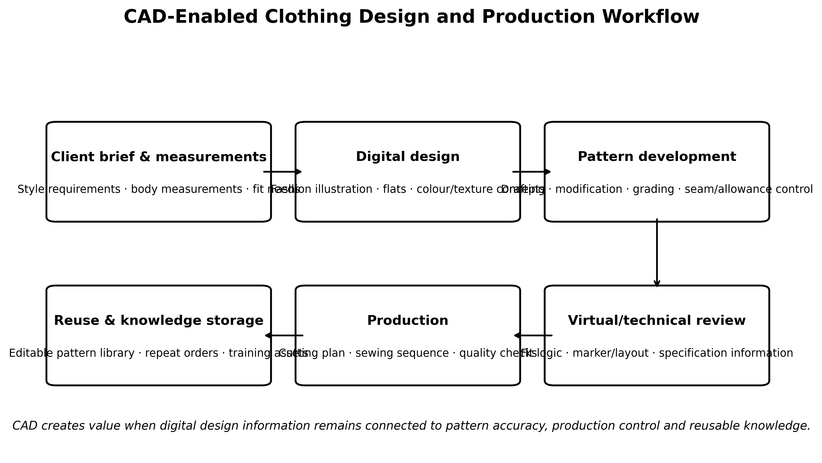
Figure 1. CAD-enabled clothing design and production workflow linking client requirements, digital design, pattern development, technical review, production and reusable knowledge. Original author synthesis informed by contemporary apparel-CAD literature.

2.2 Digital transformation in TVET and informal skills systems
UNESCO (2023) defines digital transformation in TVET as a planned restructuring of training, institutional processes and skills development through digital technology. Its significance is broader than device acquisition: infrastructure, curriculum, teacher capability, inclusion and organizational change determine whether technology improves training quality and labour-market relevance. UNESCO-UNEVOC’s 2024–2026 strategy similarly treats green and digital transformation as central to future-oriented vocational systems.
For clothing technology, this implies that CAD adoption should be taught as a production competence rather than an isolated computer course. Learners need to move from interface familiarity to measurement entry, pattern construction, grading, editing, technical communication and production transfer. In the informal sector, the same principle applies to apprenticeship upgrading. Short modular training can be embedded around real garments and customer orders, while recognition-of-prior-learning mechanisms can connect experienced manual pattern makers to certified digital skills (ILO, 2024).

2.3 Adoption lens: awareness, resources, capability and environment
Technology-adoption theory helps explain why awareness and use diverge. Diffusion of Innovations emphasizes relative advantage, compatibility, complexity, trialability and observability in the spread of innovations (Rogers, 2003). The Technology–Organization–Environment perspective adds organizational resources and the surrounding business environment (Tornatzky & Fleischer, 1990). For a small tailoring enterprise, these dimensions become highly concrete: the perceived advantage of CAD may be positive, yet adoption may stall because the business cannot afford hardware/software, lacks stable power or has no trained operator.
Accordingly, this paper interprets CAD adoption as a staged pathway: awareness → access → capability → routine use → business value. The first stage is cognitive; the middle stages are resource and skill dependent; the final stages require integration into actual pattern, fitting and production routines. This framing is directly suited to the Jos findings because the survey reports high awareness relative to use and identifies constraints at the access, infrastructure and capability stages.
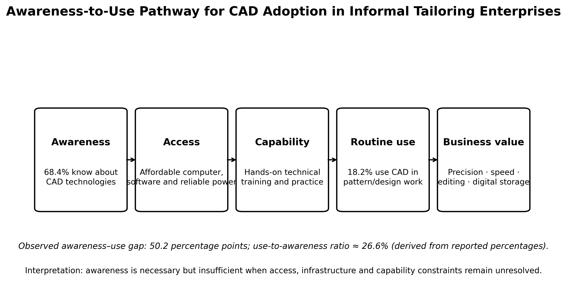
Figure 2. Awareness-to-use pathway for CAD adoption in informal tailoring enterprises. The 50.2-percentage-point awareness–use gap and 26.6% use-to-awareness ratio are descriptive indicators derived from the reported survey percentages.

3. Methodology

3.1 Research design and setting
The study adopted a descriptive survey design to examine CAD awareness, practical use and adoption barriers among practising tailors in Jos Metropolis, Plateau State, Nigeria. The design is appropriate for documenting current technology-use patterns and perceived constraints in an occupational population without manipulating the workshop environment.

3.2 Sample and data collection
A purposive sample of 150 tailors was surveyed using a structured questionnaire. Purposive selection was used to reach practitioners whose work involved tailoring and clothing production in the metropolitan study area. The questionnaire focused on three empirical domains: awareness of CAD technologies; practical use of CAD in pattern drafting and clothing-design work; and barriers to adoption. The article reports the aggregate survey percentages and does not infer unreported respondent-level characteristics.

3.3 Variables and analytical procedure
The primary indicators were binary or categorical survey measures summarized with percentages. Awareness was defined as reported knowledge of CAD technologies. Practical adoption was defined as reported use of CAD in pattern drafting or clothing-design work. Barrier prevalence was represented by the proportion identifying each specified constraint. Two transparent derived indicators were calculated from the reported percentages: the awareness–use gap (68.4 − 18.2 = 50.2 percentage points) and the use-to-awareness ratio (18.2/68.4 ≈ 26.6%). These are descriptive indicators, not causal effects or inferential estimates.
Table 1. Study constructs and analytical treatment
Construct | Operational meaning | Reported / derived measure | Interpretive role
CAD awareness | Knowledge that CAD technologies are available for clothing/pattern work | 68.4% | Measures cognitive exposure to the technology.
Practical CAD use | Use of CAD for pattern drafting and clothing-design work | 18.2% | Measures operational adoption in tailoring practice.
Awareness–use gap | Difference between awareness and practical-use percentages | 50.2 percentage points | Shows the size of the transition problem from knowledge to practice.
Use-to-awareness ratio | Practical-use percentage divided by awareness percentage | ≈26.6% | Descriptive conversion indicator; not a respondent-level transition probability.
Adoption barriers | Respondents identifying specified constraints | Cost 82.5%; power 76.0%; training 64.3% | Locates the principal affordability, infrastructure and capability constraints.

3.4 Analytical boundaries
Because the sample was purposive, the percentages describe the surveyed tailors and should not be treated as probability-sampling prevalence estimates for every tailor in Jos. The design is cross-sectional and descriptive; it does not establish that CAD use causes higher income, productivity or accuracy. The study also did not report an experimental comparison of manual and CAD production, longitudinal adoption histories, or multivariable predictors of adoption. These boundaries are maintained throughout the interpretation.

4. Results

4.1 CAD awareness and practical use
Awareness was substantially higher than practical use. A total of 68.4% of respondents reported awareness of CAD technologies, but only 18.2% reported using CAD for pattern drafting and clothing-design work. The difference is 50.2 percentage points. Expressed as a descriptive ratio, the practical-use level is approximately 26.6% of the awareness level. The result indicates that dissemination of knowledge about CAD has progressed further than operational integration into workshop practice.
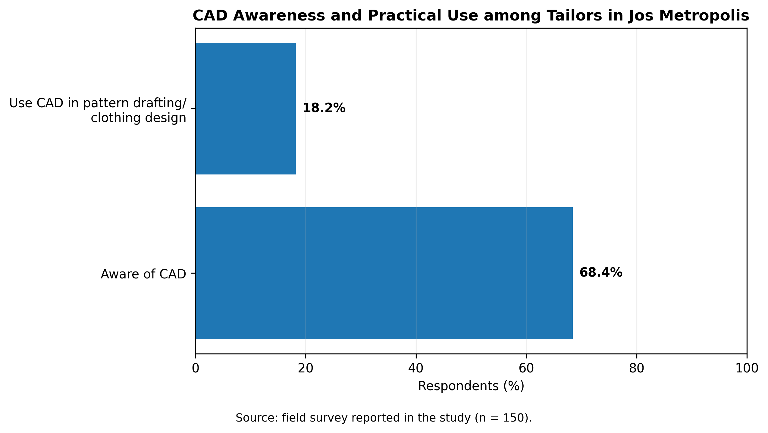
Figure 3. CAD awareness and practical use among surveyed tailors in Jos Metropolis (n = 150).
Table 2. Core empirical results on CAD adoption
Indicator | Result | Descriptive interpretation
Aware of CAD technologies | 68.4% | A majority of surveyed tailors had encountered or knew about CAD.
Use CAD in pattern drafting/clothing design | 18.2% | Routine practical adoption remained low.
Awareness–use gap | 50.2 percentage points | Large difference between cognitive awareness and operational use.
Use-to-awareness ratio | ≈26.6% | Practical use was roughly one-quarter of the awareness level.
Note: The gap and ratio are calculated from the reported percentages; they do not imply individual longitudinal conversion from awareness to use.

4.2 Barriers to practical adoption
Three barriers were especially prominent. The high cost of computer hardware and software was identified by 82.5% of respondents, making affordability the most frequently reported constraint. Epileptic power supply followed at 76.0%, showing that digital adoption is inseparable from infrastructure reliability. Lack of technical training was reported by 64.3%, confirming that awareness does not provide the operational competence required for pattern construction, editing, grading or technical documentation.
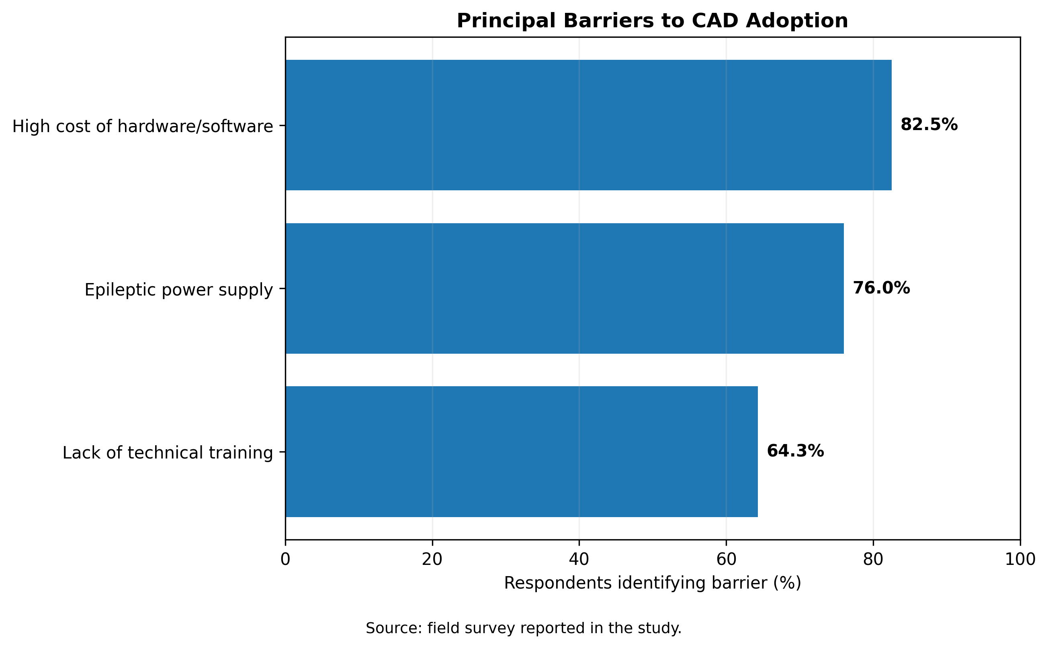
Figure 4. Principal barriers to CAD adoption among surveyed tailors in Jos Metropolis.

4.3 Barrier structure
The barrier profile is notable because all three constraints are high and mutually reinforcing. A tailor may receive training but still lack a suitable device or reliable power; a workshop may purchase hardware but fail to achieve value when no operator can build and edit production-ready patterns. The results therefore argue against single-factor interventions. The adoption problem is better understood as a three-part system comprising affordability, infrastructure and capability.
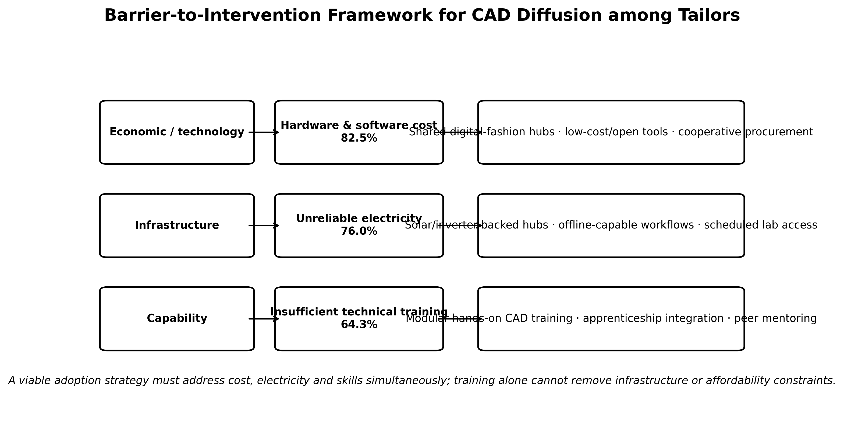
Figure 5. Barrier-to-intervention framework for CAD diffusion among tailors. The empirical percentages are paired with implementation responses that address affordability, electricity and hands-on capability.

5. Discussion

5.1 The awareness–practice gap as the central finding
The most important result is not simply that CAD use is low; it is that awareness is much higher than use. This matters theoretically and practically. If only a small minority had heard of CAD, the primary intervention would be information and exposure. Instead, 68.4% awareness suggests that the technology has already entered the occupational imagination of many tailors. The adoption bottleneck lies later in the pathway—acquiring access, building capability and integrating CAD into real orders. This is consistent with diffusion theory, where knowledge precedes adoption but does not guarantee it (Rogers, 2003).
The finding is also consistent with Nigerian education evidence. Agadagba and Azonuche (2025) found high CAD knowledge among clothing-related students in Delta State but recommended deeper hands-on training in advanced functions. Ugwu et al. (2023) demonstrated the relevance of CAD and flat techniques to pattern-drafting instruction in South-East universities. Together with the present Jos evidence, these studies suggest a national transition problem: awareness and curricular exposure are growing, but practical capability and routine use remain uneven across institutions and enterprises.

5.2 Affordability is a technology-access problem, not merely a software problem
The 82.5% cost barrier should be interpreted broadly. CAD adoption can require a capable computer, input devices, storage, maintenance, software, printing or plotting, backup power and time away from production for training. Proprietary garment systems can be especially difficult for microenterprises to finance individually. The implication is that adoption policy should not assume one-workshop–one-license–one-workstation as the only model. Shared digital-fashion hubs, cooperative procurement, institutional labs and access to appropriate lower-cost or open tools can reduce entry costs while preserving pathways to industry-standard software as enterprises mature.
This recommendation aligns with UNESCO’s digital-TVET approach, which recognizes technology hubs, maker spaces and shared infrastructure as mechanisms through which training providers can support surrounding enterprises. It also fits the local entrepreneurship environment: institutions in Jos have increasingly invested in technology-enabled vocational facilities, creating opportunities for partnerships that connect academic infrastructure with practising artisans.

5.3 Electricity is part of digital capability
Power supply was reported as a barrier by 76.0% of respondents. This local result is consistent with broader Nigerian MSME evidence. PwC Nigeria (2024) identifies poor infrastructure, including epileptic power supply, as a major obstacle to business growth and reports that many firms combine grid electricity with petrol or diesel generation. For CAD-dependent work, unreliable power can interrupt design sessions, damage equipment, limit printing/plotting and raise the total cost of each digital task. Digital-skills programmes that ignore electricity therefore risk producing trained users who still cannot practise consistently.
A practical response is to concentrate power-intensive digital work in shared facilities equipped with solar/inverter backup and scheduled access. Offline-capable software and local storage should be prioritized where connectivity is also unstable. Such arrangements convert infrastructure from an individual fixed cost into a shared service, potentially improving utilization of equipment and creating a setting in which experienced operators can mentor new users.

5.4 Training must move from interface exposure to garment production
The 64.3% training barrier indicates that digital adoption requires domain-specific competence. Generic computer literacy is insufficient. Effective training should begin with familiar tailoring problems—measurement entry, bodice or skirt blocks, pattern alteration, grading, seam allowances, technical flats and specification sheets—and then demonstrate how CAD improves or changes the workflow. Nasara (2025) emphasizes precision, speed, editing and technological literacy as benefits of CAD-supported pattern instruction, while the official Nigerian Clothing and Textile Design curriculum includes digital illustrations, technical drawings and specification packs.
Informal apprenticeship is particularly important. The ILO (2024) describes informal apprenticeship as a dominant skills pathway in Africa. Integrating short CAD modules into master-tailor apprenticeship can therefore reach practitioners who may never enrol in a full-time tertiary programme. A credible model would train both masters and apprentices, allow prior manual pattern knowledge to count as a foundation, and assess competence through finished digital patterns and garments rather than through software-menu recall.

5.5 Implications for productivity, quality and competitiveness
The study did not directly measure production time, error rates, garment fit, profitability or customer satisfaction; those outcomes should therefore not be claimed as observed effects. Nevertheless, contemporary clothing-technology literature provides a strong rationale for testing them. Parametric CAD can support faster pattern modification, consistent grading, reusable patterns and systematic design variation (Lee & Han, 2024). Digital fashion research also positions CAD as a core infrastructure for design and production innovation (Yezhova et al., 2024). For Jos tailors, the practical research question is whether these capabilities translate into measurable reductions in drafting time, material waste, alteration rates and delivery delays under local workshop conditions.

6. Nigerian Evidence and Practical Alignment
Table 3. Selected evidence relevant to CAD adoption in Nigerian clothing technology
Evidence source | Setting / focus | Key evidence | Relevance to Jos
Ugwu et al. (2023) | Clothing lecturers in South-East Nigerian universities | Investigated application of CAD and flat techniques in pattern-drafting instruction; instrument reliability α=.94. | Shows that CAD is already an explicit concern in Nigerian clothing pedagogy.
Agadagba & Azonuche (2025) | 91 College of Education students, Delta State | High CAD knowledge reported; authors recommended more compulsory hands-on advanced CAD training. | Supports the distinction between knowledge/awareness and practical capability.
Nasara (2025) | Home and Rural Economics pattern-drafting training, Nasarawa State | CAD instructional use was associated with perceived precision, speed, creativity and technological literacy. | Identifies practical training outcomes that Jos adoption programmes can target.
Federal Ministry of Education / BRIDGE CLT 206 | B.Sc./B.Tech. Clothing and Textile Design curriculum | Includes CAD for fashion illustration, flats, technical specifications and garment-production design. | Provides curricular legitimacy for CAD hubs and apprenticeship-to-TVET articulation.
PwC Nigeria (2024) | 557 MSMEs across 29 Nigerian states | Infrastructure and electricity remain important enterprise constraints; digital transformation is a strategic MSME priority. | Supports interpretation of power and affordability as enterprise-level adoption conditions.

7. Implementation Framework for Jos Metropolis
The evidence supports a staged implementation strategy rather than a one-off training workshop. The aim should be to convert awareness into routine use through progressive access, capability and enterprise integration. A shared digital-fashion hub can serve as the physical platform, but it should be embedded in training, apprenticeship, maintenance and enterprise-support arrangements.
Table 4. Staged CAD adoption roadmap for tailors and training institutions
Stage | Priority action | Minimum evidence of progress
1. Exposure and diagnosis | Demonstrate garment-specific CAD tasks; assess current computer, pattern and business skills. | Participant can identify relevant CAD functions and select a realistic learning pathway.
2. Access | Provide shared workstations, suitable software, plotting/printing and reliable backup power. | Regular scheduled access without dependence on individual capital purchase.
3. Foundation skills | File management, measurements, basic digital illustration, pattern blocks, editing and printing. | Learner produces and retrieves a correct basic digital pattern.
4. Production integration | Alteration, grading, seam/allowance control, technical flats, specification sheets and order documentation. | Digital output is used in an actual or simulated garment-production cycle.
5. Enterprise use | Build reusable pattern libraries, costing/time records, customer-order archives and collaborative workflows. | CAD is used repeatedly across customer orders rather than only during training.
6. Advanced progression | 3D visualization, digital sampling, parametric patterns, marker efficiency and industry software pathways. | Enterprise or learner demonstrates higher-level capability linked to market needs.

7.1 Minimum specification for a shared digital-fashion hub
• Workstations capable of running selected 2D/3D clothing-design applications, with secure local storage and routine backup.
• A software mix that combines accessible entry-level tools with pathways to recognized industry garment-CAD platforms; training should be software-agnostic at the level of pattern principles.
• Reliable electricity through solar/inverter or equivalent backup, surge protection and planned equipment maintenance.
• Input/output equipment appropriate to the curriculum, such as graphic tablets where useful and access to pattern printing/plotting at workable scale.
• A garment-production space so that digital patterns are tested through cutting, sewing, fitting and revision rather than evaluated only on screen.
• Trainer development that combines clothing construction expertise with CAD competence, plus peer mentoring for master tailors and apprentices.
• A simple booking and cost-recovery model that protects access for microenterprises while supporting maintenance and consumables.

8. Policy, Education and Industry Implications

8.1 Vocational institutions
Colleges, technical institutions and entrepreneurship centres in Plateau State can function as technology intermediaries for the informal clothing sector. Their role should extend beyond full-time student instruction to short courses, evening/open-lab access, competency assessment and trainer upgrading. Curriculum should link manual pattern principles to digital equivalents so that experienced tailors are not forced to abandon existing expertise in order to learn CAD.

8.2 Government and enterprise-support agencies
Public support is most defensible where it reduces shared constraints rather than subsidising isolated equipment purchases without training or maintenance. Competitive grants for shared fashion hubs, solar-backed digital labs, trainer certification and apprenticeship upgrading can address the three leading barriers simultaneously. Procurement should include maintenance, software sustainability and measurable utilisation targets.

8.3 Tailoring associations and cooperatives
Tailor associations can reduce adoption cost through cooperative access to equipment, negotiated training fees and peer demonstration. They can also improve relevance by identifying the garment types and production problems for which members need digital support. Demonstration projects should document before-and-after drafting time, fitting corrections, material utilization and repeat-order efficiency so that members can observe concrete relative advantage rather than being asked to adopt technology on reputation alone.

8.4 Software and technology partners
Technology providers should adapt training and licensing models to microenterprise realities. Short-term or pooled licensing, education/enterprise partnerships, offline operation where feasible and localized tutorials can reduce barriers. Interface simplicity matters, but garment-domain competence matters more; training material should use locally familiar clothing examples, measurement conventions and production constraints.

9. Limitations and Future Research
The study is descriptive and based on purposive sampling, which limits population-wide inference. The results identify prevalence patterns among surveyed practitioners but do not establish causal determinants of adoption. The reported dataset does not provide inferential comparisons by age, gender, education, enterprise size, apprenticeship background or years of experience, nor does it compare the performance of CAD users and non-users on productivity or business outcomes. Future work should employ probability or carefully stratified sampling where feasible, document instrument reliability, distinguish different CAD functions and software classes, and model adoption with multivariable methods.
A second research priority is outcome validation. Quasi-experimental or longitudinal studies could compare manual and CAD-assisted pattern workflows using drafting time, pattern error, fit correction, fabric utilisation, repeat-order speed, customer satisfaction and profitability. A third priority is implementation research: shared-hub pilots should measure uptake, retention, training completion, workstation utilization, power costs and whether apprentices continue to use CAD after structured support ends. These designs would move the evidence base from awareness and barriers toward tested digital-transformation models for informal fashion enterprises.

10. Conclusion and Recommendations

10.1 Conclusion
The survey demonstrates a pronounced gap between awareness of computer-aided design and its practical use among tailors in Jos Metropolis. While 68.4% of respondents were aware of CAD technologies, only 18.2% used them in pattern drafting or clothing-design work. The 50.2-percentage-point gap shows that knowledge of digital clothing technology has spread much further than operational adoption. Cost (82.5%), unreliable electricity (76.0%) and inadequate technical training (64.3%) jointly explain why awareness alone is an insufficient foundation for transformation.
The evidence points to a systems response. CAD adoption requires affordable access to devices and software, reliable power, garment-specific technical training and a pathway into real production practice. For Jos, shared digital-fashion hubs linked to colleges, entrepreneurship centres, tailoring associations and informal apprenticeship offer a practical mechanism for pooling infrastructure while building competence. Digital transformation should therefore be judged not by the number of computers installed or people sensitized, but by the number of practitioners who can create, modify, store and use digital patterns reliably in everyday clothing production.

10.2 Recommendations
• Establish shared, subsidised digital-fashion hubs in Jos with suitable workstations, pattern-printing capability and reliable backup power.
• Integrate hands-on CAD pattern drafting and technical fashion communication into formal Home Economics/Clothing Technology programmes and informal tailoring apprenticeships.
• Use modular competency training that begins with familiar garments and culminates in production-ready digital patterns, grading and specification outputs.
• Develop cooperative access and financing models so that micro-tailoring enterprises are not required to bear the full hardware/software cost individually.
• Adopt power-resilient implementation models, including solar/inverter-backed labs and offline-capable workflows where appropriate.
• Support trainer development and industry–institution partnerships so that CAD instruction remains connected to current apparel practice.
• Evaluate future interventions with measurable production and enterprise outcomes, including drafting time, fitting errors, material use, repeat-order efficiency and sustained use after training.

Declarations
Ethics and participant protection: This article reports aggregate, non-identifiable results from a non-clinical occupational questionnaire survey; no experimental intervention is reported.
Funding: No external funding is declared for this article.
Competing interests: The authors declare no competing interests.
Data availability: The paper reports the aggregate empirical statistics generated by the study. No public respondent-level dataset is deposited with this publication.
Author contributions: L. K. Akila: conceptualization, field research, investigation, interpretation and manuscript development. Anisah Jacks Zongoro: scholarly review, clothing-technology interpretation and manuscript review/editing. Both authors approved the final publication version.
AI-assisted editorial support: AI-assisted tools were used for language refinement, structural harmonization, visualization and reference-consistency checking. They were not used as authors or as substitutes for scholarly judgement. The authors and journal editor retain responsibility for evidence, interpretation and final approval.
Copyright and licence: © 2026 The Authors. Published by CHIA TECH SOLUTIONS AND RESOURCES LIMITED (RC 1839865). This open-access article is distributed under the Creative Commons Attribution 4.0 International (CC BY 4.0) licence, except for third-party material otherwise identified.

References
Agadagba, L. A., & Azonuche, J. E. (2025). Knowledge of computer technology in computer-aided design for garment pattern-making in colleges of education in Delta State, Nigeria. Asian Research Journal of Arts & Social Sciences, 23(5), 26–33. https://doi.org/10.9734/arjass/2025/v23i5678
Federal Ministry of Education, Nigeria. (n.d.). CLT 206: Computer Aided Design in Clothing and Textile. Diaspora BRIDGE / CCMAS course resource. https://diaspora-bridge.education.gov.ng/bridge-p/ccmas-courses/5ea842ef-8ce4-4376-817a-83cb123c2b57
International Labour Organization. (2024, September 19). Skills for transition to formality. https://www.ilo.org/skills-transition-formality
Lee, A. L., & Han, H. (2024). A review of parametric clothing pattern CAD software methodology. International Journal of Clothing Science and Technology, 36(1), 102–116. https://doi.org/10.1108/IJCST-01-2023-0002
Nasara, E. S. (2025). The use of Computer-Aided Design (CAD) software for drafting patterns for training students of Home and Rural Economics College of Agriculture, Science and Technology, Lafia. Lafia Journal of Scientific and Industrial Research, 3(2), 102–108. https://doi.org/10.62050/ljsir2025.v3n2.590
PricewaterhouseCoopers Nigeria. (2024). PwC’s MSME Survey 2024: Building resilience—Strategies for MSME success in a changing landscape. PwC Nigeria. https://www.pwc.com/ng/en/publications/strategies-for-msme-success.html
Rogers, E. M. (2003). Diffusion of innovations (5th ed.). Free Press.
Tornatzky, L. G., & Fleischer, M. (1990). The processes of technological innovation. Lexington Books.
Ugwu, E. I., Ezeaku, M. N., Attah, B. I., Emeghebo, U. M., & Eze, E. C. (2023). Application of Computer Aided Design (CAD) and flat techniques in teaching pattern drafting by clothing lecturers in universities in South East, Nigeria. International Journal of Home Economics, Hospitality and Allied Research, 2(1), 29–43. https://doi.org/10.57012/ijhhr.v2n1.003
UNESCO. (2023). Enhancing TVET through digital transformation in developing countries. UNESCO.
UNESCO-UNEVOC International Centre for TVET. (2024). Elevating TVET for a just and sustainable future for all: Medium-Term Strategy IV, 2024–2026. UNESCO-UNEVOC.
World Bank. (2019). Nigeria digital economy diagnostic: A plan for building Nigeria’s inclusive digital future. World Bank.
Yezhova, O., Wu, S., Pashkevych, K., Kolosnichenko, M., Ostapenko, N., & Struminska, T. (2024). Exploring design and technological aspects of digital fashion: A systematic review of recent innovations. International Journal of Fashion Design, Technology and Education, 18(3), 283–297. https://doi.org/10.1080/17543266.2024.2378032
CHIATECH JOURNAL · SETEHEM · Pioneer Publication · Volume 1 · Issue 1 · August 2026 · e040 · ISSN: Pending assignment · DOI: Pending registration

