CHIATECH JOURNAL
  - SETEHEM · Volume 1, Issue 1 · Pioneer July/August 2026 · Part 2 · e041
  - PIONEER PUBLICATION · ACCEPTED ARTICLE · EMPIRICAL RESEARCH ARTICLE · EDUCATIONAL MANAGEMENT · SCHOOL SECURITY · NORTH-CENTRAL NIGERIA

Security Challenges and Principals' Management Strategies in North-Central Nigerian Secondary Schools
Wilfred Ogbu
Department of Educational Management, Faculty of Education, University of Abuja, Abuja, Nigeria
Correspondence: ogbuwilfred212@gmail.com
ARTICLE TYPE | VOLUME / ISSUE | ELOCATOR | PUBLICATION
Empirical Research Article | 1(1) | e041 | Pioneer July/August · Part 2
IDENTIFIERS |  | JOURNAL DOI
ISSN: Pending assignment |  | Pending registration

Abstract
Background: Security threats can disrupt attendance, teaching, learning and school administration, while principals are expected to coordinate preventive, protective, detective and response functions within constrained local environments. Objective: This study examined prevalent security challenges in public senior secondary schools in three North-Central Nigerian states and assessed the effectiveness of principals' security-management strategies. Methods: The source manuscript reports a descriptive correlational survey of 45 schools drawn from a population of 894 public senior secondary schools in Benue, Kogi and Nasarawa. Respondents comprised 45 principals, 375 teachers and 384 students. Three four-point questionnaires were used, with reported reliability coefficients of 0.73–0.79. Descriptive statistics and ANOVA were reported at the 0.05 level. Results: The overall security-challenge mean was 2.80 (SD=0.86). Violence (M=3.06), kidnapping/abduction (M=3.04) and communal clashes (M=2.93) were the highest-rated threats. State-level challenge means were Nasarawa 2.93, Kogi 2.65 and Benue 2.57, with a reported significant difference (F=3.689, p=.033). Principals were rated effective in safety programmes (M=2.71), asset protection (M=2.67) and detective strategies (M=2.60), but ineffective in threat prevention (M=2.43) and emergency response (M=2.20). State differences were reported only for asset-protection strategy (F=3.293, p=.038). Conclusion: The evidence indicates a high-threat environment combined with a management gap in prevention and emergency response. The publication update preserves the source statistics without re-estimation and situates the findings within Nigeria's current safe-schools policy framework.
Keywords: school security; principals; security management; kidnapping; emergency response; secondary schools; North-Central Nigeria; educational administration
Suggested citation: Ogbu, W. (2026). Security challenges and principals' management strategies in North-Central Nigerian secondary schools. CHIATECH JOURNAL · SETEHEM, 1(1), e041.

1. Introduction
School security is both a protection obligation and a condition for effective educational management. When violence, kidnapping, communal conflict, harassment, theft, cult-related activity or environmental hazards enter the school environment, the consequences can extend beyond immediate physical harm to attendance, staff deployment, concentration, school-community trust and continuity of instruction. In conflict-exposed settings, principals are therefore required to do more than administer routine school operations: they must coordinate risk assessment, prevention, communication, protection, detection and emergency response with actors whose authority and resources often sit outside the school.
The source study supplied for this journal update focuses on public senior secondary schools in Benue, Kogi and Nasarawa States. It was designed around three practical concerns: the prevalence of security challenges, the effectiveness of principals' management strategies and variation across states. This emphasis remains policy-relevant. Nigeria's National Policy on Safety, Security and Violence-Free Schools frames safety as a shared responsibility requiring prevention, preparedness, protection and response, while the National Plan on Financing Safe Schools (2023–2026) links school protection to security-resilient communities, strengthened response capabilities and coordinated implementation. UNICEF's monitoring of the Minimum Standards for Safe Schools has subsequently shown that implementation gaps remain substantial, particularly in early warning and basic security infrastructure.
The significance of the present evidence lies in the contrast between threat intensity and administrative readiness. A school may have guards, gates or awareness programmes and still remain vulnerable if warning systems, threat prevention, medical readiness, evacuation protocols, referral pathways and external response arrangements are weak. The study's five strategy domains—safety programmes, asset protection, threat prevention, detective strategies and emergency response—therefore provide a useful administrative lens for distinguishing visible protection from full-spectrum preparedness.

1.1 Objectives and research focus
The source article examined: (1) the prevalent security challenges in North-Central Nigerian secondary schools; (2) the effectiveness of principals' security-management strategies; and (3) state-level variations in security challenges and management approaches. e041 retains those aims. Current policy and recent literature are added only to interpret the reported findings; they are not used to alter the original sample, coefficients, means, standard deviations, F statistics or p values.

2. Conceptual and Policy Framework
For educational administration, school security can be understood as a management system rather than a single intervention. Prevention reduces exposure before an incident; protection limits access and vulnerability; detection identifies threats and abnormal conditions; response coordinates immediate action; and recovery restores learning, psychosocial stability and institutional functioning. These functions require leadership, resource allocation, communication and collaboration with security agencies, parents and host communities. The source manuscript uses closely related categories and shows that performance can be uneven across them.
Nigeria's current policy architecture supports this system view. The 2021 national school-safety policy establishes a coordinated framework for safe and violence-free schools. The 2023–2026 financing plan adopts a whole-society approach and provides for security response and coordination capacity. UNICEF's 2024 monitoring report, covering implementation of the Minimum Standards for Safe Schools, found major gaps in early-warning and infrastructure performance. The 2025 Nigeria case study on implementing the Safe Schools Declaration further places implementation, coordination and accountability at the centre of protecting education from attack. These policy sources are publication-update context; they are not part of the original statistical analysis.
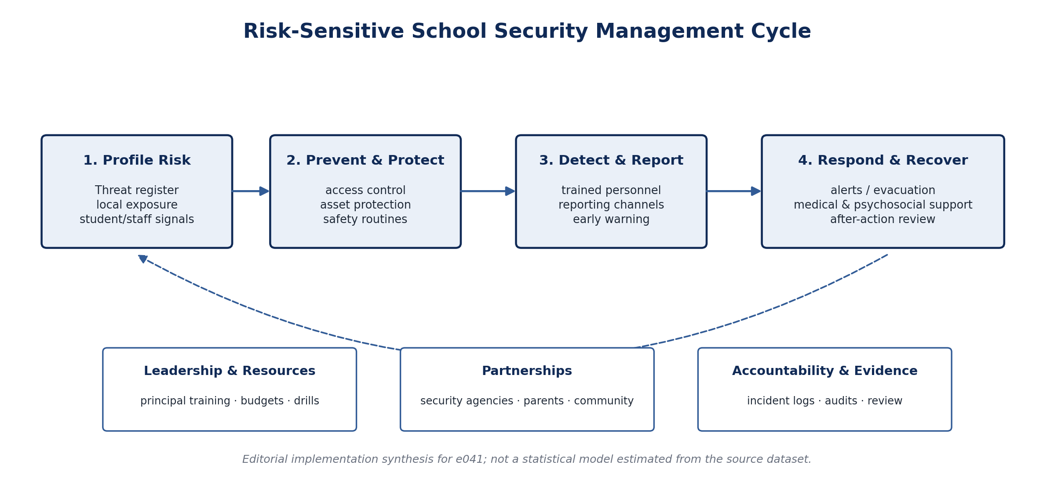
Figure 1. Risk-sensitive school security management cycle. Editorial synthesis for e041, integrating the source strategy domains with current Nigerian safe-schools implementation logic. The figure is not an estimated model.

3. Methodology and Evidence Provenance

3.1 Research design, population and sample
The source manuscript reports a descriptive correlational survey design. The study population comprised 894 public senior secondary schools across Benue, Kogi and Nasarawa States. Multistage sampling produced 45 schools, described in the source as approximately 5% of the school population. Respondents were 45 principals, 375 teachers and 384 students.
Table 1. Distribution of study population and sample as reported
State | No. of schools | Sampled schools | Principals | Teachers / Students
Nasarawa | 275 | 14 | 14 | 178 / 185
Benue | 345 | 17 | 17 | 128 / 91
Kogi | 274 | 14 | 14 | 69 / 108
Total | 894 | 45 | 45 | 375 / 384
Note. Teacher and student counts are displayed together in the final column to preserve the source totals while keeping the table compact.

3.2 Instruments and analysis
Three instruments are named in the source: the Prevalent Security Challenges Questionnaire (PSCQ) for principals; the Principals' Security Management Strategy and Conduciveness of Teaching Environment Questionnaire (PSMSCTEQ) for teachers; and the Conduciveness of the Learning Environment Questionnaire (CLEQ) for students. Each used a four-point Likert response format. Reliability coefficients are reported as ranging from 0.73 to 0.79. The methods section states that means, standard deviations, ANOVA and multiple regression were used at a 0.05 significance level.
Evidence boundary: The accessible results for this specific article report descriptive statistics and ANOVA tables, but do not provide regression coefficients, model summaries or degrees of freedom. e041 therefore does not create or infer missing regression results. Likewise, no row-level dataset, codebook, analysis syntax, ethics approval identifier or consent documentation was available for independent verification in the material used for the publication update.

3.3 Source integrity and publication-update rules
The article associated by the author/editor with Zenodo record 17834595 is treated as the empirical source. Numerical values are reproduced as reported. One ANOVA row for safety-program strategy gives F=3.689 and p=.584 without degrees of freedom; that pair is retained verbatim rather than recalculated. The original accessible manuscript ends its reference section with a placeholder rather than a complete bibliography. e041 does not invent those missing citations: contextual discussion relies on independently verifiable policy and recent research sources listed in the References section.

4. Results

4.1 Prevalent security challenges
Table 2. Level of security challenges in public senior secondary schools
Security challenge | Mean | SD | Decision
Violence | 3.06 | 0.72 | High
Kidnapping/abduction | 3.04 | 0.73 | High
Communal clashes | 2.93 | 0.79 | High
Gangsterism | 2.86 | 0.80 | High
Sexual assault/harassment | 2.84 | 0.82 | High
Arson | 2.80 | 0.81 | High
Cultism and cult-related activities | 2.78 | 0.84 | High
Cybercrime | 2.78 | 0.87 | High
Flooding | 2.73 | 0.89 | High
Intimidation/threats | 2.71 | 0.92 | High
Drug abuse | 2.71 | 0.94 | High
Burglary/theft | 2.68 | 0.96 | High
Bullying | 2.51 | 1.04 | High
Overall | 2.80 | 0.86 | High
All 13 listed challenges were classified as high in the source. The highest means were recorded for violence (M=3.06, SD=0.72), kidnapping/abduction (M=3.04, SD=0.73) and communal clashes (M=2.93, SD=0.79). The overall reported mean was 2.80 (SD=0.86), indicating that insecurity was not confined to one threat category.
Table 3. State variation in security challenges
State | Mean | SD | F | p / decision
Benue | 2.57 | 0.382 | 3.689 | .033 · Significant
Kogi | 2.65 | 0.396
Nasarawa | 2.93 | 0.318
The source reports a significant difference among the three states (F=3.689, p=.033), with Nasarawa recording the highest mean security-challenge rating (2.93), followed by Kogi (2.65) and Benue (2.57). The article does not supply post-hoc tests, so e041 does not infer which pairwise differences reached significance.

4.2 Effectiveness of principals' security-management strategies
Table 4. Effectiveness of principals' security-management strategies
Security strategy | Mean | SD | Decision
Safety programme strategy | 2.71 | 0.85 | Effective
Asset protection strategy | 2.67 | 0.84 | Effective
Detective strategy | 2.60 | 0.88 | Effective
Threat prevention strategy | 2.43 | 0.81 | Ineffective
Emergency response strategy | 2.20 | 0.88 | Ineffective
Three strategy domains exceeded the source's effectiveness threshold: safety programmes (M=2.71), asset protection (M=2.67) and detective strategies (M=2.60). Threat prevention (M=2.43) and emergency response (M=2.20) fell below the threshold. At item level, the source identifies engagement of security guards (M=3.15) and use of security gadgets (M=2.90) as strong asset-protection measures, while bell signals (M=2.00) and medical kits (M=2.20) were among the weakest emergency-response measures.
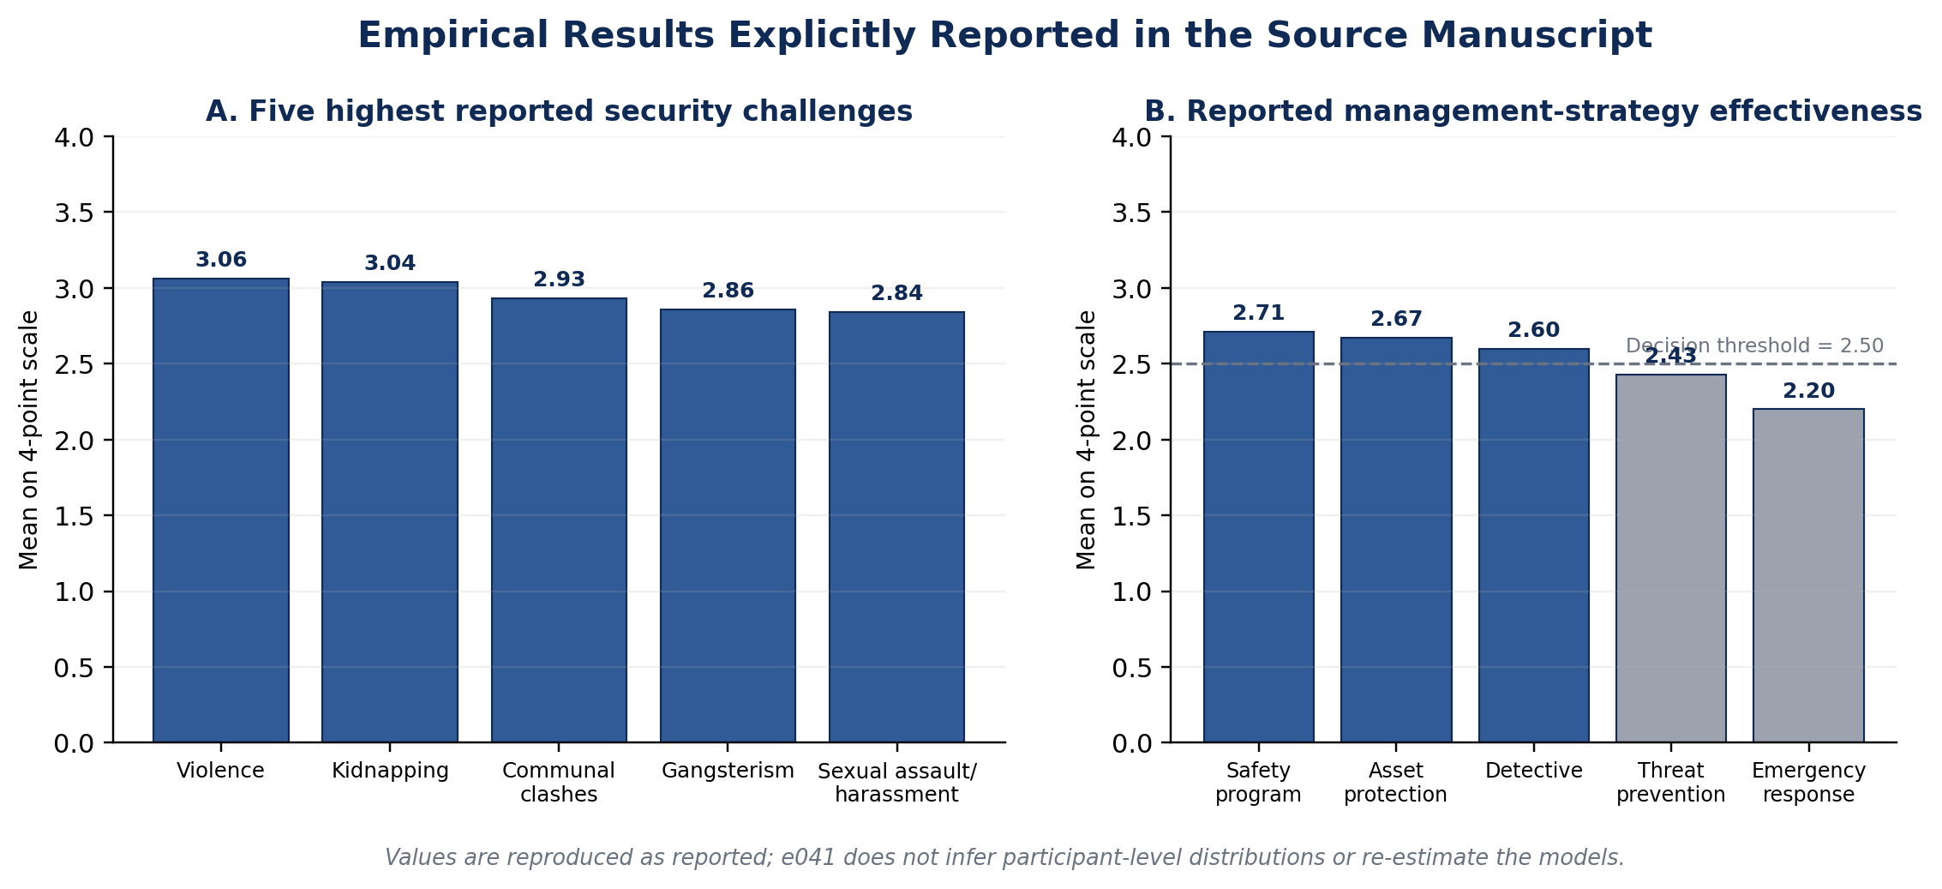
Figure 2. Empirical results explicitly reported in the source manuscript. Panel A displays the five highest threat means; Panel B displays the five management-strategy means and the 2.50 decision threshold used by the source.

4.3 State variation in management strategies
Table 5. Reported ANOVA results for security-management strategies among states
Security strategy | F | P | Decision
Safety programme strategy | 3.689 | .584 | Not significant
Asset protection strategy | 3.293 | .038 | Significant
Threat prevention strategy | .982 | .376 | Not significant
Detective strategy | 1.157 | .315 | Not significant
Emergency response strategy | .260 | .771 | Not significant
Source-verification note. Values are reproduced exactly as reported. Degrees of freedom are not supplied; the safety-program F/p pair is therefore not independently validated in this publication update.
Only asset protection was reported as varying significantly across states (F=3.293, p=.038). The remaining four strategy domains were classified as not significant. Because state-specific strategy means were not supplied, the direction of the asset-protection difference cannot be reconstructed from the available article.

5. Discussion

5.1 A multi-threat school environment
The reported overall threat level and the fact that every listed challenge was classified as high point to a broad security burden rather than a single-incident problem. Violence, kidnapping and communal clashes led the ranking, but school leaders also faced harassment, arson, cult-related activity, cybercrime, flooding, intimidation, drug abuse, burglary and bullying. This breadth matters administratively because a protection model optimized only for external intrusion cannot address internal violence, psychosocial threats, digital risk or environmental hazards.
The state difference reinforces the need for risk-sensitive planning. Nasarawa had the highest source mean, but the absence of post-hoc comparisons means the study does not establish which state pairs differ statistically. The practical implication is nevertheless compatible with Nigeria's current safe-schools approach: national minimum standards require local implementation that responds to the threat profile, infrastructure and response capacity of each school and community rather than assuming uniform exposure.

5.2 Strength in visible protection, weakness in prevention and response
The management pattern is especially important. Safety programmes, asset protection and detective strategies were rated effective, while threat prevention and emergency response were not. This suggests an asymmetry between measures that are relatively visible—guards, gadgets, awareness and detection—and the less visible organizational work required before and after a crisis: threat assessment, early warning, escalation, evacuation, first aid, medical referral, reunification, psychosocial support and continuity planning.
The item-level results support that interpretation. Security guards and security gadgets ranked strongly, whereas bell signals and medical kits were weak. Current Nigerian monitoring evidence identifies related implementation gaps: UNICEF's 2024 report found that early-warning systems were present in only a minority of assessed schools and that basic safety infrastructure remained weak in many settings. The source findings therefore fit a wider implementation problem in which formal policy and visible security inputs may exist without complete preparedness capability.

5.3 Leadership, financing and partnerships
Principals cannot close systemic security gaps alone. Threat prevention and emergency response depend on budget authority, infrastructure, training, intelligence, emergency services and inter-agency coordination. Nigeria's financing plan explicitly adopts a whole-society approach involving federal, state and local governments, security agencies, communities, businesses, donors and other partners. For school leadership, this means that a defensible security plan should specify who owns each risk, who receives alerts, how external responders are contacted, which resources are maintained, how drills are evaluated and how learning resumes after an incident.
Recent North-Central research also reports that insecurity affects monitoring, evaluation and teaching-learning processes and calls for technology-supported quality control and wider implementation of the Safe School Initiative. The convergence is useful but should not be overstated: both studies are survey-based and do not establish the causal effect of any single security intervention. What they do support is the administrative priority of integrating school-security planning with educational quality and continuity.

6. Publication-Update Limitations and Reproducibility
The study is based on a three-state sample and should not be generalized to all North-Central states without qualification. Its survey design relies on respondents' ratings, and the source does not provide item wording, respondent-response rates, validity statistics beyond the stated reliability range, degrees of freedom for the ANOVAs, post-hoc tests, or full regression output despite listing multiple regression in the analysis plan. It also does not provide a row-level dataset or analysis syntax in the material used for e041.
The accessible source manuscript's reference section is incomplete, ending with a placeholder rather than a full bibliography. This update therefore avoids reconstructing unverified references. The References section below contains the source record plus independently verifiable policy and recent empirical materials used for the publication-update discussion. Future republication or replication would be strengthened by archiving the questionnaires, scoring rules, anonymized data, codebook, statistical output and ethics/consent documentation alongside the article.

7. Conclusion and Recommendations
The source evidence portrays North-Central public secondary schools as operating within a high and diverse security-risk environment. Violence, kidnapping and communal clashes were the strongest reported threats, while security conditions differed significantly across the three sampled states. Principals were comparatively stronger in safety programmes, asset protection and detective strategies than in threat prevention and emergency response. The central administrative implication is therefore not simply to add more visible security hardware, but to build a complete prevention-to-recovery system around school leadership.

1. State education authorities should require school-specific threat registers and annual security plans aligned with national safe-school standards and local risk profiles.

2. Principal-training programmes should prioritize threat assessment, early warning, emergency command, evacuation, first aid, reunification, continuity planning and post-incident review in addition to routine safety awareness.

3. School management should test emergency communication systems through scheduled drills and document response times, equipment readiness, lessons learned and corrective actions.

4. Government and financing partners should protect budget lines for perimeter safety, lighting, communication, medical readiness, surveillance where justified, maintenance and trained personnel, rather than funding equipment without operating support.

5. Schools, parents and host communities should establish structured reporting and information-sharing channels linked to security agencies and emergency services, with clear escalation responsibilities.

6. Student and staff support systems should include confidential reporting, safeguarding referral and trauma-informed psychosocial support for people affected by security incidents.

7. Researchers and education authorities should replicate the study across all North-Central states using transparent sampling, validated instruments, complete ANOVA/regression output, post-hoc tests where required and a shareable anonymized replication package.

Declarations
Ethics and consent: The journal update introduces no new human-participant data. The source study reports questionnaires administered to principals, teachers and students, but the material available for this update does not provide an ethics-approval body, approval number or consent/assent procedure. Those records should be retained and supplied to the journal where applicable.
Funding: No funding statement is available in the source manuscript used for this publication update; e041 adds no new funded data collection.
Competing interests: No competing-interest statement is available in the source manuscript used for this publication update.
Data availability: The prior article is associated with Zenodo record 17834595. No row-level dataset or analysis code was available for the publication update; all numerical results in e041 are restricted to values reported in the source manuscript.
Author contribution: Wilfred Ogbu: source-study authorship, conceptualization and reported empirical investigation. The journal update preserves the reported evidence and adds editorial restructuring, current policy/literature context, figures, evidence-boundary clarification and publication formatting.
AI-assisted editorial support: AI-assisted tools were used for literature-discovery support, language refinement, figure preparation, document formatting and consistency checking. They were not used to create participant data, generate unreported coefficients or replace source verification. The author and journal editor retain responsibility for final scholarly approval.
Prior version: Ogbu, W. (2025). Security challenges and principals’ management strategies in North-Central Nigerian secondary schools. Zenodo record 17834595.
Copyright and licence: © 2026 Wilfred Ogbu. Published by CHIATECH JOURNAL · SETEHEM under the Creative Commons Attribution 4.0 International (CC BY 4.0) licence, except for third-party material identified otherwise.

References
Federal Ministry of Education. (2021). National policy on safety, security and violence-free schools in Nigeria with implementing guidelines. Federal Republic of Nigeria. https://education.gov.ng/wp-content/uploads/2021/09/National-Policy-on-SSVFSN.pdf
Federal Ministry of Finance, Budget and National Planning. (2022). National plan on financing safe schools (2023–2026). Federal Republic of Nigeria. https://protectingeducation.org/wp-content/uploads/Nigieria_National-Plan-on-Financing-Safe-Schools_SPREAD.pdf
Federal Ministry of Finance. (2024, August 22). Edun addresses House Committee on Alternate Education: Outlines government's financial education strategy. https://finance.gov.ng/
Global Coalition to Protect Education from Attack. (2025). Nigeria: A case study on implementing the Safe Schools Declaration. https://protectingeducation.org/publication/nigeria-a-case-study-on-implementing-the-safe-schools-declaration/
Ogbu, W. (2025). Security challenges and principals' management strategies in North-Central Nigerian secondary schools [Preprint/manuscript]. Zenodo record 17834595.
UNICEF. (2024). Minimum standards for safe schools in Nigeria: Monitoring report, July–December 2023. UNICEF Nigeria. https://www.unicef.org/nigeria/reports/minimum-standards-safe-schools-nigeria
UNICEF Nigeria. (2024, September 9). Immediate action needed to protect Nigeria's children and schools. https://www.unicef.org/nigeria/press-releases/immediate-action-needed-protect-nigerias-children-and-schools
Uwakwe, S. I., Audu, K. Y., Ikemereh, K. I., & Uwakwe, S. O. (2025). Insecurity and challenges of sustainable quality secondary school education in North-central, Nigeria. Social Sciences, 14(4), 362–370. https://doi.org/10.11648/j.ss.20251404.17
CHIATECH JOURNAL · SETEHEM · Volume 1, Issue 1 · Pioneer July/August 2026 · Part 2 · e041 · Pioneer Publication

