CHIATECH JOURNAL
  - SETEHEM · VOLUME 1 · ISSUE 2 · AUGUST 2026 · e042
  - PIONEER PUBLICATION · ACCEPTED ARTICLE · CRITICAL REVIEW ARTICLE · ARTIFICIAL INTELLIGENCE · CUSTOMS · INTELLECTUAL PROPERTY · BORDER SECURITY

Artificial Intelligence and Smart Border Surveillance for Intellectual Property Rights Enforcement at Nigeria’s Land Borders: A Critical Evidence Review and Responsible Implementation Framework
AMENGER, Gbaden
Nigeria Customs Service, Ogun State Command, Nigeria
Correspondence: amengergbaden1@gmail.com
ARTICLE TYPE  Critical Review Article | VOLUME / ISSUE  1(1) | ELOCATOR  e042
PUBLICATION  Pioneer Issue · August 2026 | IDENTIFIERS  ISSN: Pending assignment | JOURNAL DOI  Pending registration

Abstract
Background: Counterfeit and pirated trade undermines intellectual property rights (IPR), consumer safety, legitimate enterprise and revenue administration. Border enforcement is becoming harder as illicit trade fragments into small consignments and adapts to complex logistics. Objective: This article critically reviews the evidence for artificial intelligence (AI), data analytics and smart border-surveillance technologies in strengthening IPR enforcement at Nigeria’s land borders and develops a legally bounded implementation framework. Review approach: A structured critical review prioritized official evidence from the World Customs Organization (WCO), World Trade Organization (WTO), OECD/EUIPO, Nigeria Customs Service (NCS), Nigeria Data Protection Commission (NDPC) and African Union, supplemented by peer-reviewed customs-risk, African surveillance and IPR-enforcement scholarship published principally from 2020 to August 2026. Synthesis: OECD/EUIPO estimates place global counterfeit and pirated trade at about USD 467 billion in 2021, equivalent to 2.3% of global imports; shipments of fewer than ten items accounted for 79% of customs seizures in 2020–2021, intensifying selectivity pressures. WCO guidance identifies AI/ML, data analytics and cloud technologies as high-interest Customs technologies but stresses data governance, interoperability, cybersecurity, cost-benefit analysis, workforce capability, MLOps, fairness and transparency. Nigeria has moved beyond conceptual readiness: NCS modernization plans include AI-supported risk management, data analytics and geospatial surveillance, while a 2026 Nigeria–Benin operation demonstrated operational use of geospatial intelligence, drones, shared communications and risk profiling. For IPR enforcement, however, technology must be integrated with TRIPS-compliant border procedures, rights-holder product intelligence, human adjudication and data-protection safeguards. Conclusion: The strongest policy case is for phased, evidence-gated adoption rather than technology-first procurement. A Nigerian smart-IPR border architecture should combine reliable Customs data, rights-holder authentication, risk analytics, geospatial targeting and non-intrusive inspection with human review, auditable decisions, privacy-by-design and cross-border cooperation.
Keywords: artificial intelligence; smart customs; intellectual property rights; counterfeiting; Nigeria Customs Service; border surveillance; geospatial intelligence; customs risk management; responsible AI; trade facilitation
Suggested citation: Amenger, G. (2026). Artificial intelligence and smart border surveillance for intellectual property rights enforcement at Nigeria’s land borders: A critical evidence review and responsible implementation framework. CHIATECH JOURNAL · SETEHEM, 1(1), e042.

1. Introduction
Counterfeiting is simultaneously an intellectual-property problem, a trade-governance problem and a public-safety problem. The OECD and EUIPO estimated the value of internationally traded counterfeit and pirated goods at approximately USD 467 billion in 2021, representing 2.3% of global imports (OECD & EUIPO, 2025). The affected products extend beyond luxury goods to clothing, footwear, automotive parts, pharmaceuticals, toys, electronics and other goods for which substandard manufacture can create safety as well as economic harm. Customs therefore operates at a strategically important point in the enforcement chain: it can interrupt infringing trade before goods enter domestic distribution channels.
The enforcement environment is becoming more difficult, not less. Counterfeiters exploit fragmented logistics, e-commerce, postal channels, localization of assembly and smaller consignments. OECD/EUIPO data show that shipments containing fewer than ten items represented 79% of seizures in 2020–2021, compared with 61% in 2017–2019 (OECD & EUIPO, 2025). This pattern creates an acute resource-allocation problem for border agencies: physical inspection of every consignment is neither feasible nor compatible with efficient legitimate trade. The relevant question is therefore not whether Customs should use technology, but which technologies improve targeting, authentication and evidence quality enough to justify their financial, legal and institutional costs.
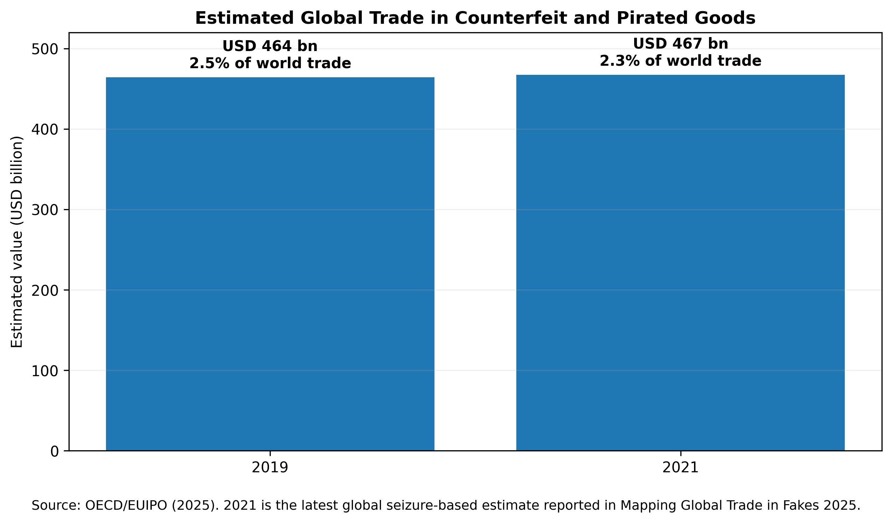
Figure 1. Estimated global value of counterfeit and pirated trade in 2019 and 2021. Source: OECD/EUIPO (2025). Values are seizure-informed estimates rather than direct counts of all illicit trade.
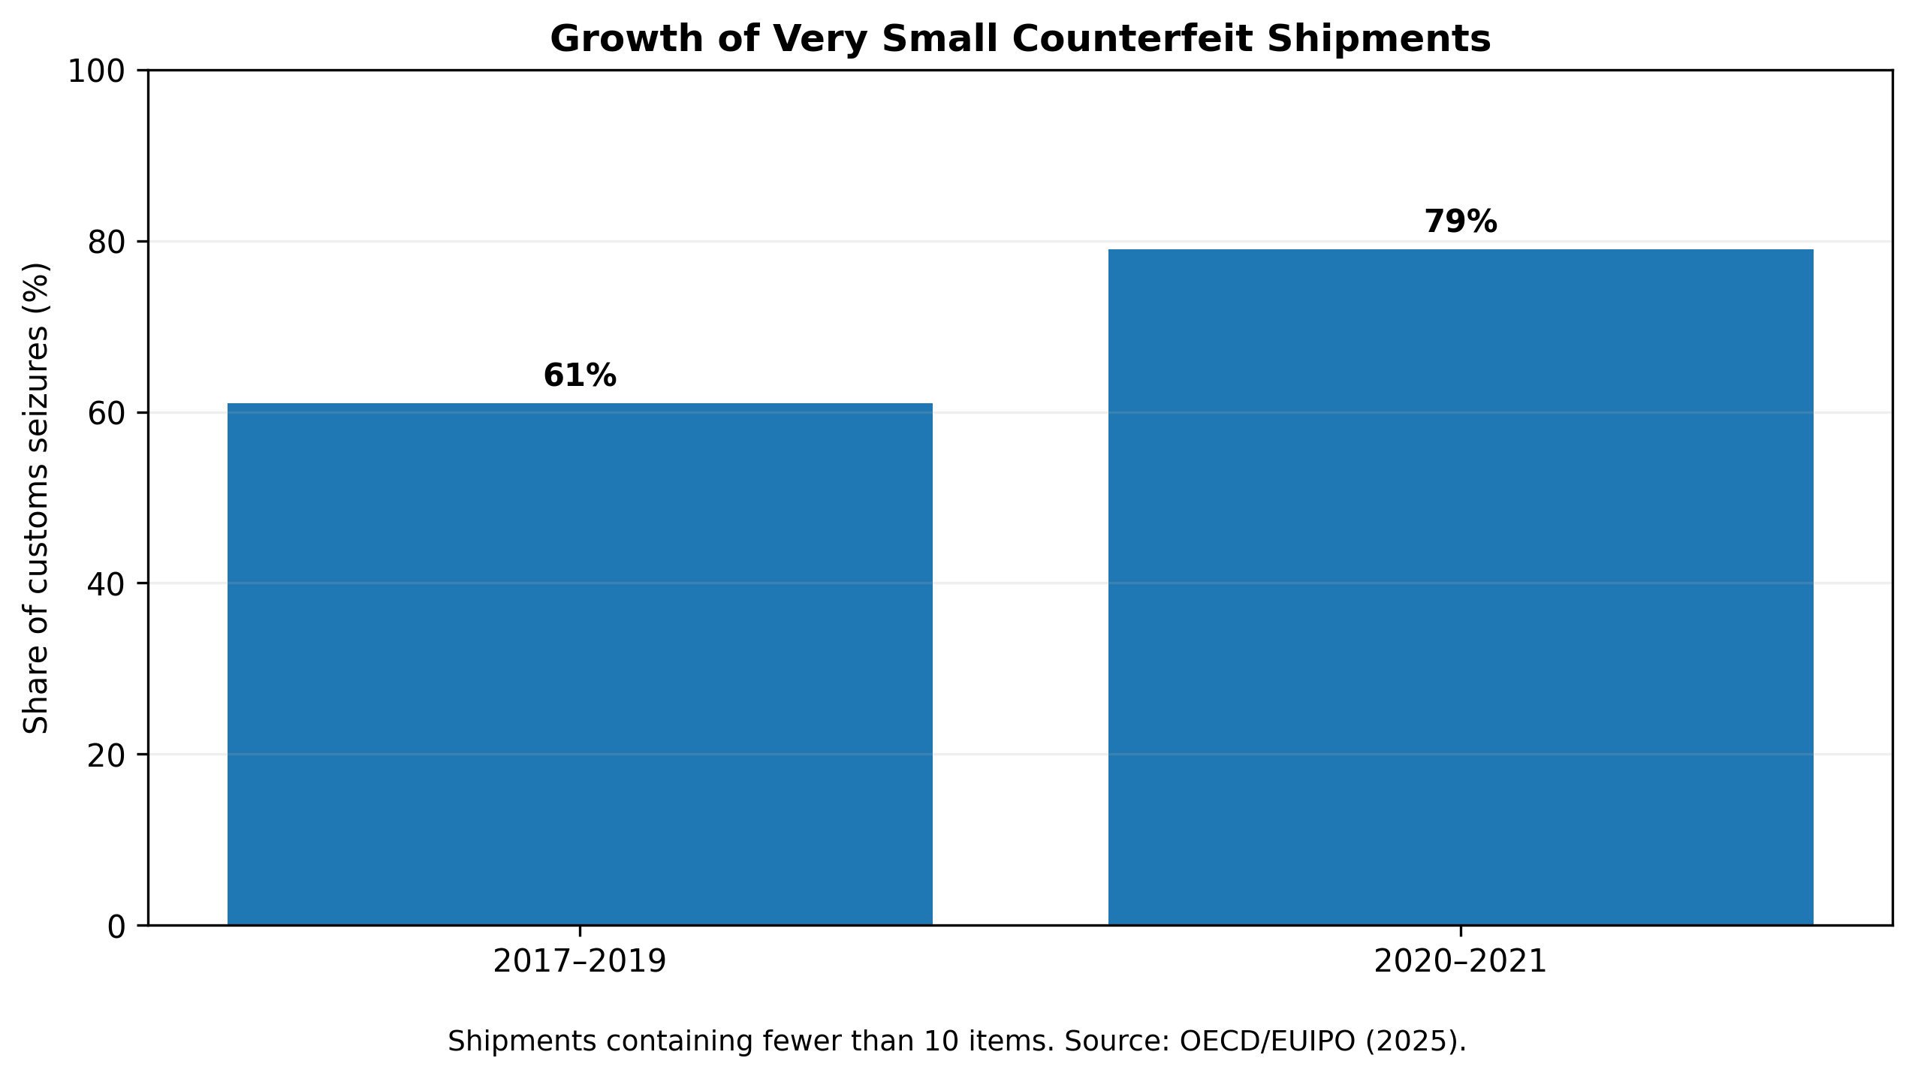
Figure 2. Rising importance of very small counterfeit shipments in global seizure data. Source: OECD/EUIPO (2025).

1.1 Nigeria’s land-border enforcement context
Nigeria’s land borders combine formal crossing points with large stretches of difficult terrain and numerous unofficial routes. In an account published by the WCO, the Nigeria Customs Service identified porous frontiers, sparse permanent state presence, criminal adaptation, connectivity and power constraints, and fragmented inter-agency data as recurring operational challenges. NCS has responded by developing geospatial-intelligence capability that combines satellite imagery, GIS, remote sensing, positioning data and analytics to identify hotspots and route anomalies (Labaran, 2025). Its 2024 annual press briefing also placed expansion of geospatial surveillance, AI in risk management and enhanced data analytics among modernization priorities for 2025 (Nigeria Customs Service, 2025).
A further step occurred in July 2026 when Benin and Nigeria conducted Operation GEOCONTROL with WCO and JICA support. The eight-day operation combined geospatial analysis, risk profiling, field intelligence, drones, the WCO Geoportal and CENcomm, resulting in 37 seizures across narcotics, pharmaceuticals, petroleum products and consumer goods (WCO, 2026a). The operation was not an IPR-only evaluation and therefore cannot be cited as evidence of a specific counterfeit-detection rate. It nevertheless demonstrates that Nigeria has already entered the operational phase of technology-enabled, intelligence-led land-border enforcement.

2. Review Design and Evidence Hierarchy
This article uses a structured critical-review design. Searches and source checks were conducted in August 2026 around the concepts AI/ML in Customs, smart Customs, counterfeit trade, IPR border measures, Customs risk management, geospatial intelligence, non-intrusive inspection, product authentication, Nigeria Customs modernization, data protection and AI surveillance in Africa. Evidence was prioritized in four tiers: current intergovernmental and national official sources; peer-reviewed Customs and legal scholarship; operational case studies from Customs administrations; and older foundational sources retained where they define established law or theory. The review does not pool heterogeneous effect sizes and is not presented as a systematic meta-analysis.
Table 1. Evidence hierarchy used in the review
Evidence tier | Examples | Primary analytical role
International/national authority | WTO TRIPS; WCO AI/ML, SAFE and risk-management guidance; OECD/EUIPO; NCS; NDPC; AU | Legal obligations, official statistics, implementation standards and current institutional practice
Peer-reviewed research | Customs risk management; African AI-surveillance law; IPR enforcement scholarship | Independent interpretation of effectiveness, risks and governance limitations
Operational case evidence | Nigeria GEOINT; Operation GEOCONTROL; China Customs AI image analysis; WCO IPM | Feasibility, workflow design and implementation lessons
Foundational theory | TOE theory; stakeholder theory | Organization of readiness, institutional capacity and collaboration factors

3. Legal and Institutional Foundations for IPR Border Enforcement

3.1 TRIPS border measures and due process
The legal starting point is the WTO Agreement on Trade-Related Aspects of Intellectual Property Rights. Article 51 requires procedures enabling right holders with valid grounds to seek suspension of release of suspected counterfeit trademark or pirated copyright goods. Article 52 requires adequate prima facie evidence and a sufficiently detailed description of the goods, while Articles 53–59 provide safeguards, notice, inspection, review and remedies. Article 60 permits exclusion of small quantities of non-commercial goods in travellers’ luggage or small consignments. The enforcement chapter is deliberately balanced: procedures should enable effective action against infringement while avoiding unnecessary barriers to legitimate trade and abuse of enforcement measures (WTO, 1994; WTO, n.d.).
This balance matters for algorithmic targeting. A high-risk score can be an investigative trigger; it cannot by itself determine that goods legally infringe an IP right. Trademark authenticity, authorization, parallel-import questions, copyright status and available remedies are legal matters requiring evidence and accountable decisions. AI should therefore rank, prioritize and surface anomalies while the final detention or release process remains tied to lawful Customs powers, competent authority procedures and rights-holder evidence.

3.2 Nigeria’s enforcement framework and rights-holder collaboration
Nigeria’s response to the WTO enforcement checklist records general Customs powers to impound goods reasonably suspected to contravene the law (WTO e-TRIPS, n.d.). The 2024 WTO Trade Policy Review also documents continuing reform of Customs procedures, while WTO Members encouraged Nigeria to reduce high levels of physical inspection and improve timely, cost-effective border processing (WTO, 2024). These two pressures—stronger enforcement and fewer indiscriminate inspections—make selective, evidence-based targeting especially relevant.
For IPR-specific selectivity, rights-holder data are indispensable. The WCO’s Interface Public-Members (IPM) model allows rights holders to supply Customs with product images, descriptions, alerts, barcodes and authentication/security-feature information. This partnership model is important because AI can detect statistical or visual anomalies, but only rights holders and competent authorities can reliably supply many product-specific indicators that distinguish legitimate distribution from infringement (WCO, 2015; WCO, n.d.-a).

3.3 Privacy, automated decisions and African responsible-AI principles
Nigeria’s Data Protection Act 2023 is directly relevant where risk systems process personal data relating to traders, drivers, declarants or other identifiable persons. Section 37 provides a right not to be subject to decisions based solely on automated processing, including profiling, where legal or similarly significant effects arise, subject to specified exceptions and safeguards including human intervention and the ability to contest the decision. The NDPC’s 2025 General Application and Implementation Directive further addresses emerging technologies, requiring attention to data-protection principles, disparate outcomes, data-protection impact assessment and appropriate testing of high-risk systems (Nigeria, 2023; NDPC, 2025).
The African Union’s Continental AI Strategy similarly places human rights, transparency, accountability, inclusion and responsible governance at the centre of AI development, while the AU Data Policy Framework calls for trusted, harmonized data governance and protection of digital rights (African Union, 2022, 2024). These principles are particularly important in surveillance contexts. Recent African human-rights scholarship warns that surveillance deployments can outpace legal and institutional safeguards when procurement, data retention and oversight are opaque (Mutuma, 2025).

4. Technology Options and Their Evidentiary Value for IPR Enforcement
Table 2. Smart-border technologies for IPR enforcement: evidence, value and limitations
Technology | IPR-enforcement contribution | Evidence base / principal limitation
AI/ML risk scoring | Ranks consignments/traders/routes for inspection using structured and historical outcome data. | WCO 2025 guidance and Customs risk-management literature support risk use; performance depends on labels, drift, calibration and local validation.
Anomaly detection / graph analytics | Surfaces unusual valuation, routing, network or declaration patterns when labelled IPR cases are scarce. | Useful for adaptive fraud patterns; anomalies are not proof of infringement and can generate false positives.
GEOINT / GIS / drones | Maps unofficial crossings, hotspots, route deviations and patrol priorities. | Operationally demonstrated in Nigeria and GEOCONTROL; requires lawful data collection, connectivity and coordinated field response.
Non-intrusive inspection + computer vision | Automates or assists interpretation of scanner images and flags concealment or packaging/quantity anomalies. | China Customs demonstrates mature AI image-analysis use; Nigerian performance requires local scanner data and labelled outcomes.
Product authentication / WCO IPM | Provides product-specific images, barcodes, security features and rights-holder alerts. | High value for IPR specificity; depends on rights-holder participation, data currency and frontline access.
OCR / NLP and document analytics | Extracts and compares invoice, manifest, brand and document information at scale. | Useful for triage; multilingual/poor-quality documents and adversarial manipulation require human verification.

4.1 AI/ML risk management
The WCO’s 2025 AI/ML report treats risk management as a core use case but explicitly rejects a model-only view of adoption. It identifies data management, legal and ethical analysis, cost-benefit assessment, infrastructure, pilot testing, interoperability, cybersecurity, workforce skills and MLOps as implementation requirements (WCO, 2025a). Peer-reviewed Customs scholarship reaches a similar conclusion: technology-centric risk management can improve selectivity only when analytical systems are embedded in institutional risk processes and evaluated against operational outcomes (Vijayakumar, 2025; Oussama et al., 2024).

4.2 GEOINT and surveillance at porous land borders
Geospatial intelligence is especially relevant where the enforcement problem is not merely selecting a declared consignment but identifying routes that bypass formal control points. Nigeria’s own GEOINT experience shows how satellite imagery, GIS, positioning and risk data can reveal new paths, route deviations and enforcement hotspots. This capability complements—not replaces—IPR product identification. GEOINT answers where and when inspection resources should be positioned; rights-holder intelligence and Customs examination answer whether a particular shipment infringes an IP right (Labaran, 2025; WCO, 2026a).

4.3 AI-assisted non-intrusive inspection and authentication
Large-scale NII creates an image-analysis bottleneck that AI can help reduce. China Customs has reported a seven-year programme for automated analysis of inspection images, illustrating how Customs-specific training data and deployment pipelines can convert NII from a purely human-reading system into AI-assisted control (General Administration of China Customs, 2024). For Nigerian land borders, the value proposition is strongest when image findings are fused with declaration risk, GEOINT, trader history and product-authentication evidence rather than interpreted independently.

5. An Integrated Responsible-AI Framework
The original technology–organization–environment logic is useful but incomplete for high-stakes public enforcement. The framework developed here combines three readiness inputs—technological readiness, organizational capacity and stakeholder collaboration—with a mandatory responsible-AI governance layer. The governance layer is not a final compliance checklist; it conditions every stage of data collection, model development, inspection and enforcement.
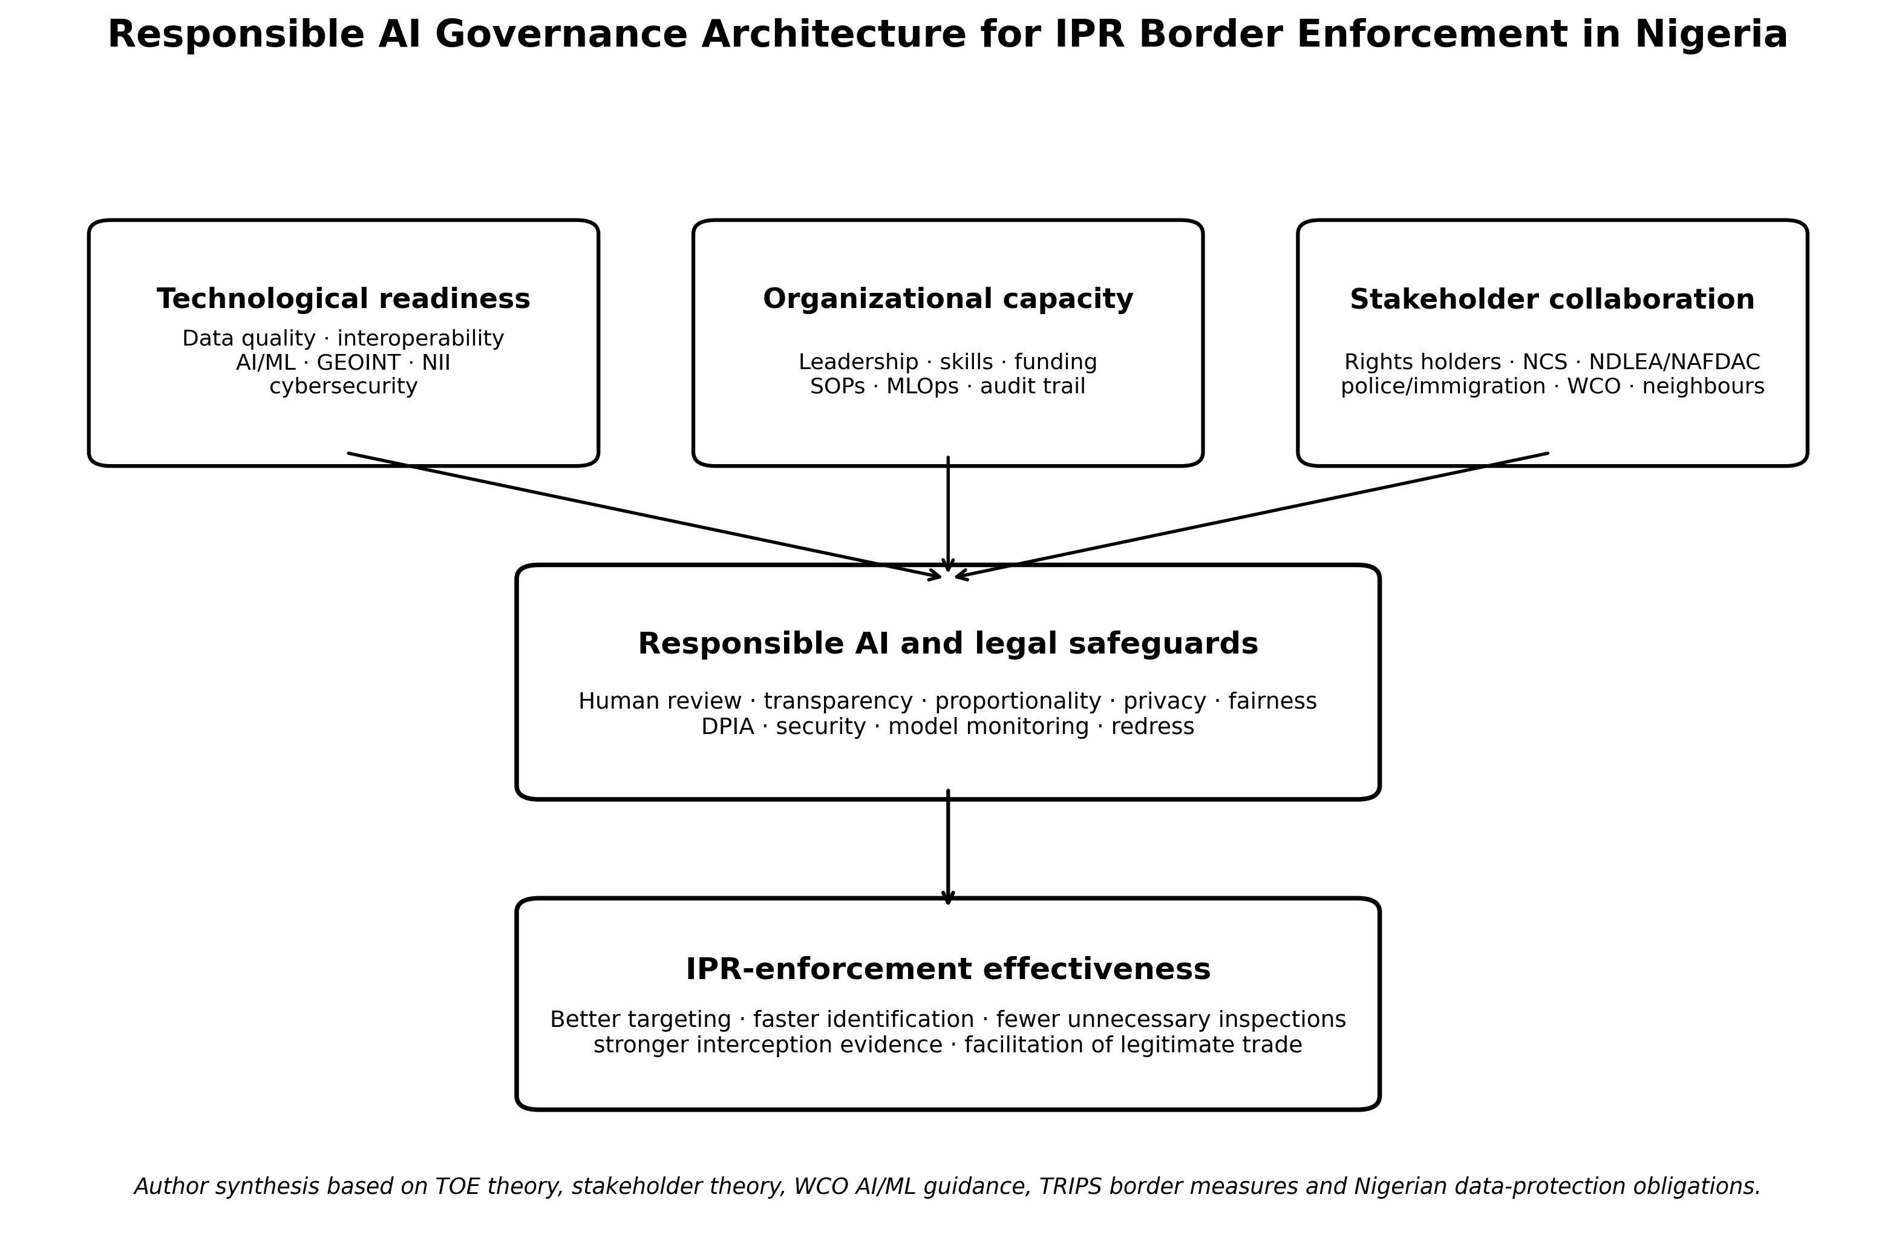
Figure 3. Responsible-AI governance architecture for IPR border enforcement in Nigeria. Original author synthesis based on TOE theory, stakeholder theory, TRIPS, WCO AI/ML guidance and Nigerian data-protection obligations.

5.1 Technological readiness
Readiness begins with data rather than algorithms. Customs declarations, trader histories, seizure outcomes, scanner images, geospatial layers and rights-holder reference information need common identifiers, metadata, quality rules, retention schedules and controlled access. WCO BACUDA’s 2026 guidance is explicit that advanced analytics cannot consistently produce reliable outputs where definitions are inconsistent, ownership is unclear or data quality is weak. Its six-pillar data-governance model emphasizes strategy and policy; organization and roles; standards and metadata; data quality; security, privacy and ethics; and monitoring and compliance (WCO BACUDA, 2026).

5.2 Organizational capacity
AI-enabled enforcement changes work design. Customs needs multidisciplinary teams that combine frontline experience, IPR knowledge, data engineering, analytics, cybersecurity, legal review and model governance. Officers require training not only to use a risk score but to understand uncertainty, failure modes and the evidence needed to override or confirm an algorithmic recommendation. WCO guidance also emphasizes pilot testing, change management and MLOps so that models can be versioned, monitored and retired when data or trade patterns change (WCO, 2025a).

5.3 Stakeholder collaboration
IPR enforcement is inherently multi-actor. NCS needs structured links with trademark and copyright owners, Nigerian IP institutions, standards and medicines regulators, police and immigration authorities, neighbouring Customs administrations, logistics operators and WCO/WTO networks. TRIPS Article 69 and WTO contact-point arrangements reinforce international cooperation against trade in counterfeit and pirated goods. At operational level, collaboration should generate usable information: known genuine product features, authorized import channels, contact points for rapid verification, seizure feedback and route intelligence.

6. Model Governance, Fairness and Due Process
A risk-targeting system should be designed as decision support, not automated guilt attribution. False positives impose real costs: delayed legitimate goods, inspection workload, reputational damage and possible legal challenge. False negatives impose different costs: missed infringing goods, consumer harm and loss to legitimate rights holders. The threshold for inspection should therefore be tuned against operational capacity and risk severity, while high-impact detention decisions retain accountable human review.
Table 3. Minimum governance controls for high-stakes Customs AI
Risk | Why it matters | Required control
Biased historical labels | Past enforcement intensity may be mistaken for underlying infringement prevalence. | Audit labels and sampling; compare error rates across routes, trader types and locations; use active review of false positives.
Data leakage / stale features | Models can appear accurate while using information unavailable at decision time or outdated patterns. | Time-aware validation, feature provenance, out-of-time testing and scheduled revalidation.
Opaque risk scores | Officers may over-trust a score they cannot interrogate. | Feature-level explanations, confidence/calibration information, SOPs and documented override reasons.
Surveillance overreach | Location, identity or communications data can exceed necessity or legal purpose. | Purpose limitation, data minimization, DPIA, retention limits, role-based access and audit logs.
Cyber compromise | Border systems are high-value targets and can expose trade/intelligence data. | Segmentation, encryption, identity/access management, monitoring, incident response and offline fallback.
Automation without remedy | A person or trader may be affected without meaningful review. | Human intervention, contest/review channel, decision logging and separation between prediction and legal determination.

7. Phased Implementation Roadmap for Nigeria
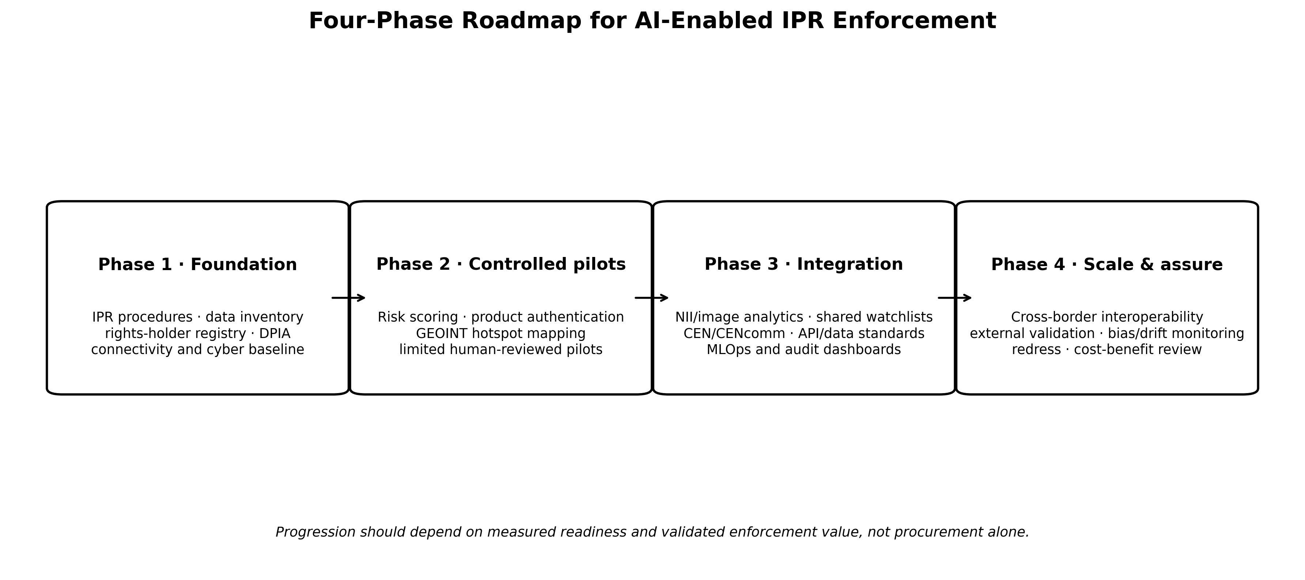
Figure 4. Evidence-gated implementation roadmap for AI-enabled IPR enforcement at Nigeria’s land borders. Original author synthesis.
Phase 1 should establish the legal, data and institutional foundation: mapped IPR procedures, rights-holder contact mechanisms, data inventory, common identifiers, cybersecurity baseline, connectivity assessment and DPIA. Phase 2 should run narrow pilots on decisions that can be independently verified—for example, ranking consignments already subject to ordinary inspection, product-authentication support, and GEOINT hotspot prioritization. Phase 3 should integrate validated models with NII, case management, WCO networks and cross-agency information exchange. Phase 4 should scale only after external or cross-site validation, cost-benefit evidence, model monitoring and a functioning redress and audit process.

7.1 Performance indicators
• IPR detection yield: confirmed infringing consignments per 100 targeted inspections and recall against known confirmed cases.
• Trade-facilitation cost: physical-inspection rate, false-positive rate, clearance time and release time for low-risk legitimate trade.
• Identification quality: time from selection to product verification; proportion of cases resolved with rights-holder or authoritative authentication evidence.
• Operational resilience: system uptime, data-quality exceptions, cybersecurity events, offline fallback and model-drift indicators.
• Governance quality: human-override rates and reasons, complaints/reviews, DPIA actions closed, audit completeness and disparities in error rates.
• Economic value: cost per actionable detection, officer-hours saved and avoided losses/health risks relative to total technology, maintenance and training costs.

8. Discussion
The evidence supports a measured but affirmative case for smart-border technology in Nigerian IPR enforcement. First, the global counterfeit problem is large and operationally fragmented. Second, international Customs practice has moved from experimentation toward institutionalized AI/ML, data analytics, NII automation and geospatial intelligence. Third, Nigeria now has concrete operational experience with GEOINT and an explicit modernization direction toward AI-based risk management. The remaining challenge is therefore not whether the technologies exist; it is whether they can be governed, validated and integrated into legally sound IPR procedures.
The most important distinction is between detection assistance and legal determination. AI can estimate risk, identify anomalies, classify images, map hotspots and retrieve product intelligence. None of those functions determines, on its own, whether a trademark is counterfeit, whether a copyright copy is pirated, whether a parallel import is lawful, or whether detention is proportionate. The architecture must therefore preserve the chain from machine-generated signal to officer review, rights-holder evidence, statutory authority and reviewable enforcement action.
A second implication concerns institutional sequencing. The 2026 WCO emphasis on data governance reflects a recurrent lesson in Customs modernization: weak data cannot be fixed by more complex algorithms. Nigerian investment priorities should therefore place data standards, connectivity, secure interoperable systems, officer skills and verified rights-holder information ahead of large-scale model procurement. This sequencing also reduces vendor lock-in and makes it possible to compare models against transparent baselines.

8.1 Limitations of the review
Published evidence does not yet provide a Nigeria-specific controlled estimate of the incremental accuracy of AI for IPR detection at land borders. GEOCONTROL demonstrates operational technology value but was multi-threat rather than IPR-specific. International case studies are informative but may not transfer directly because scanner types, trade patterns, data quality, legal procedures and staffing differ. Official reports also tend to emphasize successful implementations. These limitations make local pilot evaluation and publication of transparent performance metrics essential.

9. Conclusion and Policy Recommendations
AI and smart surveillance can strengthen IPR enforcement at Nigeria’s land borders when they are deployed as part of a governed intelligence and evidence system. The credible target state is a layered architecture in which advance Customs data and rights-holder intelligence support risk analytics; GEOINT directs attention to border hotspots and route anomalies; NII and computer vision assist inspection; product-authentication tools support rapid verification; and trained officers make legally accountable decisions. The same architecture must protect legitimate trade through calibration, selective inspection, human review and due process.
• Establish a dedicated NCS smart-IPR implementation programme with defined legal authority, rights-holder interfaces, data standards and accountable ownership.
• Create a structured digital rights-holder product-authentication registry, ideally interoperable with WCO IPM and national case-management systems.
• Prioritize high-quality outcome labels from confirmed detentions, releases and adjudicated cases before training predictive models.
• Pilot AI risk scoring, GEOINT and NII analytics at selected land-border corridors with pre-specified accuracy, facilitation and governance metrics.
• Require DPIA, cybersecurity review, model documentation, human intervention and contest/review mechanisms for systems that process personal data or materially affect traders.
• Use procurement rules that require data portability, model auditability, measurable service levels and exit arrangements to reduce vendor dependency.
• Institutionalize joint training with rights holders, regulators and neighbouring Customs administrations and publish periodic de-identified performance reports.

Declarations
Ethics: Not applicable. This article is a review and does not report new human-participant or animal research.
Funding: The author declares that no external funding was received specifically for preparation of this article.
Competing interests: The author declares no competing interests.
Data availability: No new primary dataset was generated. Quantitative statements and operational examples are traceable to the cited official and scholarly sources.
Author contribution: AMENGER, Gbaden: conceptualization, critical evidence synthesis, framework development, interpretation, visualization and manuscript authorship.
AI-assisted editorial support: AI-assisted tools were used for language refinement, document formatting, visualization support and reference-consistency checking. They were not used as an author or as a substitute for source verification and professional judgement; responsibility for the final article remains with the author and journal editor.
Copyright and licence: © 2026 The Author. Published by CHIA TECH SOLUTIONS AND RESOURCES LIMITED (RC 1839865). This open-access article is distributed under the Creative Commons Attribution 4.0 International (CC BY 4.0) licence, except for third-party material otherwise identified.

References
African Union. (2022). AU data policy framework. African Union Commission. https://au.int/en/documents/20220728/au-data-policy-framework
African Union. (2024). Continental artificial intelligence strategy. African Union Commission. https://au.int/en/documents/20240809/continental-artificial-intelligence-strategy
Ferguson, V., & Schneider, M. (2015). Enforcement of intellectual property rights in Africa. Journal of Intellectual Property Law & Practice, 10(4), 269–279. https://doi.org/10.1093/jiplp/jpv034
General Administration of China Customs. (2024). Automating image analysis: China Customs implements new model for the development and deployment of algorithms. WCO News, 104.
Labaran, A. (2025). Leveraging geospatial intelligence: The experience of Nigeria. WCO News, 108.
Mutuma, W. K. (2025). Protecting human rights amid the rise of artificial intelligence surveillance in Africa. African Human Rights Law Journal, 25(2). https://doi.org/10.17159/1996-2096/2025/v25n2a13
Nigeria. (2023). Nigeria Data Protection Act, 2023 (Act No. 37 of 2023).
Nigeria Customs Service. (2023). Nigeria Customs Service Act, 2023.
Nigeria Customs Service. (2025). Press briefing on the activities of the Nigeria Customs Service for the year 2024. Nigeria Customs Service.
Nigeria Data Protection Commission. (2025). General Application and Implementation Directive (GAID) to the Nigeria Data Protection Act 2023. NDPC.
OECD & European Union Intellectual Property Office. (2025). Mapping global trade in fakes 2025: Global trends and enforcement challenges. OECD Publishing. https://doi.org/10.1787/94d3b29f-en
Oussama, R., Nacer, B., & Wissam, A. (2024). The role of artificial intelligence in managing customs risk for Algerian customs. Les Cahiers du CREAD, 40(1), 285–317. https://doi.org/10.4314/cread.v40i1.10
Schneider, M., & Ferguson, V. (2020). Enforcement of intellectual property rights in Africa. Oxford University Press. https://doi.org/10.1093/oso/9780198837336.001.0001
Vijayakumar, S. (2025). Technology-centric and data-driven Customs risk management for supply chain security. World Customs Journal, 19(1), 38–63. https://doi.org/10.55596/001c.131745
World Customs Organization. (2015). WCO launches the new IPM platform. WCO.
World Customs Organization. (2023). Customs Risk Management Compendium (updated edition). WCO.
World Customs Organization. (2025a). Detailed report on the adoption of artificial intelligence and machine learning in Customs. WCO Smart Customs Project.
World Customs Organization. (2025b). SAFE Framework of Standards to Secure and Facilitate Global Trade: 2025 edition. WCO.
World Customs Organization. (2026a). Benin and Nigeria catch smugglers in first-of-its-kind geospatial intelligence-led Customs operation. WCO, 17 July 2026.
World Customs Organization. (2026b). Study report on disruptive technologies 2026. WCO Smart Customs Project.
World Customs Organization BACUDA Project. (2026). Data governance as the foundation for AI in Customs. WCO, 31 July 2026.
World Customs Organization & World Trade Organization. (2022). The role of advanced technologies in cross-border trade: A Customs perspective. WTO/WCO.
World Trade Organization. (1994). Agreement on Trade-Related Aspects of Intellectual Property Rights (TRIPS Agreement), Articles 41 and 51–61.
World Trade Organization. (2024). Trade policy review: Nigeria (WT/TPR/S/462). WTO.
World Trade Organization e-TRIPS. (n.d.). Nigeria: Checklist of issues on enforcement—special requirements related to border measures.
CHIATECH JOURNAL · SETEHEM · Volume 1 · Issue 1 · August 2026 · e042 · Pioneer Publication

