CHIATECH JOURNAL
  - SETEHEM · VOLUME 1 · ISSUE 2 · AUGUST 2026 · e043
  - PIONEER PUBLICATION · ACCEPTED ARTICLE · TECHNOLOGY AND OPERATIONS REVIEW · SMART CUSTOMS · RISK ANALYTICS · GEOINT · NON-INTRUSIVE INSPECTION

From Risk Profiles to Counterfeit Interception: AI-Enabled Customs Risk Targeting, Geospatial Intelligence and Non-Intrusive Inspection at Nigeria’s Land Borders
AMENGER, Gbaden
Nigeria Customs Service, Ogun State Command, Nigeria
Correspondence: amengergbaden1@gmail.com
ARTICLE TYPE  Technology and Operations Review | VOLUME / ISSUE  1(1) | ELOCATOR  e043
PUBLICATION  Pioneer Issue · August 2026 | IDENTIFIERS  ISSN: Pending assignment | JOURNAL DOI  Pending registration

Abstract
Background: Customs administrations must identify high-risk consignments while allowing compliant trade to move with minimal delay. At Nigeria’s land borders, porous routes, infrastructure constraints, fragmented data and high inspection demands make this selectivity problem particularly acute. Objective: This review examines the operational evidence for AI/ML risk targeting, anomaly detection, geospatial intelligence (GEOINT), AI-assisted non-intrusive inspection (NII) and product-authentication systems, and proposes a performance-assured detection architecture for counterfeit and other IPR-infringing goods. Review approach: Current WCO, WTO, NCS and OECD/EUIPO evidence through August 2026 was synthesized with peer-reviewed Customs risk-management and AI literature. Synthesis: International practice supports a layered model in which structured declaration data, trader history, seizure outcomes and rights-holder alerts feed risk analytics; GEOINT directs attention to spatial hotspots; NII and computer vision support cargo examination; and product-authentication platforms support IPR-specific verification. Nigeria has relevant operational foundations. NCS has documented GEOINT use for illicit-route detection and corridor monitoring, while the 2026 Nigeria–Benin Operation GEOCONTROL used GIS/GEOINT, drones, risk profiling and near-real-time information exchange and recorded 37 seizures during an eight-day operation. Internationally, China Customs has deployed AI-assisted inspection-image analysis at scale, demonstrating technical feasibility but not automatic transferability to Nigeria. The review argues that model quality must be measured with enforcement and facilitation metrics together: precision, recall, calibration, false-positive inspections, clearance time, robustness across border posts and commodities, human override, cybersecurity and cost per actionable hit. Conclusion: A Nigerian smart-border detection system should be multi-modal, human-in-the-loop and locally validated. The operational goal is not maximum automation but better allocation of scarce inspection resources with transparent evidence, continuous monitoring and legally defensible officer decisions.
Keywords: customs risk management; artificial intelligence; anomaly detection; geospatial intelligence; non-intrusive inspection; computer vision; counterfeiting; intellectual property enforcement; Nigeria; smart borders
Suggested citation: Amenger, G. (2026). From risk profiles to counterfeit interception: AI-enabled Customs risk targeting, geospatial intelligence and non-intrusive inspection at Nigeria’s land borders. CHIATECH JOURNAL · SETEHEM, 1(1), e043.

1. Introduction
Modern Customs control is a selective-control problem. Trade volumes, route complexity and speed make exhaustive inspection impractical, yet weak selectivity can allow revenue fraud, unsafe goods, smuggling and IPR infringement to pass undetected. WCO risk-management principles therefore emphasize systematic identification and treatment of risk, using data and intelligence to concentrate controls where the expected enforcement value is highest (WCO, 2023). For Nigeria, this approach has an additional trade-facilitation dimension: the WTO’s 2024 Trade Policy Review welcomed Customs reforms but recorded concern about the high rate of physical container inspection and encouraged more timely and cost-effective procedures (WTO, 2024).
AI and smart surveillance are potentially valuable because they can integrate more signals than a purely manual targeting process. Machine learning can rank declarations; anomaly detection can flag unusual combinations; graph analysis can identify connected entities; GEOINT can map illicit corridors; NII creates visibility inside vehicles and cargo; computer vision can assist image interpretation; and product-authentication tools can compare suspicious goods against rights-holder information. The challenge is integration. An isolated model may increase alerts without increasing confirmed detections, while an expensive scanner may produce images faster than trained officers can interpret them.

1.1 Why IPR enforcement needs a multi-modal architecture
Counterfeit detection differs from generic revenue risk because the enforcement question often requires product-specific knowledge. A declaration can be statistically unusual without containing counterfeit goods, and a visually plausible product can still infringe a trademark. Effective IPR control therefore benefits from combining general Customs risk indicators with rights-holder product intelligence and legally competent verification. The WCO’s IPR programme and IPM platform reflect this logic by enabling Customs officers to access rights-holder data, images, barcodes, alerts and security features in the field (WCO, 2015; WCO, n.d.-a).
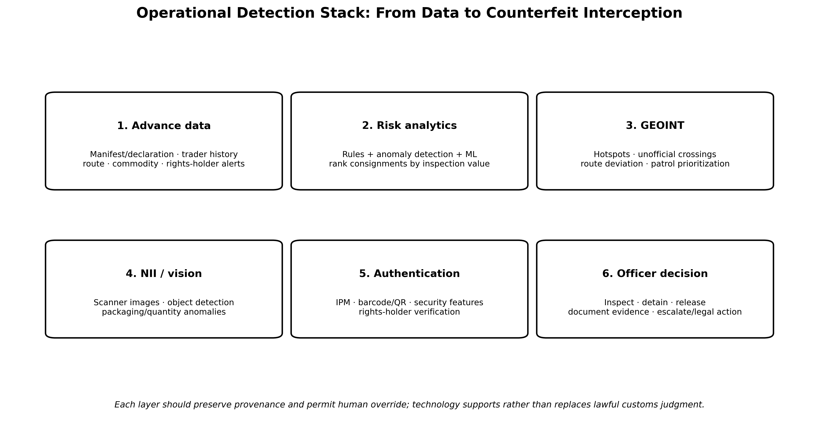
Figure 1. Layered operational detection stack for AI-enabled IPR targeting at land borders. Original author synthesis from WCO risk-management, GEOINT, NII and IPM practices.

2. Review Method and Evidence Base
The article is a structured technology-and-operations review rather than a meta-analysis. Evidence searches in August 2026 prioritized official Customs operational reports, WCO/WTO guidance, Nigeria-specific modernization evidence, current counterfeit-trade analysis and peer-reviewed research on Customs risk management and AI. Inclusion focused on sources that describe a real operational workflow, an evaluable analytical method, a governance requirement or a documented border-management outcome. Vendor marketing claims without independent or Customs-specific evidence were not used as core support.
Table 1. Core evidence streams for the technology review
Evidence stream | Representative evidence | Use in this review
Nigeria operational practice | NCS GEOINT experience; Operation GEOCONTROL; NCS modernization priorities | Grounds the discussion in terrain, connectivity, cooperation and real field deployment.
International Customs implementation | WCO AI/ML report; China Customs AI image analysis; IPM; SAFE 2025 | Defines proven use cases, implementation prerequisites and practical workflows.
Customs research | Vijayakumar (2025); Oussama et al. (2024); customs risk-management reviews | Supports analytical and institutional interpretation beyond official success narratives.
IPR/trade evidence | OECD/EUIPO 2025; WTO TRIPS and Nigeria trade-policy review | Defines enforcement demand, trade-facilitation balance and legal context.
AI/data governance | WCO BACUDA 2026; NDPA/GAID; AU AI Strategy | Defines data quality, monitoring, privacy and accountability requirements.

3. The Nigerian Smart-Border Operating Environment

3.1 Porous routes, terrain and fragmented visibility
Nigeria’s border environment makes spatial intelligence unusually important. NCS has described unofficial crossing points, sparse state presence, rapidly changing smuggling tactics, connectivity and power gaps, and siloed information among Customs, immigration, police, defence and environmental authorities (Labaran, 2025). GEOINT addresses part of this problem by combining satellite imagery, GIS, remote sensing, positioning data and analytics so that officers can see, measure and predict activity in space and time.

3.2 From training to operational deployment
In July 2026, Operation GEOCONTROL translated this capability into a joint Nigeria–Benin operation. WCO reported that the operation ran for eight days and produced 37 seizures across narcotics, pharmaceuticals, petroleum products and consumer goods. Officers used the WCO Geoportal, GIS/GEOINT, drones, CENcomm, risk profiling and field intelligence to identify hotspots and coordinate deployments (WCO, 2026a). Because the operation covered multiple threat categories, it should be interpreted as evidence that technology-enabled targeting is operationally feasible in the Nigeria–Benin corridor—not as a measured IPR classifier trial.
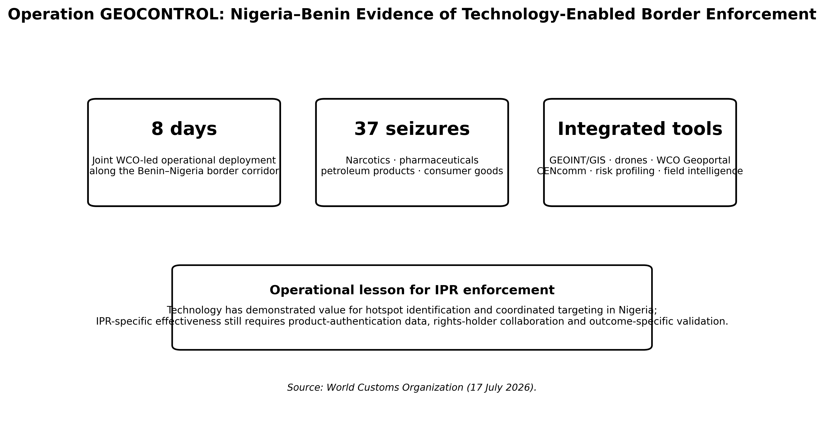
Figure 2. Operation GEOCONTROL as Nigeria–Benin evidence of technology-enabled Customs enforcement. Source: WCO (2026a); interpretation is limited to the multi-threat operation reported by WCO.

4. Data Architecture for Risk Targeting
The first technical requirement is a reliable event history. Supervised models require labelled outcomes: what was inspected, what was found, whether the finding was confirmed, and how the case was resolved. If only successful seizures are retained while released inspections disappear from the dataset, a model cannot learn the true false-positive structure. Likewise, if one border post inspects more heavily than another, historical data can encode enforcement intensity rather than underlying infringement risk.
Table 2. Data domains for AI-enabled IPR risk targeting
Data domain | Illustrative variables | Primary quality risks
Declaration / manifest | HS code, description, origin, value, quantity, weight, consignee, route | Free-text inconsistency, misclassification, missing identifiers, timing leakage
Trader / broker history | Prior compliance, inspections, verified infringements, AEO status, amendments | Historical enforcement bias, entity-resolution errors, outdated status
Transport / geospatial | Crossing point, GPS/telematics, route deviation, hotspot proximity, time | Coverage gaps, spoofing/error, lawful-purpose and retention constraints
NII / images | Scanner image, vehicle/container type, image quality, detected objects | Device/domain shift, artefacts, unbalanced labelled image classes
Rights-holder intelligence | Authorized importers, packaging, marks, barcodes, security features, alerts | Stale records, limited brand participation, confidentiality and access control
Case outcome | Release, detention, confirmed IPR infringement, disposal, prosecution/referral | Inconsistent outcome coding and delayed final labels

4.1 Data governance before machine learning
The WCO BACUDA Project’s 2026 position is directly applicable: data governance is the foundation for AI in Customs. Its six pillars—strategy and policy, organization and roles, standards and metadata, data quality, security/privacy/ethics, and monitoring/compliance—address the recurring failure mode in which administrations acquire analytical tools before resolving inconsistent definitions and unclear data ownership (WCO BACUDA, 2026). In practice, a Nigerian risk platform should maintain a data dictionary, model-ready timestamps, unique trader/consignment identifiers, documented source systems, quality exceptions and a traceable link from each training label to the underlying enforcement record.

5. AI/ML for Customs Risk Scoring and Anomaly Detection
Supervised classification is appropriate when a sufficiently large, representative set of confirmed outcomes exists. Candidate methods range from interpretable logistic regression and decision trees to random forests, gradient boosting and neural networks. The choice should follow the data and decision problem rather than a preference for complexity. In Customs settings, gradient-boosted or tree-based ensembles often provide a strong balance between nonlinear performance and feature-level explanation, while deep learning becomes more compelling for high-dimensional image or sequence data.
Anomaly detection is valuable where labels are scarce or fraud evolves rapidly. It can surface declarations, routes or networks that deviate from learned patterns without requiring every new modus operandi to be labelled in advance. Its main limitation is semantic: unusual does not equal illegal. Anomaly systems should therefore feed analyst review and targeted inspection rather than direct adverse enforcement action. Technology-centric Customs scholarship emphasizes the same point—analytics should augment risk management, not detach from it (Vijayakumar, 2025).

5.1 Graph and network analytics
IPR trafficking may involve repeated relationships among importers, declarants, transporters, addresses, routes and suppliers. Graph analytics can reveal clusters or shared links that are difficult to see in row-based declarations. The operational use is prioritization: a new entity connected to several confirmed infringement cases may warrant review. The governance risk is guilt by association. Network proximity should be treated as a risk feature with explainable weight, not as proof that the connected entity is itself non-compliant.

6. Geospatial Intelligence for Land-Border Selectivity
GEOINT adds spatial context to conventional risk scoring. A declaration model primarily sees a recorded movement through a formal process; GEOINT can reveal route activity, unofficial crossings, terrain constraints and changes that occur outside the declaration system. Nigeria’s documented experience includes mapping new paths, overlaying seizure data, monitoring transit corridors, and using geographic data to understand monitoring blind spots (Labaran, 2025).
For IPR enforcement, the strongest use is to optimize scarce patrol and inspection resources around routes associated with high-risk commodities or repeated illicit movements. The system should not attempt to infer product authenticity from geography alone. Instead, geospatial risk should be combined with commodity, trader, rights-holder and inspection evidence. This separation reduces the chance that geography becomes an opaque proxy for community or nationality.

7. AI-Assisted Non-Intrusive Inspection
NII systems allow Customs to examine the internal structure of vehicles and cargo without opening every consignment. Their operational bottleneck is image interpretation. China Customs began studying AI-assisted image analysis in 2014 and launched a dedicated project in 2017; by 2024 it described the AI-based image-analysis system as an established component of control and inspection operations (General Administration of China Customs, 2024). This history demonstrates technical feasibility at scale but also shows that capability maturation can take years of scanner-specific data, annotation, testing and deployment engineering.
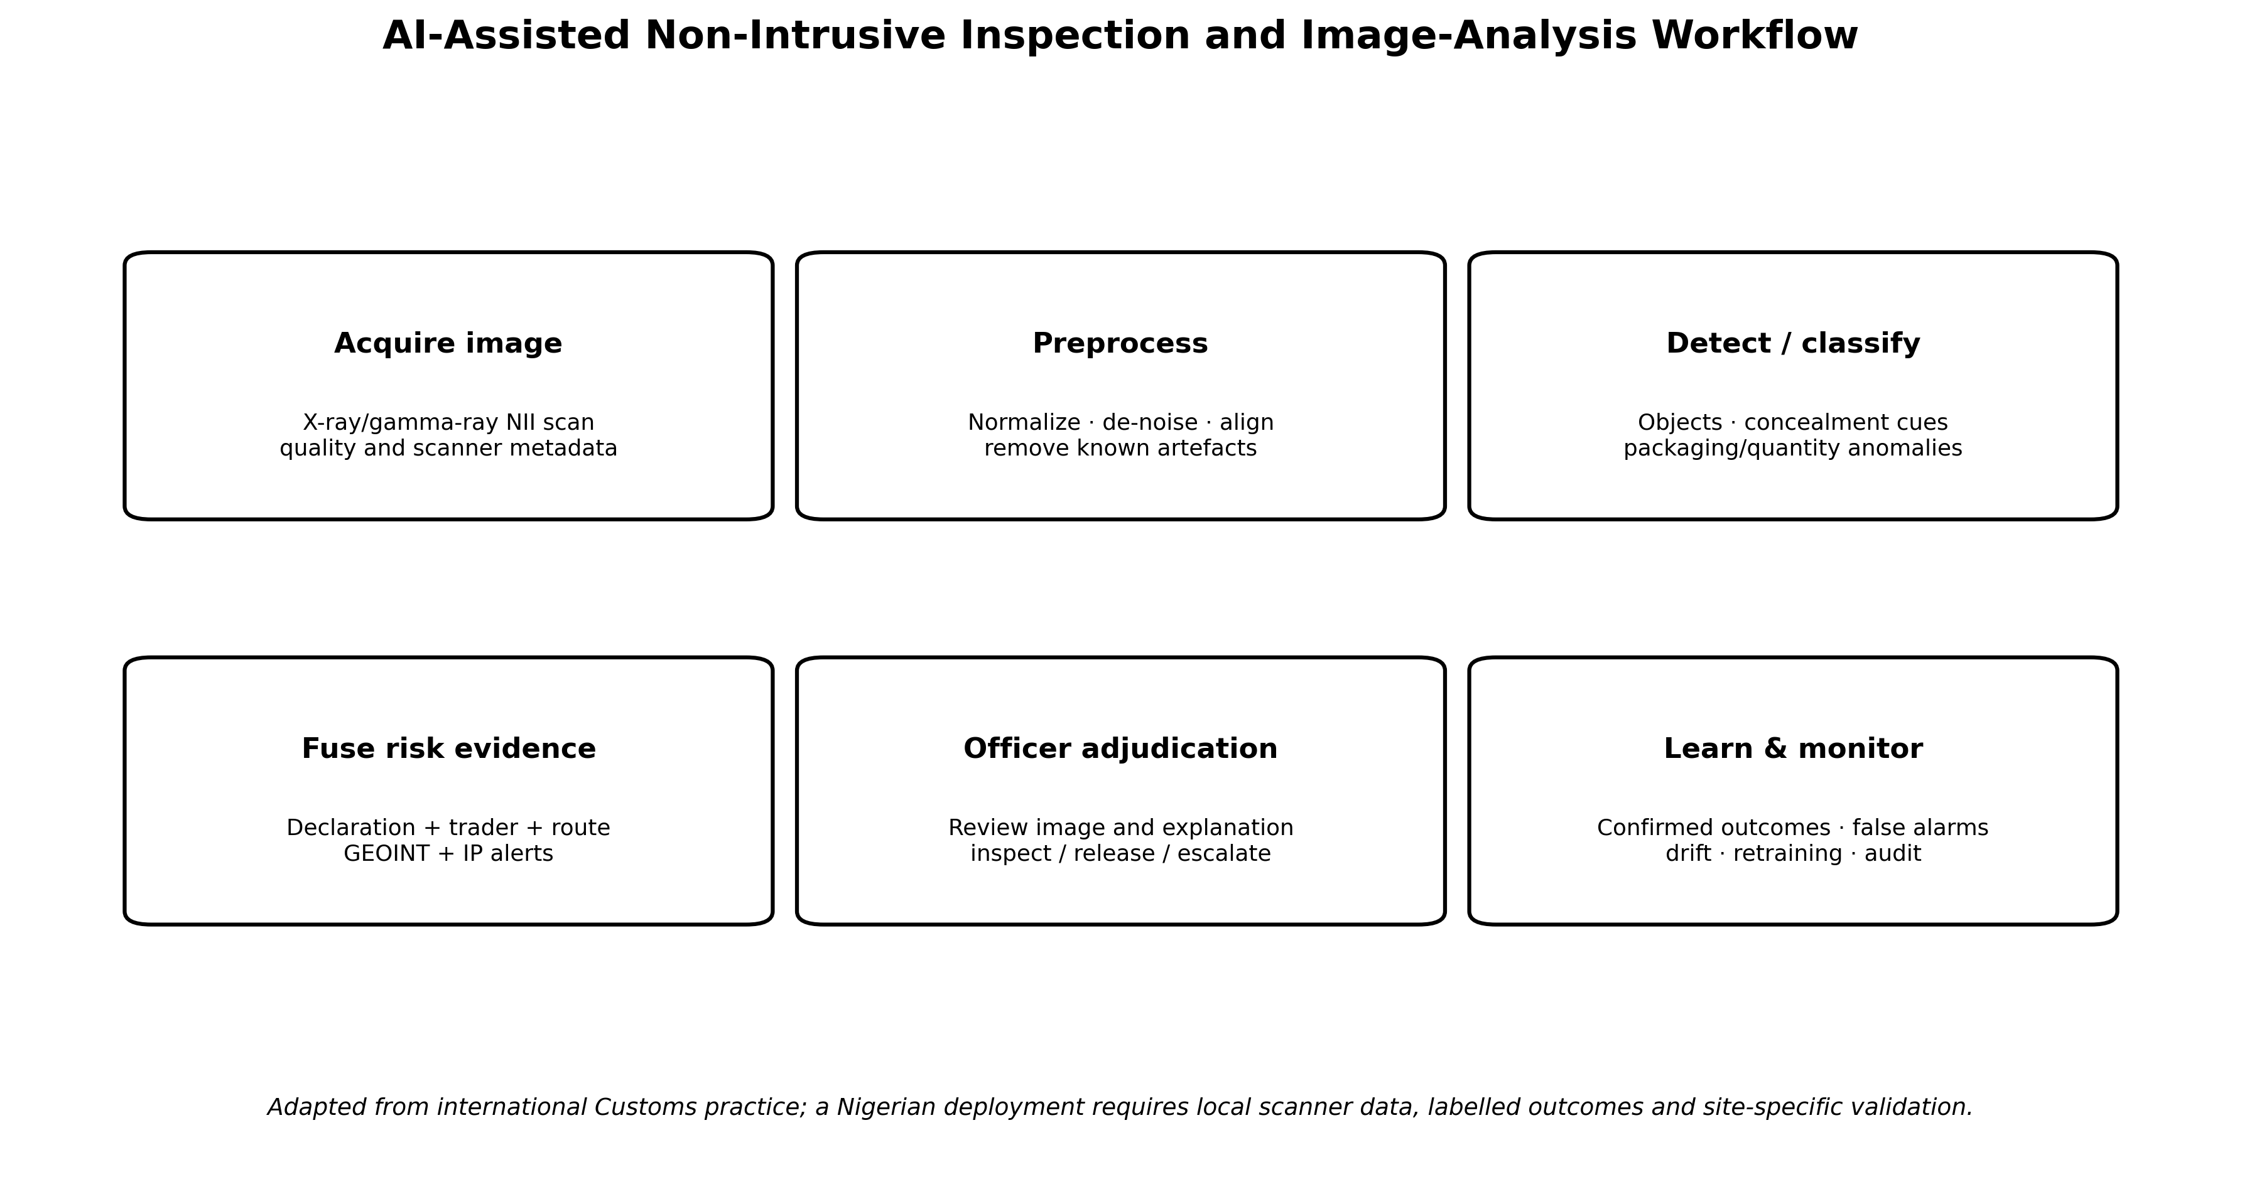
Figure 3. AI-assisted NII workflow from scanner acquisition to officer adjudication and model monitoring. Original author synthesis based on WCO/China Customs practice.

7.1 Local validation and domain shift
A model trained on images from one scanner fleet or country can fail when applied to different machines, cargo mixes or acquisition settings. This domain-shift problem makes local Nigerian validation non-negotiable. Each pilot should measure image quality, detection performance by scanner and border post, false alarms, officer acceptance and the change in inspection yield relative to the existing process. If the system cannot maintain performance after routine software, scanner or trade-pattern changes, it is not production-ready.

8. Product Authentication and Rights-Holder Intelligence
AI risk analytics identifies where to look; authentication helps determine what has been found. WCO IPM provides a useful model because it connects frontline Customs officers to rights-holder product data and can support barcode scanning, alerts, security-feature verification and route information (WCO, 2015). A Nigerian implementation should not duplicate every global system. It should create an interoperable rights-holder interface that can use WCO resources where available while maintaining national case records and rapid verification contacts.
Authentication systems should distinguish three levels of evidence: machine-readable identity signals such as barcodes or serials; physical and visual product features; and authoritative confirmation by rights holders or competent experts. A risk engine may combine these signals, but the final evidence record should show which level supported the decision. This is essential for later legal review and for retraining models using confirmed rather than assumed labels.

9. Human-in-the-Loop Decision Architecture
The decision boundary should be explicit. Models may recommend inspection, rank alerts or highlight image regions. Officers should review the evidence, apply Customs procedures and record the reason for release, inspection or detention. For decisions based on personal data that produce significant legal effects, Nigeria’s data-protection framework adds a further safeguard: Section 37 of the Nigeria Data Protection Act provides protections against solely automated decision-making and preserves human intervention and contest rights in relevant circumstances (Nigeria, 2023).
Table 3. Human–machine allocation for an AI-enabled IPR control workflow
Task | Machine role | Human / institutional role
Risk ranking | Calculate scores, anomalies and supporting feature explanations. | Set policy thresholds, review alerts, override where justified and document reasons.
GEOINT hotspot identification | Aggregate geospatial layers and rank areas/routes. | Validate intelligence, assess field safety/legal basis and deploy resources.
NII image analysis | Highlight suspicious regions or object classes. | Inspect raw image/context, determine need for physical examination and record disposition.
Product authentication | Retrieve matching records, scan codes, compare security features. | Assess authenticity evidence; contact rights holder/competent authority when needed.
Detention / enforcement | No autonomous legal determination. | Apply statutory powers, due process, evidence preservation, notification and review procedures.
Model learning | Use finalized labels and performance logs. | Approve training data, investigate errors, authorize version changes and monitor impacts.

10. Performance Evaluation: Beyond Accuracy
A Customs model can have high statistical accuracy and still be operationally poor if the positive class is rare, probabilities are poorly calibrated or false positives overwhelm inspection capacity. Evaluation must therefore start from the decision. For targeted inspection, precision or positive predictive value answers how many selected consignments produce a confirmed hit; recall answers how many known infringements are captured; calibration asks whether a stated risk probability corresponds to observed outcomes; and workload metrics determine whether the number of alerts is usable.
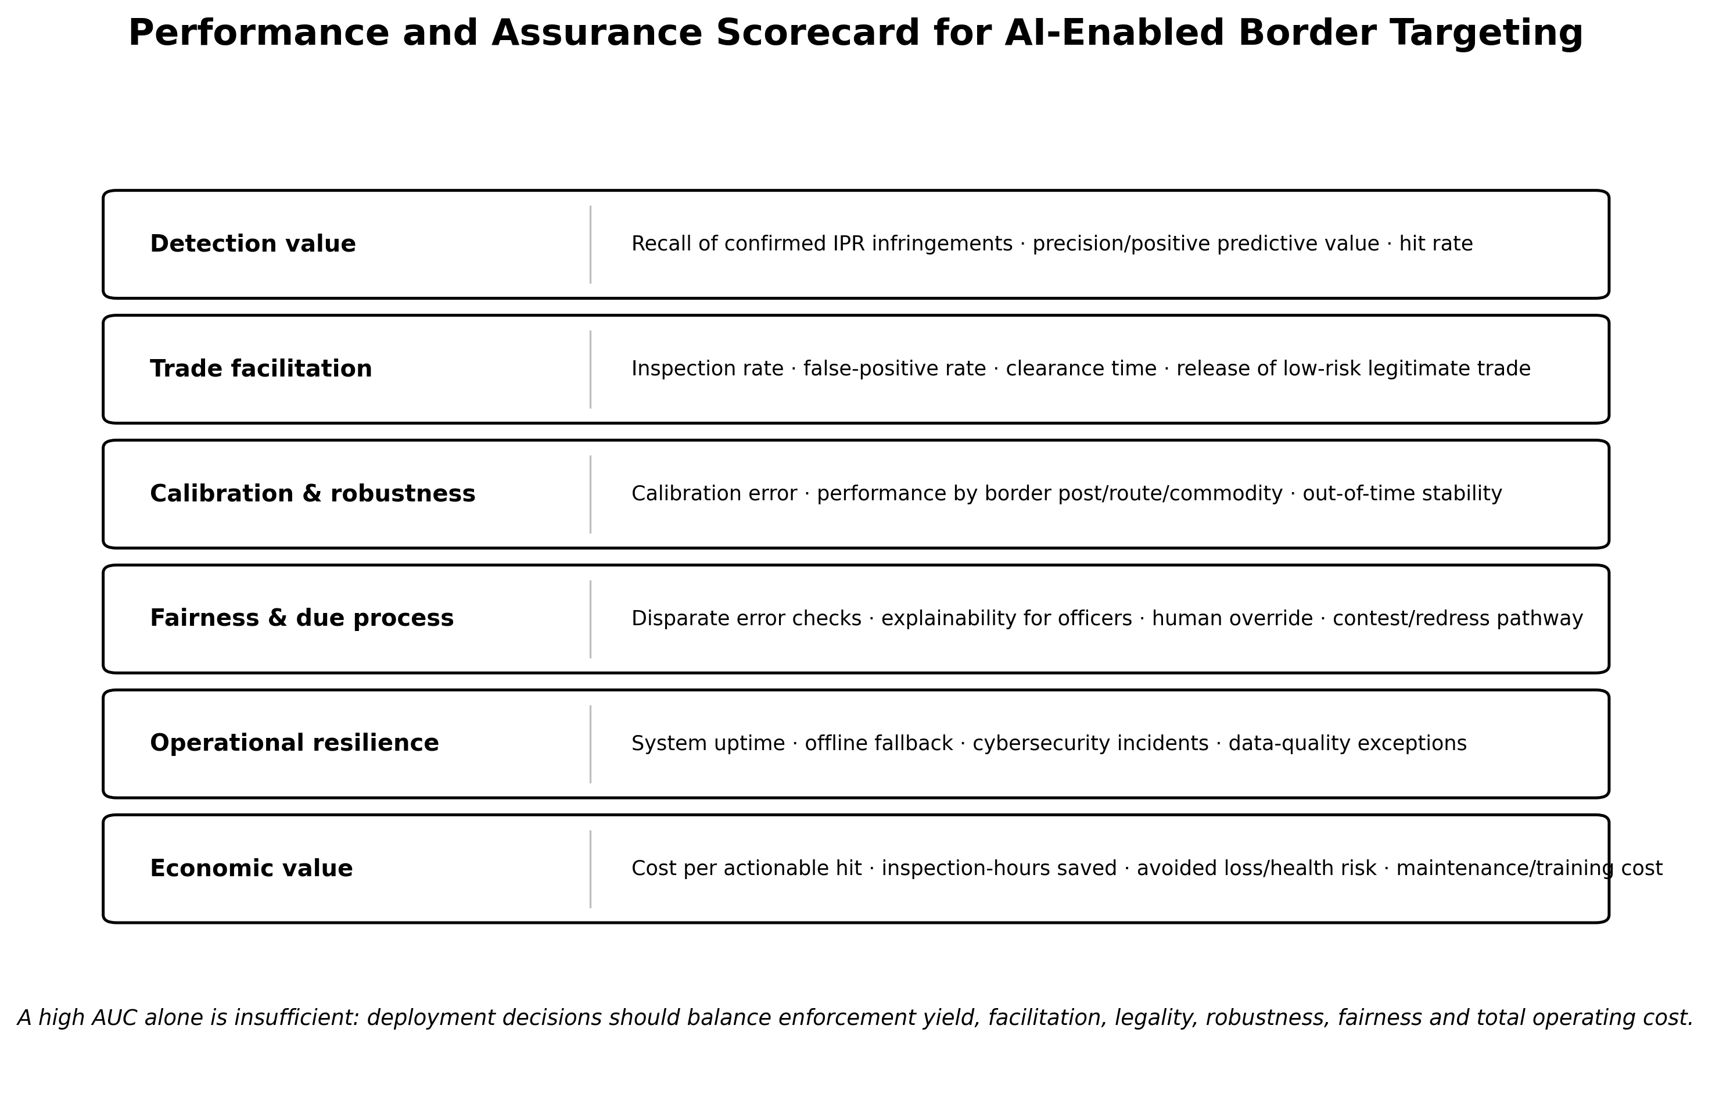
Figure 4. Performance and assurance scorecard for AI-enabled border targeting. The scorecard combines enforcement yield, trade facilitation, robustness, rights safeguards, resilience and cost.

10.1 Minimum model-validation protocol
• Use time-based or out-of-time validation so the test set occurs after the training period and better represents future deployment.
• Report precision, recall, F1, ROC-AUC or PR-AUC as appropriate, but also calibration and hit rate at the actual inspection capacity.
• Compare against transparent baselines such as current risk rules, analyst selection and simple statistical models.
• Stratify results by border post, scanner, commodity group, route and relevant trader category to expose domain-specific failure.
• Measure trade-facilitation impact: inspection rate, false-positive inspections, clearance time and delay for compliant low-risk trade.
• Monitor data drift, performance drift, override rates, complaint/review outcomes, security incidents and total operating cost after deployment.

11. Cybersecurity, Privacy and Resilience
Smart-border systems concentrate valuable trade, identity, route and enforcement intelligence, making them attractive cyber targets. WCO AI/ML guidance and SAFE 2025 both emphasize cybersecurity and interoperability. Access should therefore be role-based, privileged actions logged, data encrypted in transit and at rest where appropriate, and systems designed with incident response and offline fallback. Border posts with unreliable power or connectivity require graceful degradation: an AI platform that prevents lawful processing when the network is unavailable can reduce rather than improve resilience.
Privacy safeguards should be proportionate to purpose. Not every Customs risk model requires biometric or person-level surveillance. The AU Continental AI Strategy and Nigerian data-protection rules support data minimization, transparency, accountability and rights-respecting AI. Where high-risk surveillance data are genuinely necessary, DPIA, retention limits, access controls and oversight should precede deployment rather than be added after procurement.

12. Implementation Architecture for Nigeria
A realistic national architecture should be modular. Border posts can begin with standardized electronic risk data and officer dashboards, then add GEOINT layers, rights-holder verification and NII analytics where infrastructure and case volume justify them. Shared national services should handle identity resolution, model registry, monitoring and audit; local posts should retain operational judgment and offline workflows. This reduces duplicated procurement and makes model performance comparable across locations.
Table 4. Priority implementation sequence for Nigeria
Priority | Capability | Evidence gate before scaling
1 | Data governance, case outcome coding, rights-holder contact registry, common identifiers | Completeness/quality thresholds; documented ownership; privacy/security review
2 | GEOINT + risk dashboard at selected corridors | Measured hotspot usefulness; patrol/inspection outcomes; operator usability
3 | ML risk ranking on historical and live declarations | Out-of-time superiority to current baseline; calibration; manageable alert volume
4 | NII computer vision at selected scanners | Scanner-specific validation; false-alarm analysis; officer review performance
5 | Integrated IPR authentication and case management | Verification turnaround, evidence quality and rights-holder response performance
6 | Cross-border/inter-agency data exchange and scale-out | Interoperability, legal agreements, cyber assurance, external validation and cost-benefit evidence

13. Discussion
The evidence suggests that Nigeria does not need to begin from a hypothetical smart-border model. The country already has documented geospatial capability, modernization plans for AI-supported risk management and a recent joint operational example in GEOCONTROL. The next research and management challenge is to convert these building blocks into a measured IPR detection system with high-quality outcome data and interoperable rights-holder intelligence.
International lessons point to three design principles. First, use multiple evidence modalities because no single model can represent the legal and physical complexity of counterfeiting. Second, validate locally: Customs data are strongly shaped by routes, enforcement practices, scanners and trade patterns. Third, evaluate the system, not only the algorithm. A model that raises precision but increases clearance delays, creates unexplained disparities or fails when connectivity is lost may not improve border management overall.

13.1 Limitations and research priorities
There is no published Nigeria-specific benchmark dataset that permits independent comparison of AI models for confirmed IPR infringement at land borders. Public descriptions of operational technologies also disclose limited model-level detail for understandable security reasons. The proposed architecture therefore synthesizes demonstrated components rather than claiming measured Nigerian end-to-end performance. Priority research should build de-identified, legally governed benchmark datasets; compare rules, conventional ML and advanced models; test generalization across border posts; and evaluate officer–AI team performance in realistic workflows.

14. Conclusion
AI-enabled Customs control is best understood as a chain of selective evidence rather than a single predictive model. Advance data and analytics identify where risk is elevated; GEOINT identifies where border activity deserves attention; NII and computer vision help determine what is physically present; product-authentication systems connect the inspection to IPR-specific knowledge; and accountable officers convert these signals into lawful decisions. Nigeria’s recent GEOINT experience demonstrates that elements of this chain are already operationally relevant.
For e043’s central question—how to move from risk profiles to counterfeit interception—the answer is disciplined integration. The strongest system will be one that increases confirmed enforcement yield while reducing unnecessary inspections, remains robust across routes and equipment, protects sensitive data, records human judgment and generates evidence suitable for review. That is a more demanding standard than model accuracy, but it is the standard required for technology to strengthen both border enforcement and legitimate trade.

Declarations
Ethics: Not applicable. This article is a review and does not report new human-participant or animal research.
Funding: The author declares that no external funding was received specifically for preparation of this article.
Competing interests: The author declares no competing interests.
Data availability: No new primary dataset was generated. Quantitative statements and operational examples are traceable to the cited official and scholarly sources.
Author contribution: AMENGER, Gbaden: conceptualization, critical evidence synthesis, framework development, interpretation, visualization and manuscript authorship.
AI-assisted editorial support: AI-assisted tools were used for language refinement, document formatting, visualization support and reference-consistency checking. They were not used as an author or as a substitute for source verification and professional judgement; responsibility for the final article remains with the author and journal editor.
Copyright and licence: © 2026 The Author. Published by CHIA TECH SOLUTIONS AND RESOURCES LIMITED (RC 1839865). This open-access article is distributed under the Creative Commons Attribution 4.0 International (CC BY 4.0) licence, except for third-party material otherwise identified.

References
African Union. (2024). Continental artificial intelligence strategy. African Union Commission.
Adam P., N. N., Rosyadi, F. R., Prastyono, A., & Iswandi. (2025). The integration of artificial intelligence in customs risk management: A systematic literature review. Jurnal Perspektif Bea dan Cukai, 9(3).
General Administration of China Customs. (2024). Automating image analysis: China Customs implements new model for the development and deployment of algorithms. WCO News, 104.
Labaran, A. (2025). Leveraging geospatial intelligence: The experience of Nigeria. WCO News, 108.
Ng’wasa, N. (2025). Artificial intelligence in Customs risk management: Opportunities and readiness in the Tanzania Revenue Authority. Performance: Journal of Law and Humanities, 3(2).
Nigeria. (2023). Nigeria Data Protection Act, 2023 (Act No. 37 of 2023).
Nigeria Customs Service. (2025). Press briefing on the activities of the Nigeria Customs Service for the year 2024. Nigeria Customs Service.
Nigeria Data Protection Commission. (2025). General Application and Implementation Directive (GAID) to the Nigeria Data Protection Act 2023. NDPC.
OECD & European Union Intellectual Property Office. (2025). Mapping global trade in fakes 2025: Global trends and enforcement challenges. OECD Publishing. https://doi.org/10.1787/94d3b29f-en
Oussama, R., Nacer, B., & Wissam, A. (2024). The role of artificial intelligence in managing customs risk for Algerian customs. Les Cahiers du CREAD, 40(1), 285–317. https://doi.org/10.4314/cread.v40i1.10
Vijayakumar, S. (2025). Technology-centric and data-driven Customs risk management for supply chain security. World Customs Journal, 19(1), 38–63. https://doi.org/10.55596/001c.131745
World Customs Organization. (2015). WCO launches the new IPM platform. WCO.
World Customs Organization. (2022). Capacity Building Framework on Data Analytics. WCO.
World Customs Organization. (2023). Customs Risk Management Compendium (updated edition). WCO.
World Customs Organization. (2025a). Detailed report on the adoption of artificial intelligence and machine learning in Customs. WCO Smart Customs Project.
World Customs Organization. (2025b). SAFE Framework of Standards to Secure and Facilitate Global Trade: 2025 edition. WCO.
World Customs Organization. (2026a). Benin and Nigeria catch smugglers in first-of-its-kind geospatial intelligence-led Customs operation. WCO, 17 July 2026.
World Customs Organization. (2026b). Study report on disruptive technologies 2026. WCO Smart Customs Project.
World Customs Organization BACUDA Project. (2026a). Data governance as the foundation for AI in Customs. WCO, 31 July 2026.
World Customs Organization BACUDA Project. (2026b). New e-learning course on data governance for Customs. WCO, 2 June 2026.
World Customs Organization & World Trade Organization. (2022). The role of advanced technologies in cross-border trade: A Customs perspective. WTO/WCO.
World Trade Organization. (1994). Agreement on Trade-Related Aspects of Intellectual Property Rights (TRIPS Agreement).
World Trade Organization. (2024). Trade policy review: Nigeria (WT/TPR/S/462). WTO.
Zahorsky, T., Semjonova, D., & Krumins, G. (2024). Challenges for Customs risk management today: A literature review. Journal of Risk and Financial Management, 17(8), 321. https://doi.org/10.3390/jrfm17080321
CHIATECH JOURNAL · SETEHEM · Volume 1 · Issue 1 · August 2026 · e043 · Pioneer Publication

