CHIATECH JOURNAL
  - SETEHEM · VOLUME 1 · ISSUE 2 · AUGUST 2026 · e044
  - PIONEER PUBLICATION · ACCEPTED ARTICLE · CRITICAL ENGINEERING REVIEW AND IMPLEMENTATION FRAMEWORK · ELECTRICAL/ELECTRONIC ENGINEERING · ENERGY RESILIENCE · BORDER OPERATIONS

Resilient Hybrid Power Architecture for 24/7 Nigeria Customs Land-Border Operations: Grid, Solar PV, Battery Storage and Generator Coordination
AMENGER, Gbaden
Nigeria Customs Service, Ogun State Command, Nigeria
Officer-in-Charge (Electricity), Idiroko Barracks, Ogun I Area Command
Correspondence: amengergbaden1@gmail.com
ARTICLE TYPE  Critical Engineering Review | VOLUME / ISSUE  1(1) | ELOCATOR  e044
PUBLICATION  Pioneer Issue · August 2026 | IDENTIFIERS  ISSN: Pending assignment | JOURNAL DOI  Pending registration

Abstract
Background: Nigeria Customs land-border commands increasingly depend on continuous electricity for communications, ICT, access control, lighting, electronic documentation, surveillance and, where deployed, non-intrusive inspection and other smart-border technologies. Yet national-grid variability and local distribution constraints make generator dependence a persistent operational risk. Objective: This review synthesizes Nigerian power-sector evidence, Customs modernization requirements and microgrid-resilience literature to develop a practical hybrid energy framework for 24/7 border operations. Review approach: Official evidence from NERC, the Nigeria Energy Transition Plan, World Bank distributed-energy programmes, Nigeria Customs Service and World Customs Organization guidance was integrated with peer-reviewed literature on solar-battery-diesel microgrids, battery storage, resilience, energy management and protection through August 2026. Synthesis: NERC reported that average available grid-connected generation fell from 5,400.38 MW in 2025/Q4 to 4,457.96 MW in 2026/Q1, while Q1 2026 recorded one total and one partial system collapse. A border command should therefore treat utility supply as one source rather than the sole source. The proposed architecture combines grid supply, solar PV, lithium-ion battery energy storage, standby generators, automatic transfer/static switching, load criticality, protection and an energy-management system. Battery storage provides rapid ride-through and short-duration autonomy; solar reduces daytime fuel use and recharges storage; generators become controlled long-duration backup rather than continuously loaded prime sources. The framework emphasizes measured load profiles, N+1 thinking for critical backup, battery state-of-charge reserves, power-quality monitoring, black-start capability, preventive maintenance and lifecycle-cost optimization. Conclusion: Maximum border availability is achieved not by adding more generators but by engineering source diversity, fast storage, protected critical buses and disciplined control. Nigeria Customs should move from fragmented grid-generator-solar arrangements toward standardized, monitored hybrid microgrids designed around mission-critical loads and locally validated reliability targets.
Keywords: energy resilience; hybrid microgrid; Nigeria Customs Service; land-border operations; solar photovoltaic; battery energy storage system; diesel generator; critical infrastructure; power quality; energy management system
Suggested citation: Amenger, G. (2026). Resilient hybrid power architecture for 24/7 Nigeria Customs land-border operations: Grid, solar PV, battery storage and generator coordination. CHIATECH JOURNAL · SETEHEM, 1(1), e044.

1. Introduction
Electricity reliability has become an operational variable in border management. Modern Customs posts no longer depend only on lighting and office equipment; they increasingly rely on networked declaration systems, radio and data communications, CCTV, access-control systems, digital evidence, servers, charging infrastructure and technology-assisted inspection. Nigeria Customs Service modernization priorities include technology-enabled risk management and deployment of additional scanning systems, while WCO guidance treats ICT and non-intrusive inspection as core enablers of secure and efficient Customs control (Nigeria Customs Service [NCS], 2025a, 2025b; World Customs Organization [WCO], 2025). An interruption that disables these systems can therefore become an enforcement, trade-facilitation and safety problem rather than a simple building-services inconvenience.
The Nigerian electricity context makes this dependence difficult to manage with a single source. NERC reported an average available generation capacity of 4,457.96 MW in 2026/Q1, 17.45% below 2025/Q4, with average hourly grid generation declining by 7.64%. The quarter also recorded a total grid collapse on 23 January and a partial collapse on 27 January; average daily frequency and voltage excursions remained outside normal Grid Code limits (NERC, 2026a). These national statistics do not describe the exact supply conditions at any particular Customs formation, but they justify a resilience strategy in which utility power is treated as a variable source whose interruptions and quality deviations must be absorbed locally.
The problem is especially relevant at land-border commands where operations are continuous, security-sensitive and geographically exposed. The author’s engineering practice context at Idiroko Barracks includes intermittent grid supply, dependence on standby generators and limited solar sources. This professional context motivates the review but is not presented as a site energy audit; no confidential load, fuel, security or infrastructure records are disclosed. The paper instead develops a scalable engineering framework that can be adapted to Idiroko and other Nigerian border formations after measured load and site studies.
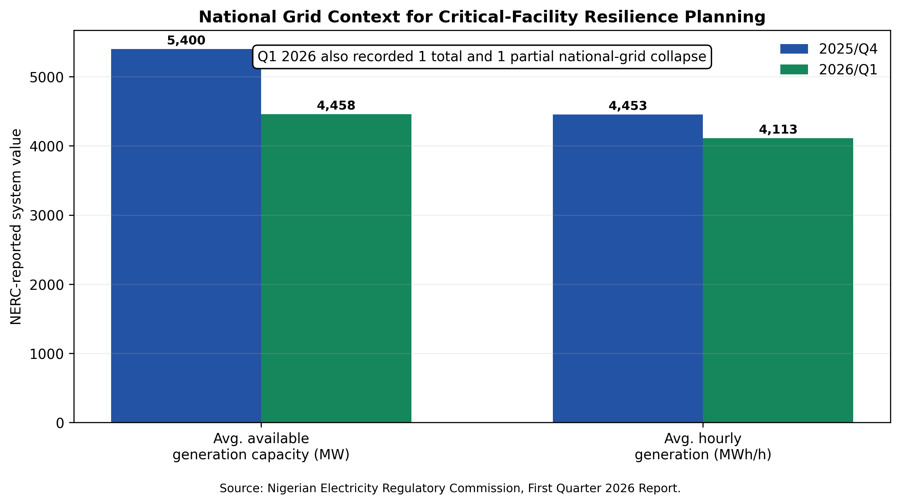
Figure 1. National-grid evidence relevant to critical-facility resilience planning. NERC reported lower available generation and average hourly generation in 2026/Q1 than 2025/Q4, with two system disturbances during the quarter (NERC, 2026a).

1.1 Review questions and contribution
The review addresses four questions: (1) what electricity-supply risks threaten continuous land-border operations; (2) what functional role should grid supply, solar PV, BESS and generators play in a resilient architecture; (3) how should critical loads, protection, control and maintenance be organized; and (4) what phased implementation pathway can move Customs formations from reactive generator dependence to evidence-based hybrid operation. The principal contribution is an operations-centred architecture that links electrical design choices to border continuity rather than treating renewable energy as a stand-alone sustainability project.

2. Review Method and Evidence Base
This paper is a critical engineering review and design synthesis rather than an empirical site study or techno-economic optimization of a measured Customs load profile. Searches were updated through August 2026 and prioritized: NERC operational and regulatory evidence; World Bank and Nigeria Energy Transition Plan material on distributed renewable energy; NCS and WCO documentation on technology-dependent Customs operations; IEA and IRENA evidence on batteries and smart mini-grids; and peer-reviewed research on hybrid PV-battery-diesel systems, energy management, microgrid resilience and protection. Evidence was retained when it informed source reliability, critical-load continuity, hybrid architecture, sizing logic, protection, control, lifecycle performance or implementation governance. Site-specific capacities and cost claims are deliberately avoided where measured Idiroko data are unavailable.

Table 1. Evidence streams used in the engineering synthesis
Evidence stream | Representative evidence | Design relevance
Nigeria grid and regulation | NERC 2026/Q1 performance; Mini-Grid Regulations 2026; captive-generation framework | Defines reliability context, regulatory due diligence and need for compliant electrical design.
Distributed renewable energy | World Bank DARES; Nigeria Energy Transition Plan | Supports distributed solar, storage and mini-grid approaches as national reliability pathways.
Customs operating requirements | NCS modernization and NII documentation; WCO ICT/NII guidelines | Establishes the growing operational dependence on electricity-backed digital systems.
Battery and mini-grid engineering | IEA 2024; IRENA 2020; peer-reviewed microgrid literature | Supports BESS ride-through, hybrid control, standards, quality infrastructure and resilience.
Nigeria-specific hybrid studies | Esan et al. 2019; Amuta et al. 2023 | Demonstrates technical/economic feasibility of PV-battery-diesel hybridization in Nigerian conditions.

3. Why Generator Dependence Is Not an Energy-Resilience Strategy
Standby generators are valuable because they are dispatchable, familiar and able to support long outages. The weakness arises when they become the default prime source for a facility whose electrical system has not been redesigned around source diversity and load priority. Generator-only continuity carries four operational exposures: fuel availability and price, engine failure, maintenance downtime and low-load inefficiency. It also introduces switching delay, noise, local emissions and the possibility that a single large unit becomes a single point of failure. World Bank distributed-energy programmes explicitly target replacement of large numbers of costly and polluting petrol/diesel generator sets with cleaner distributed solutions, while Nigerian hybrid-system studies consistently show that renewable-plus-storage configurations can reduce diesel dependence and emissions (World Bank, 2023; Esan et al., 2019; Amuta et al., 2023).
The engineering objective is therefore not generator elimination. For a security-sensitive border facility, a generator remains a valuable long-duration and black-start-capable source. The design shift is to operate generators less often, at more efficient loading, with battery storage absorbing fast transients and solar serving daytime energy. This is consistent with contemporary hybrid-plant energy-management research, which treats battery degradation, renewable uncertainty, generator scheduling and emissions as coupled operational costs rather than optimizing any one component in isolation (Amer et al., 2024).

4. Proposed Hybrid Architecture for 24/7 Border Operations
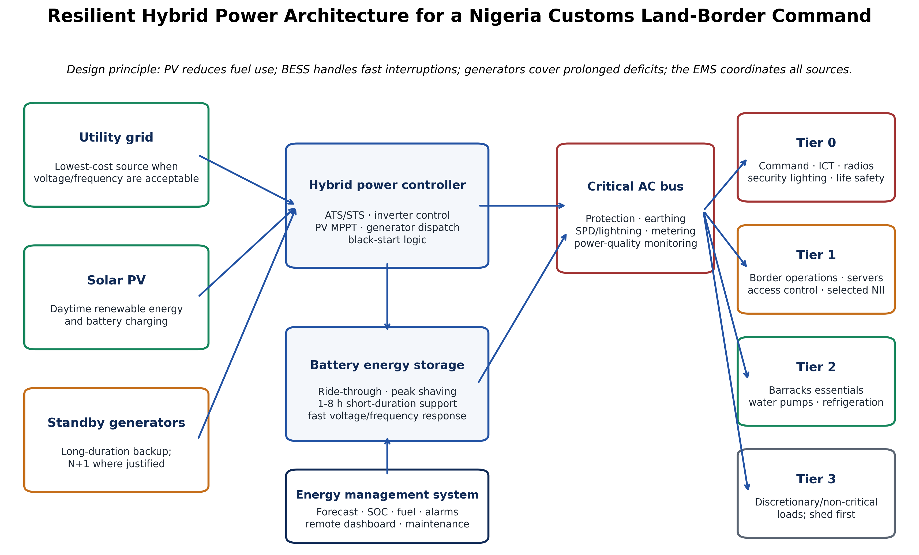
Figure 2. Proposed hybrid power architecture for a Nigeria Customs land-border command. The architecture separates energy sources from a protected critical bus and applies tiered load shedding, storage reserves and supervisory energy management. Original author synthesis.

4.1 Utility grid: economical but non-firm input
Where grid supply is available, it should remain an important input because it can reduce the required renewable and storage capacity. However, the point of common coupling should be monitored for voltage, frequency, phase sequence, outages and restoration stability. Automatic transfer logic should include delay and qualification windows so that unstable returning supply does not repeatedly transfer critical loads. Sensitive ICT and control circuits may require online UPS conditioning even when the broader site BESS is present.

4.2 Solar PV: energy source, not instantaneous continuity device
Solar PV is well matched to daytime border loads and can reduce generator runtime, but PV output alone cannot guarantee continuity because it varies with irradiance and disappears at night. Nigeria’s Energy Transition Plan projects a large long-run role for solar and storage, while the DARES programme is scaling distributed renewable energy precisely because grid-connected users can still face insufficient and unreliable supply (Nigeria Energy Transition Plan, n.d.; World Bank, 2023). For border applications, PV capacity should be derived from measured daily energy, roof/ground availability, shading, structural conditions and a defined solar-energy fraction; it should not be sized only from connected load.

4.3 Battery energy storage: the fast resilience layer
BESS closes the response-time gap between a grid event and generator availability. The IEA notes that batteries can provide 1–8 hours of short-duration flexibility and can serve as critical backup for facilities such as emergency-response centres and communications infrastructure (IEA, 2024). In a Customs microgrid, the battery should carry no-break critical loads, absorb PV variability, shave generator peaks, support black start and preserve a minimum state-of-charge reserve for unplanned events. Lithium iron phosphate chemistry is attractive for stationary use because of its thermal characteristics and cycle life, but chemistry selection must be based on certified products, environmental conditions, fire strategy, warranty, lifecycle and local support.

4.4 Standby generators: tertiary reliability and long-duration autonomy
Generators should be sized against essential peak demand, motor starting/transient requirements, ambient derating and the desired redundancy philosophy. Two smaller units can provide N+1 capability and better part-load scheduling than one oversized set, but duplication must be justified by consequence-of-failure analysis and lifecycle cost. Generator controls should exchange status with the EMS so that starts are based on outage duration, BESS state of charge, load forecast and fuel reserve—not merely on loss of grid voltage.

4.5 Critical bus, protection and energy management
A hybrid system becomes dependable only when electrical protection and control are engineered as carefully as generation. Required functions include selective overcurrent protection, short-circuit and earth-fault studies, earthing, surge protection, lightning protection, anti-islanding/interconnection protection where applicable, neutral/earthing arrangements compatible with operating mode, safe automatic transfer, generator synchronism logic where parallel operation is allowed, battery protection and fire controls, and power-quality metering. IRENA emphasizes that quality infrastructure, testing, certification and system-level monitoring are central to reliable smart mini-grids (IRENA, 2020). Microgrid protection research likewise shows that grid-connected and islanded modes create different fault-current and coordination conditions that must be addressed in design (Kumar et al., 2024).

5. Critical-Load Engineering: Power What the Border Must Not Lose
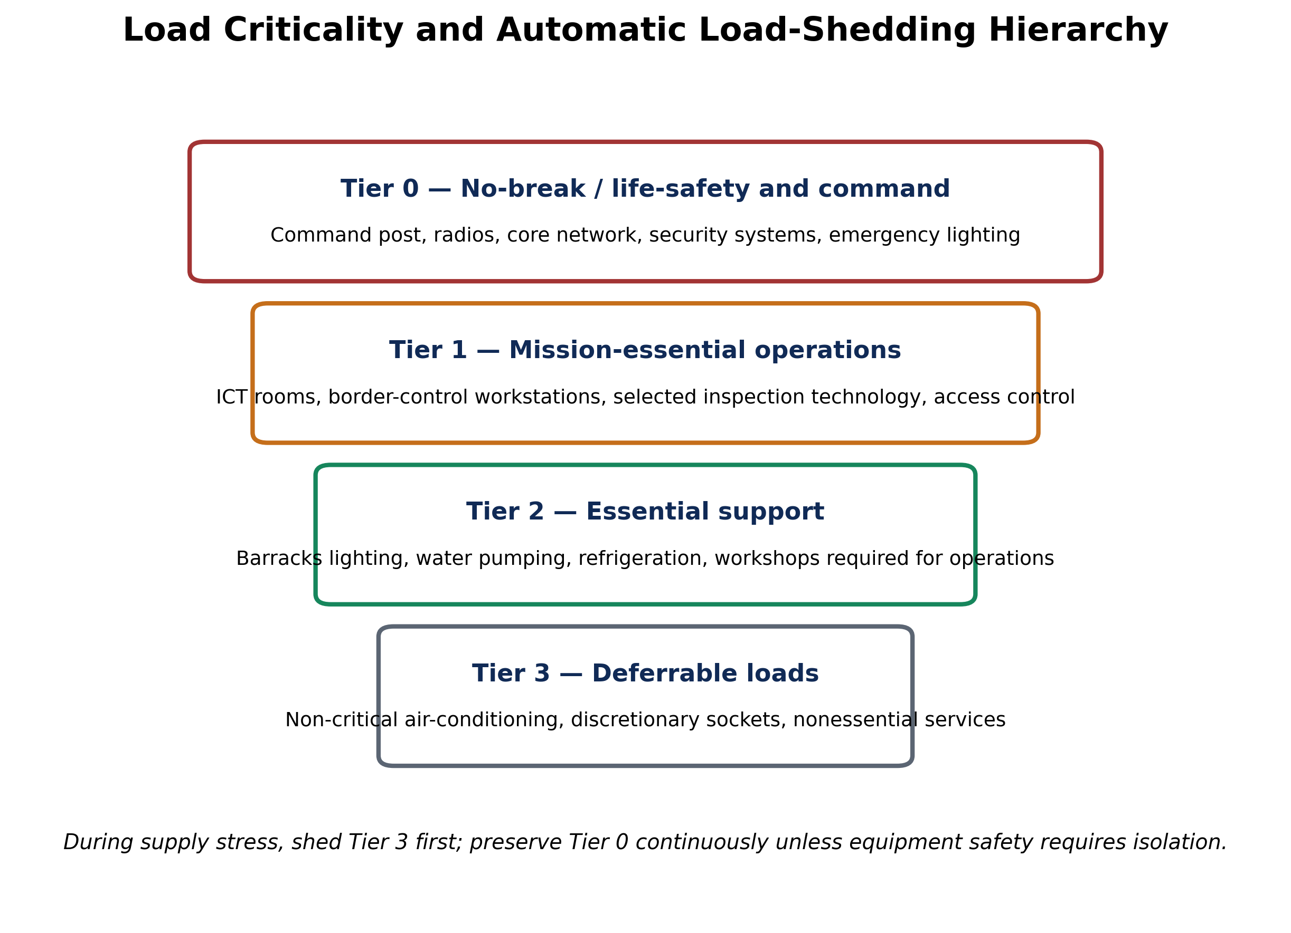
Figure 3. Load-criticality hierarchy for resilient border operations. The exact equipment assigned to each tier must be established by a site load audit and operational-risk assessment. Original author synthesis.
Load segmentation is the most cost-effective resilience measure because it prevents noncritical consumption from dictating the size of expensive backup assets. Tier 0 should include loads whose interruption immediately compromises command, safety, communications or security. Tier 1 supports mission-essential border processes and selected technology. Tier 2 supports barracks functions needed to sustain personnel and operations. Tier 3 contains discretionary loads that can be shed during source stress. This approach allows the critical bus to remain energized even when the total compound load cannot be supported.
Table 2. Suggested load classes and continuity strategy
Class | Typical border loads | Continuity strategy | Design note
Tier 0 — No-break | Command room, core routers/switches, radio base equipment, access control, security/escape lighting | Online UPS/BESS-supported critical bus with immediate ride-through | Aim for no switching interruption visible to sensitive electronics.
Tier 1 — Mission-essential | Customs workstations, servers, selected CCTV, inspection support, selected NII subsystems where applicable | BESS + generator-backed; automatic load priority | Vendor-specific power-quality requirements for scanners/NII must govern.
Tier 2 — Essential support | Water pumping, refrigeration, barracks essential lighting, critical workshop loads | Delayed connection after source stabilizes | Sequence motors to avoid simultaneous starting peaks.
Tier 3 — Deferrable | Noncritical AC, discretionary sockets, ornamental/exterior nonsecurity loads | Automatic or manual shedding first | Use demand control to reduce BESS and generator size.

6. Sizing Logic for PV, Battery and Generator Capacity
A publication-quality design should begin with at least 30 days of interval load logging at the main incomer and, where possible, at critical subpanels. The audit should record real and apparent power, maximum demand, power factor, voltage/frequency excursions, outage duration, generator runtime, fuel consumption, and the duty cycles of major motors and cooling systems. Seasonal and operational peaks should be included. Connected-load schedules alone are inadequate because they obscure diversity, starting currents and actual energy use.
For a first-pass engineering estimate, daily energy is E_day = Σ(P_i × t_i). A solar array can then be approximated from P_PV ≈ E_solar / (PSH × PR), where PSH is bankable site peak-sun-hour data and PR is a performance ratio incorporating temperature, wiring, inverter, soiling and mismatch losses. Battery energy for a critical load can be estimated from E_BESS,nom ≈ P_critical × t_autonomy /(DoD × η × EOL), with explicit depth-of-discharge, conversion-efficiency and end-of-life capacity assumptions. These equations are screening tools, not substitutes for time-series simulation, inverter power checks, battery C-rate limits, thermal design, short-circuit studies and manufacturer data.
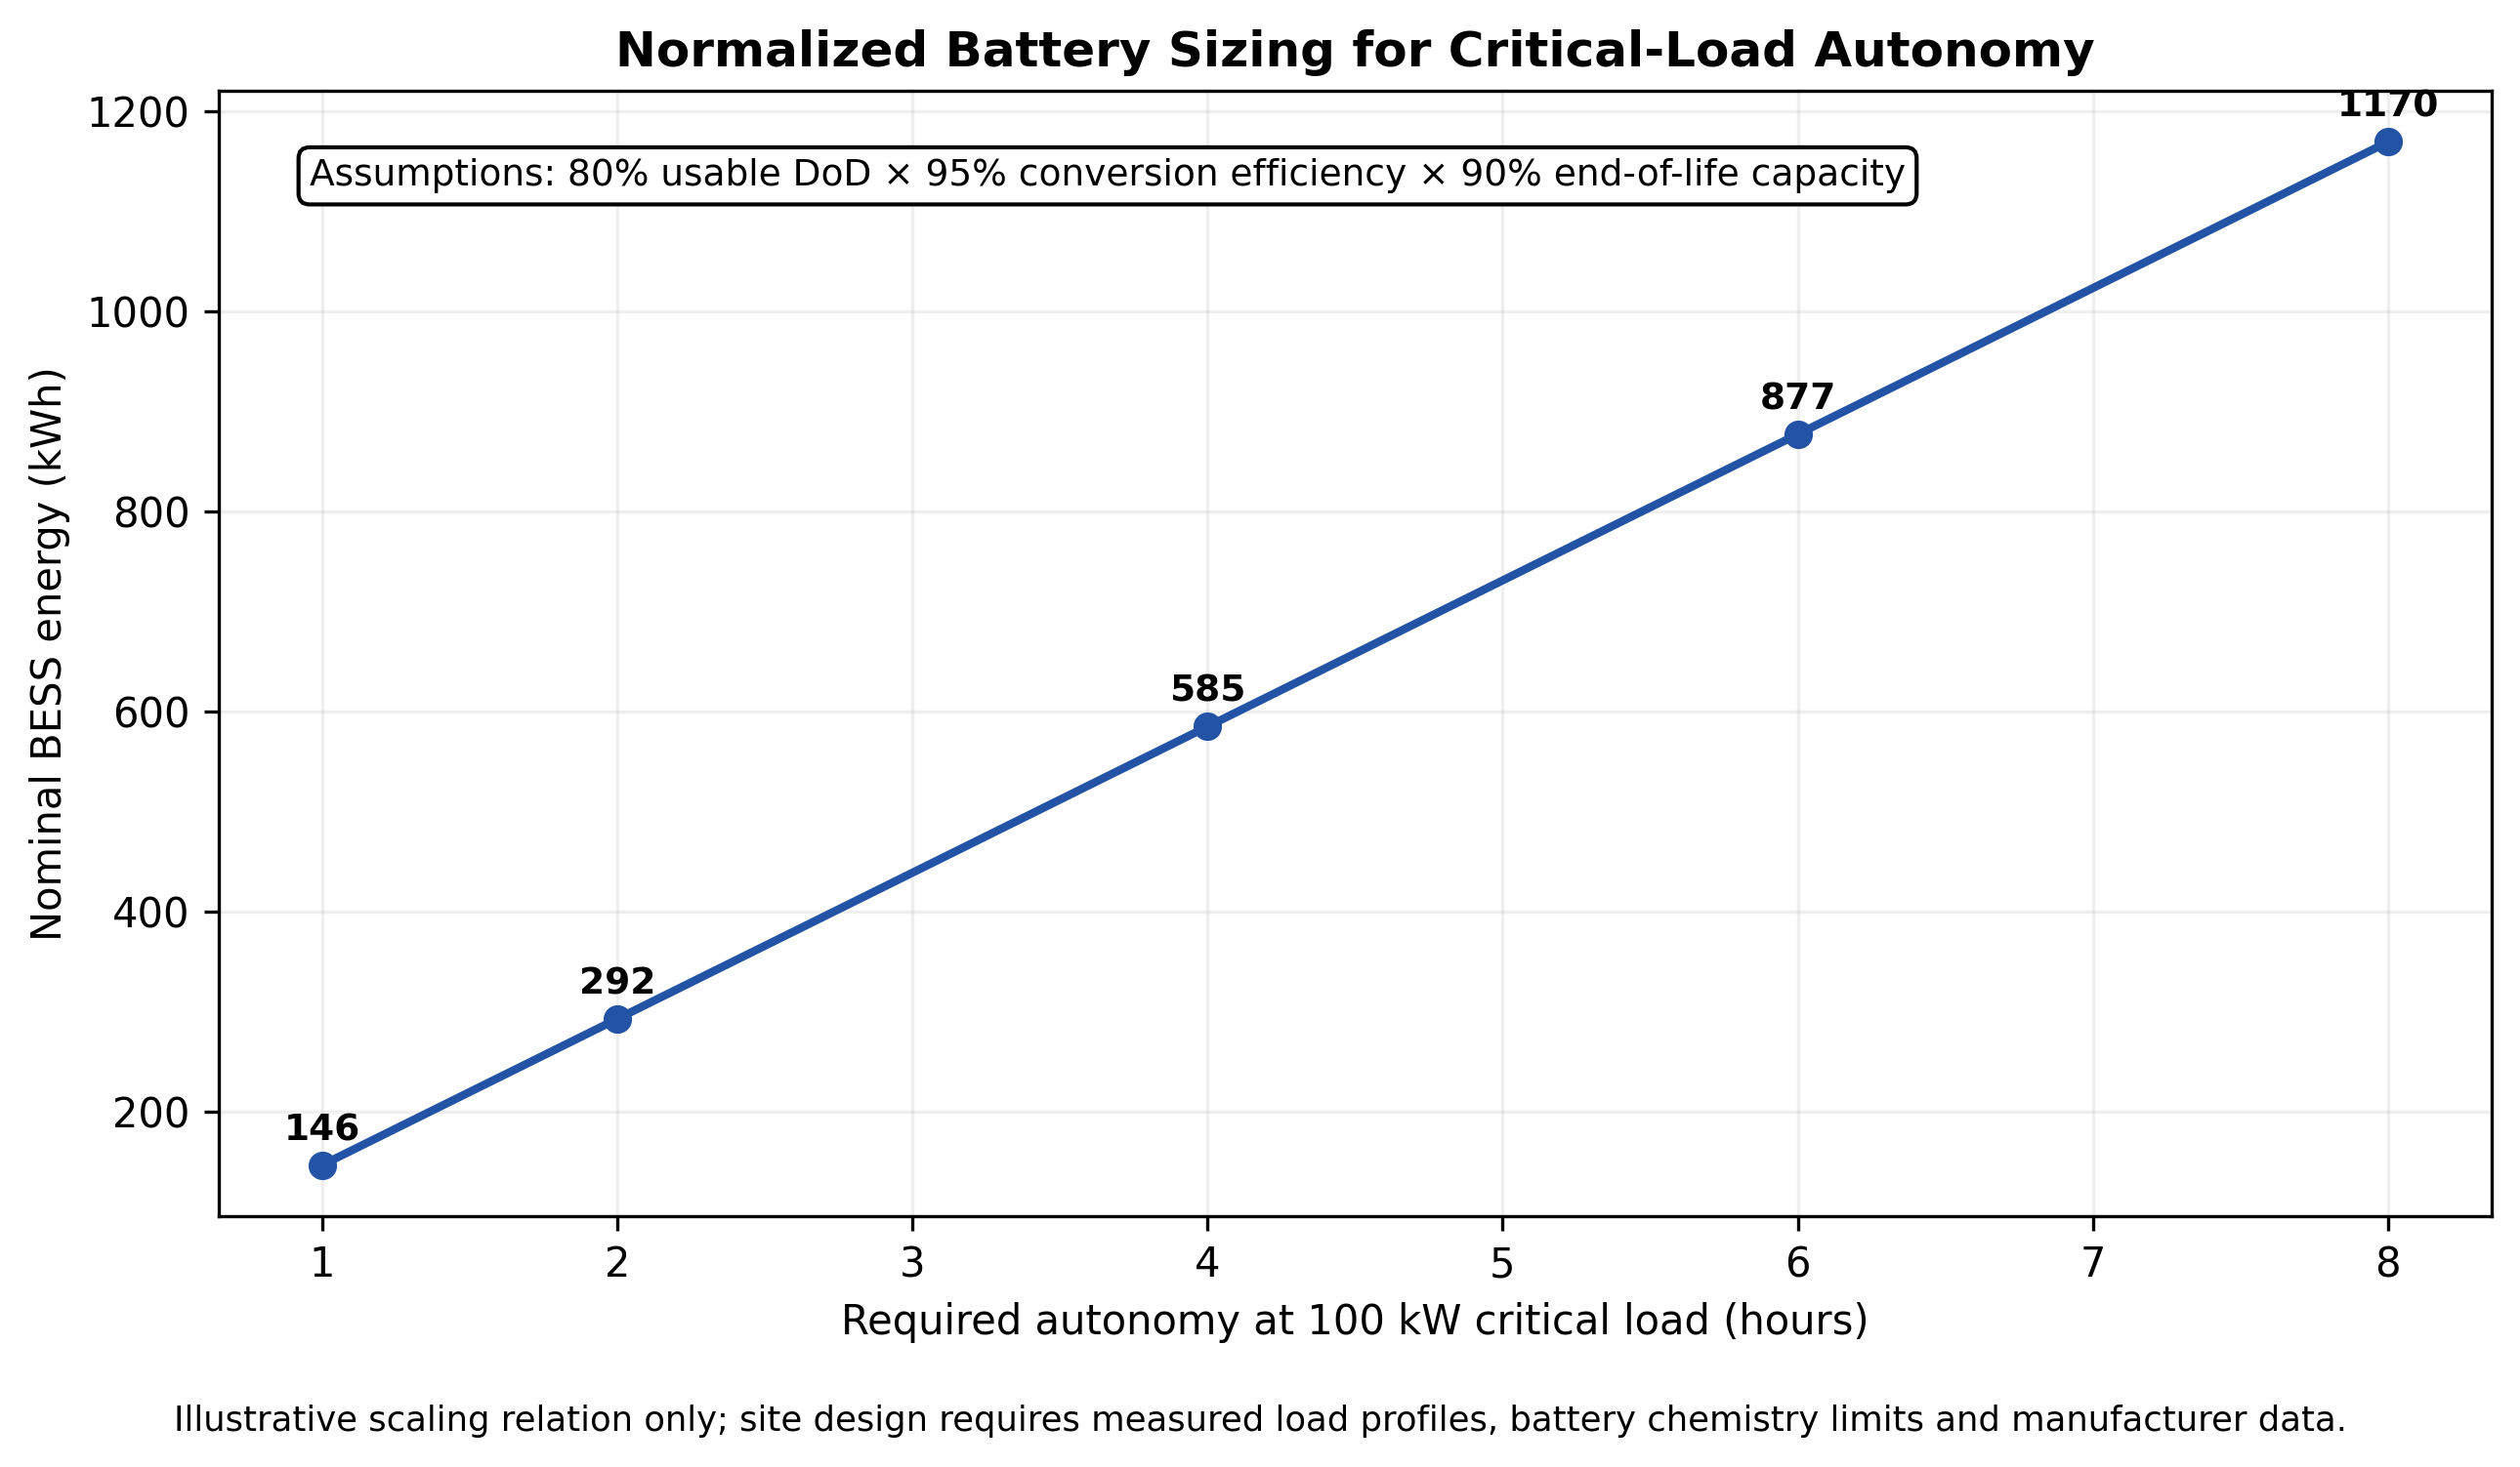
Figure 4. Normalized BESS capacity required for 1–8 hours of autonomy at a 100 kW critical load under stated derating assumptions. The figure is a scalable engineering illustration, not an Idiroko site sizing result.
Table 3. Core engineering sizing and verification questions
Subsystem | Primary sizing basis | Verification / sensitivity
PV array | Target solar-energy fraction, measured daily load, site solar resource, available area | Seasonal irradiation, temperature, shading, degradation, soiling, inverter clipping.
BESS energy | Critical kW × autonomy, reserve SOC, DoD, conversion efficiency, end-of-life capacity | Outage-duration distribution, degradation, C-rate, ambient temperature, replacement year.
BESS power / inverter | Critical peak kW/kVA, motor/transient support, black-start requirement | Overload duration, fault contribution, island stability, harmonic performance.
Generator | Essential peak kVA, motor starts, battery charging, derating, redundancy | Fuel logistics, low-load operation, maintenance outage, N+1 consequence analysis.
ATS/STS / switchgear | Transfer time, source fault levels, critical-load interruption tolerance | Interlocks, bypass, manual recovery, maintenance isolation, protection selectivity.
Cables / earthing / SPD | Ampacity, voltage drop, fault current, environmental exposure | Short-circuit withstand, earth resistance, lightning risk, corrosion, labeling.

7. Energy-Management Strategy: Make the Sources Behave as One System
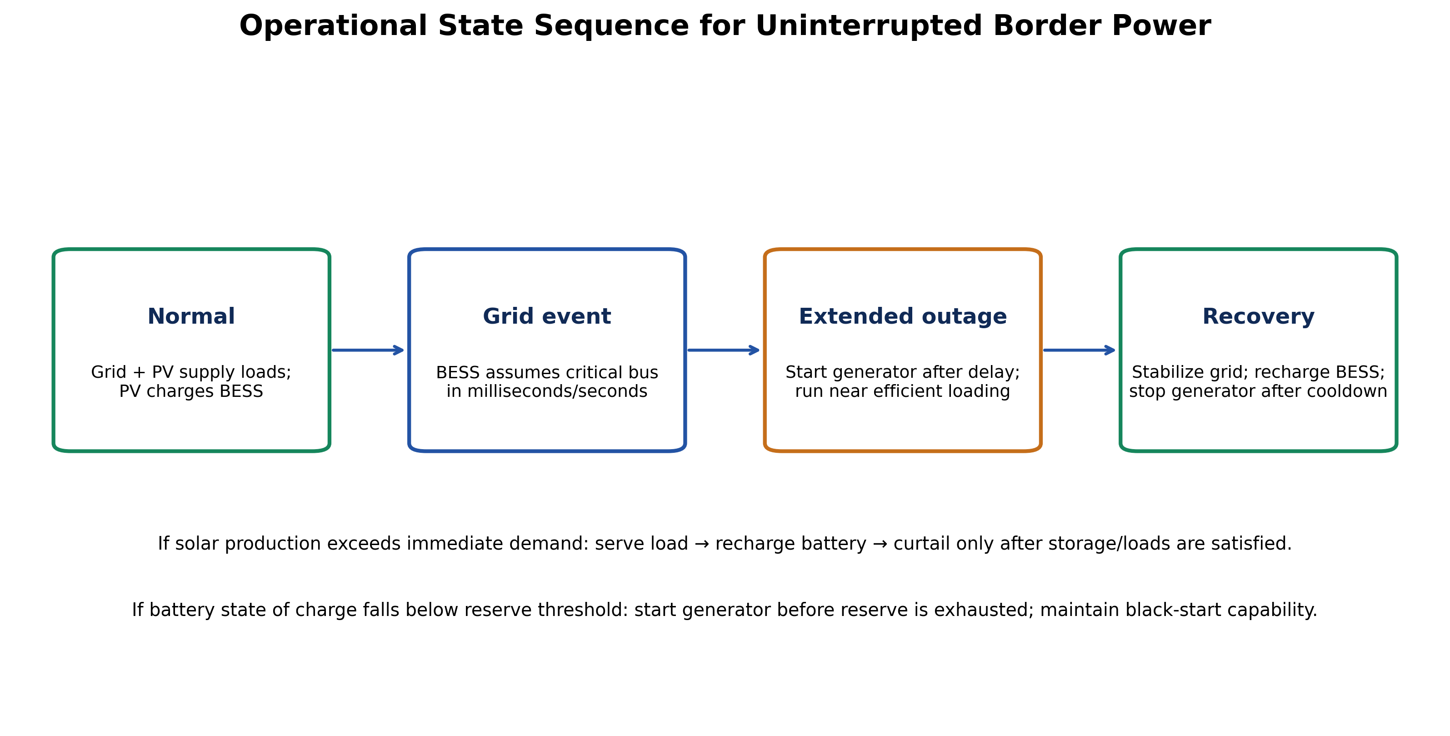
Figure 5. Recommended operating-state sequence. BESS provides immediate continuity; generators are started for extended deficits; controlled restoration avoids unstable retransfer. Original author synthesis.
The EMS should optimize reliability before fuel savings. A practical dispatch hierarchy is: serve current loads from available solar; use stable grid power when available and economical; maintain a battery reserve for sudden outages; charge from surplus PV; use grid or generator charging when state of charge approaches the reserve threshold; start the generator for prolonged outages or forecast deficits; and shed lower-tier loads before allowing the critical bus to collapse. A generator should preferably run in an efficient load band and may charge the battery while running, allowing it to shut down rather than idle at very low load.
Controls should remain understandable and recoverable by local engineering personnel. Excessively complex optimization that cannot be maintained at a border command can reduce resilience. The EMS should therefore expose clear manual/automatic modes, source status, BESS state of charge, alarms, fuel reserve, load tier, generator hours, maintenance counters and event history. Remote monitoring should be cybersecurity-hardened because smart microgrids are cyber-physical systems; remote control privileges should be restricted, logged and fail-safe.

8. Reliability, Power Quality and Safety Assurance
A resilient system is not defined solely by annual energy balance. Border equipment may fail or reset because of short interruptions, frequency drift, undervoltage, harmonics, poor earthing or surges even when total kWh supply appears adequate. NERC’s Q1 2026 report documented average daily system frequency and voltage excursions outside normal operating limits, reinforcing the need for local power-quality measurement and protection at sensitive installations (NERC, 2026a).
Commissioning should therefore include source-transfer tests under representative load, black-start tests, generator failure tests, BESS low-SOC response, loss-of-communications tests, protective-device trip verification, thermal inspection, earth continuity and resistance testing, insulation tests, harmonic/power-factor measurement, and fail-safe operation of fire/emergency systems. PV and battery equipment should be procured with appropriate IEC-compliant certification and vendor traceability. Any project falling under Nigerian mini-grid, captive-generation, state electricity-market or environmental rules should undergo formal regulatory and legal review before construction; the NERC Mini-Grid Regulations 2026 provide a current federal regulatory reference for mini-grid arrangements (NERC, 2026b).
Table 4. Reliability and maintenance scorecard for a border hybrid microgrid
KPI | What it reveals | Recommended management use
Critical-bus availability (%) | Whether mission-critical loads actually remained energized | Set tier-specific service-level targets and investigate every outage.
Unserved critical energy (kWh) | Severity of interruptions, not only their count | Use for capacity and reserve-state review.
Generator run hours / starts | Dependence on diesel backup and maintenance burden | Track reduction after hybridization; identify short-cycling.
Generator fuel (L/kWh generated) | Operating efficiency and fuel-control integrity | Compare before/after BESS dispatch; investigate low-load operation.
PV yield (kWh/kWp) | Solar performance and fouling/faults | Benchmark monthly; trigger inspection after unexplained decline.
BESS availability / SOH / cycles | Storage reliability and ageing | Forecast replacement and verify warranty conditions.
Transfer events / failed transfers | ATS/STS reliability and grid instability exposure | Review logic delays, contacts, interlocks and source quality.
Voltage/frequency/harmonic alarms | Power quality affecting ICT and electronics | Correlate with equipment resets and protective events.

9. Techno-Economic and Environmental Decision Logic
Capital cost alone is a poor selection criterion for critical-facility power. The relevant comparison is lifecycle cost under a reliability constraint: capital expenditure, replacement, maintenance, battery degradation, generator overhaul, fuel purchase and delivery, downtime consequences, spare-parts availability and residual value. Nigerian evidence already supports hybridization as a feasible alternative to diesel-only supply: Esan et al. (2019) found strong reliability and large emissions reductions for a Nigerian PV-diesel-battery configuration, while Amuta et al. (2023) optimized a Nigerian hybrid microgrid to satisfy rising remote-load demand. These studies are not directly transferable to border commands because load patterns and reliability requirements differ, but they validate the engineering direction.
The strongest economic benefit at a border command may be avoided operational disruption rather than electricity tariff savings. A resilient design protects continuity of clearance, enforcement, communications and security functions. This justifies evaluating cost per hour of critical availability, generator fuel avoided, reduction in unplanned starts, maintenance savings and avoided equipment damage from poor power quality. Carbon and local air-pollution reductions are additional benefits rather than the sole justification.

10. Implementation Framework for Nigeria Customs Service
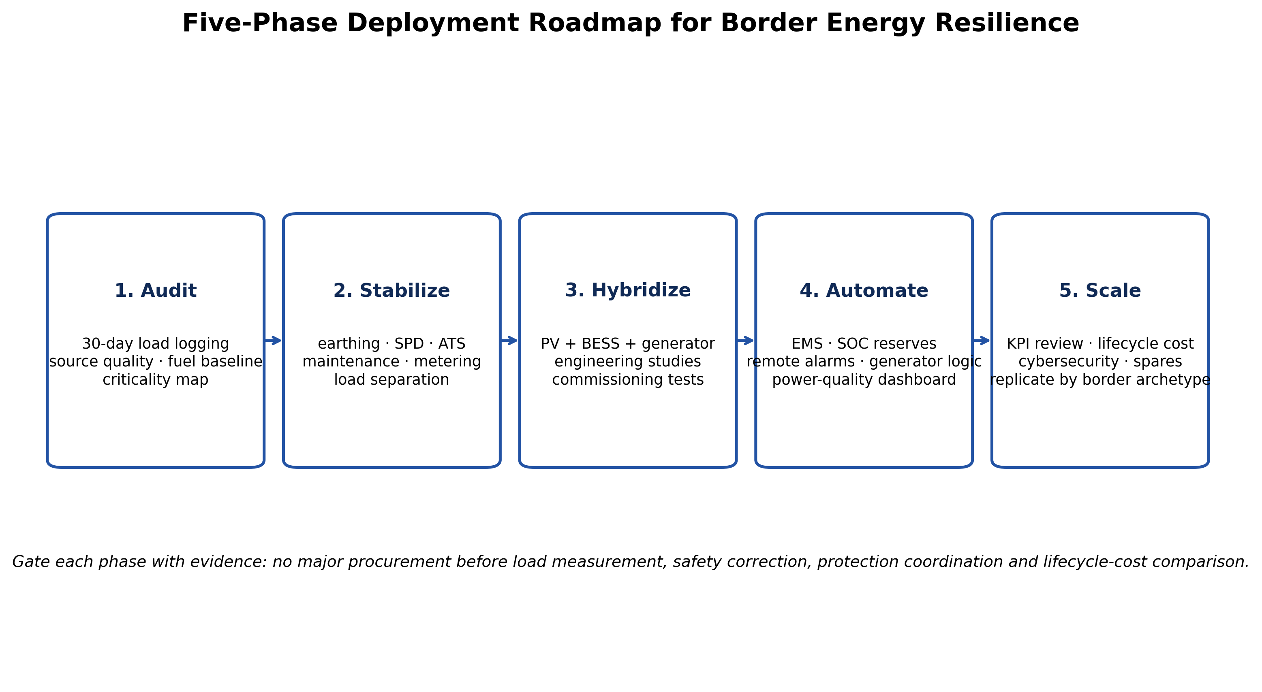
Figure 6. Evidence-gated implementation roadmap for land-border energy resilience. The roadmap begins with measurement and safety correction before major equipment procurement. Original author synthesis.

10.1 Phase 1 — Measure before buying
Each candidate border command should complete interval load logging, outage logging, generator fuel/runtime baselining, criticality mapping, power-quality monitoring, single-line verification and condition assessment. This phase produces the load duration curve, critical peak, daily critical energy and outage-duration distribution required for defensible sizing.

10.2 Phase 2 — Correct the existing electrical system
Before adding PV or batteries, correct unsafe earthing, undersized conductors, poor terminations, nonselective protection, unreliable transfer switches, missing surge protection, overloaded panels and undocumented circuits. Hybridization of a weak distribution system can multiply rather than solve failure modes.

10.3 Phase 3 — Pilot a complete hybrid system
A pilot should combine PV, BESS, existing/renewed generators, ATS/STS, critical-load panels, metering and EMS as one engineered system. The pilot should be commissioned against measurable acceptance criteria rather than equipment delivery alone. Where operationally feasible, a border command with experienced engineering supervision and representative grid/generator challenges can serve as a learning site.

10.4 Phase 4 — Digitize operations and maintenance
Energy dashboards should record source availability, generator fuel and runtime, BESS state of health, PV yield, critical-bus uptime, alarms and maintenance due dates. This creates an evidence base for preventive maintenance and future system expansion. Monitoring data should be segregated from operational-security networks and governed by role-based access.

10.5 Phase 5 — Standardize by border archetype
Nigeria Customs should avoid one-size-fits-all equipment packages. Instead, standardized architectures can be developed for small patrol posts, medium administrative commands, barracks/command complexes and sites with high-power NII or other inspection equipment. Common design rules, protection philosophy, spare parts, training and KPI definitions can be standardized while component capacities remain load-specific.

11. Discussion
The evidence points to a clear strategic direction. Nigeria’s national electricity system continues to face reliability and quality challenges, even as distributed renewable-energy policy and investment are expanding. At the same time, Customs modernization is increasing dependence on digital infrastructure, surveillance and inspection technologies. These trends mean that border electricity should be managed as critical operational infrastructure rather than as a routine facilities service.
The proposed architecture deliberately rejects two simplistic solutions. First, it does not assume that installing solar panels alone creates reliability: without storage, controls, protection and load prioritization, solar cannot ride through a night outage or sudden grid event. Second, it does not treat diesel generators as obsolete: in security-sensitive remote facilities, dispatchable generation remains valuable for long-duration deficits and maintenance contingencies. The engineering objective is coordinated redundancy—grid when usable, solar for energy, batteries for speed and short autonomy, generators for duration, and load management for survivability.
The framework also shifts the decision metric from nominal capacity to delivered mission continuity. A 200 kVA generator or 100 kWp solar array is not a resilience result; critical-bus availability, successful transfer performance, unserved energy, fuel efficiency, battery health and recovery time are. This aligns with broader resilience literature, which distinguishes the ability to withstand, degrade gracefully, restore and adapt from simple adequacy or reliability measures (Zidane et al., 2025).

11.1 Limitations and research agenda
This review does not contain a measured Idiroko load profile, generator fuel log, solar-resource study, component quotations or lifecycle optimization. Consequently, it does not specify final kWp, kWh or kVA capacities for Idiroko or another command. The next research stage should collect at least 30 days—and preferably seasonal—high-resolution load and power-quality data, record outage-duration distributions and fuel consumption, and model alternative grid/PV/BESS/generator configurations using HOMER, MILP or equivalent time-series methods. A pilot should then report pre/post generator runtime, fuel intensity, critical-bus availability, transfer performance, lifecycle cost and maintenance outcomes. Such an empirical follow-up would convert the present architecture into a Nigeria Customs-specific design standard.

12. Conclusion and Recommendations
Continuous border operations require an electrical system that fails gracefully when any one source is lost. Nigeria’s grid context, distributed-energy transition and Customs technology modernization together support a move from reactive backup generation to resilient hybrid microgrids. The recommended framework coordinates utility supply, solar PV, BESS and standby generators behind a protected critical bus, with explicit load tiers, state-of-charge reserves, automatic transfer, black-start capability, power-quality monitoring and a maintainable EMS. The framework is technologically mature, compatible with Nigeria’s distributed-energy direction and suitable for phased implementation after site measurement and regulatory review.

12.1 Priority recommendations
• Classify all border loads into no-break, mission-essential, essential-support and deferrable tiers before sizing new generation or storage.
• Install interval metering and power-quality monitoring and establish a generator fuel/runtime baseline before procurement.
• Use BESS for fast ride-through and short-duration autonomy, while retaining properly sized generators for prolonged outages and contingency reserve.
• Size PV from measured daily energy and bankable site solar-resource data, not from connected load alone.
• Adopt N+1 or equivalent redundancy for components whose single failure would disable Tier 0 operations, subject to consequence and lifecycle-cost analysis.
• Commission every hybrid system with transfer, islanding, black-start, low-SOC, generator-failure, protection and restoration tests.
• Create a Nigeria Customs energy-resilience dashboard using critical-bus availability, unserved energy, generator fuel intensity, PV yield, BESS health and failed-transfer events.
• Develop a pilot at a representative land-border command under qualified electrical engineering supervision, then standardize architecture and maintenance practices by border-post archetype.
• Keep energy monitoring networks cyber-secure and segregated from sensitive Customs operational systems, with role-based remote-control permissions.
• Review applicable NERC/state electricity, environmental, fire, procurement and IEC requirements before construction and commissioning.

Declarations
Ethics: Not applicable; this article reports no new human- or animal-participant research.
Practice-context statement: The framework is informed by the author’s professional responsibilities as an Electrical/Electronic Engineering Officer and Officer-in-Charge (Electricity) at Idiroko Barracks, Ogun I Area Command. No confidential Customs load, fuel, security, inspection or infrastructure data are disclosed, and the article is not represented as an engineering audit of the facility.
Funding: The author declares that no external funding was received specifically for this article.
Competing interests: The author declares no competing interests.
Data availability: No new primary dataset was generated. Evidence is derived from the official and peer-reviewed sources cited in the article. The normalized battery-sizing figure is an illustrative engineering calculation based on explicitly stated assumptions.
Author contributions: AMENGER, Gbaden — conceptualization, engineering problem framing, critical literature synthesis, framework development, interpretation, visualization and manuscript authorship.
AI-assisted editorial support: AI-assisted tools were used for literature organization, language refinement, figure preparation, formatting and consistency checking. They were not used as an author or as a substitute for professional engineering judgement; responsibility for source verification, interpretation and final approval remains with the author and journal editor.
Copyright and licence: © 2026 The Author. Published by CHIA TECH SOLUTIONS AND RESOURCES LIMITED (RC 1839865). This open-access article is distributed under the Creative Commons Attribution 4.0 International (CC BY 4.0) licence, except for third-party material otherwise identified.

References
Amer, A., Massoud, A., & Shaban, K. (2024). Optimization of hybrid renewable-diesel power plants considering operational cost, battery degradation, and emissions. Heliyon, 10(6), e27021. https://doi.org/10.1016/j.heliyon.2024.e27021
Amuta, E. O., Orovwode, H., Wara, S. T., Agbetuyi, A. F., Matthew, S., & Esisio, E. F. (2023). Hybrid power microgrid optimization and assessment for an off-grid location in Nigeria. Materials Today: Proceedings. https://doi.org/10.1016/j.matpr.2023.08.107
Esan, A. B., Agbetuyi, A. F., Oghorada, O., Ogbeide, K., Awelewa, A. A., & Afolabi, A. E. (2019). Reliability assessments of an islanded hybrid PV-diesel-battery system for a typical rural community in Nigeria. Heliyon, 5(5), e01632. https://doi.org/10.1016/j.heliyon.2019.e01632
International Energy Agency. (2024). Batteries and secure energy transitions. IEA, Paris.
International Renewable Energy Agency. (2020). Quality infrastructure for smart mini-grids. IRENA, Abu Dhabi.
Nigeria Customs Service. (2025a). Customs e-Newsletter, January 2025: Strategic vision for 2025 and modernization priorities. Nigeria Customs Service.
Nigeria Customs Service. (2025b). Customs e-Newsletter, February 2025: An overview of non-intrusive inspection technology. Nigeria Customs Service.
Nigeria Energy Transition Plan. (n.d.). Power sector pathway and generation expansion plan. Federal Republic of Nigeria.
Nigerian Electricity Regulatory Commission. (2026a). First Quarter 2026 NERC Quarterly Report. NERC, Abuja.
Nigerian Electricity Regulatory Commission. (2026b). Mini Grid Regulations 2026. NERC, Abuja.
World Bank. (2023a). The World Bank approves additional financing to consolidate the gains of Nigeria’s Power Sector Recovery Program. World Bank.
World Bank. (2023b). Nigeria to expand access to clean energy for 17.5 million people: Distributed Access through Renewable Energy Scale-up (DARES). World Bank.
World Customs Organization. (2025). Guidelines for the procurement and deployment of scanning/non-intrusive inspection equipment. WCO, Brussels.
World Customs Organization. (n.d.). ICT Guidelines under the Revised Kyoto Convention. WCO, Brussels.
Zidane, T. E. K., Muis, Z. A., Ho, W. S., Zahraoui, Y., Aziz, A. S., Su, C.-L., Mekhilef, S., & Campana, P. E. (2025). Power systems and microgrids resilience enhancement strategies: A review. Renewable and Sustainable Energy Reviews, 207, 114953. https://doi.org/10.1016/j.rser.2024.114953
Kumar, K., Kumar, P., & Kar, S. (2024). A review of microgrid protection for addressing challenges and solutions. Renewable Energy Focus, 49, 100572. https://doi.org/10.1016/j.ref.2024.100572
CHIATECH JOURNAL · SETEHEM · Volume 1 · Issue 1 · August 2026 · e044 · Pioneer Publication

