CHIATECH JOURNAL
  - SETEHEM · Volume 1, Issue 1 · Pioneer July/August 2026 · Part 2 · e045
  - PIONEER PUBLICATION · ACCEPTED ARTICLE · ORIGINAL MODELLING RESEARCH ARTICLE · RESIDENTIAL ENERGY · DEMAND RESPONSE · LOAD FLEXIBILITY · NIGERIA

Mathematical Modelling of Residential Electricity Demand for Peak-Load Reduction in Nigeria: A Demand-Response Optimisation Framework Calibrated to Dota Community, Gwagwalada
Abdulsalam A. Abdulrahman
Department of Building Technology, University of Abuja, Nigeria
Correspondence: Abdulsalam.abdulrahman@uniabuja.edu.ng
ARTICLE TYPE | VOLUME / ISSUE | ELOCATOR
Original Modelling Research Article | 1(1) | e045
PUBLICATION | IDENTIFIERS | JOURNAL DOI
Pioneer July/August · Part 2 | ISSN: Pending assignment | Pending registration

Abstract
Background: Nigeria’s electricity-access challenge is increasingly being addressed through grid reform and distributed renewable systems, but supply-side expansion does not by itself resolve concentrated residential peaks. The author’s prior Dota Community study reported a residential demand of 59.61 kWh/day and 9.62 kW peak, representing 57.43% of the community load. Objective: This study develops a transparent mathematical demand-response model that uses those aggregate values only as calibration anchors and asks a distinct question: how much peak demand can be redistributed when a defined share of household electricity use is time-flexible? Methods: A 24-hour residential archetype was reconstructed to preserve the reported daily energy and peak demand. Linear programming then shifted 10–40% of hourly demand within a bounded time window while conserving total energy. The primary objective minimized the daily maximum demand; secondary penalties represented a normalized time-of-use cost signal and shifting distance. Results: With 30% flexible demand and a ±3-hour shifting window, peak demand fell from 9.62 to 6.73 kW (30.0%), the peak-to-average ratio fell from 3.87 to 2.71, and load factor increased from 25.8% to 36.9%. The normalized cost index decreased by 9.2% with no reduction in daily energy. At 40% flexibility, peak demand fell to 5.77 kW and the cost index decreased by 12.2%. Sensitivity analysis showed that short shifting windows could achieve the same technical peak reduction in this calibrated case, while wider windows increased economic scheduling opportunity. Conclusion: Demand flexibility can complement solar-storage sizing and stochastic renewable-integration strategies in Nigerian households and mini-grids. The reported results are scenario-based technical potential—not measured behavioural response—and implementation depends on metering, controllable loads, consumer safeguards and locally validated tariffs.
Keywords: demand response; residential electricity; mathematical optimisation; load shifting; peak demand; Nigeria; smart metering; mini-grids; Dota Community; energy flexibility
Suggested citation: Abdulrahman, A. A. (2026). Mathematical modelling of residential electricity demand for peak-load reduction in Nigeria: A demand-response optimisation framework calibrated to Dota Community, Gwagwalada. CHIATECH JOURNAL · SETEHEM, 1(1), e045.

1. Introduction
Reliable electricity is not only a question of how much generation capacity is installed; it is also a question of when electricity is demanded. In systems with constrained generation, weak distribution networks, limited storage and widespread self-generation, a narrow residential peak can increase the capacity that must be financed even when the same daily energy could be served more evenly. Demand response (DR) addresses this timing problem by shifting, rescheduling or—where explicitly permitted—curtailing flexible loads. This article focuses on shifting rather than involuntary curtailment: daily residential energy is conserved, but a selected flexible share may move to nearby hours.
Nigeria provides a strong case for demand-side modelling. The 2024 Nigeria Residential Energy Demand-Side Survey sampled 8,100 households in 540 enumeration areas across nine states. It reported that 58.2% of households were connected to the national grid, while only 14.8% of grid-connected households used prepaid billing and 85.2% relied on estimated billing during the reference period. The same survey estimated average monthly household electricity expenditure at ₦4,155.8. These indicators show that any advanced household demand-response programme must be designed around the realities of incomplete metering and heterogeneous access rather than assuming universal smart-meter readiness (National Bureau of Statistics [NBS], 2024).
The metering constraint remains material. NERC reported that 6,422,933 of 11,821,194 active registered customers were metered by 30 June 2025, a national metering rate of 54.33% (Nigerian Electricity Regulatory Commission [NERC], 2025). At the same time, distributed renewable electricity is expanding: the World Bank’s DARES programme was approved to support new or improved clean-electricity access for more than 17.5 million Nigerians through distributed renewable solutions (World Bank, 2023). The value of flexible demand therefore extends beyond the national grid; it can reduce peak capacity pressure in solar-battery mini-grids and other distributed systems.

1.1 Research gap and originality boundary
The supplied research programme already contains two generation-side studies. The Dota Community study optimized a standalone PV mini-grid using HOMER Pro and reported the community’s aggregate load, system sizing, LCOE, battery autonomy and renewable fraction. A second study modelled uncertain solar-wind supply, grid supplementation, cost and reliability for Nigerian households. Repeating either analysis would add little novelty. The suggested-topic list, however, separately proposes mathematical modelling of residential consumption for demand-response optimization, including time-of-use, appliance management and seasonal considerations. e045 develops that distinct demand-side question.
Source study / topic | Primary question | Evidence reused in e045 | What e045 does not repeat
Dota solar mini-grid study | How should PV, inverter, battery and distribution capacity be sized for Dota Community? | Residential daily energy = 59.61 kWh; residential peak = 9.62 kW; residential share = 57.43%. | PV/battery sizing, LCOE, autonomy, renewable fraction, environmental accounting and HOMER optimisation.
Stochastic renewable-integration study | How can uncertain solar/wind generation and grid support be balanced? | Conceptual motivation for coordinating demand with variable supply. | Stochastic solar/wind distributions, grid-supplement probabilities, emissions estimate and hybrid-system cost assumptions.
Suggested topic developed as e045 | How much peak demand can be shifted under explicit flexibility and time-window constraints? | Aggregate Dota demand anchors plus transparent scenario assumptions. | No new survey respondents, no claim that reconstructed hourly values are measured smart-meter observations.

Table 1. Novelty boundary between the prior source studies and CHIATECH JOURNAL e045.

1.2 Aim and objectives
The study aims to formulate and evaluate a reproducible residential demand-response optimization framework for a Nigerian case calibrated to the Dota Community aggregate residential load. Specifically, it:
- constructs a 24-hour calibration profile that exactly preserves the prior study’s residential daily energy and reported peak demand;
- formulates an energy-conserving load-shifting optimization model with explicit flexibility and time-window constraints;
- quantifies effects on peak demand, peak-to-average ratio (PAR), load factor and a normalized time-of-use cost index;
- evaluates sensitivity to the share of flexible load and the permitted shifting window; and
- derives implementation requirements for Nigerian grid-connected households and distributed-energy/mini-grid systems.

2. Evidence Base and Case Calibration

2.1 Dota Community calibration anchors
The author-supplied Dota study describes a Gwagwalada, Federal Capital Territory case comprising 215 households and an estimated population of 1,290. Primary work included a household energy survey (n = 180), digital load measurement, GPS mapping and stakeholder interviews. Its baseline community load was 103.795 kWh/day with a 16.74 kW peak. Residential demand accounted for 59.61 kWh/day and 9.62 kW peak, equivalent to 57.43% of total daily energy. These three residential values are the only empirical anchors imported into e045.
The supplied Dota manuscript does not provide a citable 24-point measured residential smart-meter series. Accordingly, e045 does not fabricate such a dataset. Instead, it constructs a deterministic hourly archetype with a pronounced evening peak and scales it so that the 24 hourly values sum to 59.61 kWh and the maximum equals 9.62 kW. This calibrated reconstruction is a modelling device for sensitivity analysis; its within-day shape is an assumption and is published in Appendix A for full reproducibility.
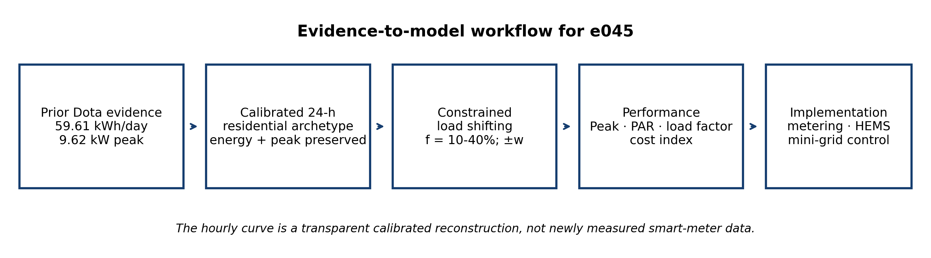
Figure 1. Evidence-to-model workflow for e045. The modelling boundary separates source-study evidence from the new demand-response analysis.

2.2 National demand-side context
National evidence reinforces the need for simple, auditable demand-side methods. NBS (2024) documents uneven electricity access and heavy dependence on estimated billing, while NERC (2025) shows that only slightly more than half of active registered customers were metered by mid-2025. These conditions favour staged DR implementation: first on prepaid/smart-metered customers, mini-grids, estates and institutional housing where interval measurement and controllable appliances are available; later at broader scale as metering and communications improve.
Residential-energy modelling literature distinguishes engineering, statistical, machine-learning and optimization approaches and emphasizes that load-shifting potential depends on appliance characteristics and occupant constraints (Nacht et al., 2023). Nigerian evidence further indicates that household energy choices are shaped by wealth, education, household size, region and place of residence (Abubakar et al., 2024). e045 therefore treats flexibility as a scenario parameter rather than assuming that every household can or will shift the same share of demand.

3. Mathematical Model and Scenario Design

3.1 Decision variables and load balance
Let Lₜ denote baseline demand in hour t (t = 1,…,24), f the fraction of each hour’s demand classified as flexible, xᵢⱼ the quantity of flexible energy shifted from source hour i to destination hour j, and w the maximum permitted shift distance in hours. The feasible destination set is Ωᵢ = {j : |i − j| ≤ w}. The rescheduled load in hour j is:
Lⱼᴰᴿ = (1 − f)Lⱼ + Σᵢ xᵢⱼ
All flexible energy allocated from a source hour must be reassigned, so Σⱼ∈Ωᵢ xᵢⱼ = fLᵢ. Because no energy is curtailed, Σⱼ Lⱼᴰᴿ = Σⱼ Lⱼ = 59.61 kWh/day in every scenario.

3.2 Objective function
The principal objective is peak shaving. A variable M bounds every optimized hourly load, Lₜᴰᴿ ≤ M. Secondary terms prefer lower-cost periods and discourage unnecessary movement of demand. The model is written conceptually as:
min Z = M + α Σₜ cₜLₜᴰᴿ + β ΣᵢΣⱼ |i − j|xᵢⱼ
where cₜ is a normalized time-of-use signal, α controls the relative importance of the cost index, and β represents a shift-distance/discomfort penalty. This is a linear programming formulation. The normalized signal is 0.7 for the illustrative off-peak periods (00:00–05:59 and 22:00–23:59), 1.0 for the shoulder period (06:00–16:59) and 1.5 for the illustrative peak period (17:00–21:59). These values are not a current NERC retail tariff and must not be interpreted as naira/kWh prices; they only provide a consistent index for comparing schedules.
Parameter | Base value / scenarios | Interpretation
Daily residential energy | 59.61 kWh | Fixed calibration anchor from prior Dota study.
Baseline peak | 9.62 kW | Fixed calibration anchor from prior Dota study.
Flexible share, f | 0, 10, 20, 30, 40% | Scenario assumption; not an observed participation rate.
Shift window, w | ±3 h base case; ±1, ±2, ±3, ±4, ±6 h sensitivity | Limits inconvenience and appliance deferral.
Normalized price signal | 0.7 / 1.0 / 1.5 | Illustrative off-peak / shoulder / peak weighting; not a tariff.
Curtailment | None | All daily energy is conserved.
Primary performance metrics | Peak, PAR, load factor, cost index | Technical and scheduling outcomes.

Table 2. Calibration and scenario parameters.

3.3 Performance metrics
Average demand is E/24. Peak-to-average ratio is PAR = Pₘₐₓ/(E/24), and load factor is LF = (E/24)/Pₘₐₓ × 100%. Lower PAR and higher load factor indicate a flatter profile. The cost index is ΣₜcₜLₜ; percentage reduction is reported relative to the baseline index. Because cₜ is normalized, the cost result measures scheduling opportunity rather than a customer bill.

4. Results

4.1 Baseline residential demand
The calibrated profile has 59.61 kWh/day, a 9.62 kW peak and an average demand of 2.484 kW. Its baseline PAR is 3.87 and load factor is 25.82%, indicating a strongly peaked demand shape. The evening peak therefore drives capacity needs far above the daily average.

4.2 Flexibility scenarios
Flexible share | Daily energy (kWh) | Peak (kW) | Peak reduction | PAR | Load factor | Cost-index reduction
0% | 59.61 | 9.620 | 0.0% | 3.87 | 25.8% | 0.0%
10% | 59.61 | 8.658 | 10.0% | 3.49 | 28.7% | 3.1%
20% | 59.61 | 7.696 | 20.0% | 3.10 | 32.3% | 6.1%
30% | 59.61 | 6.734 | 30.0% | 2.71 | 36.9% | 9.2%
40% | 59.61 | 5.772 | 40.0% | 2.32 | 43.0% | 12.2%

Table 3. Demand-response performance as the assumed flexible share increases (base shifting window ±3 h).
Peak reduction increases monotonically with the assumed flexible share in this calibrated case. At 30% flexibility, peak demand decreases by 2.886 kW, from 9.62 to 6.734 kW, without changing daily energy. The same scenario raises load factor by 11.1 percentage points and lowers the normalized cost index by 9.2%. At 40% flexibility, the modeled peak is 5.772 kW. These results describe technical scheduling potential; they do not imply that households will provide 30–40% flexibility in practice.
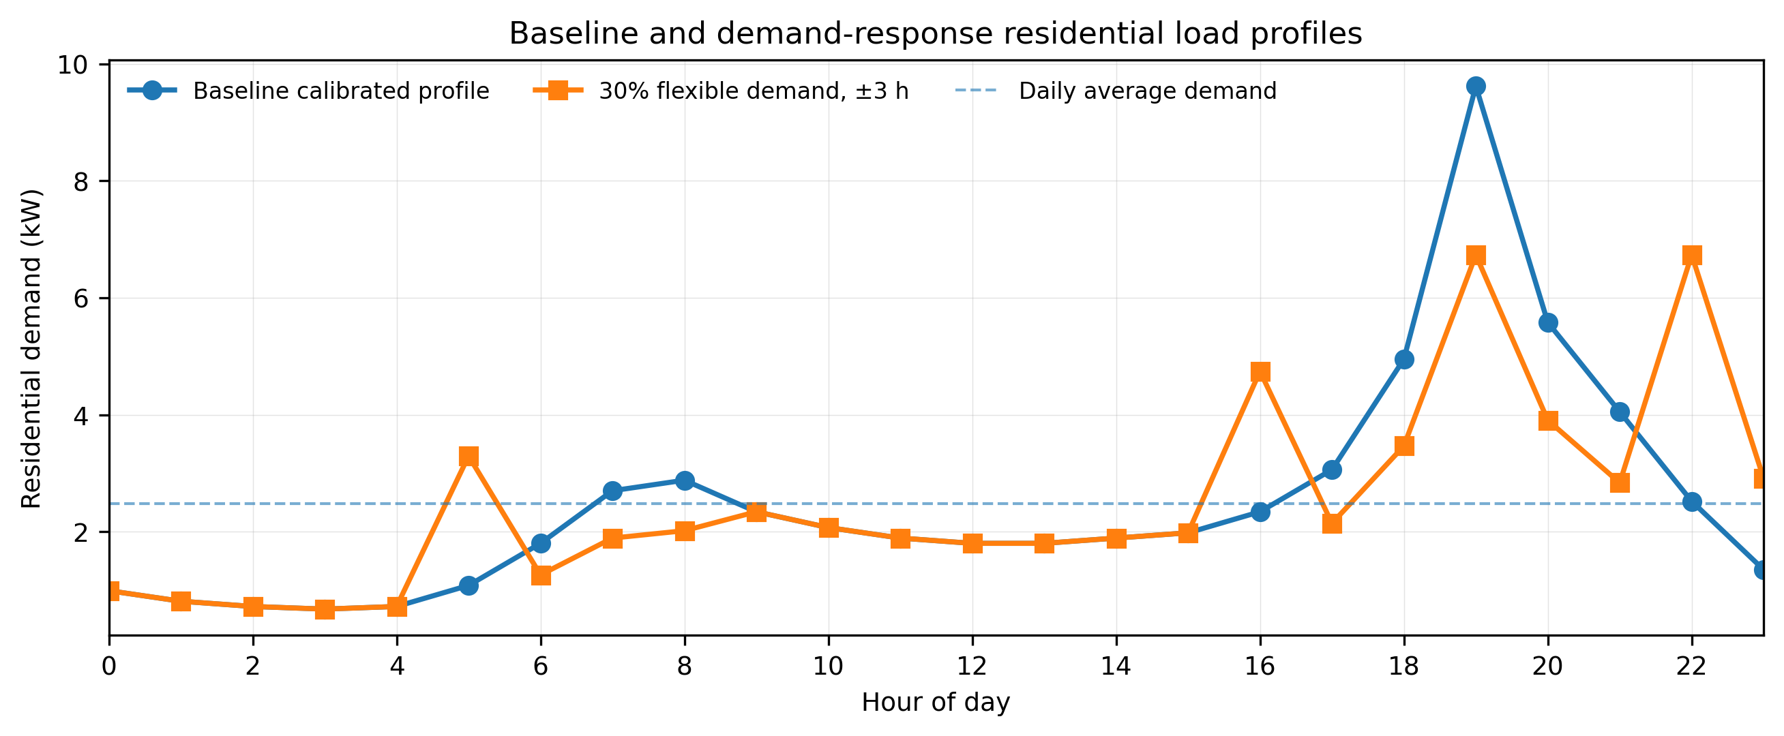
Figure 2. Baseline calibrated residential profile and optimized profile for the 30% flexibility, ±3-hour scenario. Daily energy is conserved.
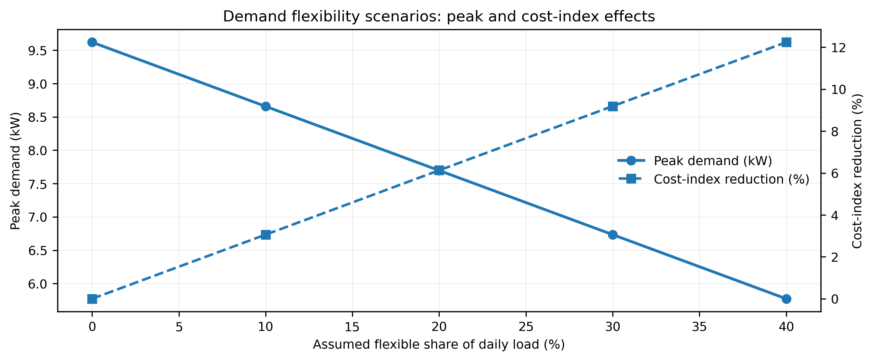
Figure 3. Effect of assumed flexible load share on peak demand and the normalized cost index.

4.3 Shifting-window sensitivity
Permitted window | Peak reduction at f = 30% | Cost-index reduction | Interpretation
±1 h | 30.0% | 2.3% | Short deferral is sufficient for technical peak clipping in the calibrated profile.
±2 h | 30.0% | 5.6% | Additional timing choice improves economic scheduling.
±3 h | 30.0% | 9.2% | Base case; balances temporal flexibility and inconvenience.
±4 h | 30.0% | 10.1% | Incremental economic benefit begins to taper.
±6 h | 30.0% | 11.3% | Wider freedom increases price-index benefit but may be less acceptable to occupants.

Table 4. Sensitivity to the permitted shifting window at 30% flexible demand.
A notable result is that the peak objective is already attainable with a narrow ±1-hour window in this stylized case, whereas the cost-index benefit depends strongly on having more hours from which the optimizer can choose. This distinction matters operationally: peak shaving may require less behavioural inconvenience than full time-of-use cost optimization.
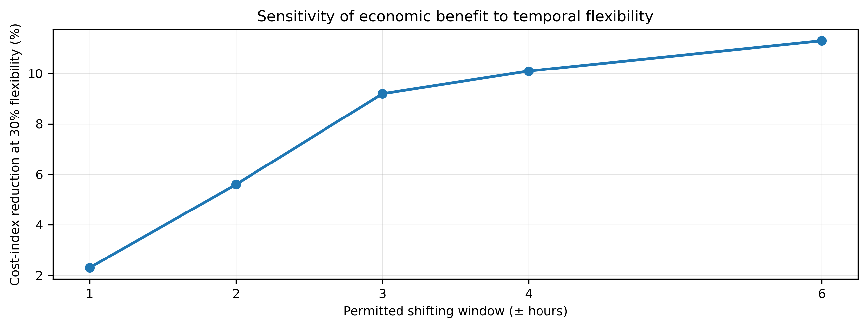
Figure 4. Sensitivity of the normalized cost-index benefit to the shifting window at 30% flexibility.

5. Discussion

5.1 Demand-side value relative to the prior supply-side studies
The two prior source studies show why demand response is a logical next step. The Dota analysis sized a 50 kW PV array, 36 kW inverter and 200 kWh battery system around an aggregate community demand of 103.795 kWh/day and 16.74 kW peak; it reported 100% renewable fraction, 66.9 hours of battery autonomy and 41.9 kWh/year unmet load. Its sensitivity analysis also identified battery cost as the strongest of the tested LCOE drivers. The stochastic study, meanwhile, reported that modeled renewable-plus-grid reliability varied by seasonal and demand conditions and that grid supplementation increased when renewable output was low. Both findings make demand timing economically relevant: a flatter peak can reduce instantaneous capacity stress and provide more freedom to align consumption with solar availability or stored energy.
e045 therefore complements rather than duplicates the earlier work. It does not claim a new PV size, new battery size, new LCOE, new emission factor or new solar/wind forecast. Its contribution is the explicit demand-side optimization layer that can sit above or inside such supply systems.

5.2 Relation to contemporary demand-response research
The direction of the result is consistent with international residential demand-management literature: deferrable and interruptible loads can be coordinated to reduce cost and grid stress, although comfort and operational constraints determine achievable flexibility (Zhang et al., 2024). More directly, Diatta, Loisel and Richefort (2025) modelled a Nigerian off-grid microgrid and found that demand-side flexibility could materially reduce system sizing and cost; their game-theoretic results also showed that negotiated participation produces less load shaving than unconstrained direct control because households value comfort. That behavioural finding is important for interpreting e045: the present 10–40% scenarios are capacity envelopes, not forecasts of voluntary participation.

5.3 Implementation pathway for Nigeria
A practical Nigerian deployment should be staged around observability, controllability and consumer protection. A DR programme cannot reliably reward time shifting without interval metering, nor should it control household appliances without clear consent and override rights. Initial deployment is therefore better suited to mini-grids, estates, campuses and prepaid/smart-metered customer clusters where consumption can be measured and flexible devices can be identified.
- Meter first: expand interval-capable metering and ensure customers can see consumption, baseline and reward calculations.
- Target naturally deferrable loads: water pumping, ironing, laundry, battery/inverter charging and other loads that can move in time without loss of essential service.
- Align with local generation: in solar-dominant mini-grids, shift flexible demand toward high-PV hours before expanding storage solely to serve a short evening peak.
- Use opt-in controls and manual override: direct load control should never remove a household’s ability to override for safety, health or essential needs.
- Publish programme metrics: report peak reduction, energy shifted, customer bill impact, opt-out rate, comfort complaints and avoided capacity/storage cost.
- Validate tariffs locally: replace the normalized cost index in this study with the actual tariff/rebate structure applicable to the customer class and location before deployment.

5.4 Limitations and reproducibility boundary
Four limitations define how the results should be used. First, the 24-hour baseline is a calibrated reconstruction because the supplied source paper reports aggregate residential energy and peak demand but not a complete measured hourly series. Second, the flexible share is an assumed scenario parameter; appliance inventories, household preferences and response fatigue were not re-measured. Third, the normalized price signal is deliberately tariff-neutral and cannot be converted directly into naira savings. Fourth, the optimization represents a single calibrated daily archetype and does not capture day-to-day weather, occupancy, outage or seasonal variation. The results are therefore best interpreted as an auditable upper-bound technical case that identifies where new field measurement would add the most value.
Reproducibility is nevertheless strong at the scenario level: Appendix A publishes the complete baseline and 30%-flexibility hourly profiles, while Tables 2–4 disclose every scenario dimension used to calculate the reported metrics. A future validation study can substitute measured smart-meter data without changing the core optimization structure.

6. Conclusion and Recommendations
This study develops the first demand-side paper in the supplied research sequence by turning the Dota Community residential aggregate findings into a transparent peak-load optimization problem. For the calibrated case, a 30% flexible share reduced peak demand from 9.62 to 6.73 kW, reduced PAR from 3.87 to 2.71 and increased load factor from 25.8% to 36.9%, while conserving 59.61 kWh/day. The normalized scheduling-cost index declined by 9.2%. The results demonstrate why demand response should be considered alongside PV, battery and stochastic supply modelling rather than after supply assets have already been oversized around unmanaged peaks.
The policy implication is not that every Nigerian household can immediately deliver 30% flexibility. National metering remains incomplete and household energy circumstances vary substantially. The practical recommendation is a phased evidence programme: deploy interval metering and opt-in load controls in suitable mini-grids and smart-meter clusters; measure appliance-level flexibility and comfort limits; test transparent incentives against actual tariffs; and only then scale algorithms whose peak, cost and consumer-welfare benefits have been verified.

Declarations
Ethics: No new human-participant or animal research was conducted for this article. The model uses aggregate calibration values from a prior author study and public national reports; no identifiable person-level data were processed.
Funding: The author declares that no external funding was received specifically for preparation of this article.
Competing interests: The author declares no competing interests.
Data availability: All numerical assumptions required to reproduce the scenario results are reported in the article. The 24-hour profile is a calibrated reconstruction and not a newly collected smart-meter dataset.
Prior-work and originality disclosure: The article uses only aggregate residential load anchors from the author-supplied Dota Community study and contextual lessons from the supplied stochastic renewable-integration study. It does not republish their HOMER Pro sizing, stochastic renewable-supply, LCOE, emission or reliability analyses. The demand-response formulation, scenario analysis and derived results reported as e045 are distinct.
Author contribution: Abdulsalam A. Abdulrahman: conceptualization, case-data interpretation, mathematical model design, analysis, interpretation, visualization, writing – original draft, and writing – review and editing.
AI-assisted editorial support: AI-assisted tools were used for language refinement, document formatting, visualization support and reference-consistency checking. They were not used as an author or as a substitute for source verification and professional judgement; responsibility for the final article remains with the author and journal editor.
Copyright and licence: © 2026 The Author. Published by CHIA TECH SOLUTIONS AND RESOURCES LIMITED (RC 1839865). This open-access article is distributed under the Creative Commons Attribution 4.0 International (CC BY 4.0) licence, except for third-party material otherwise identified.

References
Abubakar, I. R., Alola, A. A., Bekun, F. V., & Onifade, S. T. (2024). Investigating the determinants of household energy consumption in Nigeria: Insights and implications. Energy, Sustainability and Society, 14, 29. https://doi.org/10.1186/s13705-024-00451-6
Abdulrahman, A. A. (n.d.). Techno-economic optimization of a standalone solar mini-grid system for rural electrification in Dota Community, Gwagwalada, Nigeria using HOMER Pro simulation [Author-supplied manuscript used as aggregate calibration source].
Abdulsalam, A. A., Abdulraheem, A. A., & Kenneth, C. S. (n.d.). Stochastic modeling for integrating renewable energy in Nigerian households: Mitigating the energy crisis through sustainable systems [Author-supplied conference manuscript used as prior-work context].
Diatta, R., Loisel, R., & Richefort, L. (2025). Demand response in power off-grid microgrids in Nigeria: A game theory approach. Global Energy Interconnection, 8(4), 581–597. https://doi.org/10.1016/j.gloei.2025.06.003
Nacht, T., Pratter, R., Ganglbauer, J., Schibline, A., Aguayo, A., Fragkos, P., & Zisarou, E. (2023). Modeling approaches for residential energy consumption: A literature review. Climate, 11(9), 184. https://doi.org/10.3390/cli11090184
National Bureau of Statistics. (2024). Nigeria Residential Energy Demand-Side Survey Report 2024. NBS.
Nigerian Electricity Regulatory Commission. (2025). Second Quarter 2025 Quarterly Report. NERC.
World Bank. (2023, December 15). Nigeria to expand access to clean energy for 17.5 million people: Distributed Access through Renewable Energy Scale-up (DARES). World Bank.
Zhang, J., Wu, J., Fu, L., Wu, Q., Huang, Y., Qiu, W., & Ali, A. M. (2024). Energy optimization of the smart residential electrical grid considering demand management approaches. Energy, 300, 131641. https://doi.org/10.1016/j.energy.2024.131641

Appendix A. Reproducible 24-hour calibration and optimized case
The values below are published to make the e045 numerical scenario auditable. The baseline series is the calibrated reconstruction described in Section 2.1; the optimized series is the 30% flexibility, ±3-hour case. Values are rounded to three decimals, so row totals may differ from 59.61 by rounding only.
Hour | Baseline load (kW) | Optimized load (kW) | Normalized cost signal
00:00 | 0.990 | 0.990 | 0.7
01:00 | 0.810 | 0.810 | 0.7
02:00 | 0.720 | 0.720 | 0.7
03:00 | 0.675 | 0.675 | 0.7
04:00 | 0.720 | 0.720 | 0.7
05:00 | 1.080 | 3.294 | 0.7
06:00 | 1.800 | 1.260 | 1.0
07:00 | 2.700 | 1.890 | 1.0
08:00 | 2.880 | 2.016 | 1.0
09:00 | 2.340 | 2.340 | 1.0
10:00 | 2.070 | 2.070 | 1.0
11:00 | 1.890 | 1.890 | 1.0
12:00 | 1.800 | 1.800 | 1.0
13:00 | 1.800 | 1.800 | 1.0
14:00 | 1.890 | 1.890 | 1.0
15:00 | 1.980 | 1.980 | 1.0
16:00 | 2.340 | 4.743 | 1.0
17:00 | 3.060 | 2.142 | 1.5
18:00 | 4.950 | 3.465 | 1.5
19:00 | 9.620 | 6.734 | 1.5
20:00 | 5.579 | 3.906 | 1.5
21:00 | 4.050 | 2.835 | 1.5
22:00 | 2.520 | 6.734 | 0.7
23:00 | 1.350 | 2.910 | 0.7

Table A1. Complete numerical profile used for the principal e045 demand-response case.

