CHIATECH JOURNAL
  - SETEHEM · VOLUME 1 · ISSUE 2 · AUGUST 2026 · e046
  - PIONEER PUBLICATION · ACCEPTED ARTICLE · ORIGINAL ENGINEERING RESEARCH · ELECTRICAL/ELECTRONIC ENGINEERING · POWER ELECTRONICS · CONTROL SYSTEMS

Design, Small-Signal Modeling and Prototype Implementation of a 24 V-to-19 V PWM Buck Converter with Type-III Voltage-Mode Compensation
CHIA, Shiaondo Kenneth¹*. AMENGER, Gbaden²
GOSHWE, N. Y.³
¹ CHIA TECH Solutions and Resources Limited, Nigeria; original project investigator, Department of Electrical/Electronic Engineering, Federal University of Agriculture Makurdi (2016)
²Nigeria Customs Service, Ogun State Command, Nigeria. original project investigator, Department of Electrical/Electronic Engineering, Federal University of Agriculture Makurdi (2016)
³Department of Electrical/Electronic Engineering, Federal University of Agriculture Makurdi, Nigeria; project supervisor (2016)
*Corresponding author: chiakenneth01@gmail.com · ORCID: https://orcid.org/0009-0009-6434-4586
ARTICLE TYPE  Original Engineering Research | VOLUME / ISSUE  1(1) | ELOCATOR  e046
PUBLICATION  Pioneer Issue · August 2026 | IDENTIFIERS  ISSN: Pending assignment | JOURNAL DOI  Pending registration

Abstract
Background: A 2016 engineering project at the Federal University of Agriculture Makurdi designed and implemented a pulse-width-modulated buck converter to step 24 V DC down to a regulated 19 V output. Objective: This article converts that archived project into a compact, publication-ready engineering paper, reconstructing the power-stage mathematics, voltage-mode feedback loop and Type-III compensation while preserving the documented prototype and simulation evidence. Methods: The archived specifications were audited and re-expressed using continuous-conduction-mode (CCM) equations, small-signal control-to-output modeling, K-factor pole-zero placement and analytical ripple calculations. The source specifies 24 V input, 19 V rated output, 3.5 A, 66.5 W, 30 kHz switching, L = 251 µH, C = 15 µF, capacitor ESR = 10 mΩ and inductor DCR = 2 mΩ. Results: The ideal duty ratio is 0.7917. At the 3.5 A design point the equivalent rated load is 5.43 Ω, while the archived simulation schematic separately uses a nominal 5 Ω test load. The reconstructed inductor ripple is approximately 0.526 A peak-to-peak (15.0% of rated output current), with an analytical output-ripple estimate of about 0.151 V peak-to-peak when capacitive and ESR terms are combined. The LC double-pole frequency is approximately 2.594 kHz and the capacitor-ESR zero approximately 1.061 MHz. The documented Type-III network (R1 = 2.2 kΩ, R2 = 5.9 kΩ, R3 = 38.8 Ω, C1 = 34.2 nF, C2 = 0.6 nF, C3 = 90 nF) is consistent with a voltage-mode compensation strategy that places two zeros around the LC resonance and high-frequency poles above the crossover region. Conclusion: The archived design is technically coherent at its rated point and demonstrates the engineering value of PWM, CCM energy transfer and Type-III loop shaping. The article also identifies legacy reporting inconsistencies that should not be interpreted as new measurements, notably the source wording that labels 19 V and 3.5 A as ripple values.
Keywords: buck converter; DC-DC conversion; pulse-width modulation; voltage-mode control; Type-III compensation; K-factor; small-signal model; continuous conduction mode; power electronics
Suggested citation: Chia, S. K., & Goshwe, N. Y. (2026). Design, small-signal modeling and prototype implementation of a 24 V-to-19 V PWM buck converter with Type-III voltage-mode compensation. CHIATECH JOURNAL · SETEHEM, 1(1), e046.

1. Introduction
Switch-mode DC-DC converters regulate voltage by transferring energy through controlled switching rather than dissipating the excess voltage as heat. In the buck topology, a high-side switch, freewheeling path, inductor and output capacitor form a second-order power stage whose average output is controlled primarily through duty ratio. Modern design guidance continues to treat the inductor-current ripple, output-capacitor ESR, switching frequency and control-loop bandwidth as coupled design variables (Hauke, 2015; Analog Devices, n.d.-a). The archived project that forms the evidence base for this article was completed in April 2016 by Chia S. Kenneth under the supervision of Goshwe N. Y. It targeted a 24 V-to-19 V PWM converter, used voltage feedback and Type-III compensation, and reported both simulation and Vero-board implementation.
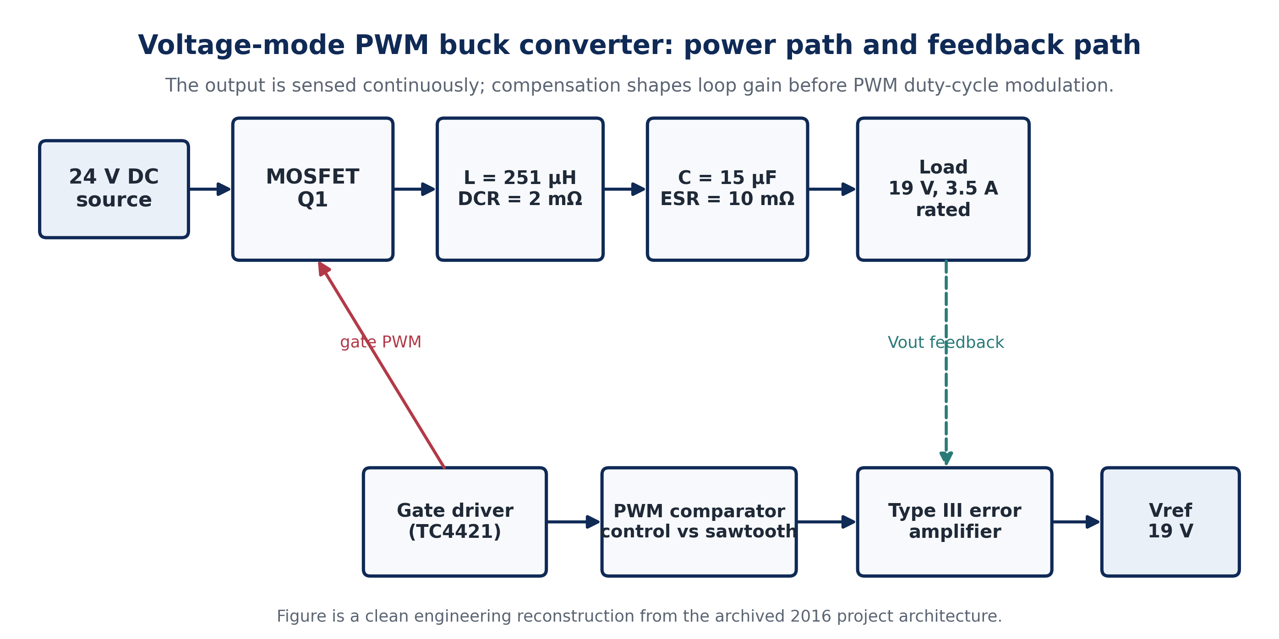
Figure 1. Reconstructed system architecture of the archived PWM buck converter. The original project describes a voltage-feedback loop in which the measured output is compared with a 19 V reference, compensated, converted to PWM by a sawtooth comparator and applied to the MOSFET through a gate driver.

1.1 Contribution and evidence provenance
The contribution of e046 is not to relabel a 2016 student project as a new 2026 experiment. Instead, it performs a transparent engineering reconstruction: it preserves the documented design parameters and implementation claims, rewrites the mathematics in a traceable form, derives quantities that follow directly from the documented parameters, and separates those analytical reconstructions from measurements that cannot be independently recovered from the archived plots. This distinction is important because the report contains several legacy notation and unit inconsistencies. The journal version resolves such issues explicitly rather than silently replacing the source record.
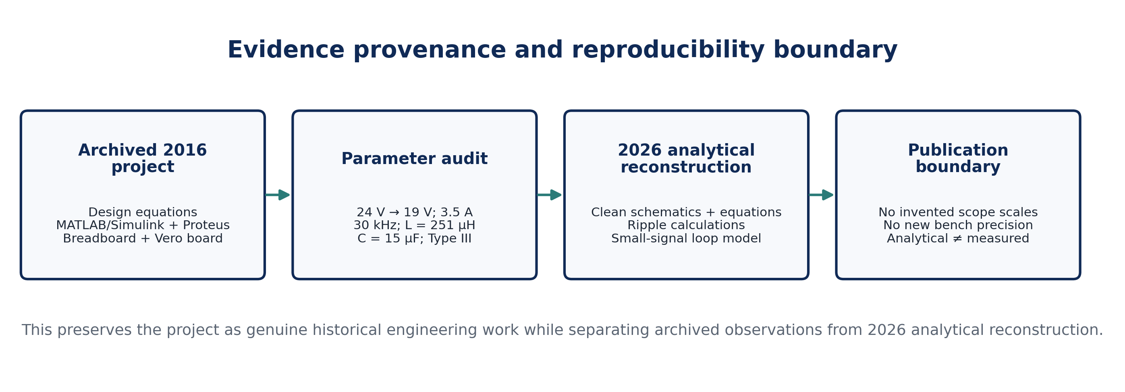
Figure 2. Evidence provenance and reproducibility boundary used for e046. Derived quantities are identified as analytical reconstruction; the article does not invent oscilloscope scales or new prototype measurements.

2. Buck-Converter Theory and Voltage-Mode Control

2.1 Ideal conversion ratio and switching interval
For an ideal buck converter operating in CCM, volt-second balance on the inductor gives the familiar conversion ratio
$$D=\frac{t_{on}}{T_{s}}, T_{s}=\frac{1}{f_{s}}, V_{o}=D V_{in}$$ | (1)
Thus the rated duty ratio for 24 V to 19 V conversion is
$$D=\frac{19}{24}=0.7917 \left(79.17\%\right)$$ | (2)
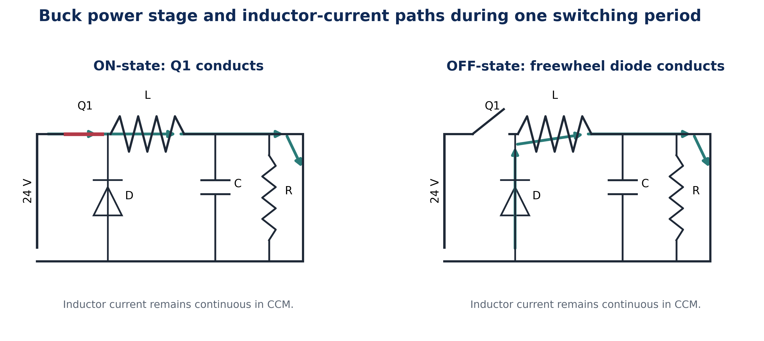
Figure 3. Power-stage states. During Q1 ON-time the source charges the inductor and supplies the load; during OFF-time the diode provides a current path so that inductor current remains continuous.

2.2 Inductor-current ripple and CCM condition
During the ON interval, the ideal inductor voltage is Vin − Vo; during the OFF interval it is approximately −Vo. The peak-to-peak current ripple is therefore
$$ΔI_{L}=\frac{\left(V_{in}-V_{o}\right)D}{Lf_{s}}=\frac{V_{o}\left(1-D\right)}{Lf_{s}}$$ | (3)
$$ΔI_{L}=\frac{\left(24-19\right)\left(0.7917\right)}{\left(251×{10}^{-6}\right)\left(30×{10}^{3}\right)}≈0.526 A_{pp}$$ | (4)
At the 3.5 A rated operating point, the reconstructed current range is approximately 3.237 to 3.763 A. Because the minimum remains well above zero, the rated point is unambiguously in CCM.

2.3 Output-capacitor ripple
For a triangular capacitor current in CCM, a common first-order ripple estimate is the sum of the capacitive charging term and the capacitor-ESR term:
$$ΔV_{o}≈\frac{ΔI_{L}}{8f_{s}C}+ΔI_{L} R_{ESR}$$ | (5)
$$ΔV_{o}≈0.146+0.005≈0.151 V_{pp}$$ | (6)

2.4 Voltage-mode PWM control
The project uses a single outer voltage loop. The output-voltage error is amplified and shaped by the compensator; the resulting control voltage is compared with a fixed-frequency sawtooth to generate the gate PWM. This is the conventional voltage-mode architecture described in contemporary control-loop guidance, in which the LC double pole introduces up to −180° phase shift and usually motivates Type-III compensation when a wider bandwidth is desired (Analog Devices, n.d.-a, n.d.-b).
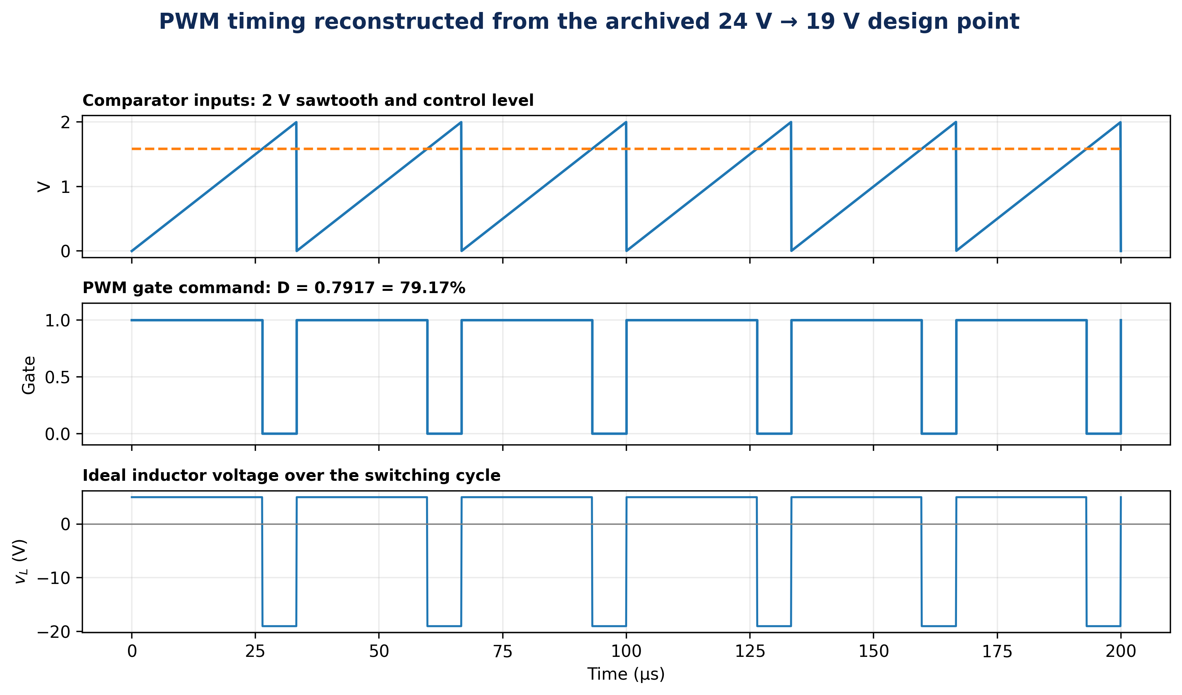
Figure 4. PWM timing at the rated ideal duty ratio. The 2 V sawtooth level is included as a reconstruction because the archived Type-III component table contains a 2 V modulation quantity; the exact original comparator scale is not independently recoverable from the source plots.

3. Design Reconstruction

3.1 Archived specifications and source reconciliation
Parameter | Value | Evidence / interpretation
Input voltage | 24 V | Directly specified in Table 3.1
Rated output voltage | 19 V | Directly specified
Rated output current | 3.5 A | Directly specified
Rated output power | 66.5 W | 19 V × 3.5 A
Switching frequency | 30 kHz | Directly specified
Inductor | 251 µH; DCR 2 mΩ | Documented schematic/component list
Output capacitor | 15 µF; ESR 10 mΩ | Documented schematic/component list
Rated equivalent load | 5.43 Ω | Derived from 19 V / 3.5 A
Simulation/bench nominal load | 5 Ω | Documented in full schematic
Compensation | Type III | Documented K-factor design
Table 1. Design specification and reconciliation. The 5.43 Ω rated equivalent load and the archived 5 Ω simulation load are not treated as the same condition.
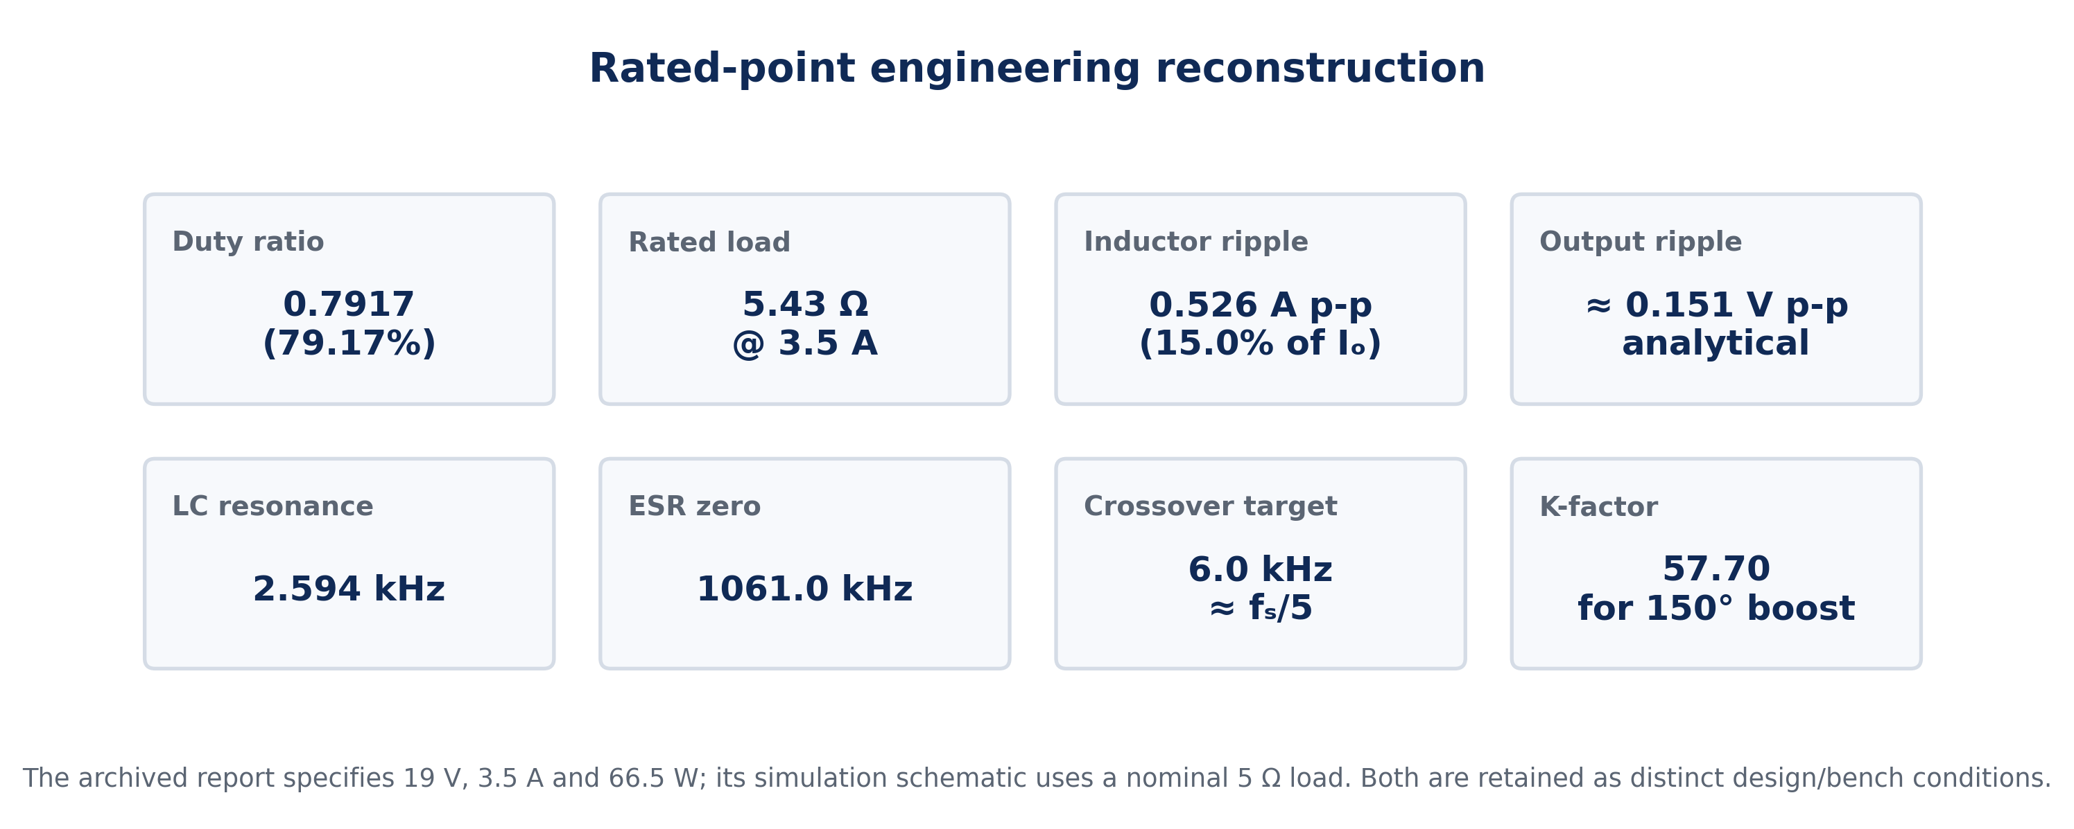
Figure 5. Rated-point engineering quantities derived from the documented design parameters.

3.2 Power, load and switch stress
$$P_{o}=V_{o}I_{o}=19×3.5=66.5 W$$ | (7)
$$R_{L,rated}=\frac{V_{o}}{I_{o}}=\frac{19}{3.5}=5.43 Ω$$ | (8)
For the ideal design point, the MOSFET must conduct approximately the inductor current during D·Ts and block approximately Vin during OFF-time; the freewheeling diode carries the inductor current during (1−D)·Ts. Practical device selection therefore requires voltage margin above 24 V, current margin above the reconstructed peak current, low conduction loss and switching performance compatible with 30 kHz. The archived schematic identifies Q1 as a MOSFET and lists a 3 A diode selection in the design narrative, while another component table identifies an IN4141-type device. That naming inconsistency is retained as a source limitation; e046 does not substitute a specific modern part number without a new hardware audit.

3.3 Output filter frequencies
The undamped LC natural frequency and the capacitor-ESR zero are
$$f_{0}=\frac{1}{2π\sqrt{LC}}, f_{ESR}=\frac{1}{2πR_{ESR}C}$$ | (9)
$$f_{0}≈2.594 \text{kHz}, f_{ESR}≈1061.0 \text{kHz}$$ | (10)
The source report independently states an output-filter double-pole frequency of 2.594 kHz, which agrees closely with the reconstruction above. Because the ESR zero is far above the LC resonance, the capacitor does not provide useful phase lead near crossover; this supports the documented choice of Type-III compensation.

3.4 Type-III compensation and K-factor interpretation
A Type-III compensator contributes one pole at the origin, two finite zeros and two high-frequency poles. A convenient generic form is
$$G_{c}\left(s\right)=K_{c}\frac{\left(1+s/ω_{z1}\right)\left(1+s/ω_{z2}\right)}{s\left(1+s/ω_{p1}\right)\left(1+s/ω_{p2}\right)}$$ | (11)
The archived project uses a K-factor design and reports a required phase boost of approximately 150°. For the common Type-III K-factor relation
$$K=\tan^{2}​\left({45}^{∘}+\frac{ϕ_{boost}}{4}\right)$$ | (12)
$$K=\tan^{2}\left({82.5}^{∘}\right)≈57.70$$ | (13)
This reproduces the archived reported K-factor of about 57.7. The source component set is listed below.
Component | Archived value | Functional role in reconstruction
R1 | 2.2 kΩ | low-frequency gain / feedback path
R2 | 5.9 kΩ | first lead branch
R3 | 38.8 Ω | high-frequency pole branch
C1 | 34.2 nF | integral / pole placement
C2 | 0.6 nF | lead zero branch
C3 | 90 nF | second lead / high-frequency branch
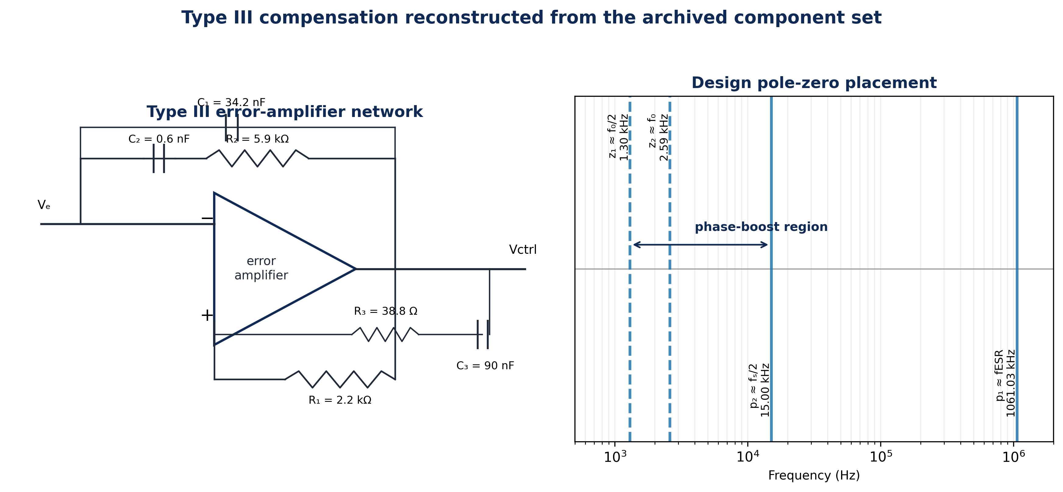
Figure 6. Clean Type-III network reconstruction and the design pole-zero placement used for the analytical loop model. Exact original op-amp parasitics are not modeled.

4. Analytical Results and Comparison with Archived Evidence

4.1 Rated-point ripple and CCM behavior
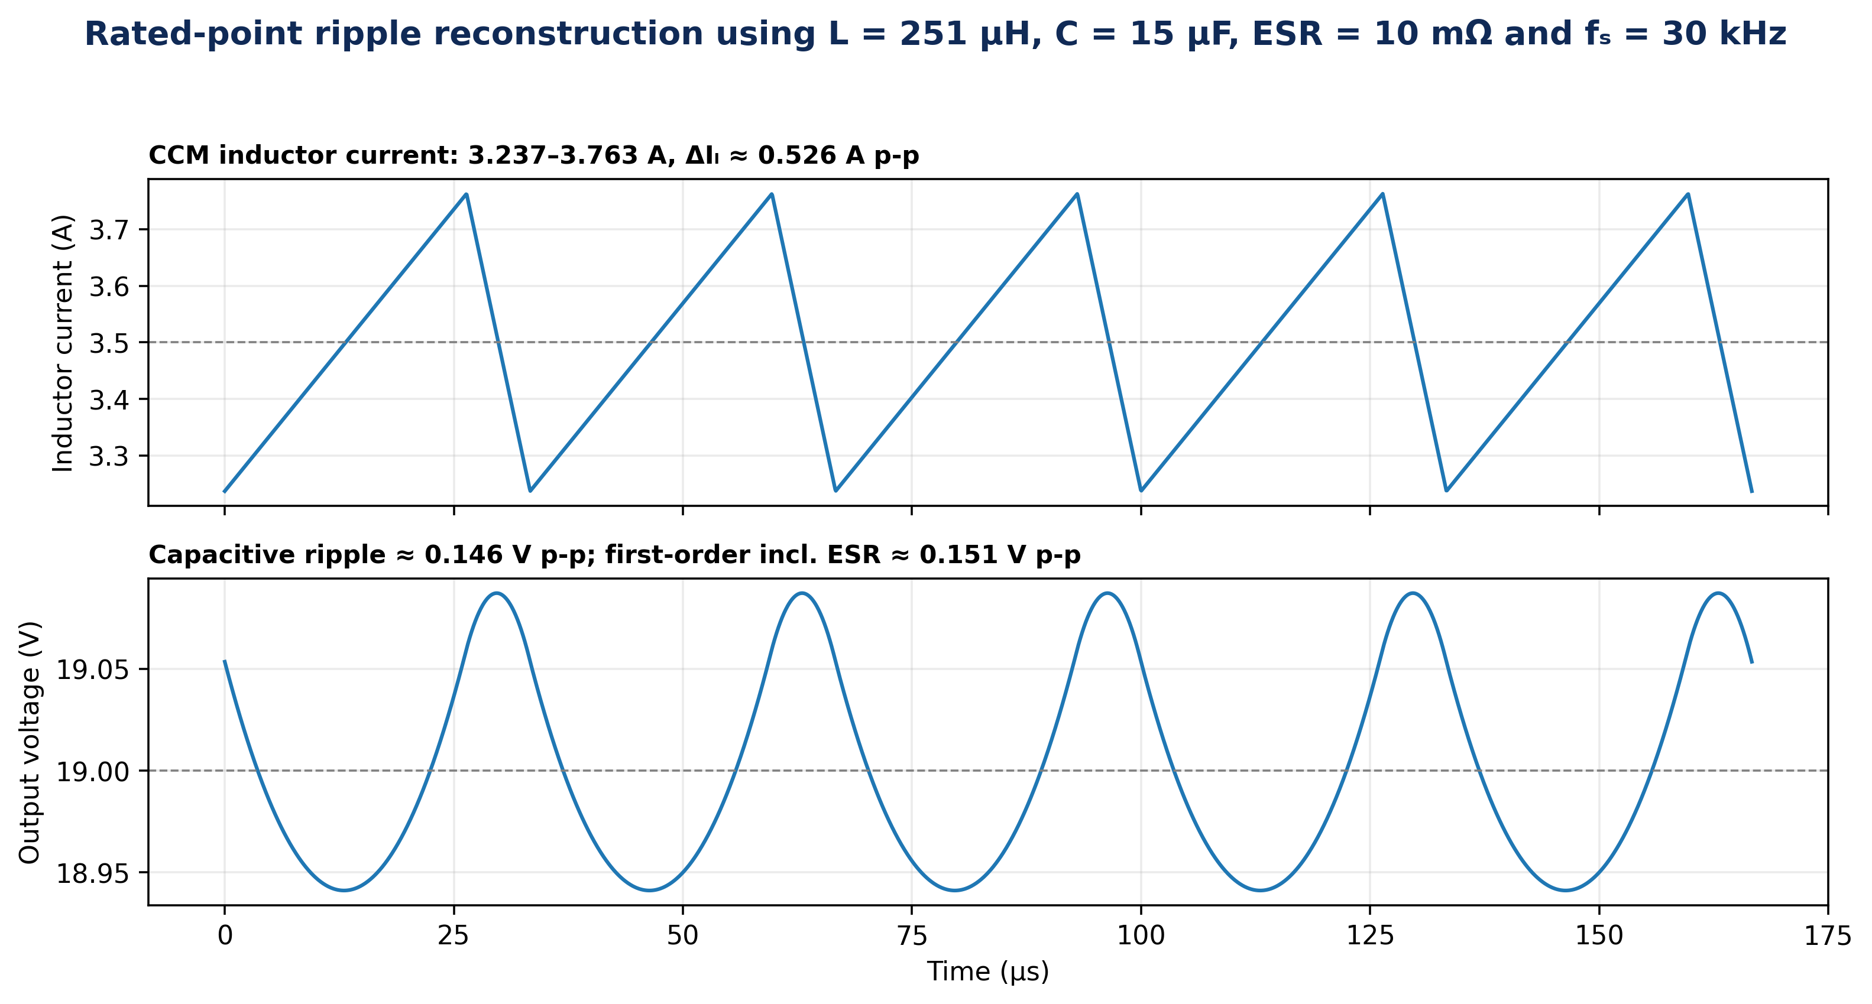
Figure 7. Analytical rated-point ripple. These are reconstructed theoretical waveforms from the documented L, C, ESR, fs, Vin and Vo; they are not digitized measurements from the archived MATLAB figure.
The reconstructed inductor ripple of 0.526 A p-p is exactly 15.0% of the rated 3.5 A current, closely matching the project design target of 15% current ripple. The corresponding output-voltage ripple estimate is about 0.151 V p-p, or 0.80% of the 19 V output. This distinction matters because the archived report states that the “measured ripple” values are 19 V and 3.5 A; those numbers coincide with the output-voltage and rated-current levels rather than plausible ripple amplitudes. e046 therefore treats that wording as a legacy reporting error and does not reproduce it as a ripple measurement.

4.2 Small-signal power-stage model
For an approximate voltage-mode analysis that retains capacitor ESR but neglects detailed switch, diode, op-amp and layout parasitics, the control-to-output plant can be represented as
$$G_{vd}\left(s\right)≈V_{in}\frac{1+sR_{ESR}C}{LCs^{2}+\left(L/R_{L}\right)s+1}$$ | (14)
The Type-III zeros were placed around one-half of f0 and f0, with a high-frequency pole near fs/2 and another near the capacitor-ESR zero. The compensator gain was normalized so that the open-loop magnitude crosses 0 dB near 6 kHz (approximately fs/5), consistent with the archived design narrative that crossover should remain well below the switching frequency.
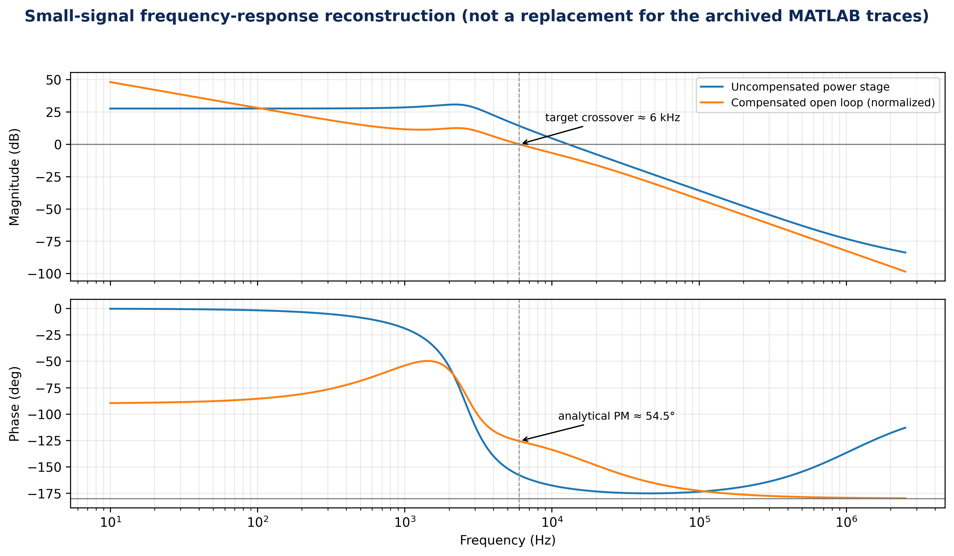
Figure 8. Analytical Bode reconstruction. With the stated pole-zero placement and normalization, the loop crosses near 6 kHz with an indicative phase margin of about 54.5°. This plot is an e046 analytical reconstruction, not a claim that the original archived MATLAB Bode trace had exactly these numerical coordinates.

4.3 Archived simulation and prototype evidence
The source report documents a full Proteus-style schematic, a MATLAB/Simulink converter model, PWM waveforms, output-voltage/load-current plots and implementation first on a breadboard and then on Vero board. It concludes that the converter produced the 19 V target from 24 V at 30 kHz and reports efficiency above 81% together with a 0.5 s settling-time statement. However, the archived pages available for this publication do not provide a traceable efficiency table, calibrated oscilloscope scales or a complete load sweep from which those two performance claims can be independently recomputed. Accordingly, they are retained as archived project observations rather than elevated to newly verified 2026 measurements.

5. Discussion

5.1 What the design demonstrates
First, the power-stage sizing is internally coherent at the central design point: the 79.17% duty ratio follows directly from the target voltage ratio, and the 251 µH inductor produces almost exactly the intended 15% current ripple at 30 kHz. Second, the 15 µF capacitor with 10 mΩ ESR gives a sub-1% first-order output-ripple estimate at rated current, illustrating how capacitor selection and ESR jointly shape both ripple and loop dynamics. Third, the LC resonance near 2.6 kHz is close enough to the intended control bandwidth that simple integral compensation would be inadequate for a fast voltage-mode loop; Type III is therefore a technically defensible choice. This agrees with modern guidance that voltage-mode buck converters frequently require two compensating zeros around the LC resonance and high-frequency poles to preserve phase margin while attenuating switching noise (Analog Devices, n.d.-a; Texas Instruments, 2010).

5.2 Source inconsistencies and how e046 handles them
Legacy issue | Archived statement | Publication treatment
Rated load vs schematic load | 19 V/3.5 A = 5.43 Ω, but schematic uses 5 Ω | Treat 5.43 Ω as rated design point and 5 Ω as separate nominal bench/simulation load.
“Ripple” statement | 19 V and 3.5 A called ripple values | Recognize these as operating levels; do not present them as ripple amplitudes.
Diode identification | Narrative says 3 A selection; table names IN4141/IN4141-like device | Do not infer an exact final diode part without hardware audit.
Efficiency/load-current sentence | Reports >81% over “0.5 mA to 1.26 mA,” inconsistent with 66.5 W rated design | Retain as archived claim only; do not use as validated rated-current evidence.
Simulation software naming | Proteus appears in design description; MATLAB/Simulink appears in results | Treat both as parts of the archived workflow rather than forcing one-tool provenance.
Table 2. Transparent treatment of legacy reporting inconsistencies. No unsupported correction is presented as if it were an original measurement.

5.3 Engineering upgrades for a contemporary re-build
A new build should retain the topology-learning value of the project while improving measurement traceability and protection. Recommended upgrades are: (i) use a modern low-RDS(on) MOSFET and a diode/synchronous rectifier with documented voltage/current margin; (ii) add input and output decoupling close to the switching loop; (iii) measure loop gain with a frequency-response analyzer or injection method rather than relying only on simulation; (iv) record output ripple with bandwidth-limited differential probing and clearly stated probe ground technique; (v) log input power and output power simultaneously to produce an efficiency curve versus load; (vi) quantify startup overshoot and settling time against a defined tolerance band; and (vii) use current limiting, over-voltage protection, thermal sensing and controlled dead time where appropriate. Modern vendor guidance also recommends verifying the calculated loop against time-domain load transients and component tolerances rather than treating a nominal Bode plot as sufficient by itself (Analog Devices, n.d.-b).

6. Conclusion
The 24 V-to-19 V PWM buck converter project is a defensible foundation for a technical journal article when its historical evidence and its modern analytical reconstruction are clearly separated. The core design is mathematically consistent: D ≈ 0.7917, Pout = 66.5 W at 3.5 A, the 251 µH inductor yields about 0.526 A p-p ripple at 30 kHz, and the LC resonance is approximately 2.594 kHz. The documented Type-III network and K-factor of about 57.7 are consistent with the need for substantial phase boost in voltage-mode control. The original project further documents MATLAB/Simulink and Proteus-based development and a Vero-board implementation that achieved the 19 V target. The most important publication improvement in e046 is evidentiary discipline: analytical results are explicitly labeled, legacy inconsistencies are exposed rather than hidden, and no new bench precision is invented from uncalibrated historical plots.

Declarations
Authorship/provenance: The archived project identifies CHIA S. KENNETH as the student investigator and ENGR. DR. GOSHWE N. Y. as supervisor. e046 presents these two project contributors as authors following editorial instruction; the 2016 role labels are preserved transparently. Funding: No external funding is documented in the archived project. Competing interests: None declared. Data and materials: The article is derived from the archived project report and its embedded schematics/simulation figures. No new raw oscilloscope or efficiency dataset is claimed. Ethics: Not applicable; the work concerns an electrical power-conversion prototype and contains no human or animal participants.

Author Contributions (CRediT-style)
Contributor | Documented / reconstructed role
Chia, Shiaondo Kenneth | Original project investigation; converter design and calculation; simulation workflow; prototype implementation; 2026 technical reconstruction and manuscript development.
Goshwe, N. Y. | Original project supervision and engineering review; 2026 manuscript-level technical review role attributed from the documented supervisory relationship. No unrecorded experimental contribution is assumed.

References
Analog Devices. (n.d.-a). AN-149: Modeling and loop compensation design of switching mode power supplies. Analog Devices.
Analog Devices. (n.d.-b). What is a control system and how to design a control loop for a DC-to-DC converter. Analog Devices.
Chia, S. K. (2016). Design and implementation of a 24 V to 19 V DC-DC buck converter using pulse width modulation [B.Eng. project]. Federal University of Agriculture Makurdi, Nigeria.
Day, M. (2004). Optimizing low-power DC/DC designs: External versus internal compensation. Texas Instruments.
Erickson, R. W., & Maksimović, D. (2020). Fundamentals of power electronics (3rd ed.). Springer.
Hauke, B. (2015). Basic calculation of a buck converter’s power stage (SLVA477B). Texas Instruments.
Kazimierczuk, M. K. (2015). Pulse-width modulated DC-DC power converters (2nd ed.). Wiley.
Mattingly, D. (2003). Designing stable compensation networks for single phase voltage mode buck regulators (TB417.1). Intersil.
Meeks, D. (2008). Loop stability analysis of voltage mode buck regulator with different output capacitor types—continuous and discontinuous modes (SLVA301). Texas Instruments.
Mohan, N., Undeland, T. M., & Robbins, W. P. (2003). Power electronics: Converters, applications, and design (3rd ed.). Wiley.
Pressman, A. I., Billings, K., & Morey, T. (2009). Switching power supply design (3rd ed.). McGraw-Hill.
Schelle, D., & Castorena, J. (2006). Buck-converter design demystified. Power Electronics Technology.
Texas Instruments. (2010). Power topology—Buck converter: Type-III compensation and efficiency calculation (SLVA432). Texas Instruments.
Xu, P., Wei, J., & Lee, F. C. (2003). Multiphase coupled-buck converter—A novel high efficient 12 V voltage regulator module. IEEE Transactions on Power Electronics, 18(1), 74–82.
Zhou, S., & Rincón-Mora, G. A. (2006). A high efficiency, soft switching DC-DC converter with adaptive current-ripple control for portable applications. IEEE Transactions on Circuits and Systems II: Express Briefs, 53(4), 319–323.

