CHIATECH JOURNAL
  - SETEHEM · VOLUME 1 · ISSUE 2 · AUGUST 2026 · e050
  - PIONEER PUBLICATION · ACCEPTED ARTICLE · ORIGINAL TECHNICAL MODELLING RESEARCH ARTICLE · BUILDING PHYSICS · ENERGY EFFICIENCY · BEEC · SONMELS · NIGERIA

Coupled Mathematical Modelling of Building Envelope and Cooling-Efficiency Standards for Nigerian Multi-Unit Housing: An Abuja-Calibrated BEEC–SONMELS Predictive Scenario Framework
ABDULRAHMAN, Abdulsalam A.² · CHIA, Shiaondo Kenneth^{1*}

1 CHIA TECH Solutions and Resources Limited, Nigeria

2 Department of Building Technology, University of Abuja, Nigeria
*Corresponding author: chiakenneth01@gmail.com · ORCID: https://orcid.org/0009-0009-6434-4586
Co-author contact: Abdulsalam.abdulrahman@uniabuja.edu.ng
ARTICLE TYPE | VOLUME / ISSUE | ELOCATOR
Original Technical Modelling Research Article | 1(1) | e050
PUBLICATION | IDENTIFIERS | JOURNAL DOI
Pioneer Issue · August 2026 | ISSN: Pending assignment | Pending registration

Abstract
Background: Nigeria now has two complementary efficiency instruments that operate at different scales: the 2017 National Building Energy Efficiency Code (BEEC), which constrains building design and regulated loads, and the 2026 Standards Organisation of Nigeria Mandatory Energy Labeling Scheme (SONMELS), which classifies air-conditioner efficiency by the Nigeria Seasonal Energy Efficiency Ratio (NSEER). Their combined energy implication for multi-unit housing has not been expressed in a transparent mathematical crosswalk. Objective: This study couples the published Abuja-calibrated BEEC multi-unit apartment benchmark with current SONMELS cooling classes to quantify whole-building energy consequences under explicit cooling-service stress. Methods: The model uses the BEEC technical-study archetype of 1,200 m² with annual intensity components of 22 kWh/m² for lighting, 116 kWh/m² for cooling and 25 kWh/m² for water heating. The BEEC study reports 49% annual savings and 52% peak-load savings over regulated loads for the multi-unit benchmark. The 49% regulated-load result is reconstructed using the BEEC lighting-power-density change from 13 to 6 W/m², leaving a consistent residual cooling component. That component is then crosswalked to the SONMELS 1–5-star lower-bound NSEER thresholds (3.10, 3.60, 4.20, 4.95 and 5.80) under a cooling-service multiplier κ = 0.8–1.3. Results: The published business-as-usual archetype corresponds to 163 kWh/m²·year or 195.60 MWh/year. Reconstructing the BEEC benchmark gives 95.38 kWh/m²·year or 114.46 MWh/year, a 41.5% whole-site reduction when the unchanged 25 kWh/m² water-heating component is retained. After the BEEC package, movement from the 1-star analytical reference to the 5-star threshold reduces modeled site energy from 114.46 to 80.81 MWh/year, a further 29.4% reduction and 58.7% below the original archetype. Even under a 20% cooling-service stress (κ = 1.2), the BEEC + 5-star scenario remains at 88.54 MWh/year, 54.7% below the baseline. Conclusion: Building-envelope compliance and appliance efficiency are multiplicative rather than substitutable. The most resilient pathway for Nigerian multi-unit housing is to reduce cooling service demand through BEEC-compliant envelope and lighting measures before improving equipment efficiency through SONMELS. The results are a standards-coupled reanalysis of published and official evidence, not new field measurements.
Keywords: building energy efficiency; BEEC; SONMELS; multi-unit housing; cooling; air conditioners; NSEER; mathematical modelling; Abuja; Nigeria
Suggested citation: Abdulrahman, A. A., & Chia, S. K. (2026). Coupled mathematical modelling of building envelope and cooling-efficiency standards for Nigerian multi-unit housing: An Abuja-calibrated BEEC–SONMELS predictive scenario framework. CHIATECH JOURNAL · SETEHEM, 1(1), e049.

1. Introduction
Residential energy efficiency is often divided administratively into “building” and “appliance” domains even though a household experiences them as one physical system. The envelope, glazing, shading, roof, ventilation and internal heat gains determine the cooling service required; the air conditioner then determines how much electricity is required to provide that service. Treating either layer in isolation can therefore misstate the achievable reduction in electricity demand.
Nigeria’s National Building Energy Efficiency Code (BEEC), launched in 2017, was developed from parametric building studies undertaken with the Federal Capital Territory’s development-control context and was designed to reduce energy use through climate-adaptive requirements. The underlying technical study established business-as-usual and benchmark configurations for residential buildings, including a multi-unit apartment archetype. For residential buildings, the benchmark moves window-to-wall ratio from 30% to 20%, installed lighting power density from 13 to 6 W/m², adds roof insulation to a minimum thermal resistance of 1.25 m²K/W and replaces non-inverter split air conditioners with inverter-type systems (Federal Ministry of Power, Works and Housing [FMPWH], 2017a, 2017b).
The equipment-policy layer has since advanced. SONMELS now provides a national appliance conformity and labelling framework. Its first phase includes room air conditioners and defines five energy classes using the Nigeria Seasonal Energy Efficiency Ratio (NSEER): 1 Star begins at 3.10, 2 Star at 3.60, 3 Star at 4.20, 4 Star at 4.95 and 5 Star at 5.80. Mandatory implementation is scheduled for December 2026 (Standards Organisation of Nigeria [SON], 2026). This creates a technically important opportunity to connect a building-efficiency benchmark developed before SONMELS with contemporary cooling-equipment performance classes.
Recent Abuja research reinforces the relevance of this coupling. Abdulkareem and Al-Maiyah (2025) used validated simulations of Nigerian affordable-housing prototypes and showed that combined passive design measures can materially reduce thermal discomfort. Their work highlights a continuing need to reduce solar and conductive heat gain before relying on mechanical cooling. The present paper advances that logic quantitatively by integrating official BEEC building evidence with current SONMELS efficiency thresholds.

1.1 Research gap, contribution and originality boundary
The supplied research sequence already contains a rural solar mini-grid optimisation study, a stochastic solar–wind household model, CHIATECH JOURNAL e045 on residential demand response, and e047 on appliance-efficiency policy at stock level. e049 deliberately avoids repeating those contributions. It does not size generation assets, estimate national appliance-stock savings, or shift hourly demand. Instead, it asks a building-physics question: how does a published multi-unit residential benchmark change when envelope constraints and current air-conditioner efficiency classes are treated as a coupled energy system?
Dimension | Prior research focus | e049 contribution
Scale | Households, mini-grids or appliance stocks | One published 1,200 m² multi-unit building archetype
Primary mechanism | Generation sizing, renewable uncertainty, load shifting or market coverage | Envelope/lighting demand reduction coupled with AC conversion efficiency
Evidence base | Field/simulation results in earlier supplied studies | Official 2017 BEEC technical benchmark + 2026 SONMELS thresholds
Output | Reliability, LCOE, peak shifting or aggregate GWh policy savings | kWh/m²·year, MWh/year, star-class crosswalk and robustness to cooling-service stress

Table 1. Originality boundary and analytical contribution of e049.

1.2 Research questions
- What whole-building annual energy intensity is implied by the published BEEC multi-unit business-as-usual archetype and its reported benchmark saving?
- How can the BEEC benchmark be decomposed consistently into lighting and residual cooling components without inventing new field data?
- How does the resulting cooling-electricity requirement change across the 2026 SONMELS 1–5-star NSEER thresholds?
- Do the combined BEEC–SONMELS savings remain material when cooling-service demand is subjected to transparent ±20–30% stress scenarios?
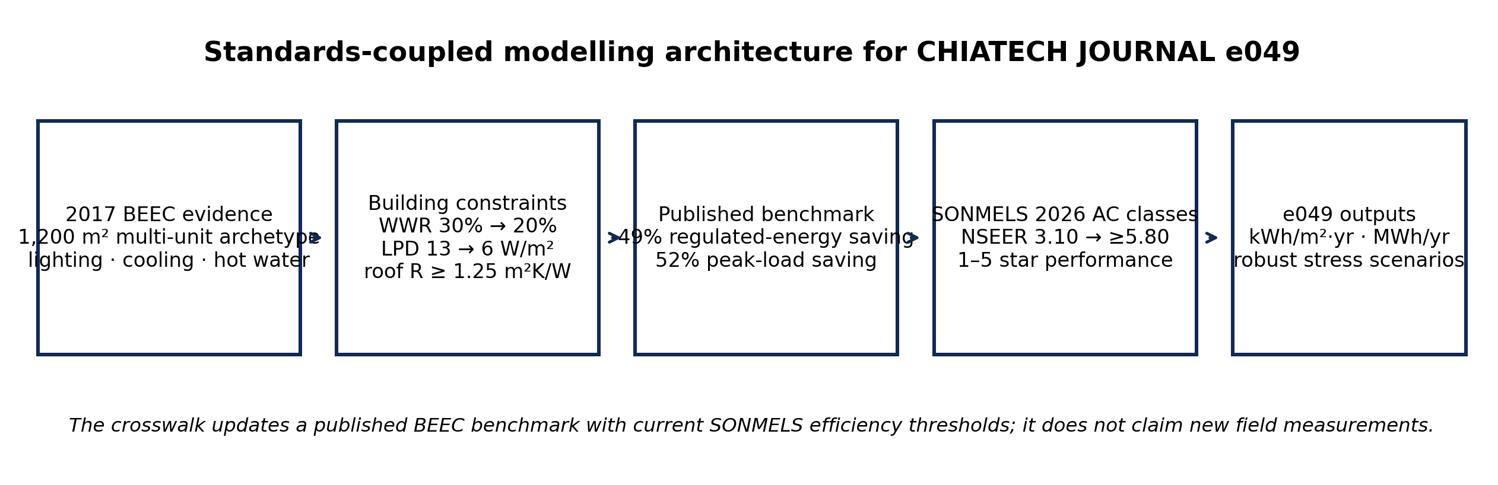
Figure 1. Standards-coupled evidence and modelling architecture used in e049. Original author synthesis.

2. Evidence Base and Technical Context

2.1 Published multi-unit apartment benchmark
The 2017 BEEC technical study reviewed residential projects and identified multi-unit apartments as one of the representative Nigerian residential typologies. Its energy-use table gives a 1,200 m² multi-unit apartment with 22 kWh/m²·year for lighting, 116 kWh/m²·year for cooling and 25 kWh/m²·year for water heating, for a stated total of 163 kWh/m²·year. The same study’s Annex reports that the BEEC-compliant multi-unit benchmark reduced annual energy over regulated loads by 49% and peak electrical load by 52% relative to business as usual (FMPWH, 2017a).
Published parameter | Business-as-usual / evidence | BEEC benchmark / result
Archetype floor area | 1,200 m² multi-unit apartment | Same reference area
Lighting intensity | 22 kWh/m²·year; 13 W/m² LPD | LPD maximum 6 W/m²
Cooling intensity | 116 kWh/m²·year | Reduced by combined envelope + AC package
Water heating | 25 kWh/m²·year | Held unchanged in e049
Window-to-wall ratio | 30% residential BAU input | 20% maximum or required shading
Roof | Aluminium roof, no insulation | Minimum R = 1.25 m²K/W
Annual regulated-load saving | — | 49% reported for multi-unit benchmark
Peak regulated-load saving | — | 52% reported for multi-unit benchmark

Table 2. Source-grounded BEEC inputs used in the mathematical reconstruction.

2.2 Contemporary SONMELS cooling-performance classes
SONMELS provides the missing modern equipment-performance scale. The guideline links room air conditioners to NIS 943:2024 and specifies star classes by NSEER. Because seasonal energy efficiency is a ratio of useful cooling service to electrical energy input, an equal cooling service can be represented approximately by electricity varying inversely with NSEER. e049 uses this physical relationship only as a scenario crosswalk. The 1-star lower threshold (NSEER = 3.10) is an analytical reference, not a claim that the 2017 BEEC benchmark or the Nigerian in-use stock has a 1-star rating.
SONMELS class | Lower-bound NSEER used in e049 | Relative cooling electricity at equal service (3.10/NSEER)
1 Star | 3.10 | 1.000
2 Star | 3.60 | 0.861
3 Star | 4.20 | 0.738
4 Star | 4.95 | 0.626
5 Star | 5.80 | 0.534

Table 3. Air-conditioner efficiency thresholds used in the standards crosswalk. Source: SON (2026).
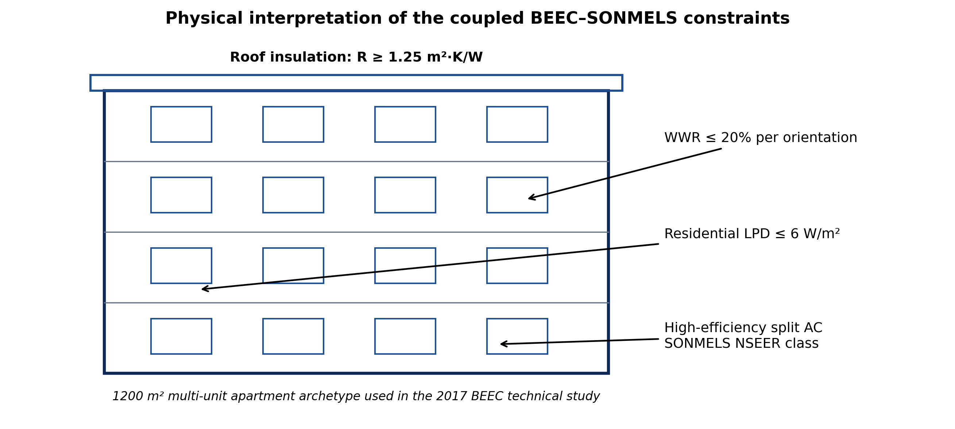
Figure 2. Physical interpretation of the BEEC–SONMELS constraints for a multi-unit residential building.

3. Mathematical Model and Reproducibility

3.1 Baseline energy identity
Let A be gross floor area and eL, eC and eW be annual area-normalized electricity intensities for lighting, cooling and water heating. The business-as-usual site-energy proxy is
E_BAU = A (eL,0 + eC,0 + eW,0) (1)
Using A = 1,200 m² and the published component intensities gives E_BAU = 195.60 MWh/year.

3.2 Reconstruction of the BEEC benchmark
The BEEC performance route excludes household appliances and water heating from the regulated energy calculation; therefore the published 49% saving is applied only to lighting plus cooling. The regulated benchmark intensity is
eREG,B = (1 − sB)(eL,0 + eC,0), sB = 0.49 (2)
The lighting component is reconstructed from the explicit LPD change:
eL,B = eL,0 (LPDB / LPD0) = 22(6/13) = 10.154 kWh/m²·year (3)
The residual cooling component that makes Equations (2) and (3) exactly consistent with the published aggregate benchmark is then
eC,B = eREG,B − eL,B = 60.226 kWh/m²·year (4)
This is a mathematical decomposition of the published benchmark, not a new measurement of cooling electricity.

3.3 SONMELS efficiency crosswalk and cooling-service stress
For SONMELS class j with lower-bound seasonal efficiency rj and cooling-service stress multiplier κ, the post-BEEC cooling electricity is modelled as
eC,j(κ) = eC,B (rref / rj) κ, rref = 3.10 (5)
The full site-energy intensity is
eT,j(κ) = eL,B + eC,j(κ) + eW,0 (6)
and the percentage saving against the original archetype is
S_j(κ) = 100 [1 − eT,j(κ) / eT,0]. (7)
The central case uses κ = 1.0. Values κ = 0.8–1.3 are sensitivity scenarios representing lower or higher delivered cooling service arising from weather, occupancy, set-point and operating-hour effects. They are not presented as forecasts of Abuja climate change.

3.4 Prescriptive feasibility constraints
The standards-coupled feasible set can be summarized as WWR ≤ 0.20 per orientation (or compliant shading), roof thermal resistance Rroof ≥ 1.25 m²K/W, residential LPD ≤ 6 W/m², and air-conditioner NSEER ≥ the selected SONMELS class threshold. The energy-minimizing solution within this constrained family is therefore obtained by first satisfying the building-load constraints and then selecting the highest feasible equipment efficiency. This sequencing is physically important: reducing cooling load avoids oversizing and operating even an efficient air conditioner for unnecessary hours.

4. Results

4.1 Baseline and BEEC benchmark reconstruction
The published 163 kWh/m²·year business-as-usual intensity corresponds to 195.60 MWh/year for the 1,200 m² archetype. Applying the published 49% saving to regulated loads (lighting + cooling) gives 70.38 kWh/m²·year of regulated benchmark energy. After the LPD reconstruction, lighting is 10.15 kWh/m²·year and the consistent residual cooling component is 60.23 kWh/m²·year. Re-attaching the unchanged 25 kWh/m²·year water-heating component gives 95.38 kWh/m²·year or 114.46 MWh/year. This is a 41.5% whole-site reduction rather than 49%, because the water-heating component is intentionally not reduced.
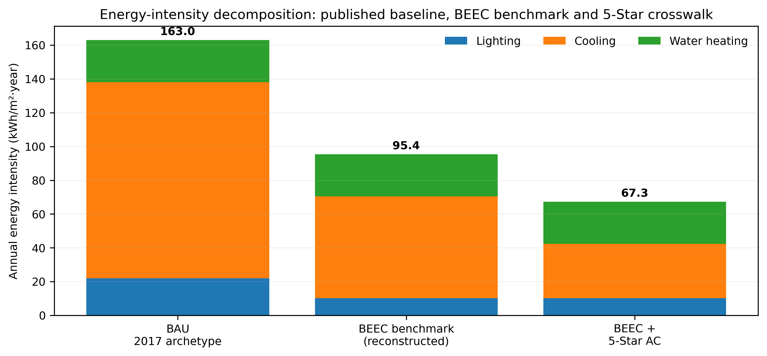
Figure 3. Decomposition of annual energy intensity. The 49% BEEC result applies to regulated loads; water heating is retained unchanged.

4.2 Incremental impact of SONMELS air-conditioner classes
AC class | NSEER | Cooling kWh/m²·yr | Total kWh/m²·yr | MWh/yr | Saving vs BAU | Extra saving vs BEEC
1 Star | 3.10 | 60.23 | 95.38 | 114.46 | 41.5% | 0.0%
2 Star | 3.60 | 51.86 | 87.02 | 104.42 | 46.6% | 8.8%
3 Star | 4.20 | 44.45 | 79.61 | 95.53 | 51.2% | 16.5%
4 Star | 4.95 | 37.72 | 72.87 | 87.45 | 55.3% | 23.6%
5 Star | 5.80 | 32.19 | 67.34 | 80.81 | 58.7% | 29.4%

Table 4. Coupled BEEC–SONMELS energy results at κ = 1.0.
The equipment-class effect is substantial after the building benchmark is already in place. Moving from the 1-star analytical reference to the 3-star lower threshold lowers modeled annual site energy to 95.53 MWh/year. The 5-star threshold gives 80.81 MWh/year, 29.4% below the reconstructed BEEC benchmark and 58.7% below the original archetype. The result demonstrates a multiplicative relationship: envelope and lighting improvements reduce the service and internal-load requirement, while higher NSEER reduces the electricity needed per unit of residual cooling service.
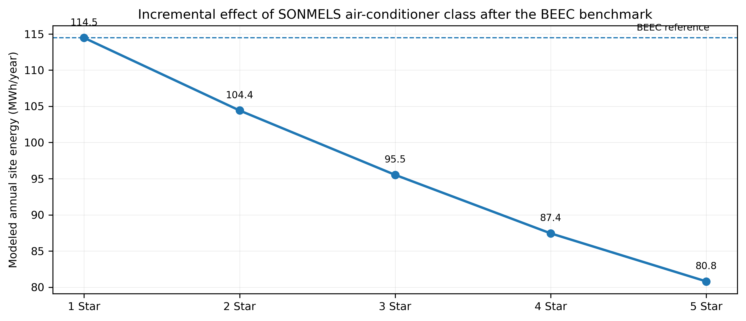
Figure 4. Modeled annual site energy across SONMELS air-conditioner classes after the BEEC benchmark.

4.3 Robustness under cooling-service stress
At κ = 1.2, which imposes a 20% increase on the post-BEEC cooling service, the 5-star scenario rises from 80.81 to 88.54 MWh/year. Even so, it remains 54.7% below the 2017 business-as-usual total. The heatmap shows that equipment efficiency becomes increasingly valuable as cooling-service stress rises, but it does not eliminate the need for load-reducing envelope measures.
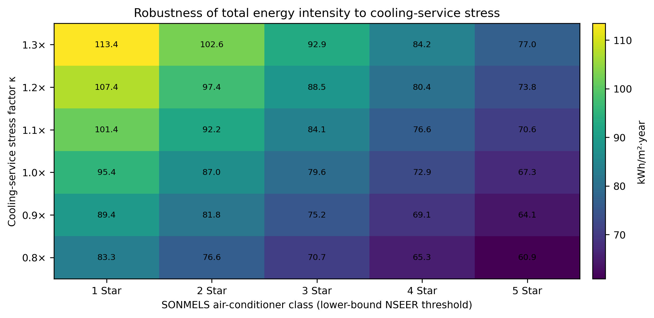
Figure 5. Total energy-intensity sensitivity to SONMELS class and the explicit cooling-service multiplier κ.

4.4 Consistency with the published peak-load result
The e049 model does not fabricate an absolute kilowatt peak because the source technical study does not publish a single absolute peak value in the extracted benchmark table. Instead, the 52% peak-load saving reported by the BEEC technical study for multi-unit apartments is retained as an external benchmark result. The energy-intensity reconstruction is consistent with the same intervention logic—lower window-to-wall ratio, roof insulation, lower lighting power density and improved AC technology—while the SONMELS crosswalk extends only the equipment-efficiency layer.

5. Discussion

5.1 Why envelope efficiency and appliance efficiency should be sequenced
The main technical implication is that efficient air conditioners cannot compensate fully for avoidable building heat gains. A thermally weak building increases cooling load, runtime and potentially required installed capacity. BEEC addresses the service-demand side through passive and prescriptive constraints; SONMELS addresses electricity conversion efficiency. The strongest pathway is therefore “load first, efficiency second”: reduce solar, conductive and internal gains, then satisfy the remaining load with higher-NSEER equipment.
This interpretation aligns with the BEEC development literature, which identifies climate-adaptive design as a low-cost foundation for Nigerian building efficiency (Geissler, Österreicher, & Macharm, 2018), and with the 2025 Abuja study showing that combined passive measures materially improve thermal conditions in existing affordable-housing prototypes (Abdulkareem & Al-Maiyah, 2025). e049 adds a current regulatory bridge by mapping those building-side gains onto SONMELS cooling classes.

5.2 Design and compliance implications for multi-unit housing
- At design approval, verify window-to-wall ratio by orientation, roof insulation specification and residential lighting power density before mechanical systems are sized.
- Specify room air conditioners by verified NSEER/star class rather than nominal cooling capacity alone; higher cooling capacity is not equivalent to higher efficiency.
- Use cooling-load calculations after envelope compliance to avoid oversizing and to reduce inverter cycling losses, capital cost and peak demand.
- For existing multi-unit buildings, prioritize shading, roof/ceiling thermal improvement and lighting retrofits before replacing still-serviceable air conditioners solely for efficiency reasons.
- At commissioning, record installed AC model, NSEER/star class, indoor/outdoor-unit pairing, thermostat settings and measured electrical demand so that future field studies can validate the scenario crosswalk.

5.3 Policy integration: BEEC + SONMELS
The policy opportunity is institutional as much as technical. Building-approval authorities can enforce envelope and lighting requirements, while SON controls the performance and labelling of regulated appliances entering the market. A coordinated compliance pathway could require building-energy submissions to state the efficiency class of proposed cooling equipment and could link commissioning documentation to SON’s approved-product register. This would reduce the current disconnect in which a building may satisfy one efficiency layer while underperforming at another.

5.4 Limitations and interpretation boundary
Five limitations are central. First, e049 is a standards-coupled reanalysis, not a new monitored-building study. Second, the 49% BEEC saving is an aggregate regulated-load result; e049 reconstructs its lighting component from the explicit LPD ratio and assigns the remaining regulated energy to cooling solely to maintain algebraic consistency. Third, the 1-star NSEER threshold is used as a neutral analytical reference because the 2017 BEEC benchmark predates SONMELS and does not report an NSEER value. Fourth, electricity is assumed to vary inversely with NSEER for equal delivered seasonal cooling service; real performance can differ because of sizing, cycling, installation quality, maintenance, humidity control and user behaviour. Fifth, κ is a sensitivity multiplier rather than a measured or forecast climate-change factor.
These boundaries are intentional. The article does not relabel historical equipment, invent field measurements or claim that every BEEC-compliant building will deliver the exact modeled values. Its contribution is a transparent framework in which observed building loads, registered AC classes and metered post-occupancy data can later replace the scenario inputs without changing the mathematical structure.

6. Conclusion and Recommendations
Using the official 2017 BEEC multi-unit apartment archetype, e049 establishes a business-as-usual total of 195.60 MWh/year and reconstructs the reported BEEC benchmark at 114.46 MWh/year when the unchanged water-heating component is retained. Coupling the post-BEEC residual cooling demand to the 2026 SONMELS star thresholds produces a monotonic decline in modeled annual site energy from 114.46 MWh/year at the 1-star analytical reference to 80.81 MWh/year at the 5-star lower threshold. The latter is 58.7% below the original archetype and remains 54.7% below it even under a 20% cooling-service stress.
The policy and engineering conclusion is clear: Nigeria should treat BEEC and SONMELS as a single efficiency chain. Building approval should first reduce the cooling service that the dwelling requires; equipment regulation should then minimize electricity per unit of remaining service; commissioning and post-occupancy measurement should verify the result. This sequence is more robust than relying on efficient appliances inside inefficient buildings or on passive design while ignoring appliance performance.

Declarations
Ethics: No new human-participant or animal research was conducted. The article reanalyses aggregated values and technical requirements from public documents.
Funding: The authors declare that no external funding was received specifically for preparation of this article.
Competing interests: The authors declare no competing interests.
Data availability: All numerical inputs required to reproduce the headline model are stated in the article and Appendix A. Primary evidence is available in the 2017 BEEC Technical Study, the National Building Energy Efficiency Code and the 2026 SONMELS Guidelines.
Originality disclosure: e049 does not republish the authors’ earlier mini-grid, stochastic-renewable, demand-response or appliance-stock results. Its new contribution is the mathematical coupling of a published multi-unit BEEC benchmark with contemporary SONMELS air-conditioner efficiency classes and explicit robustness analysis.
Author contributions: Abdulsalam A. Abdulrahman: building-technology conceptualization, source interpretation, technical validation, writing – review and editing. Shiaondo Kenneth Chia: mathematical framework, standards crosswalk, quantitative analysis, visualization, reproducibility design, writing – original draft and review. Both authors approved the final manuscript.
AI-assisted editorial support: AI-assisted tools were used for calculation checking, visualization, language refinement, document formatting and reference-consistency checking. They were not used as authors or as substitutes for source verification and professional judgement; responsibility for the final article remains with the named authors and journal editor.
Copyright and licence: © 2026 The Authors. Published by CHIA TECH SOLUTIONS AND RESOURCES LIMITED (RC 1839865). This open-access article is distributed under the Creative Commons Attribution 4.0 International (CC BY 4.0) licence, except for third-party material otherwise identified.

References
Abdulkareem, M., & Al-Maiyah, S. (2025). Improving the thermal environment of Abuja’s affordable housing through passive design solutions. Sustainability, 17(18), 8435. https://doi.org/10.3390/su17188435
Federal Ministry of Power, Works and Housing. (2017a). Technical study: Development of the Nigerian Building Energy Efficiency Code (BEEC). Federal Republic of Nigeria / Nigerian Energy Support Programme.
Federal Ministry of Power, Works and Housing. (2017b). National Building Energy Efficiency Code (BEEC) (1st ed.). Federal Republic of Nigeria.
Geissler, S., Österreicher, D., & Macharm, E. (2018). Transition towards energy efficiency: Developing the Nigerian Building Energy Efficiency Code. Sustainability, 10(8), 2620. https://doi.org/10.3390/su10082620
National Bureau of Statistics. (2024). Nigeria Residential Energy Demand-Side Survey Report 2024. National Bureau of Statistics.
Standards Organisation of Nigeria. (2026). SON Mandatory Energy Labeling Scheme (SONMELS) Guidelines (Version 1.1). Standards Organisation of Nigeria.
World Bank. (2026). Building Green: Nigeria—building energy code effectiveness and compliance dataset. World Bank Group.

Appendix A. Reproducibility Table
Input / derived term | Value | Status / source role
Reference floor area A | 1,200 m² | Published BEEC multi-unit archetype
BAU lighting eL,0 | 22 kWh/m²·yr | Published BEEC technical-study value
BAU cooling eC,0 | 116 kWh/m²·yr | Published BEEC technical-study value
Water heating eW,0 | 25 kWh/m²·yr | Published value; held unchanged
BAU lighting power density | 13 W/m² | Published BEEC residential input
BEEC lighting power density | 6 W/m² | Published BEEC minimum requirement
BAU / BEEC WWR | 30% / 20% | Published residential inputs / requirement
BEEC roof thermal resistance | ≥1.25 m²K/W | Published minimum requirement
Published regulated-energy saving | 49% | BEEC multi-unit benchmark result
Published peak-load saving | 52% | BEEC multi-unit benchmark result
Derived BEEC lighting | 10.154 kWh/m²·yr | 22 × 6/13
Derived BEEC residual cooling | 60.226 kWh/m²·yr | 70.38 − 10.154
SONMELS NSEER thresholds | 3.10, 3.60, 4.20, 4.95, 5.80 | Official 1–5-star lower bounds
Cooling stress κ | 0.8–1.3 | Explicit sensitivity only; not observed climate data

Table A1. Complete numerical basis for reproducing Equations (1)–(7).

