CHIATECH JOURNAL
  - SETEHEM · VOLUME 1 · ISSUE 2 · AUGUST 2026 · e051
  - PIONEER PUBLICATION · ACCEPTED ARTICLE · ORIGINAL RESEARCH ARTICLE · MEDICAL MICROBIOLOGY · ANTIMICROBIAL RESISTANCE · HOSPITAL EPIDEMIOLOGY · NIGERIA

Antimicrobial Resistance Profiles of Clinical and Environmental Staphylococcus aureus Across Six Secondary Health-Care Centres in Taraba State, Nigeria: Laboratory Evidence and Contemporary AMR Implications
MELLAH, Iwanger^{1*}

1 Federal University of Agriculture, Makurdi, Nigeria
*Corresponding author: whoisdrmellah@gmail.com
ARTICLE TYPE | VOLUME / ISSUE | ELOCATOR
Original Research Article | 1(1) | e051
PUBLICATION | IDENTIFIERS | JOURNAL DOI
Pioneer Issue · August 2026 | ISSN: Pending assignment | Pending registration

Abstract
Background: Methicillin-resistant Staphylococcus aureus remains a high-priority antimicrobial-resistance pathogen, while local clinical and environmental surveillance is essential for infection control. This article develops the first journal paper from a completed Medical Microbiology thesis by isolating its most internally coherent major finding: occurrence and phenotypic antimicrobial resistance of S. aureus across secondary health-care centres in Taraba State. Objective: To quantify S. aureus recovery and compare resistance patterns between clinical and hospital-environment isolates, while placing the completed experiments in contemporary 2024–2026 AMR evidence. Methods: Three hundred specimens were collected from six secondary health-care centres (50 per facility) across the Northern, Central and Southern senatorial zones. Clinical and environmental specimens underwent culture, Gram staining, catalase and coagulase testing; antimicrobial susceptibility testing was performed by agar disc diffusion using ciprofloxacin 5 µg, tetracycline 30 µg, erythromycin 15 µg, methicillin 5 µg, amoxicillin 30 µg, penicillin 10 µg, gentamicin 10 µg and ampicloxacillin 20 µg. The primary resistance endpoint uses the thesis resistance table, comprising 43 clinical and 17 environmental S. aureus isolates. Two-sided Fisher exact tests were recalculated from the reported resistance counts as a 2026 statistical update. Results: Gram/catalase screening yielded 189/300 (63.0%; 95% Wilson CI 57.4–68.3) presumptive Staphylococcus isolates. Coagulase testing identified 60/189 (31.7%; 95% CI 25.5–38.7) S. aureus, equivalent to 60/300 (20.0%; 95% CI 15.9–24.9) of all specimens. Wukari had the highest S. aureus yield (16/50; 32.0%) and Gembu the lowest (4/50; 8.0%). Across the 60 isolates, resistance was highest to penicillin (43/60; 71.7%), erythromycin (39/60; 65.0%), tetracycline (35/60; 58.3%) and ampicloxacillin (32/60; 53.3%), and lowest to gentamicin (8/60; 13.3%) and ciprofloxacin (10/60; 16.7%). Clinical versus environmental resistance was 69.8% versus 76.5% for penicillin, 69.8% versus 52.9% for erythromycin, and 23.3% versus 41.2% for methicillin. None of the eight source-group comparisons reached p<0.05 by Fisher exact test. Conclusion: The completed laboratory evidence demonstrates simultaneous clinical and environmental reservoirs of S. aureus and a substantial resistance burden, especially to penicillin, erythromycin, tetracycline and ampicloxacillin. The findings support facility-level antibiogram surveillance, antimicrobial stewardship, environmental decontamination and modern molecular follow-up.
Keywords: Staphylococcus aureus; antimicrobial resistance; hospital environment; clinical isolates; Taraba State; Nigeria; antibiogram; secondary health care
Suggested citation: Mellah, I. (2026). Antimicrobial resistance profiles of clinical and environmental Staphylococcus aureus across six secondary health-care centres in Taraba State, Nigeria: Laboratory evidence and contemporary AMR implications. CHIATECH JOURNAL · SETEHEM, 1(1), e051.

1. Introduction
Methicillin-resistant Staphylococcus aureus (MRSA) remains a major infection-control and antimicrobial-stewardship problem because S. aureus combines efficient colonization and transmission with the capacity to acquire resistance determinants. The World Health Organization’s 2024 Bacterial Priority Pathogens List places methicillin-resistant S. aureus in the high-priority category and emphasizes that regional strategies must account for local pathogen ecology and resistance patterns (World Health Organization [WHO], 2024).
The surveillance imperative has intensified. WHO’s 2025 global antibiotic-resistance report analyzed more than 23 million bacteriologically confirmed infections reported by 104 countries for 2023 and documented the continuing global expansion of resistance (WHO, 2025). Nigeria therefore requires locally interpretable datasets that connect patient-derived isolates with hospital environmental reservoirs rather than treating the two domains as unrelated.
The parent laboratory study underlying this article was completed as an M.Sc. investigation in Medical Microbiology and sampled six secondary health-care centres across Taraba State. It deliberately combined clinical material with environmental samples from floors, windows, beddings, equipment and other inanimate objects. The thesis reported phenotypic susceptibility, resistance, mecA/SCCmec, PVL and spa-related findings. To avoid fragmenting multiple major findings into an overextended paper, e051 focuses on the occurrence and comparative phenotypic resistance endpoint. The molecular and virulence findings are analytically distinct and are reserved for separate publication development.
Recent Nigerian studies confirm that S. aureus resistance remains heterogeneous rather than uniform. In a 2025 tertiary-centre study in Azare, 29/210 clinical specimens yielded S. aureus and 9/210 yielded MRSA; all nine MRSA isolates were multidrug resistant and resistant to penicillin, oxacillin and cefoxitin (Bilyaminu et al., 2025). In Lagos, whole-genome analysis of 107 clinical S. aureus isolates identified 63 MRSA, 58 of which carried mecA, with substantial non-beta-lactam resistance and multiple circulating lineages (Olalekan et al., 2025). A 2024 three-hospital Nigerian study similarly linked beta-lactam resistance with blaZ and virulence determinants (Kilani et al., 2024). These later studies do not replace the Taraba experiments; they provide a contemporary interpretive frame for their continued surveillance value.

2. Materials and Methods

2.1 Study design, setting and data provenance
The experimental work was conducted across First Referral Hospital Mutum-Biyu, General Hospital Zing, General Hospital Wukari, General Hospital Takum, General Hospital Gembu and Government House Clinic Jalingo, representing the three senatorial zones of Taraba State, North-East Nigeria. The completed experiments formed the author’s M.Sc. thesis submitted to the Federal University of Agriculture, Makurdi in October 2019 (Mellah, 2019). e051 reports and statistically re-expresses the original aggregate experimental counts; it does not generate synthetic observations or substitute new laboratory measurements.
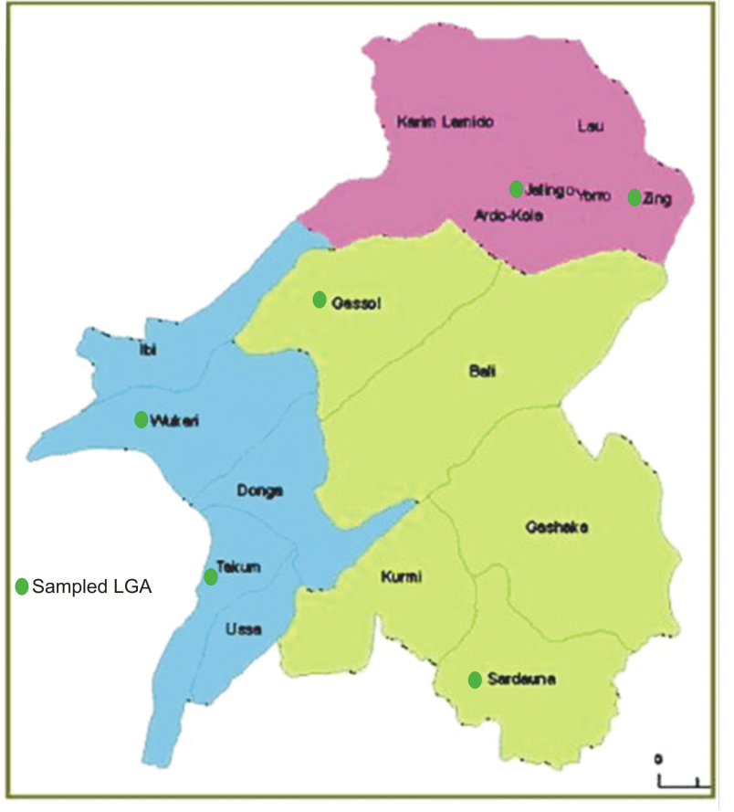
Figure 1. Taraba State study-area map retained from the thesis. The original map marks sampled LGAs associated with the six secondary health-care centres. Source identified in the thesis as Taraba State Ministry of Land and Survey; third-party map material is not included in the article’s CC BY licence.

2.2 Sampling and bacteriological identification
Three hundred samples were obtained from hospital wards and environments, with 50 samples from each of the six centres. Clinical sources included wound discharge, body-fluid aspirates, urine, faeces, sputum and swabs from nose, throat, ear and genital areas. Environmental sampling included floors, windows, beddings, equipment and other inanimate objects. Primary culture was undertaken on nutrient agar and MacConkey agar at 37 °C for 24 h, with subculture on mannitol salt agar. Presumptive identification used colony morphology, Gram staining, catalase, coagulase and latex-agglutination procedures as reported in the thesis.
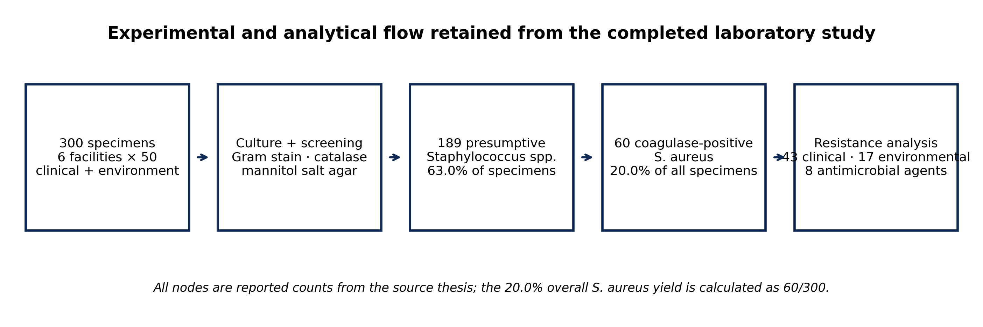
Figure 2. Experimental and analytical flow. All counts are retained from the completed thesis experiments; the overall 20.0% S. aureus yield is a direct calculation from reported counts.

2.3 Antimicrobial susceptibility testing
The thesis performed agar disc-diffusion susceptibility testing after inoculation of S. aureus cultures onto prepared nutrient-agar plates. After 24 h incubation at 37 °C, inhibitory zones were interpreted as sensitive or resistant according to the clinical and laboratory standards guidance cited in the source methodology. The tested discs were ciprofloxacin 5 µg, tetracycline 30 µg, erythromycin 15 µg, methicillin 5 µg, amoxicillin 30 µg, penicillin 10 µg, gentamicin 10 µg and ampicloxacillin 20 µg. e051 does not retrospectively reinterpret inhibition zones against a newer breakpoint system because the individual zone diameters were not supplied in the thesis tables.

2.4 Statistical analysis and 2026 reanalysis
The parent study reported analysis in SPSS Statistics version 17.0, with Student’s t-test and Pearson chi-square testing and a significance threshold of p<0.05. For e051, the principal descriptive statistics are retained exactly from the reported resistance counts. Wilson 95% confidence intervals were added for the major yield proportions. Because the environmental stratum contains only 17 isolates, each clinical-versus-environmental resistance comparison was additionally evaluated with a two-sided Fisher exact test using the reported resistant counts and the corresponding source-group denominators. This is a transparent post-thesis statistical reanalysis; it does not alter any laboratory classification.

2.5 Source-data integrity rule
The supplied thesis document contains duplicated versions of several results tables. One duplicate transposes the final erythromycin/methicillin column labels, whereas the later table and the thesis abstract consistently assign 30 clinical and 9 environmental resistant isolates to erythromycin and 10 clinical and 7 environmental resistant isolates to methicillin. e051 therefore uses the abstract-consistent later-table order PEN, CPX, CN, AMX, TET, APX, E and MC. The thesis also presents a separate susceptibility table whose counts are not complementary to the resistance table for every drug; consequently, e051 does not algebraically force those summaries to sum to 100%. The reported resistance table is the primary quantitative endpoint.

3. Results

3.1 Screening yield and facility distribution
Of 300 specimens, 189 were Gram/catalase-positive presumptive Staphylococcus isolates (63.0%; 95% Wilson CI 57.4–68.3). Coagulase testing identified 60 S. aureus among the 189 presumptive isolates (31.7%; 95% CI 25.5–38.7), corresponding to 20.0% of all 300 collected specimens (95% CI 15.9–24.9). The six-facility S. aureus yield ranged from 4/50 (8.0%) at Gembu to 16/50 (32.0%) at Wukari. A chi-square reanalysis of S. aureus-positive versus negative specimens across the six equal-sized facility samples produced χ²=10.00, df=5, p=0.075, indicating visible facility heterogeneity without conventional statistical significance at α=0.05.
Facility | Zone | Presumptive Staph. | S. aureus / all samples | Coagulase confirmation
Zing General Hospital | Northern | 32/50 (64.0%) | 12/50 (24.0%) | 12/32 (37.5%)
Government House Clinic Jalingo | Northern | 30/50 (60.0%) | 10/50 (20.0%) | 10/30 (33.3%)
First Referral Hospital Mutum-Biyu | Central | 33/50 (66.0%) | 10/50 (20.0%) | 10/33 (30.3%)
General Hospital Gembu | Central | 34/50 (68.0%) | 4/50 (8.0%) | 4/34 (11.8%)
General Hospital Takum | Southern | 28/50 (56.0%) | 8/50 (16.0%) | 8/28 (28.6%)
General Hospital Wukari | Southern | 32/50 (64.0%) | 16/50 (32.0%) | 16/32 (50.0%)

Table 1. Facility-level bacteriological screening and S. aureus confirmation. Percentages are calculated from the reported counts.
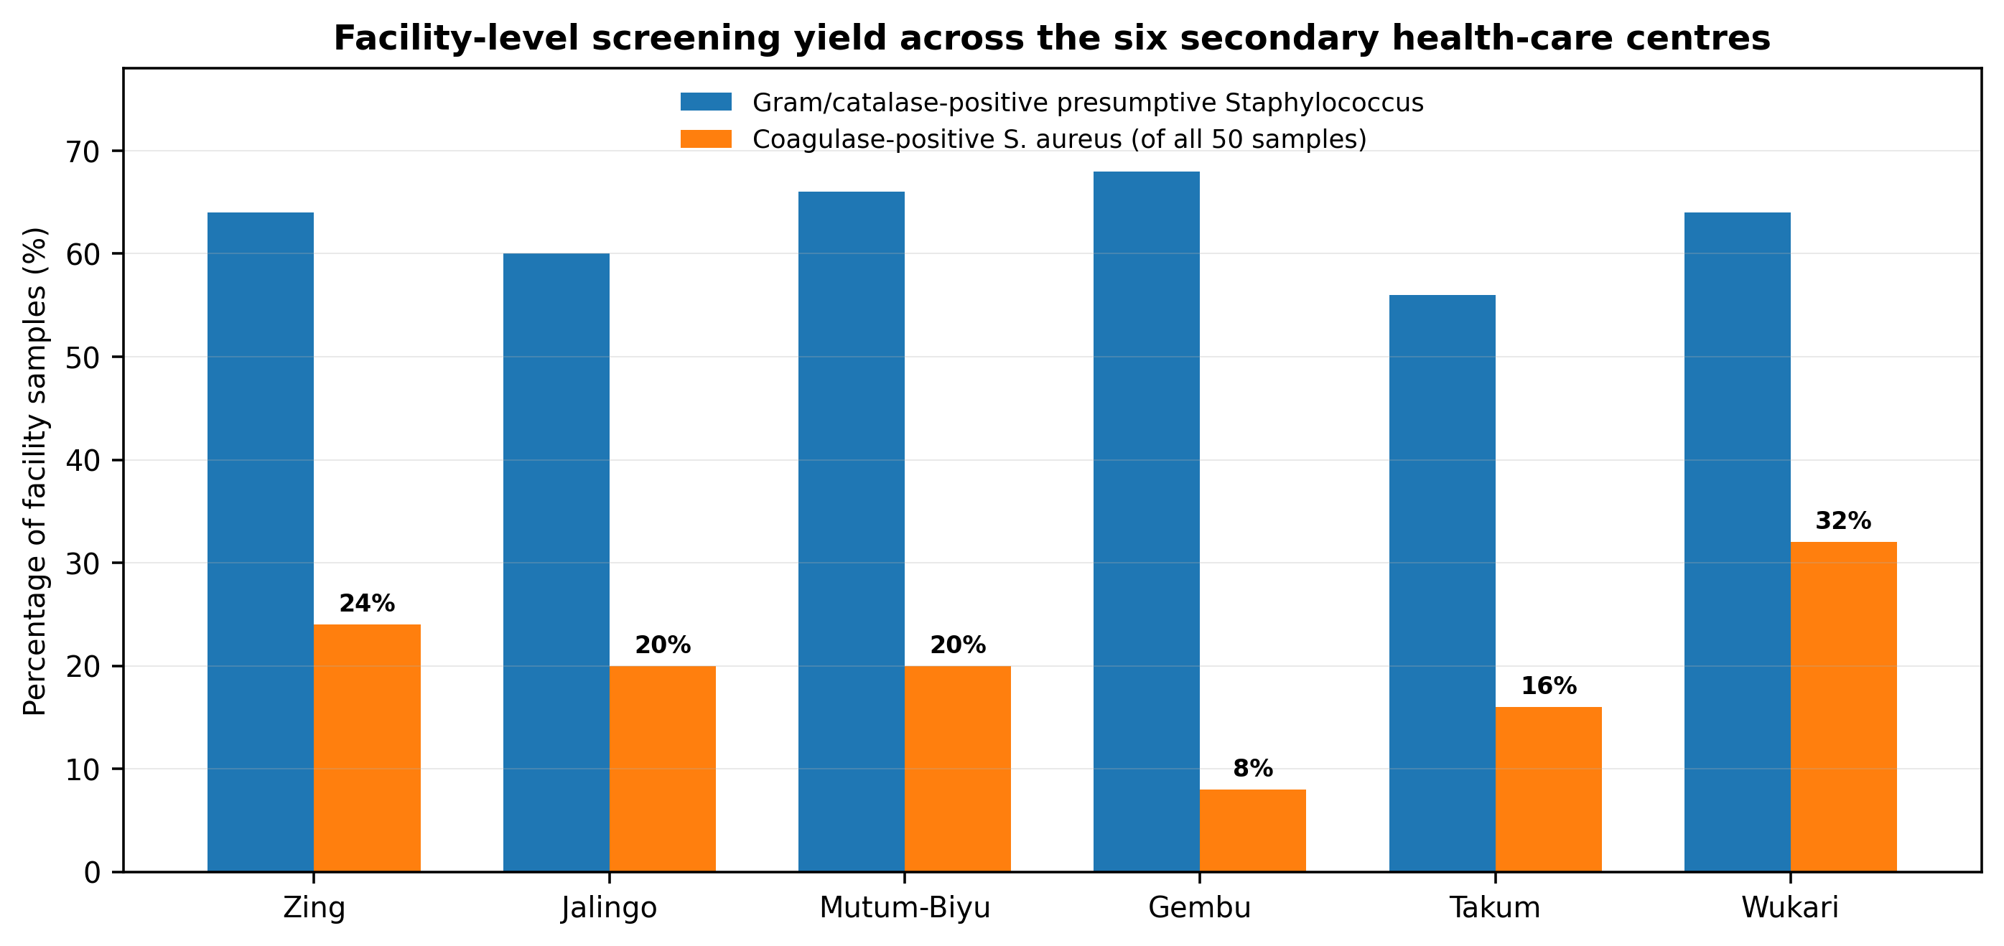
Figure 3. Facility-level presumptive Staphylococcus and confirmed S. aureus yields. Fifty specimens were collected at each centre.

3.2 Distribution by specimen/source category
The 60 reported S. aureus isolates were distributed across clinical and environmental sources. High vaginal swabs and sputum each contributed 9 isolates (15.0%), wound swabs 8 (13.3%), urine 7 (11.7%) and window swabs 6 (10.0%). Environmental recovery from floors, cupboards, beddings, doors, benches and forceps demonstrates that S. aureus was not confined to patient material.
Source | n (%) | Source | n (%)
High vaginal swab | 9 (15.0%) | Ear | 2 (3.3%)
Eye | 1 (1.7%) | Window swab | 6 (10.0%)
Stool | 2 (3.3%) | Floor swab | 2 (3.3%)
Sputum | 9 (15.0%) | Table swab tip | 2 (3.3%)
Urine | 7 (11.7%) | Wound swab | 8 (13.3%)
Cupboard swab | 3 (5.0%) | Beddings swab | 2 (3.3%)
Door swab | 1 (1.7%) | Semen | 2 (3.3%)
Bench swab | 1 (1.7%) | Forcep | 1 (1.7%)
Throat swab | 1 (1.7%) | Urethral | 1 (1.7%)

Table 2. Distribution of the 60 S. aureus isolates by source category as reported in the thesis.
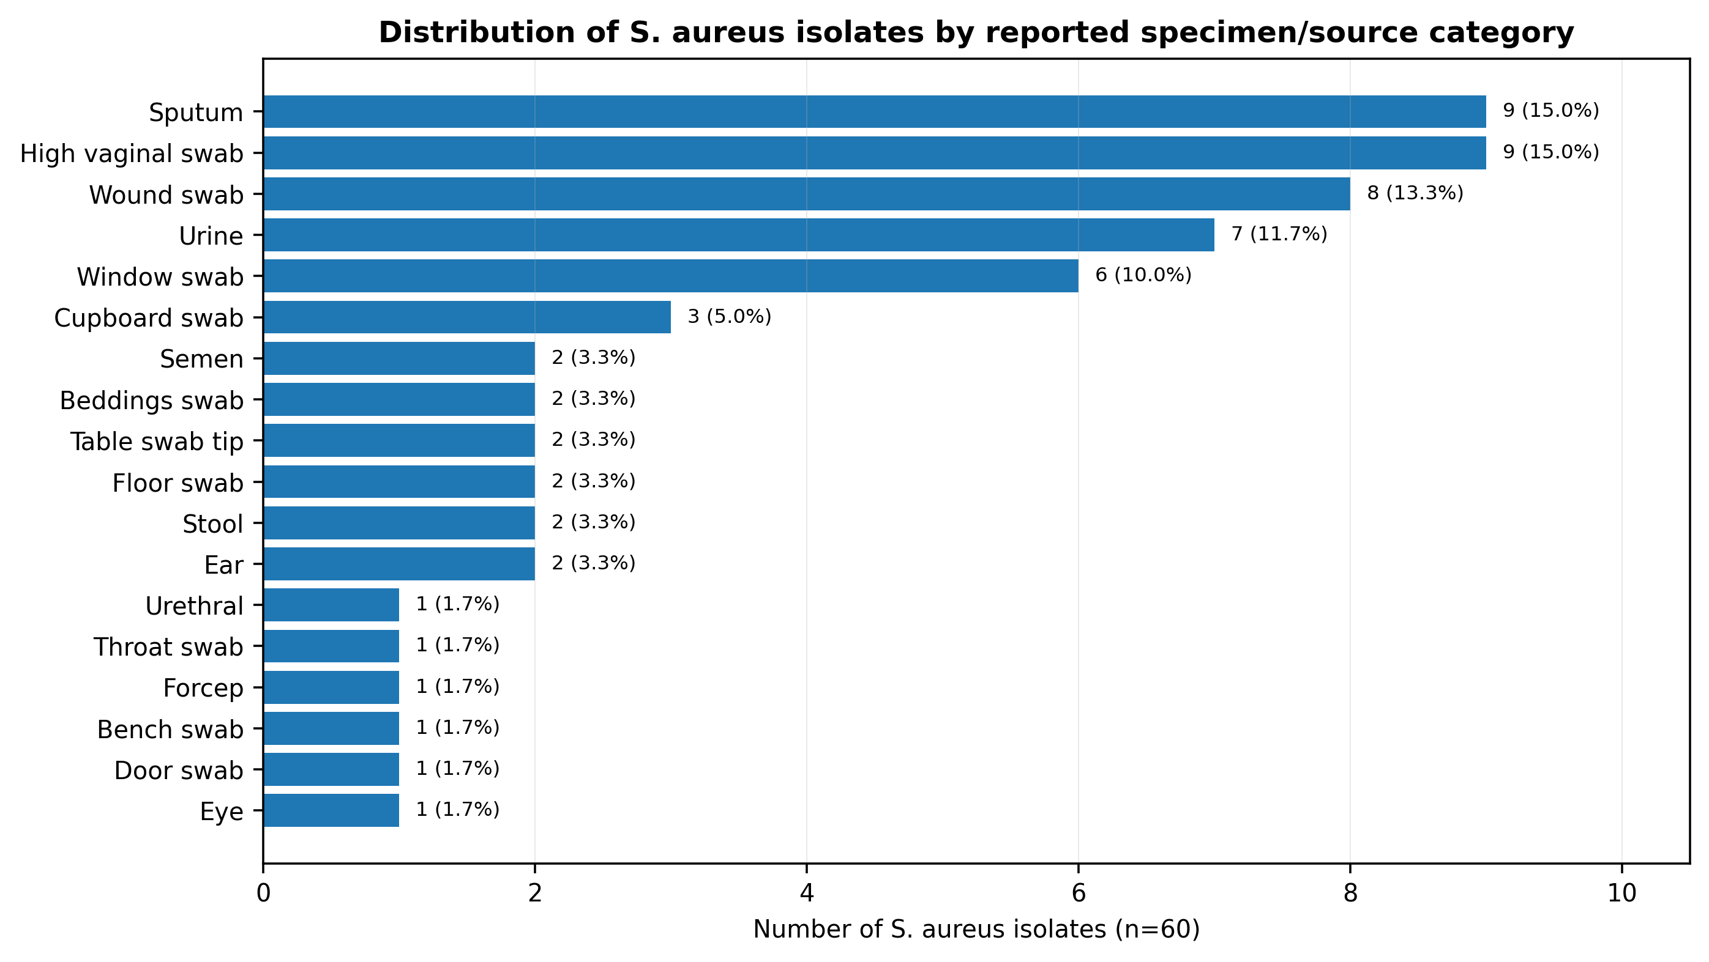
Figure 4. Source distribution of S. aureus isolates. Bars are direct visualizations of the thesis Table 7 counts.

3.3 Antimicrobial resistance profile
The dominant resistance signals were penicillin, erythromycin, tetracycline and ampicloxacillin. When the clinical and environmental counts are combined, 43/60 isolates (71.7%) were resistant to penicillin, 39/60 (65.0%) to erythromycin, 35/60 (58.3%) to tetracycline and 32/60 (53.3%) to ampicloxacillin. Resistance was lower for amoxicillin and methicillin (17/60; 28.3% each), ciprofloxacin (10/60; 16.7%) and gentamicin (8/60; 13.3%). These overall percentages are calculated directly from the total counts reported in the thesis resistance table.
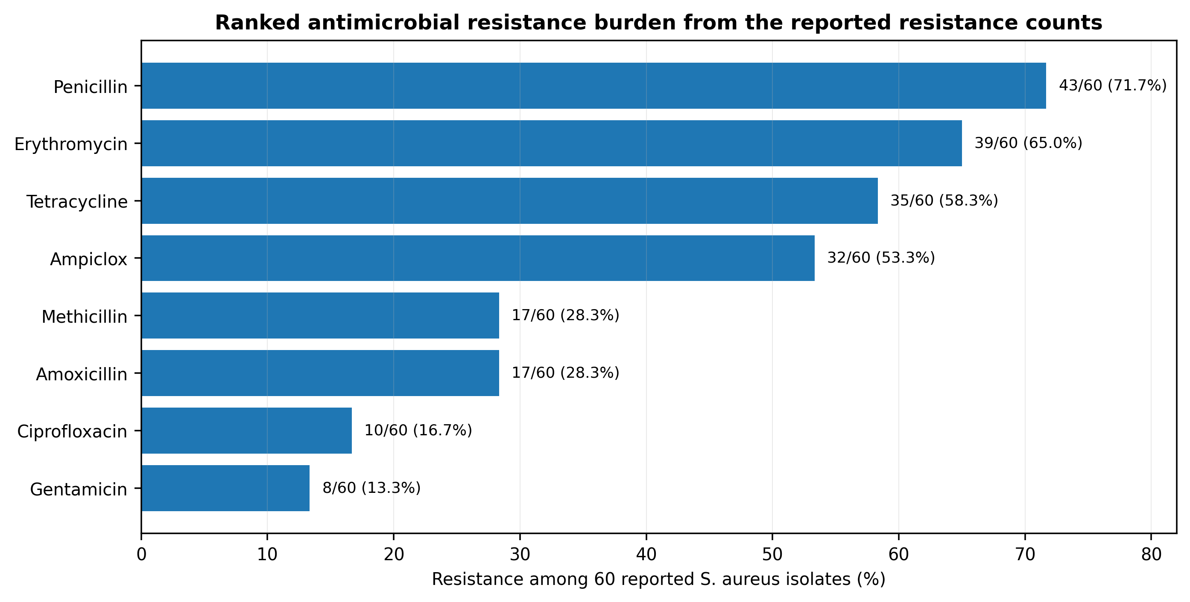
Figure 5. Ranked overall resistance burden. Percentages are derived directly from the reported resistance totals (n=60); no isolate-level pattern was synthesized.
Antimicrobial | Clinical resistant | Environmental resistant | Total resistant | Fisher p
Penicillin | 30/43 (69.8%) | 13/17 (76.5%) | 43/60 (71.7%) | 0.755
Ciprofloxacin | 6/43 (14.0%) | 4/17 (23.5%) | 10/60 (16.7%) | 0.448
Gentamicin | 6/43 (14.0%) | 2/17 (11.8%) | 8/60 (13.3%) | 1.000
Amoxicillin | 11/43 (25.6%) | 6/17 (35.3%) | 17/60 (28.3%) | 0.530
Tetracycline | 25/43 (58.1%) | 10/17 (58.8%) | 35/60 (58.3%) | 1.000
Ampiclox | 25/43 (58.1%) | 7/17 (41.2%) | 32/60 (53.3%) | 0.264
Erythromycin | 30/43 (69.8%) | 9/17 (52.9%) | 39/60 (65.0%) | 0.243
Methicillin | 10/43 (23.3%) | 7/17 (41.2%) | 17/60 (28.3%) | 0.209

Table 3. Clinical–environmental resistance comparison. Fisher p values are 2026 recalculations from the reported resistant counts; p<0.05 was the prespecified significance threshold.
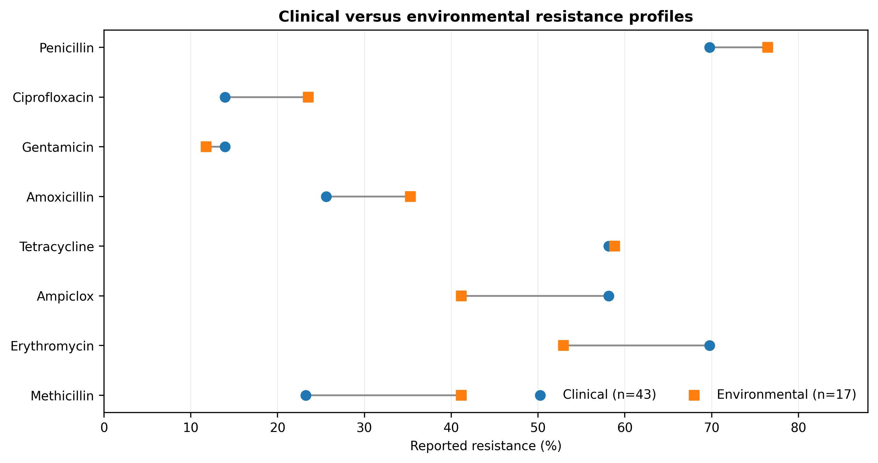
Figure 6. Clinical versus environmental resistance percentages. The numerical differences are descriptive; none of the eight exact tests reached p<0.05.

4. Discussion
The first major finding is the breadth of S. aureus recovery across the secondary-care network. Sixty confirmed isolates from 300 specimens produce an overall yield of 20.0%, with clinically important recovery from sputum, wound, urine and high vaginal swabs and simultaneous recovery from windows, floors, cupboards, beddings, doors and other hospital surfaces. This supports the parent thesis conclusion that both patients and the hospital environment can act as reservoirs. The result should not be interpreted as proof of direct patient–surface transmission, because e051 does not perform paired genomic transmission analysis; it establishes co-occurrence across connected care environments.
The second major finding is the strong resistance gradient. Penicillin resistance was the highest overall signal at 71.7%, followed by erythromycin at 65.0%, tetracycline at 58.3% and ampicloxacillin at 53.3%. This profile is biologically and clinically plausible within Nigeria’s broader S. aureus resistance problem, but e051 deliberately avoids retroactive mechanistic attribution from phenotype alone. The parent thesis performed molecular work, while a recent Nigerian three-hospital study found beta-lactamase production and blaZ carriage among multidrug-resistant S. aureus, reinforcing the value of linking phenotypic beta-lactam resistance to molecular surveillance rather than assuming a mechanism from the antibiogram (Kilani et al., 2024).
The third major finding is that environmental isolates carried resistance frequencies of the same order as clinical isolates. Environmental penicillin resistance was 76.5%, tetracycline resistance 58.8% and methicillin resistance 41.2%. Clinical isolates showed 69.8% penicillin, 69.8% erythromycin and 58.1% tetracycline resistance. None of the individual source-group comparisons reached statistical significance with Fisher exact testing, which means the study supports a shared resistance burden rather than a statistically demonstrated excess in one source. The environmental denominator is small, so wide uncertainty remains.
The contemporary Nigerian evidence underscores why this archived experimental dataset still matters. Bilyaminu et al. (2025) found lower absolute MRSA prevalence in a 2024 Azare clinical sample but multidrug resistance in every MRSA isolate. In contrast, Olalekan et al. (2025) found 59% MRSA among 107 Lagos clinical S. aureus isolates and extensive lineage diversity by whole-genome sequencing. The difference between settings is the point: AMR surveillance must be geographically and institutionally specific. Historical local datasets become more useful when they are reported transparently and can serve as baselines for repeat sampling using current methods.
From an infection-prevention perspective, the findings support routine environmental cleaning, hand hygiene, targeted surveillance of frequently touched surfaces, and feedback of local antibiogram data to prescribers. From a stewardship perspective, the high resistance percentages for several older agents argue against empirical assumptions based on historical drug availability alone. Treatment decisions should rely on current patient-specific susceptibility testing and contemporary clinical guidelines, not on e051 as a prescribing rule.

4.1 Strengths and limitations
Strengths include a deliberately distributed six-facility design, equal sample allocation by centre, inclusion of both patient and environmental sources, laboratory culture and biochemical identification, and a retained eight-agent resistance dataset. The principal limitations are equally important: the source work was restricted to secondary health-care centres; the article has aggregate rather than isolate-level data; the raw inhibition-zone measurements are unavailable; current breakpoint reinterpretation is therefore impossible; environmental and clinical isolates were not paired by exposure event; and the supplied thesis file contains duplicated result tables with some internal discrepancies. e051 addresses the last issue by declaring the resistance-table mapping rule rather than silently harmonizing incompatible entries. Molecular endpoints are intentionally not pooled into this first paper.

5. Conclusion and Recommendations
Across six secondary health-care centres in Taraba State, 189/300 specimens screened as presumptive Staphylococcus and 60/300 yielded coagulase-positive S. aureus. The strongest phenotypic resistance signals were penicillin (71.7%), erythromycin (65.0%), tetracycline (58.3%) and ampicloxacillin (53.3%), while clinical and environmental isolates showed overlapping resistance burdens. The study therefore supplies a defensible facility-level baseline for a region where contemporary molecular and phenotypic surveillance remains necessary.
- Repeat the six-facility survey using current species identification, current standardized AST medium/breakpoints and digital capture of inhibition-zone or MIC values so temporal change can be measured directly.
- Integrate clinical and environmental AMR surveillance: high-touch surfaces, bed spaces, equipment and patient isolates should be sampled within linked time windows where outbreak or transmission questions arise.
- Generate facility-specific antibiograms and stewardship feedback rather than extrapolating from national or tertiary-hospital averages.
- Prioritize molecular follow-up of methicillin resistance, beta-lactamase determinants, PVL, SCCmec and spa/whole-genome lineages in a separate analysis to distinguish resistance burden from clonal transmission.
- Strengthen hand hygiene, environmental decontamination, audit trails for cleaning, and staff training in the secondary-care network.

Declarations
Ethics and permission: The parent thesis documents ethical/administrative permission from the Executive Secretary, Health Services Management Board, Jalingo, for conduct of the research across the secondary health-care centres. The supplied source does not provide an approval reference number, and none is invented here.
Funding: No external funding is declared for preparation of this journal article.
Competing interests: The author declares no competing interests.
Data availability: All aggregate counts used for e051 are contained in the completed M.Sc. thesis and are reproduced or transparently recalculated in this article. No synthetic experimental observations were created. Raw isolate-level inhibition-zone data were not available in the supplied thesis document.
Originality and prior-source disclosure: The laboratory experiments were originally completed for the author’s 2019 M.Sc. thesis. e051 is a focused journal article developed from the occurrence and phenotypic-resistance major finding, with updated literature context and transparent statistical reanalysis. Detailed molecular/virulence endpoints are not duplicated here and are reserved for separate paper development.
Author contribution: MELLAH, Iwanger: conceptualization, investigation, laboratory methodology, data collection, original analysis, interpretation and manuscript authorship. Journal preparation added updated literature synthesis, statistical checking and publication visualization under the author’s responsibility.
AI-assisted editorial support: AI-assisted tools were used for literature updating, calculation checking, visualization, language refinement, reference consistency and document formatting. They did not generate experimental observations, replace laboratory work, or act as an author.
Copyright and licence: © 2026 The Author. Published by CHIA TECH SOLUTIONS AND RESOURCES LIMITED (RC 1839865). This open-access article is distributed under the Creative Commons Attribution 4.0 International (CC BY 4.0) licence, except for third-party material otherwise identified.

References
Bilyaminu, U., Saggah, A. M., Abubakar, B. M., & Moi, I. M. (2025). Methicillin-resistant Staphylococcus aureus colonization and associated factors in clinical isolates among patients attending a tertiary medical centre in Nigeria. BMC Infectious Diseases, 25, 1777. https://doi.org/10.1186/s12879-025-12166-w
Cheesbrough, M. (2008). District laboratory practice in tropical countries (2nd ed.). Cambridge University Press.
Kilani, A. M., Alabi, E. D., & Adeleke, O. E. (2024). Coexistence of the blaZ gene and selected virulence determinants in multidrug-resistant Staphylococcus aureus: Insights from three Nigerian tertiary hospitals. BMC Infectious Diseases, 24, 1269. https://doi.org/10.1186/s12879-024-10171-z
Mellah, I. (2019). Molecular characterisation and antibiotics susceptibility pattern of Staphylococcus aureus isolates from hospital wards and their environment [M.Sc. thesis, Federal University of Agriculture, Makurdi].
Olalekan, A., Boutin, S., Watson, C. M., Galarion, L., Adesida, S., Iwalokun, B., Popoola, O., Esemu, S., Adegbola, R., & Nurjadi, D. (2025). Molecular landscape of methicillin-resistant Staphylococcus aureus strains in clinical infections from hospitals in Lagos, Nigeria. JAC-Antimicrobial Resistance, 7(5), dlaf161. https://doi.org/10.1093/jacamr/dlaf161
Shittu, A. O., Okon, K., Adesida, S., Oyedara, O., Witte, W., Strommenger, B., Layer, F., & Nübel, U. (2011). Antibiotic resistance and molecular epidemiology of Staphylococcus aureus in Nigeria. BMC Microbiology, 11, 92.
Vandepitte, J., Verhaegen, J., Engbaek, K., Rohner, P., Piot, P., & Heuck, C. C. (2003). Basic laboratory procedures in clinical bacteriology (2nd ed.). World Health Organization.
World Health Organization. (2024). WHO bacterial priority pathogens list, 2024: Bacterial pathogens of public health importance to guide research, development and strategies to prevent and control antimicrobial resistance. WHO. ISBN 978-92-4-009346-1.
World Health Organization. (2025). Global antibiotic resistance surveillance report 2025. WHO. ISBN 978-92-4-011633-7.

Appendix A. Reproducibility Ledger
Item | Value | Provenance / treatment
Total specimens | 300 | Reported experiment
Facilities | 6 × 50 specimens | Reported experiment
Presumptive Staphylococcus | 189/300 (63.0%) | Reported counts; percentage verified
Coagulase-positive S. aureus | 60/189 (31.7%) | Reported counts; percentage verified
Overall S. aureus yield | 60/300 (20.0%) | Derived directly from reported counts
Resistance analytical set | 43 clinical + 17 environmental | Reported Table 9 denominators
Primary resistance endpoint | PEN, CPX, CN, AMX, TET, APX, E, MC | Abstract-consistent later Table 9 order
Post-thesis inferential update | Two-sided Fisher exact tests | Calculated only from reported resistance counts
Raw inhibition-zone data | Not available in supplied thesis | No breakpoint reclassification performed
Synthetic observations | None | Explicitly prohibited and not used

Table A1. Reproducibility and provenance ledger for e051.

