CHIATECH JOURNAL
  - SETEHEM · Volume 1, Issue 1 · Pioneer July/August 2026 · Part 2 · e053
  - PIONEER PUBLICATION · ACCEPTED ARTICLE · ORIGINAL RESEARCH ARTICLE · MEDICAL MICROBIOLOGY · MOLECULAR EPIDEMIOLOGY · MRSA · NIGERIA

Molecular Virulence and Clonal Architecture of Clinical and Environmental Staphylococcus aureus in Taraba State, Nigeria: PVL, mecA, SCCmec and spa-Typing Evidence
MELLAH, Iwanger¹*
¹ Federal University of Agriculture, Makurdi, Nigeria
*Corresponding author: whoisdrmellah@gmail.com
Article type  Original Research | eLocator  e053 | ISSN  Pending assignment | DOI  Pending registration

Abstract
Background: Molecular surveillance is necessary to distinguish methicillin resistance, virulence and clonal spread within Staphylococcus aureus populations. This article develops the molecular-epidemiology findings of a completed six-hospital laboratory investigation in Taraba State, Nigeria. Methods: The parent study processed 300 clinical and hospital-environment specimens. Sixty coagulase-positive S. aureus isolates were obtained after culture and biochemical identification. Molecular work included PCR confirmation with the S. aureus-specific nuc target; detection of mecA and Panton-Valentine leukocidin (PVL) targets; SCCmec characterization; and protein A (spa) typing, with Sanger sequencing of PCR products. Results: The thesis reports that all MRSA isolates carried mecA. One PVL-positive MRSA was assigned SCCmec I/spa t8439 and a second PVL-positive MRSA SCCmec IV/spa t8440; other MRSA were reported as non-typeable by the applied SCCmec assay. The two resolved spa fingerprints were 07-23-21-17-34-383-16-34-33-13 and 07-13-12-12-34-34-33-212, respectively. The thesis further reports dominance of spa-CC084 among clinical isolates. An archived virulence-gene table reported significant clinical-environmental contrasts, but its category counts are internally inconsistent with the 43-clinical/17-environmental isolate partition; those inferential values are therefore preserved as source-reported outputs rather than recalculated. Contemporary Nigerian whole-genome evidence now demonstrates additional PVL-positive MRSA lineages, including t657/ST772/SCCmec V and t4690/ST152/SCCmec Vc. Conclusion: The Taraba dataset documents genetically heterogeneous PVL-positive MRSA and illustrates why local spa/SCCmec surveillance should progress toward whole-genome sequencing with strict denominator and metadata control.
Keywords: Staphylococcus aureus; MRSA; mecA; Panton-Valentine leukocidin; SCCmec; spa typing; molecular epidemiology; Taraba State; Nigeria
Suggested citation: Mellah, I. (2026). Molecular virulence and clonal architecture of clinical and environmental Staphylococcus aureus in Taraba State, Nigeria: PVL, mecA, SCCmec and spa-typing evidence. CHIATECH Journal: SETEHEM, 1(1), e053. DOI pending registration.

1. Introduction
Methicillin-resistant Staphylococcus aureus (MRSA) remains a high-priority bacterial pathogen because methicillin resistance can coexist with virulence determinants and mobile genetic elements that facilitate persistence, transmission and therapeutic failure. The World Health Organization retained methicillin-resistant S. aureus in the high-priority tier of its 2024 Bacterial Priority Pathogens List, emphasizing the continuing need for regionally tailored surveillance, infection prevention and research.
Phenotypic resistance data alone cannot resolve whether cases arise from a single spreading clone or multiple unrelated lineages. Molecular epidemiology addresses this gap by combining species-confirmatory markers such as nuc, resistance determinants such as mecA, virulence markers including the lukS-PV/lukF-PV locus encoding Panton-Valentine leukocidin (PVL), staphylococcal cassette chromosome mec (SCCmec) typing and sequence variation in the protein A gene (spa). The combination of these markers provides a practical bridge between routine bacteriology and whole-genome surveillance.
The completed Taraba State thesis from which this article is derived investigated five linked objectives: isolation of S. aureus from clinical and environmental sources, antimicrobial susceptibility profiling, methicillin-resistance characterization, detection of resistance/virulence genes and assessment of clonal relatedness. The first journal paper from the dataset (e051) focused on the antibiogram and clinical-environmental resistance burden. The present e053 isolates the second major contribution: the molecular architecture of the recovered S. aureus population, with particular attention to PVL-positive MRSA, mecA, SCCmec and spa evidence.
This separation is important because contemporary Nigerian data show that the MRSA population is dynamic. Whole-genome sequencing of 107 S. aureus isolates from Lagos hospitals, published in 2025, identified 63 MRSA and demonstrated predominance of the PVL-positive Bengal Bay clone t657/ST772/SCCmec V, followed by PVL-positive t4690/ST152/SCCmec Vc and additional ST8 lineages. The older Taraba molecular findings therefore provide a valuable regional baseline rather than a substitute for present-day genomic surveillance.

2. Materials and Methods

2.1 Study design and provenance
The experimental study was conducted in six secondary health-care centres serving the three senatorial zones of Taraba State: First Referral Hospital Mutum-Biyu, General Hospital Zing, General Hospital Wukari, General Hospital Takum, General Hospital Gembu and Government House Clinic Jalingo. Three hundred samples were collected, 50 per centre, from clinical specimens and hospital environmental surfaces. Culture, Gram staining, catalase/coagulase testing and further molecular work were completed as reported in the 2019 M.Sc. thesis.
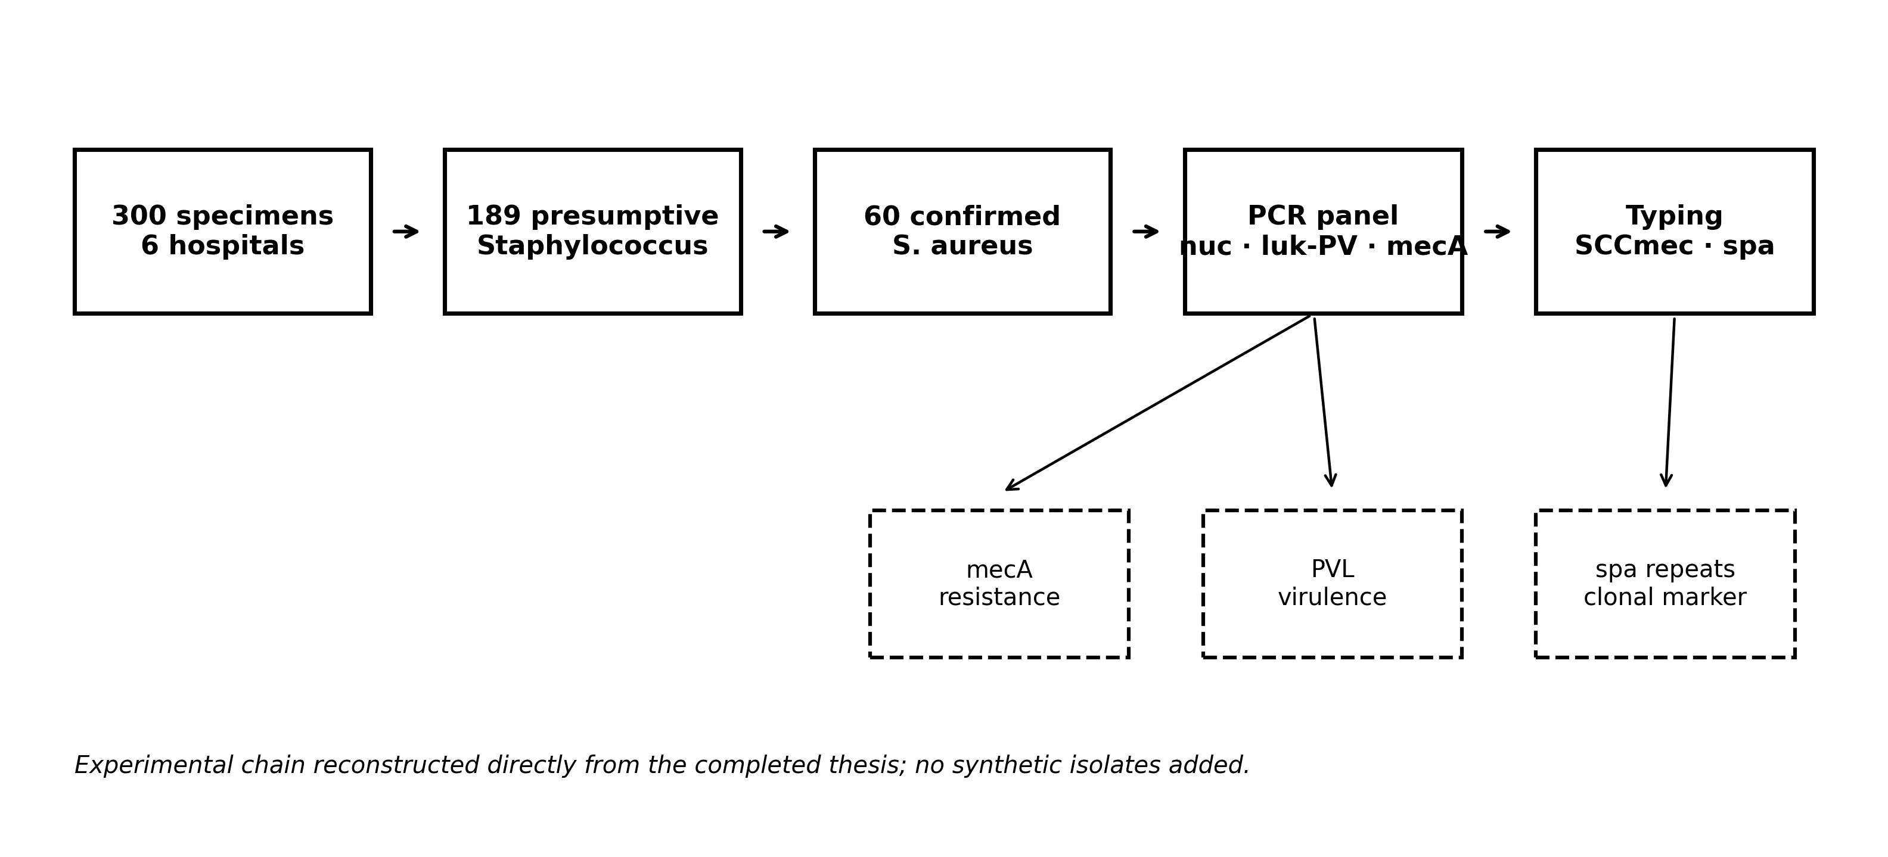
Figure 1. Molecular-epidemiology workflow reconstructed from the completed experimental study. Counts are source-derived; no synthetic observations were introduced.

2.2 DNA amplification and molecular targets
PCR products were purified and submitted for Sanger sequencing. The thesis reports a 20 µL multiplex PCR reaction containing 1× HOT FIREPol Blend Master Mix, 2.0 mM MgCl₂, 200 µM of each dNTP, 20 pMol of each primer, 2 U Hot FIREPol DNA polymerase, 5 µL extracted DNA and sterile distilled water to volume. Thermal cycling comprised 95 °C for 5 min; 35 cycles of 95 °C for 30 s, 58 °C for 1 min and 72 °C for 1 min 30 s; and 72 °C for 10 min. Products were separated on 1.5% agarose at 80 V for 90 min with a 100 bp ladder.
Target | Forward primer (5′→3′) | Reverse primer (5′→3′) | Annealing | Amplicon
nuc | GCGATTGATGGTGATACGGTT | AGCCAAGCCTTGACGAACTAAAGC | 58 °C | 279 bp
luk-PV | ATCATTAGGTAAAATGTCTGGACATGATCCA | GCATCAASTGTATTGGATAGCAAAAGC | 58 °C | 433 bp
mecA | AAAATCGATGGTAAAGGTTGGC | AGTTCTGCAGTACCGGATTTGG | 58 °C | 532 bp
Table 1. PCR primers, annealing temperature and expected amplicon sizes as reported in the thesis.
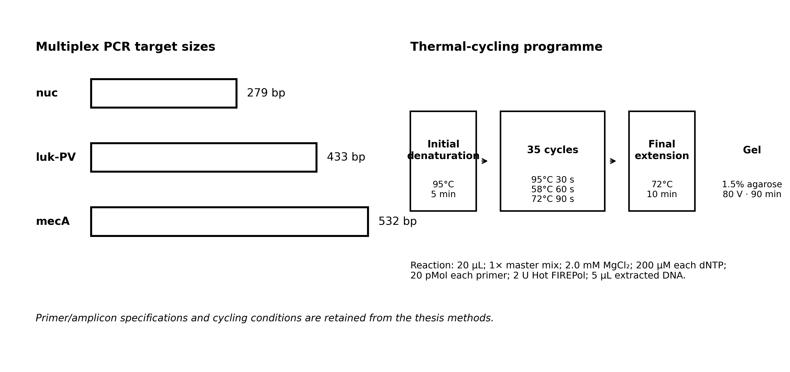
Figure 2. PCR targets and thermal-cycling programme used in the molecular characterization.

2.3 Resistance, virulence and clonal typing
Methicillin resistance was evaluated molecularly through mecA detection and SCCmec typing. Virulence characterization included PVL and other toxin/capsular targets described in the thesis, while accessory gene regulator (agr) typing was performed by multiplex PCR. Genotyping was undertaken by amplification and sequence analysis of the spa gene. The present paper reports only findings explicitly recoverable from the archived results and discussion; it does not reconstruct missing isolate-level genotypes.

2.4 Statistical and integrity treatment for e053
The thesis reported SPSS version 17.0 analysis and a significance threshold of p<0.05. Its virulence-gene table provides percentages, odds ratios, confidence intervals and p values. However, several table counts conflict with the clearly stated source partition of 43 clinical and 17 environmental S. aureus isolates. Because the raw isolate-by-gene matrix is not present in the supplied file, e053 does not recompute those inferential statistics. They are reproduced verbatim in a dedicated archival table and explicitly flagged as denominator-ambiguous. Direct molecular statements that are internally coherent—mecA carriage in MRSA, resolved SCCmec/spa types and reported spa-CC084 dominance—form the principal evidentiary basis of this article.

3. Results

3.1 Molecularly resolved MRSA lineages
The thesis reports that all MRSA isolates carried mecA. SCCmec typing fully resolved two PVL-positive MRSA isolates: one SCCmec type I isolate with spa type t8439 and one SCCmec type IV isolate with spa type t8440. Other MRSA isolates were recorded as non-typeable by the SCCmec assay used. These findings establish molecular heterogeneity within the Taraba MRSA population rather than a single resolved clone.
Resolved isolate | Methicillin marker | PVL | SCCmec | spa type | Reported spa repeat pattern
MRSA lineage A | mecA positive | Positive | I | t8439 | 07-23-21-17-34-383-16-34-33-13
MRSA lineage B | mecA positive | Positive | IV | t8440 | 07-13-12-12-34-34-33-212
Other MRSA | mecA positive | Not fully specified | Non-typeable by assay | Not fully recoverable | Not recoverable from supplied aggregate results
Table 2. Molecular characteristics directly supported by the archived study findings.
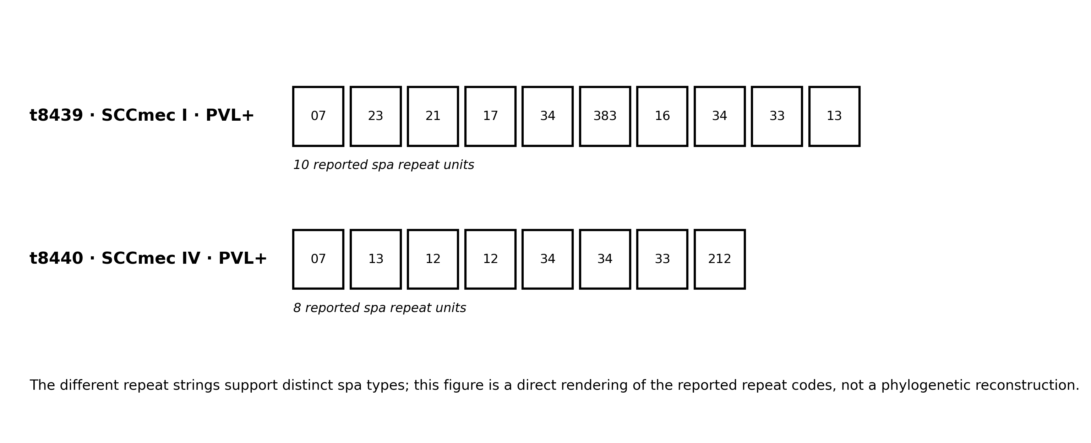
Figure 3. Reported spa repeat fingerprints of the two fully characterized PVL-positive MRSA isolates.

3.2 spa clonal-complex signal
The thesis discussion reports a clear dominance of spa-CC084 among isolates from clinical sources and associates this cluster with the CC15 background frequently documented in Nigeria and other African settings. Because isolate-level spa assignments are not tabulated in the supplied results, e053 preserves this as a source-reported clonal-complex finding and does not generate a synthetic frequency distribution.

3.3 Archived virulence-gene statistics
The source table below is retained because it represents a reported major finding, but its numerical structure requires caution. The clinical/environmental counts in several rows do not reconcile with the independently reported 43/17 isolate partition. Accordingly, the odds ratios, confidence intervals and p values are treated as archived thesis outputs rather than validated e053 reanalysis.
Marker | Clinical (as reported) | Environmental (as reported) | Total | OR (95% CI) | p value | e053 status
Luk-PV-1 | 75% (n=45) | 25% (n=15) | 60 | 0.3 (0.2-0.5) | <0.001 | Archived; denominator conflict
Luk-PV-2 | 23 (38.33%) | 37 (61.67%) | 60 | 0.1 (0.0-1.4) | 0.051 | Archived; denominator conflict
mecA-1 | 80% (n=48) | 20% (n=12) | 60 | 0.4 (0.1-1.6) | 0.033 | Archived; denominator conflict
mecA-2 | 61.67% (n=37) | 38.33% (n=23) | 60 | 0.5 (0.2-1.8) | 0.013 | Archived; denominator conflict
nuc F | 71.67% (n=43) | 28.33% (n=17) | 60 | 0.1 (0.1-1.5) | 0.01 | Counts reconcile with 43/17 split
nuc R | 45% (n=45) | 15% (n=15) | 60 | 0.4 (0.2-2.0) | 0.03 | Archived; percentage/count mismatch
Table 3. Virulence/resistance-gene statistics reproduced from the thesis. Values are not recalculated because the raw isolate-level matrix is unavailable and some denominators are internally inconsistent.

3.4 Position within the contemporary Nigerian MRSA landscape
The Taraba genotypes differ from the dominant lineages identified by recent Nigerian WGS. Olalekan et al. (2025) found that 58/63 MRSA carried mecA and that the dominant MRSA was t657/ST772/SCCmec V/PVL+, followed by t4690/ST152/SCCmec Vc/PVL+ and ST8 lineages. African systematic-review evidence also shows that PVL-positive MRSA occurs in multiple clonal complexes, including ST152 documented in Nigeria. The comparison supports lineage diversity and temporal/geographic turnover, not direct descent between the Taraba and Lagos isolates.
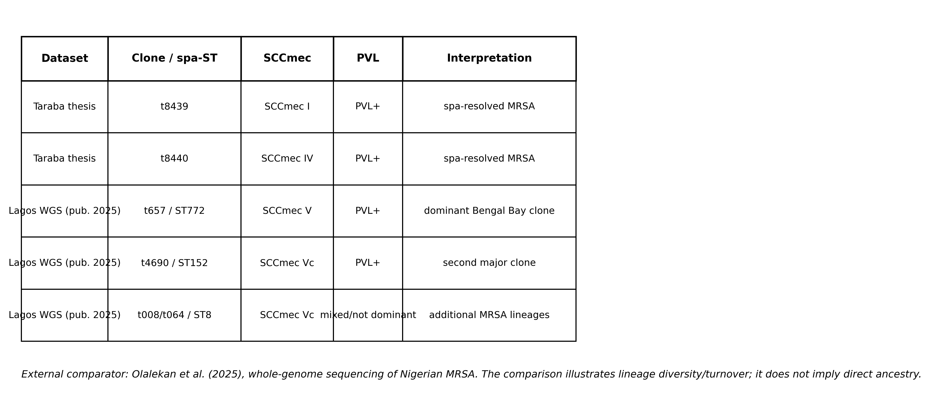
Figure 4. Molecular context of the Taraba resolved spa/SCCmec profiles against contemporary Nigerian WGS evidence. External evidence is shown solely for epidemiological comparison.

4. Discussion
The most important molecular finding is the coexistence of two PVL-positive MRSA isolates with different SCCmec and spa backgrounds. t8439/SCCmec I and t8440/SCCmec IV possess distinct repeat patterns, demonstrating that PVL positivity in the study was not confined to a single resolved spa genotype. This matters epidemiologically because PVL can occur across diverse S. aureus lineages; it should therefore be interpreted as a virulence marker within a broader genomic background rather than as a clone identifier by itself.
The SCCmec contrast is also informative. Type IV has historically been associated with community-associated MRSA backgrounds, although epidemiological boundaries between community and health-care lineages have blurred substantially. The presence of a PVL-positive SCCmec IV/t8440 isolate in the Taraba dataset is therefore consistent with the broader African observation that PVL-positive MRSA can occur in several community-associated clonal backgrounds. Conversely, the reported SCCmec I/t8439 combination shows that PVL carriage was not restricted to the smaller community-associated cassette architecture in this dataset.
The source-reported spa-CC084 dominance among clinical isolates adds another layer of population structure. spa-CC084 has been associated with the CC15 genetic background in African S. aureus populations. Importantly, e053 does not convert this qualitative dominance statement into a prevalence estimate because the supplied aggregate thesis results do not provide a complete spa-type count table. This restriction protects the evidentiary boundary while retaining the thesis finding.
Contemporary genomic surveillance demonstrates why the Taraba molecular baseline remains relevant but cannot be assumed to represent the present clonal landscape. The 2025 Lagos study identified ST772 Bengal Bay MRSA as the dominant clone and also detected ST152 and ST8 backgrounds. The change in dominant lineages across geography and time reinforces the need for repeated, high-resolution surveillance rather than permanent reliance on a single historical antibiogram or typing survey.
A second methodological lesson concerns data architecture. Molecular epidemiology depends not only on PCR and sequencing quality but also on exact linkage between isolate identifier, specimen source, phenotypic AST, gene result, SCCmec assignment and spa sequence. The denominator inconsistencies in the archived virulence table prevent defensible recalculation of several odds ratios. Future studies should therefore maintain a one-row-per-isolate digital dataset and deposit sequence/accession metadata whenever possible. This is particularly important as Nigeria moves from targeted PCR/spa typing toward whole-genome sequencing.

4.1 Strengths and limitations
Strengths include multisite sampling across six secondary health-care centres, inclusion of clinical and environmental material, molecular confirmation, resistance/virulence PCR, SCCmec characterization and spa typing. The two resolved PVL-positive MRSA genotypes provide concrete clonal evidence that can be compared with later Nigerian genomic studies. Limitations include the age of the dataset, lack of the raw isolate-level molecular matrix in the supplied file, incomplete SCCmec typeability, absence of recoverable per-isolate spa assignments for the whole population, and internal inconsistencies in the aggregate virulence table. These limitations are made explicit rather than repaired by assumption.

5. Conclusion and Recommendations
The Taraba State study identified molecularly heterogeneous MRSA within secondary health-care settings. All MRSA were reported as mecA-positive; two PVL-positive isolates were fully resolved as t8439/SCCmec I and t8440/SCCmec IV, while other MRSA were not typeable by the applied SCCmec assay. The source also reported spa-CC084 dominance among clinical isolates. Together, these findings show that resistance and virulence were distributed across more than one clonal background and justify sustained molecular surveillance.
- Repeat molecular surveillance in the six health-care centres using current species confirmation, current AST standards and whole-genome sequencing for all MRSA or a representative sentinel subset.
- Capture isolate-level metadata digitally so specimen source, AST phenotype, mecA/mecC, PVL, SCCmec, spa, MLST and sequence accession remain linked and auditable.
- Use spa/SCCmec typing as a lower-cost surveillance bridge where WGS is not immediately available, but refer suspected clusters and non-typeable MRSA for higher-resolution sequencing.
- Integrate environmental and clinical molecular surveillance during suspected transmission events to test whether genetically related strains are shared between patients, staff and high-touch surfaces.
- Interpret PVL as a virulence marker within clonal context rather than as an independent marker of community origin or outbreak relatedness.

Declarations
Ethics and permission: The parent thesis documents ethical/administrative permission from the Executive Secretary, Health Services Management Board, Jalingo, for conduct of the research across secondary health-care centres in Taraba State.
Funding: No external funding is declared for preparation of this journal article.
Competing interests: The author declares no competing interests.
Data availability: All molecular findings reported in e053 are derived from the completed M.Sc. thesis supplied for editorial development. Aggregate tables, primer sequences, PCR conditions and spa repeat patterns are retained from that source. The raw isolate-level gene-by-isolate matrix and sequence chromatograms were not included in the supplied file.
Originality and prior-source disclosure: The laboratory experiments were completed for the author’s 2019 M.Sc. thesis. e053 is a focused journal article developed from the molecular findings of that completed work. No new isolates, PCR results, gene detections, SCCmec types or spa sequences were fabricated for this publication.
Author contribution: MELLAH, Iwanger: conceptualization, investigation, laboratory methodology, data collection, molecular analysis, interpretation and manuscript authorship. Journal preparation included literature updating, visual reconstruction and source-integrity review without alteration of the underlying experimental findings.
AI-assisted editorial support: AI-assisted tools were used for literature updating, visualization, language refinement, source-consistency checking and document formatting. All experimental observations remain those of the author’s completed study, and ambiguous source statistics are explicitly identified rather than silently corrected.
Copyright and licence: © 2026 The Author. Published by CHIA TECH SOLUTIONS AND RESOURCES LIMITED (RC 1839865). This open-access article is distributed under the Creative Commons Attribution 4.0 International (CC BY 4.0) licence.

References
Adeyemi, F. M., Oyedara, O. O., Yusuf-Omoloye, N. A., Ajigbewu, O. H., Ndaji, O. L., Adegbite-Badmus, M. K., Olumakinde, T. S., et al. (2024). Guardians of resistance and virulence: Detection of mec, femA, Van, pvl, hlg and spa genes in methicillin- and vancomycin-resistant Staphylococcus aureus from clinical and food samples in Southwestern Nigeria. BMC Microbiology, 24, 498. https://doi.org/10.1186/s12866-024-03660-3
Cheesbrough, M. (2008). District laboratory practice in tropical countries (2nd ed.). Cambridge University Press.
Lawal, O. U., Ayobami, O., Abouelfetouh, A., Mourabit, N., Kaba, M., Egyir, B., Abdulgader, S. M., & Shittu, A. O. (2022). A 6-year update on the diversity of methicillin-resistant Staphylococcus aureus clones in Africa: A systematic review. Frontiers in Microbiology, 13, 860436. https://doi.org/10.3389/fmicb.2022.860436
Lina, G., Boutite, F., Tristan, A., Bes, M., Etienne, J., & Vandenesch, F. (2003). Bacterial competition for human nasal cavity colonization: Role of Staphylococcal agr alleles. Applied and Environmental Microbiology, 69(1), 18-23.
Olalekan, A., Boutin, S., Watson, C. M., Galarion, L., Adesida, S., Iwalokun, B., Popoola, O., Esemu, S., Adegbola, R., & Nurjadi, D. (2025). Molecular landscape of methicillin-resistant Staphylococcus aureus strains in clinical infections from hospitals in Lagos, Nigeria. JAC-Antimicrobial Resistance, 7(5), dlaf161. https://doi.org/10.1093/jacamr/dlaf161
Shittu, A. O., Okon, K., Adesida, S., Oyedara, O., Witte, W., Strommenger, B., Layer, F., & Nübel, U. (2011). Antibiotic resistance and molecular epidemiology of Staphylococcus aureus in Nigeria. BMC Microbiology, 11, 92.
O'Malley, S. M., Emele, F. E., Nwaokorie, F. O., Idika, N., Umeizudike, A. K., Emeka-Nwabunnia, I., Hanson, B. M., Nair, R., Wardyn, S. E., & Smith, T. C. (2015). Molecular typing of antibiotic-resistant Staphylococcus aureus in Nigeria. Journal of Infection and Public Health, 8(2), 187-193. https://doi.org/10.1016/j.jiph.2014.08.001
Mellah, I. (2019). Molecular characterisation and antibiotics susceptibility pattern of Staphylococcus aureus isolates from hospital wards and their environment [M.Sc. thesis, Federal University of Agriculture, Makurdi].
World Health Organization. (2024). WHO bacterial priority pathogens list, 2024: Bacterial pathogens of public health importance to guide research, development and strategies to prevent and control antimicrobial resistance. World Health Organization. ISBN 978-92-4-009346-1.
Zhang, K., McClure, J. A., Elsayed, S., Louie, T., & Conly, J. M. (2005). Novel multiplex PCR assay for characterization and concomitant subtyping of staphylococcal cassette chromosome mec types I to V in methicillin-resistant Staphylococcus aureus. Journal of Clinical Microbiology, 43, 5026-5033.

Reproducibility and Evidence Ledger
Element | Status in e053 | Basis
300 specimens / six centres | Direct source finding | Parent thesis methods/results
60 confirmed S. aureus | Direct source finding | Parent thesis results
PCR primers and cycling conditions | Direct source method | Parent thesis molecular methods
mecA carriage in MRSA | Direct source finding | Parent thesis results/abstract
t8439/SCCmec I/PVL+ and t8440/SCCmec IV/PVL+ | Direct source finding | Parent thesis abstract/discussion
spa repeat strings | Direct source finding | Parent thesis discussion
spa-CC084 dominance | Direct source-reported interpretation | Parent thesis discussion; full isolate table not available
Virulence-gene OR/CI/p values | Archived source statistics only | Retained verbatim; not recalculated due denominator inconsistency
2024-2025 Nigerian genomic comparisons | External contextual evidence | WHO 2024; Lawal et al. 2022; Adeyemi et al. 2024; Olalekan et al. 2025
Table 4. Evidence ledger separating experimental findings, archived statistics and external contemporary context.

