CHIATECH JOURNAL
  - SETEHEM · VOLUME 1 · ISSUE 2 · AUGUST 2026 · e054
  - PIONEER PUBLICATION · ACCEPTED ARTICLE · ORIGINAL RESEARCH ARTICLE · MEDICAL BIOCHEMISTRY · MATERNAL HEALTH · RENAL PHYSIOLOGY

Renal Biochemical Signatures of Pregnancy-Induced Hypertension in Tertiary Antenatal Care in Enugu State, Nigeria: Electrolyte, Urea–Creatinine and Plasma-Protein Profiles
EMMANUEL, CEPHASKING OGBOTU¹*
¹ Department of Biochemistry, Joseph Sarwuan Tarka University, Makurdi, Nigeria; original study investigator (research completed 2021)
*Corresponding author: cephasking2021@gmail.com
Article | Volume / Issue | Published | ISSN | DOI
e054 | 1(1) | August 2026 | Pending assignment | Pending registration

Abstract
Background: Hypertensive disorders of pregnancy remain a major maternal–fetal health problem in Nigeria, and renal involvement is clinically important because pre-eclampsia can alter renal perfusion, glomerular filtration and protein handling before conventional azotemia becomes prominent. Objective: To characterize serum electrolytes, nitrogenous-waste markers and plasma proteins in women with pregnancy-induced hypertension (PIH) compared with normotensive pregnant women across gestation, using the completed 2021 tertiary-hospital study as the primary evidence base and contemporary guidance for interpretation. Methods: The archived study recruited pregnant women aged 24–36 years attending the University of Nigeria Teaching Hospital and Enugu State University Teaching Hospital. The listed analytic groups comprised 149 women: normotensive first trimester (n=30), normotensive second trimester (n=30), normotensive third trimester (n=30), hypertensive second trimester (n=30) and hypertensive third trimester (n=29). Serum Na⁺, K⁺, Cl⁻, HCO₃⁻, urea, creatinine, total protein, albumin and globulin were assessed by documented colorimetric/titrimetric methods. The source analysis used one- and two-way ANOVA, Duncan multiple-range testing and SPSS v24, with p<0.05 as significant. Results: The original analysis found no significant between-group differences in Na⁺, K⁺, Cl⁻, HCO₃⁻, urea or creatinine (all reported p>0.05), although urea and creatinine were numerically higher in the hypertensive third-trimester group than in the corresponding normotensive group. In contrast, total protein, albumin and globulin were significantly lower in hypertensive groups (p<0.05). Digitization of the archived figures places albumin at approximately 31.4 g/L in hypertensive second trimester and 27.7 g/L in hypertensive third trimester, versus approximately 43.6 and 40.4 g/L in trimester-matched normotensive groups. Conclusion: The completed cohort shows a biochemical phenotype dominated by plasma-protein depletion rather than overt electrolyte failure or statistically demonstrable azotemia. Contemporary interpretation requires caution: preserved serum creatinine and electrolytes do not exclude pre-eclamptic renal involvement, and the study did not quantify urine protein. Current practice should integrate blood pressure with urine protein:creatinine or albumin:creatinine ratio, serum creatinine and broader maternal-organ assessment.
Keywords: pregnancy-induced hypertension; pre-eclampsia; renal biochemistry; creatinine; albumin; total protein; electrolytes; Nigeria; Enugu State
Suggested citation: Emmanuel, C. O. (2026). Renal biochemical signatures of pregnancy-induced hypertension in tertiary antenatal care in Enugu State, Nigeria: Electrolyte, urea–creatinine and plasma-protein profiles. CHIATECH JOURNAL · SETEHEM, 1(1), e054.

1. Introduction
Pregnancy-induced hypertension is a clinically important component of the hypertensive disorders of pregnancy (HDP). Modern definitions distinguish chronic hypertension, gestational hypertension and pre-eclampsia, with pre-eclampsia recognized as a multisystem syndrome rather than a diagnosis that depends on proteinuria alone. The 2021 International Society for the Study of Hypertension in Pregnancy (ISSHP) recommendations and current NICE guidance treat new hypertension after 20 weeks together with proteinuria, maternal-organ dysfunction or uteroplacental dysfunction as evidence relevant to pre-eclampsia (Magee et al., 2022; NICE, 2026).
The Nigerian burden gives this biochemical question continuing relevance. In a 2024 analysis of 71,758 women across 54 Nigerian referral facilities, 6.4% had a hypertensive disorder of pregnancy and outcomes were substantially worse among affected women (Abdurrahman et al., 2024). A 2024 systematic review and meta-analysis estimated pooled Nigerian prevalences of 4.51% for pre-eclampsia and 1.39% for eclampsia, with acute kidney injury among reported complications (Kokori et al., 2024). These data reinforce the need for locally grounded biochemical characterization rather than relying only on reference patterns derived from other populations.
Renal physiology makes interpretation difficult. Healthy pregnancy increases renal plasma flow and glomerular filtration, producing lower serum creatinine than in the non-pregnant state. A systematic review of 4,421 creatinine measurements found pregnancy means to be approximately 16–23% lower than non-pregnant means and suggested that values above about 77 µmol/L may lie outside the normal pregnancy range when a non-pregnant upper reference limit of 90 µmol/L is assumed (Wiles et al., 2019). That value is a physiologic reference signal, not a diagnostic threshold. NICE defines renal insufficiency in the pre-eclampsia framework at creatinine 90 µmol/L or more and emphasizes proteinuria and other organ domains (NICE, 2026).
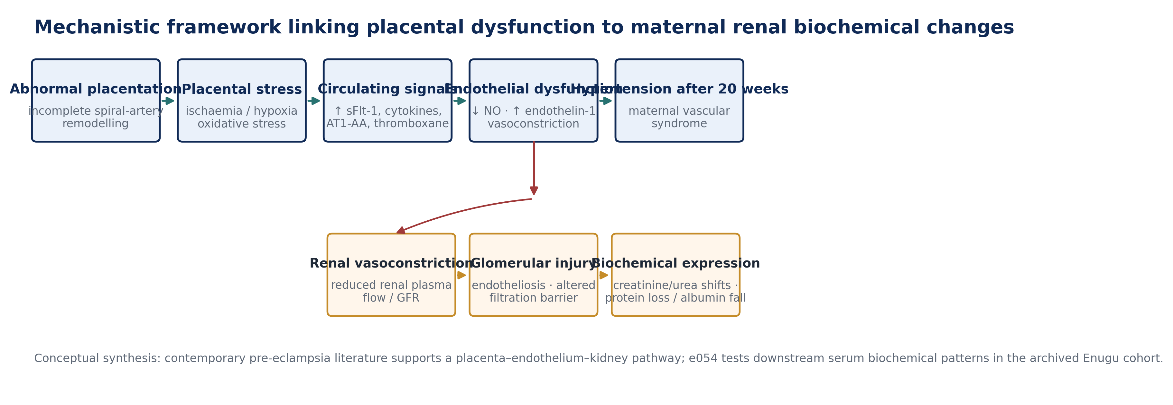
Figure 1. Mechanistic framework linking abnormal placentation and endothelial dysfunction to renal biochemical expression. Original synthesis based on Magee et al. (2022), Wang et al. (2023), Ali et al. (2024) and the pathways described in the completed study archive.
The present article develops the completed 2021 study into a publication-ready evidence record. Its contribution is not to manufacture new observations, but to preserve the original recruitment, laboratory methods and inferential findings; reconstruct the plotted aggregate values transparently; correct internally inconsistent unit and location labels using the strongest source evidence; and interpret the findings against contemporary renal and hypertensive-pregnancy literature.

1.1 Aim and research questions
The study aimed to determine whether pregnancy-induced hypertension was associated with measurable renal biochemical changes in pregnant women attending tertiary hospitals. The publication analysis addresses three questions: (i) do serum Na⁺, K⁺, Cl⁻ and HCO₃⁻ differ between hypertensive and normotensive pregnancy groups; (ii) do urea and creatinine indicate altered renal filtration; and (iii) are total protein, albumin and globulin concentrations altered in hypertensive pregnancy?

2. Materials and Methods

2.1 Study design, setting and participants
This was a comparative cross-sectional laboratory study conducted among pregnant women attending antenatal care at the University of Nigeria Teaching Hospital (UNTH) and Enugu State University Teaching Hospital (ESUTH), Enugu State, Nigeria. The archived sample section records 149 serum samples from apparently healthy pregnant women aged 24–36 years. Women with a past history of hypertension or other metabolic illnesses were excluded, and verbal consent was documented in the source report.
The experimental-design paragraph states that 150 women were used, but the five listed groups contain 30 + 30 + 30 + 30 + 29 = 149 participants. Because the sample description and group arithmetic converge on 149, e054 treats n=149 as the analysed cohort and does not invent a reason for the one-participant discrepancy.
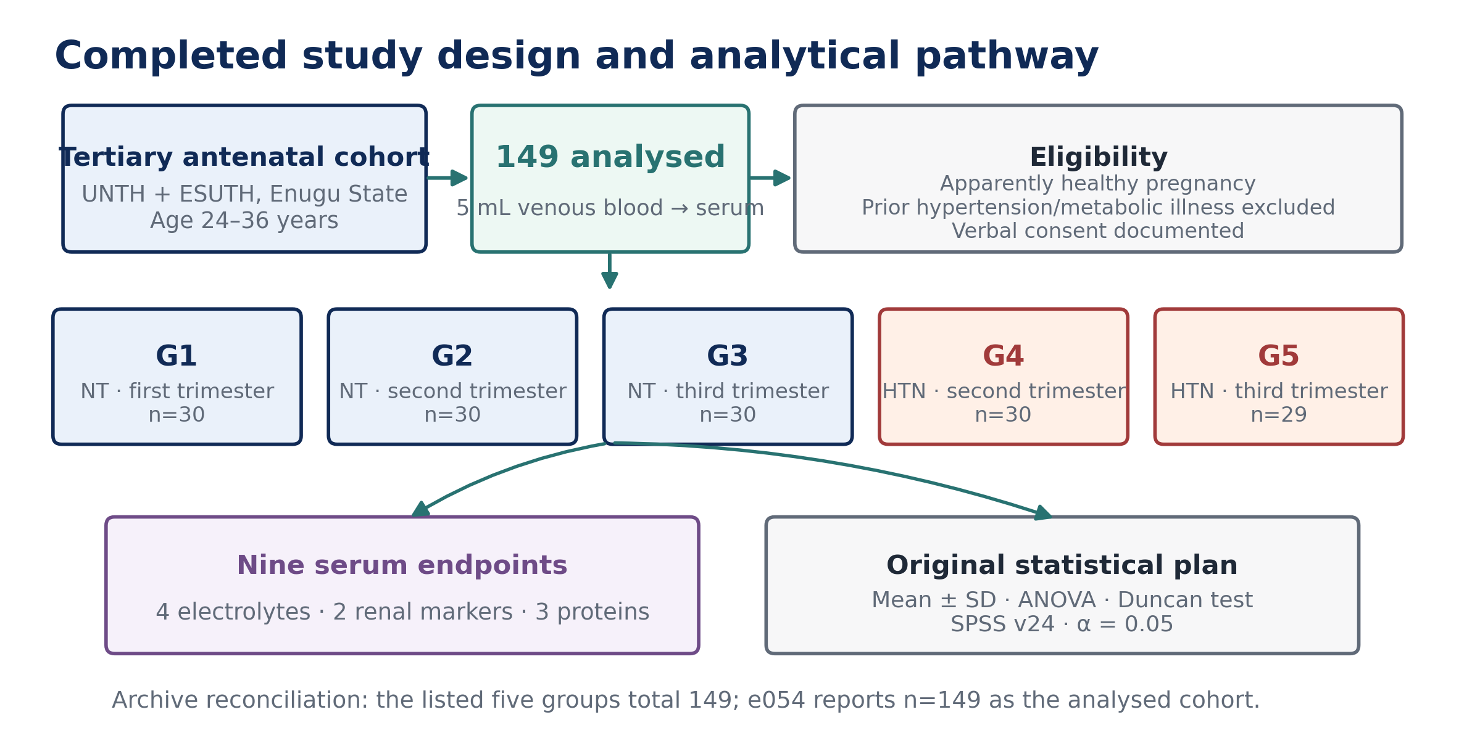
Figure 2. Completed study design, participant groups, serum assays and original statistical plan. Group counts are transcribed from the archive and sum to n=149.
Group | Blood-pressure status | Trimester | n | Analytical role
G1 | Normotensive | First | 30 | Control
G2 | Normotensive | Second | 30 | Trimester-matched control for G4
G3 | Normotensive | Third | 30 | Trimester-matched control for G5
G4 | Hypertensive | Second | 30 | PIH test group
G5 | Hypertensive | Third | 29 | PIH test group

Table 1. Analytic groups in the completed study. No hypertensive first-trimester group was present, consistent with the post-20-week onset of gestational hypertension/PIH.

2.2 Specimen collection and biochemical assays
Venous blood (5 mL) was collected, allowed to clot and serum separated. Sodium was measured using the Teco diagnostic-kit method described in the archive, based on sodium magnesium uranyl acetate precipitation and color development read at 550 nm. Potassium was assessed by sodium tetraphenylboron turbidimetry at 500 nm. Chloride was measured through thiocyanate release and ferric-thiocyanate color development at 480 nm, while bicarbonate was determined by acid release of carbon dioxide followed by back-titration. These procedures were attributed in the source to Tietz-based clinical chemistry methods.
Creatinine was determined by a modified Jaffé procedure using a Randox kit, with paired absorbance readings at 492 nm and a 177 µmol/L (2 mg/dL) standard. Urea was assayed by the urease–Berthelot reaction, in which urease-generated ammonia produces an indophenol chromophore read at 546 nm (Weatherburn, 1967). Total protein was determined by the Biuret method using a 60 g/L protein standard and absorbance at 530 nm. Albumin was measured by bromocresol-green dye binding at approximately 623–632 nm.

2.3 Statistical analysis and reconstruction boundary
The archived report states that results were expressed as mean ± SD and analysed with one-way and two-way analysis of variance (ANOVA), with Duncan multiple-range testing for mean separation; p<0.05 was considered statistically significant and SPSS version 24 was used. Participant-level data were not included in the supplied archive, so e054 does not recalculate F statistics, exact p values, confidence intervals or adjusted models.
Δ% = 100 × ( X₍HDP₎ − X₍NT, matched trimester₎ ) / X₍NT, matched trimester₎ | (1)
Equation (1) is used only for descriptive visualization of the digitized plotted means. It is not presented as a substitute for participant-level effect-size analysis.

2.4 Archival reconciliation and evidentiary safeguards
Archive issue | Primary evidence | Publication treatment
Study location | Title and sample/methods identify Enugu State, UNTH and ESUTH; some legacy headings say Makurdi/Benue. | e054 uses Enugu State as the study setting and discloses the conflicting legacy labels.
Analytic sample | One sentence states 150; the listed groups total 149 and the sample section says 149 serum samples. | n=149 is reported as the analysed cohort.
Creatinine unit | Archived graph labels mmol/L, but the method uses a 177 µmol/L creatinine standard and plotted values are ~69–73. | Creatinine is harmonized to µmol/L.
Protein units | Archived graphs label mmol/L, while the Biuret standard is 60 g/L and plotted values are consistent with g/L. | Total protein, albumin and globulin are harmonized to g/L.
Raw data availability | Only aggregate figures and inferential statements are preserved in the supplied archive. | Means/SDs reproduced here are approximate digitizations; significance claims are transcribed, not recomputed.

Table 2. Source-integrity audit applied before publication. No missing fact, ethics identifier or raw-data statistic has been invented.

3. Results

3.1 Electrolyte profile
Sodium concentration did not differ significantly between hypertensive and normotensive groups (reported p>0.05). The hypertensive third-trimester group was numerically highest, whereas the hypertensive second-trimester group was slightly lower than its trimester-matched control. Potassium likewise showed no significant difference; the highest mean occurred in hypertensive second trimester. Chloride and bicarbonate were also statistically similar across groups, although bicarbonate was numerically lower in the hypertensive groups.
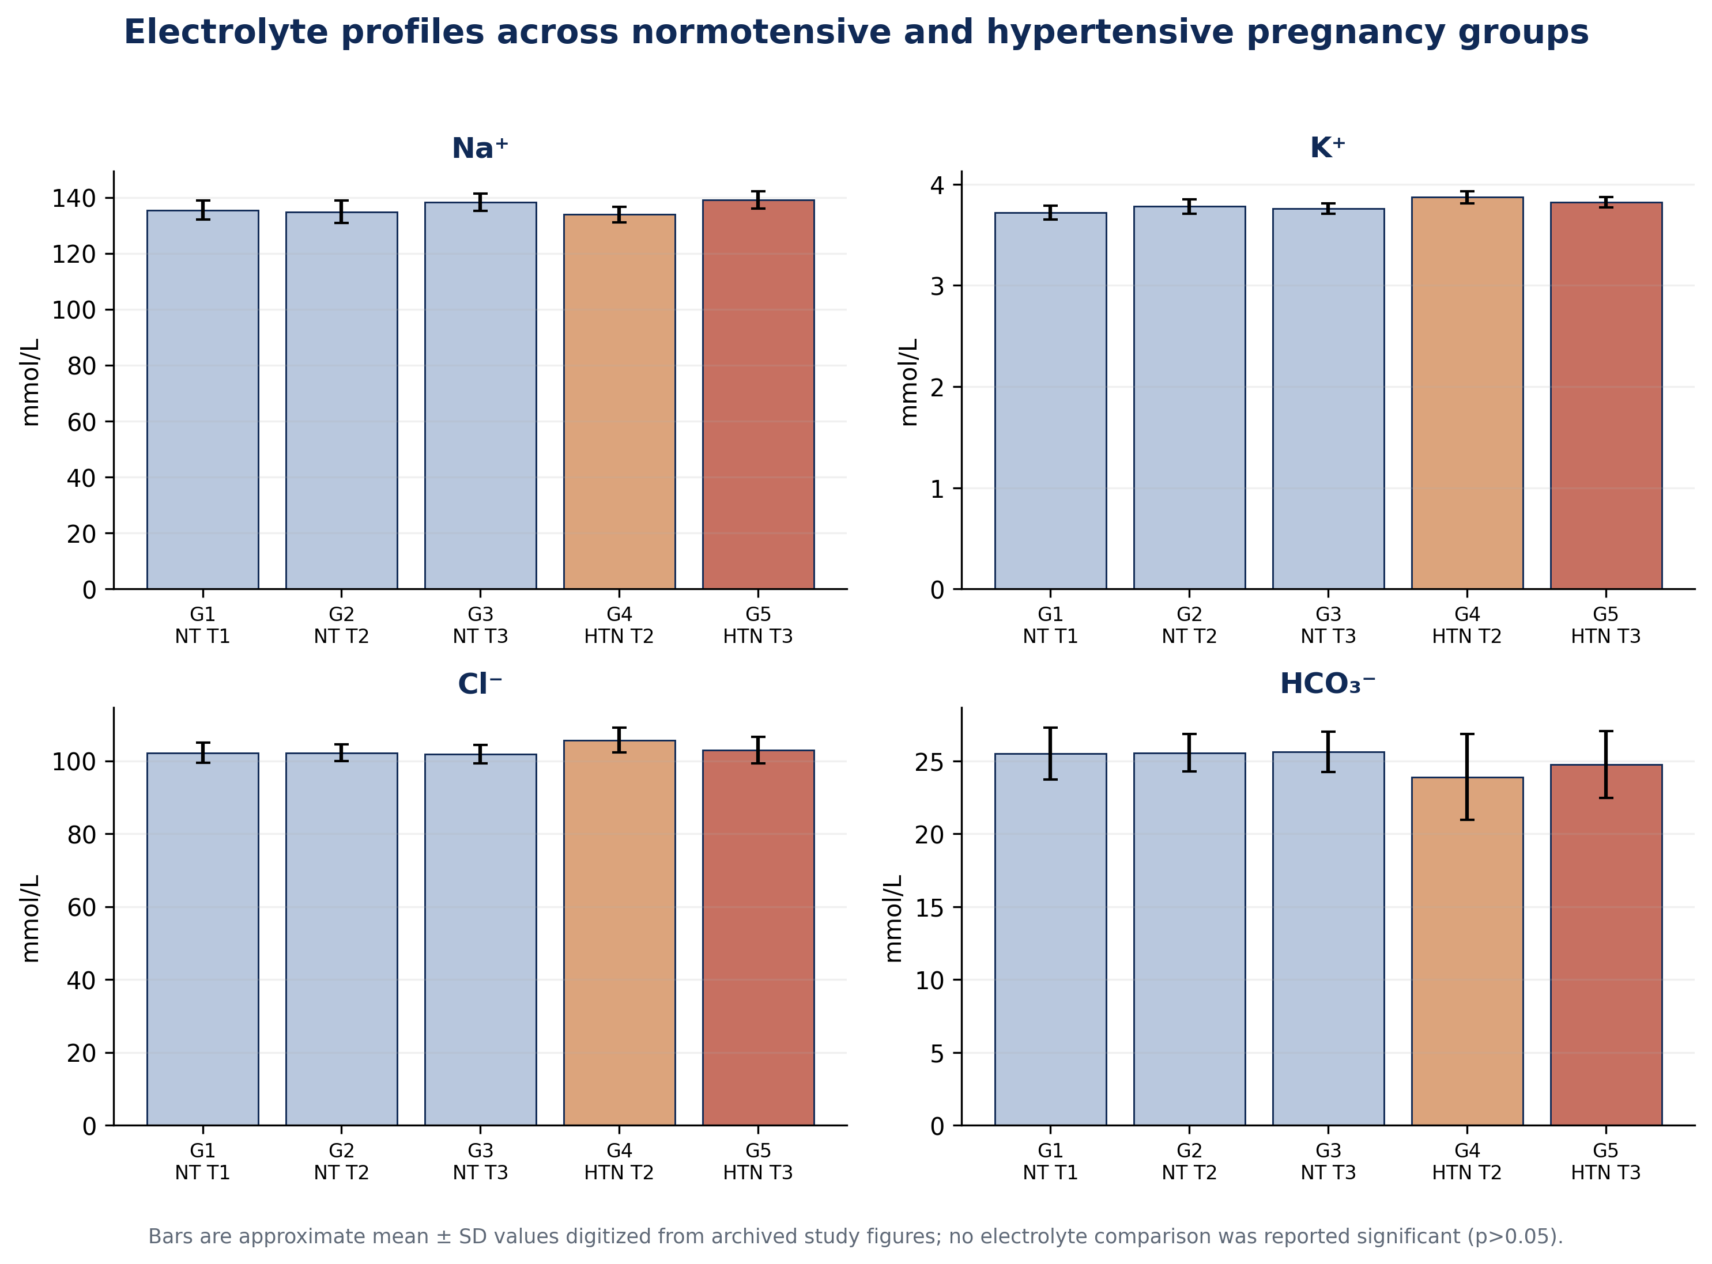
Figure 3. Serum electrolyte profiles. Bars are approximate mean ± SD values digitized from the archived study figures; the completed study reported p>0.05 for Na⁺, K⁺, Cl⁻ and HCO₃⁻ comparisons.

3.2 Urea and creatinine
The original analysis found no significant difference in urea or creatinine between hypertensive and normotensive pregnancy groups (p>0.05). Both markers were, however, numerically higher in hypertensive third trimester than in the corresponding normotensive third-trimester group: urea approximately 4.15 versus 3.71 mmol/L and creatinine approximately 71.3 versus 69.4 µmol/L. These differences are descriptive and should not be interpreted as independently tested effect sizes.
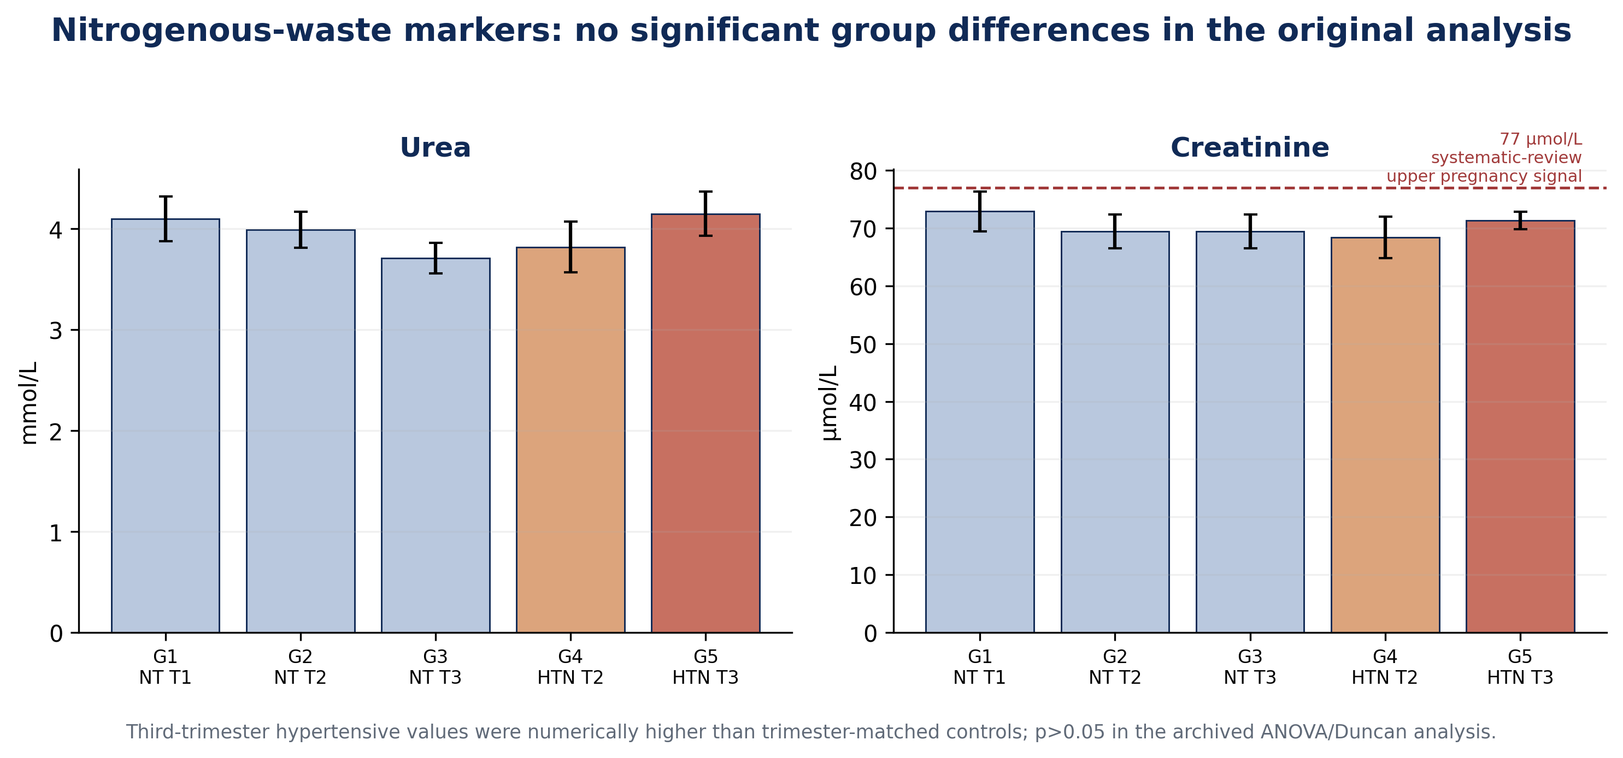
Figure 4. Urea and creatinine profiles. The dashed 77 µmol/L line is a literature-derived pregnancy reference signal from Wiles et al. (2019), not a diagnostic threshold; NICE uses creatinine ≥90 µmol/L as a renal-insufficiency criterion in its pre-eclampsia definition.

3.3 Total protein, albumin and globulin
The clearest biochemical separation occurred in the plasma proteins. Total protein was significantly lower in hypertensive second- and third-trimester groups than in normotensive controls (reported p<0.05). Albumin was also significantly reduced in both hypertensive groups, with the lowest value in hypertensive third trimester. Globulin was significantly lower in both hypertensive groups than in controls. These three endpoints therefore constitute the principal positive finding of the study.
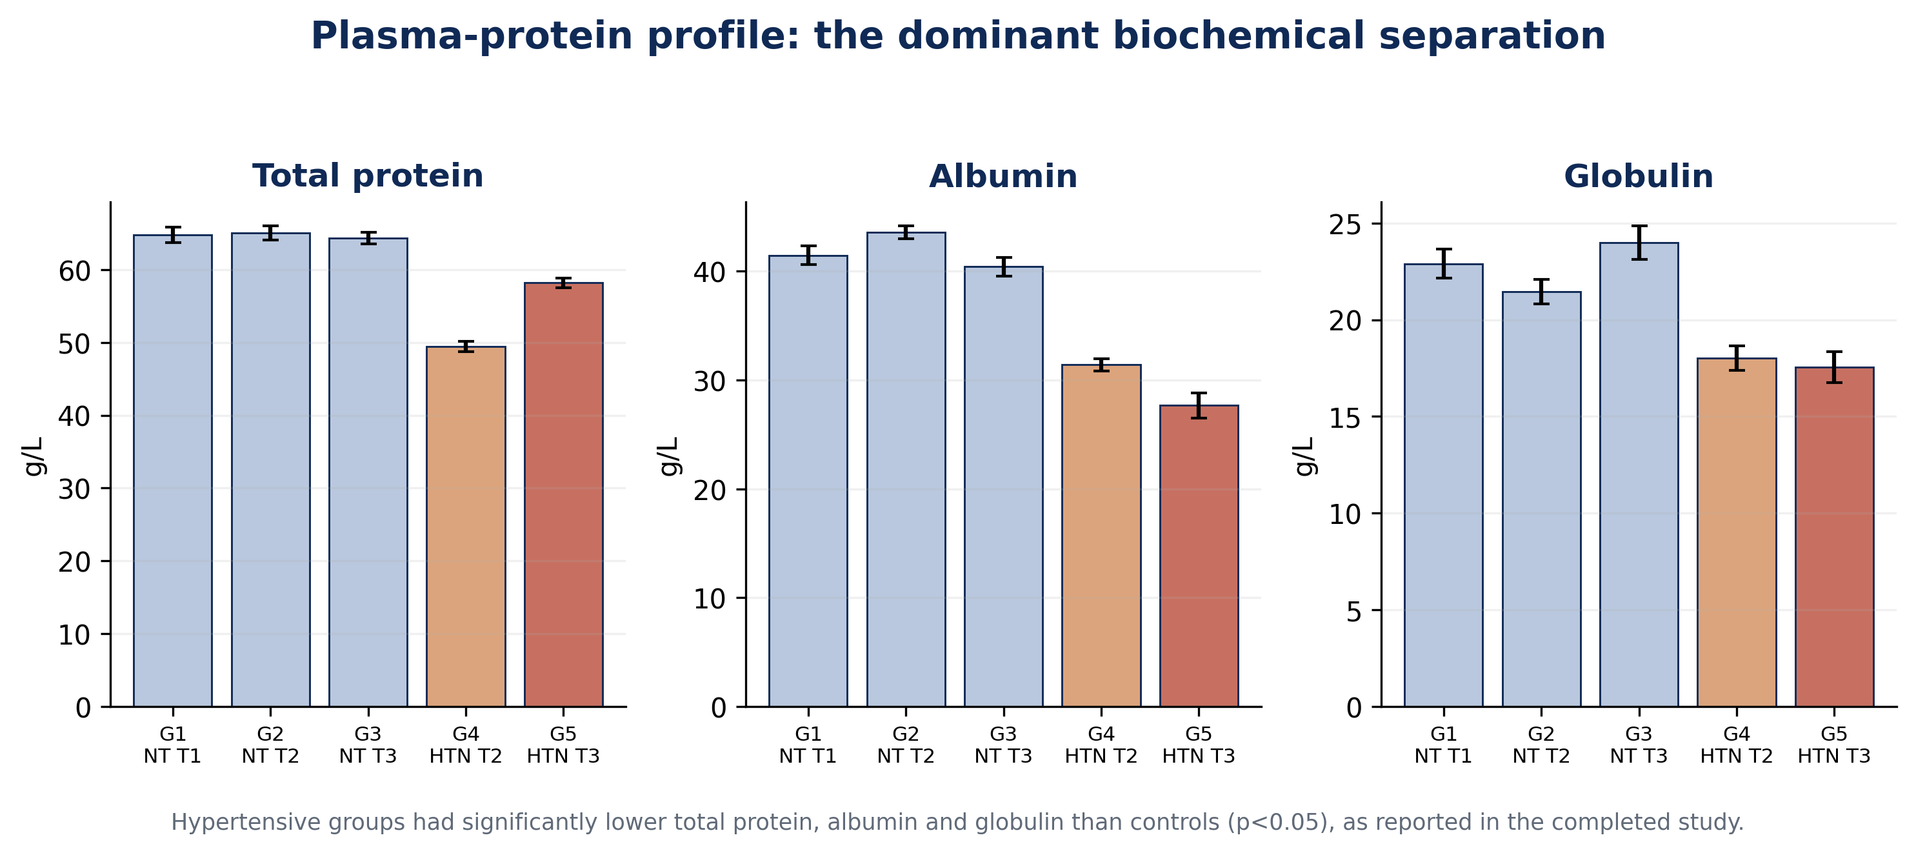
Figure 5. Plasma-protein profile. Total protein, albumin and globulin were reported significantly lower in hypertensive pregnancy groups (p<0.05). Values are approximate mean ± SD digitizations of the archived figures.
Marker (unit) | G1 NT-T1 | G2 NT-T2 | G3 NT-T3 | G4 HTN-T2 | G5 HTN-T3 | Original inference
Na⁺ (mmol/L) | 135.4 ± 3.4 | 134.8 ± 4.0 | 138.2 ± 3.1 | 133.9 ± 2.8 | 139.1 ± 3.1 | p>0.05
K⁺ (mmol/L) | 3.72 ± 0.07 | 3.78 ± 0.07 | 3.76 ± 0.05 | 3.87 ± 0.06 | 3.82 ± 0.05 | p>0.05
Cl⁻ (mmol/L) | 102.3 ± 2.8 | 102.3 ± 2.3 | 101.8 ± 2.5 | 105.7 ± 3.5 | 103.0 ± 3.7 | p>0.05
HCO₃⁻ (mmol/L) | 25.5 ± 1.8 | 25.6 ± 1.3 | 25.6 ± 1.4 | 23.9 ± 2.9 | 24.8 ± 2.3 | p>0.05
Urea (mmol/L) | 4.10 ± 0.22 | 3.99 ± 0.18 | 3.71 ± 0.15 | 3.82 ± 0.25 | 4.15 ± 0.22 | p>0.05
Creatinine (µmol/L) | 72.9 ± 3.5 | 69.4 ± 2.9 | 69.4 ± 2.9 | 68.4 ± 3.6 | 71.3 ± 1.6 | p>0.05
Total protein (g/L) | 64.8 ± 1.1 | 65.0 ± 0.9 | 64.4 ± 0.8 | 49.4 ± 0.7 | 58.2 ± 0.7 | p<0.05
Albumin (g/L) | 41.5 ± 0.9 | 43.6 ± 0.6 | 40.4 ± 0.9 | 31.4 ± 0.6 | 27.7 ± 1.2 | p<0.05
Globulin (g/L) | 22.9 ± 0.8 | 21.5 ± 0.6 | 24.0 ± 0.9 | 18.0 ± 0.6 | 17.6 ± 0.8 | p<0.05

Table 3. Approximate mean ± SD values digitized from the completed study figures. Inferential outcomes are transcribed from the source narrative; exact p values were not available and have not been invented.

3.4 Trimester-matched descriptive differences
When the hypertensive groups are compared descriptively with the corresponding normotensive trimester, the protein pattern is substantially larger than the electrolyte pattern. The approximate G4-versus-G2 differences are −24.0% for total protein, −27.9% for albumin and −16.0% for globulin; the approximate G5-versus-G3 differences are −9.6%, −31.5% and −26.8%, respectively. By comparison, most electrolyte differences are within about ±7%. Urea in G5 is approximately 11.9% above G3, but this was not statistically significant in the original analysis.
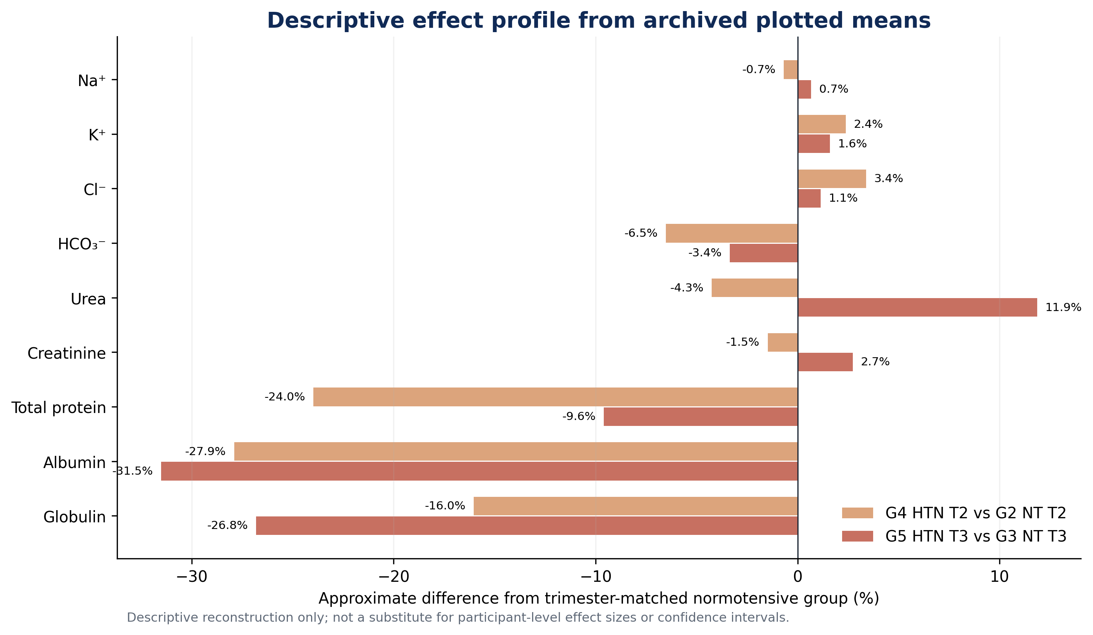
Figure 6. Descriptive matched-trimester percentage differences calculated from digitized figure means using Equation (1). These are visual effect profiles only, not recalculated inferential effect sizes.

4. Discussion

4.1 Principal findings
This completed study demonstrates a selective biochemical pattern. Serum sodium, potassium, chloride and bicarbonate remained statistically stable across normotensive and hypertensive pregnancy groups, and urea/creatinine did not show significant separation. In contrast, total protein, albumin and globulin were consistently lower in hypertensive pregnancy. The evidence therefore does not support generalized renal biochemical failure in this cohort; it supports a more specific disturbance in circulating protein status.
The electrolyte findings are concordant with Bera et al. (2011), who reported no change in serum sodium or potassium in gestational hypertension and pre-eclampsia compared with normotensive pregnancy. That consistency strengthens the interpretation that serum Na⁺ and K⁺ may remain within a narrow physiological range despite important vascular pathology. Homeostatic preservation of a serum electrolyte does not imply absence of altered renal sodium handling, extracellular-volume redistribution or neurohormonal activation.

4.2 Creatinine, pregnancy hyperfiltration and the meaning of “normal”
The absence of a statistically significant creatinine rise should be interpreted in the context of pregnancy physiology. Glomerular filtration rises early in healthy pregnancy, and serum creatinine falls relative to non-pregnant values (Lopes van Balen et al., 2019; Wiles et al., 2019). The digitized hypertensive third-trimester mean in this cohort (~71 µmol/L) remains below both the 77 µmol/L systematic-review reference signal and the 90 µmol/L renal-insufficiency threshold used by NICE. That supports the narrow conclusion that overt creatinine-defined renal insufficiency was not demonstrated at group level.
It does not support the broader statement that renal involvement was absent. Preeclampsia is a vascular–renal syndrome in which endothelial dysfunction, renal vasoconstriction and glomerular endotheliosis can alter filtration and permeability, and diagnosis may be supported by proteinuria or other maternal-organ dysfunction even when serum creatinine is not markedly elevated (Magee et al., 2022; Wang et al., 2023; NICE, 2026). Thus, the archived conclusion that renal function was simply “not impaired” is too categorical by contemporary standards.

4.3 Why the protein signal is important—but not specific
The magnitude and consistency of the protein findings deserve emphasis. Relative to trimester-matched normotensive groups, albumin was approximately 28% lower in hypertensive second trimester and 32% lower in hypertensive third trimester. Reduced total protein and globulin accompanied the albumin reduction. Physiologically plausible contributors include haemodilution, increased vascular permeability and capillary leak, altered hepatic synthesis, nutritional status, inflammation and urinary protein loss. The source discussion proposed albuminuria as a mechanism; however, urine protein was not one of the nine measured endpoints in the preserved methods. Renal protein loss therefore cannot be confirmed from this dataset alone.
The distinction matters clinically. Current NICE recommendations quantify proteinuria with urine protein:creatinine ratio (PCR) or albumin:creatinine ratio (ACR), using thresholds of 30 mg/mmol and 8 mg/mmol respectively, interpreted alongside the complete clinical picture. Serum albumin is valuable as a severity/context marker but is not a substitute for direct urinary protein assessment. A future replication should therefore pair serum proteins with urine PCR/ACR and serial renal-function measurements.

4.4 Nigerian clinical relevance
The present cohort is modest compared with national datasets, but its question remains clinically important. Contemporary Nigerian evidence shows that HDP is common in referral care and carries substantial maternal and perinatal risk (Abdurrahman et al., 2024). The 2024 Nigerian meta-analysis also found measurable acute kidney injury among PE/E complications and high maternal and fetal mortality, highlighting the value of early laboratory surveillance (Kokori et al., 2024). The Enugu study adds a biochemical signal from tertiary antenatal patients in South-East Nigeria and supports a surveillance strategy that goes beyond blood pressure alone.
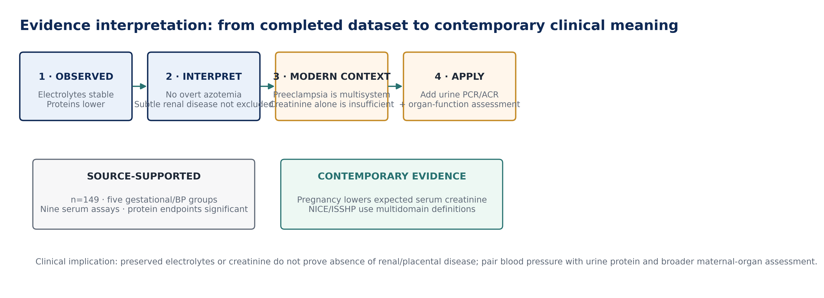
Figure 7. Evidence-interpretation framework separating source-supported observations from contemporary clinical interpretation. PCR = protein:creatinine ratio; ACR = albumin:creatinine ratio.

4.5 Strengths, limitations and reproducibility boundary
Strengths include a completed human-subject laboratory dataset, clear trimester and blood-pressure grouping, nine biochemical endpoints, named analytical methods, and an original inferential plan. The evidence is more valuable than a synthetic reconstruction because it derives from an actual antenatal cohort and preserved laboratory work.
Limitations arise from the archive. Individual participant records are unavailable; therefore, exact p values, confidence intervals and multivariable analyses cannot be reproduced. The source contains inconsistent location labels (Enugu versus Makurdi/Benue), one recruitment-count discrepancy, and unit-label errors in several graphs. Blood-pressure distributions, antihypertensive treatment, parity, body mass index, nutritional status, urine protein and maternal–fetal outcomes are not sufficiently preserved for adjusted interpretation. Because hypertensive women were present only in second and third trimester, the five-group design is not a complete factorial trimester-by-hypertension matrix. These limitations are explicitly reported rather than silently corrected.

5. Conclusion
Among 149 analysed pregnant women in the completed tertiary-hospital study, pregnancy-induced hypertension was not associated with statistically significant changes in serum Na⁺, K⁺, Cl⁻, HCO₃⁻, urea or creatinine. The dominant biochemical difference was a significant reduction in total protein, albumin and globulin in hypertensive pregnancy. These findings support a phenotype of altered protein status without demonstrable group-level azotemia or electrolyte failure. They do not establish absence of renal involvement, because pregnancy-specific creatinine physiology and the lack of direct urine-protein measurement limit that conclusion.
For contemporary practice and future research, the strongest extension is a prospective PIH/preeclampsia panel that combines standardized blood-pressure classification with serum creatinine, urine PCR or ACR, electrolytes, serum proteins, platelet count, liver enzymes and maternal–fetal outcomes. Such a design would preserve the biochemical strengths of the 2021 study while aligning interpretation with current ISSHP/NICE multidomain criteria.

Declarations
Author contribution: EMMANUEL, CEPHASKING OGBOTU conducted the original study and is responsible for the archived research evidence. The e054 publication version reorganizes, reconciles and interprets that completed work without creating new participant observations.
Ethics and consent: The archived report documents verbal informed consent and exclusion of women with prior hypertension or metabolic illness. A named institutional ethics committee and approval/reference number are not preserved in the supplied archive; no unverified identifier is stated in this article.
Data availability: Aggregate study results and laboratory methods are preserved in the archived research report. Participant-level raw data were not included in the supplied publication archive. Figure values in e054 are transparent digitizations of the original aggregate plots and are labelled as approximate.
Funding: No external funding information is documented in the supplied study archive.
Competing interests: The author declares no competing interest in the supplied publication record.
Publication identifiers: CHIATECH JOURNAL ISSN and article DOI remain pending formal assignment/registration and are not fabricated in this Version-of-Record-style pioneer publication.

References
Abdurrahman, A., Adamu, A. N., Ashimi, A., Adekunle, O. O., Bature, S. B., Aliyu, L. D., et al. (2024). Predictors, prevalence and outcome of hypertensive disorders in pregnancy in Nigerian tertiary health facilities. BJOG: An International Journal of Obstetrics & Gynaecology, 131(Suppl 3), 42–54. https://doi.org/10.1111/1471-0528.17902
Ali, M., Ahmed, M., Memon, M., Chandio, F., Shaikh, Q., Parveen, A., & Phull, A.-R. (2024). Preeclampsia: A comprehensive review. Clinica Chimica Acta, 563, 119922. https://doi.org/10.1016/j.cca.2024.119922
Bera, S., Siuli, R. A., Gupta, S., Ray, T. G., Taraphdar, P., Bal, R., & Ghosh, A. (2011). Study of serum electrolytes in pregnancy induced hypertension. Journal of the Indian Medical Association, 109(8), 546–548.
Blass, K. G., Thiebert, R. J., & Lam, L. K. (1974). A study of the mechanism of the Jaffé reaction. Journal of Clinical Chemistry and Clinical Biochemistry, 12, 336–343.
Kokori, E., Aderinto, N., Olatunji, G., Komolafe, R., Babalola, E. A., et al. (2024). Prevalence and materno-fetal outcomes of preeclampsia/eclampsia among pregnant women in Nigeria: A systematic review and meta-analysis. European Journal of Medical Research, 29, 482. https://doi.org/10.1186/s40001-024-02086-x
Lopes van Balen, V. A., van Gansewinkel, T. A. G., de Haas, S., Spaan, J. J., Ghossein-Doha, C., van Kuijk, S. M. J., van Drongelen, J., Cornelis, T., & Spaanderman, M. E. A. (2019). Maternal kidney function during pregnancy: Systematic review and meta-analysis. Ultrasound in Obstetrics & Gynecology, 54(3), 297–307. https://doi.org/10.1002/uog.20137
Magee, L. A., Brown, M. A., Hall, D. R., Gupte, S., Hennessy, A., Karumanchi, S. A., Kenny, L. C., McCarthy, F., Myers, J., Poon, L. C., Rana, S., Saito, S., Staff, A. C., Tsigas, E., & von Dadelszen, P. (2022). The 2021 International Society for the Study of Hypertension in Pregnancy classification, diagnosis & management recommendations for international practice. Pregnancy Hypertension, 27, 148–169. https://doi.org/10.1016/j.preghy.2021.09.008
National Institute for Health and Care Excellence. (2026). Hypertension in pregnancy: Diagnosis and management (NG133). NICE. https://www.nice.org.uk/guidance/ng133
Ogbodo, S. O., Nwagha, U. I., Okaka, A. N. C., Okeke, A. C., Chukwurah, F. E., & Ezeonu, P. O. (2012). Low levels of some nutritional parameters of pregnant women in a rural community of South East Nigeria: Implications for the attainment of the Millennium Development Goal. Annals of Medical and Health Sciences Research, 2(1), 49–55. https://doi.org/10.4103/2141-9248.96939
Tietz, N. W. (1994). Textbook of Clinical Chemistry (2nd ed.). W. B. Saunders.
Wang, X., Shields, C. A., Ekperikpe, U., Amaral, L. M., Williams, J. M., & Cornelius, D. C. (2023). Vascular and renal mechanisms of preeclampsia. Current Opinion in Physiology, 33, 100655. https://doi.org/10.1016/j.cophys.2023.100655
Weatherburn, M. W. (1967). Phenol-hypochlorite reaction for determination of ammonia. Analytical Chemistry, 39(8), 971–974. https://doi.org/10.1021/ac60252a045
Wiles, K., Bramham, K., Seed, P. T., Nelson-Piercy, C., Lightstone, L., & Chappell, L. C. (2019). Serum creatinine in pregnancy: A systematic review. Kidney International Reports, 4(3), 408–419. https://doi.org/10.1016/j.ekir.2018.10.015

