CHIATECH JOURNAL
  - SETEHEM · Volume 1, Issue 1 · Pioneer July/August 2026 · Part 2 · e055
  - PIONEER PUBLICATION · ACCEPTED ARTICLE · CRITICAL REVIEW ARTICLE · MEDICAL MICROBIOLOGY · MRSA · GENOMIC SURVEILLANCE · ONE HEALTH · NIGERIA

From Antibiograms to Whole-Genome Surveillance: A Critical Review of Methicillin-Resistant Staphylococcus aureus in Nigeria Across Clinical, Environmental and One Health Interfaces
MELLAH, Iwanger¹*
¹ Federal University of Agriculture, Makurdi, Nigeria
*Corresponding author: whoisdrmellah@gmail.com
Article type  Critical Review Article | eLocator  e055 | ISSN  Pending assignment | DOI  Pending registration

Abstract
Background: Methicillin-resistant Staphylococcus aureus (MRSA) remains a high-priority antimicrobial-resistance pathogen and an important cause of healthcare-, community- and livestock-associated infection. Nigeria now has an evidence base spanning classical antibiograms, targeted PCR, spa/SCCmec typing and, increasingly, whole-genome sequencing (WGS), yet these layers are rarely synthesized into a single surveillance pathway. Objective: To critically integrate Nigerian evidence on antimicrobial resistance, mecA/mecC-SCCmec architecture, Panton-Valentine leukocidin (PVL), clonal diversity, environmental persistence and One Health transmission, while identifying the laboratory and policy transition required for contemporary surveillance. Review approach: This structured critical narrative review searched PubMed/PMC-indexed literature, publisher records, World Health Organization (WHO) reports and Nigerian AMR policy documents, prioritizing Nigerian studies and systematic reviews published through 30 August 2026. It is not presented as an exhaustive systematic review or meta-analysis. Synthesis: Nigeria exhibits marked MRSA heterogeneity across settings. Historical studies documented diverse spa backgrounds and PVL-positive strains; recent clinical WGS from Lagos identified a dominant PVL-positive t657/ST772/SCCmec V Bengal Bay lineage, whereas other Nigerian studies report ST152, ST8, mecC, heterogeneous SCCmec types, biofilm determinants and clinically important phenotype-genotype discordance. A 2025 Nigerian One Health meta-analysis estimated pooled mecA prevalence at 51% (95% CI 14-86%) across included resistance-gene studies, with substantial heterogeneity. Livestock, foods and hospital environments provide plausible connected reservoirs, reinforcing the need to link clinical microbiology with environmental and veterinary surveillance. Conclusion: Nigeria should move from isolated antibiograms and single-gene PCR toward a tiered national model in which standardized AST and targeted molecular confirmation feed referral WGS, interoperable metadata and One Health response. The country's 2024-2028 AMR National Action Plan provides a policy platform for this transition.
Keywords: Staphylococcus aureus; MRSA; antimicrobial resistance; mecA; mecC; Panton-Valentine leukocidin; SCCmec; spa typing; whole-genome sequencing; One Health; Nigeria
Suggested citation: Mellah, I. (2026). From antibiograms to whole-genome surveillance: A critical review of methicillin-resistant Staphylococcus aureus in Nigeria across clinical, environmental and One Health interfaces. CHIATECH Journal: SETEHEM, 1(1), e055. DOI pending registration.

1. Introduction
Staphylococcus aureus combines efficient colonization, environmental persistence, toxin production and rapid acquisition of resistance determinants. The defining molecular feature of most MRSA is mecA, carried within the staphylococcal cassette chromosome mec (SCCmec) and encoding the low-affinity penicillin-binding protein PBP2a. mecC provides an alternative methicillin-resistance route in a smaller subset of lineages. These resistance determinants can coexist with virulence loci, including the lukS-PV/lukF-PV genes encoding Panton-Valentine leukocidin, superantigens, adhesins and biofilm-associated genes. The epidemiological consequence is that two isolates with the same resistant phenotype may represent very different transmission histories and virulence architectures.
The World Health Organization retained methicillin-resistant S. aureus in the high-priority tier of its 2024 Bacterial Priority Pathogens List, specifically emphasizing its healthcare burden and the need for regionally tailored research and public-health measures (WHO, 2024). The 2025 WHO global antibiotic-resistance surveillance report further illustrates the scale of the surveillance challenge: more than 23 million bacteriologically confirmed infections contributed to global analyses, with data from 104 countries for 2023 and 110 countries across 2016-2023 (WHO, 2025). For Nigeria, the central question is no longer whether MRSA exists, but whether laboratory, genomic and epidemiological systems can detect its changing lineages quickly enough to guide treatment, infection prevention and One Health control.
Nigeria is especially suited to an integrated review because its evidence base now spans several methodological eras. Earlier molecular studies established extensive strain diversity, PVL carriage and heterogeneous spa backgrounds (Shittu et al., 2011; O'Malley et al., 2015). The author's completed Taraba State investigation combined six-centre clinical and hospital-environment sampling with culture, antimicrobial susceptibility testing, PCR, SCCmec typing and spa analysis, illustrating the pre-WGS molecular surveillance model used in many resource-constrained settings (Mellah, 2019). More recently, Nigerian studies have incorporated mecC, food and livestock interfaces, biofilm determinants and WGS, culminating in high-resolution descriptions of circulating clinical clones in Lagos (Adeyemi et al., 2024; Beshiru et al., 2024; Olalekan et al., 2025).
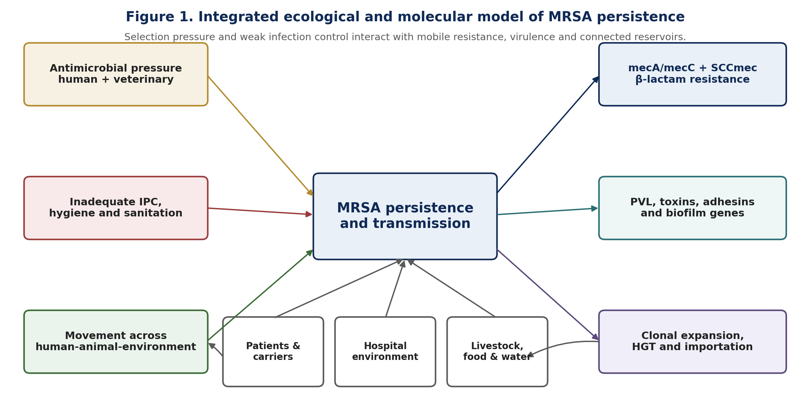
Figure 1. Integrated ecological and molecular model of MRSA persistence. The figure synthesizes mechanisms and transmission pathways discussed in the review; it is a conceptual model, not a quantitative transmission estimate.

2. Review Approach and Evidence Boundaries
A structured critical narrative review was undertaken to integrate evidence relevant to Nigerian MRSA surveillance. Searches were conducted through 30 August 2026 using PubMed/PMC-indexed records, publisher websites, WHO publications and Nigerian AMR policy sources. Search concepts combined “Nigeria”, “Staphylococcus aureus”, “MRSA”, “mecA”, “mecC”, “PVL”, “SCCmec”, “spa typing”, “whole-genome sequencing”, “hospital environment”, “livestock”, “food”, “One Health”, “antimicrobial resistance” and “surveillance”. Priority was given to peer-reviewed Nigerian primary studies, Nigerian or African systematic reviews, national policy documents and global WHO standards. Older molecular studies were retained where they establish lineage history or methodological continuity.
This article is intentionally a critical review rather than a systematic review or meta-analysis. No exhaustive database-count or PRISMA-flow claim is made. Numerical estimates are reproduced only when directly reported by cited sources; prevalence figures are not pooled across studies with incompatible populations, specimen types, breakpoints or molecular definitions. The 2019 Taraba thesis is used as a practice-informed historical anchor, not as a substitute for the published contemporary literature. This distinction is important because differences in sampling, AST interpretation, cefoxitin/oxacillin screening, mecA/mecC confirmation and genotyping can generate apparently conflicting prevalence estimates.

3. Molecular Architecture: Why Phenotype Alone Is Insufficient

3.1 Methicillin resistance and SCCmec
Phenotypic methicillin resistance is clinically important, but molecular confirmation resolves mechanism. mecA and mecC encode alternative PBP2a-like proteins that preserve cell-wall synthesis despite beta-lactam exposure. Their location within SCCmec makes methicillin resistance part of a mobile genomic island rather than an isolated drug phenotype. SCCmec typing therefore adds epidemiological information: different cassette structures can occur within distinct clonal backgrounds, and the same sequence type may acquire different SCCmec elements over time. Nigerian evidence now documents types II, III, IV and V across human and livestock sources, while recent Lagos WGS found SCCmec V-family elements dominant among the most frequent MRSA lineages (Beshiru et al., 2024; Olalekan et al., 2025).
Phenotype-genotype discordance must be treated as a quality signal rather than ignored. Adeyemi et al. (2024), examining clinical and ready-to-eat food samples in Southwestern Nigeria, reported 59/138 isolates phenotypically classified as MRSA but only 7/138 mecA-positive and 6/138 mecC-positive. Such discordance can reflect breakpoint choice, heteroresistance, non-mec mechanisms, assay performance or classification errors. The appropriate response is not to privilege phenotype or PCR automatically, but to reconcile species confirmation, cefoxitin/oxacillin testing, PBP2a/mec assays and, where epidemiologically important, sequence data.

3.2 Virulence, PVL and biofilm
PVL is an important virulence marker but should not be used as a stand-alone synonym for community-associated MRSA. Nigerian studies show that lukS-PV/lukF-PV can occur in MRSA and MSSA and across multiple clonal backgrounds. In Calabar, Ide et al. (2025) detected lukSF-PV in 10/80 S. aureus isolates from soft-tissue infections; six were MSSA and four were MRSA. In Lagos, by contrast, 34/36 ST772 MRSA were PVL-positive, creating a strong lineage-specific association within the dominant Bengal Bay clone (Olalekan et al., 2025). The interpretation is therefore clonal: PVL modifies pathogenic potential, but its epidemiological meaning depends on the genomic background in which it occurs.
Biofilm capacity adds a further persistence mechanism. Beshiru et al. (2024) characterized 76 mecA-positive livestock-associated MRSA isolates from cattle; 50/76 (65.8%) were reported as strong biofilm formers, and PVL was detected in 62/76 (81.6%). These results do not establish direct zoonotic transmission, but they demonstrate that resistant, virulent and surface-persistent phenotypes can coexist outside hospitals. For infection prevention, this matters because hospital environmental contamination, animal contact, food handling and wastewater can all participate in a wider ecological network of exposure.
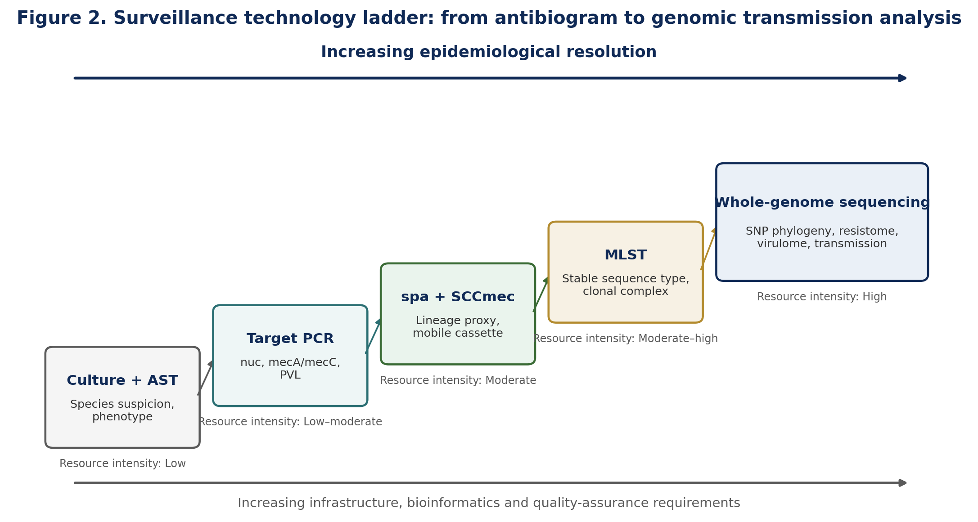
Figure 2. Surveillance technology ladder. Each successive layer answers a different epidemiological question; WGS complements rather than abolishes the need for high-quality culture, AST and metadata.

4. The Nigerian Evidence Landscape
Evidence stream | Setting / sample | Key reported signal | Review interpretation
Mellah (2019) | 6 secondary hospitals, Taraba; clinical + environment | 300 specimens; phenotype + PCR + SCCmec + spa; PVL-positive mecA MRSA documented | Regional historical baseline showing value of linked clinical/environmental molecular sampling
Adeyemi et al. (2024) | Southwest Nigeria; clinical + RTE foods | 138 nuc-confirmed S. aureus; mecA 5.1%, mecC 4.3%, spa 55.8%; marked phenotype-genotype discordance | Shows need for harmonized MRSA definitions and confirmatory molecular testing
Beshiru et al. (2024) | Edo State cattle | 76 mecA-positive MRSA characterized; PVL 81.6%; multiple SCCmec types; strong biofilm 65.8% | Demonstrates livestock reservoir potential and molecular complexity
Ugbo et al. (2024) | Raw chicken meat, Abakaliki | 61/150 S. aureus; 7 phenotypic LA-MRSA among S. aureus isolates | Extends MRSA concern into food-chain surveillance
Ide et al. (2025) | Calabar soft-tissue infections | 80 S. aureus/360 participants; MRSA 47/80; lukSF-PV 10/80, spanning MSSA and MRSA | PVL cannot be equated with methicillin resistance; clinical context matters
Olalekan et al. (2025) | Lagos hospitals; WGS | 63/107 MRSA; 58 mecA-positive; t657/ST772/SCCmec V/PVL+ predominant | High-resolution evidence of dominant high-risk clone and inter-hospital transmission potential
Ugbo et al. (2025) | Nigeria One Health meta-analysis | 56 studies; pooled mecA 51% (95% CI 14-86%); only 10 studies used WGS | High heterogeneity plus genomic-capacity gap supports tiered surveillance
Table 1. Representative Nigerian evidence streams used in the critical synthesis. Values are source-reported and should not be compared as if they arose from one surveillance design.

4.1 Clinical diversity and the WGS transition
The strongest contemporary evidence of clonal structure comes from Lagos. Olalekan et al. (2025) subjected 107 clinical S. aureus isolates to WGS and identified 63 MRSA, of which 58 (92%) harboured mecA. Among typable MRSA, SCCmec V-family cassettes predominated. Thirty-six isolates belonged to ST772 or a single-locus variant with spa type t657; 34/36 of these ST772 isolates were PVL-positive. The next major lineages included t4690/ST152/SCCmec Vc/PVL-positive MRSA and ST8 backgrounds. This matters because ST772, ST152 and ST8 are epidemiologically distinct populations: a national surveillance programme that reports only “MRSA positive” would miss the changing balance between them.
Earlier Nigerian evidence anticipated this diversity. Shittu et al. (2011) and O'Malley et al. (2015) documented multiple resistant S. aureus genotypes, while Lawal et al. (2022) showed that African MRSA clone diversity remained substantial over a six-year update. The Taraba study similarly described more than one PVL-positive spa/SCCmec background. Together, these studies suggest that Nigeria should not be conceptualized as having a single dominant MRSA lineage; rather, local clonal structure is spatially and temporally dynamic, with both endemic persistence and potential importation.

4.2 One Health expansion: animals, food and environment
The Nigerian MRSA problem is not confined to hospital patients. Gaddafi et al. (2025) systematically reviewed livestock-production studies and found MRSA occurrence ranging widely by animal system, with reports spanning poultry, cattle, pigs, sheep/goats and exposed workers; one reviewed study identified the characteristic livestock-associated CC398 lineage. Beshiru et al. (2024) added molecular evidence from cattle, while Ugbo et al. (2024) demonstrated mecA/lukD investigation in raw chicken meat. Adeyemi et al. (2024) identified resistance and virulence markers in both clinical and ready-to-eat food sources. These studies differ in quality and methodology, but together they support surveillance across connected human-animal-food-environment compartments.
A 2025 Nigerian One Health review identified antimicrobial overuse, inadequate stewardship, weak infection prevention, poor regulation and environmental contamination among interacting AMR drivers (Alabi et al., 2025). A separate Nigerian One Health meta-analysis of resistance genes included human, animal and environmental studies from all six geopolitical zones and estimated a pooled mecA prevalence of 51% (95% CI 14-86%), with high heterogeneity (Ugbo et al., 2025). The wide confidence interval is itself informative: it warns against using a single national MRSA percentage divorced from specimen type, denominator, geography and laboratory definition.
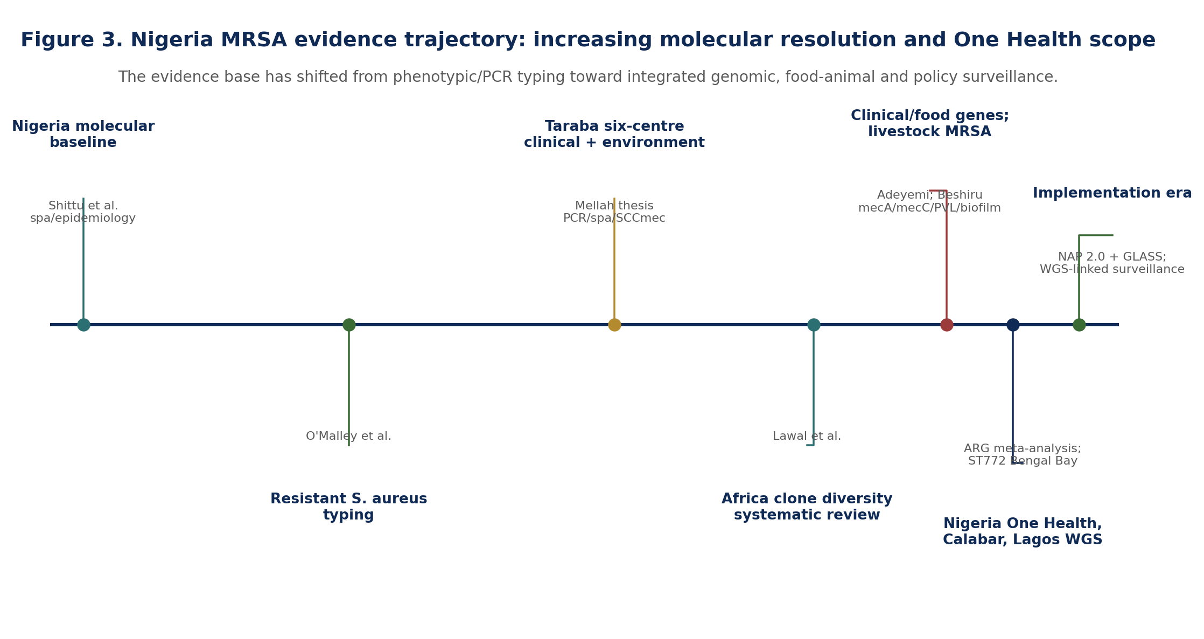
Figure 3. Nigeria MRSA evidence trajectory. The timeline is a selective synthesis of representative milestones rather than a complete bibliometric census.

5. From Laboratory Result to Transmission Intelligence
The central surveillance challenge is to match laboratory resolution to the decision being made. Culture and AST answer which organism grows and which antimicrobials remain active. Targeted PCR can confirm species and selected determinants. spa and SCCmec typing can rapidly distinguish some lineages and cassettes at lower cost than WGS. MLST provides stable sequence types and clonal complexes. WGS then resolves SNP-level relatedness, accessory-genome content, resistance/virulence repertoires and potential transmission clusters. These methods are therefore complementary tiers, not mutually exclusive competitors.
Layer | Primary question answered | Strength | Main limitation
Culture + AST | Is the isolate phenotypically resistant and what may treat it? | Routine, clinically actionable, widely scalable | Low transmission resolution; breakpoint and method dependent
Target PCR | Is mecA/mecC/PVL or another defined determinant present? | Fast mechanism confirmation | Only detects targets selected in advance
spa / SCCmec | Are isolates likely to share protein-A/cassette backgrounds? | Useful low-cost epidemiological bridge | Can over-group or under-resolve related isolates
MLST | Which sequence type/clonal complex is present? | Portable global nomenclature | Limited within-clone resolution
WGS | Are isolates genomically linked; what is the resistome/virulome? | Highest resolution and retrospective re-analysis | Cost, bioinformatics, QA, turnaround and data governance
Table 2. Complementary laboratory layers for MRSA surveillance.
For Nigeria, the most realistic model is tiered. Every sentinel laboratory does not need immediate WGS capacity. What every site does need is standardized specimen metadata, reliable species identification, current AST, quality-assured storage of epidemiologically important isolates and a defined referral pathway. Regional or national genomic hubs can then sequence outbreaks, invasive isolates, unusual resistance phenotypes, non-typeable SCCmec, suspected inter-facility spread and strategically sampled One Health isolates. This architecture preserves routine feasibility while creating a national genomic memory.

6. Infection Prevention, Stewardship and Environmental Control
Genomic sophistication does not replace basic infection prevention and control (IPC). MRSA transmission requires opportunities for contact, colonization or contamination; hand hygiene, environmental cleaning, device care, screening during defined outbreaks and antimicrobial stewardship remain essential. The author's Taraba study was notable for sampling both patients and hospital environments, an approach that remains relevant because environmental isolates can help test whether contamination accompanies clinical transmission. However, environmental positivity alone does not prove direction of transmission. That requires temporally linked sampling and strain-level relatedness, ideally WGS.
Stewardship also needs molecular context. High resistance to non-beta-lactam agents in contemporary Lagos MRSA demonstrates that methicillin resistance can travel with broader multidrug-resistance repertoires (Olalekan et al., 2025). In livestock and food systems, antimicrobial exposure can select resistant staphylococci that persist in animals, products and production environments. Nigeria's policy response therefore needs synchronized human and veterinary prescribing governance, laboratory surveillance, IPC/biosecurity, wastewater/environmental monitoring and public communication rather than a hospital-only programme.

7. Policy Alignment: Nigeria AMR NAP 2.0 and GLASS
Nigeria's Second One Health Antimicrobial Resistance National Action Plan (2024-2028) provides the policy foundation for an integrated MRSA surveillance strategy. The plan explicitly frames AMR as a multisectoral crisis and seeks to strengthen surveillance, infection prevention and control, antimicrobial stewardship, diagnostics, research and collaboration across human, animal and environmental sectors. NCDC implementation activities in 2025 continued this focus on surveillance, stewardship, IPC and One Health coordination. The challenge is operational: national plans require interoperable data, sustainable laboratory financing, isolate referral networks, quality assurance and feedback loops that translate surveillance into local action.
WHO GLASS provides an external standardization framework, but nationally useful MRSA surveillance must retain sufficient metadata to answer local questions. At minimum, isolate records should link patient/specimen context, facility and date, AST result, MRSA confirmation method, mecA/mecC, PVL where indicated, typing/WGS identifier and sequence accession when available. The loss of linkage between laboratory and epidemiological fields is one of the most avoidable reasons that valuable molecular results fail to become actionable surveillance.
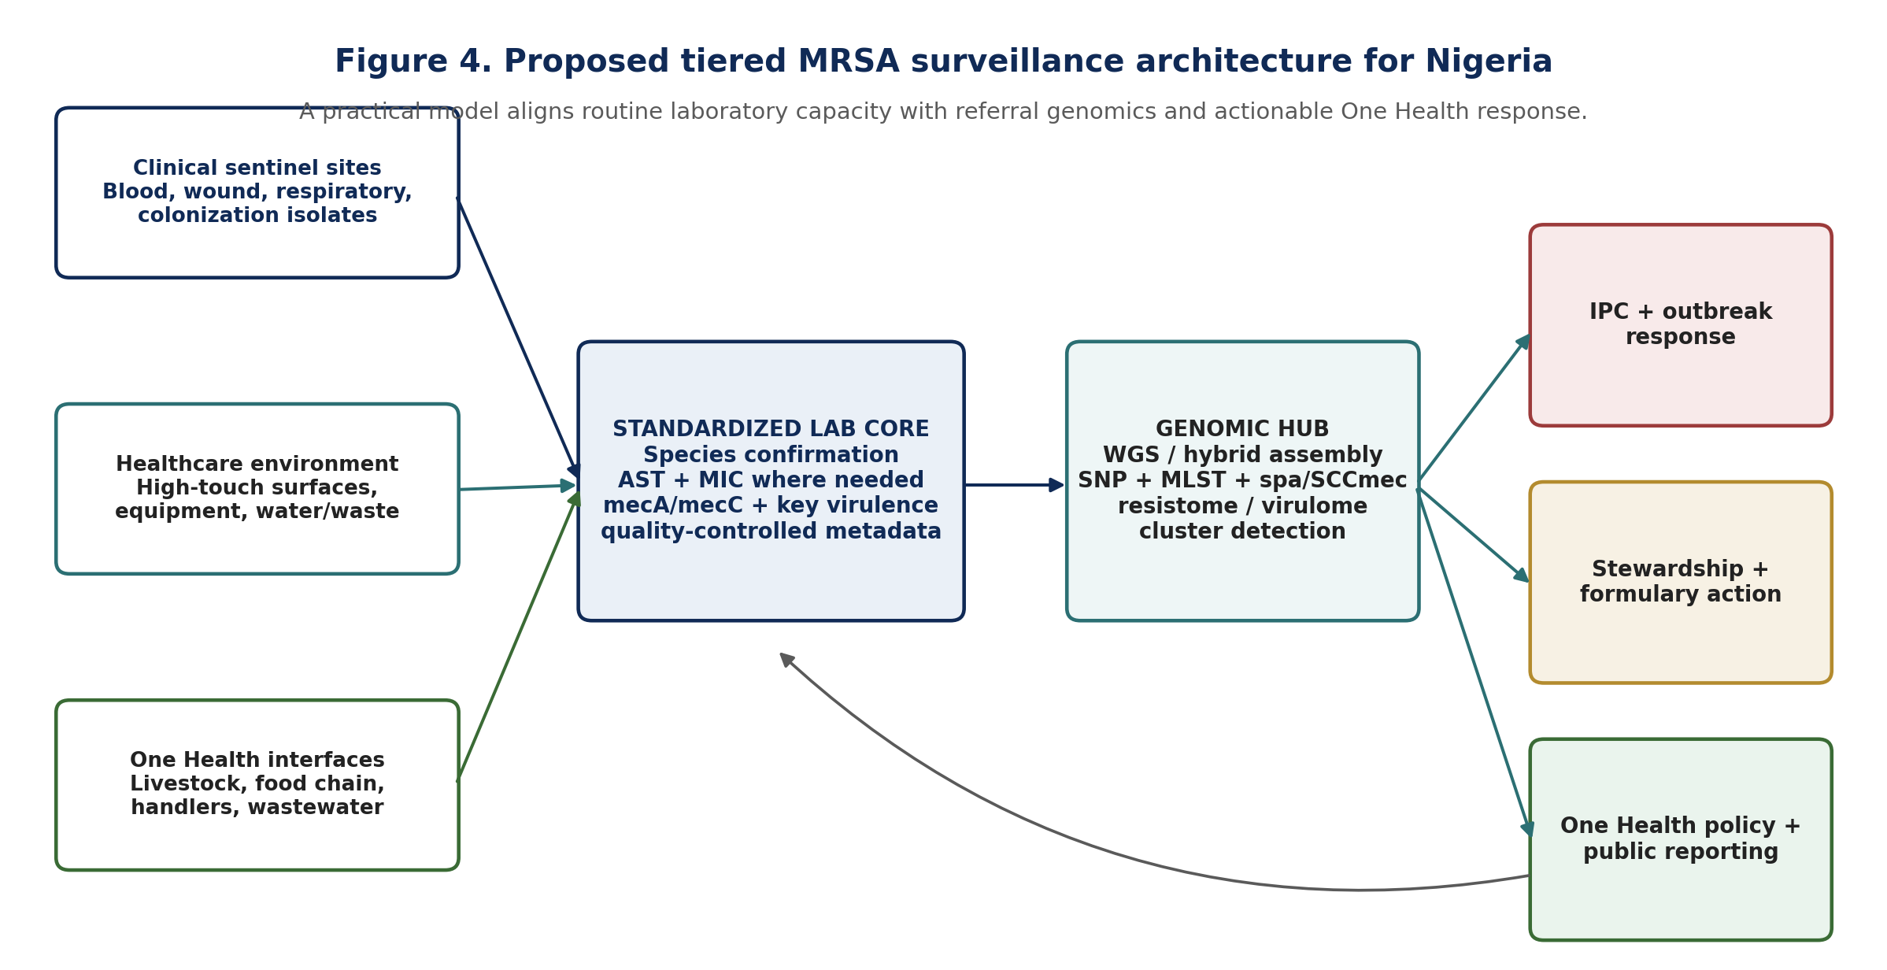
Figure 4. Proposed tiered MRSA surveillance architecture for Nigeria. The model aligns routine sentinel capacity with referral genomics and One Health decision-making.

8. Priority Research Agenda for 2026-2030
The current literature supports a focused Nigerian MRSA research agenda rather than more disconnected prevalence studies. Priority questions include:
- How stable is the t657/ST772/SCCmec V/PVL-positive Bengal Bay clone across Nigerian regions and over time, and what proportion of cases reflects local transmission versus repeated importation?
- Which clinical, hospital-environment, livestock, food and wastewater isolates are genomically related across the human-animal-environment interface?
- How often do phenotype-genotype discrepancies occur under harmonized CLSI/EUCAST-compatible workflows, particularly for mecA/mecC, cefoxitin/oxacillin and glycopeptide susceptibility?
- What resistance and virulence determinants are carried on plasmids, phages, SCCmec and other mobile elements, and which co-selection pressures maintain them?
- Can lower-cost spa/SCCmec or targeted sequencing algorithms reliably triage isolates for WGS in secondary and tertiary hospitals?
- What is the clinical impact of PVL-positive MSSA versus PVL-positive MRSA in Nigerian skin, soft-tissue, invasive and recurrent infections?
- Which IPC and stewardship interventions measurably reduce acquisition or transmission of defined MRSA clones rather than only aggregate culture positivity?

9. Conclusion
Nigeria's MRSA evidence base has matured from antibiograms and targeted molecular typing to a stage where whole-genome surveillance is both scientifically justified and operationally necessary. The central finding of this review is not a single prevalence estimate; it is heterogeneity. Different Nigerian settings contain different combinations of mecA/mecC, PVL, SCCmec, spa and sequence-type backgrounds, and those combinations extend beyond hospitals into livestock, foods and the environment. Recent Lagos WGS demonstrates the power of genomic resolution by identifying a dominant PVL-positive ST772 Bengal Bay lineage that would be obscured by a generic MRSA label.
A practical national response should therefore be layered: reliable routine culture and AST at sentinel sites; targeted molecular confirmation; isolate archiving and standardized metadata; referral spa/SCCmec or MLST where useful; and WGS for high-value surveillance and transmission questions. Coupled to Nigeria's AMR NAP 2.0 and One Health governance, this architecture would convert laboratory results into lineage-aware infection control, stewardship and national situational awareness.

Declarations
Ethics statement: This is a review article and involved no new recruitment, specimen collection or intervention in humans or animals. Ethics approval was therefore not required for the review itself. The author's 2019 thesis is discussed only as a historical evidence source and retains its original institutional/administrative approvals.
Funding: No external funding is declared for preparation of this review article.
Competing interests: The author declares no competing interests.
Data availability: No new dataset was generated. All quantitative statements are traceable to the cited publications, official reports or the author's archived 2019 thesis.
Review provenance and scope: e055 is a new critical review article. It does not present the aggregate e051 antimicrobial-resistance analysis or the e053 Taraba molecular findings as new experiments; those findings are used only where necessary to establish historical and methodological continuity.
Author contribution: MELLAH, Iwanger: conceptualization, original research context, review framing, interpretation, critical synthesis and manuscript approval.
AI-assisted editorial support: AI-assisted tools were used for literature updating, source-consistency checking, figure construction, language refinement and document formatting under human editorial control. No experimental observations or literature findings were fabricated.
Copyright and licence: © 2026 The Author. Published by CHIA TECH SOLUTIONS AND RESOURCES LIMITED (RC 1839865). This open-access article is distributed under the Creative Commons Attribution 4.0 International (CC BY 4.0) licence.

References
Alabi, E. D., Rabiu, A. G., & Adesoji, A. T. (2025). A review of antimicrobial resistance challenges in Nigeria: The need for a One Health approach. One Health, 20, 101053. https://doi.org/10.1016/j.onehlt.2025.101053
Adeyemi, F. M., Oyedara, O. O., Yusuf-Omoloye, N. A., Ajigbewu, O. H., Ndaji, O. L., Adegbite-Badmus, M. K., Olumakinde, T. S., & Oluokun, T. E. (2024). Guardians of resistance and virulence: Detection of mec, femA, Van, pvl, hlg and spa genes in methicillin- and vancomycin-resistant Staphylococcus aureus from clinical and food samples in Southwestern Nigeria. BMC Microbiology, 24, 498. https://doi.org/10.1186/s12866-024-03660-3
Beshiru, A., Igbinosa, I. H., Akinnibosun, O., Ogofure, A. G., Dunkwu-Okafor, A., Uwhuba, K. E., & Igbinosa, E. O. (2024). Characterization of resistance and virulence factors in livestock-associated methicillin-resistant Staphylococcus aureus. Scientific Reports, 14, 13235. https://doi.org/10.1038/s41598-024-63963-3
Federal Ministries of Agriculture and Food Security, Environment, and Health and Social Welfare. (2024). Nigeria Second One Health Antimicrobial Resistance National Action Plan 2.0, 2024-2028.
Fenta, M. D., Bitew, A. B., Demisse, B. W., Abey, S. L., Mengistu, B. A., Kinde, M. Z., Getnet, K., Demessie, Y., Mekasha, Y. T., Feleke, M. G., & Mebratu, A. S. (2025). Systematic review and meta-analysis of Staphylococcus aureus at the human-animal-environment interface in Eastern Africa: Prevalence, virulence genes, and antimicrobial resistance profile. One Health, 21, 101229. https://doi.org/10.1016/j.onehlt.2025.101229
Gaddafi, M. S., Yakubu, Y., Bello, M. B., Lawal, H., Bitrus, A. A., Musawa, I. A., & Fasina, F. O. (2025). Prevalence of methicillin-resistant Staphylococcus aureus in livestock production system of Nigeria: A systematic review. Acta Veterinaria Eurasia, 51(1), 1-11. https://doi.org/10.5152/actavet.2024.24009
Ide, C. J., Ogban, G. I., Ekeng, B. E., Emanghe, U. E., Onukak, A. E., Iwuafor, A. A., Udoh, U. A., Chukwuma, S. T., Jimmy, E. M., Ukpeh, I. E., Mirabeau, T. Y., & Egah, D. Z. (2025). Molecular detection of mecA and lukSF-PV in patients with Staphylococcus aureus soft tissue infections in a tertiary hospital setting, Calabar, Nigeria: A cross-sectional study. Therapeutic Advances in Infectious Disease, 12, 20499361251357394. https://doi.org/10.1177/20499361251357394
Lawal, O. U., Ayobami, O., Abouelfetouh, A., Mourabit, N., Kaba, M., Egyir, B., Abdulgader, S. M., & Shittu, A. O. (2022). A 6-year update on the diversity of methicillin-resistant Staphylococcus aureus clones in Africa: A systematic review. Frontiers in Microbiology, 13, 860436. https://doi.org/10.3389/fmicb.2022.860436
Mellah, I. (2019). Molecular characterisation and antibiotics susceptibility pattern of Staphylococcus aureus isolates from hospital wards and their environment [M.Sc. thesis, Federal University of Agriculture, Makurdi].
O'Malley, S. M., Emele, F. E., Nwaokorie, F. O., Idika, N., Umeizudike, A. K., Emeka-Nwabunnia, I., Hanson, B. M., Nair, R., Wardyn, S. E., & Smith, T. C. (2015). Molecular typing of antibiotic-resistant Staphylococcus aureus in Nigeria. Journal of Infection and Public Health, 8(2), 187-193. https://doi.org/10.1016/j.jiph.2014.08.001
Olalekan, A., Boutin, S., Watson, C. M., Galarion, L., Adesida, S., Iwalokun, B., Popoola, O., Esemu, S., Adegbola, R., & Nurjadi, D. (2025). Molecular landscape of methicillin-resistant Staphylococcus aureus strains in clinical infections from hospitals in Lagos, Nigeria. JAC-Antimicrobial Resistance, 7(5), dlaf161. https://doi.org/10.1093/jacamr/dlaf161
Shittu, A. O., Okon, K., Adesida, S., Oyedara, O., Witte, W., Strommenger, B., Layer, F., & Nübel, U. (2011). Antibiotic resistance and molecular epidemiology of Staphylococcus aureus in Nigeria. BMC Microbiology, 11, 92. https://doi.org/10.1186/1471-2180-11-92
Ugbo, E. N., Kotey, F. C. N., & Donkor, E. S. (2025). Antibiotic resistance genes circulating in Nigeria: A systematic review and meta-analysis from the One Health perspective. BMC Medical Genomics, 18, 113. https://doi.org/10.1186/s12920-025-02163-y
Ugbo, E. N., Ugbo, A. I., Effendi, M. H., et al. (2024). Prevalence and molecular detection of mecA and lukD genes from livestock-associated methicillin-resistant Staphylococcus aureus isolated in raw chicken meats sold in Abakaliki, Nigeria. Open Veterinary Journal, 14(12), 3327-3335. https://doi.org/10.5455/OVJ.2024.v14.i12.17
World Health Organization. (2024). WHO bacterial priority pathogens list, 2024: Bacterial pathogens of public health importance to guide research, development and strategies to prevent and control antimicrobial resistance. World Health Organization. ISBN 978-92-4-009346-1.
World Health Organization. (2025). Global antibiotic resistance surveillance report 2025. World Health Organization. ISBN 978-92-4-011633-7.
World Health Organization. (2023). GLASS manual for antimicrobial resistance surveillance in common bacteria causing human infection. World Health Organization. ISBN 978-92-4-007660-0.

