CHIATECH JOURNAL
SETEHEM · VOLUME 1 · ISSUE 1 · e056 · SEPTEMBER 2026
PIONEER PUBLICATION · PEER-REVIEWED CRITICAL REVIEW AND ENGINEERING FRAMEWORK ARTICLE · ENERGY · AGRICULTURE · RURAL DEVELOPMENT
Renewable Energy and Sustainable Power Systems for Rural Farming Communities in Nigeria:
Productive-Use Electrification, Agricultural Resilience and an Integrated Engineering Framework
AMENGER, Gbaden
Nigeria Customs Service, Ogun State Command, Nigeria
Correspondence: amengergbaden1@gmail.com
ARTICLE TYPE  Critical Review & Engineering Framework | VOLUME / ISSUE  1(1) | ELOCATOR  e056
PUBLICATION  September 2026 | ISSUE STATUS  Pioneer Issue | IDENTIFIERS  ISSN: Pending assignment · DOI: Pending registration

Abstract
Background: Rural agricultural productivity in Nigeria is constrained by a persistent energy-access deficit, unreliable grid supply, high dependence on small petrol and diesel generators, and weak cold-chain and processing infrastructure. Renewable energy can therefore create development value only when electricity access is converted into productive energy services across irrigation, storage, processing and rural enterprise. Objective: This article critically synthesizes contemporary evidence on decentralized renewable energy for Nigerian farming communities and develops an engineering and implementation framework for reliable, productive-use electrification. Methods: A structured critical review was updated through September 2026 using peer-reviewed studies and authoritative policy and programme documents published mainly from 2020 to 2026, with foundational sources retained where they define established engineering practice. Evidence was prioritized from Nigeria, then Sub-Saharan Africa, and evaluated across technical reliability, agricultural productivity, economic viability, environmental safeguards and institutional feasibility. Results: Nigeria’s 2021 electricity access was about 60% nationally but only 26% in rural areas, leaving more than 85 million people without access. Evidence from northeast Nigeria shows that small solar-powered cold stores can reduce food losses while increasing horticultural sales and revenues. Rural mini-grid studies show strong gains in productive activity and reduced reliance on generators, although household-income effects are heterogeneous. Geospatial modelling indicates that financing productive-use equipment can lower the modelled levelized cost of off-grid electrification more strongly than conventional loan or capital-subsidy approaches. Solar irrigation, cold-chain systems, agro-processing loads, solar-battery mini-grids and context-appropriate biogas are the most immediately relevant technology pathways, but adoption is limited by capital cost, technical capacity, maintenance, water-resource risks, tariff design and fragmented energy-agriculture planning. Conclusion: The most effective rural-energy strategy is not technology deployment in isolation but an integrated productive-use system that begins with agricultural load and resource assessment, sizes hybrid power for reliability, couples energy finance with income-generating equipment, builds local maintenance capacity, governs water and data responsibly, and verifies outcomes such as uptime, crop loss reduction, income, energy cost and emissions. The proposed READF-N framework provides a practical pathway for engineering, financing and governing renewable energy as productive agricultural infrastructure in Nigeria.
Keywords: renewable energy; productive use of energy; rural electrification; solar irrigation; solar cold chain; mini-grids; agro-processing; biogas; energy poverty; Nigeria
Suggested citation: Amenger, G. (2026). Renewable energy and sustainable power systems for rural farming communities in Nigeria: Productive-use electrification, agricultural resilience and an integrated engineering framework. CHIATECH JOURNAL · SETEHEM, 1(1), e056. ISSN pending assignment; DOI pending registration.

1. Introduction
Energy is a productive input in modern agriculture. Water pumping, feed preparation, milling, drying, refrigeration, storage, packaging, lighting, communications and digital farm services all depend on energy of sufficient quantity and quality. When electricity is unavailable or unreliable, farmers and rural enterprises either forgo these services or substitute small petrol and diesel generators, manual labour and traditional biomass. The consequence is not merely an electricity deficit; it is a constraint on cropping intensity, value addition, food preservation, labour productivity, enterprise formation and climate resilience (FAO & IRENA, 2021; Ojo & Ogundeji, 2025).
Nigeria illustrates this energy–agriculture constraint sharply. World Bank project documentation reported that in 2021 approximately 60% of the population had access to electricity, but the urban rate was about 89% compared with only 26% in rural areas, leaving more than 85 million people without access (World Bank, 2023a). Access figures alone also understate the problem because many grid-connected households and enterprises experience insufficient or unreliable supply and compensate with costly self-generation. The national policy direction now recognizes distributed renewable energy as a central part of electrification: the Nigeria Distributed Access through Renewable Energy Scale-Up (DARES) project targets more than 17.5 million people and explicitly links solar systems and mini-grids to productive uses (World Bank, 2023b; REA, 2025a).
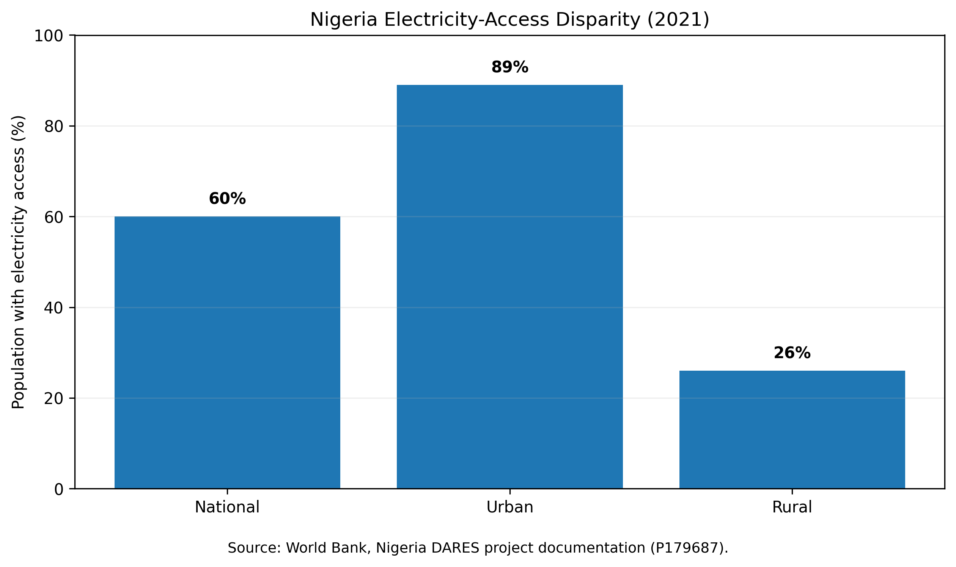
Figure 1. Nigeria electricity-access disparity in 2021. The rural–urban gap illustrates why agricultural electrification cannot rely on conventional grid extension alone. Source: World Bank DARES project documentation (P179687).
The agricultural case for renewable energy is therefore broader than household electrification. Solar pumping can unlock dry-season irrigation; solar refrigeration can reduce the loss of perishable food; electric milling and processing can keep more value within rural communities; digital energy services can improve metering and payment; and biogas can convert selected organic wastes into dispatchable energy and fertilizer. Yet every technology also creates engineering and governance requirements. Solar pumping can accelerate groundwater depletion if water abstraction is unmanaged; cold rooms fail when loads, tariffs or maintenance are poorly planned; mini-grids become financially weak when productive demand is absent; and biogas systems underperform when feedstock logistics and operator capability are neglected (Durga et al., 2024; Nwankwo et al., 2024).

1.1 Contribution of the article
This article develops the renewable-energy-for-agriculture argument in four directions. First, it treats energy access as a set of productive services across the agricultural value chain rather than as a connection count. Second, it integrates evidence from Nigerian field studies, engineering studies and national programmes. Third, it adds an electrical-engineering design layer—load assessment, storage, hybridization, protection, reliability and energy management—to the development literature. Fourth, it proposes the Renewable Energy–Agriculture Development Framework for Nigeria (READF-N), an implementation sequence that links diagnosis, design, finance, delivery, governance and impact verification.

2. Review Design and Evidence Hierarchy
A structured critical-review approach was used rather than a meta-analysis. The evidence update covered literature and institutional material available through September 2026, emphasizing work published from 2020 onward and retaining older foundational guidance where necessary. Search concepts included renewable energy and agriculture; productive use of energy; solar irrigation; solar cold storage; agro-processing; rural mini-grids; biogas; energy poverty; Nigeria; and Sub-Saharan Africa. Sources were drawn from peer-reviewed journal platforms and authoritative repositories including FAO, IRENA, the World Bank, the Rural Electrification Agency (REA), the Energy Commission of Nigeria and the Nigeria Energy Transition Plan.
Evidence was interpreted hierarchically. The strongest weight was assigned to Nigerian empirical or engineering studies with explicit methods and measurable outcomes; next were multi-country African studies and high-quality reviews; official programme documents were used for current policy, programme design and implementation status; and theoretical or foundational sources were used for conceptual interpretation. This hierarchy prevents national policy targets from being presented as empirical impact and prevents promising pilot results from being generalized beyond their study settings.
Table 1. Evidence hierarchy used in the review
Evidence level | Typical source | Primary use | Main caution
I. Nigerian empirical / engineering evidence | Field interventions, surveys, geospatial models, power-system optimization | Estimate observed outcomes, technical feasibility and context-specific constraints | Local design, sample and geography may limit generalization.
II. Multi-country African peer-reviewed evidence | Cohort studies, systematic reviews, mini-grid and irrigation research | Assess recurring mechanisms, adoption barriers and transferable lessons | Country heterogeneity can mask Nigerian institutional differences.
III. Nigerian official programmes and policy | REA/DARES, Energy Transition Plan, National Energy Master Plan | Define current programmes, standards, financing windows and national direction | Targets and programme announcements are not impact evaluations.
IV. International technical guidance | FAO, IRENA, development-finance guidance | Frame technology options and agrifood-energy linkages | Requires local engineering, water, tariff and market adaptation.

3. Conceptual and Engineering Framework

3.1 Sustainable livelihoods, energy transition and technology adoption
Three complementary perspectives are useful. The Sustainable Livelihoods Framework treats reliable energy as an enabling asset that can strengthen financial, physical and human capital when it improves productive capability rather than consumption alone. Energy-transition thinking explains the shift from generator-dependent and traditional-biomass systems toward distributed solar, storage, mini-grids and sustainable bioenergy. Diffusion-of-innovation theory helps explain why technically feasible systems may still diffuse slowly when farmers perceive high cost, weak compatibility with existing practices, uncertain repair support or unclear advantage. Together, these perspectives imply that adoption depends on both engineering performance and the institutions that make a technology affordable, understandable, maintainable and useful.

3.2 Productive-use electrification as a value-chain problem
Agricultural energy demand is heterogeneous in time, duty cycle and criticality. Irrigation pumps may operate intensively during daylight or selected seasons; cold rooms are continuous critical loads; mills create high short-duration power demand; dryers may be flexible; telecommunications and digital payment systems are low-energy but high-value services. Designing one generic rural electricity package therefore wastes capital or compromises reliability. The productive-use approach begins with the agricultural service, converts that service into a load profile, and only then selects the generation, storage and distribution architecture.
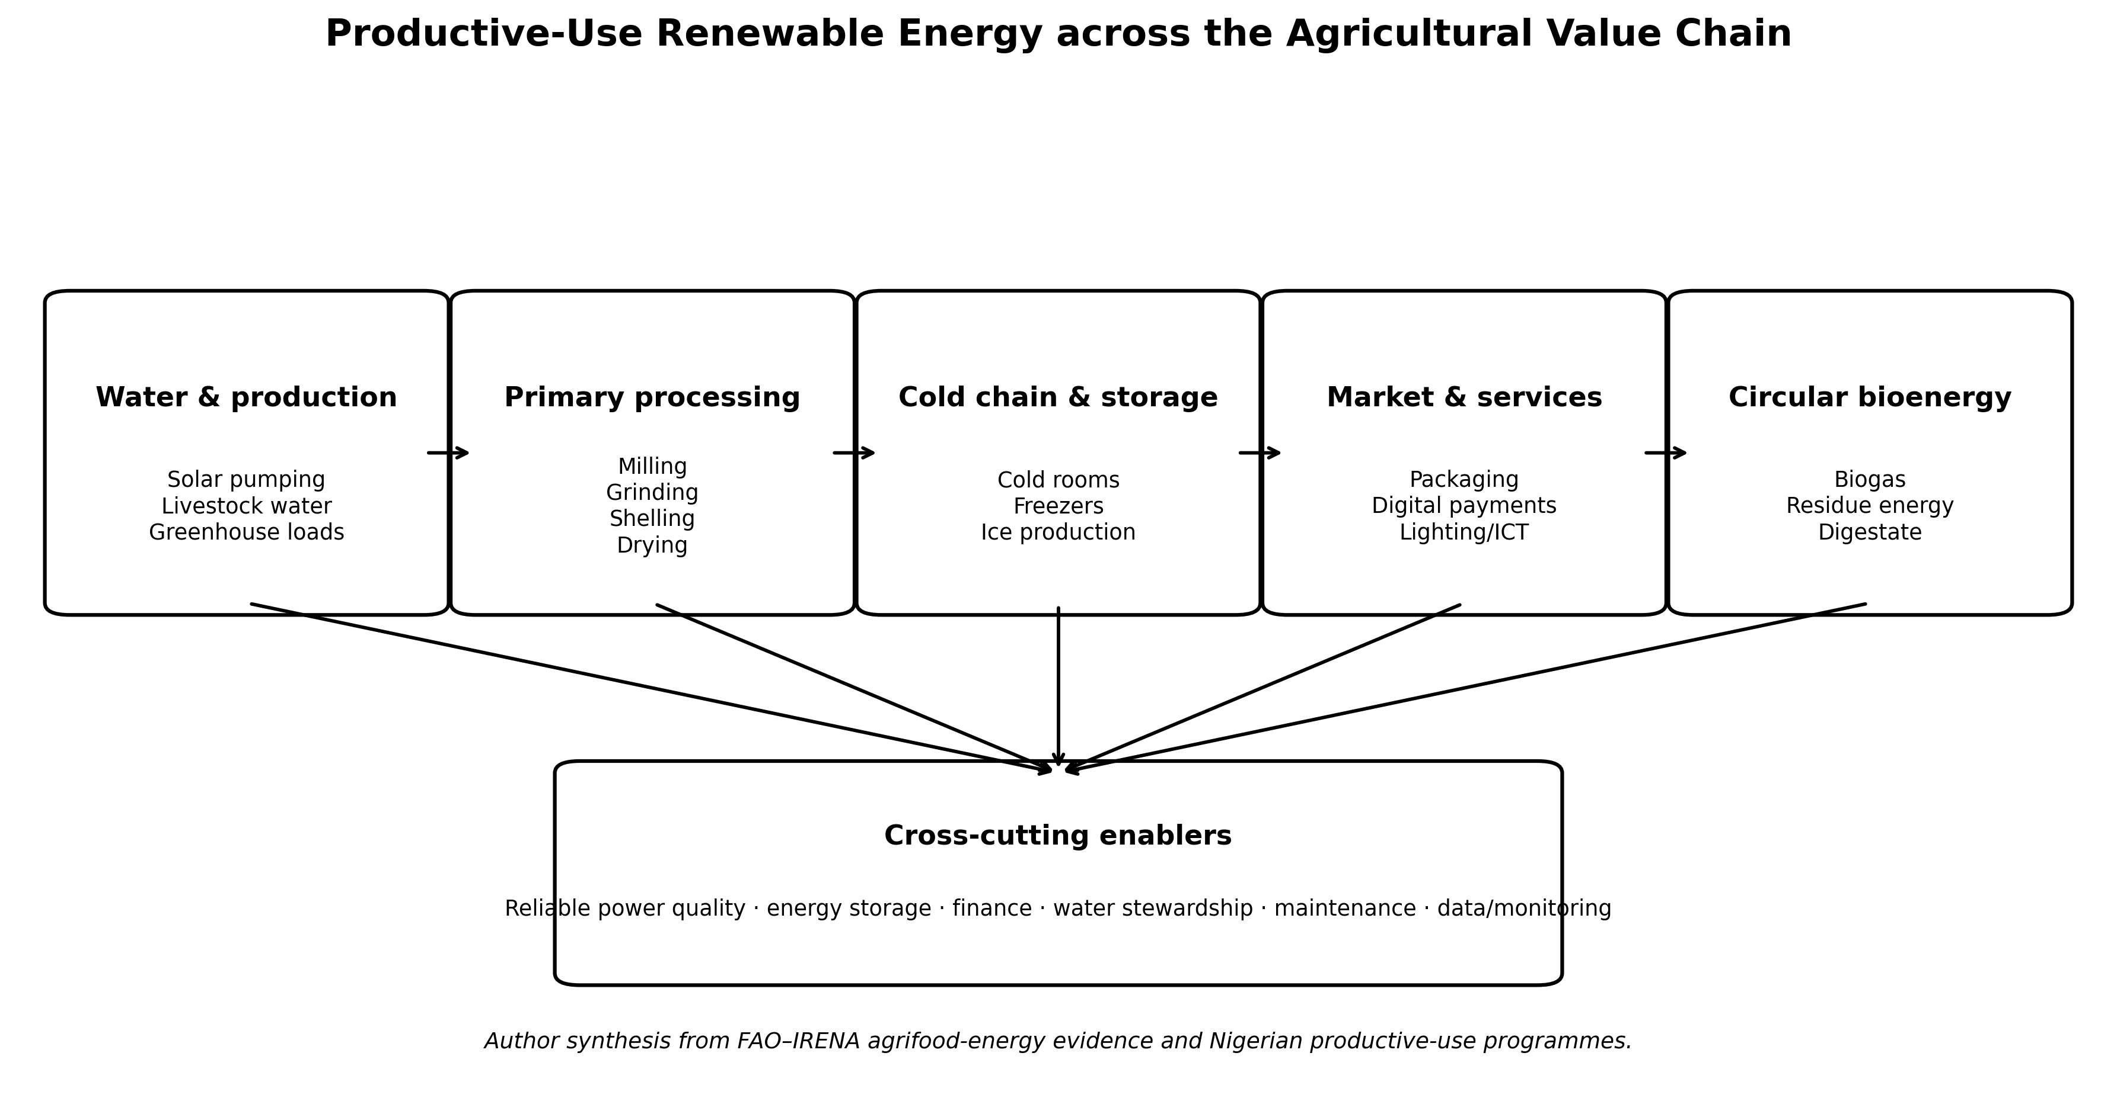
Figure 2. Productive-use renewable energy across the agricultural value chain. Renewable electricity and sustainable bioenergy create value when they are matched to specific farm, processing, storage and market services. Source: author synthesis based on FAO and IRENA (2021) and Nigerian productive-use programmes.

3.3 Minimum engineering quantities for system design
A publication or project proposal that describes a “solar farm system” without quantifying load, solar resource, autonomy, efficiency and reliability is incomplete. At minimum, the daily electrical energy requirement should be constructed from appliance or process loads:
E_d = Σ(P_i × t_i) (1)
where E_d is daily energy demand, P_i is the rated or measured power of load i, and t_i is its operating duration. A first-order photovoltaic array estimate can then be expressed as:
P_PV = (E_d × SF) / (H_PSH × η_sys) (2)
where H_PSH is peak-sun-hours, η_sys is the aggregate system efficiency and SF is a design/safety factor. Critical-load battery energy should be based on required autonomy rather than an arbitrary battery size:
C_bat = (E_critical × N_aut) / (DoD × η_bat) (3)
For irrigation, the electrical design must also be linked to hydraulic duty. The approximate pumping power requirement is:
P_pump = (ρ × g × Q × H) / η_pump (4)
where ρ is water density, g is gravitational acceleration, Q is flow rate, H is total dynamic head and η_pump is combined pump/motor efficiency. These equations are not substitutes for detailed design; they are minimum checks against oversizing, undersizing and financially misleading capacity claims.

4. Nigeria’s Rural Energy and Productive-Use Policy Context
Nigeria’s current policy environment is unusually favourable to distributed renewable energy, although implementation remains uneven. The Renewable Energy Roadmap developed by IRENA with the Energy Commission of Nigeria identifies substantial renewable deployment potential and emphasizes policy, regulatory and finance reforms needed to move from resource potential to implementation (IRENA, 2023). The National Energy Master Plan supports solar energy as a major option for rural and peri-urban areas, while the Energy Transition Plan envisages large-scale solar deployment, storage and the progressive displacement of decentralized diesel and petrol generation (Energy Commission of Nigeria, 2022; Federal Republic of Nigeria, 2024).
DARES is especially relevant because it links access to productive activity. The World Bank-backed programme targets more than 17.5 million Nigerians with new or improved distributed renewable electricity. Under the REA productive-use window, eligible technologies include solar irrigation pumps, solar cold rooms and freezers, milling and grinding systems and related market-ready equipment for smallholder farmers, cooperatives, food processors and rural enterprises. The productive-use subcomponent has a US$50 million results-based financing envelope, making it a direct institutional bridge between electrification and agricultural productivity (REA, 2025a, 2025b).
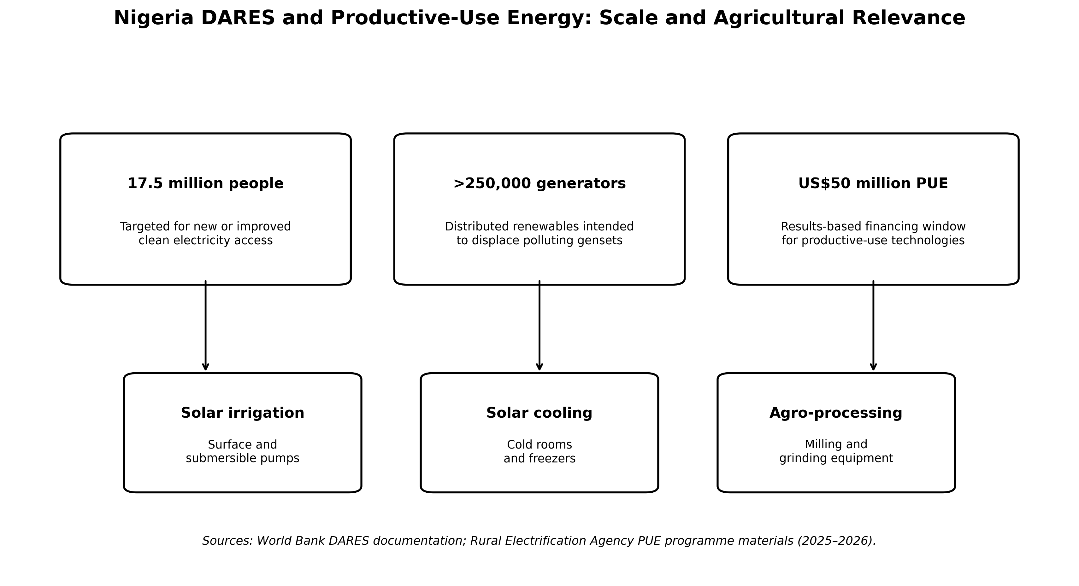
Figure 3. Scale and agricultural relevance of Nigeria’s DARES and Productive Use of Energy programme. The figure separates programme targets from impact evidence. Sources: World Bank (2023b) and REA (2025a, 2025b).

5. Renewable-Energy Technology Pathways for Farming Communities

5.1 Solar photovoltaic irrigation
Solar-powered irrigation is one of the strongest productive-use cases because pump demand often coincides with daytime solar availability and because diesel pumping exposes farmers to fuel-price volatility and recurrent maintenance. A 2025 engineering study in Karshi village, Abuja, demonstrates the continuing technical relevance of PV water-pumping design for crop production in a Nigerian farming context (Ani, 2025). At regional scale, Durga et al. (2024) conclude that solar irrigation can accelerate irrigation access but identify uncovered risks, weak incentives, high local system costs and inadequate technical capacity as major barriers. The correct policy response is therefore not simply to subsidize pumps; it is to develop finance, water governance, service networks and quality assurance together.
Water is the limiting safeguard. Once the marginal cost of pumping falls, farmers may have an incentive to abstract more water. Solar irrigation should therefore be linked to water-source assessment, pump sizing, efficient application methods, abstraction monitoring where groundwater is stressed, and extension guidance. Energy efficiency without water governance can shift a fuel problem into a resource-depletion problem.

5.2 Solar cold chain and food-loss reduction
Cold storage has unusually strong Nigerian evidence. Takeshima et al. (2023) evaluated seven small solar-powered cold stores installed in seven horticultural markets in northeast Nigeria, with comparison markets selected from the same eligible set. Each installation had approximately three tonnes of storage capacity and a 5.6 kW solar array. Difference-in-differences and propensity-score-based analyses showed that cold-storage use significantly increased horticultural sales volumes and revenues, reduced the share of products lost, lengthened shelf life and was associated with improved product quality and value-adding activity. This is important because it demonstrates that renewable energy can alter market behaviour and value-chain performance, not only reduce electricity expenditure.

5.3 Agro-processing and productive mini-grids
Milling, grinding, shelling, oil extraction, drying and packaging can improve rural value retention, but these loads can create sharp power peaks and may not justify individual systems for every farm. Clustered mini-grids can aggregate household, commercial and agricultural demand. A 2025 optimization study for Dugub, a rural farming community in northeastern Nigeria, found that a PV-battery system with a small backup generator and capacity expansion over time was the least-cost configuration among the evaluated alternatives; the optimal scenario achieved a renewable-energy penetration of 94.7%, with the generator contributing less than 6% of supply (Agbo et al., 2025). The result supports hybridization as a reliability strategy while keeping fossil generation as a limited reserve rather than the dominant source.

5.4 Biomass and biogas
Agricultural residues and livestock wastes create an opportunity for dispatchable renewable energy and circular nutrient recovery. Nigeria possesses substantial biomass resources, but residue availability cannot be equated directly with energy potential because some residues already serve as animal feed, soil amendments or household fuel. Nwankwo et al. (2024) identify policy, awareness, feedstock availability, social acceptance and technical capacity as major constraints on Nigerian biogas penetration. For farming communities, biogas is most credible where feedstock can be collected reliably, digester operation is locally maintainable and the digestate has an explicit agronomic use.

5.5 Wind, small hydropower and hybrid systems
Wind pumping and small hydropower are site-dependent rather than universal solutions. They can be attractive where measured wind regimes or perennial water resources are suitable, but they should not be included in a technology mix merely because they are renewable. Hybrid systems become valuable when the resources and loads are complementary—for example, solar plus battery with micro-hydro or biogas support. The engineering objective is a reliable energy service at an acceptable life-cycle cost, not maximum technology diversity.
Table 2. Technology-to-service matrix for rural agricultural energy in Nigeria
Technology | Best-fit agricultural services | Engineering strengths | Critical risks / conditions
Solar PV + pumping | Irrigation; livestock watering | Daytime load matching; low recurring fuel cost; modular | Water over-abstraction; pump sizing; borehole/source yield; theft and maintenance.
Solar PV + cold storage | Horticulture, fish, dairy, meat cold chain | High-value loss reduction; continuous service with storage | 24-hour reliability; refrigerant/service capacity; tariffs; utilization rate.
Solar-battery mini-grid | Processing clusters, markets, mixed rural loads | Load aggregation; scalable AC service; supports productive equipment | Demand forecasting; battery replacement; tariff viability; distribution losses.
Standalone solar PUE | Milling, grinding, cooling, charging, small irrigation | Rapid deployment; asset-level finance; remote monitoring | Equipment quality; after-sales service; working-capital and end-user credit.
Biogas / biomass | Thermal loads; selected electricity; cooking; waste management | Dispatchable energy; residue valorization; digestate co-benefit | Feedstock logistics; competing residue uses; digester skills; methane leakage.
Micro-hydro / wind | Site-specific pumping or community power | Potentially high capacity factor at suitable sites | Resource measurement, seasonal variability, civil works and site-specific O&M.

6. Evidence Synthesis: Productivity, Livelihoods and Rural Transformation
The strongest evidence indicates that the development effects of rural renewables are real but heterogeneous. In a cohort study covering 2,658 respondents connected to solar mini-grids in communities in Nigeria and Kenya, Carabajal et al. (2024) reported improvements in productivity, safety, health, gender-related indicators and business activity. In Nigeria, household reliance on petrol generators fell sharply after connection in the study communities. However, median household income in the Nigerian subsample decreased during the observation period, even while many commercial and institutional customers reported earnings improvements. That result is analytically important: electrification should not be assumed to raise every household income automatically, especially over a short follow-up period and without an untreated comparison group.
A second strand of evidence links energy poverty directly to farming productivity. Ojo and Ogundeji (2025), using Nigeria’s 2018/2019 General Household Survey panel, reported that 49.4% of farming households in their analysis had low productivity and only 15% accessed credit. Their multidimensional energy-poverty model estimated a negative effect on total factor productivity and emphasized that rural households were disproportionately represented among the energy-poor. Energy access is therefore not only an infrastructure outcome; it interacts with credit, literacy, technology adoption and the ability to use irrigation and storage.
A third strand concerns the economics of electrification. Husein et al. (2024) modelled 22,696 Nigerian population clusters and compared grid extension, mini-grids and stand-alone systems under alternative incentive policies. Productive-use financing had the strongest effect among the tested incentives, increasing the modelled share of mini-grid and stand-alone solutions and lowering average LCOE to approximately EUR 0.27/kWh, compared with EUR 0.30/kWh under capital subsidy and EUR 0.31/kWh under concessionary loans. This result provides a powerful policy rationale for financing income-generating appliances together with electricity supply: productive demand improves both development value and system economics.
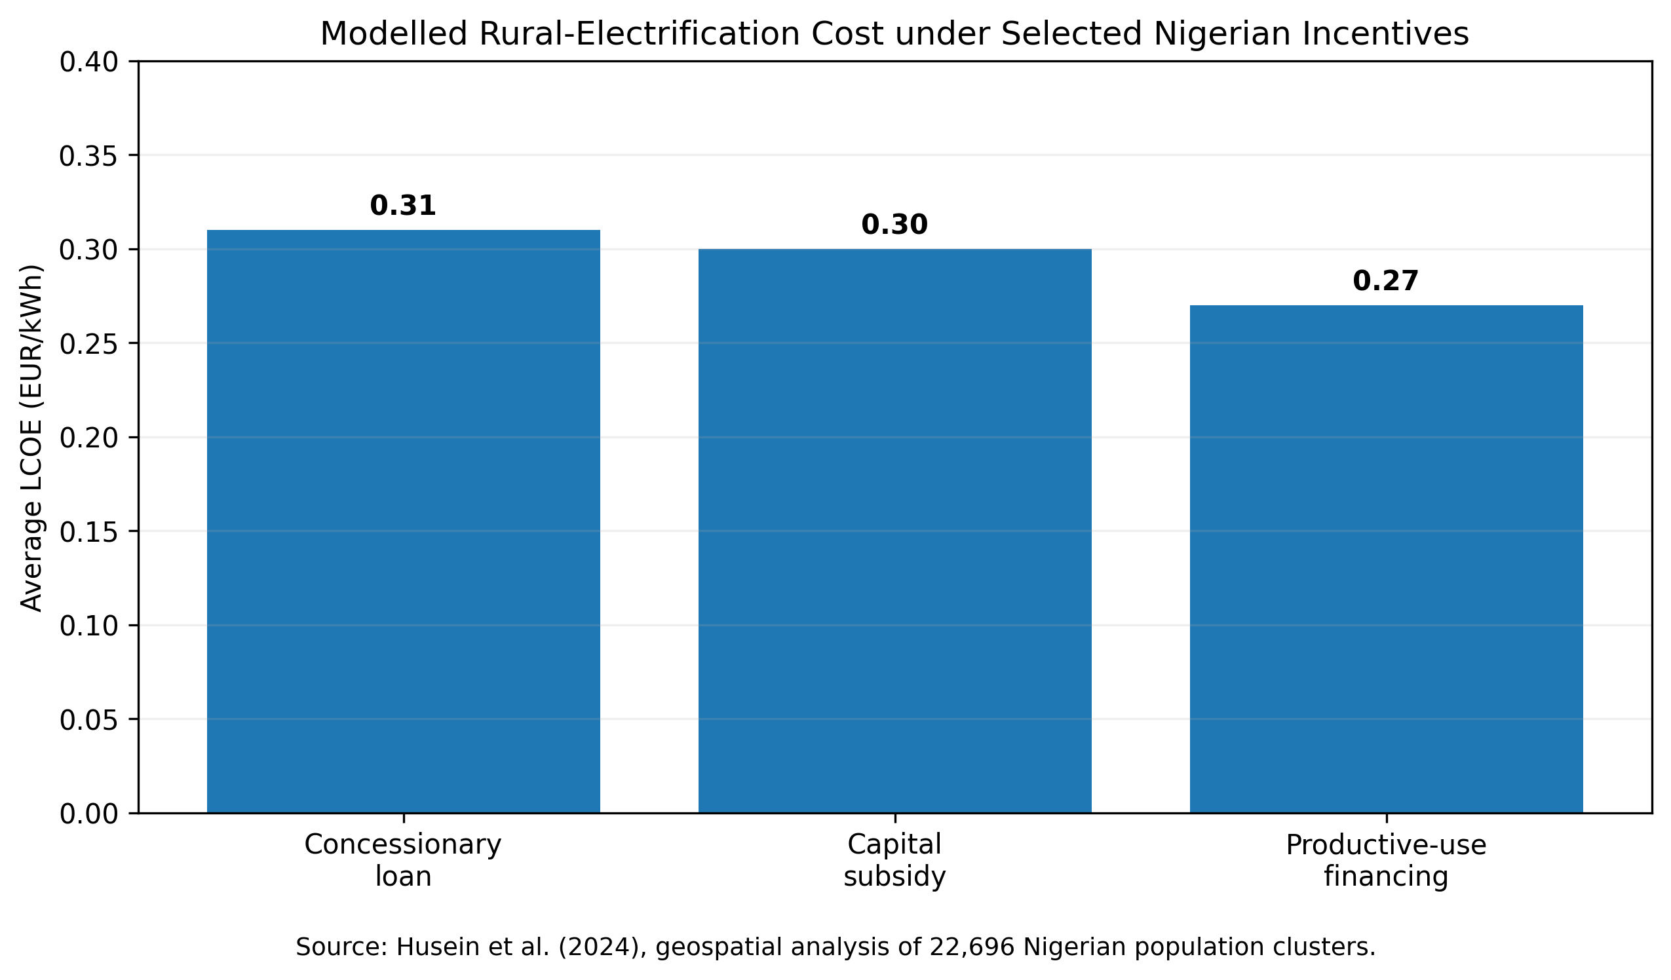
Figure 4. Modelled average levelized cost of electricity under three Nigerian rural-electrification incentive structures. Productive-use financing produced the lowest average LCOE among the analysed incentives. Source: Husein et al. (2024).
Table 3. Selected high-value evidence for renewable energy and productive agriculture
Study / programme | Design / setting | Key evidence | Implication for Nigeria
Takeshima et al. (2023) | Difference-in-differences and propensity-score methods; seven solar cold stores in northeast Nigerian horticulture markets | Higher sales and revenues; reduced product loss; longer shelf life; market/value-chain effects | Cold-chain energy can generate measurable agricultural-market value, not merely electricity access.
Carabajal et al. (2024) | Pre/post cohort study; 2,658 households/businesses in Nigeria and Kenya | Broad gains in productivity and services; strong displacement of generator use; heterogeneous income effects | Track multiple outcomes and avoid assuming uniform household-income gains.
Husein et al. (2024) | Geospatial least-cost analysis of 22,696 Nigerian clusters | PUE financing lowered modelled LCOE more than loan or capital-subsidy scenarios | Finance productive assets alongside electricity infrastructure.
Agbo et al. (2025) | Optimization of off-grid electrification for Dugub, northeastern Nigeria | PV-battery-backup hybrid reached 94.7% renewable fraction; generator <6% of energy | Hybrid designs can provide reliability while limiting generator dependence.
Ojo & Ogundeji (2025) | Nigeria GHS panel; farming households; energy poverty and productivity | Energy poverty associated with lower TFP; credit access and rural deprivation remain important | Electrification must be integrated with agricultural finance and capability.
REA DARES PUE (2025–2026) | National results-based financing programme | Supports solar irrigation, cooling and agro-processing equipment for farmers/MSMEs | Creates an institutional route for scaling the productive-use model.

7. Engineering a Reliable Rural Agricultural Energy Hub
Agricultural electrification should be designed as a small power system with differentiated loads. A cold room is a critical 24-hour load; an irrigation pump may be shifted toward solar hours; milling can be scheduled to avoid coincident peaks; and battery charging can be delayed when state of charge is low. This load-priority logic reduces the battery and generator capacity required for a given reliability target. It also makes the energy-management system an agricultural productivity tool, not merely an electrical controller.
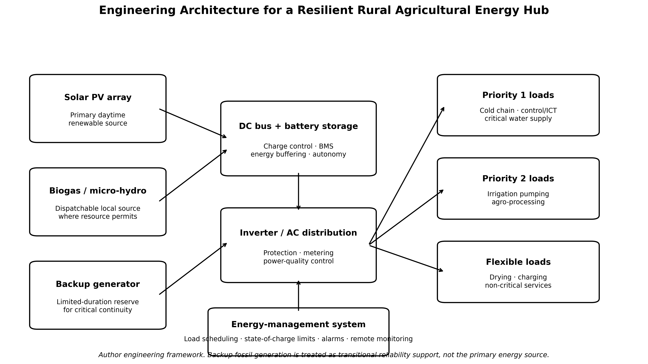
Figure 5. Engineering architecture for a resilient rural agricultural energy hub. Solar PV and storage provide the primary energy platform; dispatchable local renewables and limited generator backup protect critical services; an energy-management system prioritizes loads and monitors system health. Source: author engineering framework.
Protection and power quality deserve explicit attention. Pumps, compressors and mills have motor starting currents; low voltage, poor frequency control or undersized inverters can damage equipment. Designs should include suitable overcurrent protection, earthing, surge protection, isolators, residual-current protection where appropriate, correctly sized conductors, motor protection and documented operating procedures. Remote monitoring can support preventive maintenance, but it does not replace local capability to diagnose wiring faults, degraded batteries, failed contactors, refrigerant problems or pump blockage.
Table 4. Minimum engineering checks before deploying productive-use renewable energy
Design domain | Minimum evidence | Failure prevented
Load audit | Rated and measured power, operating hours, simultaneity, seasonal demand, critical/flexible classification | Undersized inverters, excessive battery cycling, idle generation capacity.
Resource assessment | Solar irradiation/PSH, water yield and head, biomass/feedstock logistics, hydro/wind measurements where applicable | Technology chosen for a resource that is unavailable or seasonal.
Generation and storage sizing | Energy balance, peak power, autonomy, depth of discharge, derating, growth margin | Premature outages, short battery life and generator overuse.
Distribution and protection | Cable sizing, voltage drop, short-circuit/overcurrent protection, earthing, surge protection, motor starting | Fire, equipment damage, unsafe touch voltage and poor power quality.
Reliability and control | Critical-load priority, state-of-charge limits, backup logic, alarm thresholds, remote/local monitoring | Loss of cold chain, water service or control systems during low-resource periods.
Maintainability | Local skills, spare parts, warranty route, cleaning/service schedule, documentation | High downtime after minor component failure.
Environmental safeguards | Water abstraction, battery end-of-life, refrigerant choice, biomass sustainability, noise/emissions of backup generation | Shifting environmental impacts from fuel use to water, waste or local pollution.

8. Financing, Business Models and Institutional Design
The capital intensity of productive renewable energy remains a major barrier for smallholder farmers. The correct financing unit is therefore often the energy service rather than the equipment purchase. Results-based financing can reduce developer risk; RESCO models can spread capital recovery through service payments; cooperative ownership can aggregate demand; agricultural credit can finance pumps or processing assets; and market-based cold-room fees can convert storage into an operating business rather than a grant-dependent installation. The DARES PUE window operationalizes this logic by supporting market-ready solar productive-use equipment through performance-based incentives (REA, 2025b).
Community participation should be designed for accountability and local fit rather than assumed to require full community ownership. A 2025 review of 23 Sub-Saharan African mini-grid cases found that for-profit models often performed strongly on economic and technical sustainability, while meaningful participation remained important for legitimacy, demand understanding and benefit sharing (Oemmelen et al., 2025). For Nigeria, this supports hybrid institutional arrangements in which professional developers or cooperatives manage technical assets, farmers shape productive demand and tariff rules, local technicians are trained for first-line maintenance, and public agencies verify quality and development outcomes.
Financing also needs outcome metrics. A solar irrigation loan should not be assessed only by repayment; it should record hectares irrigated, water use, crop value and pump uptime. A cold-room programme should track occupancy, food loss, compressor energy use, storage temperature and trader income. A mini-grid supporting agro-processing should track productive kWh, machine utilization and tariff recovery. These metrics create evidence for subsequent investment and protect policy from counting installed hardware as equivalent to successful development.

9. READF-N: Integrated Renewable Energy–Agriculture Development Framework for Nigeria
The evidence supports a six-stage implementation framework. READF-N begins with the productive service and ends with verified impact. Its central rule is that technology procurement occurs only after agricultural demand, local resources, water and market conditions have been assessed. The framework can be applied to a single farm cluster, cooperative, market, irrigation scheme or rural mini-grid catchment.
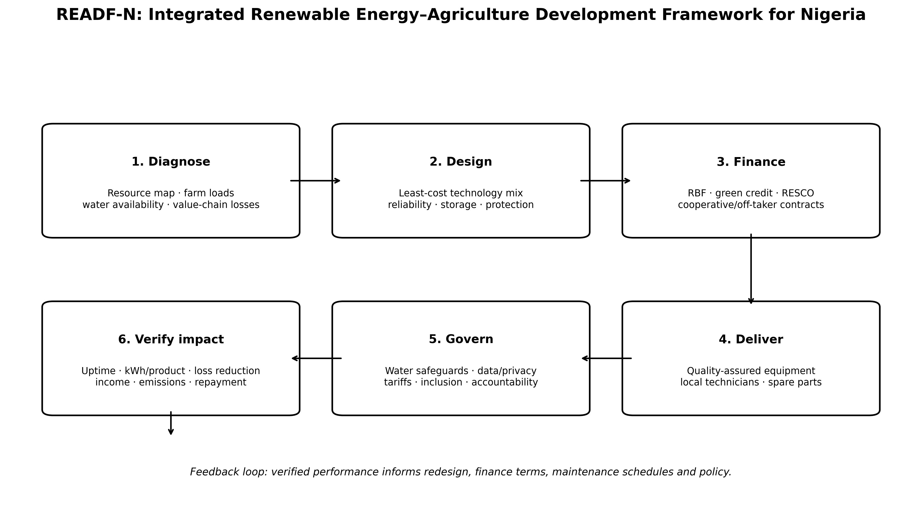
Figure 6. READF-N: Integrated Renewable Energy–Agriculture Development Framework for Nigeria. The six stages create a feedback loop from diagnosis to verified impact. Source: author synthesis.
Stage 1—Diagnose: map solar and other local resources; identify water-source constraints; measure agricultural loads and seasonal production; quantify current generator/fuel use and post-harvest losses; and identify paying users. Stage 2—Design: select the least-cost technology mix and size generation, storage, backup, distribution and protection against defined reliability targets. Stage 3—Finance: combine grants or results-based incentives with user payments, cooperative equity, green credit or RESCO structures that fit the revenue model. Stage 4—Deliver: procure quality-assured equipment, document commissioning, train operators and establish spare-parts and warranty pathways. Stage 5—Govern: set tariffs, access rules, water safeguards, data/privacy rules, maintenance responsibilities and inclusive participation. Stage 6—Verify impact: measure uptime, energy cost, productive kWh, yield or sales effects, food-loss reduction, income, emissions, water use and repayment performance; use results to revise system size and programme rules.

10. Policy and Practice Recommendations

10.1 Integrate agricultural development and energy planning
Agricultural programmes should include an energy-service assessment, and rural-electrification programmes should include a productive-demand assessment. Irrigation, cold-chain, milling, aquaculture, livestock and digital-agriculture initiatives should not be designed separately from the power systems required to operate them. State agricultural development agencies and REA-compatible electrification programmes can use common geospatial and demand data to identify high-value clusters.

10.2 Prioritize productive-use financing
The evidence from Nigerian geospatial modelling and the current DARES architecture supports financing packages that pair energy supply with productive equipment. Public support should be structured around verified installations, uptime and productive outcomes rather than indiscriminate equipment subsidies. Credit terms should reflect agricultural cash-flow cycles, especially for seasonal irrigation and processing enterprises.

10.3 Establish engineering and service-quality standards
Procurement standards should include energy efficiency, motor starting capability, battery cycle life, inverter protection, refrigeration performance, pump curves, remote monitoring, warranty duration, installation documentation and local repair arrangements. Quality assurance should extend to commissioning and performance verification; a technically installed system that cannot sustain the intended agricultural duty is not a successful project.

10.4 Build local technical capability
Training should include more than installation. Rural technicians need skills in PV array inspection, DC protection, battery management, inverter faults, motor diagnostics, pump hydraulics, refrigeration basics, data logging and safe isolation. Training farmer cooperatives in simple load scheduling, cleaning and fault reporting can further reduce downtime, but high-risk electrical work should remain with qualified personnel.

10.5 Protect water and environmental resources
Solar irrigation programmes should integrate water governance, especially in groundwater-dependent zones. Efficient pumps and low operating costs can increase abstraction; therefore, water-source yield, crop water demand and irrigation efficiency should be included in project appraisal. Battery end-of-life, refrigerants, biogas leakage and generator emissions also require explicit environmental-management plans.

10.6 Measure development impact, not only connections
The most meaningful national indicators are not the number of panels, pumps or connections but the services delivered: irrigation hours, tonnes processed, cold-room occupancy, food-loss reduction, uptime, energy cost per unit of product, income effects, jobs, women/youth participation, emissions displaced and system repayment. These outcomes should be monitored with transparent definitions and independent verification where public finance is involved.

11. Limitations and Research Agenda
This is a structured critical review rather than a registered systematic review or meta-analysis. The evidence base remains heterogeneous in technology, geography, outcome definitions and follow-up periods. Many Nigerian renewable-energy projects report connections or installed capacity without publishing comparable agricultural outcomes, and some empirical studies use pre/post designs without untreated controls. Cost results are sensitive to exchange rates, financing terms, battery replacement assumptions, solar resource, tariff rules and utilization. In addition, evidence on long-term groundwater effects of solar irrigation, battery end-of-life management, gender-disaggregated enterprise outcomes and the durability of productive-use business models remains insufficient.
Future research should therefore prioritize prospective evaluations that couple engineering monitoring with farm and enterprise outcomes. Useful designs include cluster-level quasi-experiments or randomized rollout where feasible; standardized logging of power quality, state of charge and downtime; water-use measurement for solar irrigation; life-cycle cost and emissions comparison against generator baselines; cold-chain food-loss measurement; and external validation of business models across agro-ecological zones. The strongest future evidence will connect kilowatt-hours to agricultural value rather than report either electrical or socioeconomic outcomes in isolation.

12. Conclusion
Renewable energy can become a productive infrastructure platform for rural farming communities in Nigeria, but only when technology is integrated with agricultural demand, finance, maintenance and governance. Solar irrigation can expand controlled water access; solar cold chain can reduce losses and strengthen horticultural markets; mini-grids can energize processing clusters; biogas can convert selected organic wastes into dispatchable energy; and hybrid solar-battery systems can provide high renewable fractions while retaining limited backup for critical continuity. Nigerian evidence already demonstrates meaningful benefits, but it also shows that outcomes are heterogeneous and that access alone is not a guarantee of income growth.
The policy opportunity is therefore to move from “electrification projects” to productive energy systems. READF-N operationalizes that transition by requiring demand and resource diagnosis, engineering design, fit-for-purpose finance, quality-assured delivery, environmental and institutional governance, and impact verification. This approach aligns Nigeria’s distributed renewable-energy expansion with food security, rural enterprise, agricultural resilience and the broader national energy transition while keeping engineering reliability and accountable evidence at the centre of implementation.

Declarations
Ethics: Not applicable. This article is a critical review and engineering framework and reports no new human-participant or animal research.
Funding: The author declares that no external funding was received specifically for this article.
Competing interests: The author declares no competing interests.
Data availability: No new primary dataset was generated. The quantitative values and programme information used in the synthesis are traceable to the cited peer-reviewed studies and authoritative institutional sources.
Author contributions: AMENGER, Gbaden: conceptualization, critical evidence synthesis, engineering framework development, interpretation, visualization and manuscript authorship.
AI-assisted editorial support: AI-assisted tools were used for language refinement, formatting, consistency checking and production support. They were not used as authors or as substitutes for scholarly judgement. Responsibility for source verification, interpretation and final approval remains with the author and journal editor.
Copyright and licence: © 2026 The Author. Published by CHIA TECH SOLUTIONS AND RESOURCES LIMITED (RC 1839865). This open-access article is distributed under the Creative Commons Attribution 4.0 International (CC BY 4.0) licence, except for third-party material otherwise identified.

References
Agbo, C. O., Onori, A., Stevanato, N., Mereu, R., Ogbuka, C. U., Eke, M. N., & Ujah, C. O. (2025). Planning off-grid rural electrification with MicroGridsPy: The case of Dugub, Nigeria. Energy Strategy Reviews, 60, 101775. https://doi.org/10.1016/j.esr.2025.101775
Alengebawy, A., Ran, Y., Osman, A. I., Jin, K., Samer, M., & Ai, P. (2024). Anaerobic digestion of agricultural waste for biogas production and sustainable bioenergy recovery: A review. Environmental Chemistry Letters, 22, 2641–2668. https://doi.org/10.1007/s10311-024-01789-1
Ani, V. A. (2025). Design of a solar water pumping system for efficient irrigation systems for crop production. Frontiers in Sustainable Food Systems, 9, 1546320. https://doi.org/10.3389/fsufs.2025.1546320
Carabajal, A. T., Orsot, A., Moudio, M. P. E., Haggai, T., Okonkwo, C. J., Jarrard, G. T., III, & Selby, N. S. (2024). Social and economic impact analysis of solar mini-grids in rural Africa: A cohort study from Kenya and Nigeria. Environmental Research: Infrastructure and Sustainability, 4, 025005. https://doi.org/10.1088/2634-4505/ad4ffb
Durga, N., Schmitter, P. S., Ringler, C., Mishra, S., Magombeyi, M. S., Ofosu, A., Pavelic, P., Hagos, F., Melaku, D., Verma, S., Minh, T. T., & Matambo, C. (2024). Barriers to the uptake of solar-powered irrigation by smallholder farmers in sub-Saharan Africa: A review. Energy Strategy Reviews, 51, 101294. https://doi.org/10.1016/j.esr.2024.101294
Energy Commission of Nigeria. (2022). National Energy Master Plan. Abuja, Nigeria.
FAO & IRENA. (2021). Renewable energy for agri-food systems: Towards the Sustainable Development Goals and the Paris Agreement. Food and Agriculture Organization of the United Nations and International Renewable Energy Agency. https://doi.org/10.4060/cb7433en
Federal Republic of Nigeria. (2024). Nigeria Energy Transition Plan: 2024 update and implementation resources. Energy Transition Office, Abuja, Nigeria. https://www.energytransition.gov.ng/
Husein, M., Moner-Girona, M., Falchetta, G., Stevanato, N., Fahl, F., & Szabó, S. (2024). The impacts of incentive policies on improving private investment for rural electrification in Nigeria – A geospatial study. Heliyon, 10(5), e27440. https://doi.org/10.1016/j.heliyon.2024.e27440
IRENA. (2023). Renewable Energy Roadmap: Nigeria. International Renewable Energy Agency, Abu Dhabi.
Nwankwo, N. C., Madougou, S., Inoussa, M. M., Okonkwo, E., & Derkyi, N. S. A. (2024). Review of Nigeria’s renewable energy policies with focus on biogas technology penetration and adoption. Discover Energy, 4, 14. https://doi.org/10.1007/s43937-024-00035-7
Oemmelen, K., Page, B., & Parikh, P. (2025). Shared Power, Shared Benefits? Reviewing private sector collaborations with community actors in Sub-Saharan Africa’s mini grid sector. Renewable and Sustainable Energy Reviews, 222, 115948. https://doi.org/10.1016/j.rser.2025.115948
Ojo, A. O., & Ogundeji, A. (2025). Effect of multidimensional energy poverty on the productivity of farming households in Nigeria. Poverty & Public Policy, 17(4), e70037. https://doi.org/10.1002/pop4.70037
Rural Electrification Agency. (2025a). DARES Project Implementation Manual: Productive Use of Energy technologies and performance-based grants. Abuja, Nigeria.
Rural Electrification Agency. (2025b). Official launch: Solar for Business and Productive Use of Energy sub-components under DARES. Nigeria Electrification Programme, Abuja, Nigeria.
Takeshima, H., Yamauchi, F., Edeh, H. O., & Hernández, M. A. (2023). Solar-powered cold-storage and agrifood market modernization in Nigeria. Agricultural Economics, 54(2), 234–255. https://doi.org/10.1111/agec.12771
Wamalwa, F., Maqelepo, L., Williams, N., & Falchetta, G. (2024). Solar irrigation potential in Sub-Saharan Africa: A crop-specific techno-economic analysis. Environmental Research: Food Systems, 1, 025001. https://doi.org/10.1088/2976-601X/ad5e82
World Bank. (2023a). Nigeria Distributed Access through Renewable Energy Scale-up Project (P179687): Project appraisal and sector context. World Bank Group, Washington, DC.
World Bank. (2023b). Nigeria to expand access to clean energy for 17.5 million people. World Bank Group, Washington, DC.
World Bank. (2025). Expanding Nigeria’s mini-grid market. World Bank Group, Washington, DC.
CHIATECH JOURNAL · SETEHEM · Volume 1 · Issue 1 · e056 · September 2026 · Pioneer Publication

