Input Files
File A = All existing items (includes system ID, SKU, description, pricing, etc.)
File B = All existing online items (includes online variant ID, e-commerce details)
File C = New file to process (contains new SKUs, descriptions, pricing data)

Output Files
File D = Retail Update File
File E = Online Update File

Step-by-Step Process
Step 1: SKU Matching
- For each row in File C, attempt to match the Manufacturer SKU with items in File A.
- Use the Manufacturer SKU field as the unique identifier for this match.

Step 2: Populate Retail Update (File D)
- Step 2A: If a match is found in File A, bring the System ID into File D.
- Step 2B: Fetch and bring the latest UPC code from File A into File D.
- Step 2C: If no match is found:
- Create a new item in File D.
- Auto-generate the description using: Could we label the Rows upon inport to app?
Brand + " - " + Description + " - " + Finish + " - " + Manufacturer SKU
(Brand=The file brand, we can set this at begining? + Description = found Column B = Column Q (51 = Black, 01 = Cotton White, 03= Bone ETC) + Column A
Step 3: Check for Duplicate Manufacturer SKUs
- Scan File D for any duplicate Manufacturer SKUs.
- Flag duplicates for further processing.

Step 4: Check for Custom SKU Rules
- Examine the Custom SKU column for any of these tags: “Clearance”, “Display”, “Clearance Display”, or other predefined special tags.
- Apply appropriate handling (see Step 5).

Step 5: Bring System ID for Rule-Matched SKUs
- If the item matches a custom rule, pull the corresponding System ID & Custom Sku from File A into File D (even if the SKU match is otherwise ambiguous).

Step 6: Mark Pure Duplicates for Archiving
- Identify pure duplicates (i.e., identical Manufacturer SKUs with no rule or other differentiator).
- Set Archive column = Y for these records in File D. You will find Archive at AN Column. If there are 2 duplicate Skus, Archive the one with the Lower MSRP.

Step 7: Assign Category
- For each item in File D, check File C for provided category guidance. Please see attached Catagories List
- If missing, attempt to infer category by:
- Looking at the Model Name.
- Comparing to similar items in File A.
- Assign the most appropriate category.

Step 8: Update Pricing
- Reference Master Vendor List for discount rules: See Master Discount list
- Example: Repair parts = no discount; always full MSRP
- Clearance Item - Clearance Discount Rules

- Set pricing fields as follows:
- MSRP = As provided in File C (or File A if matched).
- Default Cost = MSRP minus vendor discount (from Master Vendor List).
- Vendor Cost = MSRP minus vendor discount (same as Default Cost unless specified).
- Default Price = MSRP.
- Retail Price = MSRP less discount per Master Vendor List.
- Contractor Price = MSRP less discount per Master Vendor List.
- Designer Price = MSRP less discount per Master Vendor List.
- Online Price = MSRP less discount per Master Vendor List.
- VIP Price = MSRP less discount per Master Vendor List.

Step 9: Prepare Online Update (File E)
- For items where Ecom = Y in File A:
- Include the Manufacturer SKU in File E.
- Search File B for matching Manufacturer SKU.
- Fetch and populate:
Variant ID
Shipping Weight
Shipping Box Dimensions A
Shipping Box Dimensions B
Shipping Box Dimensions C

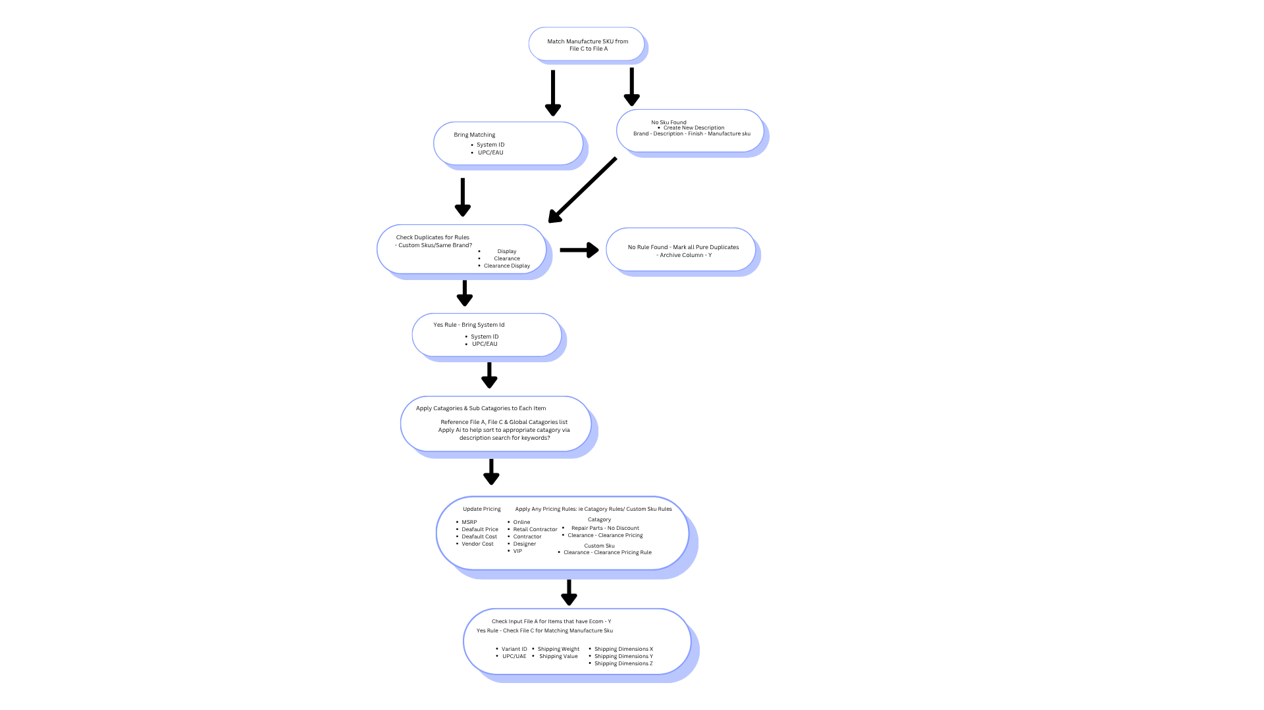
Additional Developer Notes
✅ Error Handling
Flag records where required fields are missing (e.g., SKU, price, description).
Log duplicates and conflicts for review.

✅ Performance
Ensure matching is optimized to handle large datasets (potentially thousands of rows).
Consider fuzzy matching options if requested later.

✅ Outputs
File D: Contains both updates and new items for retail system import.
File E: Contains all updates/new items relevant for online store sync.

✅ Logging
Maintain a change log for every file processed (e.g., X records matched, Y new items created, Z duplicates archived).
Max Output files 10,000. Records

Application - Issues
1 Brand selection not pulldown field
2 Vendor selection pulldown field missing
3 Missing record count display at file creation completion
4 Input fields don't expand with application.
5 Vendor field empty in export file.
6 Category field empty in export file.
7 Missing " - " after Brand name in description field in export file.
8 Mastter Discount List: 48/10 - "Input string was not in a correct format."
9 Invalid Brand - "Object reference not set to an instance of an object."
10 Not accepting Excel file imputs.
11 Needs pick and choose field options.

Output File D - Issues
1 Over 10,000 records in output file.
2 Missing description
3 Description - Missing in found records
4 Description - Brand not seperated by dash
5 No category or categories
6 Brand field not changed in found records
7 Vendor field not populated in new records.
8 Record count doesn't match new file record count.

I have attached a .zip file a proposed changes to the application.
When you select a file in the Current Items field you will then be able to press the "Read New Price List" button.
This will populate the dropdown fields at the bottom right of the form and make visible the 2 main processing buttons.
I am using this button for testing the functionality of populating the pull down fields.
Currently the selection buttons only select CSV files but we would like the functionality of reading Excel files.
The pull down fields at the bottom right of the form will be used to select which field from the "New Price List" will be used in creation of the 2 update files. More pull downs will have to be added for all the fields. This will allow us to proceed with the creating the update files without preprocessing the New Price List into the a standard format.
I would also like one of the pull downs to be for the "Brand" field with a use or don't use radio button. Sometimes the price list files will have the brand in a field and not the whole file will be for 1 brand.
I made some minor changes to the application.
To remove any errors we get from commas I have changed the Master Discount List from CSV to an Excel file.
I have also made it possible for the user to select which pricing rule they want to choose. You can find attached the source and release version of the app. I have also attached a copy of the new Master Discount List.
I was thinking of layout that we may want to move the field selection pulldowns to a popup form. This will give us more room to work with.
1. The current items file can be found in the file previously sent. (products_export_2025-07-09_20-01-41.zip)
The current items file will be in CSV format at is usually a listing of the items for a specific brand or vendor. This fill will include items in the retail and ecom sections.
2. The output parameters for the inputs can be found in the zip file I sent previously. (Import Templates.zip)
3. The use of the pulldowns are used to match the fields in creating the output files and the fields in the “New Price List” file. This user will have to select which field in the “New Price List” corresponds to the desired field name/description. Some fields will not be present and should be able to be ignored. i.e. Some time the weight is not in the file.
The field titles on the left i.e.: SKU, Description, List Price … are the field titles you will be using in the processing of the output files. In the sample app I sent you I didn’t include all the fields that need to be checked.

Summary
The purpose of the application is to streamline the processing of new price lists from the vendor into our Lightspeed application. Lightspeed is an online Retail and ECOM application that we do all our retail business.
I will start out by explaining to you my current process. Currently I am not taking into account ECOM or special fields like weight or category.

In the example I have included (Hansgrohe), we are sent the file “Hansgrohe-CAN-Data-File-March-2025-Approved-File.xlsx”. This file includes a list of current items that the Vendor sells and the prices attached to each item. You can find the information in the tab “Full List”. My task is to cross-reference the items in Lightspeed with this file and update the prices accordingly.

My first step is to create an Excel file where I do all my preliminary work. (Hansgrohe - Working.xlsx). On the fist sheet “Sheet1” I copy the relevant fields from the vendor’s file and only include the data and field headings.

This data I import into an Access database as table “Sheet1”. I then export from Lightspeed a list of items for the vendor and import it into the Access database as table “Lightspeed”. Using different queries, I check for duplicates in Sheet1 and Lightspeed.

I then create a query “Found” to find matching records using the fields “Manufact SKU” from Lightspeed and “Item” from Sheet1. I copy the four fields from the query into the “Found – Working” sheet. Next, I copy over a template for the columns E-R and then I place the pricing rates for Hansgrohe in Cells E1-M1. (From Master Discount List).

Next I will create a query for new items. These are records in sheet1 that don’t match any “Manufact SKU”. The results from this query I copy over to “New – Working” sheet, use the template and copy the data from “Master Discount List”. Found and New sheet1 are basically the same except for the addition of the “System ID” field.

After the “- Working” sheet1 have been completed I copy them to an import sheet and remove the original query results from sheet. These are not needed in the import and have been used in the creation of new fields. i.e. “Item Description”

I then copy the 2 import sheets into their own files and proceed with the import into LightSpeed. “Hansgrohe_Found.xlsx” & “Hansgrohe_New.xlsx” You will notice that there is a file “Hansgrohe_Found2.xlsx” this was created when I noticed that there were multiple spaces at the end of the “Description” field in Sheet1. I sometimes have to create a second Found file to remove the description for some items that are matrix items. When the Found and New files are imported successfully, that is the end of my procedure.

Pricing Application Requirements
• Able to take files from vendors and convert them into import files for Lightspeed.
User will do clean up of the file to include only the field headings and data.
• Be flexible enough to take into account different vendor files. i.e. Field Layout
• Archive duplicate items from the Lightspeed list.
• Ignore duplicate items from the Vendor’s price list.
• Create update files for Retail and ECOM sections for Lightspeed.
• Determine which category the item fits in based on item description and other parameters.
• Include weight and dimensions required for ECOM shipping.
• Take into account different pricing structures for regular items and parts.
• Be able to handle stacked pricing structures.
i.e. “50/10” = List Price - 50% and then - 10%.
• At the finish of the creation of the import files a quick report on the number of found and new records will be displayed.
• Allow the user to pick which fields in the price list file from the vendor corresponds with the fields in the import files.
• Able to handle Excel and CSV files.
Find attached a zip file of the files I mentioned in the previous message.

I have also include a screen shot of the import screen from Lightspeed. I was hoping the application will have a feature like that.

