**DrumKit manual**

1. Playing the drums

2. Editing the current layout

3. General settings

4. Drumkits manager

5. Drum manager

6. Layout manager

## 1. Playing the drums

To play the drums, simply use your fingers (if you have a touch screen), a keyboard (by default, using the A, B, C, D... keys), or a mouse.

## 2. Editing the current layout

To edit how the drums are arranged, open the bottom app bar (by swiping from the bottom on a touch screen, or right clicking with a mouse), and choose “Edit”. Now you can rearrange the drums. To reposition a drum, simply drag it to another location. The orange circles with an arrow allow you to rotate the drums, by clicking and dragging. Using the white circles, you can resize the drums.

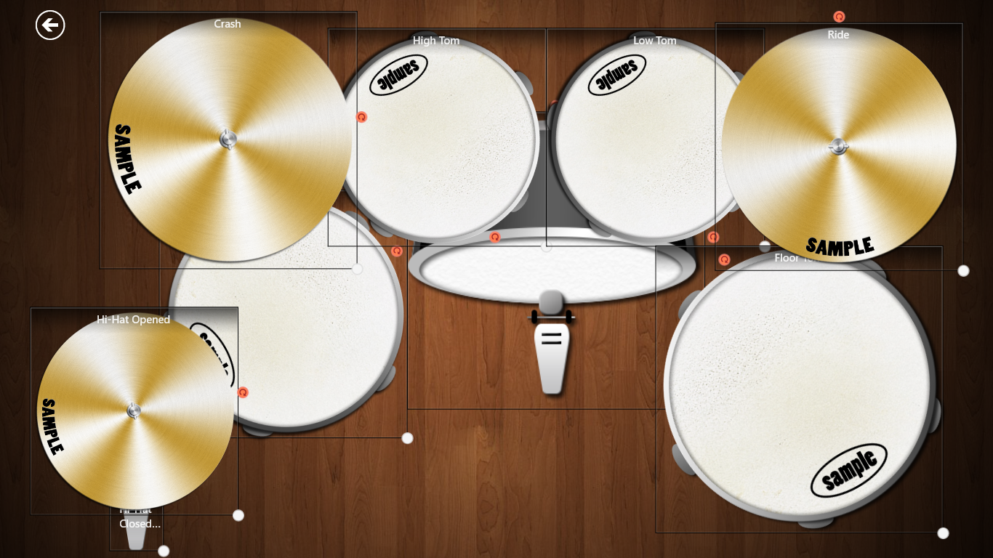

When you are done, you can go back to playing the drums using the “back” button in the top left corner.

## 3. General settings

To access general settings you can either click “Settings” in the bottom app bar, or you can use the settings charm (swipe from the left, and choose the wrench icon).

Here, you can adjust things like the volume (how loud the drums sound), whether animations are enabled or not, or you can reset to factory settings if something is not right. By activating the “Debugging mode” switch, the next time the “Settings” screen is opened, a new tab, “Logs” will appear. The logs are used mainly for investigating problems with the application.

## 4. Drumkits manager

To access the drumkit manager, open the “Settings” screen, and on the top, choose the “Drumkits” tab.

On this screen, you can import, export, delete, or activate drum packages.

## 5. Drum manager

To access the drum manager, open the “Settings” screen, and choose the “Drums” tab.

Here, you can see all the drums that are available in the current drum package. You can hide a drum by toggling “Enabled”. If you want to change which key on the keyboard plays that drum, you can click the “Key” text box, and press the new key. Changes are saved right away.

## 6. Layout manager

To access the drum manager, open the “Settings” screen, and choose the “Layouts” tab.

Here, you can edit the layouts used by the application. Active layouts have a distinct greenish background. The application uses distinct layouts for each view, so there are separate layouts for the “Snapped” view, or the “Portrait” view.

You can create your own layouts by clicking the “Create” button at the bottom of the screen.

You can edit a layout by selecting it (click it so that the background becomes bluish).

This is the algorithm used by the application by which layouts are chosen:

1. It looks for a layout which has a single view, which is the current view, and is active. If not found,

2. It looks for a layout which has multiple views, but not all views, and one of them is the current view, and is active. If not found,

3. It looks for a layout which has all views, and is active. If not found,

4. It looks for a layout which has a single view, which is the current view, and is not active. If not found,

5. It looks for a layout which has multiple views, but not all views, and one of them is the current view, and is not active. If not found,

6. It looks for a layout which has all views, and is not active. If not found,

7. It uses the first layout available.