# Muscle and Force Compliation

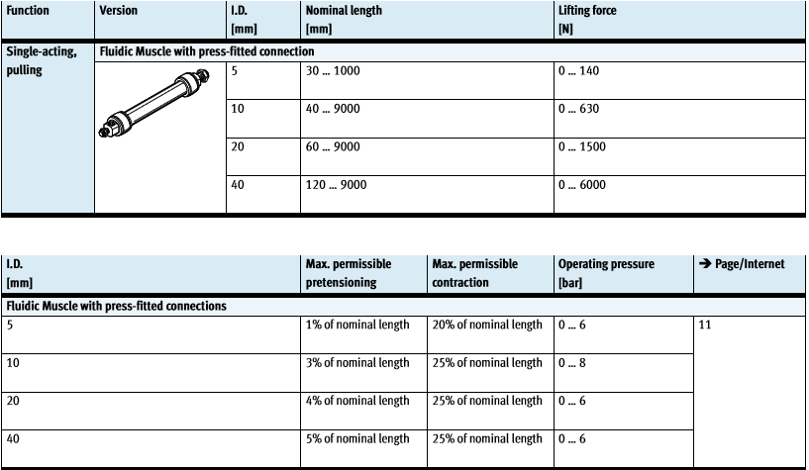

Figure 1: Festo Air Muscle Specifications

Table 1: Body Segments by Weight

|  |  |  |  |
| --- | --- | --- | --- |
| Segment | Sex | Age | Weight (grams) |
| Right Upper Arm | F | 20 | 1525.6 |
| Right Upper Arm | M | 40 | 2560.1 |
| Right Upper Arm | M | 68 | 1420.7 |
| Left Upper Arm | M | 30 | 1484.5 |
| Left Upper Arm | M | 30 | 1411.3 |
| Left Upper Arm | M | 68 | 1239.1 |
| Right Forearm | F | 20 | 725.6 |
| Right Forearm | M | 40 | 1389.7 |
| Right Forearm | M | 30 | 821.0 |
| Right Forearm | M | 68 | 767.2 |
| Left Forearm | M | 68 | 765.3 |
| Left Forearm | M | 30 | 770.1 |
| Right Hand | M | 68 | 447.1 |
| Right Hand | M | 40 | 525.1 |
| Right Hand | F | 20 | 316.8 |
| Right Hand | M | 30 | 393.2 |
| Left Hand | M | 68 | 443.9 |
| Left Hand | M | 30 | 374.0 |

|  |  |
| --- | --- |
| Variable | Equation/Constant |
| Torque ($τ$) | $$F*r*\sin{θ}$$ |
| Lifting force (F) | $$F= \frac{f*r1}{r2}$$ where f is the input force, r1 is the radius of the wheel, and r2 is the length of the arm |

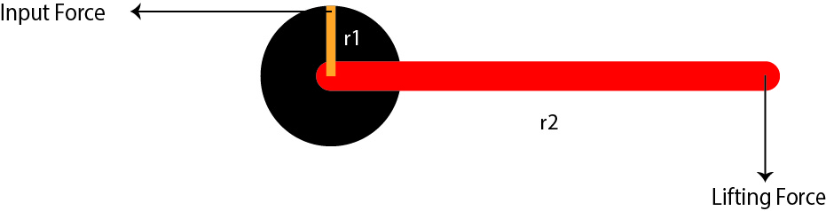

Figure 2: Force Diagram