GatherLoop Static Site Deployment
Documented Report
Cloud & DevOps Bootcamp — Capstone Project
Personal Project — Group 3: Static Site Deployment, Choose Your Architecture
EZUKA CHIBUEZE
Reg. No.: CLC/2026/TC-7/0110
Date: 21 July 2026
GitHub Repository: github.com/chibucious/gatherloop-static-site
Live Site: gatherloopsite18025.z1.web.core.windows.net

Table of Contents

Table of Contents 2

1. Executive Summary 3

2. Client Scenario 3

3. Architecture Overview 3
3.1 Deployed Resources 3

4. Phase 0 — Design Worksheet 4
4.1 Understanding the Two Options 4
4.2 Two-Architecture Comparison 4
4.3 Decision and Justification 4
4.4 Note to the Founder (plain English) 4

5. Build Process — Step by Step 5
Step 1 — Phase 0 Design Worksheet 5
Step 2 — Provision Azure Blob Static Website Hosting (CLI only) 5
Step 3 — Upload Site Content 7
Step 4 — Confirm Public Access Configuration 8
Step 5 — GitHub Actions Auto-Deploy (Mandatory) 9
Step 6 — Incident Report 10

6. CI/CD Pipeline Details 10

7. Incident Report 10
7.1 Symptom 10
7.2 Investigation Trail 10
7.3 Root Cause 10
7.4 Fix 10
7.5 Design Reflection 11
7.6 Clarifying Note: Client ID vs. Client Secret 12

8. Deliverables Checklist 12

9. Conclusion 12

1. Executive Summary
This report documents the design, deployment, and operation of a static website for GatherLoop, a fictional events company launching a single-page site to promote a ticketed conference. The project was completed as the personal capstone deliverable for Group 3 (“Static Site Deployment — Choose Your Architecture”) of the Cloud & DevOps Bootcamp.
The central requirement of this project was not simply to deploy a website, but to choose — and justify — between two valid hosting architectures given GatherLoop's specific operational constraints: a traffic pattern that is near-zero for weeks and then spikes hugely on a single morning, combined with having no in-house staff available to operate a server. Azure Blob Static Website Hosting was selected over a Linux VM running Nginx, provisioned entirely via the Azure CLI, deployed with a Tailwind CSS v4 landing page, and wired to a GitHub Actions pipeline that auto-deploys content changes on every push to main.
During the build, a real production incident occurred — a credential-rotation key-mismatch that broke the deployment pipeline — which was diagnosed, fixed, and is documented in full in Section 8, including the design lesson it revealed.
Cloud Provider Used: Microsoft Azure (Free Tier account). All resources referenced in this report were provisioned under a free-tier subscription and are noted accordingly where cost is discussed.

2. Client Scenario
GatherLoop is a small events company launching a single-page website to promote a ticketed conference. The stated business constraints were:
- The site must handle a traffic spike on sale-morning without falling over.
- The company has almost no ops budget and no one in-house to babysit a server.
- Content updates (new speakers, schedule changes) should go live automatically when pushed to GitHub.
- The founder has heard “a real server gives you more control” and is nervous that a storage-based site isn't a “real” website.
These constraints directly informed the architecture decision documented in Section 4: the choice was treated as being just as important as the deployment itself, per the project brief.

3. Architecture Overview
The deployed architecture consists of three parts working together: an Azure Storage Account with Static Website Hosting enabled, a Tailwind CSS v4 static front-end, and a GitHub Actions pipeline that syncs content on every push. The flow is as follows:
- A developer pushes a change to the site/ folder on the main branch of the GitHub repository.
- GitHub Actions authenticates to Azure using a scoped service principal, then runs az storage blob upload-batch to sync the site/ folder into the storage account's $web container.
- Azure serves the updated content immediately from its static website endpoint, over HTTPS, with no server process or port configuration required on the developer's part.

3.1 Deployed Resources
Resource | Value
Cloud Provider | Microsoft Azure (Free Tier account)
Resource Group | gatherloop-rg
Region | South Africa North
Storage Account | gatherloopsite18025
Storage SKU | Standard_LRS
Live Static Site Endpoint | https://gatherloopsite18025.z1.web.core.windows.net/
GitHub Repository | https://github.com/chibucious/gatherloop-static-site

4. Phase 0 — Design Worksheet
Per the project brief, the hosting architecture decision was reasoned through in writing before any cloud resources were created. The full comparison is reproduced below.

4.1 Understanding the Two Options
Azure Blob Static Website Hosting is Azure's cloud storage service (“Blob Storage”) switched into a mode where it automatically serves uploaded files to any visitor at a public web address — there is no server to manage, patch, or restart.
A Linux Virtual Machine (VM) running Nginx is a full, general-purpose rented computer, on which Nginx (a web server program) is installed to serve the site's files. Unlike Blob hosting, the VM's owner is responsible for every aspect of its ongoing operation — operating system patches, web server configuration, and uptime.

4.2 Two-Architecture Comparison
Criterion | Blob Static Website Hosting | Linux VM + Nginx
Handles the sale-morning spike? | Yes — Azure's storage infrastructure spreads load across many physical machines behind the scenes; there is no single machine that can get “full.” | Only if the VM was already sized (and paid for) big enough to handle peak load before the spike happens. One VM has a ceiling on CPU, memory, and simultaneous connections.
Ongoing maintenance burden? | Basically none — no operating system to patch, no server software to configure, nothing that can crash and need a restart. | Real and continuous — someone must apply security updates, keep Nginx configured, and notice and fix it if it ever goes down.
Cost pattern (idle vs. spike)? | Very cheap during quiet weeks (pay only for storage/bandwidth actually used); rises only a little on the spike day, then drops back down. | A fixed price runs 24/7 whether anyone visits or not — the same cost during quiet weeks as during a busy day.
What breaks first under load? | Realistically nothing at this traffic scale — Azure's storage layer is built for far higher load than one ticket-sale spike. | The VM itself — CPU maxes out, or it runs out of connections it can serve, and visitors see errors or slow loading.
What would I tell the nervous founder? | “This is still a fully real, production website. It just doesn't need a computer sitting there for you to maintain — which is exactly what makes it the better fit here.” | “A VM gives more low-level control, but that control comes with responsibility. Since no one is available to provide that, control becomes a risk, not a benefit.”

4.3 Decision and Justification
Decision: Azure Blob Static Website Hosting.
Justification: it directly answers GatherLoop's two hardest constraints at once — it automatically handles the sale-morning spike without anyone managing server capacity, and it requires no ongoing maintenance, which matters because there is no one available to provide that maintenance.

4.4 Note to the Founder (plain English)
“We're hosting your site using Microsoft's cloud storage system instead of a traditional server. On the morning tickets go live, your site isn't limited by one machine's capacity — it's backed by the same infrastructure that handles much bigger sites. During the quiet weeks before and after, you're not paying to keep a server running and secured for traffic that isn't there. Updates go live automatically the moment we push a change — no manual step for either of us. It's still a real, production website; it's simply not one either of us has to babysit.”

5. Build Process — Step by Step
The project was built incrementally, with each step's reasoning and outcome logged before moving to the next (full log in docs/BUILD-LOG.md). A summary of each step follows, with supporting evidence.

Step 1 — Phase 0 Design Worksheet
Completed the written comparison and decision documented in Section 4, before any Azure resources were created.

Step 2 — Provision Azure Blob Static Website Hosting (CLI only)
Ran a Bash script (scripts/provision-static-site.sh) that created a resource group (gatherloop-rg), a storage account (gatherloopsite18025, Standard_LRS SKU), and enabled static website hosting with index.html as both the index and error document. Provisioning was done entirely via the Azure CLI, with no manual Portal clicks, so the process is scripted and repeatable.
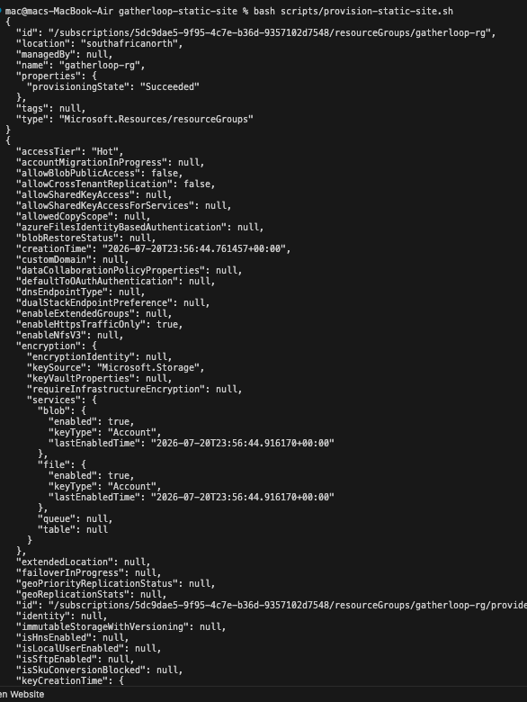

Figure 1 — Terminal output: resource group created successfully.
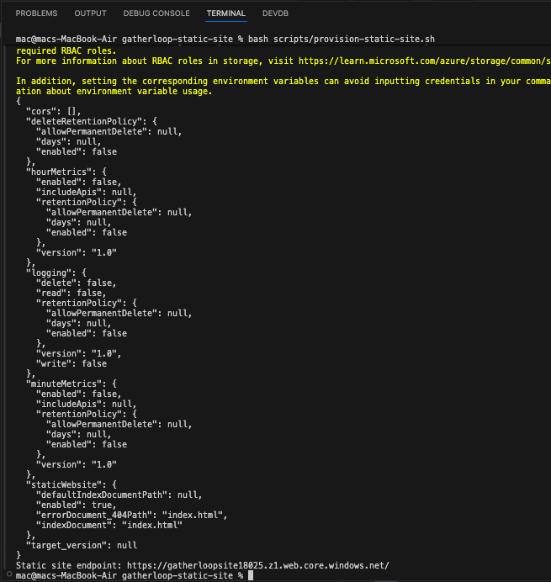
Figure 2 — Terminal output: static website hosting enabled, live endpoint printed.

Step 3 — Upload Site Content
Built the landing page locally using Tailwind CSS v4, compiled to a single static CSS file (no runtime build dependency, consistent with Blob hosting serving static files only), then uploaded the site/ folder into the storage account's $web container using az storage blob upload-batch. Verified the live endpoint served the real page.
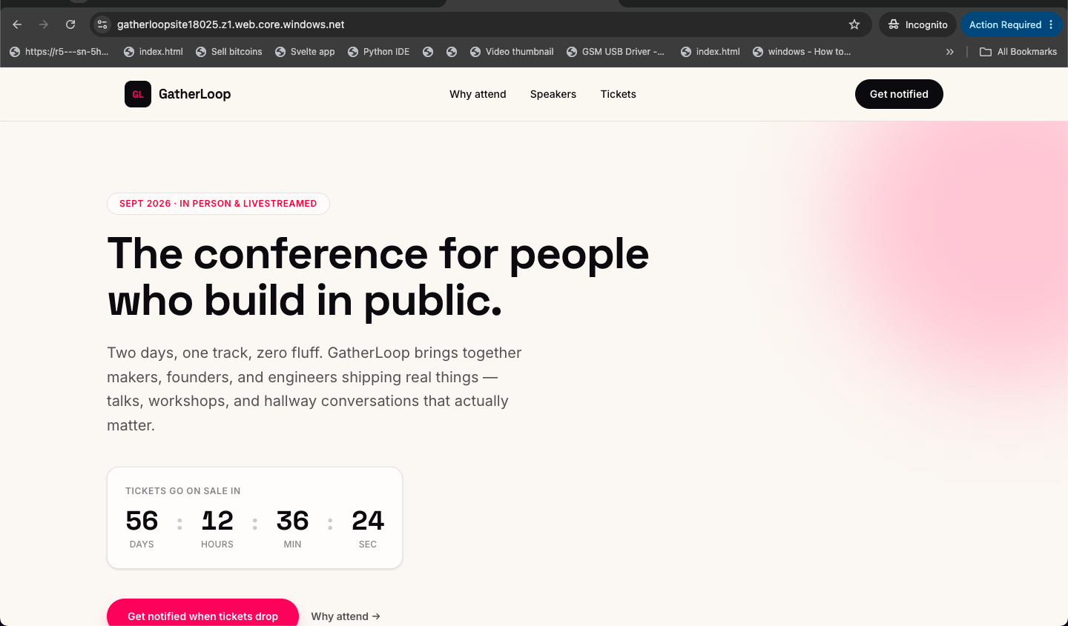
Figure 3 — The live GatherLoop landing page, served directly from the Azure static website endpoint.

Step 4 — Confirm Public Access Configuration
Confirmed in the Azure Portal that static website hosting was correctly enabled, with index.html set as the index document, and that the endpoint is served over HTTPS by default — no manual port configuration was required, unlike the VM+Nginx alternative.
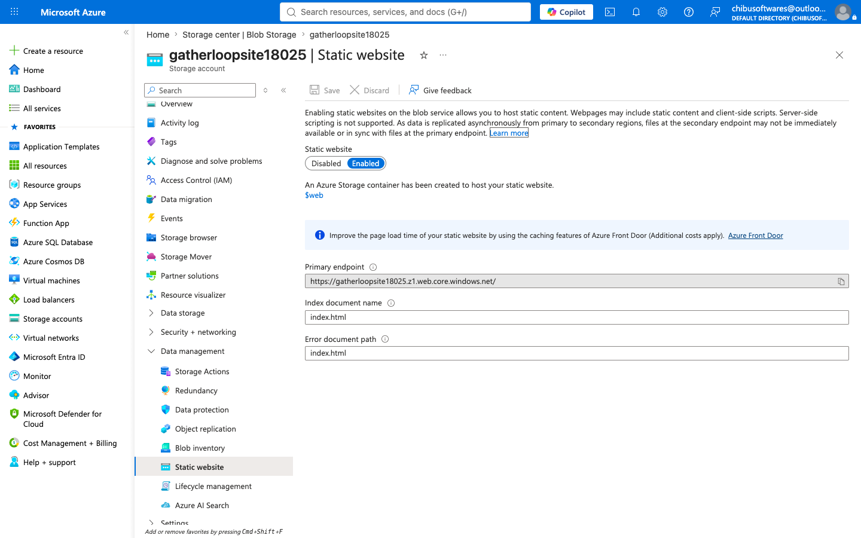
Figure 4 — Azure Portal confirming Static Website hosting is Enabled, with the live primary endpoint shown.

Step 5 — GitHub Actions Auto-Deploy (Mandatory)
Created a dedicated Azure service principal, scoped specifically to the gatherloop-rg resource group (rather than the whole subscription) to limit blast radius in case of credential compromise. Added the resulting credentials as GitHub repository secrets, and built a GitHub Actions workflow (.github/workflows/deploy-static-site.yml) that authenticates to Azure and syncs the site/ folder to the $web container on every push to main.
Tested the pipeline end-to-end by making a visible content change and pushing it, then confirming both that the workflow ran successfully and that the live site actually reflected the change.
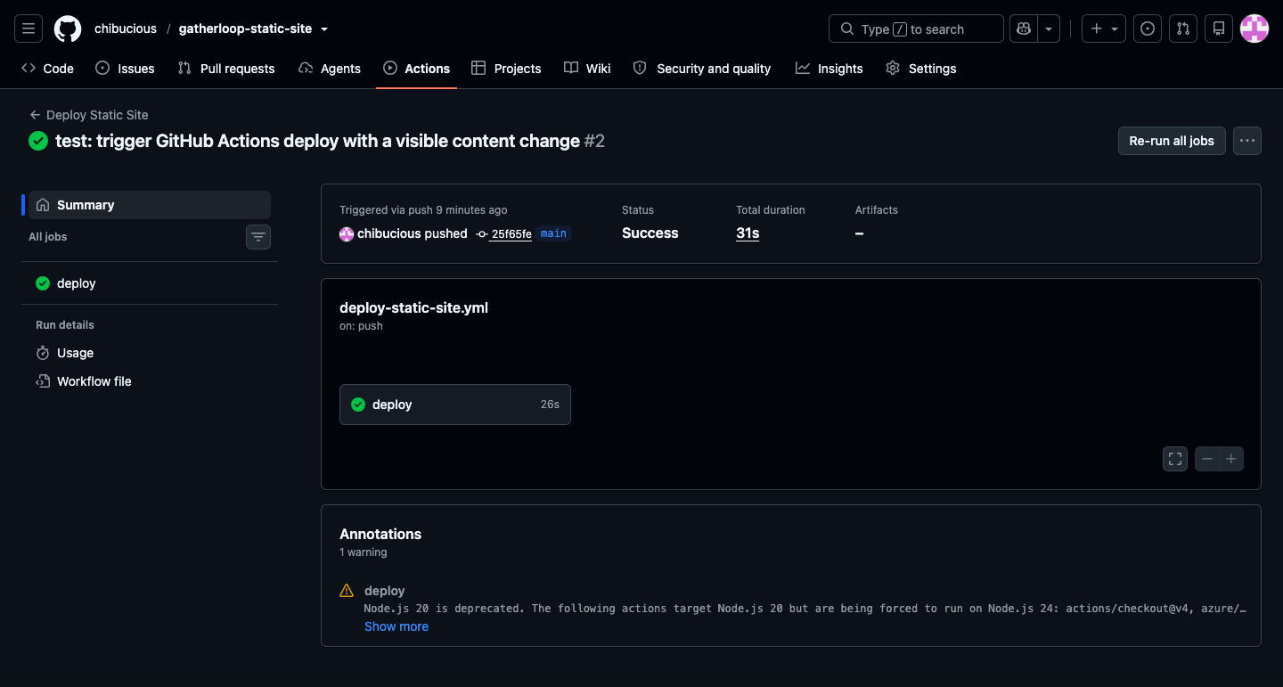
Figure 5 — GitHub Actions run completing successfully after a push to main.
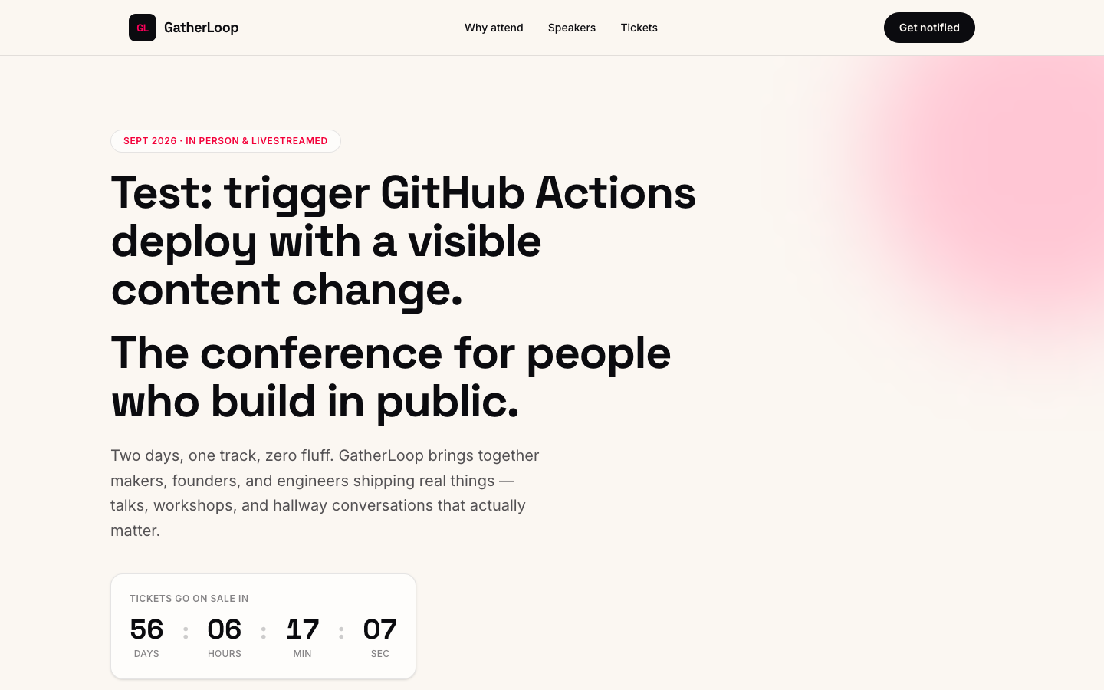
Figure 6 — The live site reflecting the pushed content change, confirming the pipeline genuinely deploys, not just runs without error.

Step 6 — Incident Report
A real deployment failure occurred during a subsequent credential rotation, was diagnosed and fixed, and is documented in full in Section 8.

6. CI/CD Pipeline Details
The GitHub Actions workflow triggers on any push to main that touches the site/ folder (or via manual dispatch). It performs two steps: authenticating to Azure using a scoped service principal stored as the AZURE_CREDENTIALS repository secret, then running az storage blob upload-batch to sync the site/ folder into the storage account's $web container, using the STORAGE_ACCOUNT repository secret to identify the target account.
Secrets handling: no credential is ever hardcoded in the workflow file or committed to the repository. Both AZURE_CREDENTIALS and STORAGE_ACCOUNT are stored exclusively as encrypted GitHub Actions secrets, referenced only via the ${{ secrets.* }} syntax at runtime.

7. Incident Report

7.1 Symptom
After rotating the Azure service principal's credential with az ad sp credential reset, and updating the AZURE_CREDENTIALS GitHub secret with the new output, the next GitHub Actions run failed at the Azure login step with the error: “Login failed with Error: Not all parameters are provided in 'creds': Double-check if all keys are defined in 'creds': 'clientId', 'clientSecret', 'tenantId'.” This was observed directly in the Actions tab's failed-run logs.

7.2 Investigation Trail
- First check: confirmed the AZURE_CREDENTIALS secret had actually been updated in GitHub's settings (ruled out “the paste didn't save”).
- Second check: compared the exact JSON keys the workflow's azure/login@v2 step expects (clientId, clientSecret, subscriptionId, tenantId) against what az ad sp credential reset actually produced (appId, password, tenant — with subscriptionId missing entirely). This ruled in the actual cause.
- Third check: traced why the two differed — the original credential was generated with the now-deprecated --sdk-auth flag, which reformats output into the exact shape azure/login expects, while credential reset has no such flag and returns Azure's default key names instead.

7.3 Root Cause
Rotating the service principal's credential with az ad sp credential reset returns a different JSON key-naming convention than the original --sdk-auth-formatted credential that azure/login@v2 requires, and omits subscriptionId entirely — so pasting the reset command's raw output into the AZURE_CREDENTIALS secret produced an incomplete, incorrectly-shaped object.

7.4 Fix
Manually remapped the reset command's output into the required shape, retaining the unchanged subscriptionId from the original credential, updated the AZURE_CREDENTIALS secret with the corrected JSON, and re-ran the failed workflow. The Azure login step then passed and the site content synced successfully.
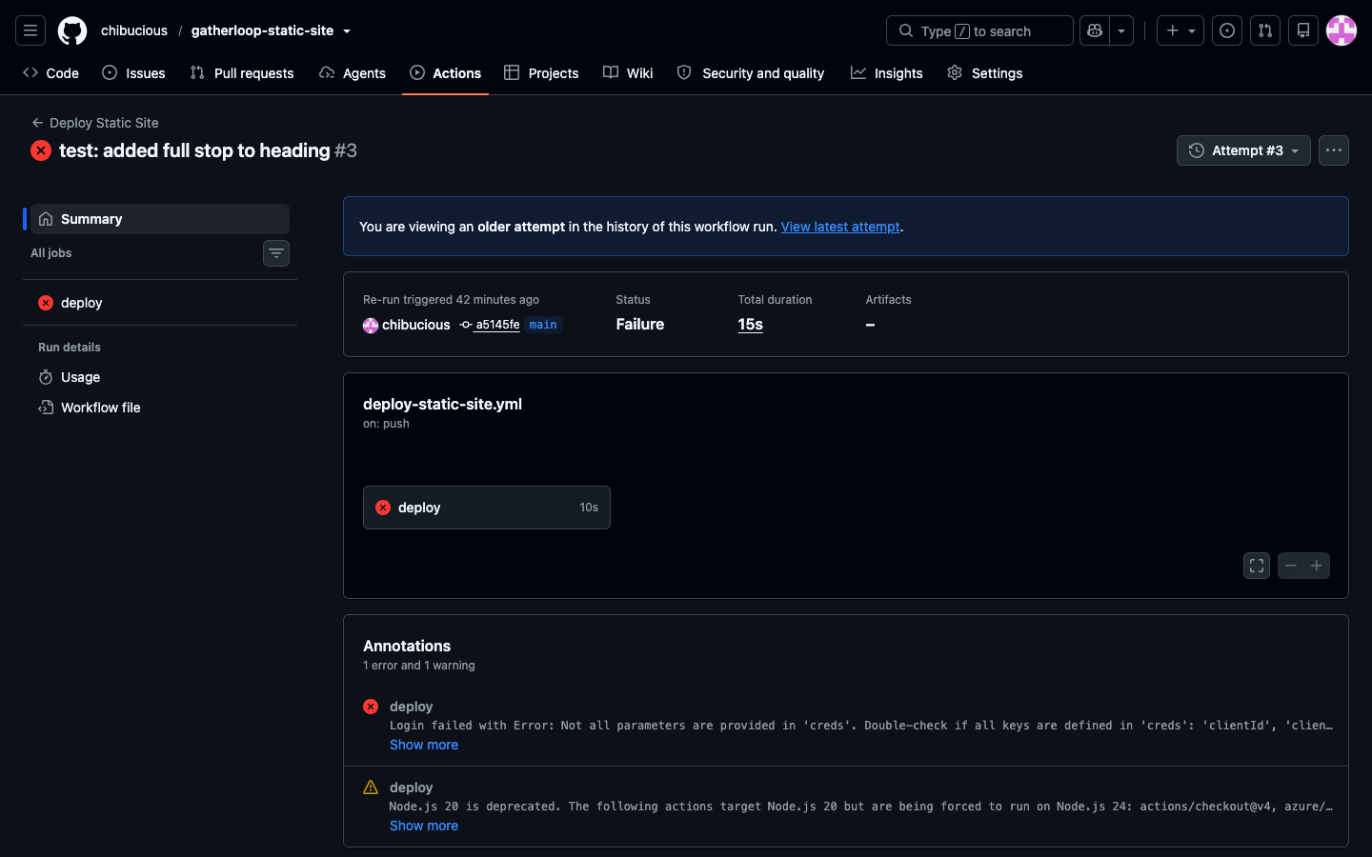
Figure 7 — The failing Actions run: Azure login step erroring on the mismatched credential shape.
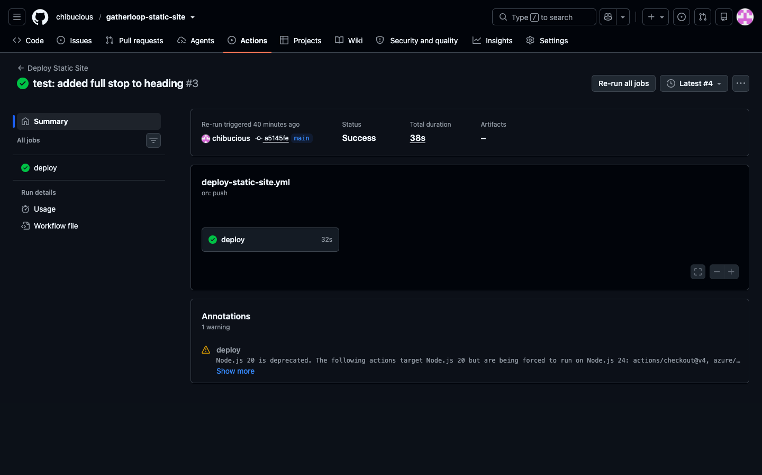
Figure 8 — The successful re-run after correcting the credential JSON shape.

7.5 Design Reflection
This failure was more likely, not less, because of a design gap: the original secrets-handling plan documented where the secret lives, but not the exact procedure for rotating it safely — specifically, that Azure's two credential-generating commands return incompatible shapes. A rotation is exactly the kind of routine, expected maintenance action a design should anticipate rather than treat as a one-off. Going forward, the exact required JSON shape should be documented directly alongside the rotation instructions, so future rotations are a copy-paste against a known-correct template rather than a rediscovery of the correct format each time.

7.6 Clarifying Note: Client ID vs. Client Secret
Worth stating explicitly, since it is easy to conflate the two during a rotation like this one: the Client ID is the permanent identity of the service principal, assigned once at creation and unchanged afterward — comparable to a username. The Client Secret is that identity's password, and it is the value that changes each time credential reset is run. This incident involved only a secret/key-shape mismatch; the identity itself never changed. A genuinely new identity would only result from re-running create-for-rbac with a different name.
Security note: the exposed Client Secret values referenced during this incident were rotated a further time after this report's findings were documented, as a precaution, since they had been displayed in multiple non-version-controlled contexts during troubleshooting.

8. Deliverables Checklist
Deliverable | Status
Site code (site/) | Complete
CLI provisioning script (scripts/provision-static-site.sh) | Complete
GitHub Actions workflow (.github/workflows/deploy-static-site.yml) | Complete — tested end-to-end, including recovery from a real failure
Two-architecture comparison worksheet (docs/design-worksheet.md) | Complete
Screenshots (live site, Actions run, incident before/after) | Complete
Incident report (docs/incident-report.md) | Complete
Documented Report (this document) | Complete

9. Conclusion
This project delivered a working, automatically-deploying static website for GatherLoop, built on a hosting architecture chosen through explicit, written comparison against the client's actual operational constraints rather than default familiarity. The CI/CD pipeline was not only built but genuinely tested — including surviving and recovering from a real production-style incident during a routine credential rotation, which strengthened both the deployment process and its documentation. All deliverables specified in the project brief have been completed and are available in the linked GitHub repository.

