

**Infographics Generator**

**Project Plan**

Louis Bodnar Peter Chen Lok Cheung Kevin Shreve

April 15, 2012

**Contents**

**1 Executive Summary 2**

**2 Functional Specifications 2**

**3 Design Specifications 3**

|  |  |  |  |  |  |  |  |  |  |  |  |  |  |  |  |  |  |  |  |  |  |  |  |  |  |
| --- | --- | --- | --- | --- | --- | --- | --- | --- | --- | --- | --- | --- | --- | --- | --- | --- | --- | --- | --- | --- | --- | --- | --- | --- | --- |
| 3.1 | Overview . . . . . . | . | . | . | . | . | . | . | . | . | . | . | . | . | . | . | . | . | . | . | . | . | . | . | 3 |
| 3.2 | System Architecture | . | . | . | . | . | . | . | . | . | . | . | . | . | . | . | . | . | . | . | . | . | . | . | 3 |
| 3.3 | Main Menu . . . . . | . | . | . | . | . | . | . | . | . | . | . | . | . | . | . | . | . | . | . | . | . | . | . | 4 |
| 3.4 | Infographic Page . . | . | . | . | . | . | . | . | . | . | . | . | . | . | . | . | . | . | . | . | . | . | . | . | 5 |
| 3.5 | Drill Down Display . | . | . | . | . | . | . | . | . | . | . | . | . | . | . | . | . | . | . | . | . | . | . | . | 6 |
| 3.6 | Web Backend . . . . | . | . | . | . | . | . | . | . | . | . | . | . | . | . | . | . | . | . | . | . | . | . | . | 7 |

**4 Technical Specifications 7**

**5 Schedule 8**

|  |  |  |  |  |  |  |  |  |  |  |  |  |  |  |  |  |  |  |  |  |  |  |
| --- | --- | --- | --- | --- | --- | --- | --- | --- | --- | --- | --- | --- | --- | --- | --- | --- | --- | --- | --- | --- | --- | --- |
| 5.1 | Week 1 (January 9, 2012) | . | . | . | . | . | . | . | . | . | . | . | . | . | . | . | . | . | . | . | . | 8 |
| 5.2 | Week 2 (January 16, 2012) |  | . | . | . | . | . | . | . | . | . | . | . | . | . | . | . | . | . | . | . | 8 |
| 5.3 | Week 3 (January 23, 2012) |  | . | . | . | . | . | . | . | . | . | . | . | . | . | . | . | . | . | . | . | 9 |
| 5.4 | Milestone: Status Reports | . | . | . | . | . | . | . | . | . | . | . | . | . | . | . | . | . | . | . | . | 9 |
| 5.5 | Week 4 (January 30, 2012) |  | . | . | . | . | . | . | . | . | . | . | . | . | . | . | . | . | . | . | . | 9 |
| 5.6 Milestone: Project Plan Presentation . . . . . . . . . . . . . . 9 | | | | | | | | | | | | | | | | | | | | | | |
| 5.7 | Week 5 (February 6, 2012) . | | . | . | . | . | . | . | . | . | . | . | . | . | . | . | . | . | . | . | . | 9 |
| 5.8 | Week 6 (February 13, 2012) | | . | . | . | . | . | . | . | . | . | . | . | . | . | . | . | . | . | . | . | 9 |
| 5.9 | Week 7 (February 20, 2012) | | . | . | . | . | . | . | . | . | . | . | . | . | . | . | . | . | . | . | . | 9 |
| 5.10 | Milestone: Alpha Demonstrations . | | | | | | . | . | . | . | . | . | . | . | . | . | . | . | . | . | . | 10 |
| 5.11 | Week 8 (February 27, 2012) . . . . | | | | | | . | . | . | . | . | . | . | . | . | . | . | . | . | . | . | 10 |
| 5.12 | Week 9 (March 12, 2012) | . | . | . | . | . | . | . | . | . | . | . | . | . | . | . | . | . | . | . | . | 10 |
| 5.13 | Week 10 (March 19, 2012) | . | . | . | . | . | . | . | . | . | . | . | . | . | . | . | . | . | . | . | . | 10 |
| 5.14 | Week 11 (March 26, 2012) | . | . | . | . | . | . | . | . | . | . | . | . | . | . | . | . | . | . | . | . | 10 |
| 5.15 Milestone: Beta Demonstrations . . . . . . . . . . . . . . . . 10 | | | | | | | | | | | | | | | | | | | | | | |
| 5.16 | Week 12 (April 2, 2012) . | . | . | . | . | . | . | . | . | . | . | . | . | . | . | . | . | . | . | . | . | 10 |
| 5.17 | Week 13 (April 9, 2012) . | . | . | . | . | . | . | . | . | . | . | . | . | . | . | . | . | . | . | . | . | 11 |
| 5.18 | Week 14 (April 16, 2012) | . | . | . | . | . | . | . | . | . | . | . | . | . | . | . | . | . | . | . | . | 11 |
| 5.19 | Week 15 (April 23, 2012) | . | . | . | . | . | . | . | . | . | . | . | . | . | . | . | . | . | . | . | . | 11 |
| 5.20 | Milestone: Projet Video . | . | . | . | . | . | . | . | . | . | . | . | . | . | . | . | . | . | . | . | . | 11 |
| 5.21 | Milestone: All Deliverables |  | . | . | . | . | . | . | . | . | . | . | . | . | . | . | . | . | . | . | . | 11 |
| 5.22 | Milestone: Design Day . . | . | . | . | . | . | . | . | . | . | . | . | . | . | . | . | . | . | . | . | . | 11 |

**1 Executive Summary**

Over three decades ago, a professor at Wayne State University took on a challenge that Cadillac deemed unsolvable. That professor was Jim Ander- son. His computer-generated dot maps gave Cadillac’s marketing depart- ment a competitive advantage by allowing them to easily visualize dealer- ship locations across the nation. Jim began using the power of computers to analyze these networks of dealerships and started a company that spe- cialized in the planning and management of these networks. Thus, Urban Science was born.

Urban Science is now an international company, headquartered in De- troit, Michigan. They assist nearly every original equipment manufacturer (OEM) in over 60 countries. We designed a web application to show OEMs monthly performance data on vehicle sales, lead management, and service for their primary market area. OEMs use this performance data to adjust spending to maximize their market potential. The appeal of our web appli- cation is its ease of use, and visual appeal.

In today’s world, the display of information is an evolving art. Yester- day’s solution was clipart and spreadsheets, but that is no longer enough. We require a more engaging approach to delivering a point. The modern solution is an information graphic or infographic. An infographic is a graphi- cal display that quickly conveys data that would otherwise require a lengthy explanation. Modern infographics use clever design schemes and cartoon characters to keep the viewer interested while showing relationships in the data.

Our web application uses a brand new flavor of infographic that is de- signed to update dynamically. It uses information directly from Urban Sci- ence to generate graphics that reflect the most up-to-date monthly data. The web application also provides the ability to view previous months to allow OEMs to refrence historical data.

**2 Functional Specifications**

The purpose of our infographics generator is to creatively display informa- tion on the iPad. It simplistically conveys performance data to the manager of a dealership or original equipment manufacturer (OEM). The main page allows users to select an infographic by swiping through a menu. Each info- graphic communicates with a database to ensure it is being displayed with the most current data available. Users have the ability to change the month

of the data being displayed by swiping their fingers across the infographic. They can also tap on any of the data to see a detailed description of the data and a trend chart to show how it has changed over the last six months.

**3 Design Specifications**

**3.1 Overview**

The menu interface is based on a Lazy Susan. A user can swipe their finger across the screen to rotate the icons, and touch any one of them to select a category. Selecting an icon will trigger the infographics generator using the category that was selected. The infographics generator then grabs the preloaded data from local storage and displays it as part of an infographic. The user can then select different infographics to display the other informa- tion.

**3.2 System Architecture**

The infographic application is comprised of two major components: a web application and a database. Safari displays the menu screen. When an info- graphic is selected, data will be pulled from the database and kept in local storage so it can be used to generate the infographic.

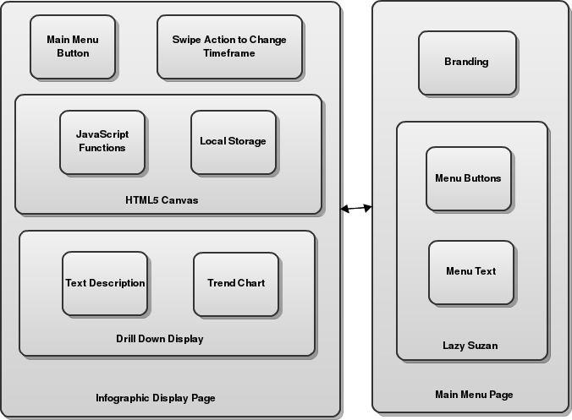

**3.3 Main Menu**

This image shows the swiping action that is used to rotate the icons. Below it is a screenshot of the main menu. The menu is displayed in a lazy Suzan style to allow the user to scroll through the icons. The corresponding info- graphic display page is shown when the icon is clicked.

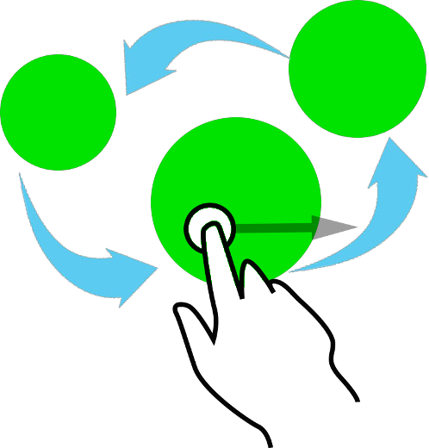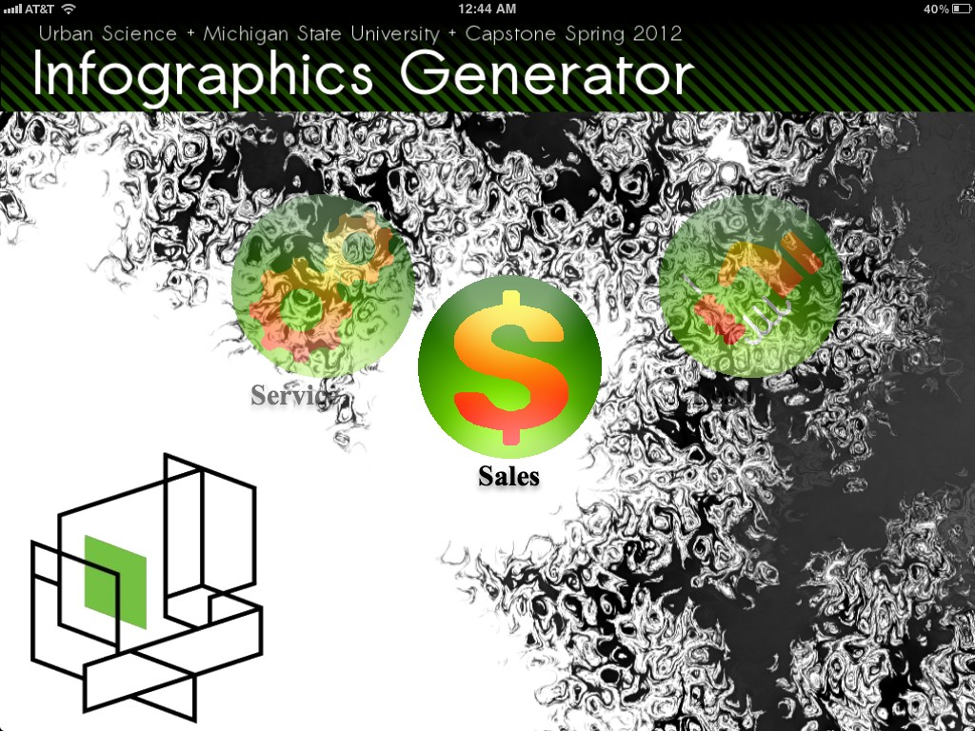

**3.4 Infographic Page**

This is how the display page looks for the sales infographic. The current month is displayed at the top right next to the menu button. The menu button navigates back to the menu screen. Swiping left and right increases and decreases the month. Tapping a KPI data brings up additional infor- mation.

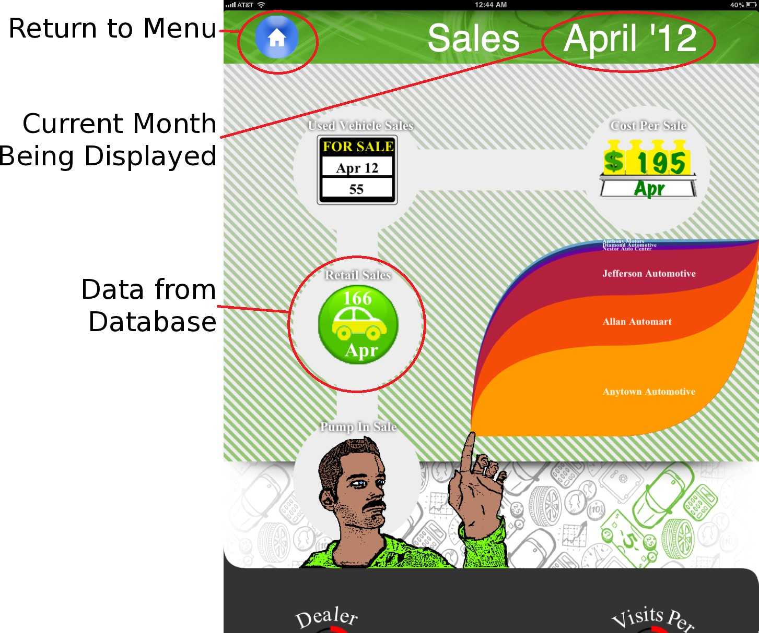

**3.5 Drill Down Display**

The drill down display is shown when a KPI data is tapped. It is a box that appears in the center of the screen with a description of the KPI data and a trend chart which shows the data for the last 6 months.

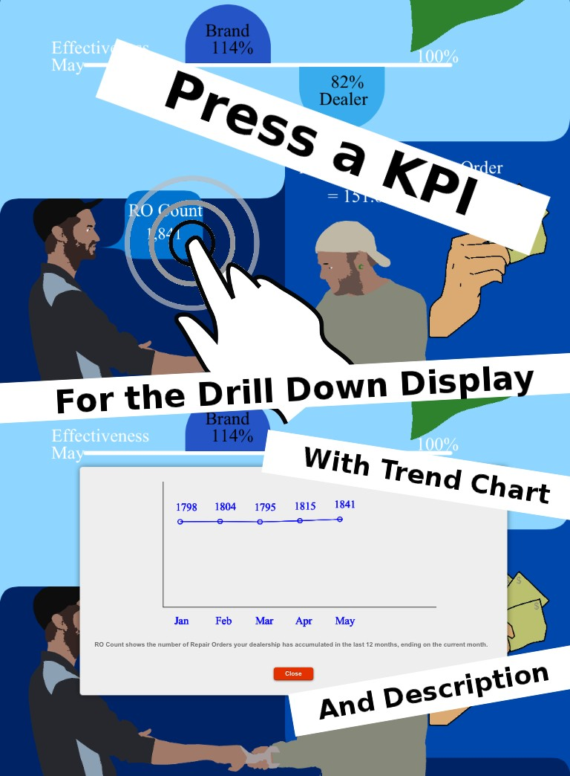

**3.6 Web Backend**

The user connects to the web backend via Safari. As the page loads, a script runs to automatically retrieve and store data from the database into tem- porary local storage. If there is newer data it will update the local storage when the user refreshes the page. This data is used by the infographics generator to update values in the infographic.

**4 Technical Specifications**

The infographics generator produces infographics suitable for display on the iPad 2 using the Safari browser.

The Index.html page in our webapp contains the infographic selector menu. The infographic selector menu is used to browse all available info- graphics. The infographics available to choose from include: Sales, Service, and Lead Management. The selector interface has three icons, each repre- senting an infographic, arranged in a horizontally elongated ellipse. A swipe in the left direction causes the icons to rotate clockwise following the ellip- tical path. Likewise, the icons rotate counter clockwise when swiped in the right direction. By swiping, the user feels that they are causing the invisible lazy suzan to rotate. Upon tapping the front most icon, Safari navigates to the corresponding infographic’s page.

The infographic display page contains a floating image called the header. The header spans the width of the page and remains at the top of the page when the user scrolls. The header has a button on the left hand side which, if tapping, navigates back to the infographic selector menu. The right side of the header has text displaying the month and year of the data being displayed. The infographic is located immediately beneath the header and spans the entire width of the page. If the infographic is swiped left, the next month’s data is displayed. If swiped right, the previous month’s data is displayed. If no data exists for the month attempting to be displayed, the current date is not changed.

Each infographic displays multiple key performance indicators (KPI) data. The data is obtained from a Microsoft SQL database. The server host- ing the infographics generator uses an ASP.NET script (KPI Handler.ashx) to query the database for all available KPI data, serializes the data, and returns the data to the client device in JavaScript Object Notation (JSON). The client device then parses this data using a JavaScript function (found in Scripts/KPILocalStorage.js) and adds the data to local storage.

An infographic element is a visual representation of KPI data, respon- sible for displaying one or more KPI data. An infographic is comprised of multiple infographic elements. Each infographic element is drawn on an HTML5 canvas using JavaScript functions found in one of the three in- fographic drawing files (draw-sales.js, draw-service.js, draw-lead.js) or the common element file (elements.js). The common element file is used to cen- tralize the generic JavaScript functions that are used to draw the elements in the infographics. The infographic specific files call functions from the common element file and have their own JavaScript functions to draw the infographic. They also calls functions to retrieve specific KPI values from local storage.

A drill down display is shown in the center of the screen if an infographic element is tapped. The drill down display gives an brief description of the KPI that was tapped and shows a trend chart of the KPI over the last 6 months (ending in the current month) or the maximum number of months available, whichever number is smaller.

**5 Schedule**

**5.1 Week 1 (January 9, 2012)**

*•* Had our first conference call with our customer

*•* Set up weekly conference calls with our customer

*•* Set up regular team meetings to meet twice a week

*•* Installed virtual machines

**5.2 Week 2 (January 16, 2012)**

*•* Started UML diagrams

*•* Installed Windows Server 2008 R2

*•* Installed IIS 7

*•* Installed ASP.NET

*•* Installed Microsoft SQL Server

*•* Talked with our customer about interface mockups

**5.3 Week 3 (January 23, 2012)**

*•* Completed more UML diagrams

*•* First draft of project-plan

*•* Installed Visual Studio 2010

*•* Created screen mockups

*•* Created sample infographic elements

**5.4 Milestone: Status Reports**

*•* Gave report to class

**5.5 Week 4 (January 30, 2012)**

*•* Created infographic elements using actual KPI data

*•* Wrote website to showcase infographics

*•* Decided to work on sales infographic first

**5.6 Milestone: Project Plan Presentation**

*•* Gave presentation in class

**5.7 Week 5 (February 6, 2012)**

*•* Presented project plan to class

*•* Changed from using XML to JSON for pulling database information

*•* Have roundabout working with several images for infographic selector buttons

*•* Successfully pulled data from a SQL database using ASP.NET

**5.8 Week 6 (February 13, 2012)**

*•* Sales infographic exists in basic form

*•* Added background image to main menu

**5.9 Week 7 (February 20, 2012)**

*•* Infographics now use values from database

*•* Rewrote pump in sales infographic

*•* Practiced Alpha Demonstration

**5.10 Milestone: Alpha Demonstrations**

*•* Demonstrated software to Urban Science for first time

*•* Recieved usefull feedback from Urban Science

**5.11 Week 8 (February 27, 2012)**

*•* Planning for betas

*•* Created mockups of service and lead management infographics

**5.12 Week 9 (March 12, 2012)**

*•* Added service infographic to website

*•* Fixed bugs with swiping

*•* Local storage now refreshes with website

**5.13 Week 10 (March 19, 2012)**

*•* Added MSU and Urban Science branding to website

*•* Visited Urban Science headquarters in Detroit, MI

**5.14 Week 11 (March 26, 2012)**

*•* Added remaining KPI to service and lead management infographics

*•* Implemented drill down display

*•* Began writing script for video

*•* Practiced for Beta presentation

**5.15 Milestone: Beta Demonstrations**

*•* Presentation was successful

*•* Project was feature complete

**5.16 Week 12 (April 2, 2012)**

*•* Changed text formatting upon customer request

*•* Fixed bugs with swiping

**5.17 Week 13 (April 9, 2012)**

*•* Updated project plan to reflect most recent version of webapp

*•* Discovered origin of grey background in jQuery css file

*•* Filmed video

**5.18 Week 14 (April 16, 2012)**

*•* Edited video

*•* Wrote user manual

*•* Fixed elevator

**5.19 Week 15 (April 23, 2012)**

*•* Set up for design day

*•* Presented at design day

**5.20 Milestone: Projet Video**

*•* Filmed using Dr. D’s new camera

*•* Filmed video in capstone lab

**5.21 Milestone: All Deliverables**

*•* Successfully submitted

**5.22 Milestone: Design Day**

*•* Great success!