SOFTWARE ARCHITECTURE
================================================================================
DOCUMENT ID: software_architecture
FILENAME: software_architecture.docx
FORMAT: DOCX (.docx)
CATEGORY: documents
CONTENT TYPES: text, table
EXPECTED METADATA ATTR: page_number, section, paragraph_number, table_number
================================================================================

MEDRAG SOFTWARE ARCHITECTURE & RETRIEVAL SYSTEM SPECIFICATION
**Document ID:** software_architecture
**Source File:** software_architecture.docx
**Prepared By:** Apex Software Consulting Systems Engineering
**Client:** HealthPulse Technologies
**Classification:** Controlled Evaluation Corpus / Internal Technical Specification

SECTION 1: ARCHITECTURAL OVERVIEW & DESIGN PRINCIPLES

1.1 System Purpose & Scope
The MedRAG software architecture provides a modular, horizontally scalable foundation for executing high-precision retrieval-augmented generation in clinical environments. Developed by Apex Software Consulting for HealthPulse Technologies, the platform decouples heavy ingestion processing from real-time user query execution. This guarantees high throughput, deterministic source attribution, and zero-trust security isolation.

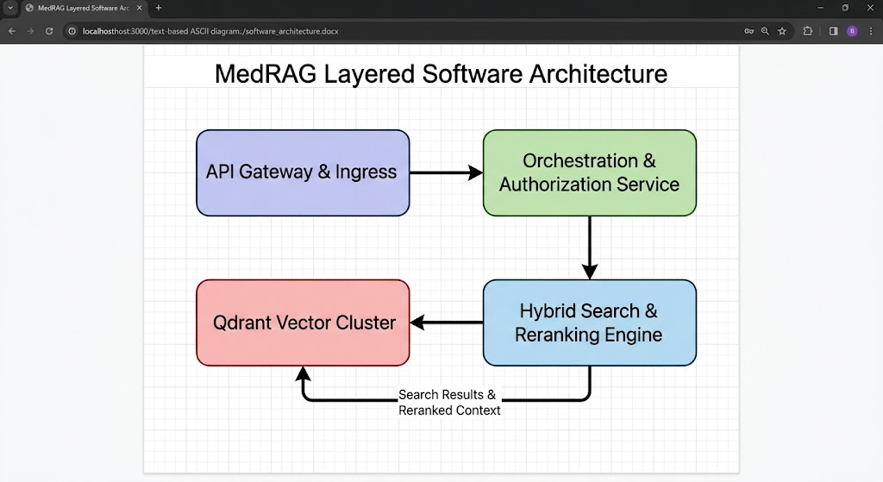

Figure 1

1.2 Microservice Decomposition
To meet clinical availability requirements, MedRAG separates concerns into distinct microservices:

1. **API Ingress Gateway:** Handles client TLS termination, OAuth2/OIDC token validation, and rate limiting.
2. **Ingestion & Extraction Service:** Asynchronously parses incoming multi-format files (`.pdf`, `.docx`, `.pptx`, `.xlsx`), extracts tabular layouts, and attaches provenance attributes.
3. **Hybrid Search Service:** Coordinates concurrent dense vector lookups and sparse BM25 query evaluations.
4. **Context Reranking Service:** Executes deep cross-encoder evaluation over candidate pools returned by hybrid search fusion.
5. **LLM Generation Engine:** Constructs grounded prompts and streams citations alongside model tokens back to client applications.

SECTION 2: HYBRID RETRIEVAL ARCHITECTURE

2.1 Multi-Stage Retrieval Flow
In clinical decision support, relying solely on dense vector embeddings can lead to missed exact keyword matches, such as medical record numbers, drug codes, or financial quantities. Conversely, reliance on sparse search ignores semantic synonyms. MedRAG resolves this by implementing a two-stage hybrid retrieval pipeline.

┌───────────────────────────┐
│ Clinical User Query │
└─────────────┬─────────────┘
│
┌─────────────────────┴─────────────────────┐
▼ ▼
┌───────────────────────────┐ ┌───────────────────────────┐
│ Dense Vector Retrieval │ │ Sparse BM25 Indexing │
│ (Qdrant / Bi-Encoder) │ │ (Lexical Term Search) │
└─────────────┬─────────────┘ └─────────────┬─────────────┘
│ │
└─────────────────────┬─────────────────────┘
│
▼
┌───────────────────────────┐
│ Reciprocal Rank Fusion │
│ (RRF Candidate Pool) │
└─────────────┬─────────────┘
│
▼
┌───────────────────────────┐
│ Cross-Encoder Reranker │
└─────────────┬─────────────┘
│
▼
┌───────────────────────────┐
│ Context Window Assembly │
└───────────────────────────┘

Figure 2

2.2 Stage 1: Candidate Generation via Reciprocal Rank Fusion (RRF)
During candidate generation, the query is dispatched simultaneously to Qdrant (dense vector search) and the inverted lexical index (sparse BM25). The top 50 results from each engine are combined using Reciprocal Rank Fusion:

$$\text{RRF\_Score}(d \in D) = \sum_{m \in M} \frac{1}{k + r_m(d)}$$

Where $M = \{\text{dense}, \text{sparse}\}$, $r_m(d)$ represents the ordinal rank position of document $d$ within retriever $m$, and $k$ is set to $60$.

2.3 Stage 2: Cross-Encoder Reranking
The top candidate chunks output by RRF undergo full cross-attention scoring. The cross-encoder joint model evaluates the entire query-document token sequence concurrently, scoring relevance on a continuous scale $[0, 1]$. Chunks scoring below a strict threshold ($\tau = 0.65$) are pruned prior to context injection.

SECTION 3: SYSTEM CAPACITY & LATENCY TARGETS

3.1 Non-Functional Requirements Matrix
The table below specifies the architectural SLA thresholds verified during Phase 8 testing.

Table 1: MedRAG Architectural Performance Targets

Service Component | Target Metric | Metric SLA / Benchmark | Operational Target
API Ingress Gateway | p99 Latency | < 15 ms | Token verification & route dispatch
Qdrant Vector Search | Query Throughput | > 1,200 QPS | 1536-dimensional HNSW similarity lookup
Hybrid RRF Fusion | Execution Time | < 25 ms | Fusing top-50 sparse and dense lists
Cross-Encoder Reranker | Processing Latency | < 120 ms | Rescoring 50 candidate context chunks
End-to-End Search Pipeline | Total Latency | < 200 ms | Complete context prep prior to LLM call

SECTION 4: CONTROLLED CORPUS EVALUATION MAPPING

To validate MedRAG's semantic search and exact-location provenance attribution against `software_architecture.docx`, the evaluation suite tests the following ground-truth targets:

1. **Query:** "How does the software architecture handle dense and sparse retrieval combinations?"
* **Expected Answer:** "Using Reciprocal Rank Fusion (RRF) with a smoothing parameter $k=60$ followed by cross-encoder reranking."
* **Expected Provenance:** `{"document_id": "software_architecture", "section": "SECTION 2: HYBRID RETRIEVAL ARCHITECTURE"}`
2. **Query:** "What is the targeted operational processing latency for the Cross-Encoder Reranker?"
* **Expected Answer:** "< 120 ms"
* **Expected Provenance:** `{"document_id": "software_architecture", "section": "SECTION 3: SYSTEM CAPACITY & LATENCY TARGETS", "table_number": 1}`
3. **Query:** "What is the threshold score for pruning context chunks during cross-encoder reranking?"
* **Expected Answer:** "tau = 0.65"
* **Expected Provenance:** `{"document_id": "software_architecture", "section": "2.3 Stage 2: Cross-Encoder Reranking"}`

