**Chapter 6**

1. 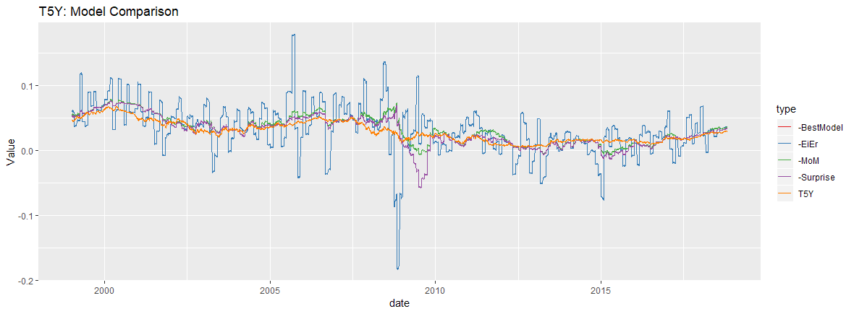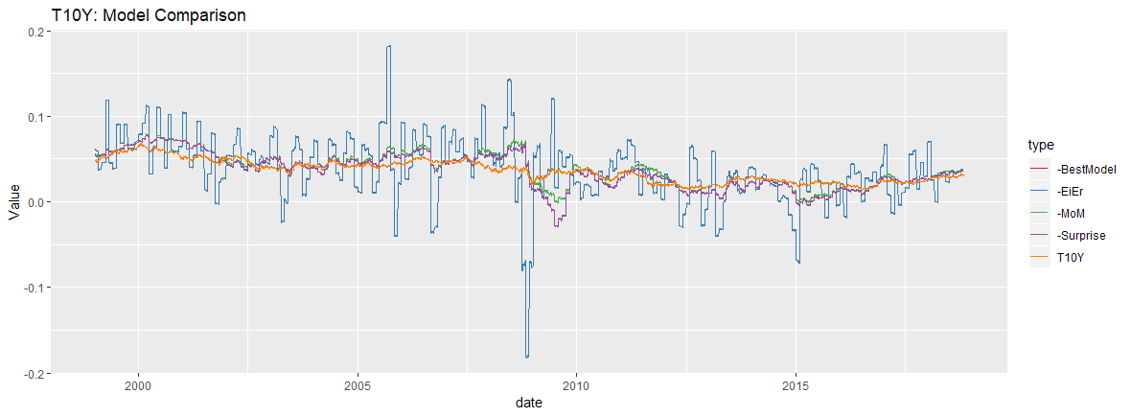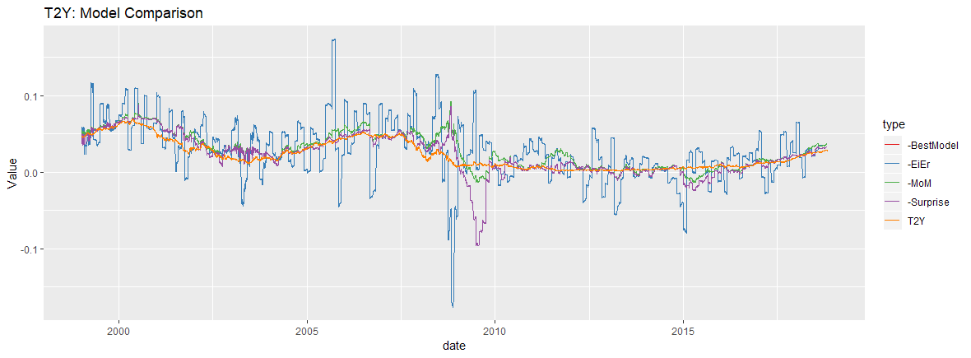To answer the following questions, I plotted different models that analyzed whether risk-free rates are equal to real rates plus inflation, plus an inflation variance penalty, and/or plus an inflation surprise. The following plots show the differences of these models, and the “BestModel” line (red) includes all of the previous 3 components (i.e. this is equation 6.25)



Here is a summary table of the means of each model, per Treasury expiration (Y02, Y05, Y10).

As we can see from the plots and the summary table, RF-rates are not equal to real rates + inflation. When an inflation surprise is added to the model, the result is a much closer approximation than if we just used real rates + inflation, but there is still room for improvement. When a variance penalty is added in addition to the previous components, this results in a MUCH better model and approximation of RF-rates, but again, this is still not perfect. Still, this model is still significantly better than the EiEr, MoM inflation, and Inflation-Surprise models.

The data implies that there is a lot of uncertainty about inflation. We know this to be true from class, as many leading analysts and wizards still don’t have a sure-fire model to predict inflation. In particular, I remember the story of the machine learning group that wanted to “tackle” this problem through algorithms and failed (in a pretty embarrassing manner, I might add).

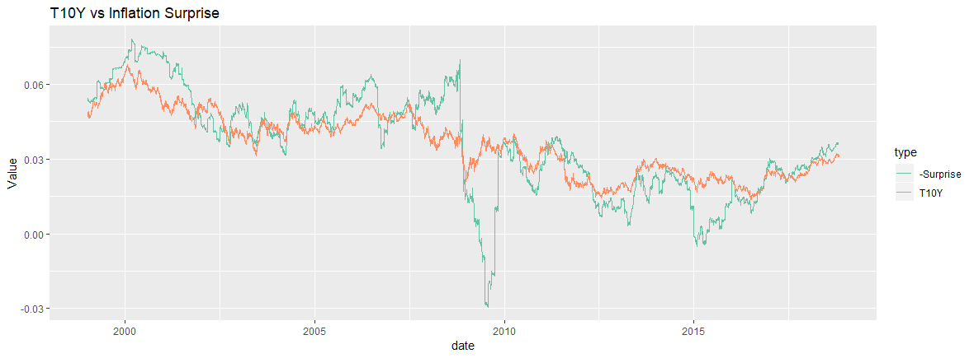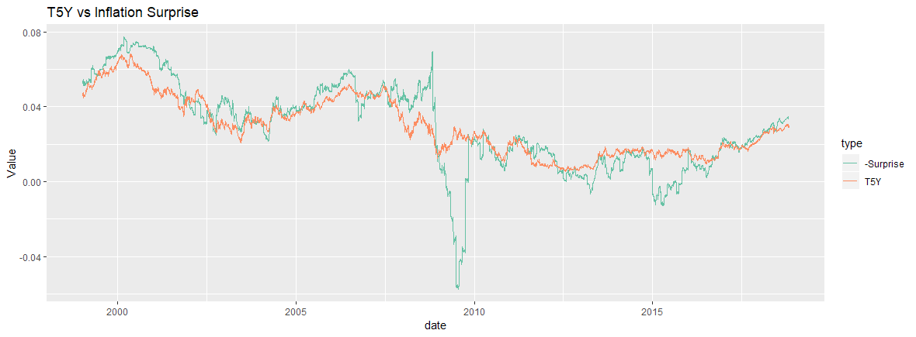We can see this uncertainty by plotting different constant-maturity Treasuries against the surprise in inflation, such as the T5Y and T10Y plots below. Notice the huge difference in inflation surprise vs the T yields during the 2008 Financial Crisis. We can see the volatility/uncertainty of inflation in many periods, including the early 2000s and in 2014-2015.

1. 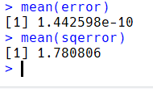Following the suggestion of Ravn and Uhlig, a penalty of 6.25(observations/year)4 was used as the curvature penalty for the monthly data. After writing the for-loop to do this prediction, I plotted the prediction vs. the CPI index, which is displayed below. The prediction’s mean error and mean squared error is:

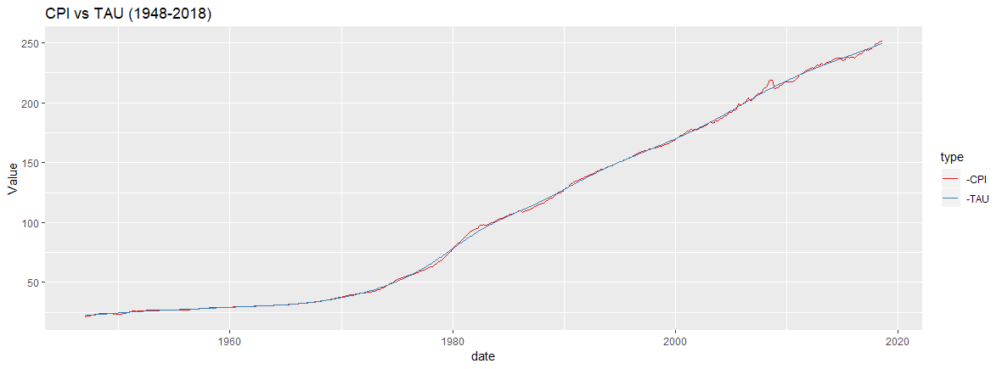

**Chapter 7**

1. 1. Average yield over the three years:   
      
   2. Average of approximated log returns is given by:   
      
   3. Annually-scaled volatility of these returns:   
      
   4. 
2. a + b.   
   

c.   


Comparison: ED1 has extremely different risk measures than the similar-term 3M CMT. A skewness of -5.54 indicates that there are often more negative surprises than there are positive ones. In addition, it has massive excess kurtosis of 54.29, which not only indicates fat tails but also the pointy heads, meaning that its returns are extremely deceptive and show little variation (which we can actually verify this deception, look at its volatility in the table). T3M has an excess kurtosis of 3.69, which can indicate fat tails as well. This could be due to the macro/political changes involving the FED (surprise rate hikes, etc.)

I think that the cause of the difference in these risk measures is because the CMT contracts are considered “risk-free”, having the backing & full-faith of the US government. Eurodollar futures, on the other hand, reflect the interest rates offered on USD-denominated deposits held in banks outside of the US. Specifically, it reflects the 3M interest rate at which banks can borrow funds in the London interbank market. As we know, banks can fail, hence the heightened risk measures of ED1 and ED8.

d.   


1. 1. 
   2. 
   3. We can see from the table below that the annualized average log-returns for these equities is significantly greater than the average UST yields. We see this because UST are generally considered “safe” investments (not realistically 100% risk free but close enough for all intents & purposes), while equities are considered more risky (due to company defaults and other risk factors, etc.) In return for the higher risk, one would expect to receive greater return for taking that risk.   
        
      
   4. Annualized volatility of log returns  
      
   5. Skewness/Kurtosis  
        
      
   6. While the volatilities are very different, the skewness and kurtosis of the equities and USTs are surprisingly similar. This might be due to the fact that all of these assets (US equities and USTs) are within the US financial markets, thus any downturn or upswing due to the US economy or US markets likely impact both of these asset groups to a somewhat similar degree.  
      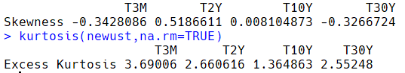
2. 1. Average Prices  
      
   2. Average Daily log returns  
       
   3. Annualized average log returns  
      I’ve noticed overall that commodities have greater annualized log-returns than USTs, due to the greater amount of risk taken on by buying these contracts (have to “deliver” X amount of the commodity at expiration, or hedging against rise in the price of a given commodity).  
      
   4. Annualized volatility  
      
   5. Skewness/Kurtosis  
        
      
   6. The annualized volatility is significantly higher in commodities than in USTs. The T2Y, along with Oil, have .4-.5 positive skew, which indicates that there are more often positive surprises than negative ones. For the T3M and T30Y, there is a much higher negative skew and higher kurtosis than we see in commodities. In regards to the negative skew, this makes sense logically: whenever the Federal Reserve announces news surrounding rates, it generally isn’t reflected as “positive news” for the fixed income market (and the Fed gets a lot of criticism on top of it).  
      
3. 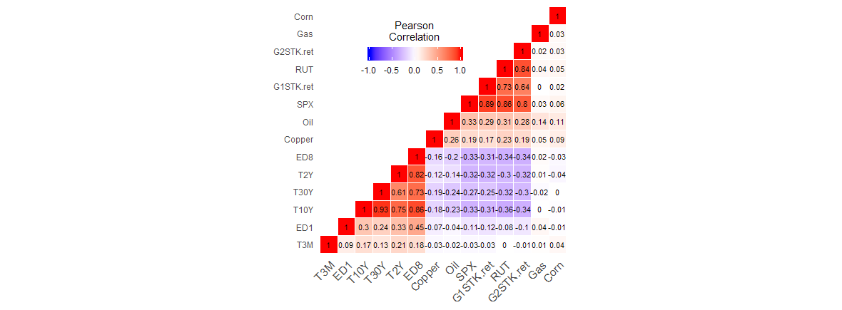From the correlation heat map below, it is clear that the long-term USTs are closely correlated with each other (long-term: T30Y+T10Y), which is likely due the greater uncertainty of inflation and interest rates at 10 and 30 years from now. There is also a high correlation between ED8 and these long-term USTs, but the highest correlation is between the ED8 (2Yr Eurodollar futures contract) and the T2Y (2Yr UST), which makes sense because these two contracts are both representations of interest rates and have the same maturity.   
   In addition, the SPX, RUT, and G1/G2 Stock Indices all have a very high correlation, which makes sense because these are all US equities and thus are impacted by the ups/downs of the US economy/equity market.

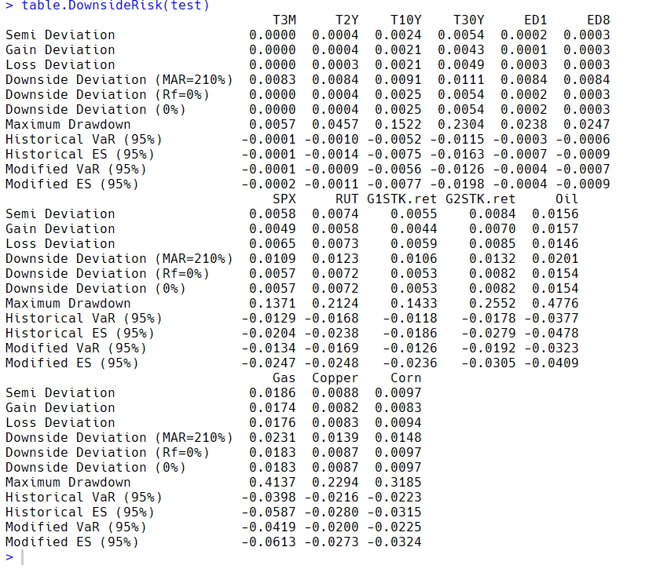**Chapter 8** 1. Note: I could not change the rounding of the table.DownsideRisk function (PerformanceAnalytics package), so I double-checked these values by doing the same function calls to the alldata dataframe. Everything checked out, for example semi-deviation(alldata$T3M) was 0.0000389904 (hence it is 0.0000 in the table below). T2Y semi-deviation was 0.0003888897, and we can see that reflected in the 0.0004 value below.

1.  If you were to order these instruments by Historical Cornish-Fisher VaR or Expected Shortfall, the commodities would be ranked as having the highest risk. However, if you were to rank these instruments based on Kurtosis, the UST contracts would actually be ranked higher than commodities. Equities would be ranked even higher if we ordered on Kurtosis, and Eurodollar futures would be the highest rank by a significant margin. If ranked on annualized volatility, we would see the opposite ranking of Eurodollar futures (having annualized vol at only 0.0037 and 0.0066.
2. As mentioned in #2, it is clear that the Eurodollar futures contracts seem deceptively lower risk than they actually are. This is also the case with some of the CMTs, particularly the short-term 3M maturity UST. All of these contracts have an extremely small annualized volatility, but an ugly and enormous (relative to other risk measures) kurtosis.